

SOFTWARE DESIGN SPECIFICATION
LICENSE MARKETPLACE SYSTEM

– Hanoi, Sep 2025 –

Table of Contents
I. Record of Changes 3
II. Software Design Document 4
1. High Level Design 4
1.1 Software Architecture 4
1.2 Package Diagram 4
1.3 Database Design 5
2. State Transition Diagrams 7
2.1 PIN Validation 7
2.2 … 7
3. Detailed Design 8
3.1 <Feature/Function Name1> 8
3.2 <Feature/Function Name2> 9

I. Record of Changes
Date | A*  M, D | In charge | Change Description
*A - Added M - Modified D - Deleted

II. Software Design Document

1. High Level Design

1.1 Software Architecture
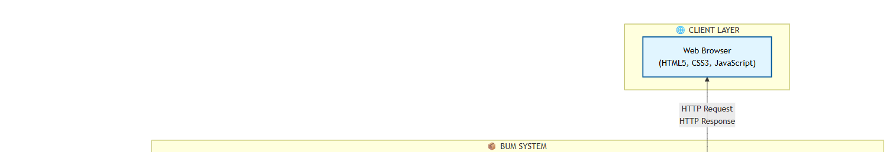
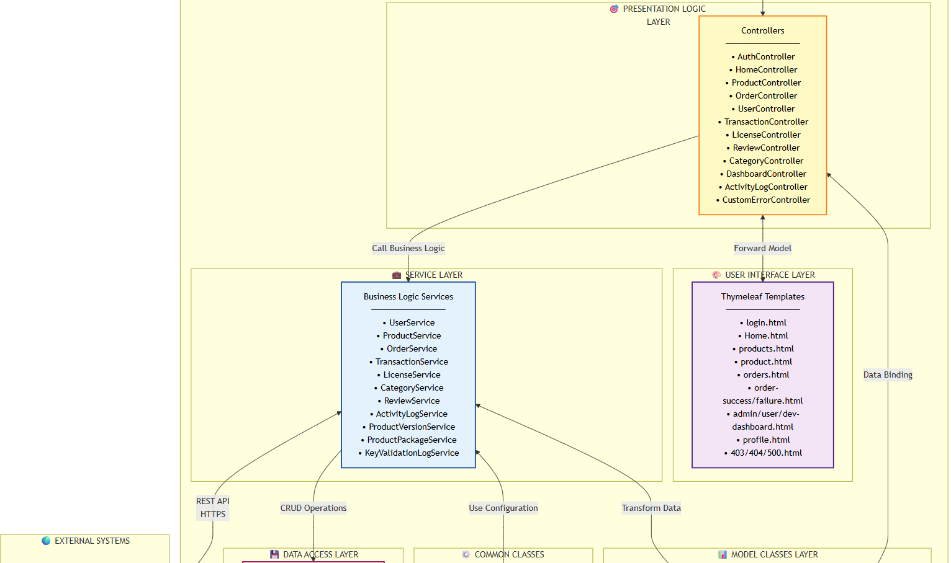
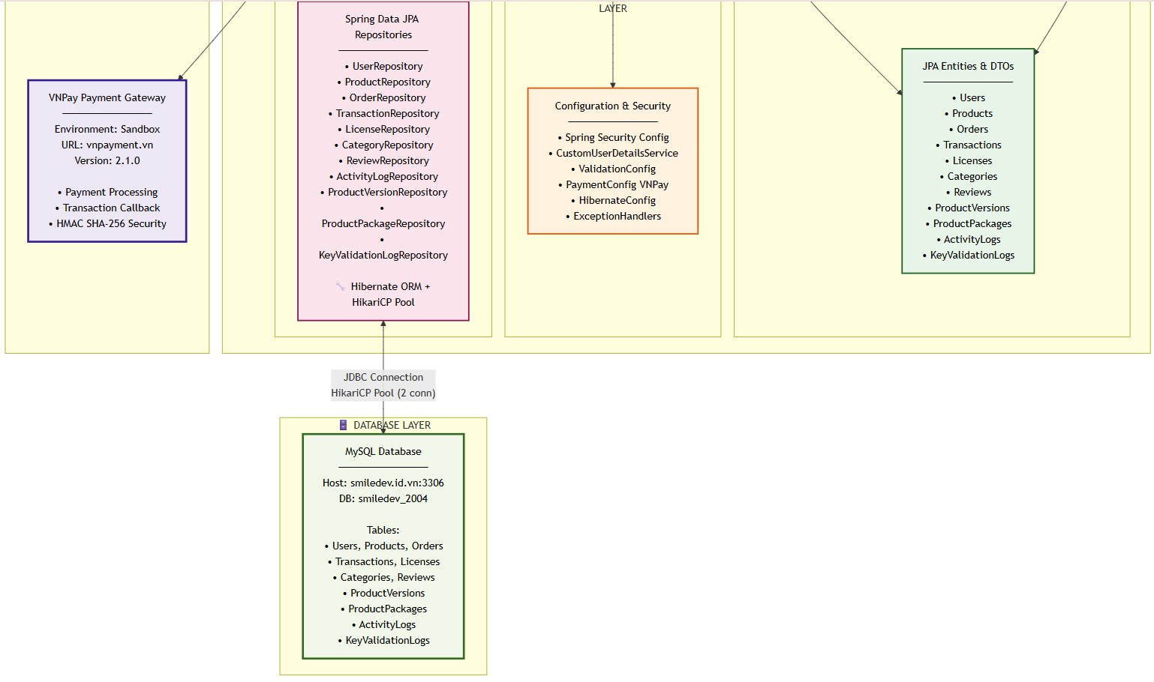

1.2 Package Diagram
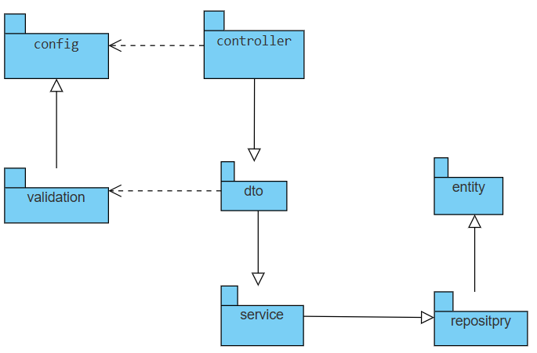
Package descriptions

No | Package | Description
01 | com.smiledev.bum | Root/Base Package - Contains the main application entry point (BumApplication.java) with @SpringBootApplication annotation. This class bootstraps the Spring Boot application.
02 | config | Configuration Package - Contains all Spring configuration classes including security, payment gateway, and custom handlers.  - SecurityConfig: Configures Spring Security (authentication, authorization, CSRF protection)  - VNPAYConfig: VNPay payment gateway configuration (API keys, endpoints)  - CustomAuthenticationSuccessHandler: Custom login success handler for role-based redirection
03 | controller | Web Controller Package - Contains Spring MVC controllers that handle HTTP requests and responses. Implements the Controller layer of MVC pattern.  - 15 controller classes handling different functional areas  - Uses @Controller, @RequestMapping, @GetMapping, @PostMapping annotations  - Manages request routing, input validation, and view rendering
04 | dto | Data Transfer Object Package - Contains objects used for data transfer between layers, especially between presentation and service layers.  - Separates internal domain models from external representations  - Includes validation annotations (@NotNull, @Email, @Size, etc.)  - Sub-packages: request/ (incoming data), response/ (outgoing data)
05 | dto.request | Request DTO Sub-package - Contains DTOs for handling incoming HTTP requests.  - RegistrationRequest: User registration form data  - UpdateProfileRequest: User profile update data  - DepositRequest: Wallet deposit request data
06 | dto.response | Response DTO Sub-package - Contains DTOs for formatting outgoing HTTP responses.  - Currently empty (responses use direct entities or generic DTOs)
07 | entity | Domain Model Package - Contains JPA entity classes representing database tables. These are persistent domain objects.  - 11 entity classes annotated with @Entity, @Table, @Id, etc.  - Maps to MySQL database tables  - Uses Lombok annotations (@Data, @NoArgsConstructor, @AllArgsConstructor)  - Defines relationships (@OneToMany, @ManyToOne, @ManyToMany)
08 | repository | Data Access Package - Contains Spring Data JPA repository interfaces for database operations.  - Extends JpaRepository<T, ID> interface  - Provides CRUD operations automatically  - Defines custom query methods using method naming conventions  - Uses @Repository annotation (optional with Spring Data JPA)
09 | service | Business Logic Package - Contains service classes that implement core business logic and orchestrate operations.  - 12 service classes annotated with @Service  - Implements business rules, workflows, and validations  - Manages transactions with @Transactional  - Coordinates between controllers and repositories  - Transforms entities to DTOs and vice versa
10 | validation | Custom Validation Package - Contains custom validation annotations and validators for complex validation rules.  - PasswordMatches: Custom annotation for password confirmation matching  - PasswordMatchesValidator: Validator implementation for password matching logic  - Integrates with Jakarta Bean Validation (JSR-380)

1.3 Database Design
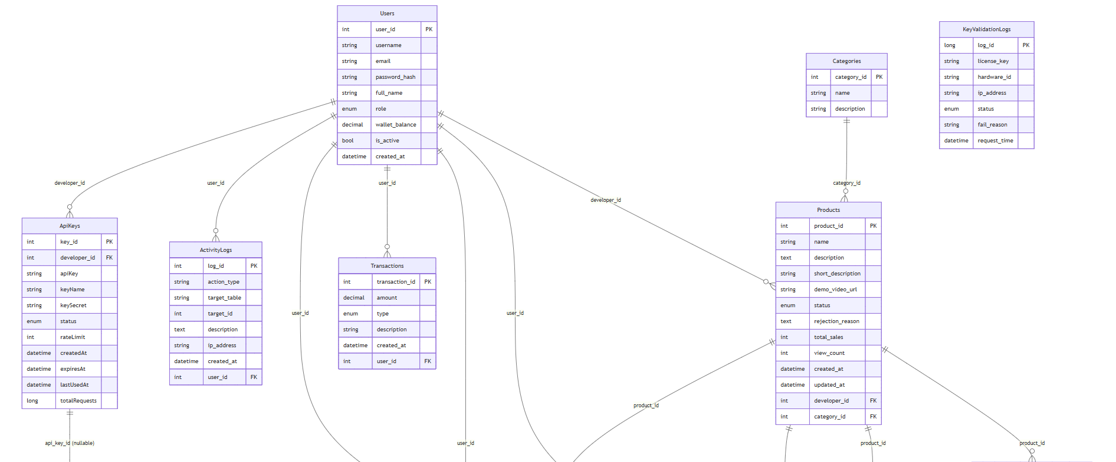
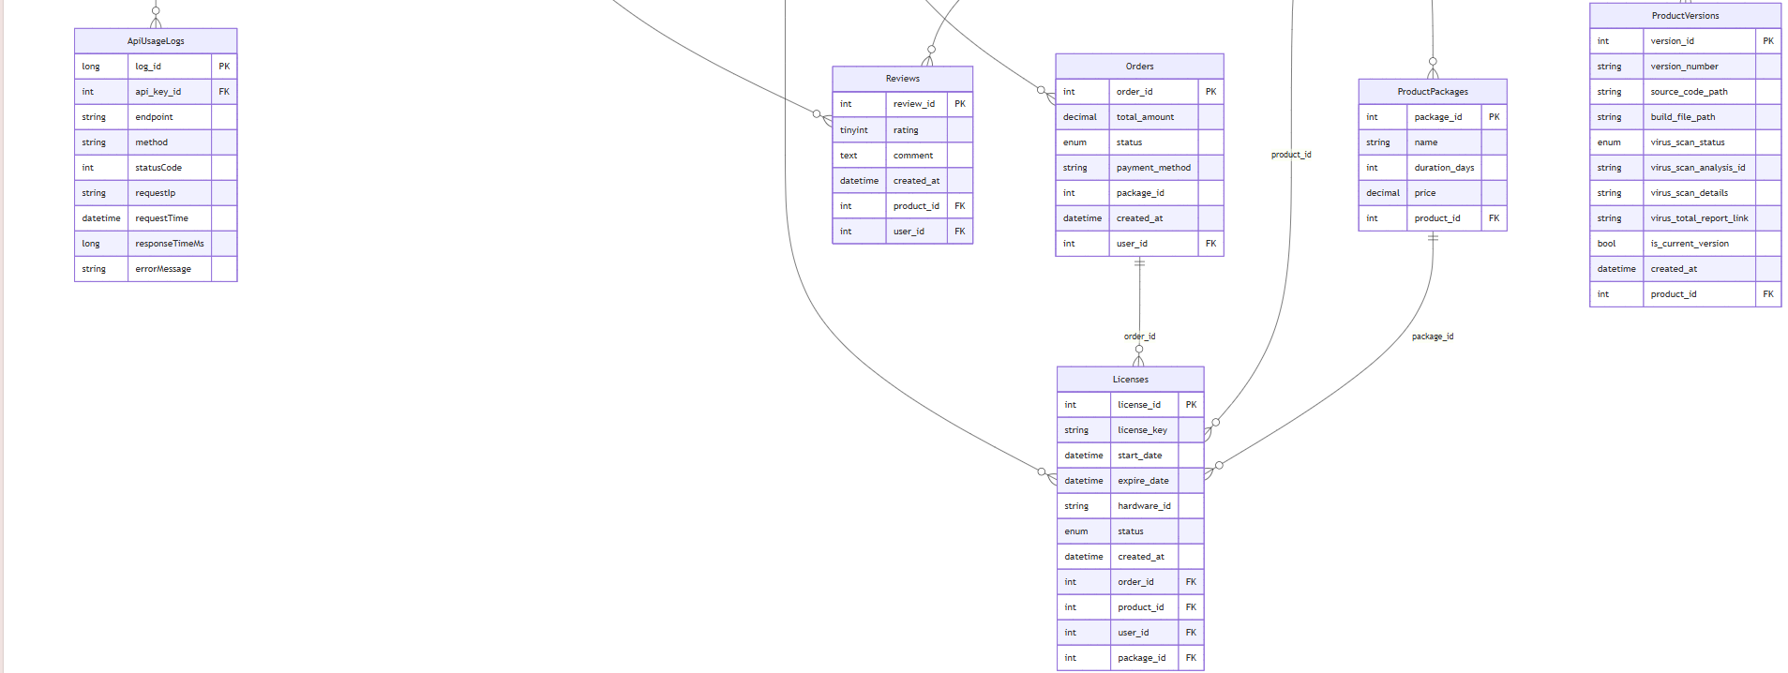

1.3.2 Table Descriptions
Notation: PK = Primary Key; FK = Foreign Key; UN = Unique; NN = Not Null
No | Table | Brief Description
01 | Users | Store user accounts, credentials, roles, wallet info
02 | Products | Product catalog data
03 | ProductVersions | Version metadata per product
04 | ProductPackages | Bundles of products/versions
05 | Categories | Product category hierarchy
06 | Orders | Customer orders and status
07 | Transactions | Payment transactions (VNPay)
08 | Licenses | Software license keys per user/product/version
09 | Reviews | Product reviews and ratings
10 | ActivityLogs | Audit log of user/system actions
11 | KeyValidationLogs | License key validation history

1.3.2.1 Users
Brief: User accounts, authentication, roles, wallet.
No | Field | PK | FK | UN | NN | Description
01 | id | PK |  | UN | NN | Auto-increment user id
02 | username |  |  | UN | NN | Login username
03 | email |  |  | UN | NN | User email
04 | password_hash |  |  |  | NN | BCrypt password hash
05 | role |  |  |  | NN | Role (ADMIN/USER/DEVELOPER)
06 | full_name |  |  |  |  | Display name
07 | wallet_balance |  |  |  | NN | Current wallet balance
08 | created_at |  |  |  | NN | Created timestamp
09 | updated_at |  |  |  |  | Updated timestamp

1.3.2.2 Products
Brief: Product master data.
No | Field | PK | FK | UN | NN | Description
01 | id | PK |  | UN | NN | Product id
02 | name |  |  | UN | NN | Product name
03 | description |  |  |  |  | Product description
04 | price |  |  |  | NN | Base price
05 | developer_id |  | FK |  | NN | FK to Users (developer)
06 | category_id |  | FK |  |  | FK to Categories
07 | created_at |  |  |  | NN | Created timestamp
08 | updated_at |  |  |  |  | Updated timestamp

1.3.2.3 ProductVersions
Brief: Version metadata for each product.
No | Field | PK | FK | UN | NN | Description
01 | id | PK |  | UN | NN | Version id
02 | product_id |  | FK |  | NN | FK to Products
03 | version |  |  |  | NN | Version string (e.g., 1.0.0)
04 | release_date |  |  |  |  | Release date
05 | download_url |  |  |  |  | Binary download link
06 | changelog |  |  |  |  | Release notes

1.3.2.4 ProductPackages
Brief: Bundles/package offers.
No | Field | PK | FK | UN | NN | Description
01 | id | PK |  | UN | NN | Package id
02 | product_id |  | FK |  | NN | FK to Products (main product)
03 | name |  |  |  | NN | Package name
04 | description |  |  |  |  | Package description
05 | price |  |  |  | NN | Package price
06 | is_active |  |  |  | NN | Active flag

1.3.2.5 Categories
Brief: Product category hierarchy.
No | Field | PK | FK | UN | NN | Description
01 | id | PK |  | UN | NN | Category id
02 | name |  |  | UN | NN | Category name
03 | slug |  |  | UN | NN | URL slug
04 | parent_id |  | FK |  |  | Self FK to Categories
05 | created_at |  |  |  | NN | Created timestamp

1.3.2.6 Orders
Brief: Orders placed by users for products/packages.
No | Field | PK | FK | UN | NN | Description
01 | id | PK |  | UN | NN | Order id
02 | user_id |  | FK |  | NN | FK to Users
03 | product_id |  | FK |  |  | FK to Products
04 | package_id |  | FK |  |  | FK to ProductPackages (optional)
05 | amount |  |  |  | NN | Order amount
06 | status |  |  |  | NN | Status (PENDING/PAID/FAILED/CANCELLED)
07 | created_at |  |  |  | NN | Created timestamp
08 | updated_at |  |  |  |  | Updated timestamp

1.3.2.7 Transactions
Brief: VNPay and payment transactions per order.
No | Field | PK | FK | UN | NN | Description
01 | id | PK |  | UN | NN | Transaction id
02 | order_id |  | FK |  | NN | FK to Orders
03 | user_id |  | FK |  | NN | FK to Users
04 | vnp_transaction_id |  |  | UN |  | VNPay transaction ref
05 | amount |  |  |  | NN | Paid amount
06 | status |  |  |  | NN | Payment status
07 | pay_date |  |  |  |  | Payment timestamp

1.3.2.8 Licenses
Brief: License keys per user and product/version.
No | Field | PK | FK | UN | NN | Description
01 | id | PK |  | UN | NN | License id
02 | user_id |  | FK |  | NN | FK to Users
03 | product_id |  | FK |  | NN | FK to Products
04 | product_version_id |  | FK |  |  | FK to ProductVersions
05 | license_key |  |  | UN | NN | License key string
06 | status |  |  |  | NN | ACTIVE/INACTIVE/REVOKED
07 | issued_at |  |  |  | NN | Issue timestamp
08 | expired_at |  |  |  |  | Expiry timestamp

1.3.2.9 Reviews
Brief: Product reviews and ratings.
No | Field | PK | FK | UN | NN | Description
01 | id | PK |  | UN | NN | Review id
02 | user_id |  | FK |  | NN | FK to Users
03 | product_id |  | FK |  | NN | FK to Products
04 | rating |  |  |  | NN | Rating (1-5)
05 | comment |  |  |  |  | Review text
06 | created_at |  |  |  | NN | Created timestamp

1.3.2.10 ActivityLogs
Brief: Audit trail of user/system actions.
No | Field | PK | FK | UN | NN | Description
01 | id | PK |  | UN | NN | Log id
02 | user_id |  | FK |  |  | FK to Users (nullable for system events)
03 | action |  |  |  | NN | Action type/description
04 | details |  |  |  |  | Additional details
05 | created_at |  |  |  | NN | Timestamp

1.3.2.11 KeyValidationLogs
Brief: History of license key validations.
No | Field | PK | FK | UN | NN | Description
01 | id | PK |  | UN | NN | Validation id
02 | license_id |  | FK |  | NN | FK to Licenses
03 | license_key |  |  |  | NN | License key used
04 | result |  |  |  | NN | SUCCESS/FAIL
05 | message |  |  |  |  | Validation message
06 | created_at |  |  |  | NN | Timestamp

2. State Transition Diagrams

2.1 Payment (Order + VNPay) Validation

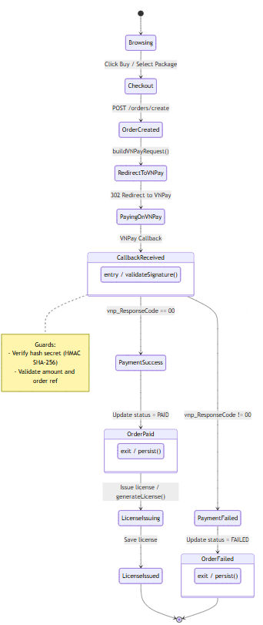

2.2 License Lifecycle

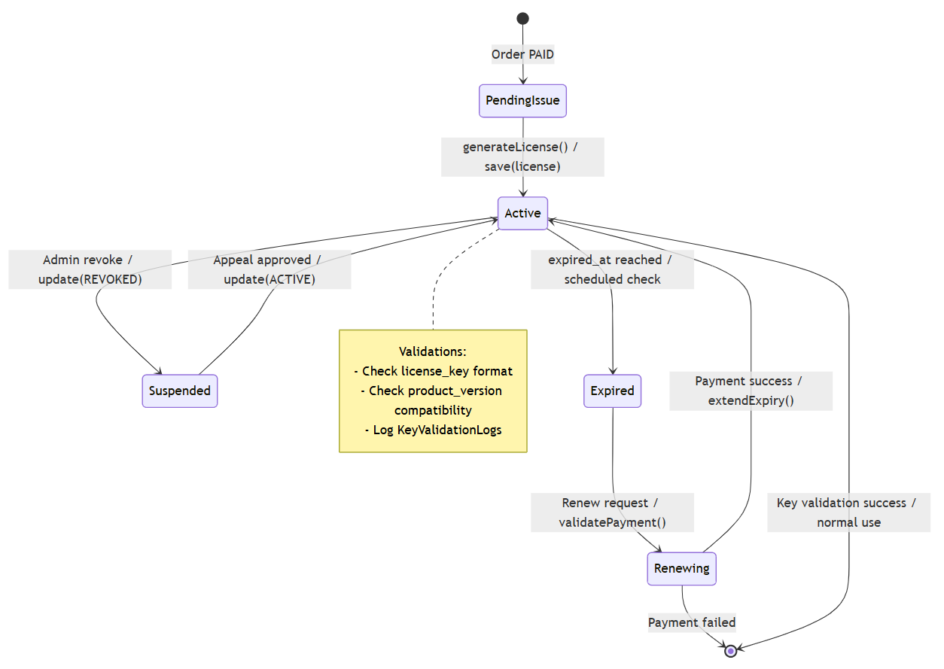

2.3 Authentication & Session

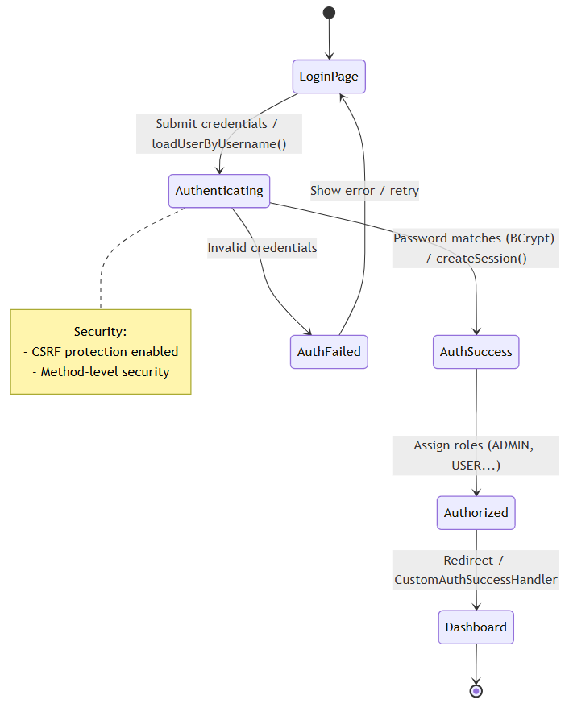

3. Detailed Design

3.1 Order Processing & Payment

3.1.1 Class Diagram
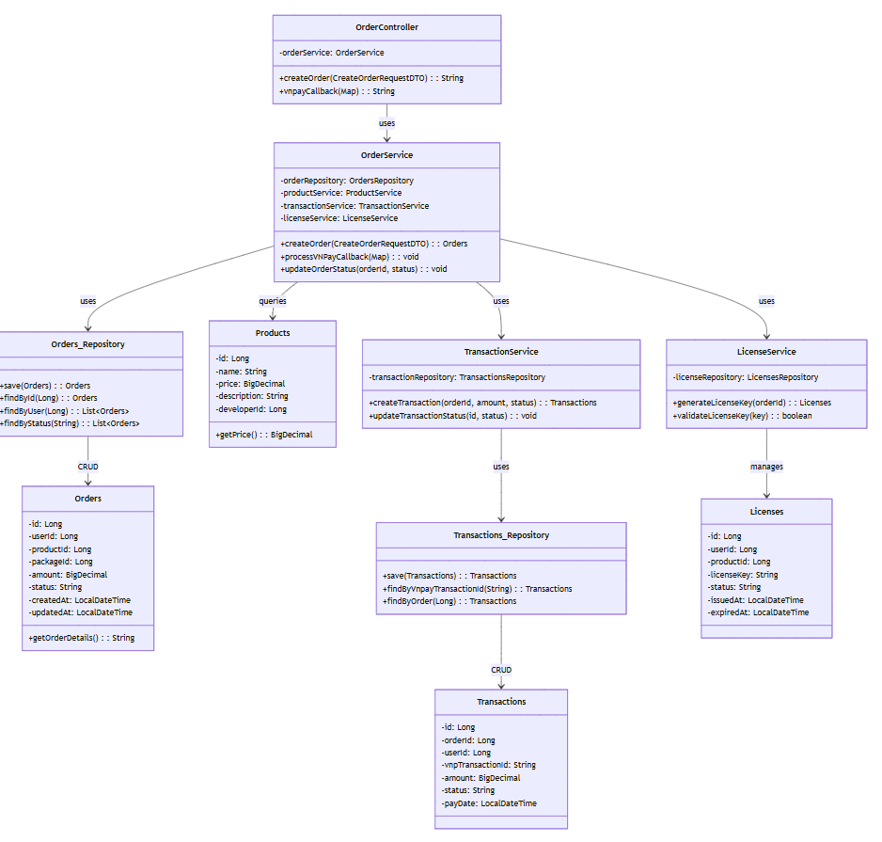

3.1.2 Sequence Diagram: Create Order & Initiate Payment

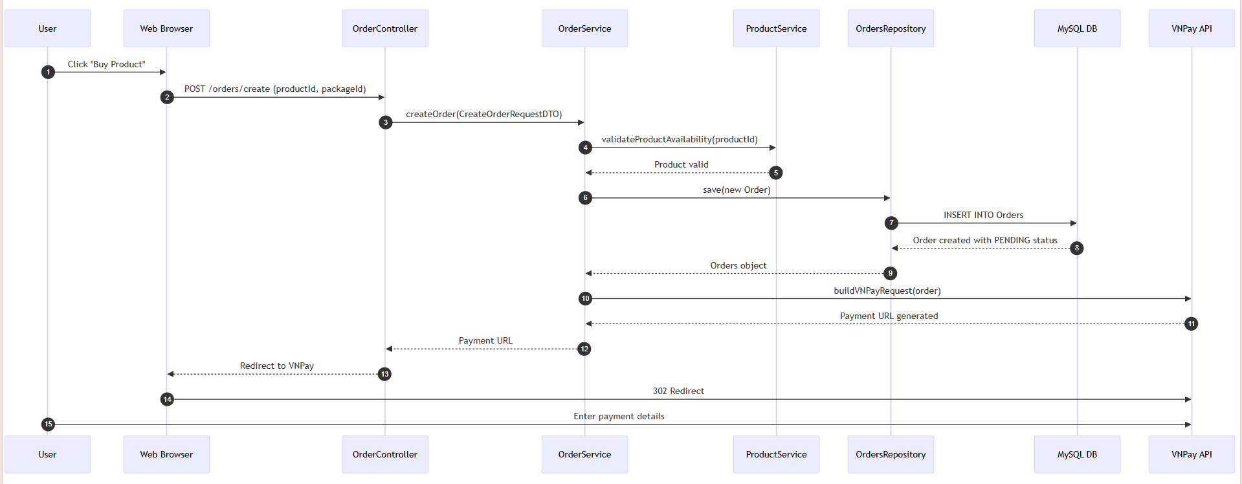

3.1.3 Sequence Diagram: Process VNPay Callback & Issue License

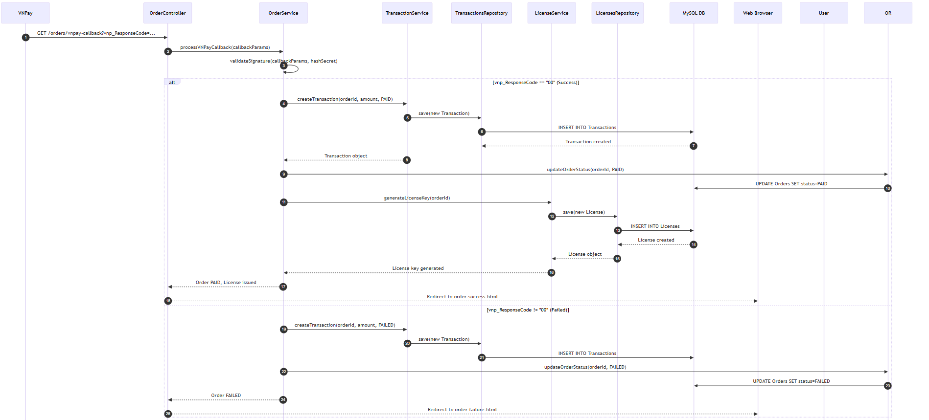

3.2 License Management & Validation

3.2.1 Class Diagram

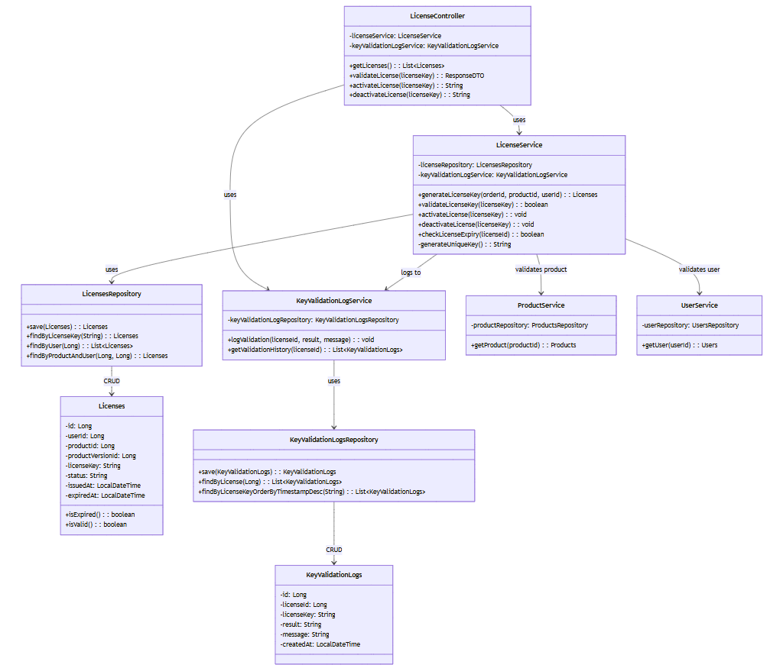

3.2.2 Sequence Diagram: Generate License Key (After Successful Payment)
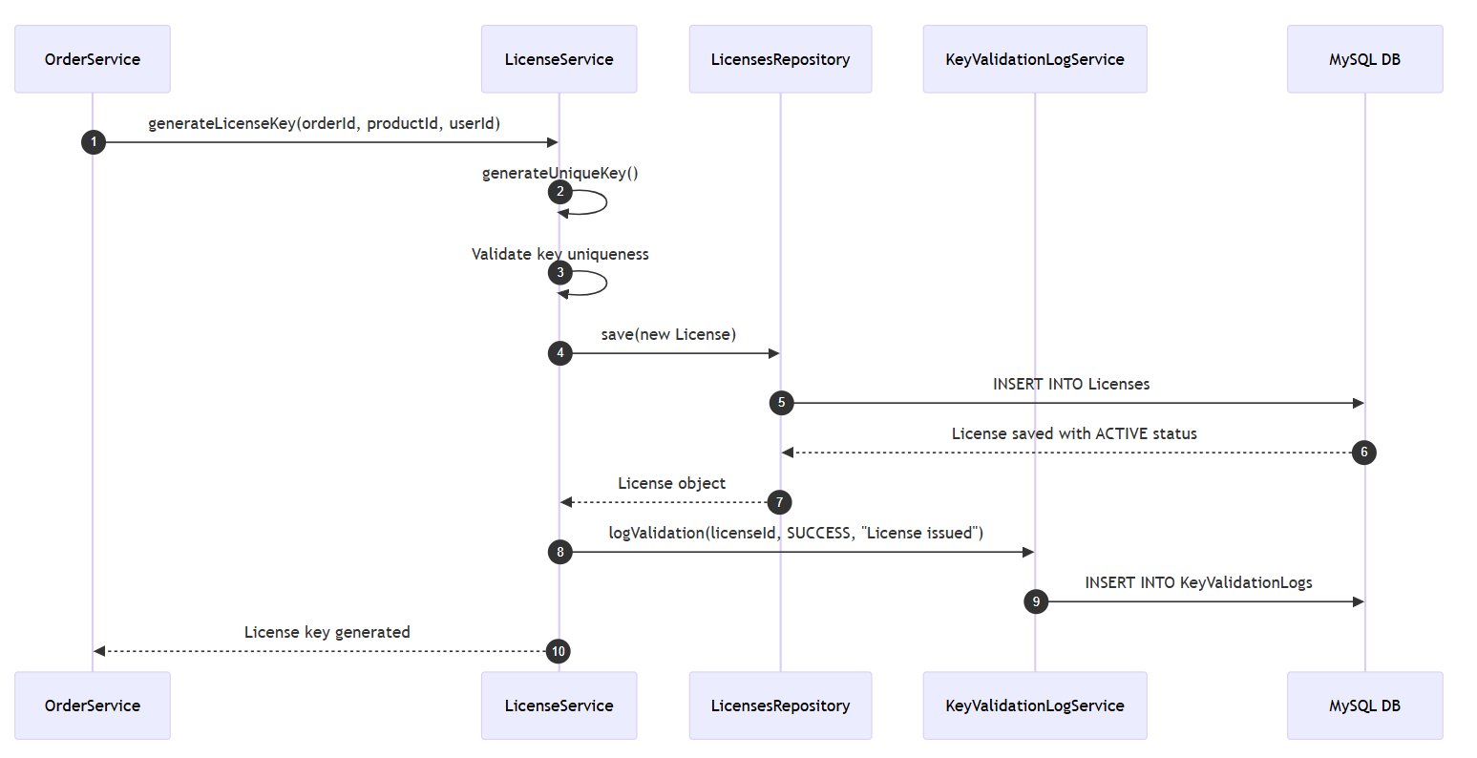

3.2.3 Sequence Diagram: Validate License Key (User Software Activation)
