

HCMC UNIVERSITY OF TECHNOLOGY AND EDUCATION

Faculty For High Quality Training

----------

FINAL PROJECT REPORT

CREATE NOTE PROGRAM

NOTE PROGRAMME

TUTOR: PhD. Huỳnh Xuân Phụng

CLASS ID: WIPR230579E_19_2_02CLC

(Tuesday, period 7-10)

STUDENT INVOLVEMENT:

Nguyễn Trần Thành Long 18110028

Nguyễn Trọng Nghĩa 18110033

Ho Chi Minh City

July / 2020

HCMC UNIVERSITY OF TECHNOLOGY AND EDUCATION

Faculty For High Quality Training

----------


FINAL PROJECT REPORT

CREATE NOTE PROGRAM

NOTE PROGRAMME

TUTOR: PhD. Huỳnh Xuân Phụng

CLASS ID: WIPR230579E_19_2_02CLC

(Tuesday, period 7-10)

STUDENT INVOLVEMENT:

Nguyễn Trần Thành Long 18110028

Nguyễn Trọng Nghĩa 18110033

Ho Chi Minh City

July / 2020
SCORE

CRITERION | CONTEXT | PRESENTATION | TOTAL

TUTOR’S COMMENT

ASSESSMENT:

- Nguyễn Trần Thành Long: .................................................................................

- Nguyễn Trọng Nghĩa: ...........................................................................................

……………….......................................................................................................

...............................................................................................................................

...............................................................................................................................

...............................................................................................................................

...............................................................................................................................

...............................................................................................................................

...............................................................................................................................

Instructor
PREAMBLE

A completed study would not be done without any assistance. Therefore, the author, who have completed this project, gratefully gives acknowledgement to the support and motivation during the time of doing this research as a requirement of completing my Windows Programming.

First of all, we would like to express our endless gratefulness to our lecturer, PhD.Huynh Xuan Phung. His support and advices went through the process of completion of our thesis. His encouragement and comments had significantly enriched and improved our work. Without his motivation and instructions, the thesis would have been impossible to be done effectively.

Our special thanks approve to all of teachers in Faculty For High Quality Training with having assistances and motivating us for our thesis. We also would like to explain our thanks to our classmates for their support.

At last, we wish all of teachers more health, happiness and always success in the teaching path

Ho Chi Minh, July 10, 2020

Our group
Contents

List of tables 1

Chapter 1: Program overview 3

1. General Introduction 3

1.1 Project requirement 3

1.2 Project analysis 3

1.3 Mode of implement 3

Chapter 2: Plan of operation 4

1. Plan 4

2. Task divisions 5

Chapter 3: Design program 7

1. Algorithm 7

2. Design class 7

3. Design database 7

4. Fields 8

5. Design interface 10

Chapter 4: Setting and Testing 16

Chapter 5: Conclusion and development path 19

List of tables

Table 1: Weekly plan 4

Table 2: Task divisions in teams 5

1
List of images

Image 1: LoginUser 7

Image 2: Note 7

Image 3: ConfigureNote 8

Image 4: Trash 8

Image 5: ConfigureTrash ..9

Image 6: Login form 10

Image 7: Register form 10

Image 8: Forgot password form 11

Image 9: Manage your account form 11

Image 10: Note form 12

Image 11: Note form(Trash mode) 12

Image 12: Note form(No login) 13

Image 13: Note form(login with account ‘long’) 13

Image 14: Note form(focus mode) 14

Image 15: Theme light 14

Image 16: Instruction1 15

Image 17: Instruction2 15

Image 18: Testing 1 16

Image 19: Testing 2 16

Image 20: Testing 3 17

Image 20: Testing 4 17

Image 20: Testing 5 18

Image 20: Testing 6 18

2
Chapter 1: Program overview

1. General Introduction

1.1 Project requirement
Our product is object-oriented and written mainly by C# which is mainly used to

allow different users to create new notes and manage their notes.

1.2 Project analysis
- Build object - oriented program

- Allow different users to create their accounts

- Allow users to create, manage and share their notes by directly interacting with our program

1.3 Mode of implement
- Build object-oriented program by C#: inheritance, escapsulation

- Apply Windows form application to create program interface for users

3
Chapter 2: Plan of operation

1. Plan

 |  | Table 1: Weekly plan
Week | Task
5 | Try using SimpleNote program and make a list of functions which are
 | needed to be developed.
6 | Divide tasks for group members and design user interface
7 | Develop functions:
 | - | Create new note
 | - Edit note (Copy, Cut, Paste, Select All)
 | - | Save modified note
 | - | Search note
 | - | Restore note
 | - Login, register, get password
8 | Develop functions:
 | - Edit note (Change Font, Color, Size, Font style)
 | - Double click to open toolbar
 | - Count characters, words of note

- Develop functions:

  - Change View (Light – Dark View)
  - Sort note, reverse
  - Focus mode
  - Manage your account

  - Redevelop user interfaces for user-friendly being.

Test and fix bugs. Complete program

11 Write report and report

4

- Task divisions

Table 2: Task divisions in teams
 | Name | Task description |  |  | Distribution
1 | Nguyễn | - | Give tasks for members |  | 60%
 | Trần | - | Write functions:
 | Thành |  | o | Create new notes
 | Long |  | o | Modify old notes
 |  |  | o | Search note (by title)
 |  |  | o Delete notes
 |  |  | o | Manage notes
 |  |  | o | Manage Trash  Edit Account
- Complete product from written functions of all
members
- Connect to SQL
- Check and fix bugs
 |  | - | Write Report
2 | Nguyễn | - | Plan and give more ideas about further project |  | 40%
 | Trọng | - | Write functions:
 | Nghĩa |  | o Edit note: Copy, Cut, Paste, Select
 |  |  |  | - All, Change Font, Color, Size, Font Style,...
 |  | - | Write: | Login, Register, Forgot password
 |  | - | Design interface
 |  | - | Write Report
5

Chapter 3: Design program

- Algorithm

- Design class
List of classes:

- Class LoginUser

- Class Note
- Class ConfigureNote
- Class Trash
- Class ConfigureTrash
- Design database

  - Table 1 Name: LoginUser

Purpose of table: This table use for remember all of user use the programme, it is applied in login, register, forgot password function. Besides that, by using foreign key in database, the UserID field in this table can be use to link with all of other table in database.

- Table 2 Name: Note

Purpose of table: This table use for remember all of Note of all user using this programme. When the programme is running it is going to call all notes of that user to the programme or if user want to save a note, it will be save in this table.

- Table 3 Name: CofigureNote

Purpose of table: This table use for remember font, size, color ,… of note of all user using this programme. When the programme is running it is going to call note and configureNote of that user to the programme or if user want to save a note, it will be save font ,size , color ,.. in this table.

- Table 4 Name: Trash

Purpose of table: This table use for remember all delete Notes of all user using this programme.When the program is running if you change trash mode, it is going to call delete note you can delete or restore it.

- Table 5 Name: ConfigureTrah
Purpose of table: This table use for remember font, size, color ,… of note of all user using this programme. When the programme is running it is going to call Trash and configureTrash of that user to the programme or if user want to call a trash, it will be save font ,size , color ,.. in this table
6

- Fields
  - Table 1 Name: LoginUser

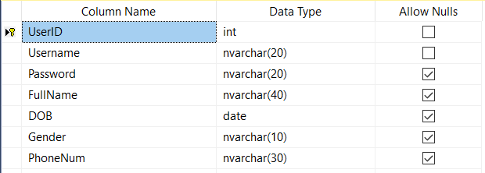

Image 1: LoginUser

Username and Password use for login . Your information is saved fullname, DOB, Gender ,PhoneNum. Apply in login function, registration funtion and Forgot password function. Beside that this is the main table, All other table have to link with this table thru UserID. If you lost password, you can input PhoneNum to get your password.

- Table 2 Name: Note

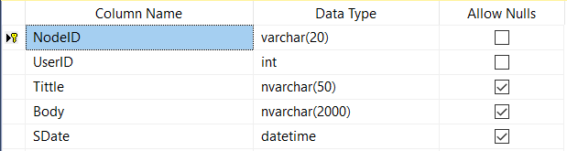

Image 2: Note

NodeID is a primary key and it makes sure that want username can have many notes. Title and Body are where the database save the information of note like content or header. The day of note which is created, it is saved in SDate.UserID is also a foreign key references to LoginUser table.

7

- Table 3 Name: ConfigureNote

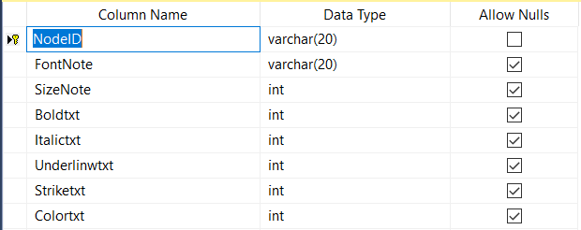

Image 3: ConfigureNote
NodeID is a primary key. Each table Note has a ConfigureNote. This table save font , size ,color and font style(bold, italic, underline, strikeount).

- Table 4 Name: Trash

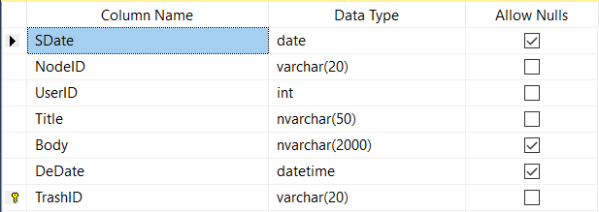

Image 4: Trash

This table is similar to table Note. In addition, table Trash have a DeDate which is saved the date the user deleted

8
- Table 5 Name : ConfigureTrash
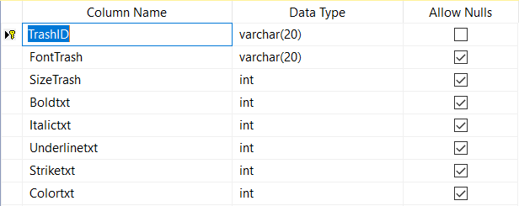

Image 5: ConfigureTrash
This table is similar to table ConfigureNote. It also save font family, size, color and fontstyle.

9

5. Design interface
- Login form:

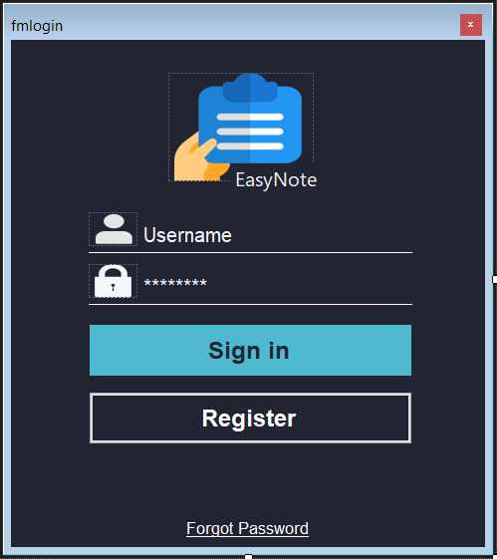

Input username and password

Click Sign In to Login account

Click button Register to register an account

Find your password

Image 6: Login form

- Register form:
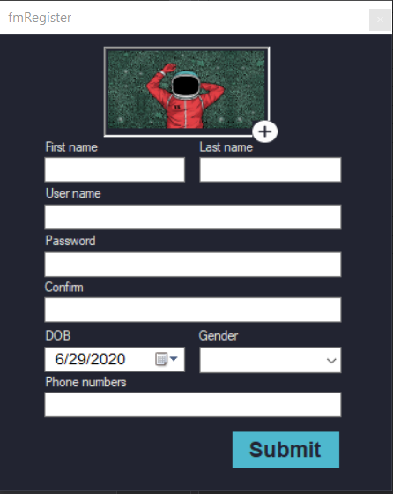

Choose image to make your avatar

Fill in your information

Image 7: Register form

10
- Forgot password form:
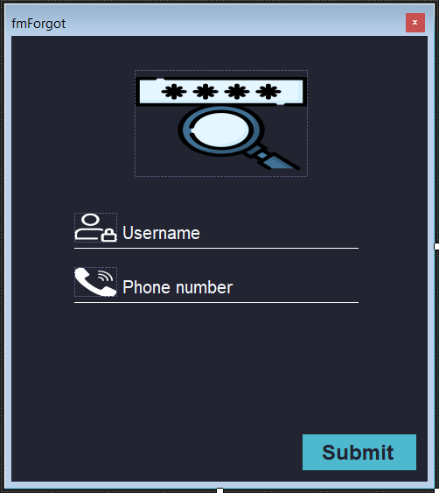

Input username and phone number to get password

Image 8: Forgot passord form
- Manage your account form
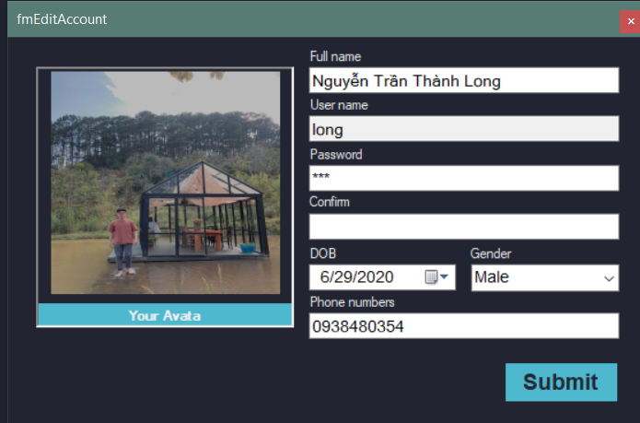

You can edit your information

Image 9: Manage your account

11
- Note form:
Information note
Delete note

Save note
Expand
New note
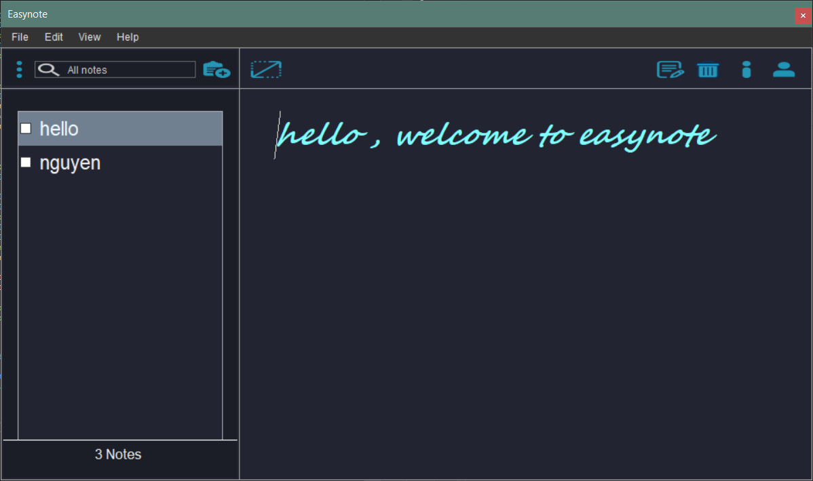
Find note
Login

Image 10: Note form(No login)

- Trash form:
Restore note

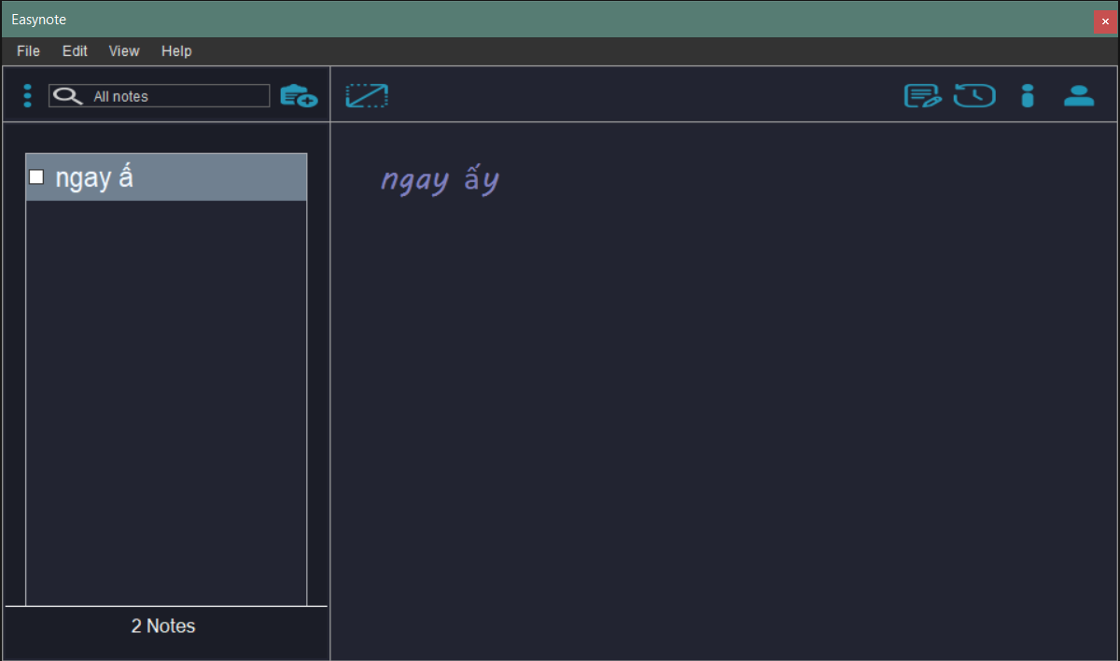

Image 11: Note form(No login)

12

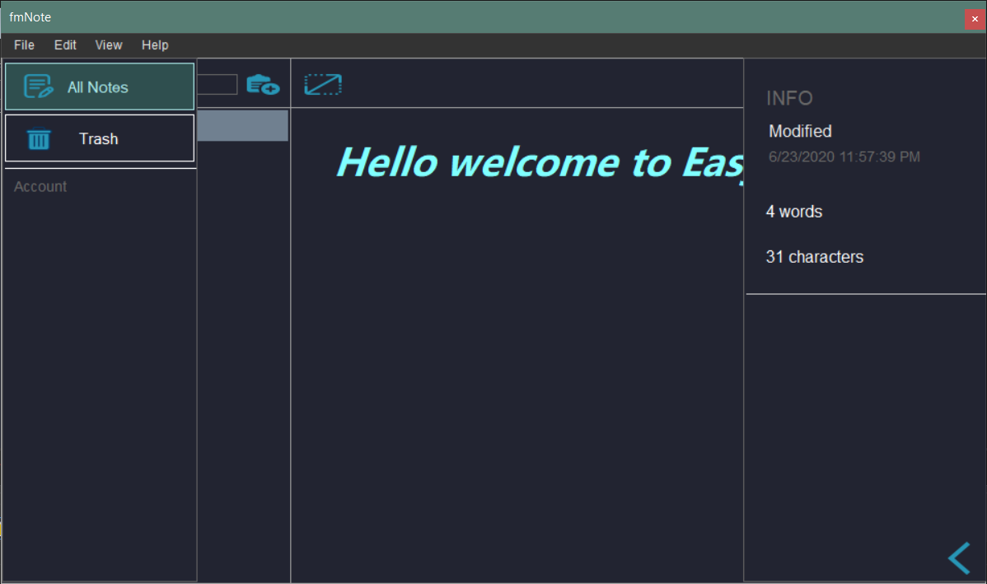

Image 12: Note form(No login)

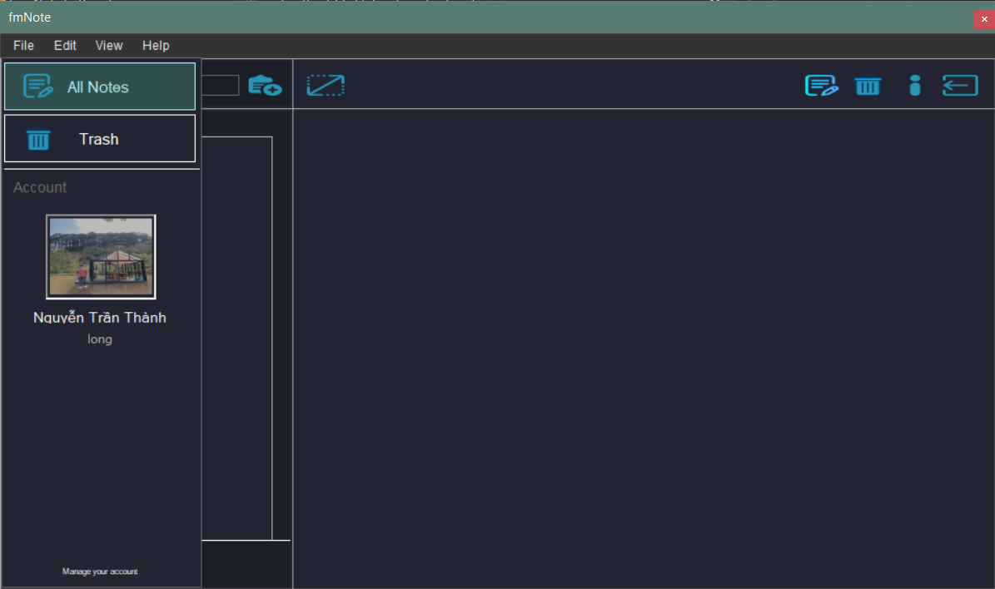

Image 13: Note form(Login with account ‘long’)

13
- Focus mode

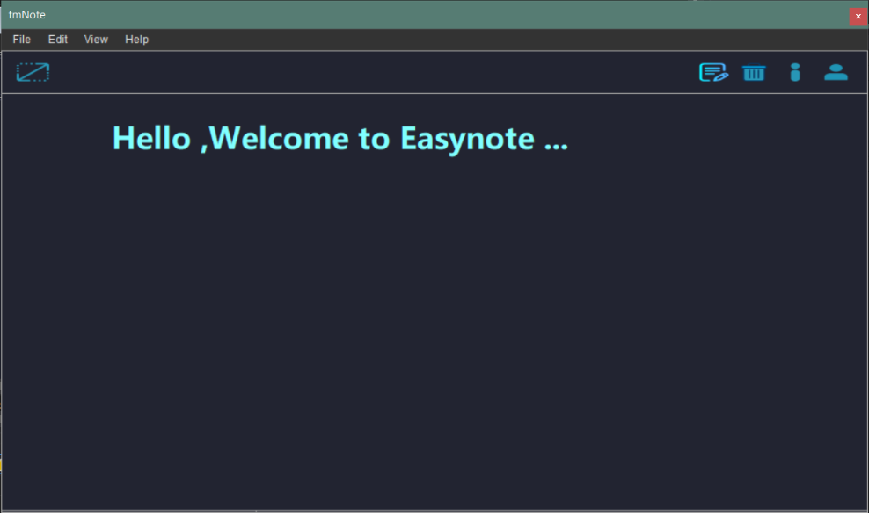

Image 14: application in focus mode

- Theme: Light
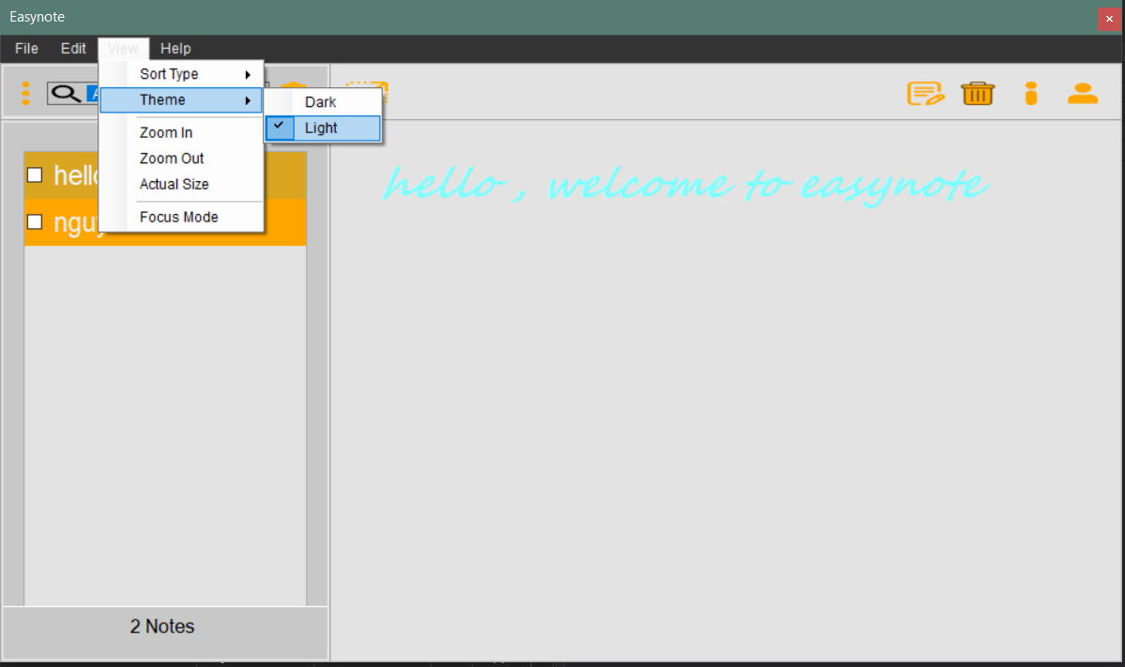

Image 15: Theme Light

14

- Intruction
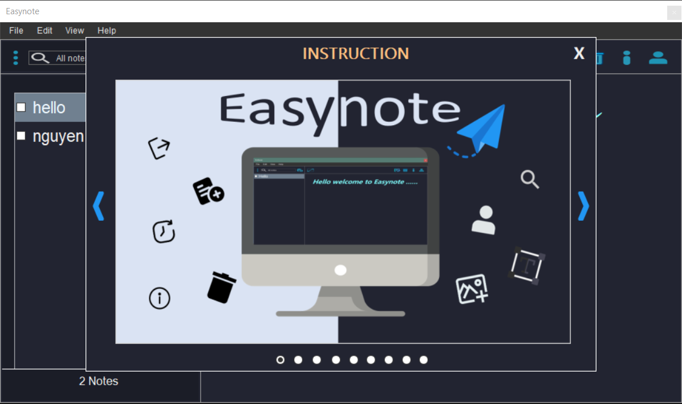

Image 16: Theme Light

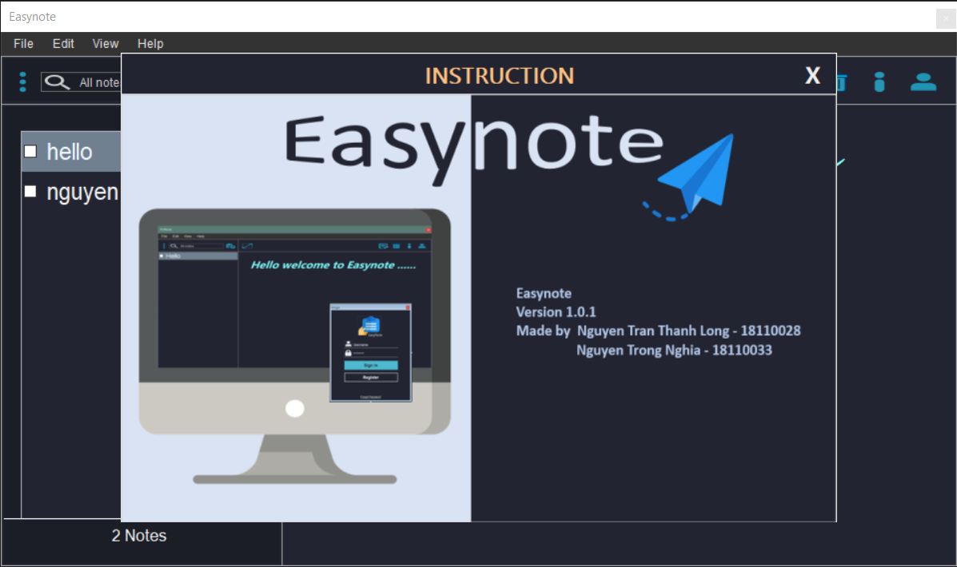

Image 17: Theme Light

15

Chapter 4: Setting and Testing

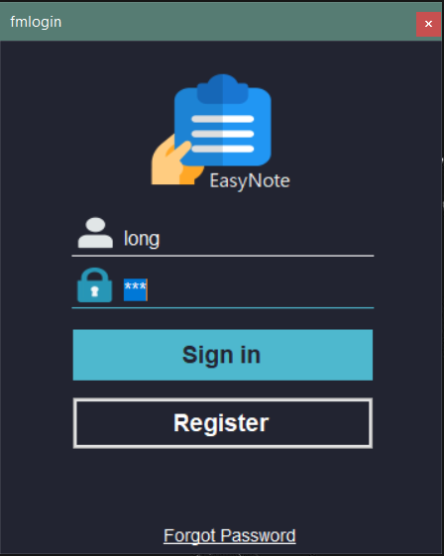

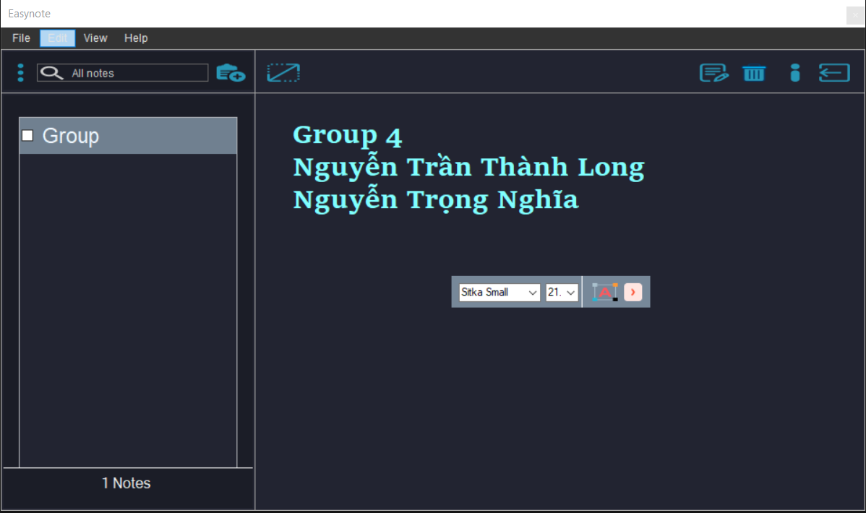
Image 18: Testing 1

Image 19: Testing 2

16
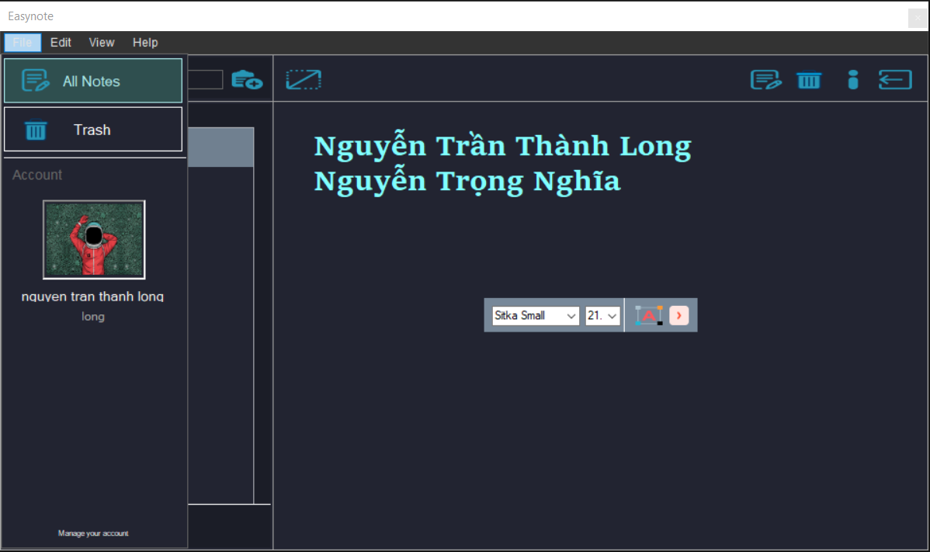

Image 20: Testing 3

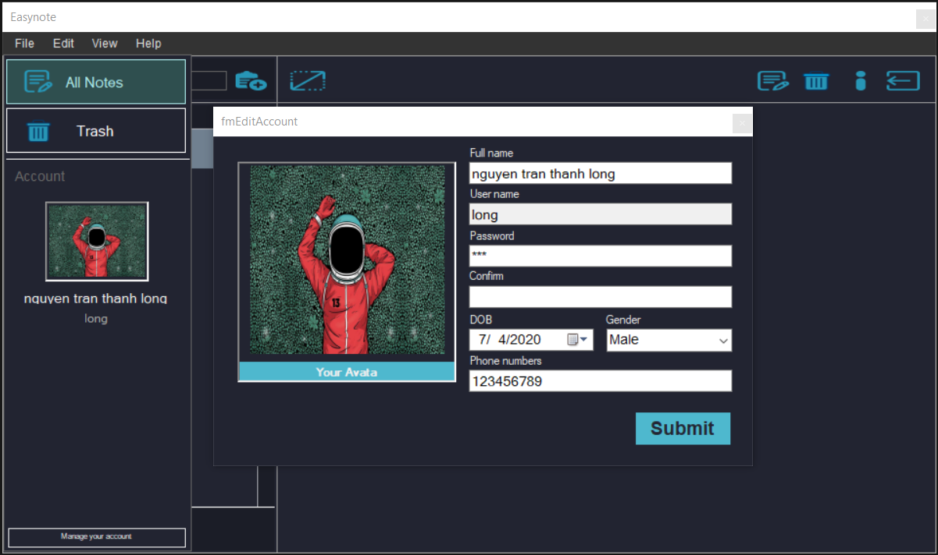

Image 21: Testing 4

17

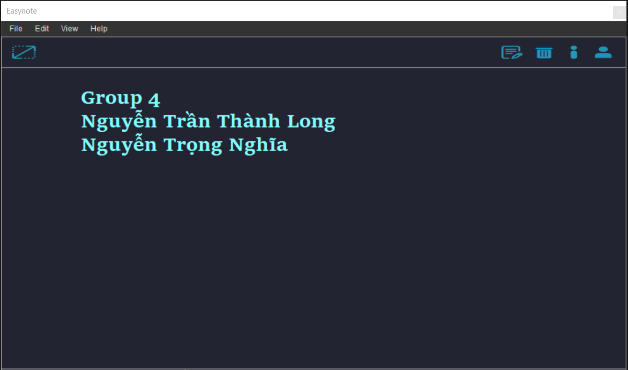

Image 22: Testing 5

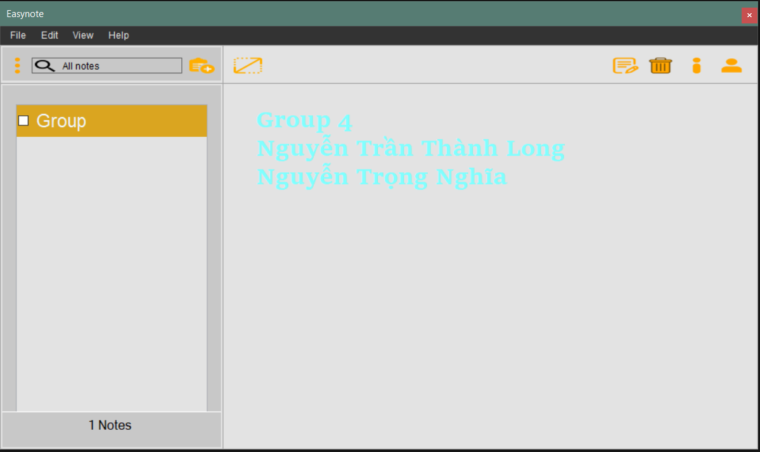

Image 23: Testing 6

18
Chapter 5: Conclusion and development path

1. Conclusion

In general, our group has reached almost all requirements of project. Here are some positive and negative points of our product.

- Advantages:

- Have many advanced functions for users to manage their notes
  - Allow users to transfer their notes via emails

- Disadvantages:

- The programme can not remember email and password of use which are used for sending email

- If user click too much on the sidebar to change the note, it will harm the programme and bug can be created when modify a note.

- Can not use Vietnamese or Unicode in the programme, the programme just aim to user who use English.

References:

- Stackoverflow

- Simple note
- https://www.youtube.com/watch?v=kcrOAF473LM

19

