Lab 1 – Unit testing
40 minutes
Student name: trần Minh Tâm
Student code: He190669
Question 1 (5 points): Event Ticket Pricing
Description: The following Java method calculates the final ticket price for an event, applying discounts based on age groups and promotional codes.
Requirements:
- Design test cases using JUnit to validate the calculateTicketPrice method.
- Ensure 100% Branch Coverage, 100% Code Coverage, 100% valid and invalid boundary values.
- Assumptions: The output is an int. If the calculated price is negative, the method must return 0.
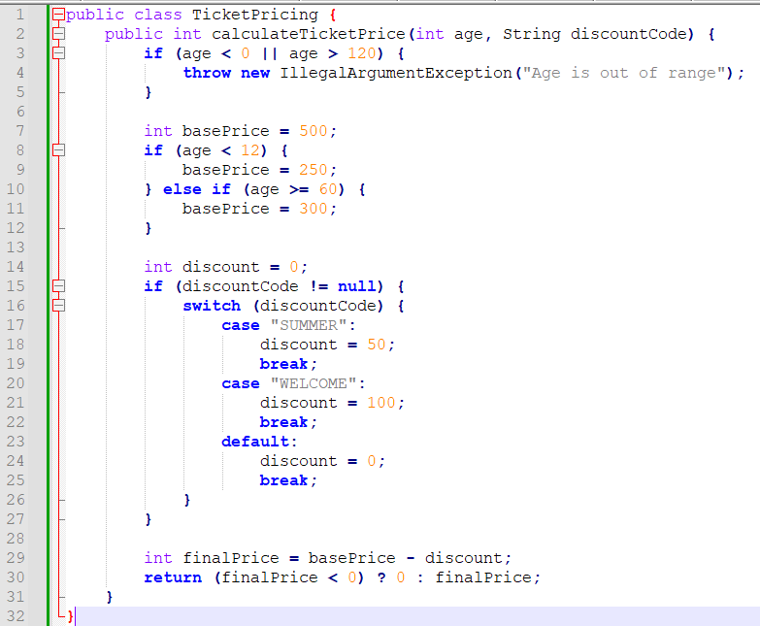
Your Test Cases:

import org.junit.jupiter.api.Test;
import static org.junit.jupiter.api.Assertions.*;
public class TicketPricingTest {
@Test
public void testSummerDiscountForAdult() {
// TC01: Testing Adult base price with "SUMMER"
int result = new TicketPricing().calculateTicketPrice(25, "SUMMER");
assertEquals(250, result); // 300-250
}
@Test
public void testWelcomeDiscountForAdult() {
// TC02: Testing Adult base price with "WELCOME" code
int result = new TicketPricing().calculateTicketPrice(30, "WELCOME");
assertEquals(200, result); // 300-100
}
@Test
public void testInvalidDiscountCode() {
// TC03: Testing invalid discount code
int result = new TicketPricing().calculateTicketPrice(30, "ABC");
assertEquals(300, result); // 300-0
}
@Test
public void test10agePriceAndNullDiscount() {
// TC05: Testing child ticket price (age < 12)
int result = new TicketPricing().calculateTicketPrice(10, null);
assertEquals(250, result);250-0
}
@Test
public void testAge60() {
// TC09: Testing 60 age people ticket price
int result = new TicketPricing().calculateTicketPrice(60, null);
assertEquals(300, result);300
}
@Test
public void testBoundaryAge120() {
// TC10: Upper valid boundary age
int result = new TicketPricing().calculateTicketPrice(121, null);
assertThrows(“age is out of range”,result); 0
}
@Test
public void testBoundaryAge0() {
// TC10: Upper valid boundary age
int result = new TicketPricing().calculateTicketPrice(-1, null);
assertThrows(“age is out of range”,result);0
}
}Test Sample:
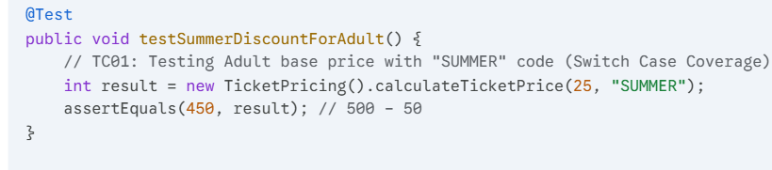

Question 2 (5 points): Shipping Fee Calculator
Description: The following Java method calculates the shipping fee for a delivery service based on package weight and travel distance.
Requirements:
- Apply Equivalence Partitioning, Boundary Value Analysis , White-box testing.
- Ensure 100% Branch Coverage, 100% Code Coverage.
- Assumptions: For double output, use a delta (tolerance) of 0.01 in your assertions
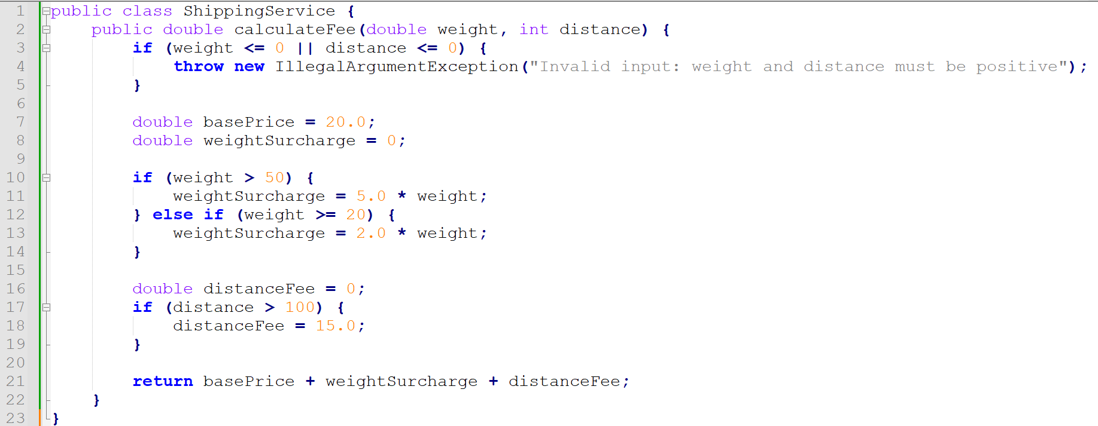

Your Test Cases:

@Test
public void testWeight50() {
// TC1:
int result = new ShippingService().calculateFee(50, 101);
assertEquals(285.0,result);20.0+5*50+15
}
@Test
public void testWeight20() {
// TC2:
int result = new ShippingService().calculateFee(20, 101);
assertEquals(75.0,result);20.0+2*20+15
}
@Test
public void testDistanceLessThan100() {
// TC3:
int result = new ShippingService().calculateFee(20, 99);
assertEquals(60,result);20.0+2*20+0
}
@Test
public void InvalidWeightAndDistance() {
// TC4:
int result = new ShippingService().calculateFee(0, 0);
assertEquals(“Invalid input: weight and distance must be positive”,result);20+5.0*0+0
}
@Test
public void testWeight30 () {
// TC5:
int result = new ShippingService().calculateFee(30, 15);
assertEquals(170,result); 20+5.0*30+0
}

