
CAPSTONE PROJECT REPORT
Report 4 - Software Design Specification
Project: SEP490_G55 - Automation Antidetect Browser
-- Hanoi, April 2026 --

Table of Contents
I. Record of Changes 3
II. Software Design Document 4
1. High Level Design 4
1.1 Software Architecture 4
1.2 Package Diagram 4
1.3 Database Design 6
2. Detailed Design 11
2.1 Profile Management 11
2.2 Browser Launch + Fingerprint 12
2.3 Proxy Management 14
2.4 Automation Execution 16
3. Class Specifications 18
3.1 controllers 18
3.2 services 19
3.3 storage 20
3.4 engine 21
3.5 models 24
4. Other Design Specifications 26
4.1 Key Algorithms 26
4.2 Data Design 28
4.3 System Integrations 28
4.4 Security Design 29
4.5 Configuration Defaults 30
4.6 Logging & Observability 30
4.7 Error Handling 30

I. Record of Changes
This section tracks all changes to the Software Design Specification document across revisions. A* refers to: A = Added, M = Modified, D = Deleted.
Date | A*/M/D | In charge | Change Description
2026-02-15 | A | Nguyen Van A | Initial draft of Software Design Specification
2026-02-28 | A | Tran Van B | Added High Level Design, Package Diagram and Database Design
2026-03-10 | A | Le Thi C | Added Detailed Design for Profile Management and Browser Launch features
2026-03-20 | A | Pham Van D | Added Detailed Design for Proxy Management and Automation Execution features
2026-04-01 | A | Hoang Van E | Added Class Specifications for controllers, services, storage and engine packages
2026-04-10 | M | Nguyen Van A | Updated Database Design tables with final JSON schema
2026-04-15 | A | Team G55 | Added Other Design Specifications: algorithms, security, integrations
* A - Added M - Modified D - Deleted

II. Software Design Document

1. High Level Design

1.1 Software Architecture
The system follows a layered Electron-based architecture with three main runtime surfaces: (1) the Electron Renderer Process hosting the React UI, (2) the Electron Main Process hosting business logic, storage and the automation engine, and (3) an optional REST API + Web Admin SPA for external automation. The Renderer communicates with the Main Process only through a secure contextBridge (preload) exposing a whitelisted window.electronAPI. The Main Process orchestrates Playwright/CDP browser instances and persists data as JSON files on the local file system.
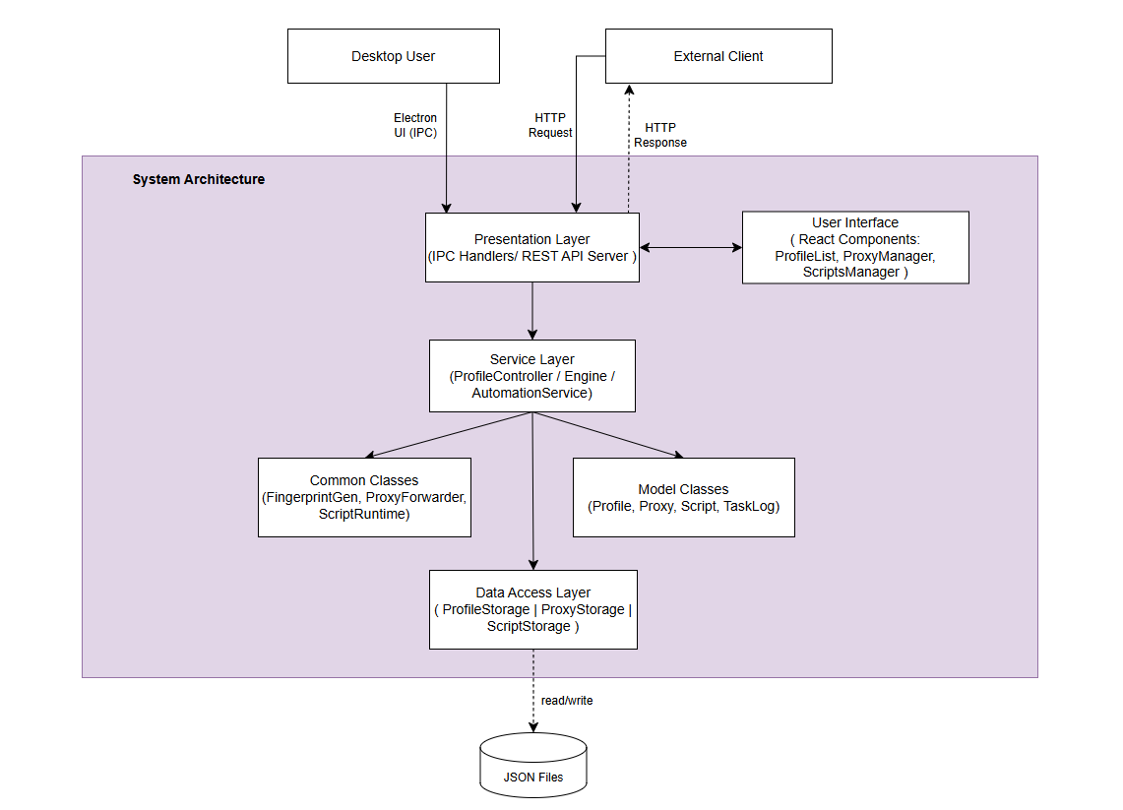

1.2 Package Diagram
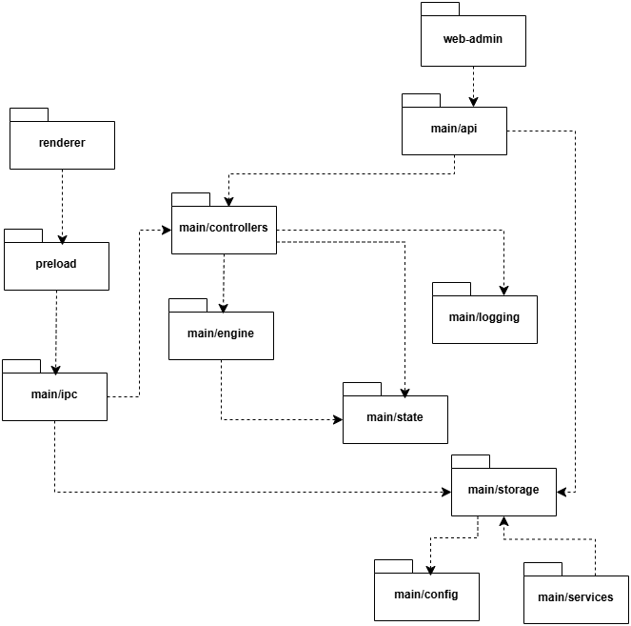
Package descriptions
No | Package | Description
01 | renderer | Electron Renderer Process. Contains all React UI components: ProfileList, ProxyManager, ScriptsManager, LogViewer, SettingsTab. Communicates with Main Process via preload bridge.
02 | web-admin | Standalone React SPA for browser-based administration. Uses Ant Design, connects to REST API via Axios.
03 | preload | Electron preload script. Exposes secure IPC bridge (window.electronAPI) to renderer via contextBridge.
04 | main/ipc | IPC event handlers. Receives requests from renderer, delegates to controllers and storage modules.
05 | main/api | Express-based REST API server. Exposes all profile/proxy operations via HTTP with Swagger UI and optional API key auth.
06 | main/controllers | Business logic for profile lifecycle: launch, stop, run automation steps, apply fingerprints.
07 | main/engine | Browser automation engine: Playwright integration, FingerprintGenerator, ScriptRuntime (VM sandbox), ProxyForwarder, AutomationScheduler.
08 | main/services | Utility services: BrowserManagerService (install/uninstall runtimes), ProxyCheckerService (batch proxy testing), MachineIdService.
09 | main/state | In-memory runtime state. Tracks running browser instances (runningProfiles Map) and profile statuses.
10 | main/logging | File-based logging. Writes per-profile log files and broadcasts log events to renderer via IPC.
11 | main/storage | JSON file persistence layer. CRUD operations for profiles, proxies, scripts, task-logs, settings.
12 | main/config | Application configuration constants: default ports, file paths, timeout values.

1.3 Database Design
The application uses a JSON file-based persistence layer instead of a traditional RDBMS. Each entity is stored as a JSON file under the application data directory (getDataRoot()). The diagram below shows the logical relationships between entities (soft references by id). Primary Keys (PK) are enforced at the application layer; Foreign Keys (FK) are maintained as string references.
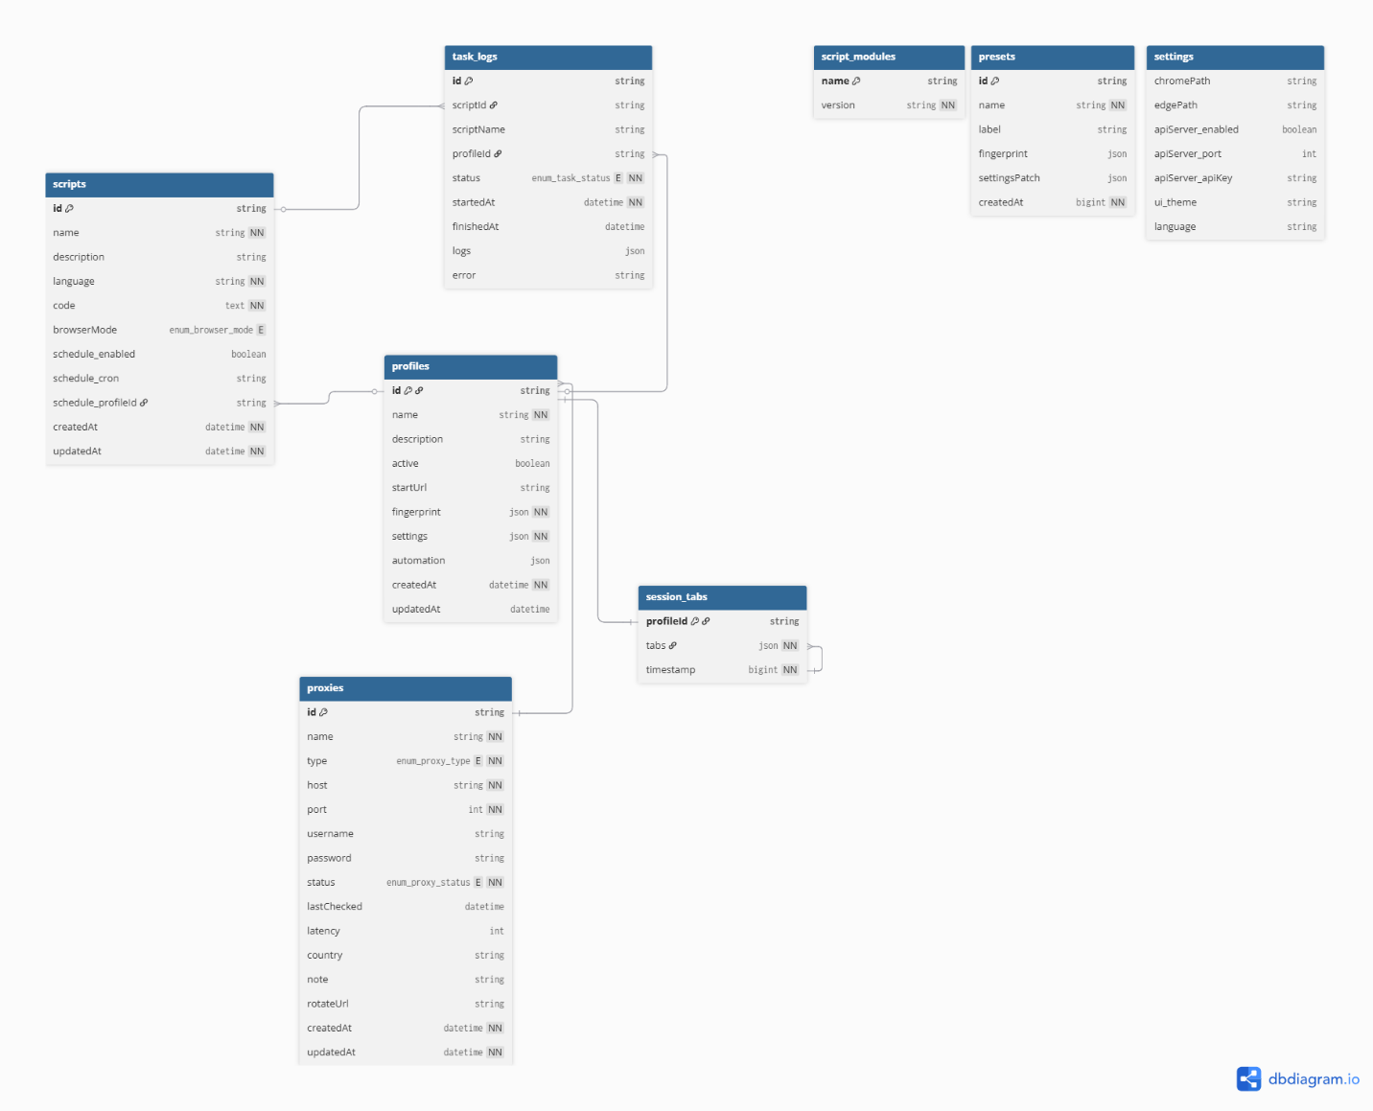
* PK ~ Primary Key; FK ~ Foreign Key; UN ~ Unique; NN ~ Not Null

1.3.1 profiles
Stores browser profile entities. Each profile defines identity (id, name), a deterministic fingerprint seed (OS, browser, userAgent, resolution, timezone, WebGL vendor, etc.), runtime settings (engine, proxy, geolocation, apply-overrides flags), and automation rules (runOnLaunch, steps, cron schedule). Persisted to profiles.json.
No | Field | PK | FK | UN | NN | Description
01 | id | x |  | x | x | Unique identifier of the profile (6-char alphanumeric).
02 | name |  |  | x | x | Human-readable display name (max 120 chars).
03 | description |  |  |  |  | Optional free-text description for the profile.
04 | active |  |  |  |  | Whether the profile is enabled (default: true).
05 | startUrl |  |  |  |  | Default URL opened on profile launch (default: https://www.google.com).
06 | fingerprint |  |  |  | x | Fingerprint seed object: os, browser, browserVersion, userAgent, language, screenResolution, timezone, webgl, canvas, audio.
07 | settings |  |  |  | x | Runtime settings object: engine (playwright | playwright-firefox | camoufox | cdp | auto), cpuCores, memoryGB, proxy, webrtc, geolocation, mediaDevices, applyOverrides flags, advanced overrides.
08 | automation |  |  |  |  | Automation object: enabled, runOnLaunch, steps[] (navigate / wait / eval / screenshot), schedule { enabled, cron }.
09 | createdAt |  |  |  | x | ISO 8601 timestamp of creation.
10 | updatedAt |  |  |  |  | ISO 8601 timestamp of the last update.

1.3.2 proxies
Stores proxy server entries used by profiles. Supports HTTP, HTTPS, SOCKS4 and SOCKS5 proxies. Each entry tracks connectivity status, last-check time, latency and location. Persisted to proxies.json.
No | Field | PK | FK | UN | NN | Description
01 | id | x |  | x | x | Unique identifier (timestamp + random bytes).
02 | name |  |  |  | x | Display name (max 200 chars).
03 | type |  |  |  | x | Proxy protocol: http | https | socks4 | socks5 (default: http).
04 | host |  |  |  | x | Proxy server hostname or IP address.
05 | port |  |  |  | x | Proxy server port (1-65535).
06 | username |  |  |  |  | Authentication username (optional).
07 | password |  |  |  |  | Authentication password (optional).
08 | status |  |  |  | x | Last known status: unchecked | working | dead | slow.
09 | lastChecked |  |  |  |  | ISO 8601 timestamp of the last health check.
10 | latency |  |  |  |  | Measured latency in milliseconds.
11 | country |  |  |  |  | Proxy geographic location / country code.
12 | note |  |  |  |  | User notes about the proxy.
13 | rotateUrl |  |  |  |  | Endpoint URL for IP rotation, if the proxy supports it.
14 | createdAt |  |  |  | x | ISO 8601 timestamp of creation.
15 | updatedAt |  |  |  | x | ISO 8601 timestamp of the last update.

1.3.3 scripts
Stores user-defined automation scripts written in JavaScript. Each script can be scheduled via a cron expression and bound to a specific profile. Persisted to scripts.json.
No | Field | PK | FK | UN | NN | Description
01 | id | x |  | x | x | Unique identifier (12-char hex).
02 | name |  |  |  | x | Script display name (max 128 chars).
03 | description |  |  |  |  | Script description (max 1000 chars).
04 | language |  |  |  | x | Script language (fixed: 'javascript').
05 | code |  |  |  | x | JavaScript source code executed by ScriptRuntime.
06 | browserMode |  |  |  |  | Browser mode: visible | headless | background (default: visible).
07 | schedule.enabled |  |  |  |  | Whether scheduled execution is enabled.
08 | schedule.cron |  |  |  |  | Cron expression for recurring execution.
09 | schedule.profileId |  | x |  |  | FK to profiles.id - profile to run this script against.
10 | createdAt |  |  |  | x | ISO 8601 timestamp of creation.
11 | updatedAt |  |  |  | x | ISO 8601 timestamp of the last update.

1.3.4 task-logs
Stores execution history for automation task runs. The store keeps only the most recent 200 entries (auto-pruned on every write). Persisted to task-logs.json.
No | Field | PK | FK | UN | NN | Description
01 | id | x |  | x | x | Unique identifier (12-char hex).
02 | scriptId |  | x |  |  | FK to scripts.id - script that was executed.
03 | scriptName |  |  |  |  | Snapshot of the script name at execution time.
04 | profileId |  | x |  |  | FK to profiles.id - profile that executed the task.
05 | status |  |  |  | x | Execution status: running | completed | error.
06 | startedAt |  |  |  | x | ISO 8601 timestamp when execution started.
07 | finishedAt |  |  |  |  | ISO 8601 timestamp when execution finished.
08 | logs |  |  |  |  | Array of log entries { message, timestamp, level } captured during execution.
09 | error |  |  |  |  | Error message if status = 'error'.

1.3.5 settings
Stores global application settings as a flat JSON object, merged with defaults on load. Persisted to settings.json.
No | Field | PK | FK | UN | NN | Description
01 | chromePath |  |  |  |  | Custom path to a user-installed Chrome executable.
02 | edgePath |  |  |  |  | Custom path to a user-installed Edge executable.
03 | apiServer.enabled |  |  |  |  | Whether the REST API server is enabled at startup.
04 | apiServer.port |  |  |  |  | Port on which the REST API server listens.
05 | apiServer.apiKey |  |  |  |  | Optional API key required on the X-API-Key header.
06 | ui.theme |  |  |  |  | UI theme preference (light | dark | system).
07 | language |  |  |  |  | UI language code.

1.3.6 presets
Stores reusable fingerprint + settings templates that can be applied to profiles. Persisted to presets.json.
No | Field | PK | FK | UN | NN | Description
01 | id | x |  | x | x | Unique identifier (base36 timestamp + random).
02 | name |  |  |  | x | Preset internal name.
03 | label |  |  |  |  | Display label shown in the UI.
04 | fingerprint |  |  |  |  | Fingerprint template (same schema as profiles.fingerprint).
05 | settingsPatch |  |  |  |  | Partial settings overlay applied on top of a profile's settings.
06 | createdAt |  |  |  | x | Unix timestamp (ms) of creation.

1.3.7 session-tabs
Persists the open tab URLs for a profile so they can be restored on the next launch. Stored as one file per profile at {dataRoot}/session-tabs/{profileId}.json.
No | Field | PK | FK | UN | NN | Description
01 | profileId (filename) | x | x | x | x | FK to profiles.id - profile that owns this tab list.
02 | tabs |  |  |  | x | Array of HTTP/HTTPS URLs currently open (filters out chrome://, edge://, about:blank).
03 | timestamp |  |  |  | x | Unix timestamp (ms) when the tab list was saved.

1.3.8 script-modules
Stores the npm dependencies exposed to user scripts via require(). Stored as a dedicated package.json at {dataRoot}/script-modules/package.json (not a data table in the classical sense).
No | Field | PK | FK | UN | NN | Description
01 | name | x |  | x | x | npm package name (with optional @version).
02 | version |  |  |  | x | Installed version string.

2. Detailed Design

2.1 Profile Management

2.1.1 Class Diagram
The class diagram below shows the classes involved in the Profile Management feature and their relationships.
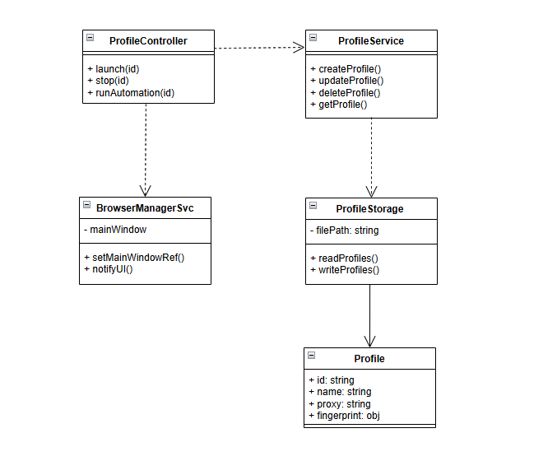

2.1.2 Sequence Diagram - Create Profile
Flow when the user creates a new profile from the Renderer UI. The request is forwarded through the preload bridge to the IPC handler, which validates the input, generates a unique id, and persists the profile through ProfileStorage.
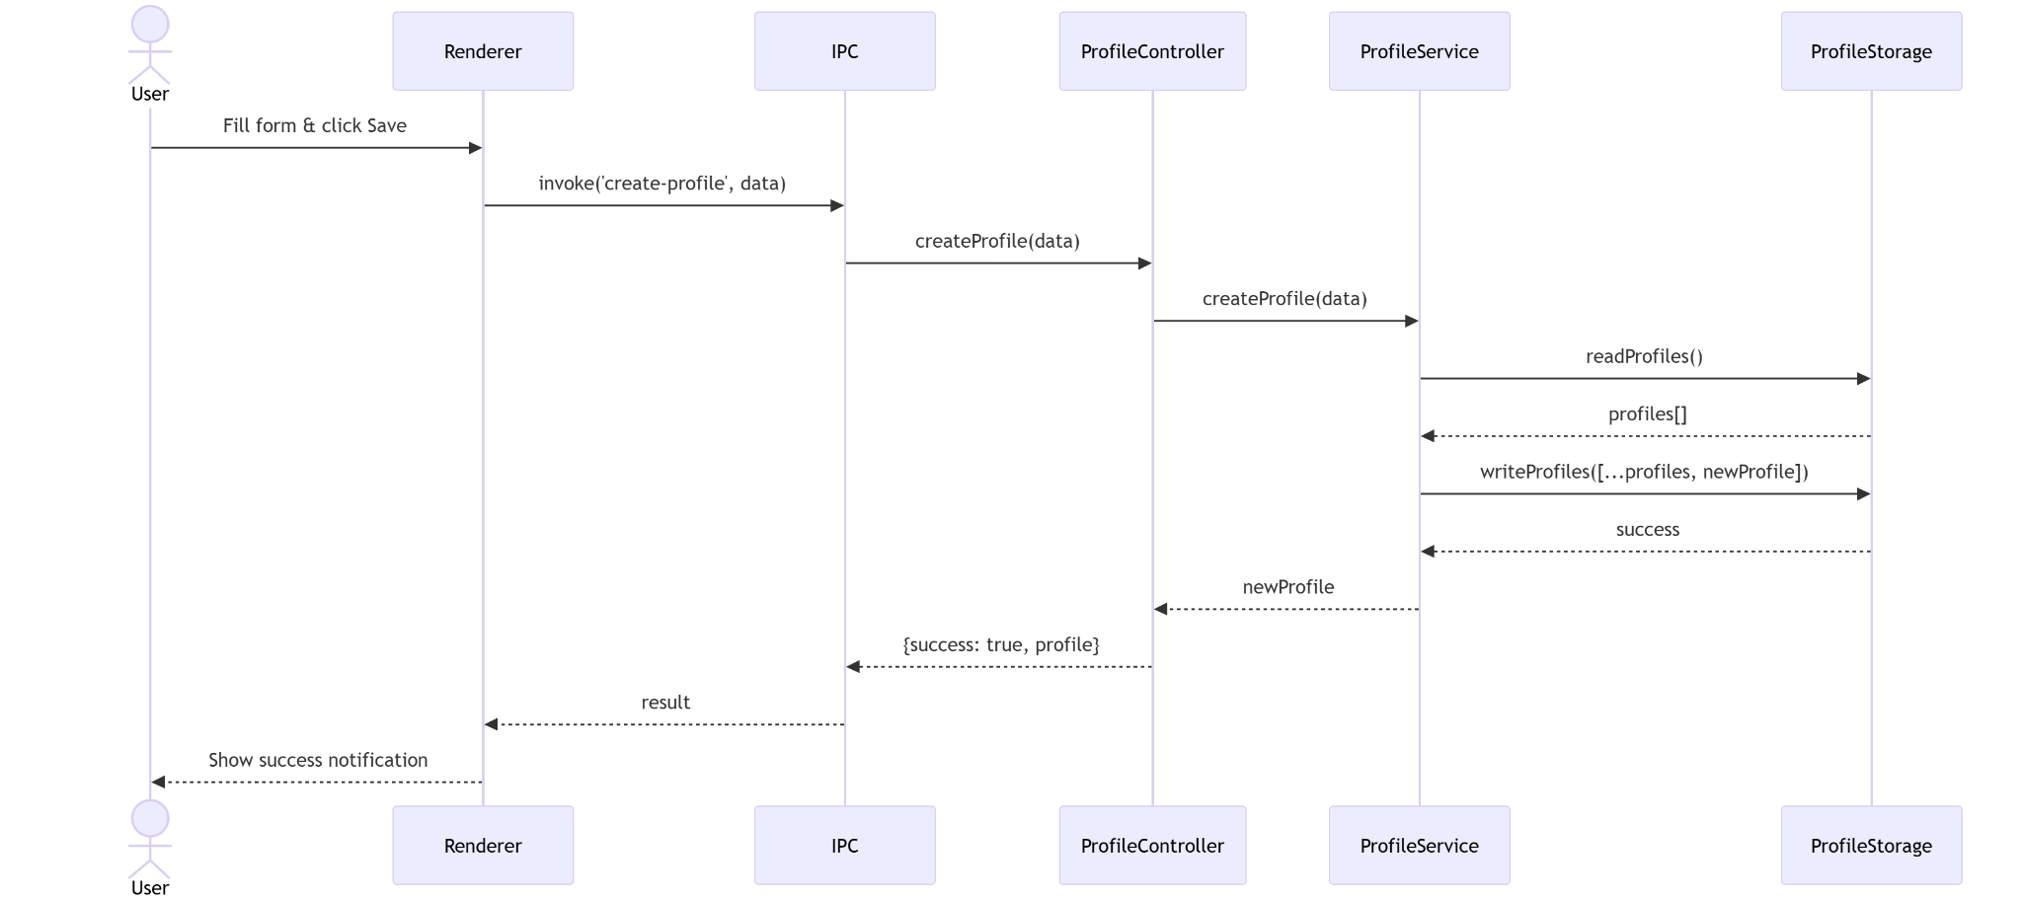

2.1.3 Sequence Diagram - Delete Profile
Flow when the user deletes a profile. The handler stops any running browser instance for that profile, removes its storage-state file and log file, and rewrites profiles.json.
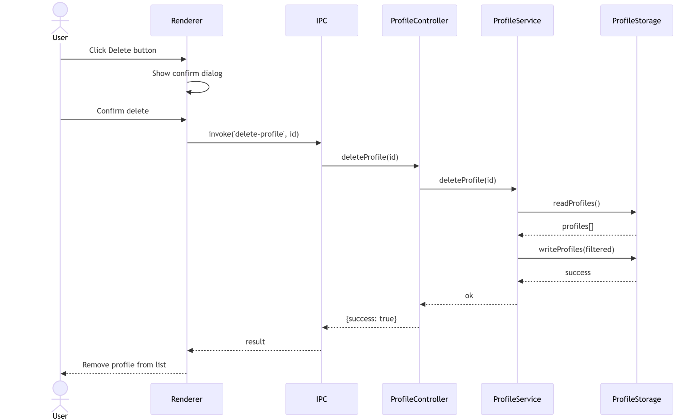

2.2 Browser Launch + Fingerprint

2.2.1 Class Diagram
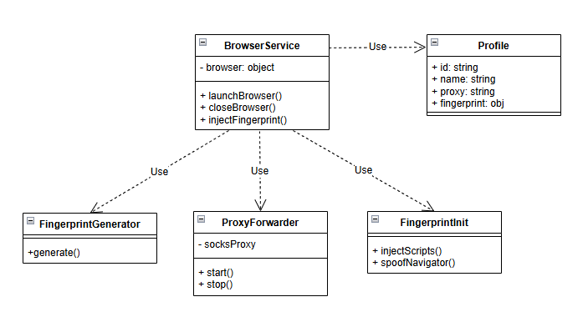

2.2.2 Sequence Diagram - Launch Browser
Flow of launching a browser profile: generate/load the fingerprint, start the ProxyForwarder if a SOCKS proxy is configured, launch Playwright with the profile's engine, inject the fingerprint init scripts, and register the instance in runningProfiles.
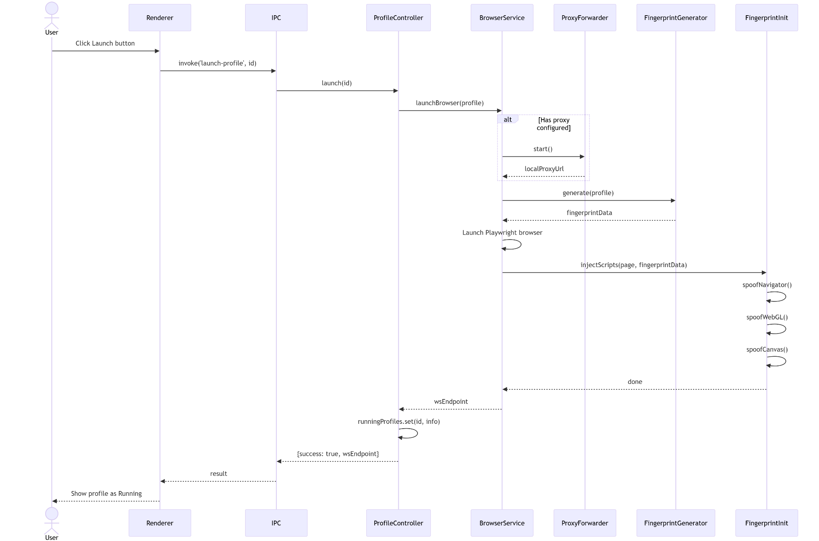

2.2.3 Sequence Diagram - Stop Browser
Flow of stopping a running browser profile: save session tabs, close Playwright context and browser, stop ProxyForwarder, remove the entry from runningProfiles and broadcast status to the Renderer.
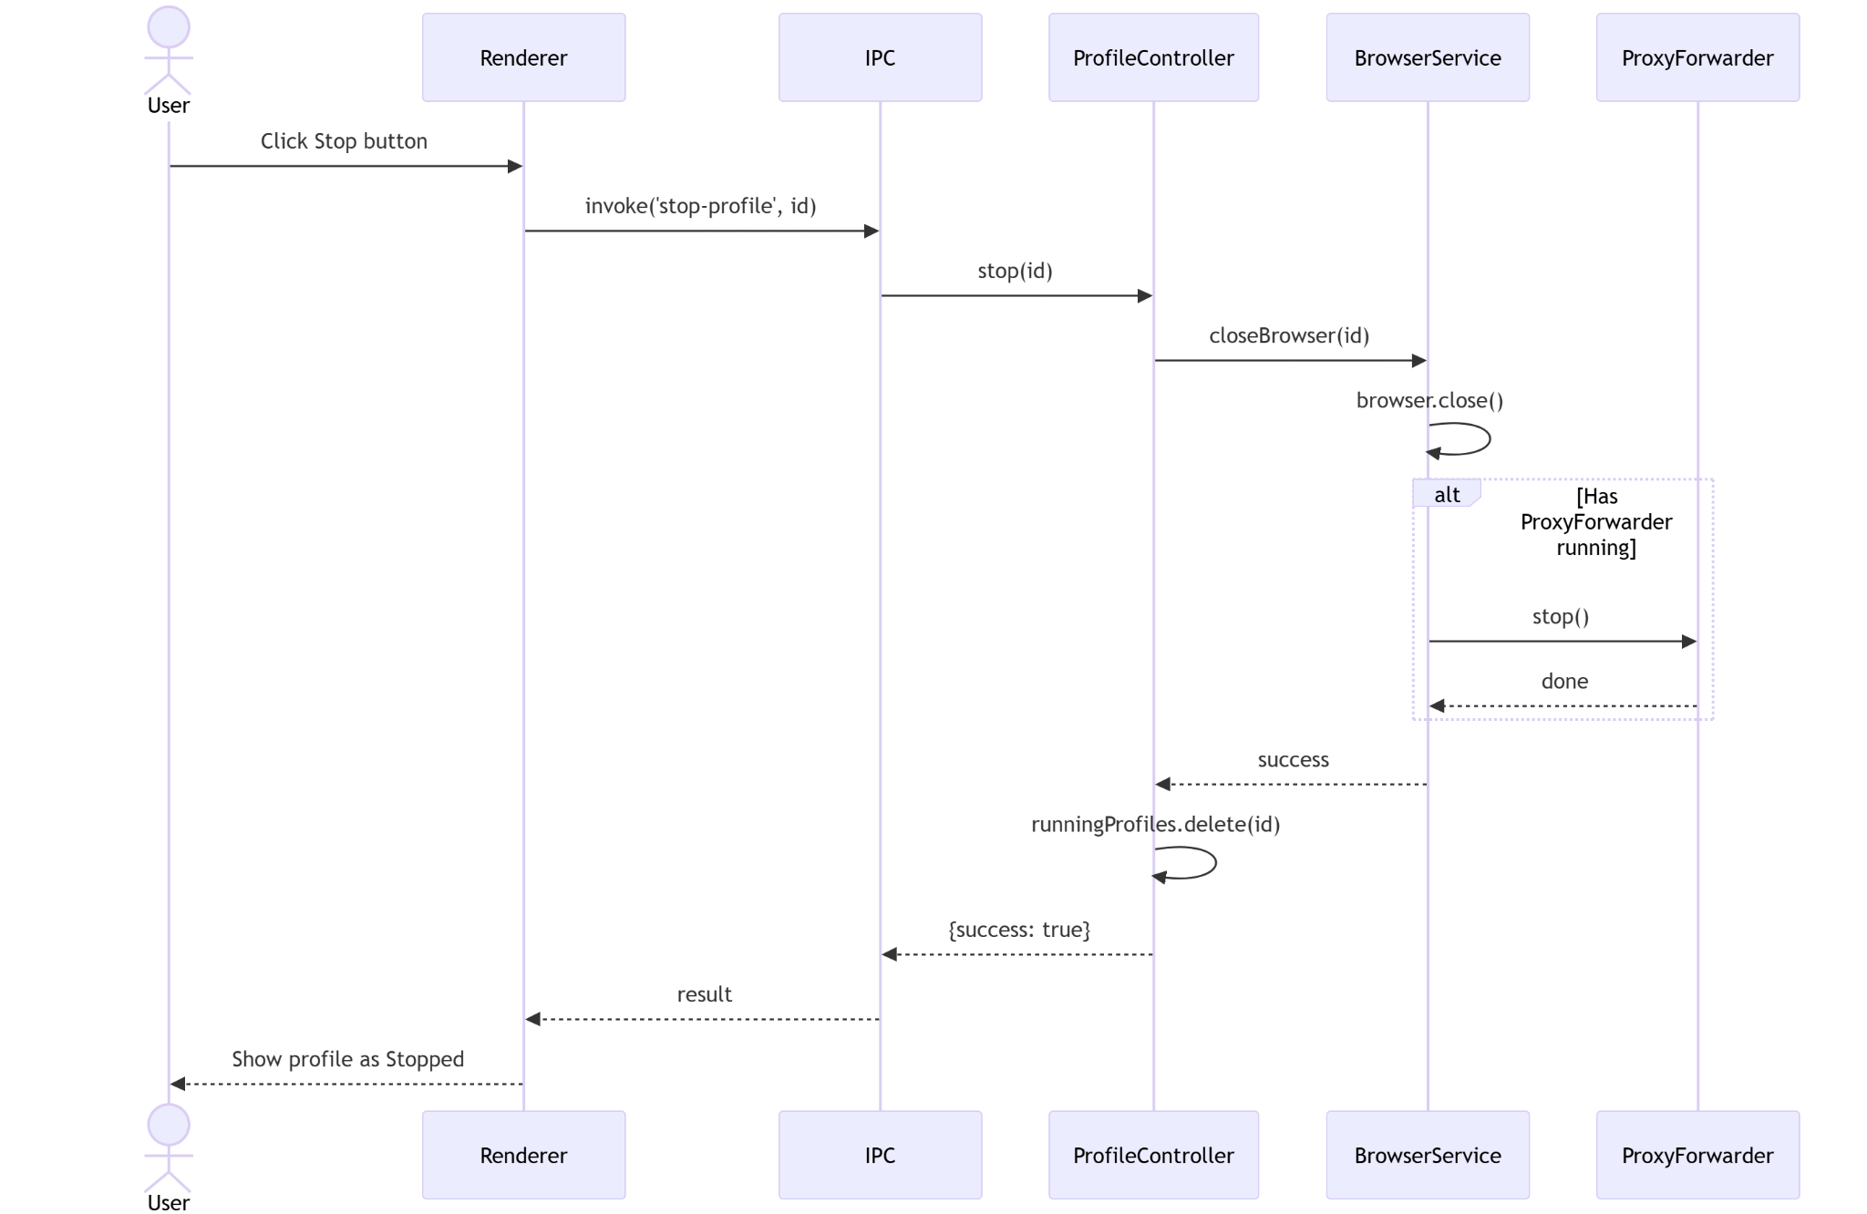

2.3 Proxy Management

2.3.1 Class Diagram
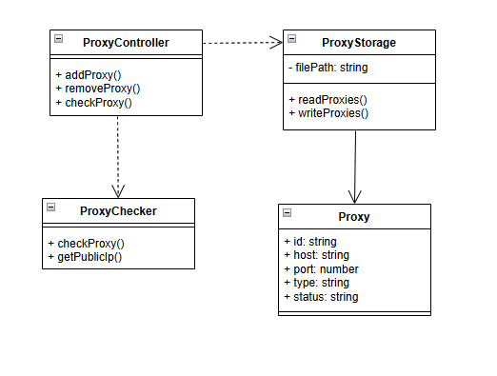

2.3.2 Sequence Diagram - Add Proxy
Flow when the user adds a proxy. Input is validated (host/port/type), a unique id is assigned, and the proxy is persisted to proxies.json with status = 'unchecked'.
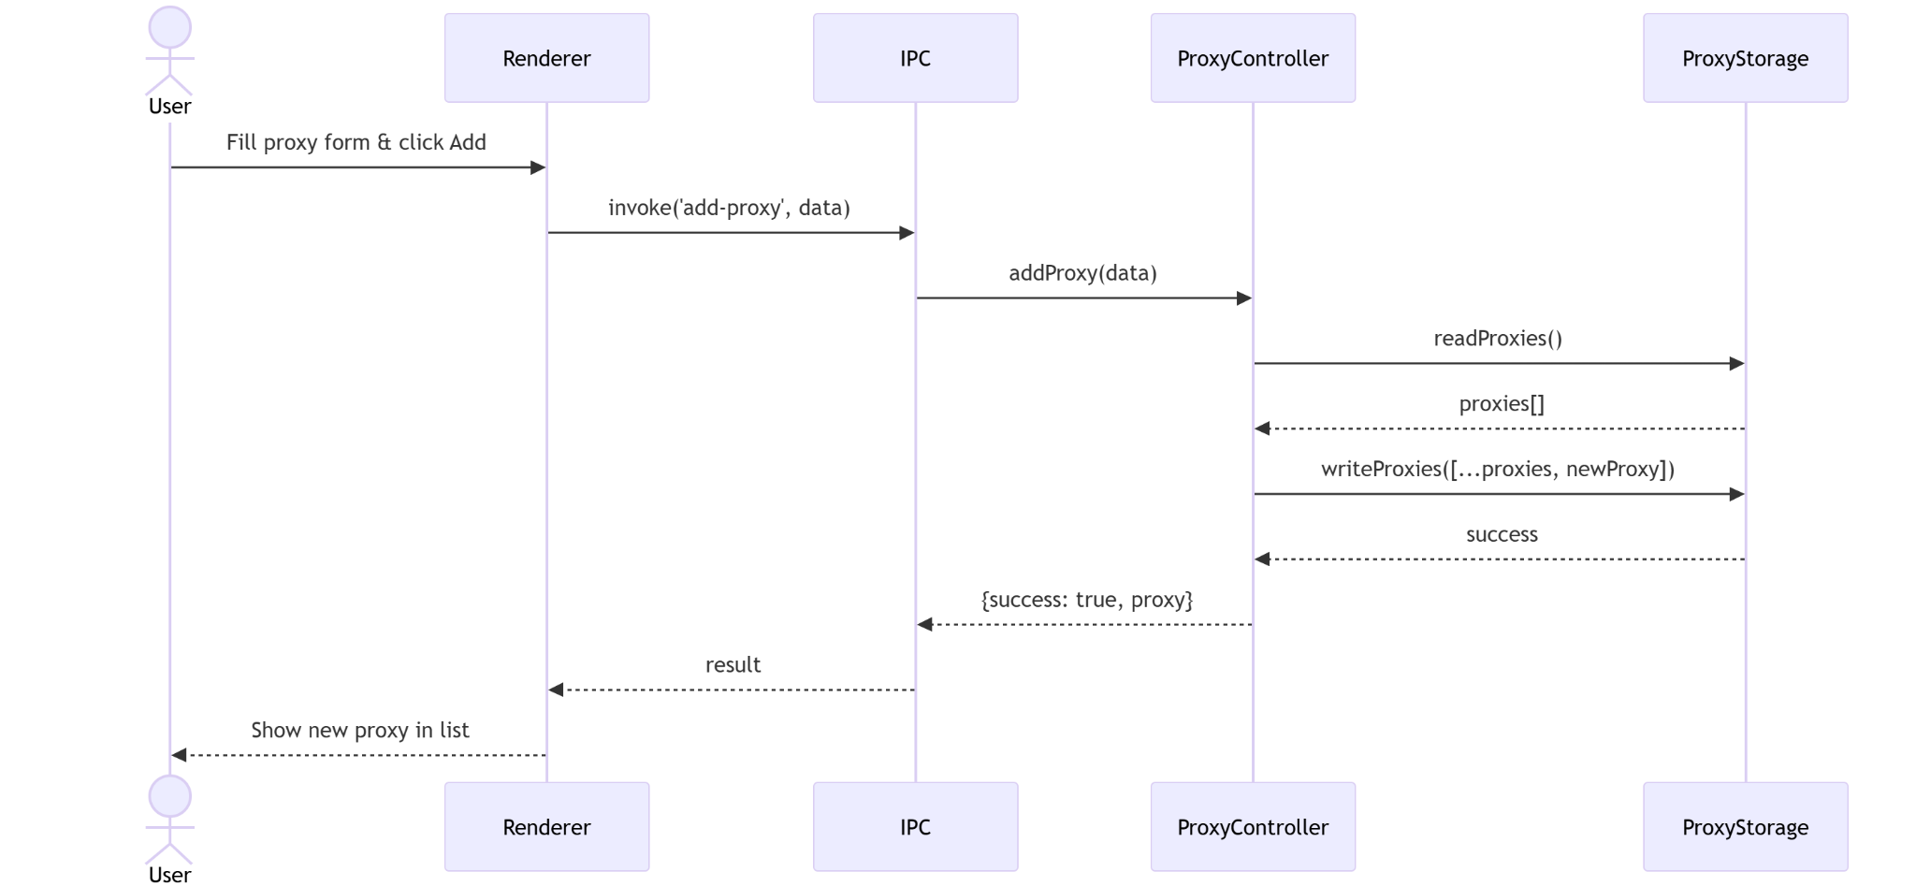

2.3.3 Sequence Diagram - Check Proxy
Flow of the proxy health check. ProxyChecker opens a TCP connection, issues a GET to a public IP endpoint (api.ipify.org with fallbacks), measures latency, and updates status (working | dead | slow) and country.
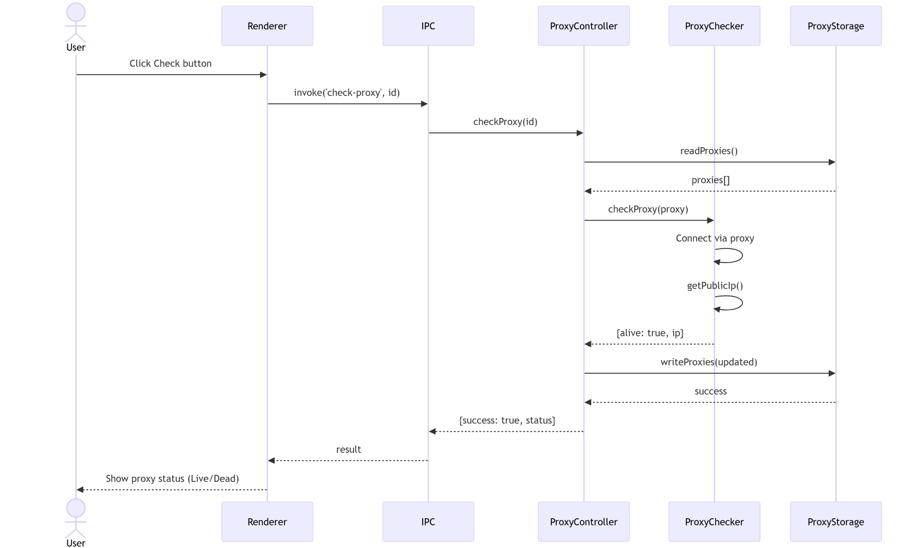

2.4 Automation Execution

2.4.1 Class Diagram
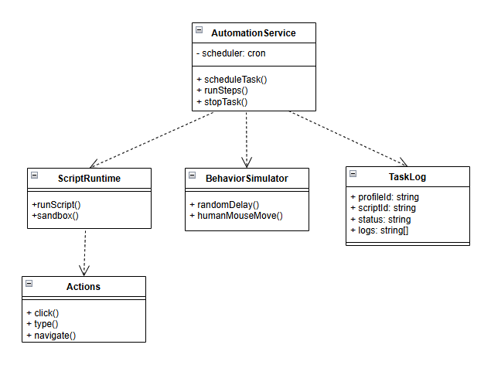

2.4.2 Sequence Diagram - Run Automation Script
Flow of executing an automation script. ScriptRuntime builds a VM sandbox exposing page/context/actions/require, runs the script inside vm.runInContext wrapped in an async IIFE, and writes logs + final status to task-logs.json.
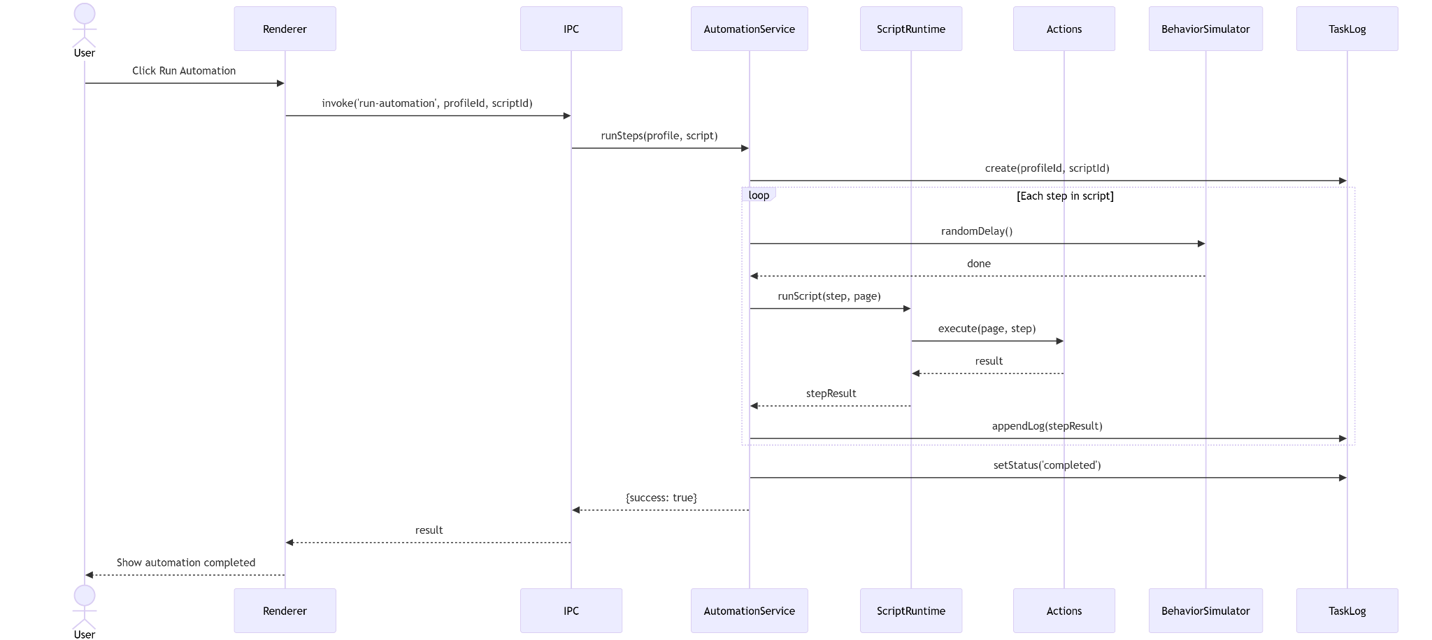

2.4.3 Sequence Diagram - Schedule Automation
Flow of scheduled automation. AutomationScheduler reads profiles/scripts with schedule.enabled = true, registers a node-cron job per entry, and on fire launches the profile (if not running) and calls runScript().
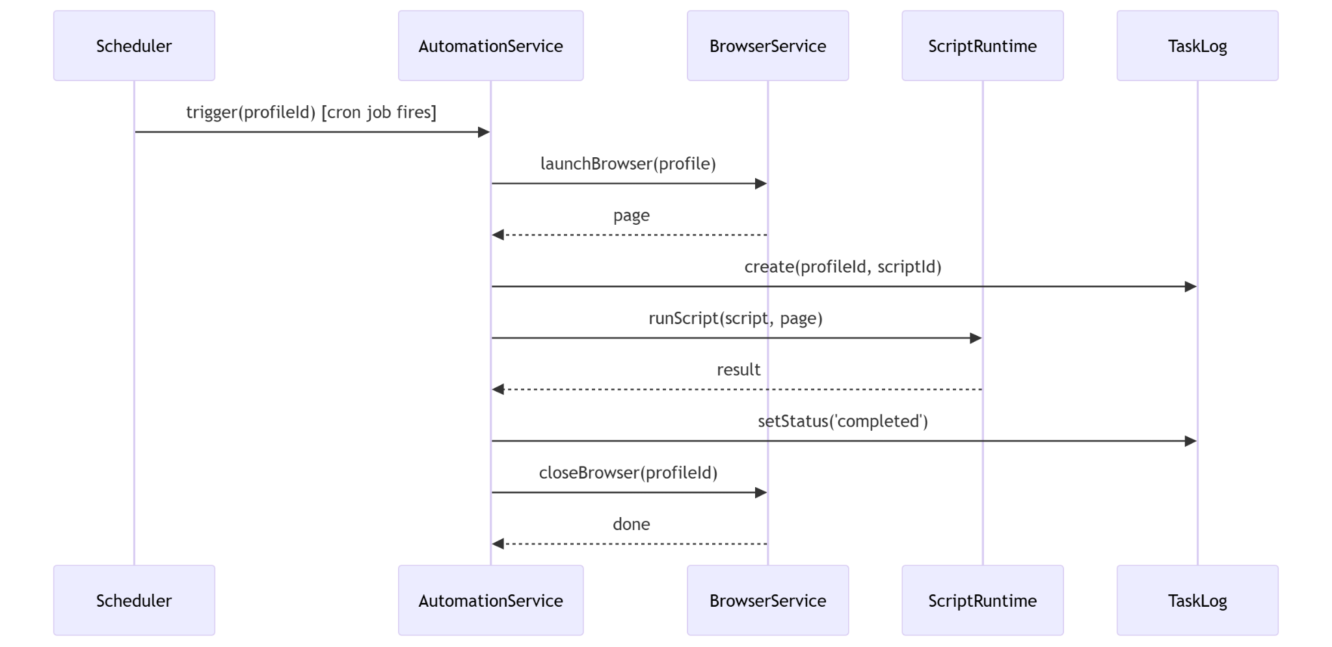

3. Class Specifications
This section provides the detailed specifications of all the key classes in the main packages of the application.

3.1 controllers
This section provides the detailed specifications for the classes in the controllers package.

3.1.1 ProfileController
Handles the lifecycle of browser profiles. Acts as the entry point for IPC calls from the renderer process and REST API requests.
No | Name | Description
Attributes
--- | (none) | ---
Methods/Operations
01 | launch(id) | Visibility: public  Return: Promise<object>  Purpose: Launch a browser profile by ID with fingerprint and proxy injection.  Parameters: - id: string, the profile ID to launch.
02 | stop(id) | Visibility: public  Return: Promise<object>  Purpose: Stop a running browser profile and release all resources.  Parameters: - id: string, the profile ID.
03 | runAutomation(id) | Visibility: public  Return: Promise<void>  Purpose: Execute the profile's automation steps on demand.  Parameters: - id: string, the profile ID.

3.2 services
This section provides the detailed specifications for the classes in the services package.

3.2.1 BrowserService
Manages the full lifecycle of a Playwright browser instance, including fingerprint injection and proxy configuration.
No | Name | Description
Attributes
01 | browser | Visibility: private  Type: object  Purpose: Holds the active Playwright browser instance.
Methods/Operations
01 | launchBrowser(profile) | Visibility: public  Return: Promise<object>  Purpose: Launch a Chromium browser with fingerprint and proxy applied.  Parameters: - profile: object, profile data including proxy and fingerprint config.
02 | closeBrowser(id) | Visibility: public  Return: Promise<void>  Purpose: Close the browser instance and stop the proxy forwarder.  Parameters: - id: string, the profile ID.
03 | injectFingerprint(page, fp) | Visibility: public  Return: Promise<void>  Purpose: Inject fingerprint spoofing scripts into the browser page.  Parameters: - page: object, Playwright page instance. - fp: object, fingerprint data.

3.2.2 AutomationService
Manages scheduled and manual automation task execution using cron-based scheduling.
No | Name | Description
Attributes
01 | scheduler | Visibility: private  Type: CronJob  Purpose: Holds the active cron job instance for scheduled automation.
Methods/Operations
01 | scheduleTask(profile) | Visibility: public  Return: void  Purpose: Register a cron job to automatically launch and run a profile's script at scheduled times.  Parameters: - profile: object, profile data including schedule config.
02 | runSteps(profile, steps) | Visibility: public  Return: Promise<void>  Purpose: Execute a sequence of automation steps for a given profile.  Parameters: - profile: object, the profile data. - steps: array, list of automation steps to execute.
03 | stopTask(id) | Visibility: public  Return: void  Purpose: Cancel the scheduled cron job for a profile.  Parameters: - id: string, the profile ID.

3.2.3 ProxyChecker
Verifies proxy connectivity by making a test HTTP request through the proxy.
No | Name | Description
Attributes
--- | (none) | ---
Methods/Operations
01 | checkProxy(proxy) | Visibility: public  Return: Promise<boolean>  Purpose: Test whether a proxy is alive by connecting through it.  Parameters: - proxy: object, proxy data including host, port, type.
02 | getPublicIp(proxy) | Visibility: public  Return: Promise<string>  Purpose: Retrieve the public IP address when routing through the proxy.  Parameters: - proxy: object, proxy connection data.

3.3 storage
This section provides the detailed specifications for the classes in the storage package.

3.3.1 ProfileStorage
Handles reading and writing profile data to the JSON file-based storage system.
No | Name | Description
Attributes
01 | filePath | Visibility: private  Type: string  Purpose: Absolute path to the profiles.json data file.
Methods/Operations
01 | readProfiles() | Visibility: public  Return: Profile[]  Purpose: Read and parse all profiles from the JSON file.  Parameters: (none)
02 | writeProfiles(profiles) | Visibility: public  Return: void  Purpose: Serialize and write the updated profiles array to the JSON file.  Parameters: - profiles: Profile[], the full updated list of profiles.

3.3.2 ProxyStorage
Handles reading and writing proxy data to the JSON file-based storage system.
No | Name | Description
Attributes
01 | filePath | Visibility: private  Type: string  Purpose: Absolute path to the proxies.json data file.
Methods/Operations
01 | readProxies() | Visibility: public  Return: Proxy[]  Purpose: Read and parse all proxies from the JSON file.  Parameters: (none)
02 | writeProxies(proxies) | Visibility: public  Return: void  Purpose: Serialize and write the updated proxies array to the JSON file.  Parameters: - proxies: Proxy[], the full updated list of proxies.

3.4 engine
This section provides the detailed specifications for the classes in the engine package.

3.4.1 FingerprintGenerator
Generates a randomized browser fingerprint profile based on a seed configuration.
No | Name | Description
Attributes
--- | (none) | ---
Methods/Operations
01 | generate(profile) | Visibility: public  Return: object  Purpose: Generate a complete fingerprint object including WebGL, Canvas, AudioContext, and navigator properties.  Parameters: - profile: object, profile config used as seed for fingerprint generation.

3.4.2 FingerprintInit
Injects fingerprint spoofing scripts into a Playwright browser page before navigation.
No | Name | Description
Attributes
--- | (none) | ---
Methods/Operations
01 | injectScripts(page, fp) | Visibility: public  Return: Promise<void>  Purpose: Inject all fingerprint override scripts into the page context.  Parameters: - page: object, Playwright page instance. - fp: object, fingerprint data to apply.
02 | spoofNavigator(page, fp) | Visibility: public  Return: Promise<void>  Purpose: Override navigator properties (userAgent, platform, language, etc.).  Parameters: - page: object, Playwright page instance. - fp: object, fingerprint data.

3.4.3 ProxyForwarder
Converts a SOCKS5 proxy into a local HTTP proxy for Playwright compatibility.
No | Name | Description
Attributes
01 | socksProxy | Visibility: private  Type: string  Purpose: The SOCKS5 proxy URL to forward.
02 | localPort | Visibility: private  Type: number  Purpose: The local port assigned to the HTTP forwarder server.
Methods/Operations
01 | start() | Visibility: public  Return: Promise<string>  Purpose: Start the local HTTP proxy forwarder and return its URL.  Parameters: (none)
02 | stop() | Visibility: public  Return: Promise<void>  Purpose: Shut down the local HTTP proxy.  Parameters: (none)

3.4.4 ScriptRuntime
Executes user-defined automation scripts in an isolated Node.js VM sandbox.
No | Name | Description
Attributes
--- | (none) | ---
Methods/Operations
01 | runScript(script, page) | Visibility: public  Return: Promise<void>  Purpose: Execute an automation script string inside a sandboxed VM context.  Parameters: - script: string, the script source code. - page: object, Playwright page instance exposed to the script.
02 | createSandbox(page) | Visibility: public  Return: object  Purpose: Build the VM sandbox context exposing safe APIs to the script.  Parameters: - page: object, Playwright page instance.

3.4.5 Actions
Provides reusable browser interaction primitives for automation scripts.
No | Name | Description
Attributes
--- | (none) | ---
Methods/Operations
01 | click(page, selector) | Visibility: public  Return: Promise<void>  Purpose: Click a DOM element matching the given selector.  Parameters: - page: object, Playwright page instance. - selector: string, CSS or XPath selector.
02 | type(page, selector, text) | Visibility: public  Return: Promise<void>  Purpose: Type text into an input element.  Parameters: - page: object, Playwright page instance. - selector: string, input selector. - text: string, text to type.
03 | navigate(page, url) | Visibility: public  Return: Promise<void>  Purpose: Navigate the browser to a given URL.  Parameters: - page: object, Playwright page instance. - url: string, target URL.

3.4.6 BehaviorSimulator
Simulates human-like behavior (mouse movement, scrolling, typing cadence) to reduce automation detection.
No | Name | Description
Attributes
--- | (none) | ---
Methods/Operations
01 | randomDelay() | Visibility: public  Return: Promise<void>  Purpose: Pause execution for a randomized duration to mimic human reaction time.  Parameters: (none)
02 | humanMouseMove(page) | Visibility: public  Return: Promise<void>  Purpose: Move the mouse cursor along a natural curved (Bezier) path.  Parameters: - page: object, Playwright page instance.

3.5 models
This section provides the detailed specifications for the data model classes.

3.5.1 Profile
Represents a browser profile entity with identity, proxy, and fingerprint configuration.
No | Name | Description
Attributes
01 | id | Visibility: public  Type: string  Purpose: Unique identifier for the profile.
02 | name | Visibility: public  Type: string  Purpose: Human-readable display name for the profile.
03 | proxy | Visibility: public  Type: string  Purpose: Proxy ID reference or inline proxy URL assigned to this profile.
04 | fingerprint | Visibility: public  Type: object  Purpose: Fingerprint configuration seed (OS, browser, screen, language, etc.).
Methods/Operations
--- | (none) | ---

3.5.2 Proxy
Represents a proxy server entry with connection and status information.
No | Name | Description
Attributes
01 | id | Visibility: public  Type: string  Purpose: Unique identifier for the proxy.
02 | host | Visibility: public  Type: string  Purpose: IP address or hostname of the proxy server.
03 | port | Visibility: public  Type: number  Purpose: Port number of the proxy server.
04 | type | Visibility: public  Type: string  Purpose: Protocol type of the proxy (http, https, socks4, socks5).
05 | status | Visibility: public  Type: string  Purpose: Last known connectivity status (working, dead, unchecked, slow).
Methods/Operations
--- | (none) | ---

3.5.3 TaskLog
Records the execution log of an automation task run.
No | Name | Description
Attributes
01 | profileId | Visibility: public  Type: string  Purpose: Reference to the profile that executed the task.
02 | scriptId | Visibility: public  Type: string  Purpose: Reference to the script that was executed.
03 | status | Visibility: public  Type: string  Purpose: Execution result status (running, completed, error).
04 | logs | Visibility: public  Type: string[]  Purpose: Array of log messages captured during execution.
05 | startedAt | Visibility: public  Type: string  Purpose: ISO timestamp of when the task was started.
Methods/Operations
--- | (none) | ---

4. Other Design Specifications
This section gathers cross-cutting design concerns that do not fit in High-Level, Detailed, or Class specifications: core algorithms, external integrations, security, performance and configuration.

4.1 Key Algorithms

4.1.1 Deterministic Fingerprint Generation
FingerprintGenerator uses a seeded Mulberry32 PRNG so that every profile regenerates the same fingerprint across launches. The seed is derived from the profile id (or an explicit seed field). Randomization draws from weighted pools that mirror real-world browser/OS distribution:
- OS / Browser pool (Windows / macOS / Linux, Chrome / Firefox / Edge) with weights tuned to 2026 market share.
- Chrome/Edge/Firefox version pool weighted toward current stable releases.
- 20 locale + timezone pairs (en-US / America_New_York, de-DE / Europe_Berlin, etc.) chosen geographically.
- Screen resolution pool of 12 common sizes with 1920x1080 as the most common (40% weight).
- CPU cores (2-16, 8 = 30%), memory (4-64 GB, 8-16 = 55%), DPR (1.0 / 1.25 / 1.5 / 2.0 / 3.0).
- GPU WebGL vendor/renderer strings selected per OS (NVIDIA / AMD / Intel with realistic ANGLE and OpenGL version strings).

4.1.2 Fingerprint Injection (Anti-detection)
FingerprintInit injects a layered init-script into each page before navigation (via page.addInitScript).
- Phase 1 - Anti-automation cleanup: removes navigator.webdriver, Playwright globals (__playwright, __pw_inspect, cdc_*), Selenium/Marionette markers.
- Phase 2 - Hardware overrides: navigator.hardwareConcurrency, navigator.deviceMemory, devicePixelRatio, maxTouchPoints.
- Phase 3 - Navigator overrides: userAgent, language, languages, platform, timezone getter.
- Phase 4 - WebGL / Canvas / Audio noise: overrides WebGLRenderingContext.getParameter, adds per-pixel noise to getImageData, perturbs AudioContext outputs.
- Safe mode: when Object.defineProperty overrides would be detected (Cloudflare Enterprise), only Phase 1 runs.

4.1.3 SOCKS-to-HTTP Proxy Forwarding
Playwright's Chromium build does not natively consume SOCKS5 proxies with authentication. ProxyForwarder starts a local HTTP proxy server on 127.0.0.1:<random> which:
- Accepts HTTP and HTTPS CONNECT requests from the browser.
- For SOCKS4/5: opens an upstream tunnel via the socks library and pipes TCP traffic.
- For HTTP / HTTPS upstream proxies: uses proxy-chain to add auth and forward.
- Passes the local URL back to Playwright via the launch proxy.server option.

4.1.4 Script Sandbox Execution
ScriptRuntime executes untrusted user scripts in a controlled environment using Node.js vm:
- The source is wrapped in an async IIFE so top-level await works.
- Sandbox exposes only: page, context, cdp, actions (click / type / navigate / evaluate), sleep(ms), console logger, and a safe require() that whitelists Node built-ins (path, url, crypto, buffer, stream, events, util, os, zlib) plus user-installed npm modules located under {dataRoot}/script-modules/node_modules.
- Execution is bounded by a default 120-second timeout via Promise.race().
- sleep() polls an abort/pause flag every 100 ms to support responsive stop() / pause() requests from the UI.

4.1.5 Human-like Behavior Simulation
BehaviorSimulator applies per-profile deterministic randomness (seeded from the profile id) to mimic a real user:
- Mouse: Bezier curve paths with randomized control points and per-step delays of 2-12 ms; 30% chance of micro-adjustment before a click.
- Scroll: 50-150 px steps, 30-120 ms delay, 10% chance to pause, 5% chance to scroll back (overshoot correction).
- Typing: Gaussian inter-character delay from a configurable WPM baseline (default 60), space characters 1.5x, 3% chance of thinking pause.
- Idle: configurable 2-8 s idle with 40% chance of mouse jitter every 500-1500 ms.

4.1.6 Automation Scheduling
AutomationScheduler uses node-cron with 5-field expressions. On application start and on every profiles.json change (fs.watch with 500 ms debounce), it rebuilds the active schedule set. Each cron job:
- Respects the profile's settings.timezone.
- Auto-launches the profile if it is not already running.
- Executes either profile.automation.steps (declarative) or the bound script via ScriptRuntime.

4.2 Data Design
Persistence uses atomic JSON writes (write temp file then rename) over a per-entity mutex to avoid partial writes. Data root is chosen as:
- Development: userData/dev-data - isolates dev data from packaged installs and prevents hot-reload watchers from restarting on JSON writes.
- Packaged production: {exe_directory}/data - portable-app style, data lives next to the executable.
- Fallbacks: userData/data and userData.
All entity ids are string UUID-like values generated from crypto.randomBytes; timestamps are ISO-8601 for consistency. task-logs.json is auto-trimmed to the most recent 200 entries on each write.

4.3 System Integrations

4.3.1 Third-party Libraries
The application bundles the following key dependencies:
- Browser automation: playwright (via rebrowser fork @1.52.0), playwright-extra, puppeteer-extra-plugin-stealth, fingerprint-injector, fingerprint-generator.
- Proxy: proxy-chain (HTTP/HTTPS forwarding with auth), socks (SOCKS4/5 tunneling).
- REST API: express @5.x, fastify @5.x with @fastify/cors, @fastify/swagger and @fastify/swagger-ui.
- Scheduling: node-cron @4.x.
- Utilities: electron-store, commander, better-sqlite3, drizzle-orm.
- Build / packaging: vite, electron-vite, electron-builder; javascript-obfuscator runs in an afterPack hook on the packaged bundle.

4.3.2 External APIs
ProxyChecker queries public IP services through the proxy to validate connectivity and detect geolocation. The primary endpoint is https://api.ipify.org?format=json with fallbacks: http://ip-api.com/json, https://ipinfo.io/json, https://ipwhois.app/json. Each request has a 10-second timeout and the batch checker runs at most 5 concurrent checks.

4.3.3 REST API
The optional REST API server is mounted at /api and documented via Swagger UI at /docs (OpenAPI 3.0 at /openapi.json). Key endpoints:
- GET /api/health - liveness probe.
- CRUD /api/profiles and /api/profiles/bulk - create / update / delete / clone profiles.
- POST /api/profiles/:id/launch and /stop - control running browsers.
- POST /api/stop-all - emergency stop.
- POST /api/profiles/:id/automation/run - run automation on demand.
- /api/profiles/:id/cookies (GET / POST / PUT / DELETE) - manage cookies.
- GET /api/running-map and /api/profiles/:id/ws - live status and WebSocket log stream.
All endpoints except /openapi.json and /docs/* accept an optional X-API-Key header; the key is loaded from settings (apiServer.apiKey) or the REST_API_KEY environment variable.

4.3.4 IPC Bridge
The preload script exposes a whitelisted window.electronAPI via contextBridge. The renderer never touches ipcRenderer directly. Each exposed function maps 1:1 to a single ipcRenderer.invoke channel handled in src/main/ipc/handlers.js. Event listeners (onRunningMapChanged, onProfilesUpdated, onApiServerStatus, onBrowserProgress, onAppLog, onBackendReady) return explicit unsubscribe functions to prevent listener leaks.

4.4 Security Design

4.4.1 Machine Binding & License Validation
MachineIdService generates a machine code by SHA-256-hashing the primary MAC address + CPU model + total memory + platform + architecture, then formatting as XXXX XXXX XXXX XXXX. A license key is derived as HL-XXXX-XXXX-XXXX from SHA-256(machineCode + LICENSE_SECRET). Validation recomputes the expected key and compares it to the user-supplied value; on success license.json is written to the data directory.

4.4.2 Renderer-Main Isolation
Node integration is disabled in all renderer windows. contextIsolation is enabled. Preload uses contextBridge.exposeInMainWorld to expose only safe, typed wrappers - arbitrary IPC messages cannot be sent from the renderer. Script content executed in the Electron side is routed through ScriptRuntime's sandbox, never eval'd in the main context.

4.4.3 Build-time Hardening
electron-builder runs an afterPack hook that invokes javascript-obfuscator over the packaged .js bundles to obfuscate application logic and string tables, making reverse engineering significantly harder. SQLite and license files are placed under the user-data directory so they are not trivially extractable from the .asar archive.

4.4.4 Legitimate Use Considerations
The anti-detection features are designed for legitimate use cases: QA testing across multiple environments, managing multiple accounts on social platforms that allow it, web scraping under site ToS, privacy protection, and affiliate-marketing workflow automation. Users are expected to comply with the terms of service of the sites they automate; the application does not bypass authentication, captchas, or rate limits programmatically.

4.5 Configuration Defaults
src/main/config/app.config.js exposes the following defaults:
- Main window: 1400 x 900 px (min 1024 x 768).
- Navigation timeout: 30 s; element wait: 10 s; individual action timeout: 5 s; user-script runtime timeout: 120 s.
- Default automation action delay: 500 ms; max retries: 3.
- Default engine: playwright; supported: playwright, playwright-firefox, camoufox, cdp.
- Default CDP endpoint: 127.0.0.1:9222.
- Default fingerprint fallback: Windows 10, Chrome, en-US, 1920x1080, timezone Asia/Ho_Chi_Minh.

4.6 Logging & Observability
src/main/logging writes per-profile log files at {dataRoot}/logs/{profileId}.log and broadcasts log events to the renderer via IPC for real-time display in the Log Viewer. Task execution runs also write structured entries into task-logs.json (capped at 200). The REST API exposes a WebSocket at /api/profiles/:id/ws for external tools to tail logs in real-time.

4.7 Error Handling
All IPC handlers wrap business logic in try / catch, return a uniform { ok: false, error: string } shape on failure, and log the stack to the application log. The renderer surfaces errors as toast notifications. Long-running operations (browser launch, proxy check, script execution) always resolve (never throw into event-loop rejection) so UI state machines remain consistent.

