**RStudio & GitHub**

**RSTUDIO**

1. **Introduction to R and RStudio**

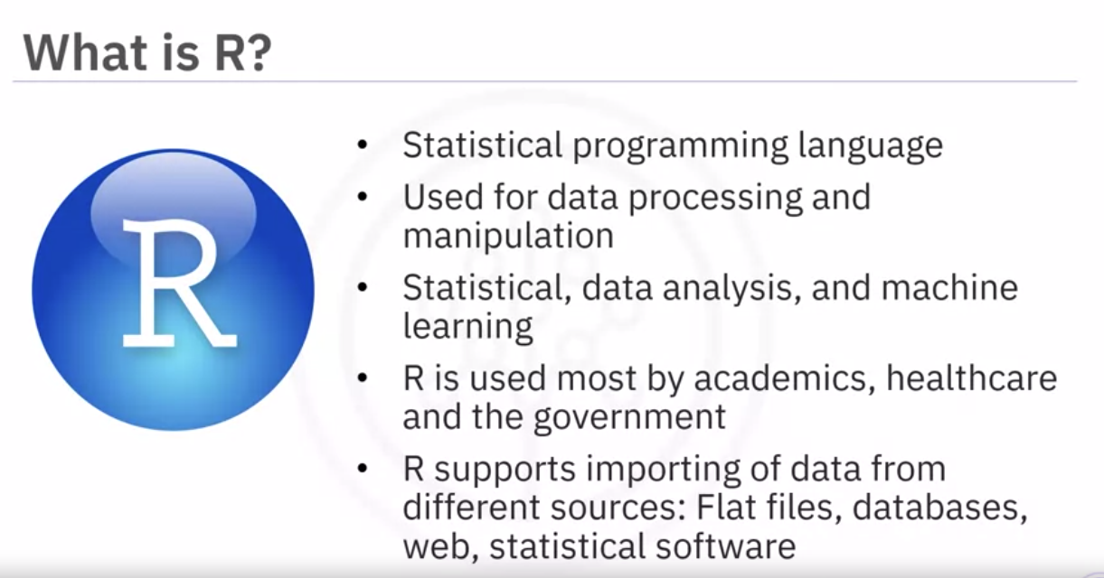

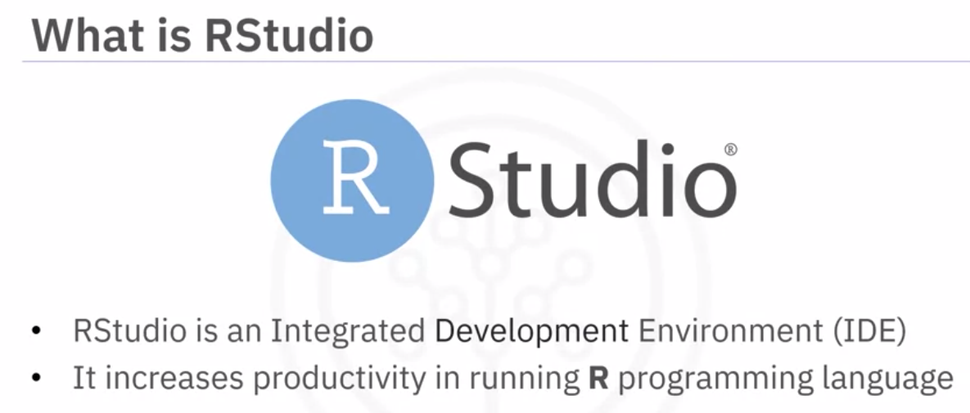

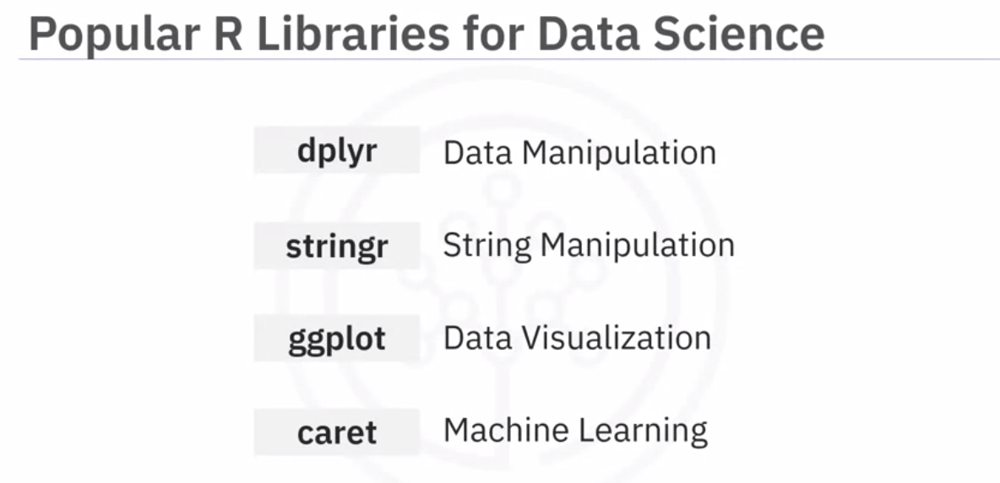

1. **Optional Reading: Download & Install R and RStudio**
2. **R Basics with RStudio**
3. **Plotting in RStudio**

To install packages, use the command: install.packages <package name>

Packages are:

* ggplot: Histograms, bar charts, scatterplots
* Plotly: Web-based data visualizations
* Lattice: Complex, multi-variable data sets
* Leaflet: Interactive plots

1. **Getting started with RStudio and Installing packages**
2. **Creating Data Visualizations using ggplot**
3. **Plotting with RStudio**

**GITHUB**

1. **Overview of Git/GitHub**

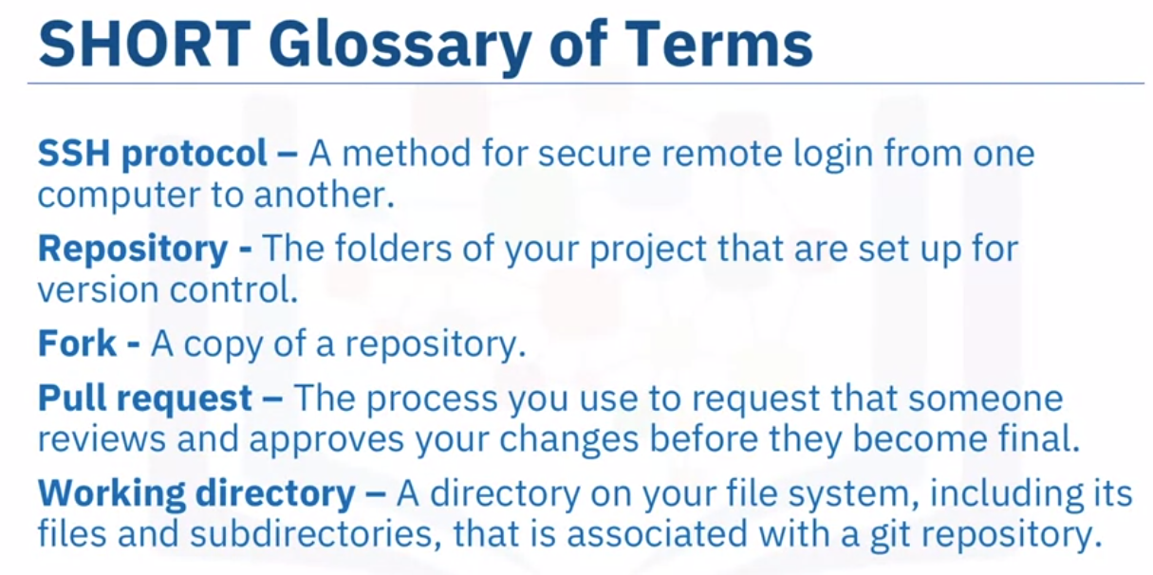

**Basic Git Commands:**

* Git init: to start out with a new repository, you only need create it once, and then push to GitHub. Can be used to clone an existing repository
* Git add: moves changes from the working directory to the staging area
* Git status: to see the state of your working directory and the staged snapshot of your changes
* Git commit: takes your staged snapshot of changes and commits them to the project
* Git reset: undoes changes that you’ve made to the files in your working directory
* Git log: enables to browse previous changes to a project
* Git branch: creates an isolated environment within your repository to make changes
* Git checkout: lets you see and change existing branches
* Git merge: let you put everything back together again

**Git tutorial:** [Link](https://try.github.io)

1. **Introduction to GitHub**

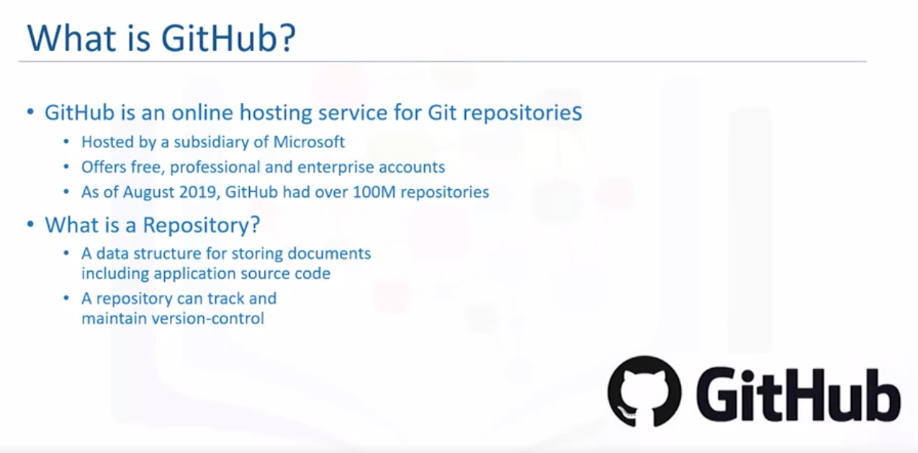

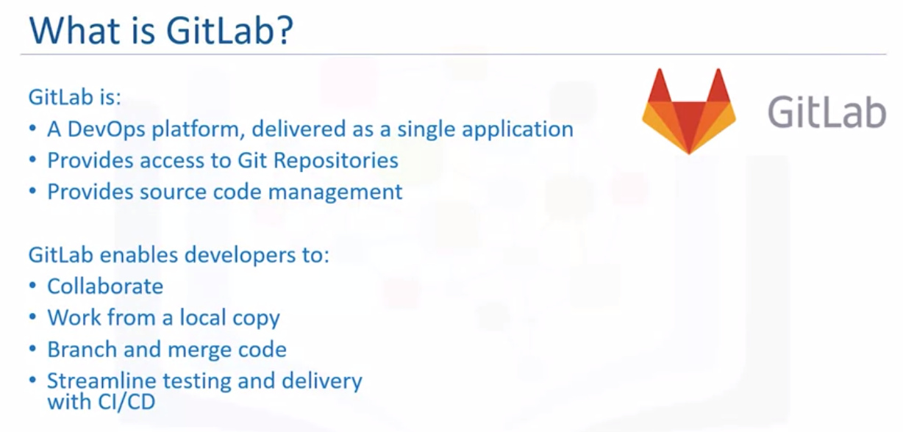

1. **GitHub Repositories**
2. **GitHub – Getting Started**
3. **Hands-on Lab: Getting Started with GitHub**
4. **GitHub – Working with branches**
5. **Hands-on Lab: Branching and Merging (Web UI)**
6. **Getting Started with Branches using Git commands**