Introduction
- Project Scenario and Overview

In this capstone, you will take the role of a data scientist working for a new rocket company SpaceY that would like to compete with SpaceX founded by Billionaire industrialist Allon Mask :)
Your job is to determine the price of each launch. You will do this by gathering information about SpaceX and create dashboards for your team. You will also determine if SpaceX will reuse the first stage. Instead of using Rocket Science to determine if the first stage will land successfully, you will train a machine learning model and use public information to predict if SpaceX will reuse the first stage.

- Get started with GitHub
Link
- Data Collection Overview
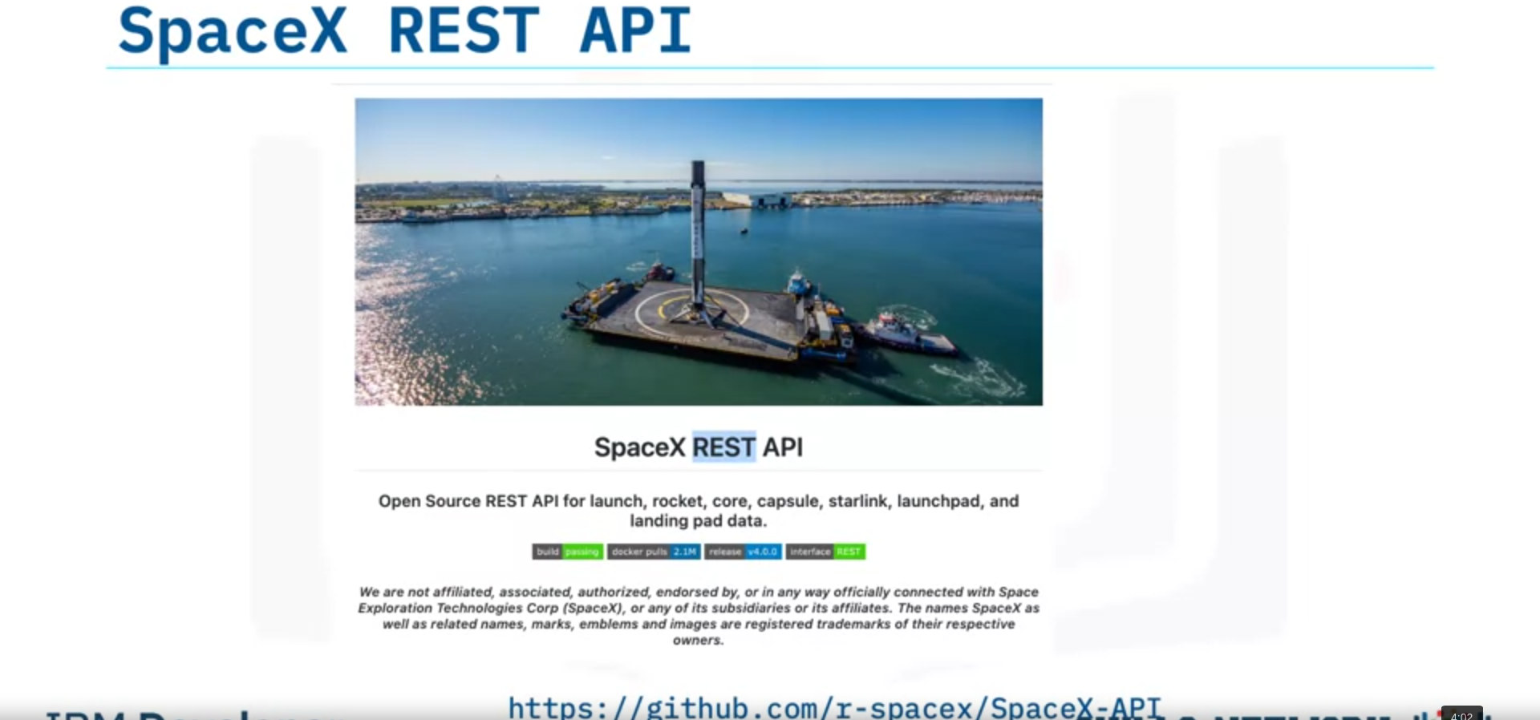
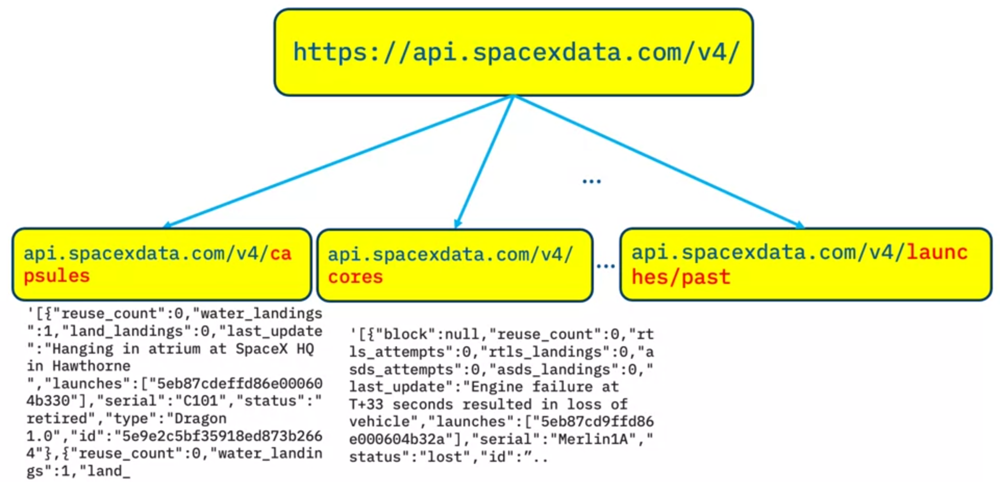
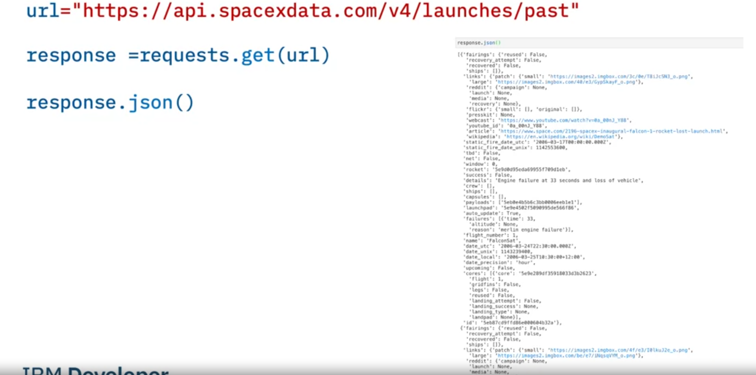
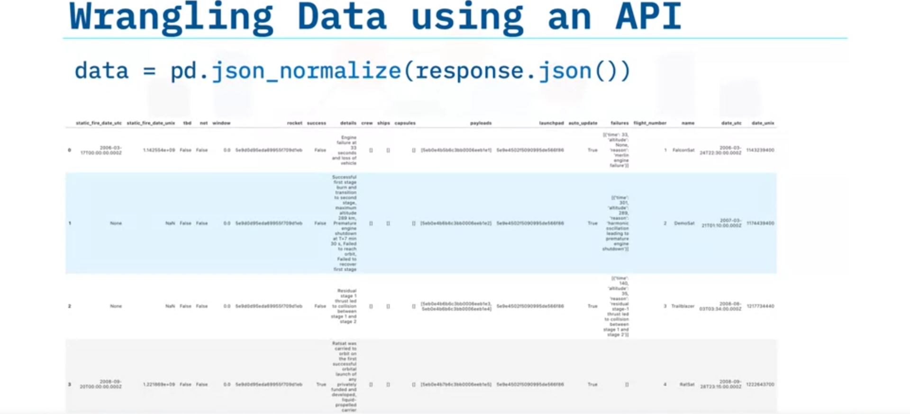
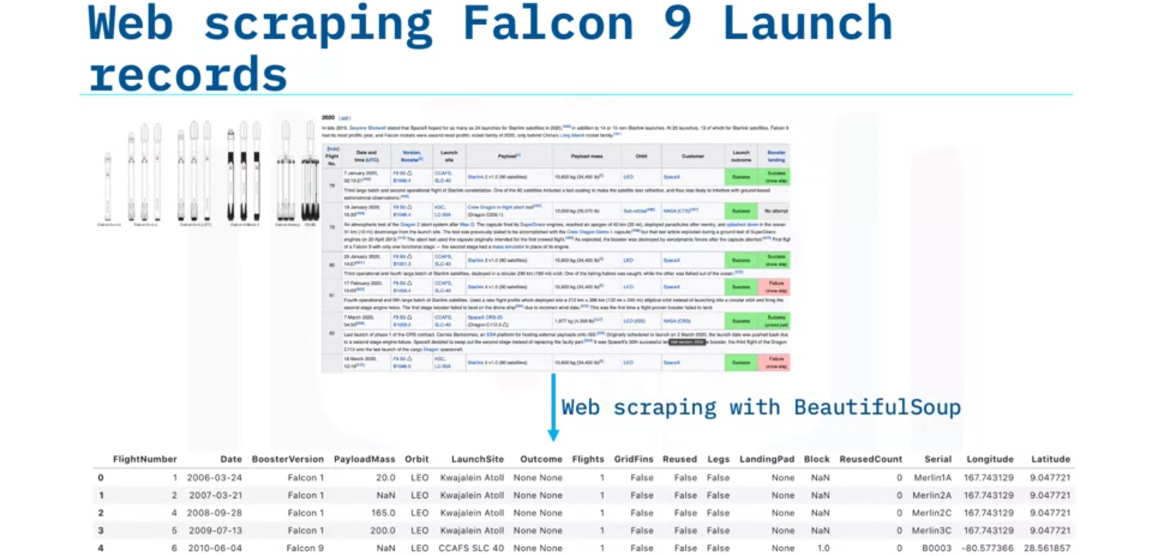

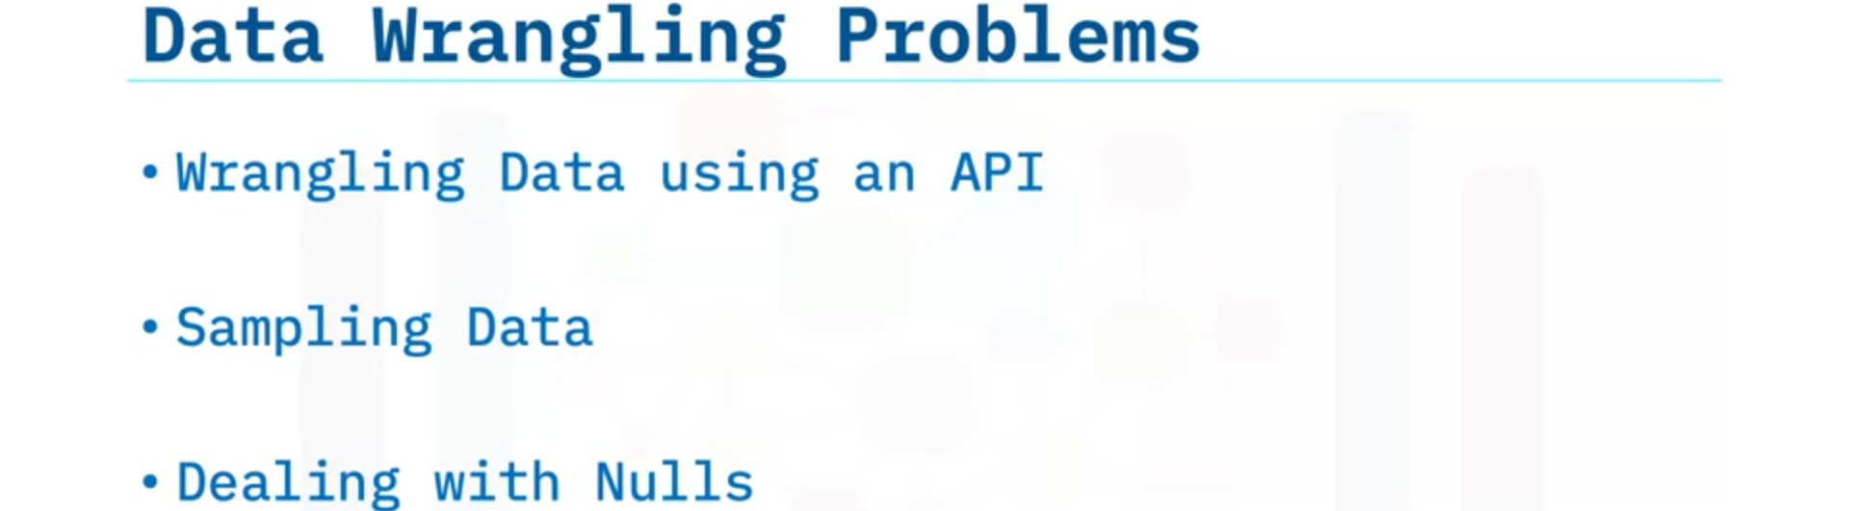
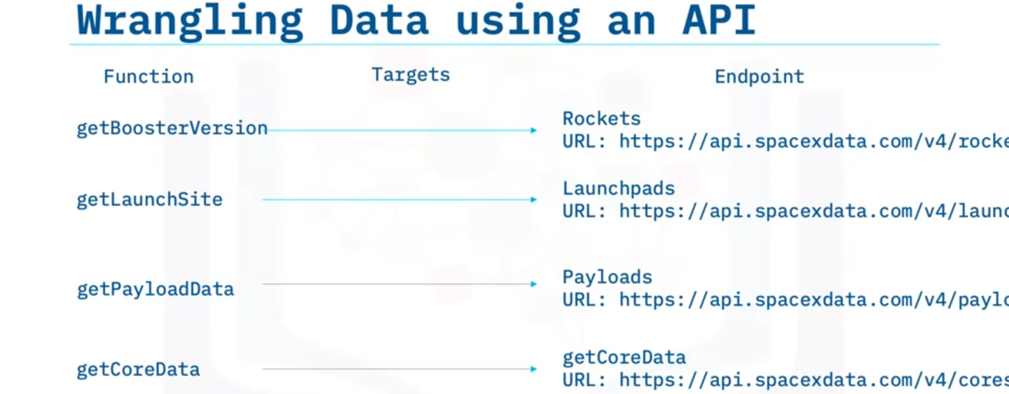
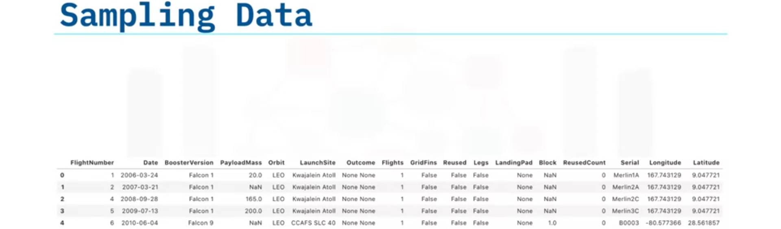
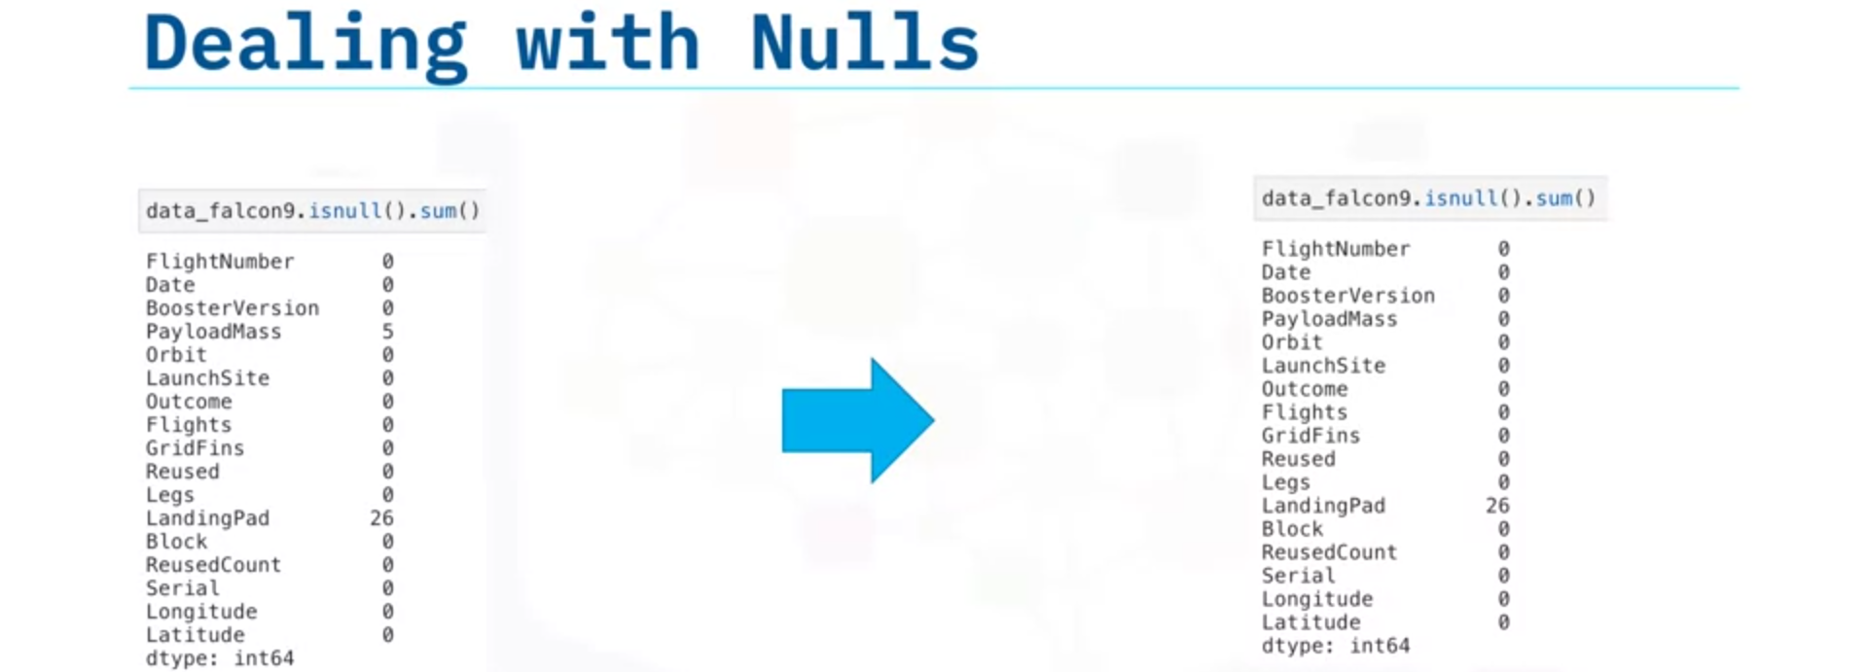

- Data Wrangling Overview
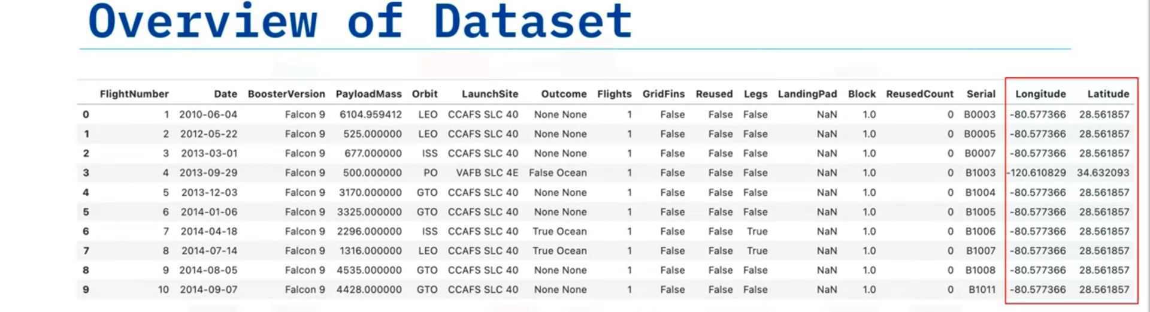
Column LaunchSite: Launching Site in the US
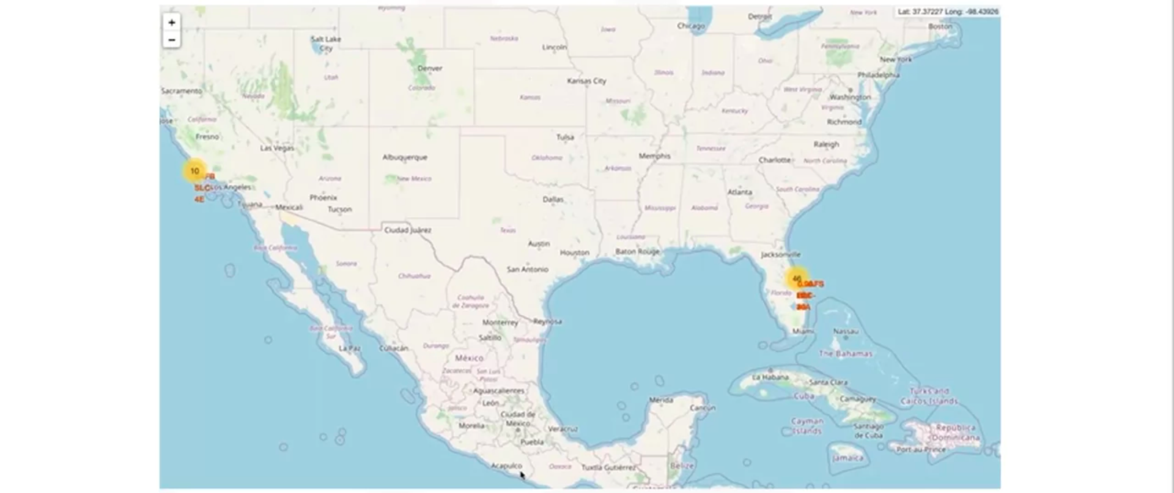
Column Orbit: Orbit of different payloads


