Data Science and Generative AI
Generative AI in Data Science
- Generative AI Tools for Data Scientists
Link
- Synthetic data generation:
  - Tasks: Creating artificial data samples that mimic real-world datasets
  - Tools: TensorFlow Probability, PyTorch, SDV (Synthetic Data Vault), GANs (Generative Adversarial Networks)
  - Purpose and Applications: TensorFlow Probability and PyTorch enable probabilistic modeling, while SDV provides a framework for generating synthetic data based on statistical models. GANs, a well-known generative modeling technique, excel in creating realistic data samples. These tools are used in healthcare for creating synthetic patient records, in finance for creating simulated financial transactions, and for training machine learning models when the original data is scarce or sensitive.
- Image generation and manipulation
  - Tasks: Generating synthetic images, modifying visual attributes, and creating new designs
  - Tools: StyleGAN, DALL-E, BigGAN
  - Purpose and Applications: StyleGAN, a specialized implementation and extension of GANs, can create high-quality images, DALL-E's can create images based on text descriptions, and BigGAN can generate diverse and realistic images. These tools have applications in the art and design, content creation, fashion, and gaming industries. They enable the creation of unique images and enhance creative workflows.
- Natural language generation
  - Tasks: Generating human-like text, creating stories, articles, or dialogue
  - Tools: OpenAI's GPT (Generative Pre-Trained Transformer) models, Hugging Face's Transformers
  - Purpose and Applications: GPT models can generate coherent and context-appropriate text, and transformers provide flexibility in text generation and fine-tuning specific tasks. Data professionals use these tools in chatbots, content generation, automated summarization, and conversational AI in media, customer service, and content creation.
- Music and audio synthesis
  - Tasks: Generating musical compositions or synthesizing audio samples
  - Tools: Magenta, Jukebox, NSynth
  - Purpose and Applications: Magenta can generate melodies, harmonies, and musical compositions using deep learning techniques. Jukebox can create new songs in various genres, and NSynth can generate new sounds by combining existing ones. Artists use these tools in music production, gaming, and entertainment for creating original compositions, sound effects, and adaptive soundtracks.

- Simulation and data augmentation
  - Tasks: Simulating scenarios and augmenting datasets for machine learning models
  - Tools: Unity ML-Agents, NVIDIA's SimNet, Augmentor
  - Purpose and Applications: Unity ML-Agents can create intelligent agents for simulations, SimNet can simulate realistic data, and Augmentor provides data augmentation techniques. Data professionals use these tools in robotics, gaming, autonomous vehicles, and simulations for training AI models and testing algorithms in different environments.
- Content generation
  - Tasks: Creating human-like content, such as text, images, and music
  - Tools: OpenAI's GPT models, DeepDream, StyleGAN
  - Purpose and Applications: GPT models excel in generating coherent text, DeepDream creates surreal images, and StyleGAN ensures realistic image generation. Content creators use these tools in content creation, storytelling, art, and the entertainment industries.
- Anomaly detection
  - Tasks: Identifying outliers or anomalies in datasets
  - Tools: Autoencoders, Isolation Forest, GANs
  - Purpose and Applications: Autoencoders can detect anomalies or outliers in the data, Isolation Forest can effectively handle anomaly detection in high-dimensional data, and GANs can generate normal data distributions. Data professionals use these tools to detect financial fraud, manufacturing errors, and cybersecurity.
- Data augmentation
  - Tasks: Enhancing training datasets by generating variations of existing data
  - Tools: CycleGAN, Augmentor, Neural Style Transfer
  - Purpose and Applications: CycleGAN can perform an image-to-image translation, Augmentor can generate augmented images, and Neural Style Transfer allows the artistic transformation of images based on the style of one image and the content of another. Data professionals use computer vision, medical imaging, and data augmentation tools for machine learning models.
- Human-computer interaction
  - Tasks: Enabling human-like interactions through chatbots, assistants, and avatars
  - Tools: Dialogflow, Rasa, RunwayML
  - Purpose and Applications: Dialogflow and Rasa effectively build conversational AI, whereas RunwayML suits creative coding. These tools are used in customer service, virtual assistants, and gaming industries to enhance the user experience.

- Generative AI’s Impact Across Industries
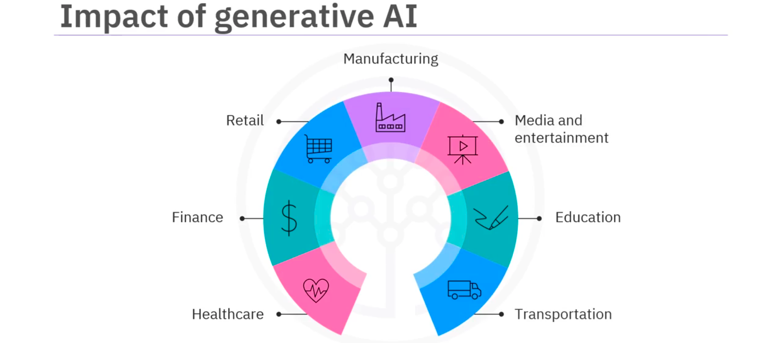
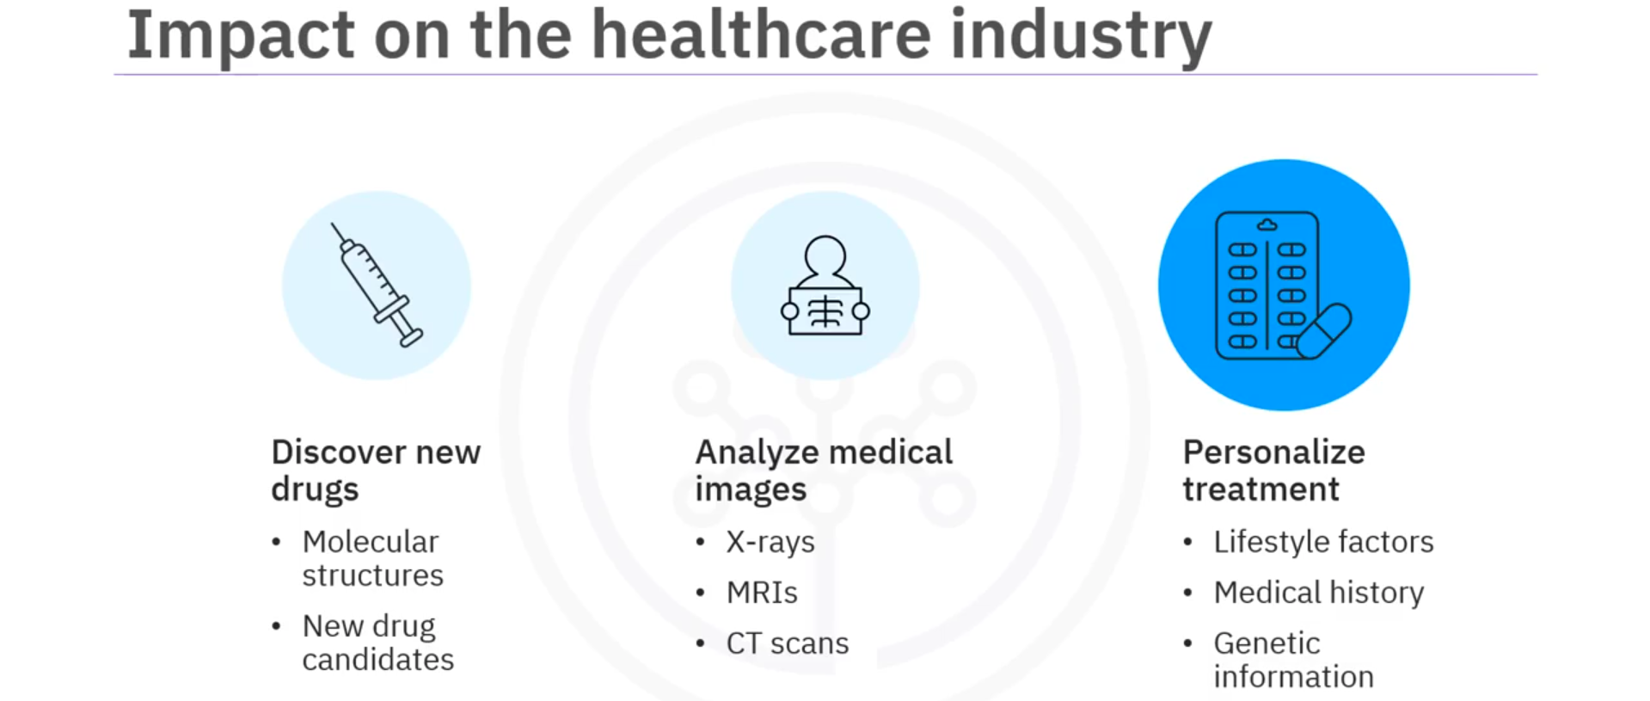
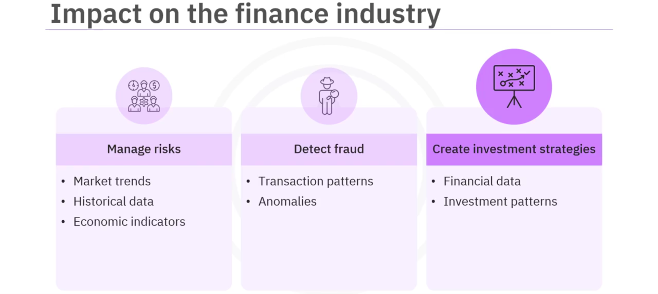
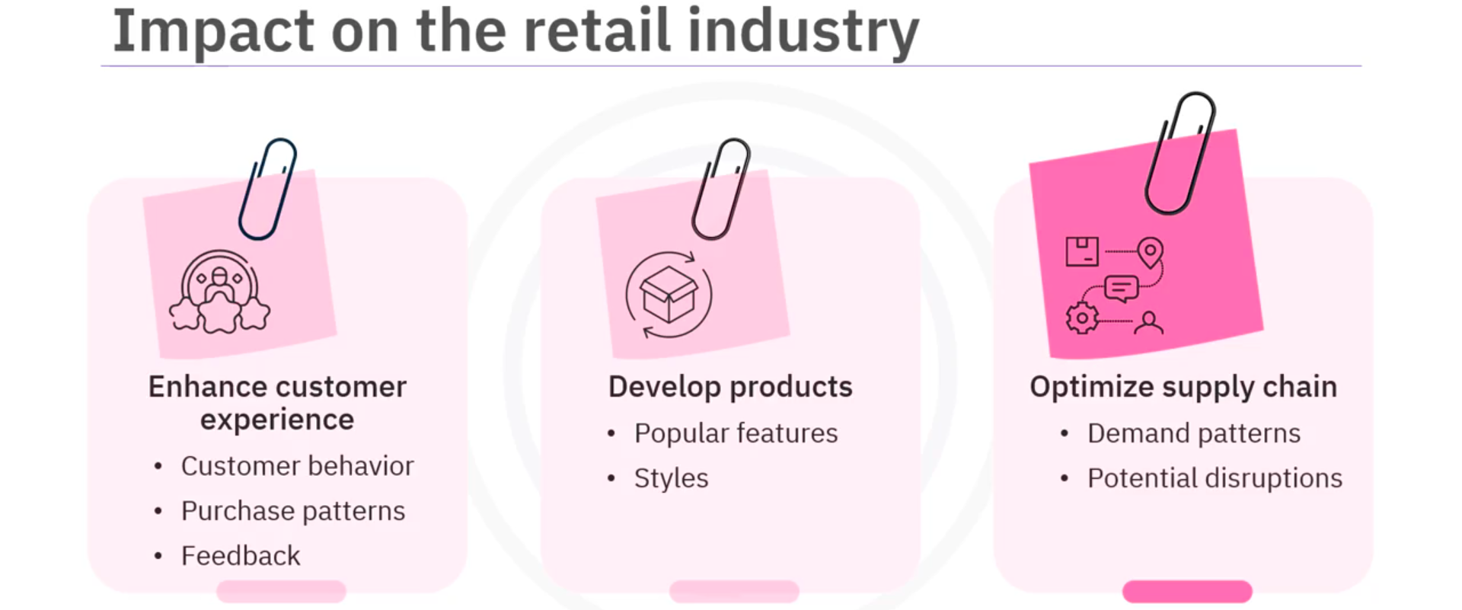
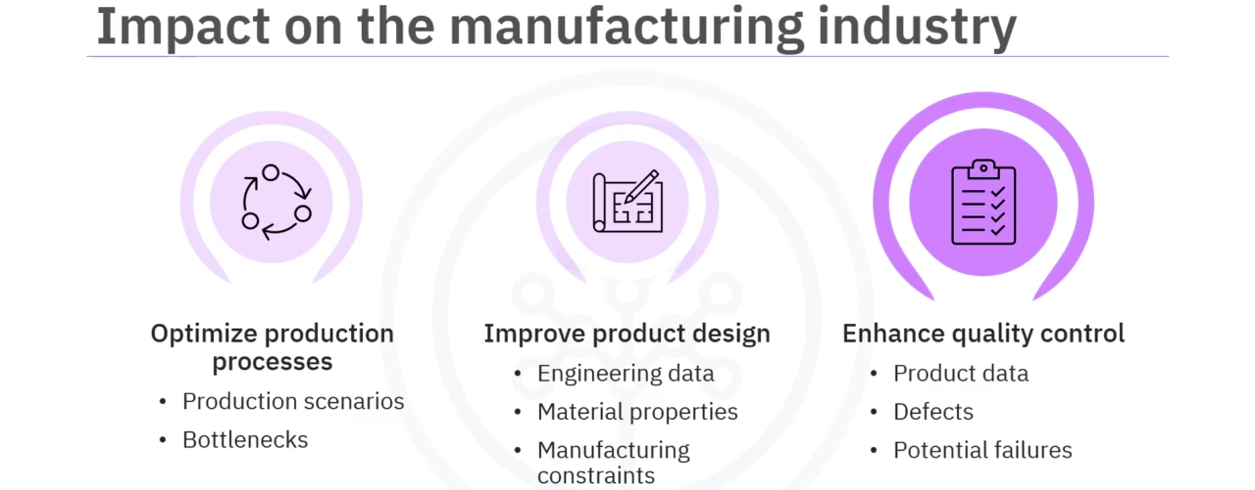
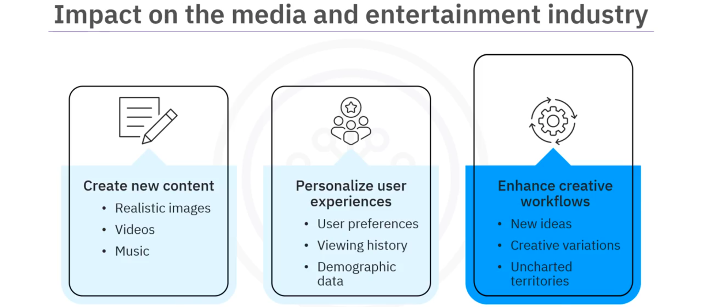
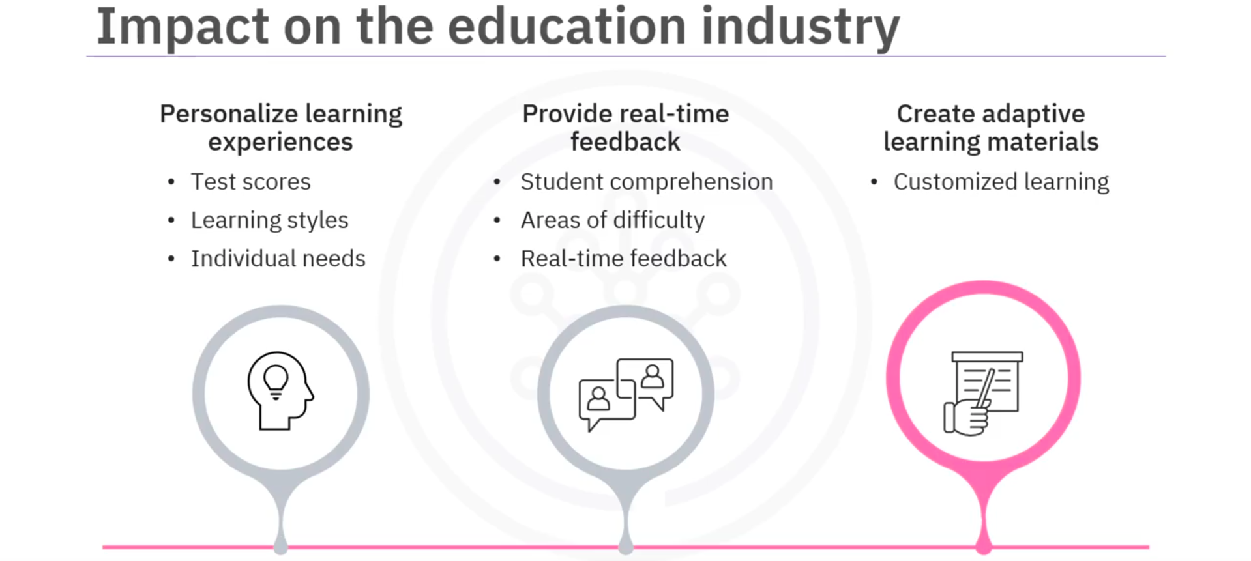
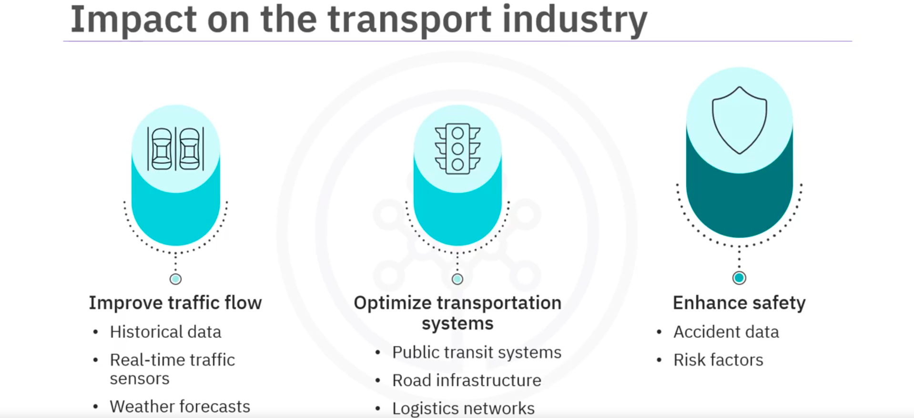

- Leveraging Generative AI in Data Science Lifecycle
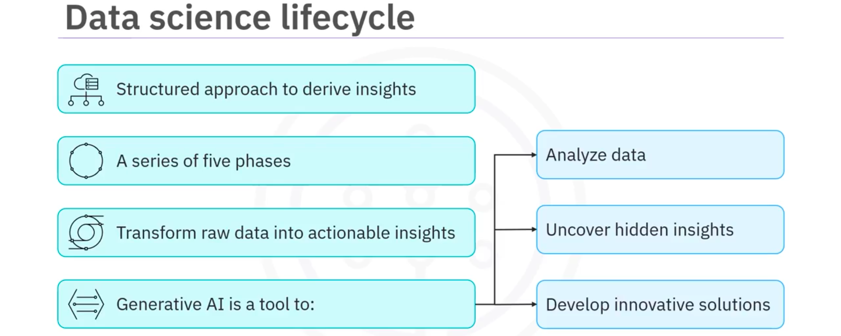
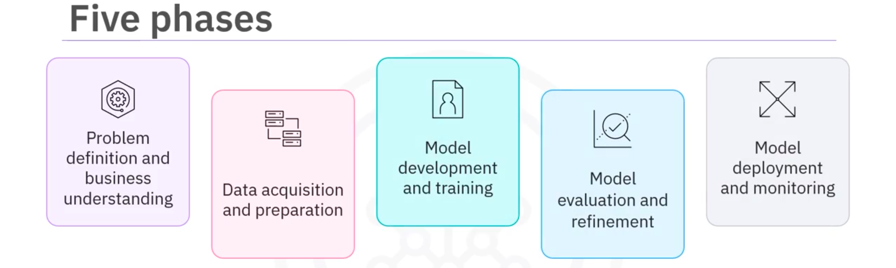
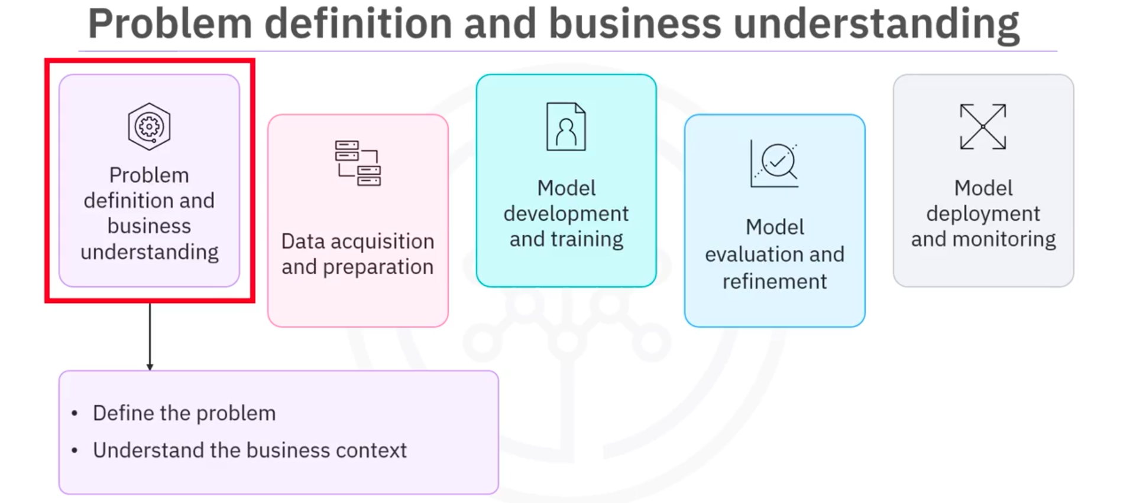
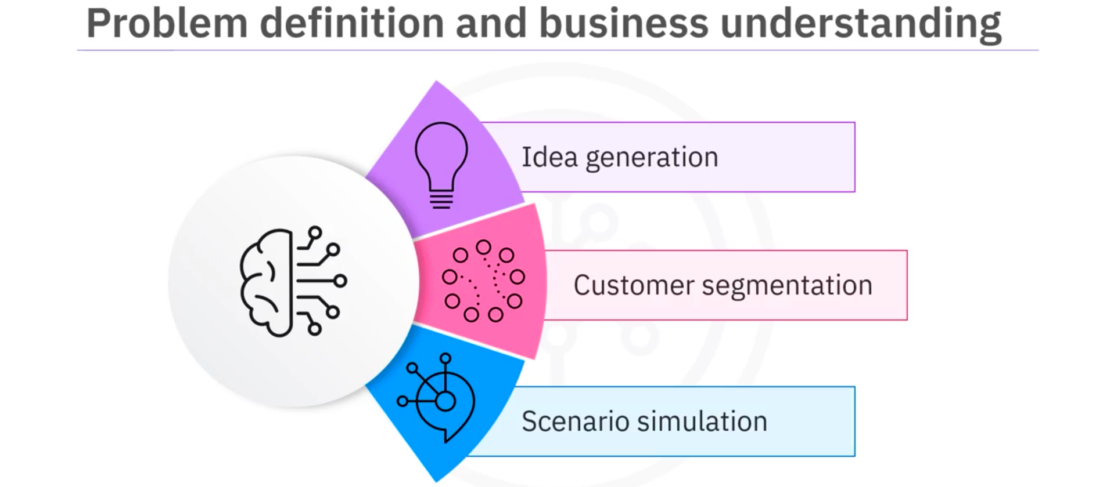
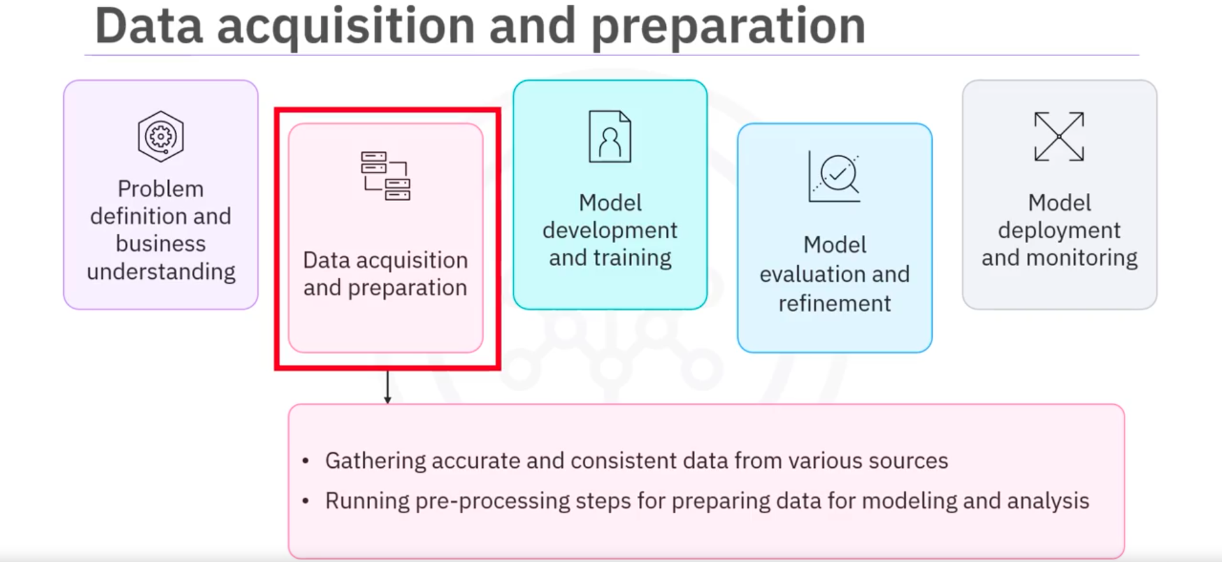
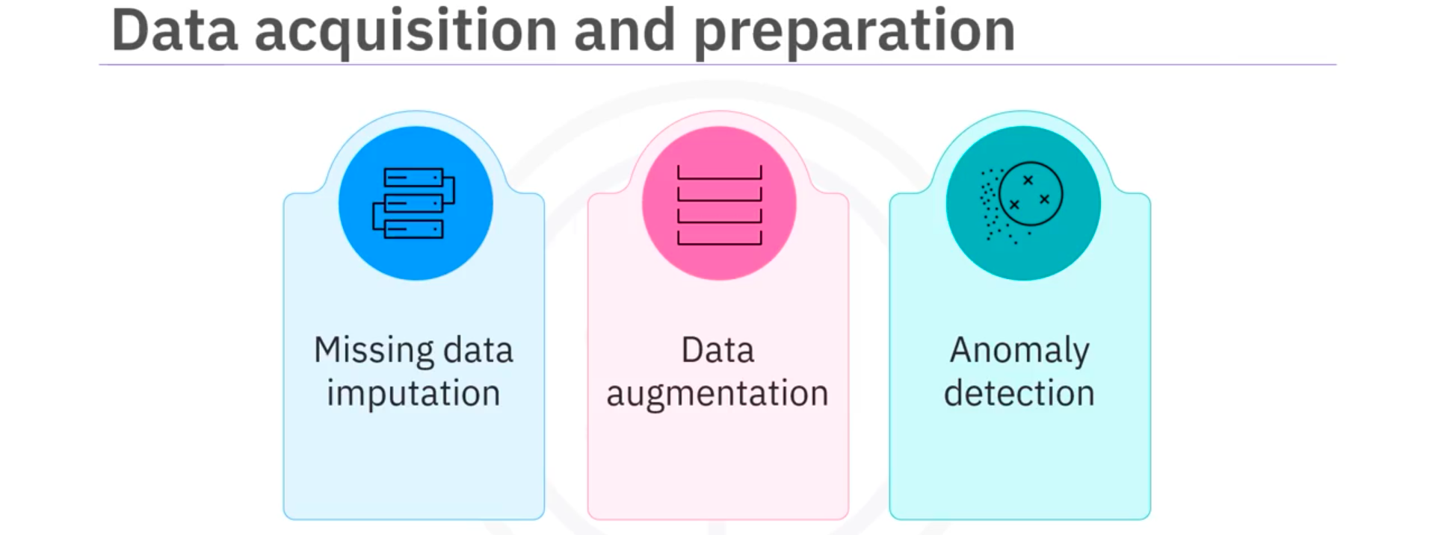
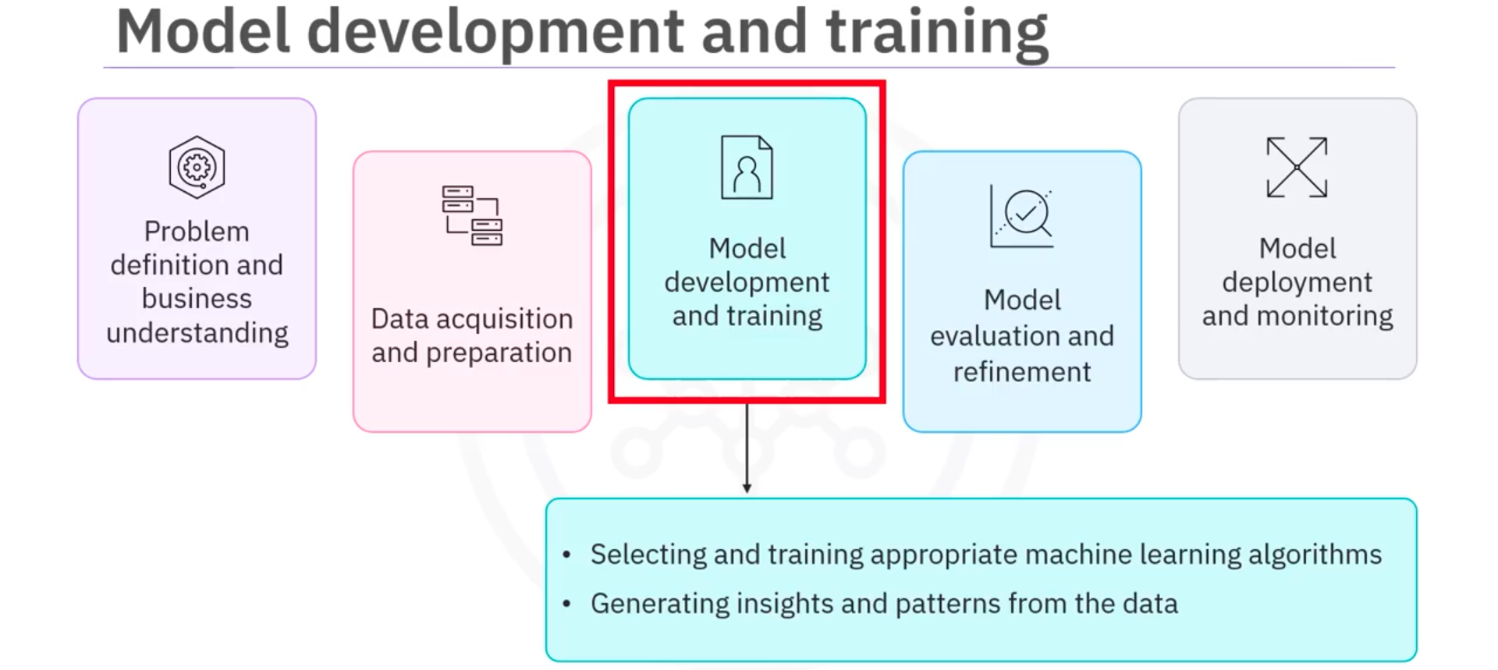
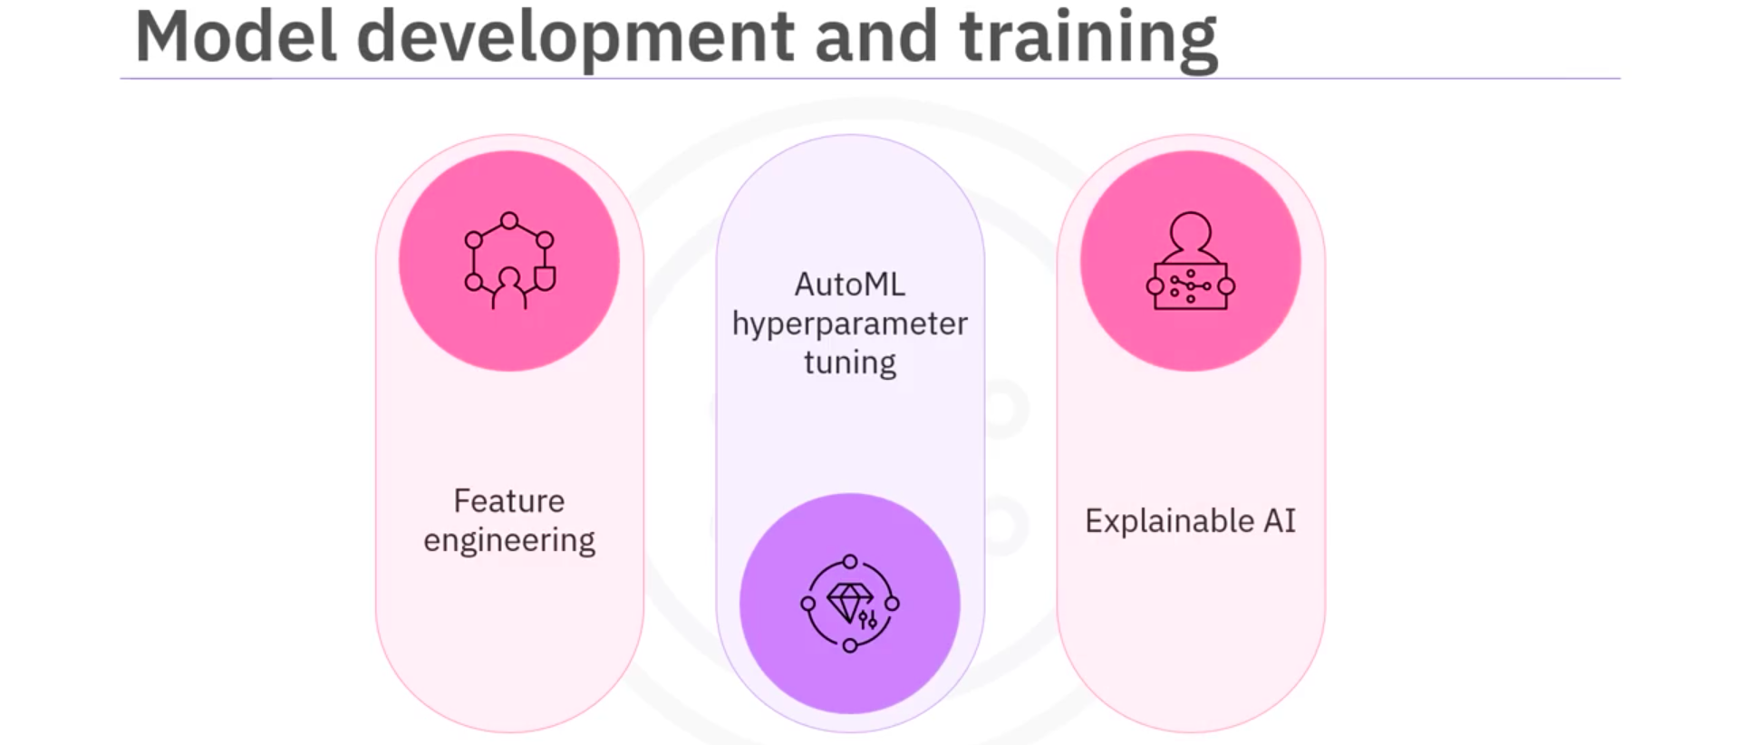
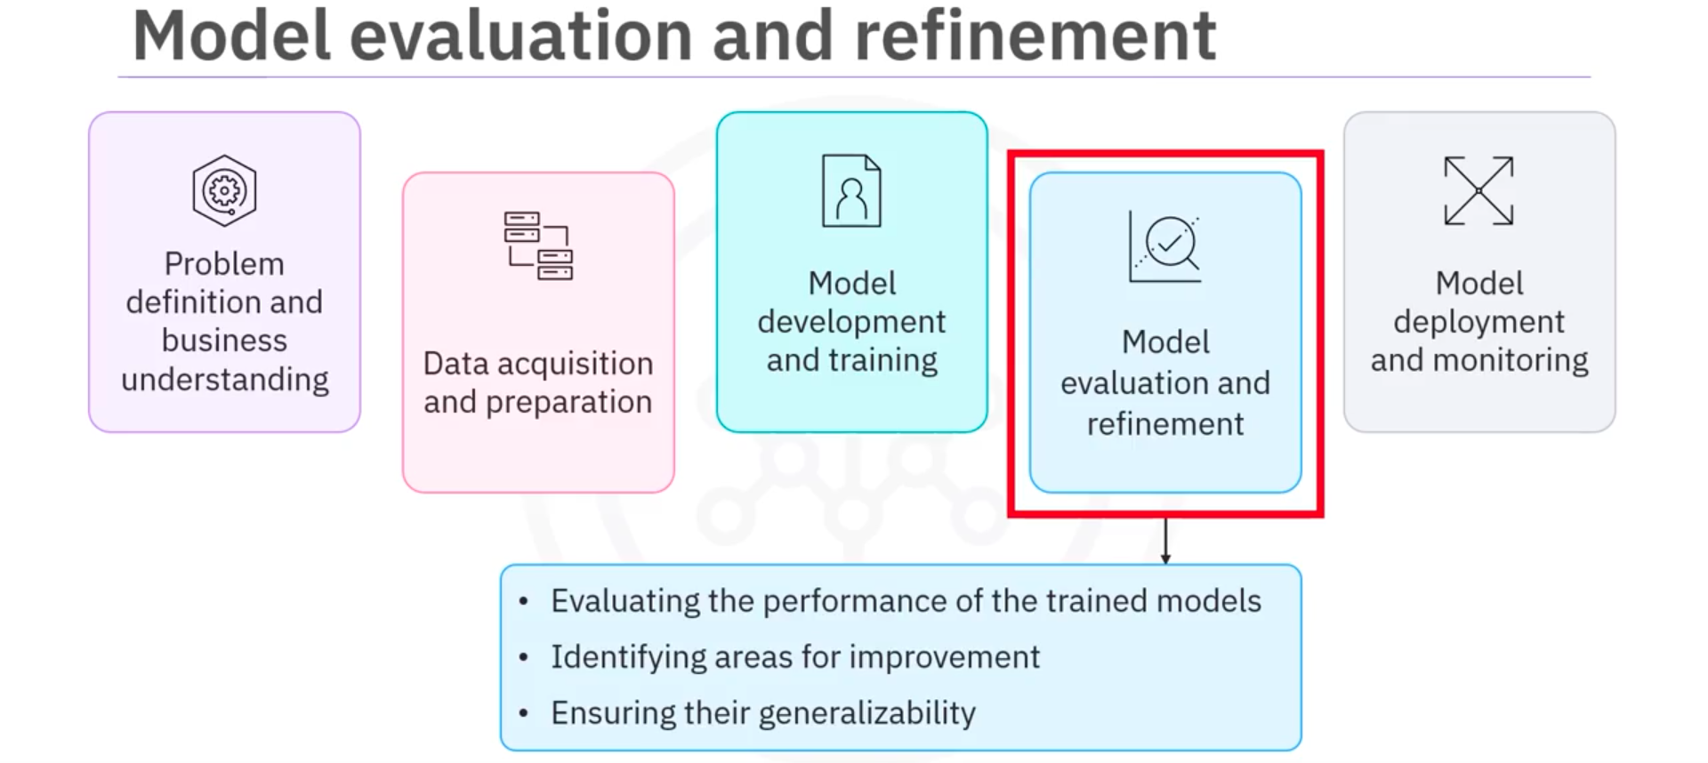
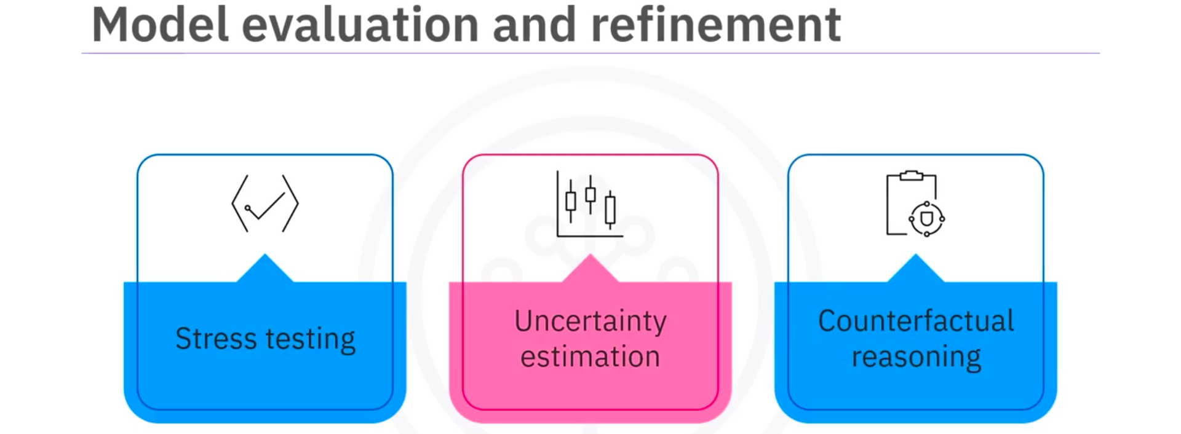
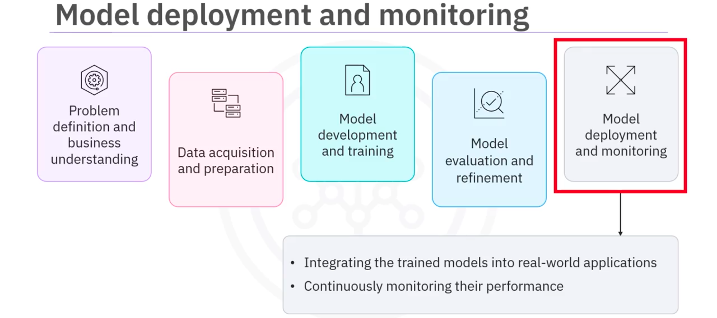
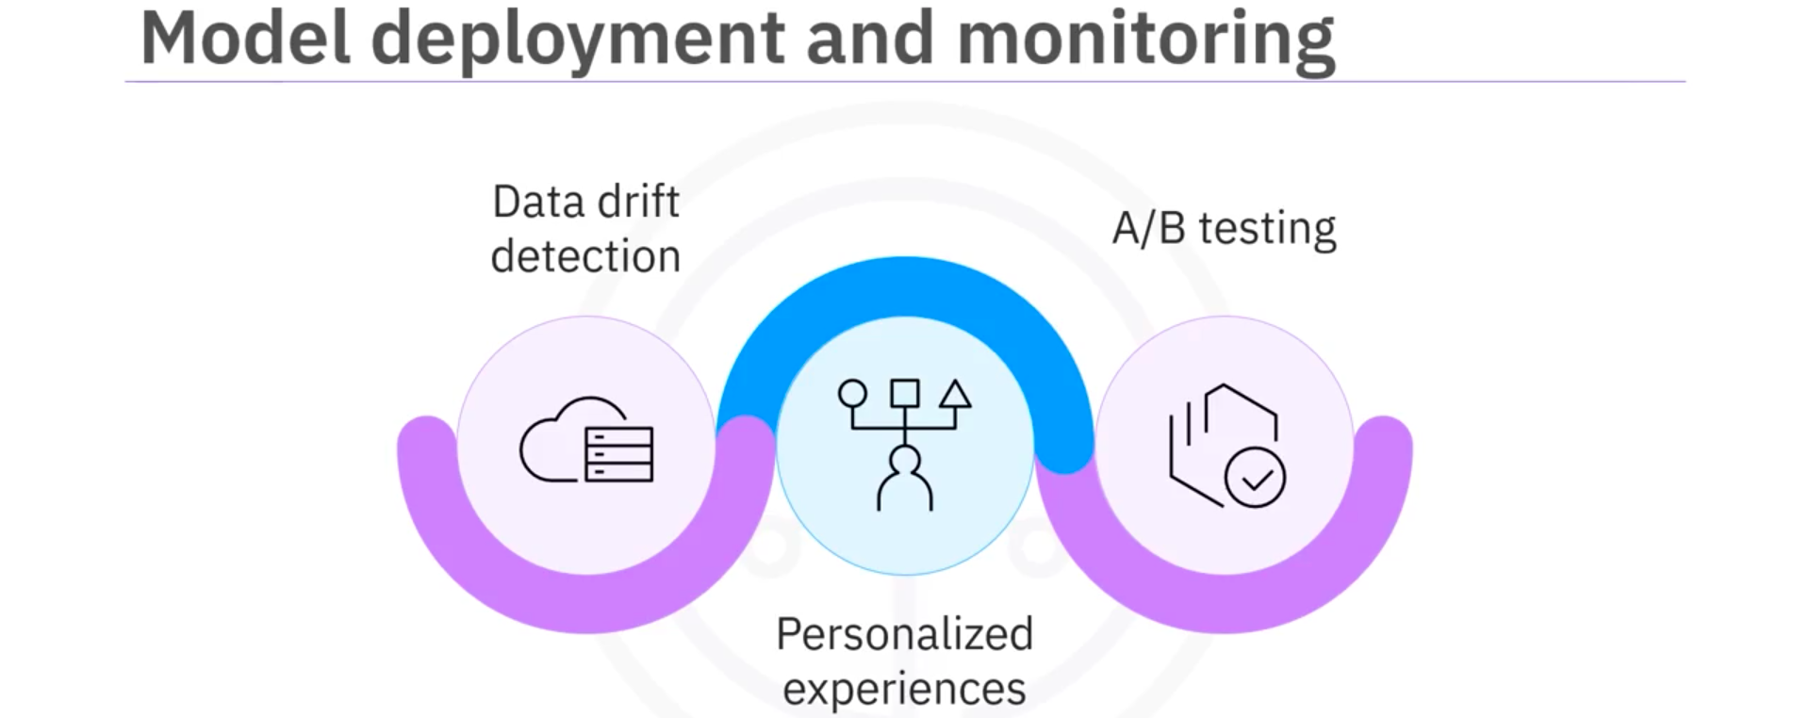

- Types of Generative AI Models
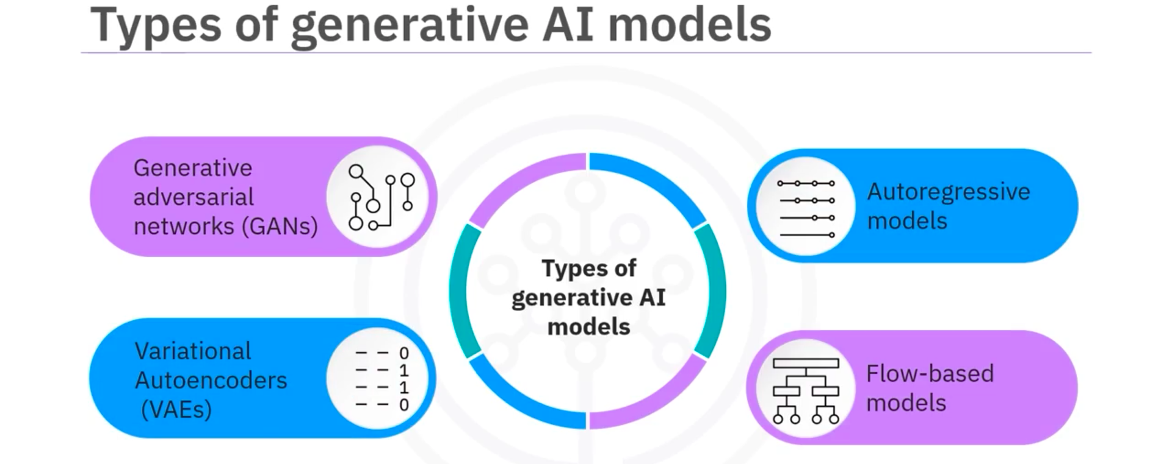
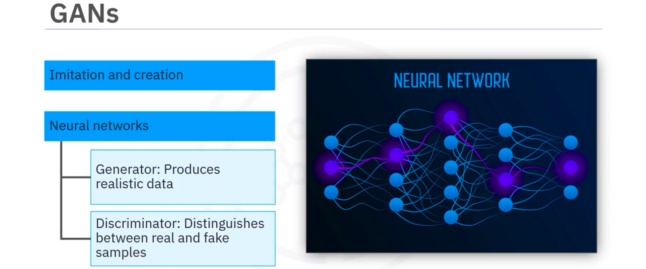
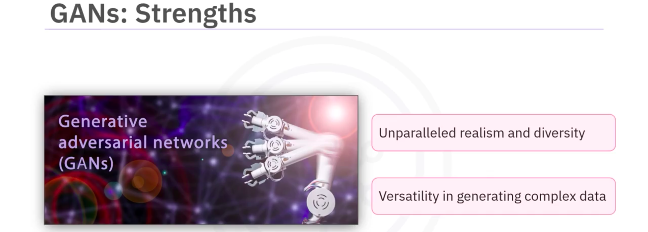
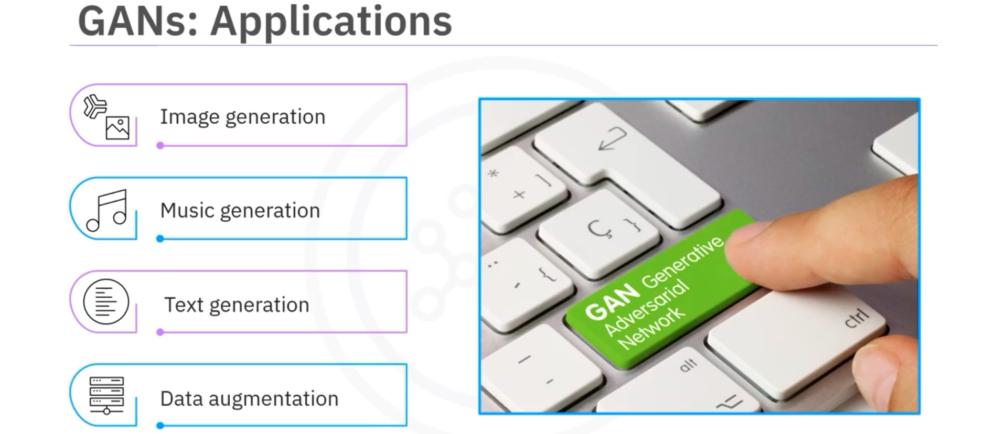
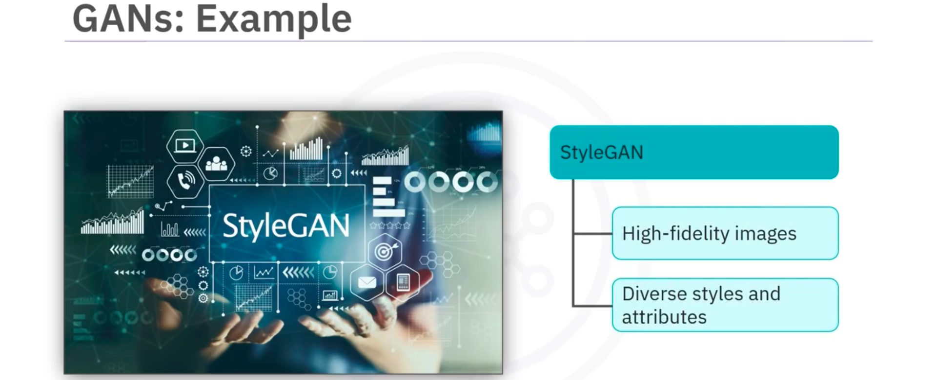
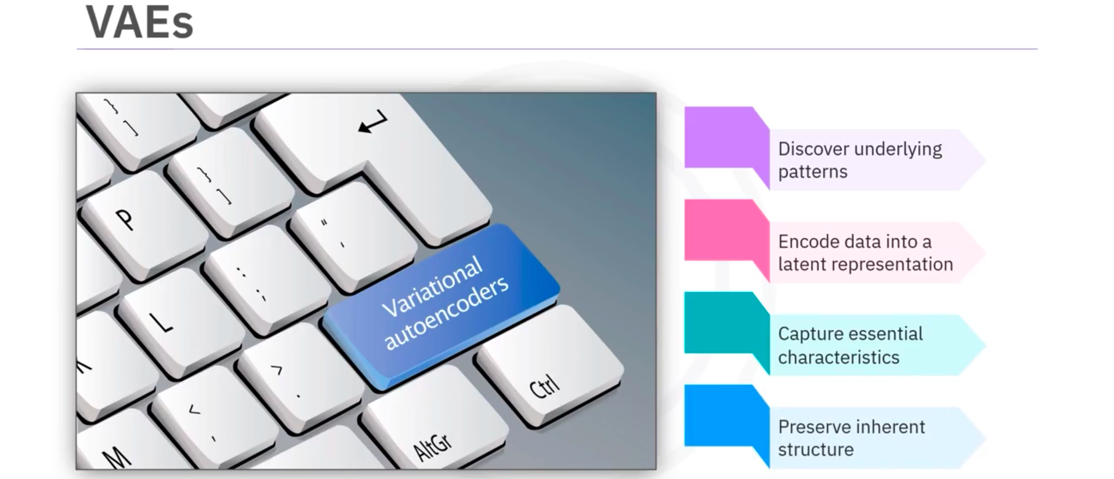
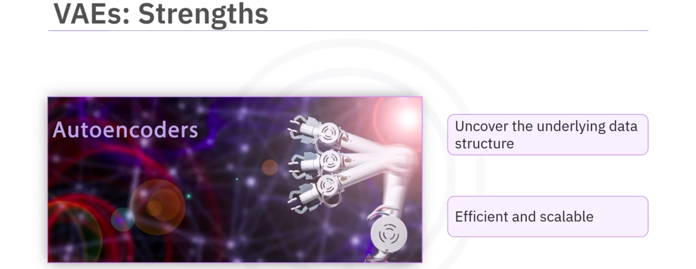
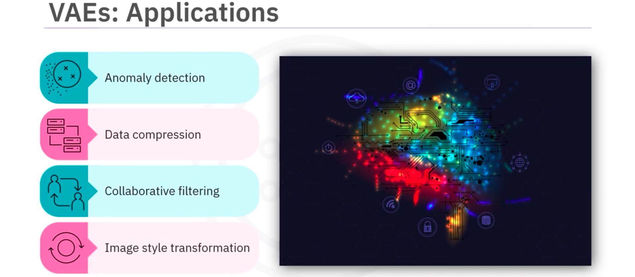
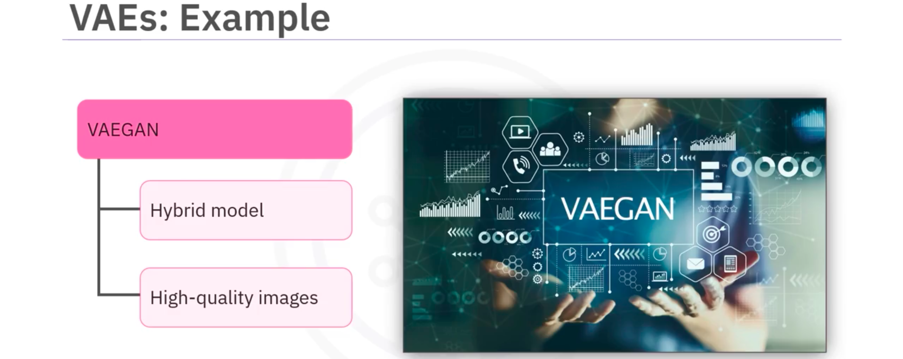
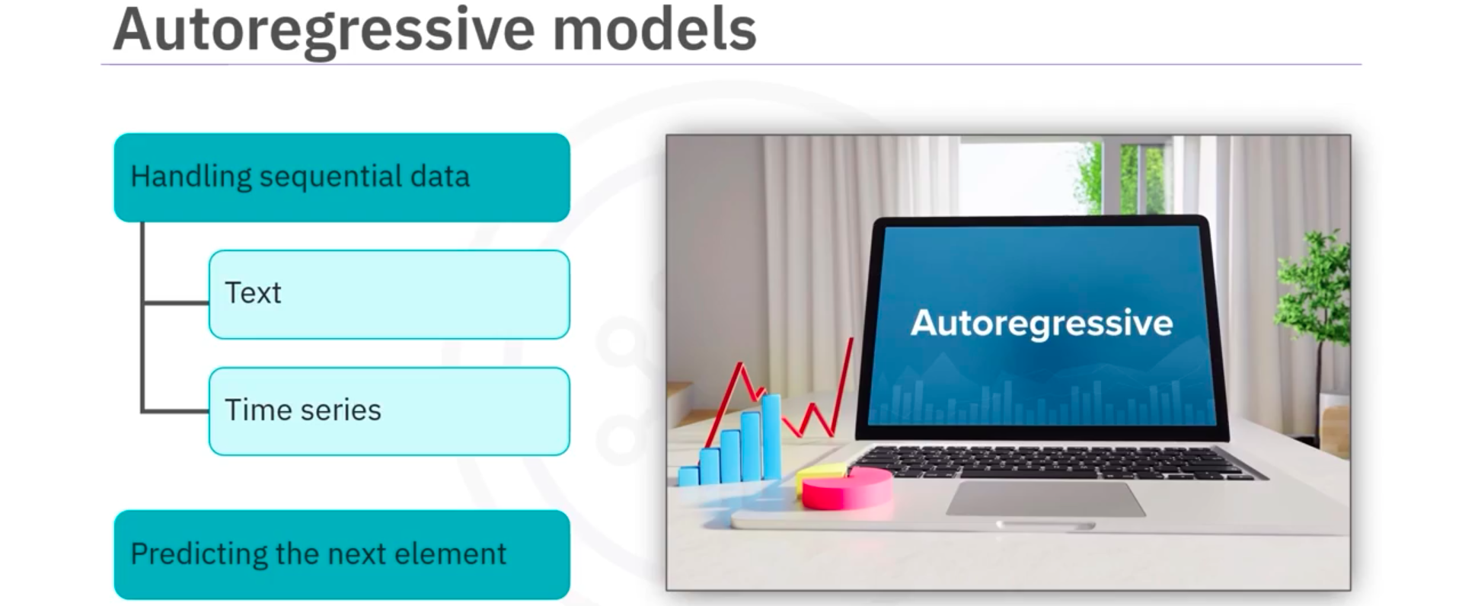
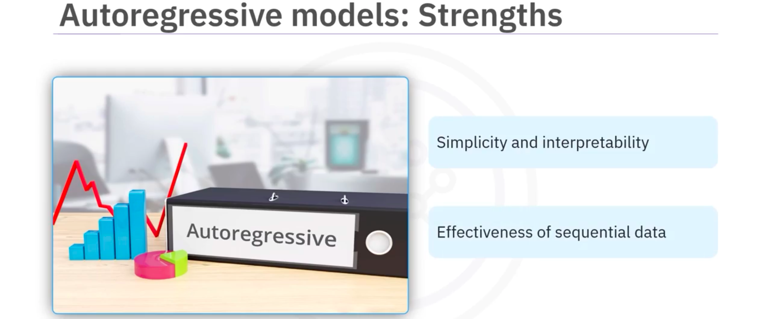
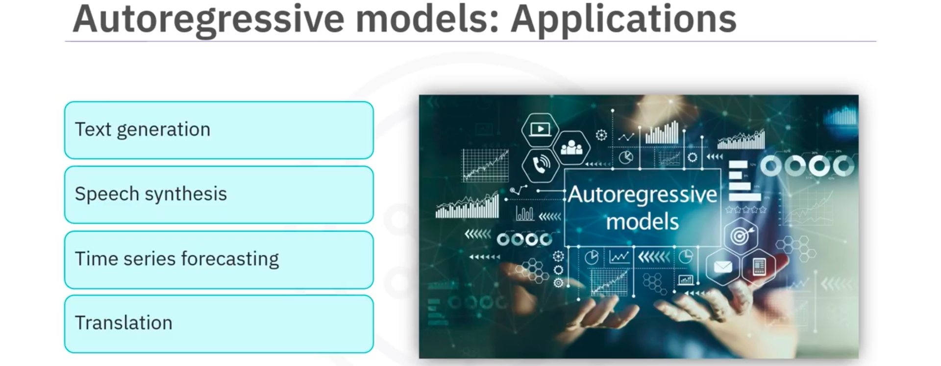
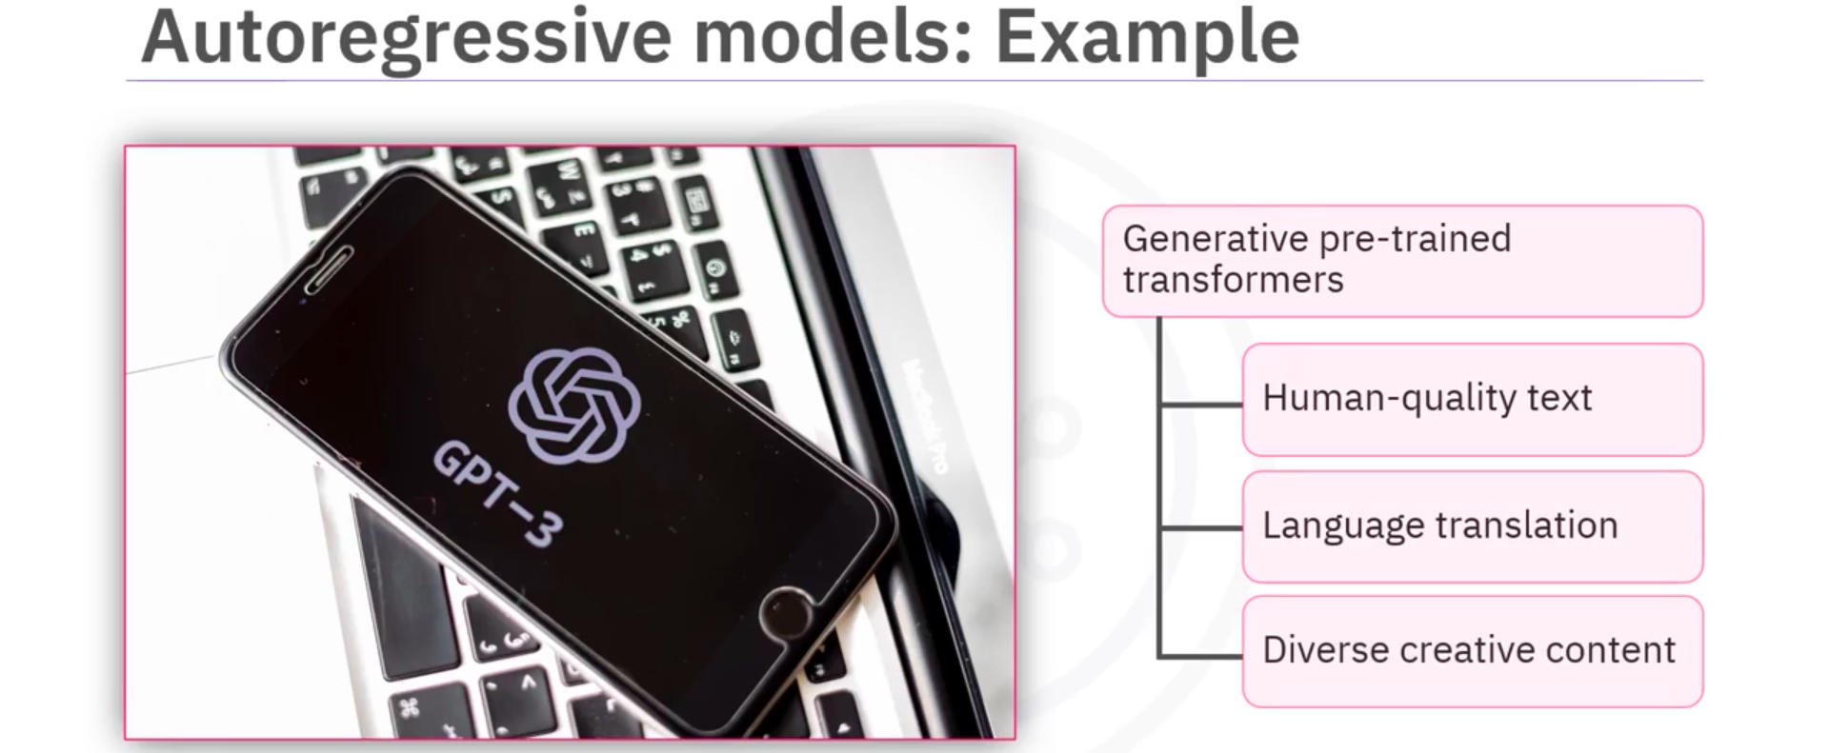
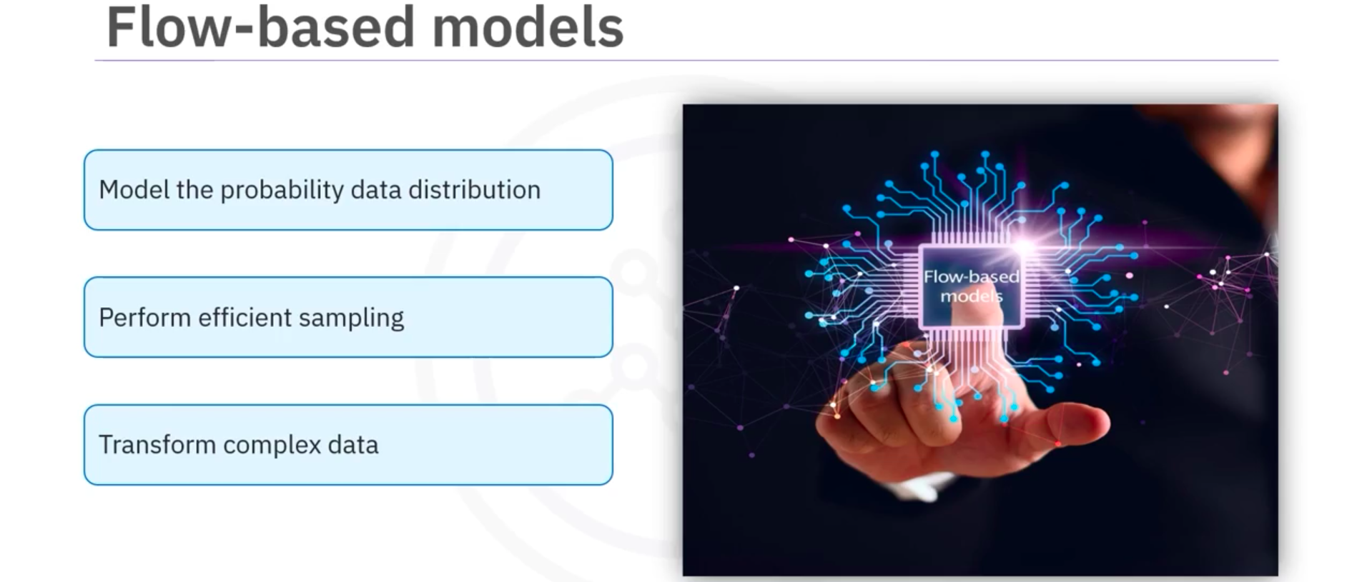
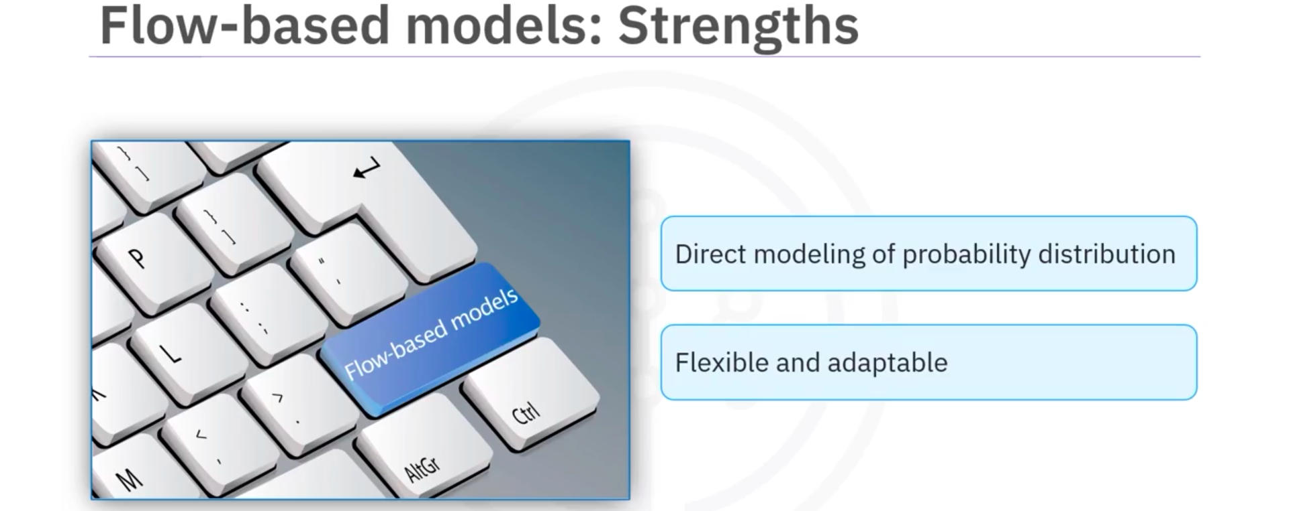
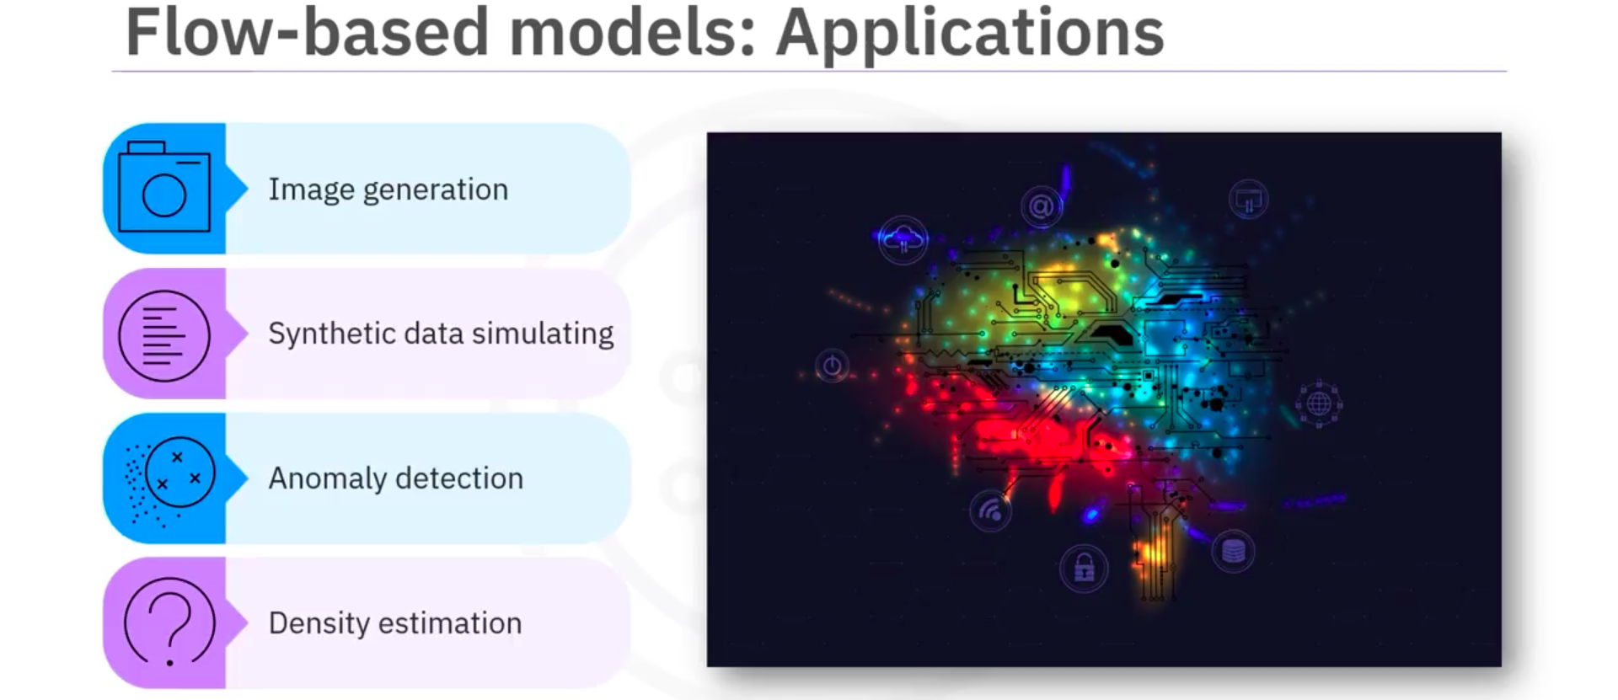
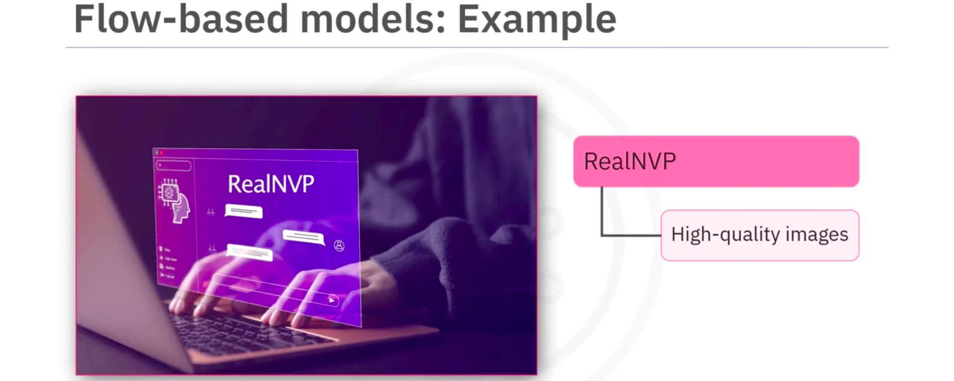

- Guide to Choosing a Generative AI Model Type
Link
- Case Study: Successful Implementation of Generative AI
Link

Generative AI for Data Preparation and Querying (Mostly.ai)
- Demo: Generative AI for Data Generation and Augmentation
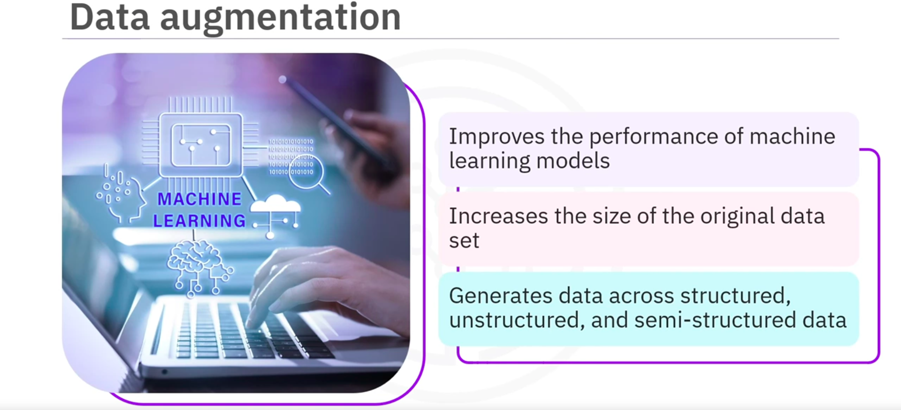
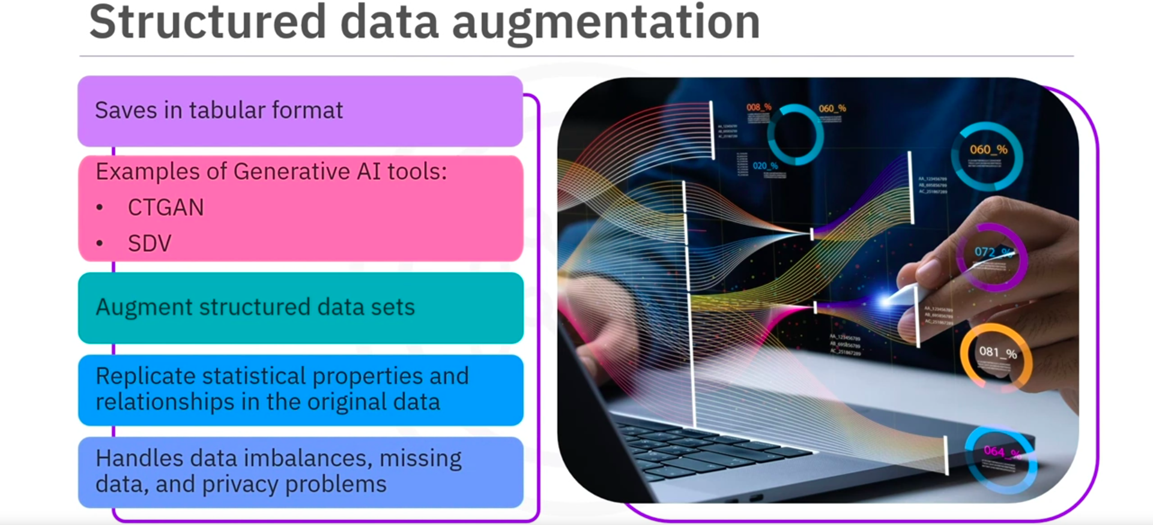
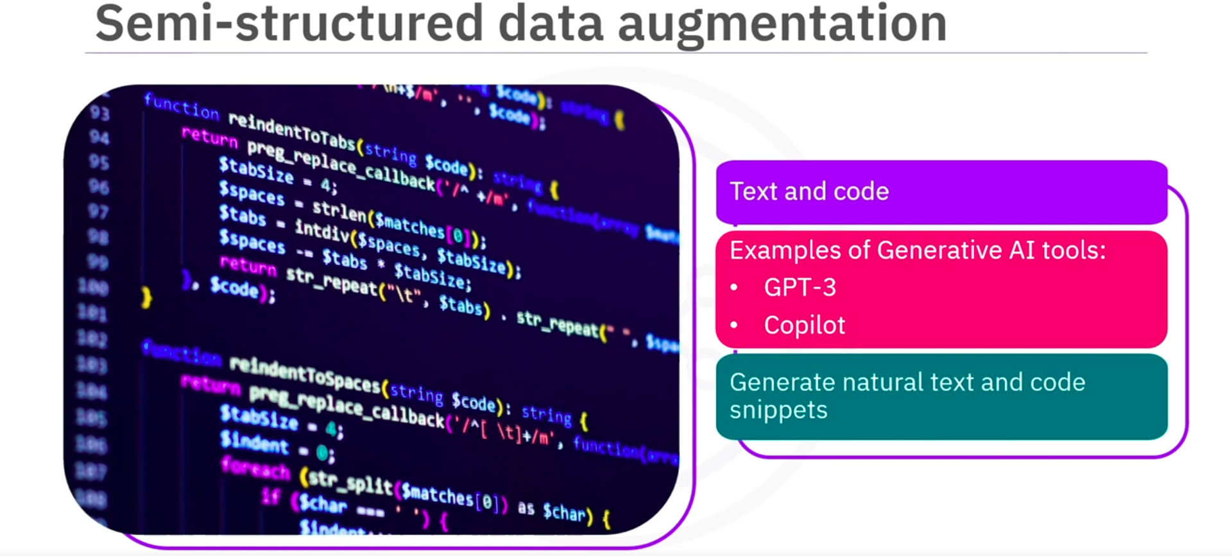
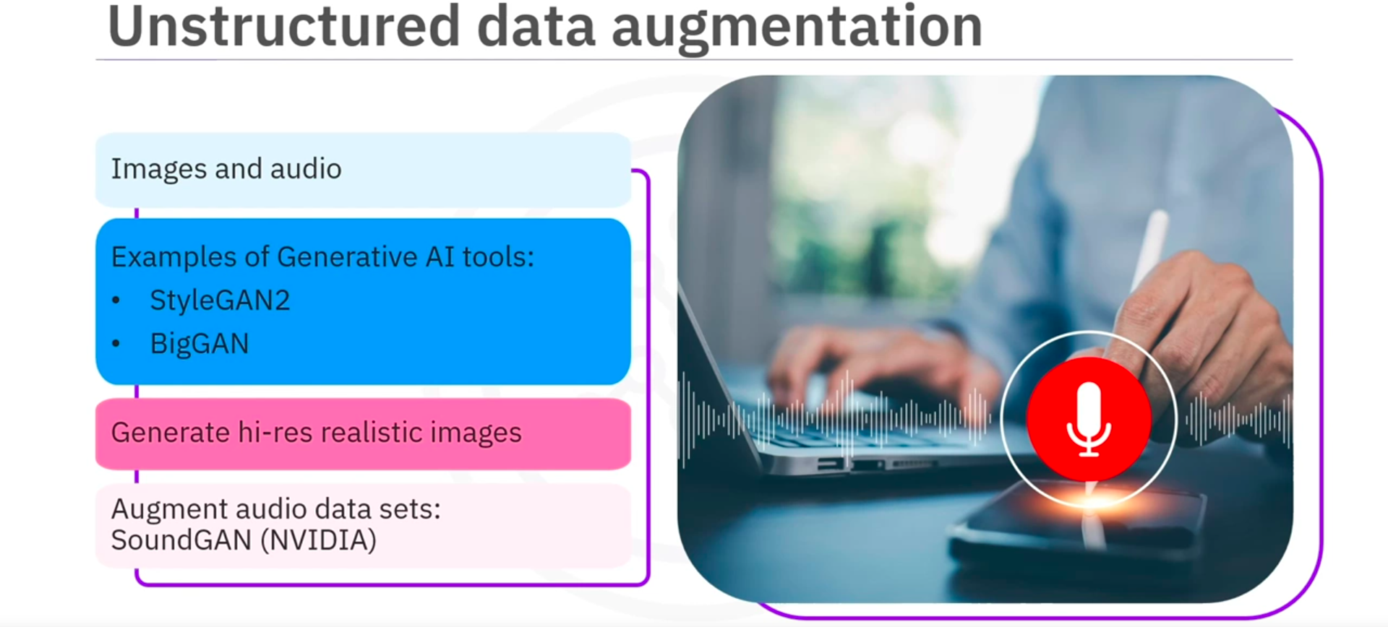

- Generative AI for Data Preparation and Data Querying
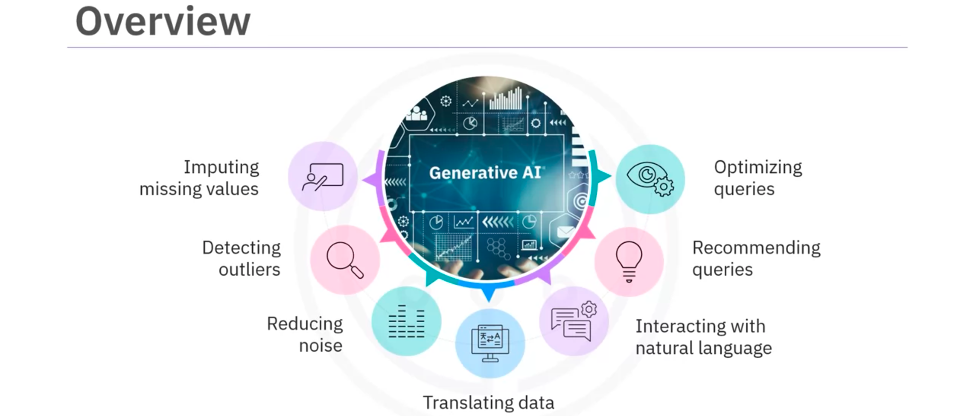
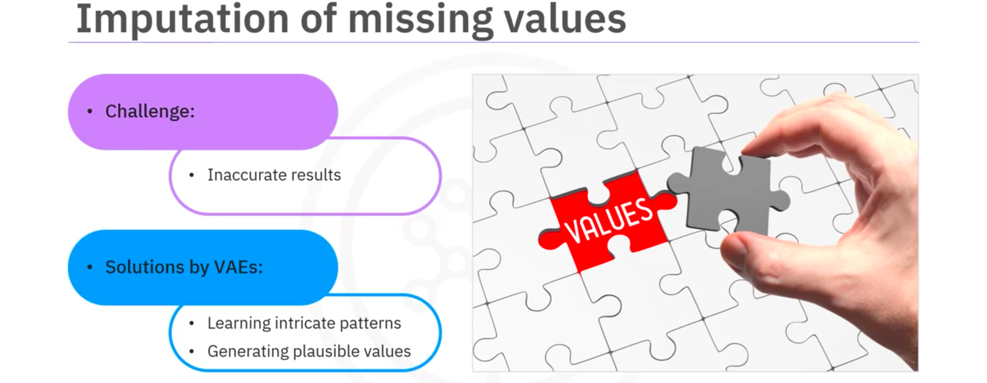
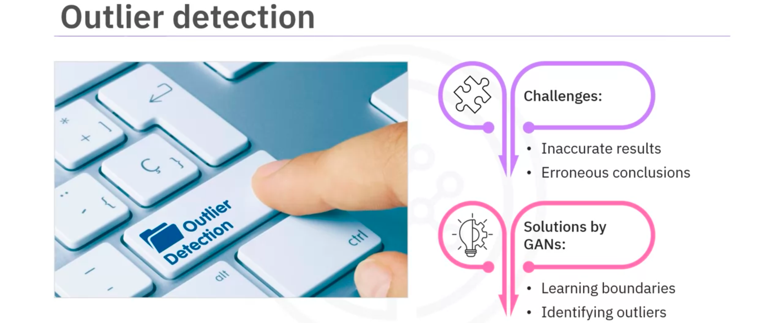
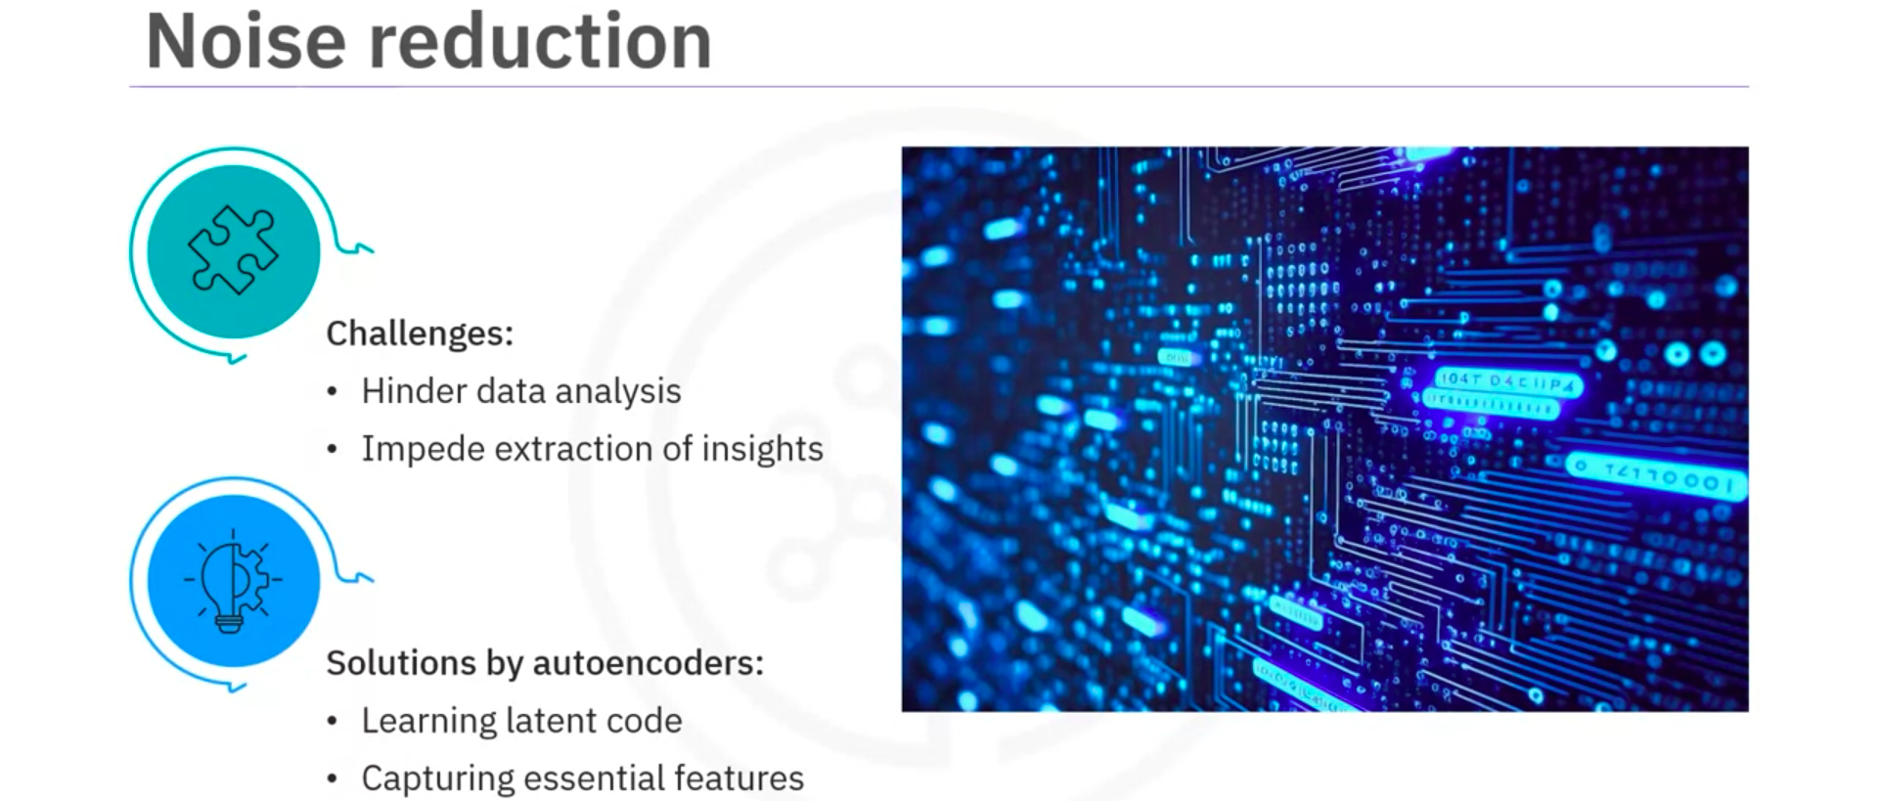
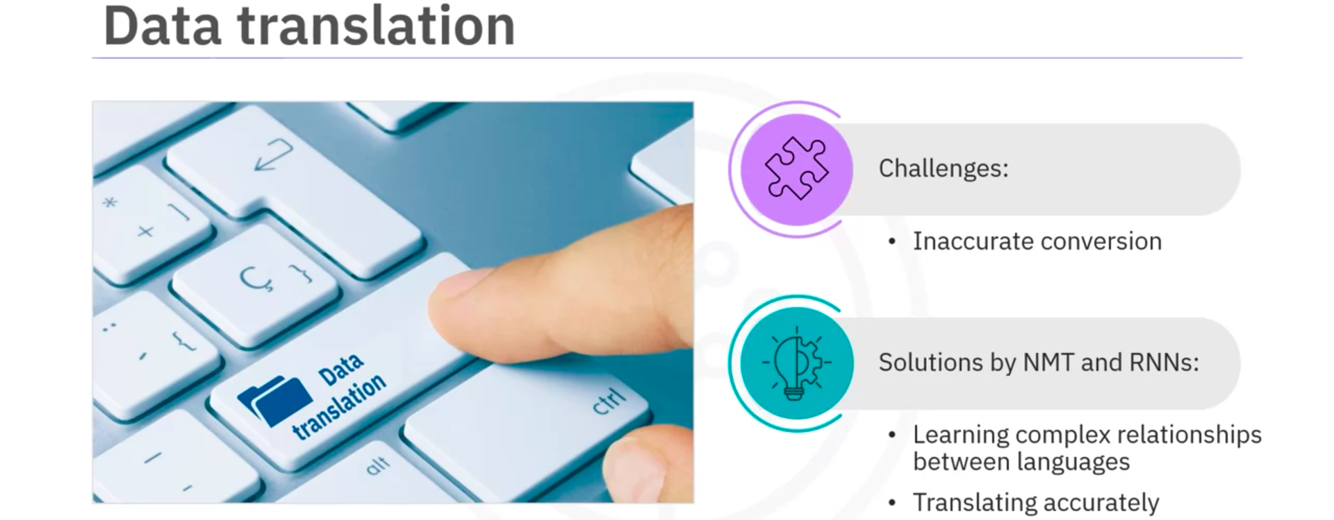
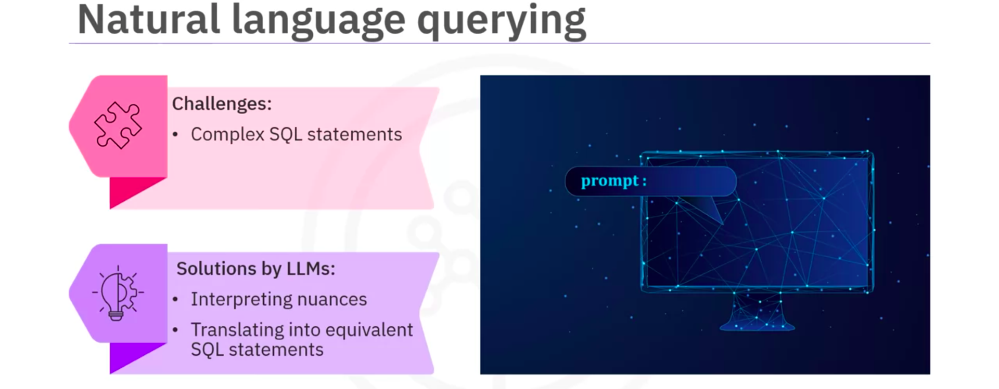
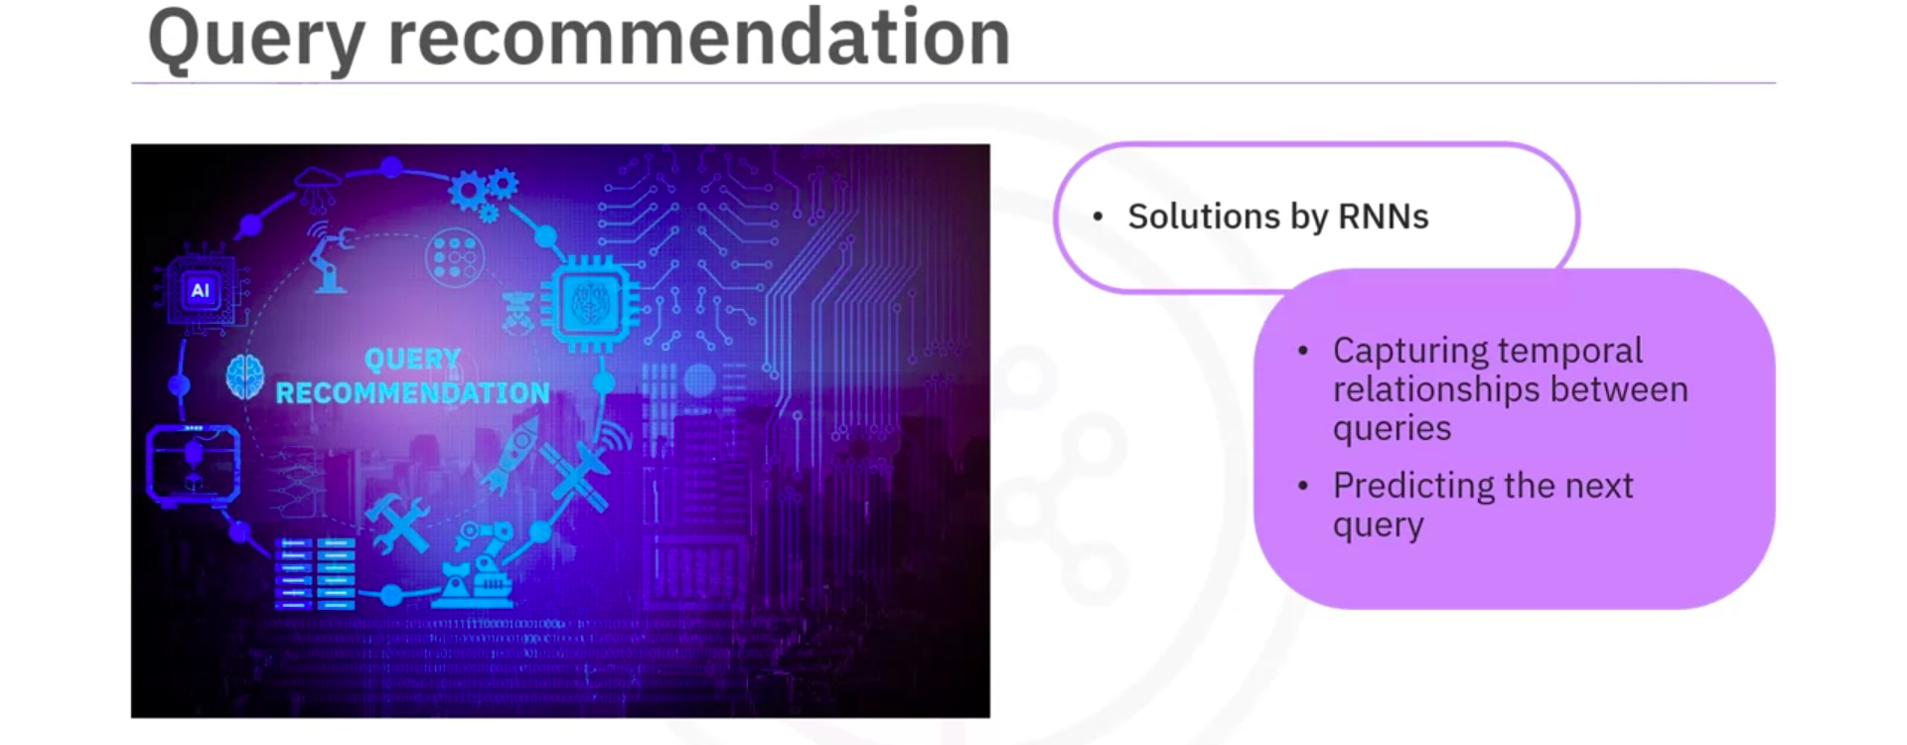
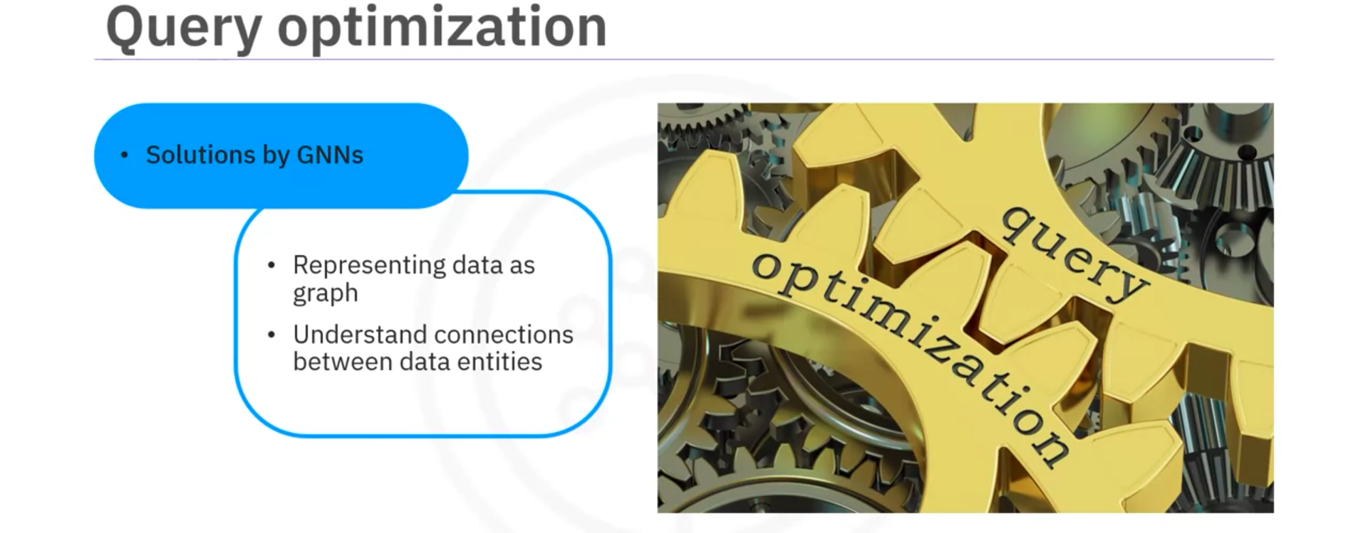

- Demo: Generative AI for Data Preparation (ChatGPT & Tomat)
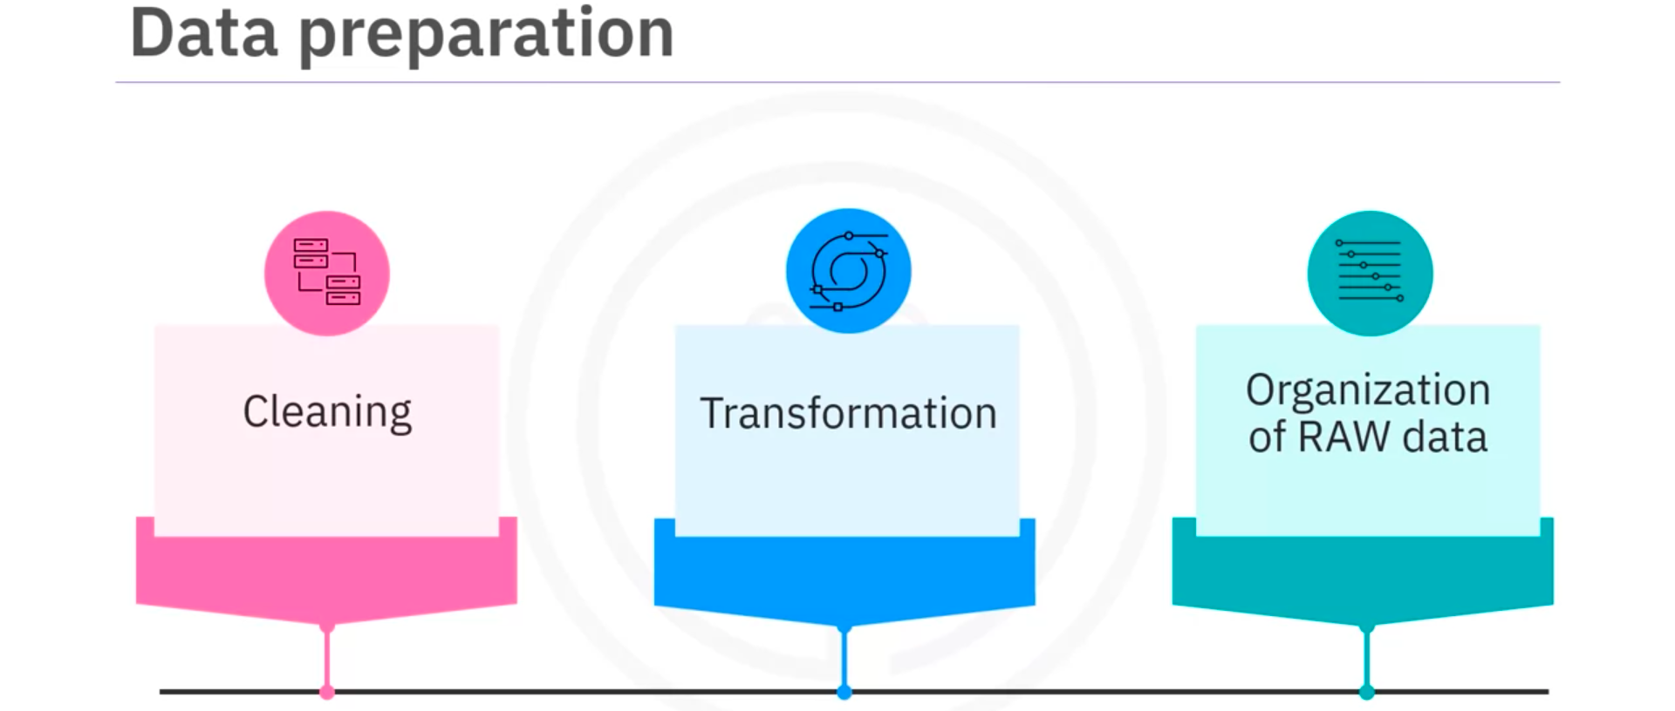

- Demo: Generative AI for Querying Databases (SQLthroughAI)
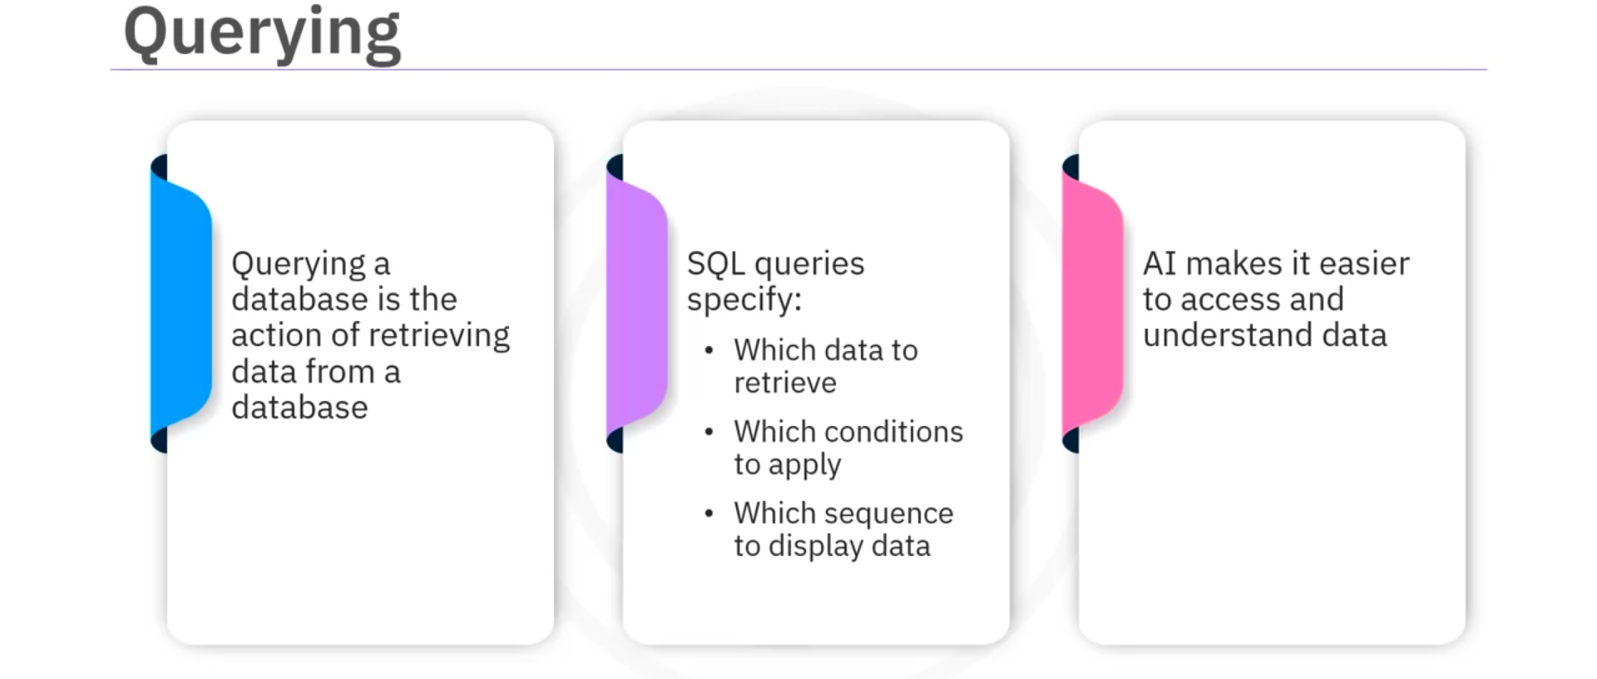
- Cheatsheet: Data Science and Generative AI
Link

