Overview of Data Science Tools
- Course Introduction

Explore Data Science Tools
- Overview of Data Science Tools
  - Categories of tools in Data Science
  - Examples of Open Source and Commercial offerings in each category
  - Pros and cons of tools
- Languages of Data Science
  - Python
  - R
  - Scala
  - Java
  - julia
  - SQL
- Libraries, APIs, Datasets, and Models
- Jupyter Project
  - Jupyter Notebook
  - JupyterLab
  - JupyterLite
  - IBM Watson Studio and Google Colab
  - Anaconda
- Rstudio and Github
  - R
  - Rstudio
  - Github
- Final project – Create Jupyter Notebook
- [Optional] IBM Tools for Data Science
  - IBM Watson Studio
  - IBM Watson Knowledge Catalog
  - IBM Watson Machine Learning

Learning Goal
Link

- Data Science Tools

1. Categories of Data Science Tools

Data Science Task Categories:
- Data Management
  - Collecting, persisting, and retrieving data securely, efficiently, and cost-effectively
  - Data is collected from many sources
- Data Integration and Transformation
  - Extract, Transform, and Load (ETL)
  - Extract the data and save it in a central repository
  - Data transformation is the process of transforming the values, structure and format of the data.
  - Transformed data is loaded back to the warehouse.
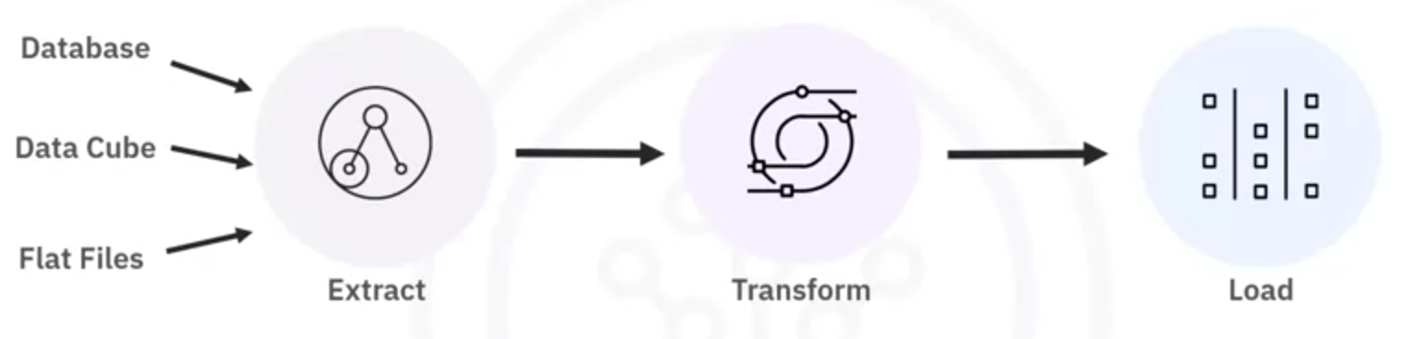
- Data Visualization
  - Graphical representation of data and information
  - In the form of charts, plots, maps and animations
  - Data visualization conveys data more effectively
- Model Building
  - Model building is a step where you train the data and analyze patterns using suitable machine learning algorithms
  - Create Machine Learning models using IBM Watson machine learning
- Model Deployment
  - Integrating a model into a production environment
  - Model development uses APIs to enable data-based decisions
  - Watson Studio
  - IBM AutoAI
  - Watson OpenScale
  - IBM Watson Machine Learning
- Model Monitoring and Assessment
  - Model Monitoring: Tracks developed models (using tools like fiddler)
  - Model Assessment: Checks for accuracy, fairness, and robustness monitoring via Metrics (F1 score, True positive rate, Sum of squared error)
  - IBM Watson Open Scale is a popular Model Monitoring and Assessment tool

And to do those tasks above, you need:
- Data Asset Management
  - Platform for organizing and managing the data
  - Replication, backup, and access right management
- Code Asset Management (Github)
  - is a unified view where you manage an inventory of asset.
  - Developers use versioning to track and manage changes to a software project’s code
  - Collaboration allows diverse people to share and update the same project together.
- Execution Environments
  - An execution environment has libraries for code compiling and system resources to execute and verify code
  - Cloud-based execution environment aren’t tied to specific hardware or software.
  - IBM Watson Studio has tools for data preprocessing, model training, and deployment
- Development Environments
  - Integrated development environments (IDEs) provide a workspace and tools to work on source code (Develop, Implement, Execute, Test, Deploy)
  - IBM Watson Studio
- Fully-Integrated visual tools
  - Covers all tooling components
  - Watson Studio
  - IBM Cognos Dashboard Embedded

2. Open Source Tools for Data Science – Part 1
- Data management
  - MySQL
  - PostgreSQL
  - NoSQL Databases:
    - MongoDB
    - CouchDB
    - cassandra
  - File-based tools:
    - Hadoop file system (HDFS)
    - Cloud file system: ceph
  - elasticsearch
- Data integration and transformation
  - for ETL or ELT
  - Also termed Data Refinery and Cleansing
  - Tools:
    - Apache Airflow
    - Kubeflow
    - Apache kafka
    - Apache nifi
    - Apache Spark SQL
    - Node-RED
- Data Visualization
  - Supported by programming libraries where you need to use code
  - Contain a user inferface
  - Tools:
    - PixieDust
    - Hue
    - kibana
    - Apache Superset
- Model deployment
  - PredictionIO
  - Seldon
  - mleap
  - TensorFlow Serving
  - TensorFlow Lite
  - TensorFlow.JS
- Model monitoring and assessment
  - Tools to keep track of machine learning model’s prediction performance to maintain outdated models
  - ModelDB: A system to manage ML models
  - Prometheus
  - IBM AI Fairness 360 Open Source Toolkit
  - IBM Adversarial Robustness 360 Toolbox
  - IBM AI Explainability 360
- Code asset management
  - Tools for code asset management, also known as version management or version control
  - Git
  - Github
  - Gitlab
  - Bitbucket
- Data asset management
  - Tools for data asset management, also known as data governance or data lineage
  - ApacheAtlas
  - ODPi EGERIA
  - kylo
3. Open Source Tools for Data Science – Part 2

Development Environment
- Jupyter Notebook
  - Supports more than a hundred different programming languages through “kernels”
  - Encapsulates the execution environment for the different programming languages
- Jupyter Lab
  - Jupyter with a lot more modern feature, will replace Jupyter Notebook in the future
- Apache Zeppelin:
  - Similar to Jupyter Lab, with integrated plotting capabilities, doesn’t require coding
- R Studio:
  - Exclusively runs R and associated libraries
  - Enables Python development
  - Provides optimal user experience when tightly integrated in the tool
- Spyder:
  - Similar to R studio, but in python. Jupyter is used more

Execution Environment
- Apache Spark
  - Provides cluster execution environment (for data that doesn’t fit into a single computer)
  - Provides linear scalability: more the number of servers in a cluster more the performance
  - Batch Processing engine
  - Capable of processing huge amounts of data one by one or file by file
  - Choice for most use cases
- Apache Flink
  - Stream processing image
  - Capable of processing real-time data streams
- RiseLab Ray
  - Enables large scale deep learning model training

Fully Integrated Visual Tools (Programming-free Open-Source tools)
- Data Integration and Transformation
- Data Visualization
- Model Building
- Tools:
  - KNIME
    - Drag-and-drop capabilities
    - Built-in visualization capabilities
    - Can be extended by programming in R and Python
    - Has connectors to Apache Spark
  - orange
    - Less flexible than KNIME, but easier to use

4. Open source tool board (Important)
Link
5. Commercial Tools for Data Science

Data management
- ORACLE DATABASE
- Microsoft SQL Server
- IBM DB2
- Commercial supports delivered by
  - Software vendors
  - Influential partners
  - Support networks
Data integration and transformation
- ETL tools:
  - Informatica
  - IBM InfoSphere DataStage
  - talend
  - IBM Watson Studio Desktop
Data visualization
- Tableau
- Power BI
- IBM Cognos Analytics
- IBM Watson Studio Desktop
Model building
- SPSS
- SAS
- IBM Watson Studio Desktop

Model deployment
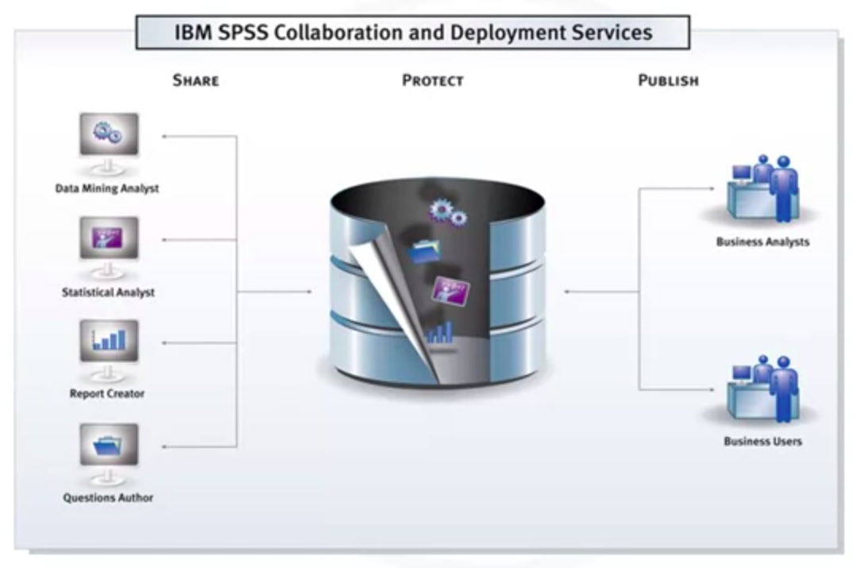
Model monitoring and code asset management

- Open source:
  - Model monitoring:
  - Code asset management
Data asset management
- Functions include:
  - Data governance
  - Data versioned and annotated
  - Data dictionary
  - Data lineage
  - Data privacy and retention
- Tools:
  - Informatica
  - IBM InfoSphere Information Governance Catalog
Development environment
- Watson Studio Desktop
  - Fully integrated development environment for data scientists
  - Combine Jupyter Notebooks with graphical tools
Fully integrated visual tools
- Watson Studio
- Watson Open Scale
- H2O.ai
6. Cloud Based Tools for Data Science

Fully integrated visual tools and platforms
Large-scale execution of data science workflows happens in compute clusters:
- Composed of multiple server machines
- Watson Studio and Watson OpenScale, cover the complete development life cycle for all data science, machine learnin, and AI tasks
- Microsoft Azure Machine Learning: Fully cloud-hosted offering supports the complete development life cycle of all data science, machine learning, and AI tasks.
- H2O driverless AI:
  - A product that you download and install
  - One-click deployment for the common cloud service providers
  - Cloud provider does not do operations and maintenance
Data management
Comprises software as a service (SaaS) versions of existing open source and commercial tools
- AWS Amazon DynamoDB
- Cloudant
- CouchDB
- IBM DB2
Data integration and transformation
- Comprises ETL and ELT tools
- Transformation steps are pushed toward the domain of the data scientist or data engineer
- Tools:
  - Informatica
  - IBM Data Refinery
    - is a part of IBM Watson Studio
    - Allows transforming large amounts of raw data into consumable, quality information in a spreadsheet
Data visualization
- Datameer
- IBM Cognos Analytics
- IBM Data Refinery
Model building
- IBM Watson Machine Learning
- Google Cloud: AI platform training
Model deployment
- Tightly integrated into the model-building process
- Commercial software can export models in an open format, such as PMML
- Tools:
  - IBM SPSS Collaboration and Development Services
  - IBM Watson Machine Learning

Model monitoring and assessment
A cloud tool to monitor deployed machine learning and deep learning models continuously
- Amazon SageMaker Model Monitor
- Watson OpenScale

