Packages, APIs, Datasets and Models

- Libraries for Data Science
A collection of functions and methods that allow you to perform many actions without writing the code
Python libraries:
- Scientific Computing Libraries in Python
  - Libraries contain built-in modules providing different functionalities
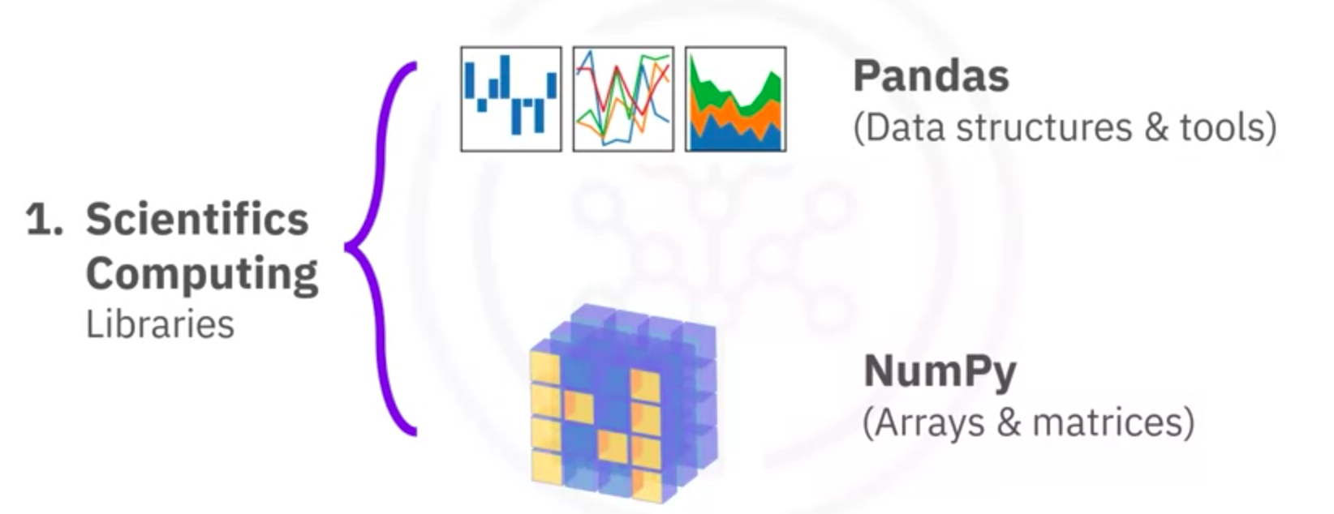
- Visualization Libraries in Python
  - Use data visualization libraries to communicate with others and display meaningful results of an analysis
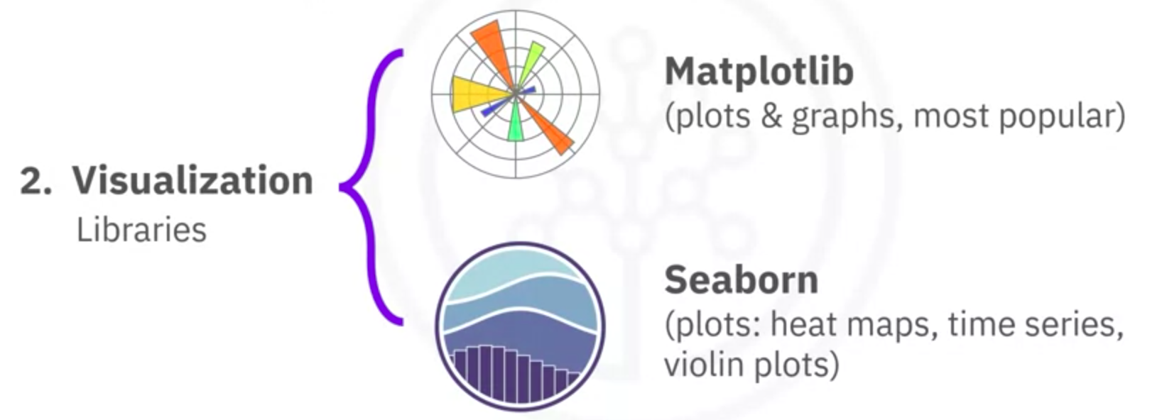

- High-Level Machine Learning and Deep Learning
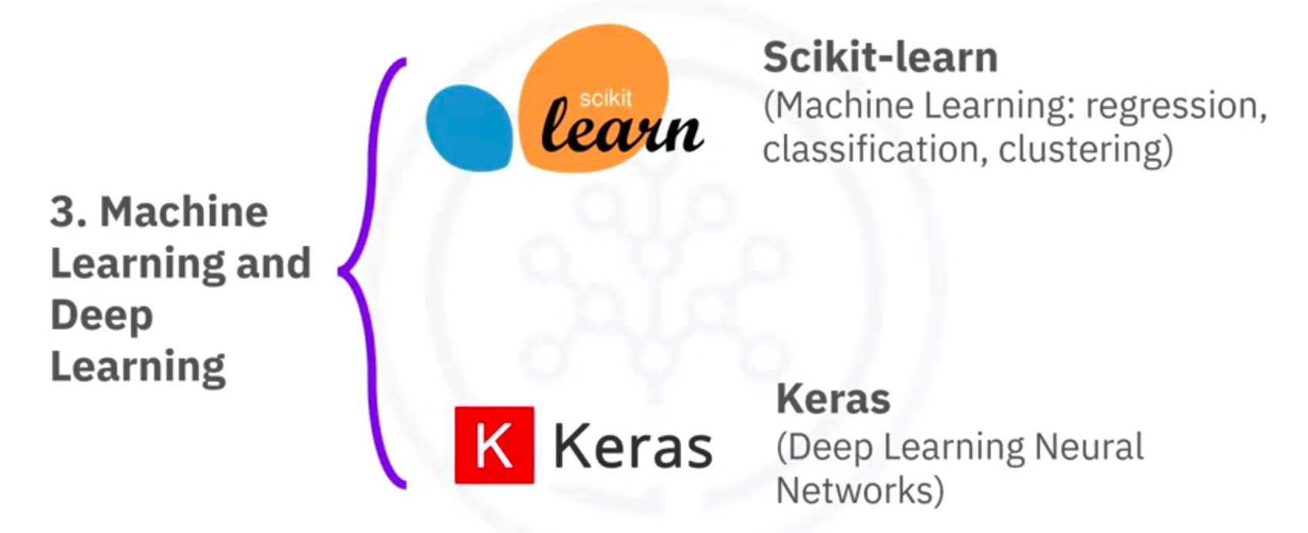
- Deep Learning Libraries in Python
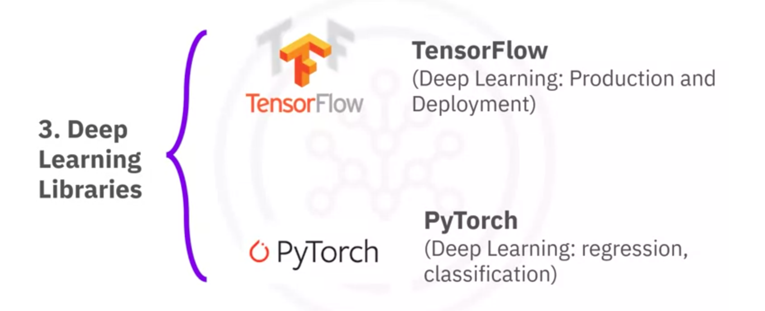
- Apache Spark
  - Similar functionalities to Pandas, NumPy, Scikit-learn
  - Apache Spark data processing jobs can be in:
    - Python
    - R
    - Scala
    - SQL
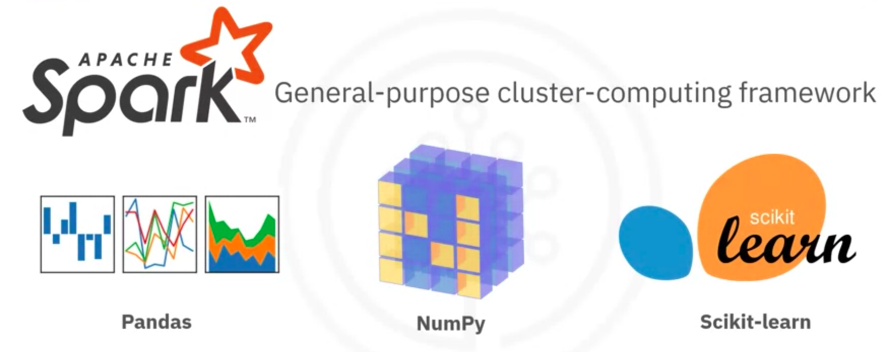

- Libraries used in other languages
  - Scala libraries:
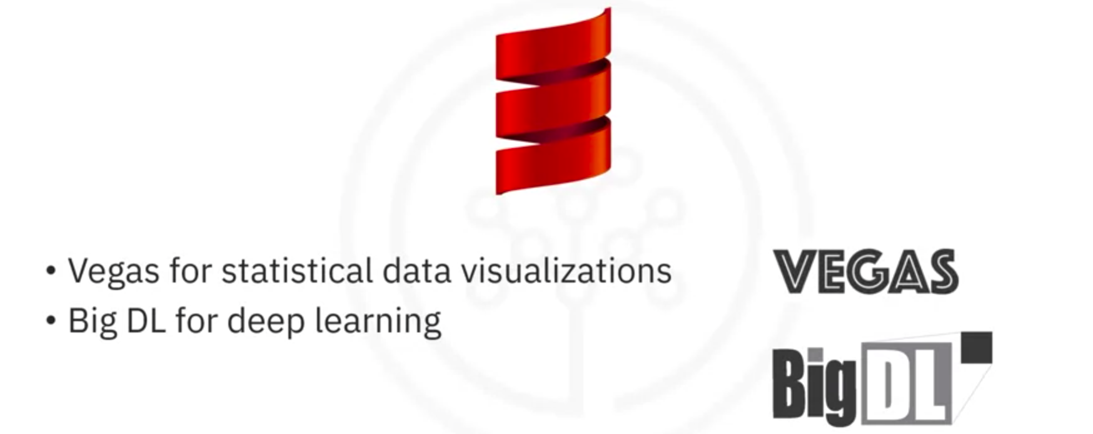
  - R libraries:
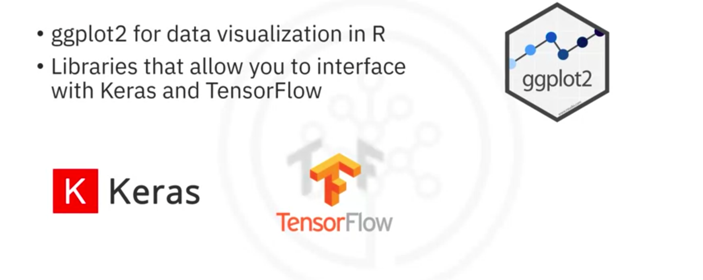

- Application Programming Interfaces (APIs)

What is an API?
Application Programming Interface allows communication between two pieces of software
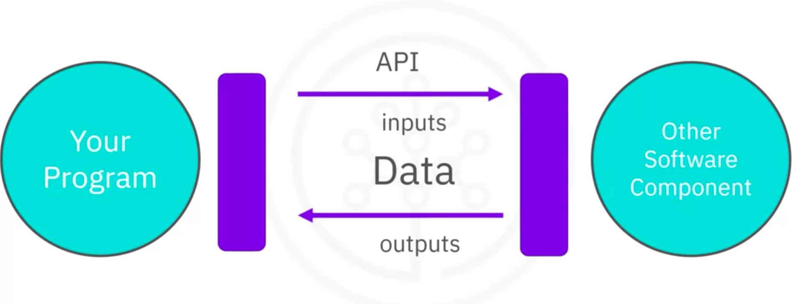
API library
Pandas library in Python:
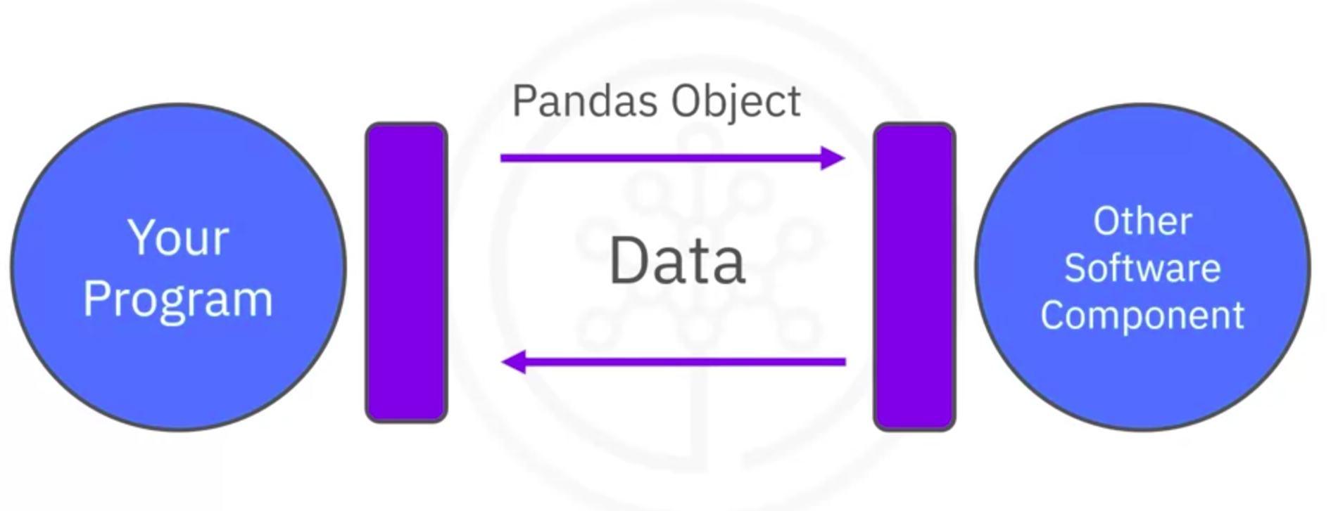
Other languages API:
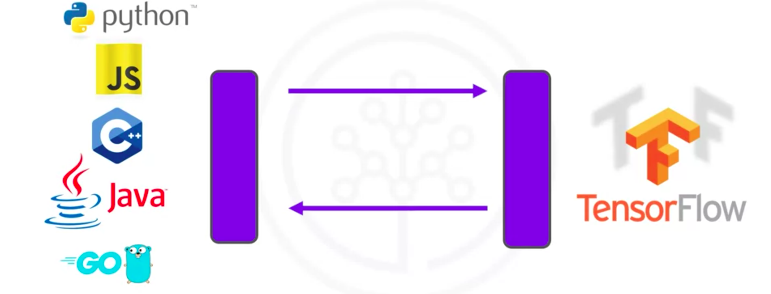

More languages API:
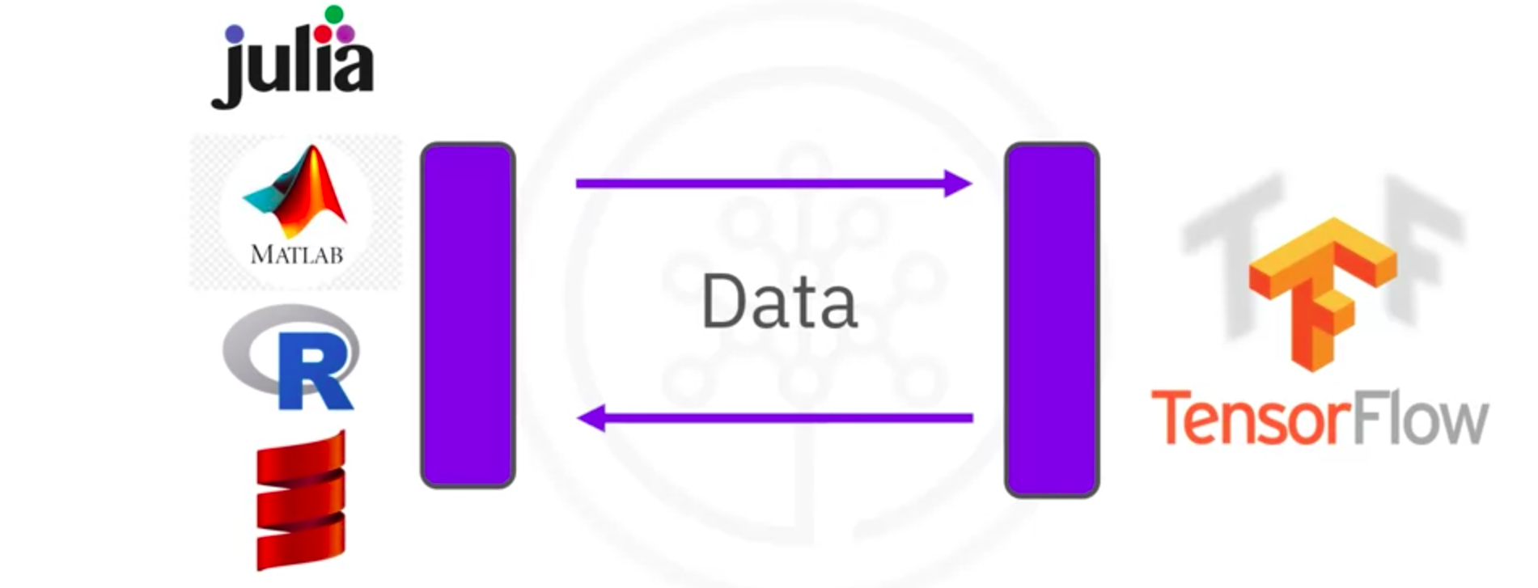
REST API
Representational State Transfer APIs
- Allow you to communicate through the internet
- Enable you to use resources like storage, data, and artificial intelligent algorithms
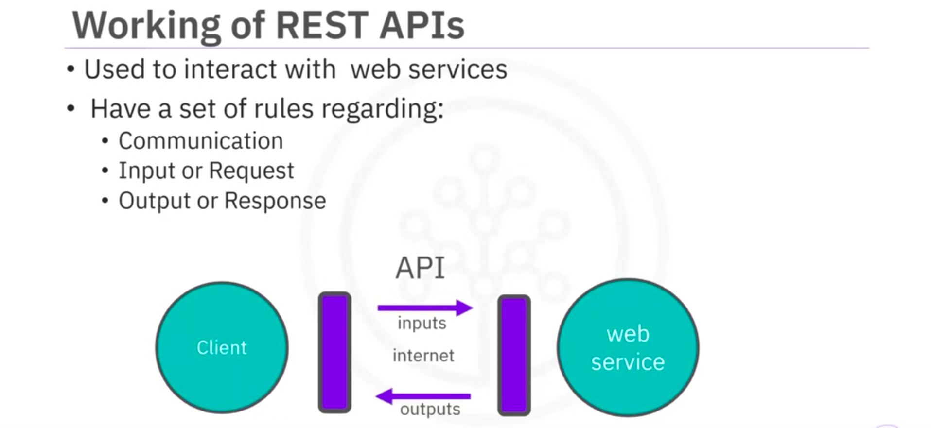

- Data Sets – Powering Data Science
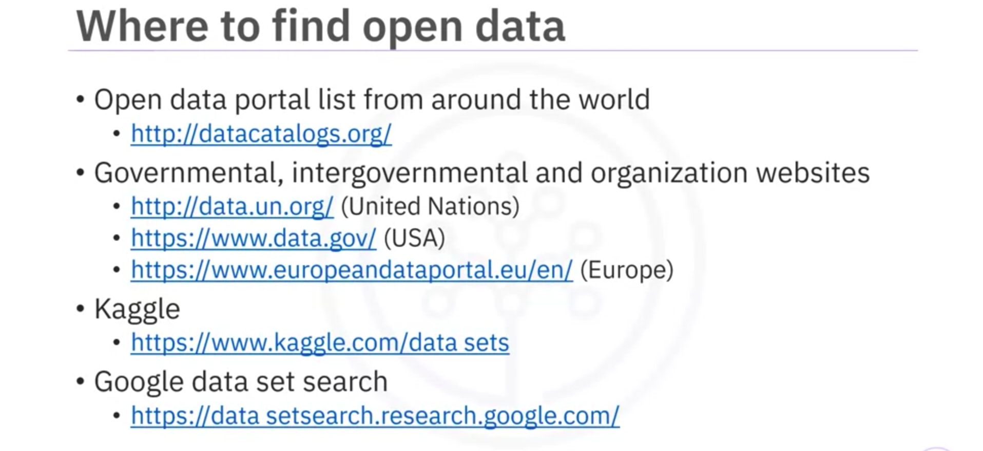
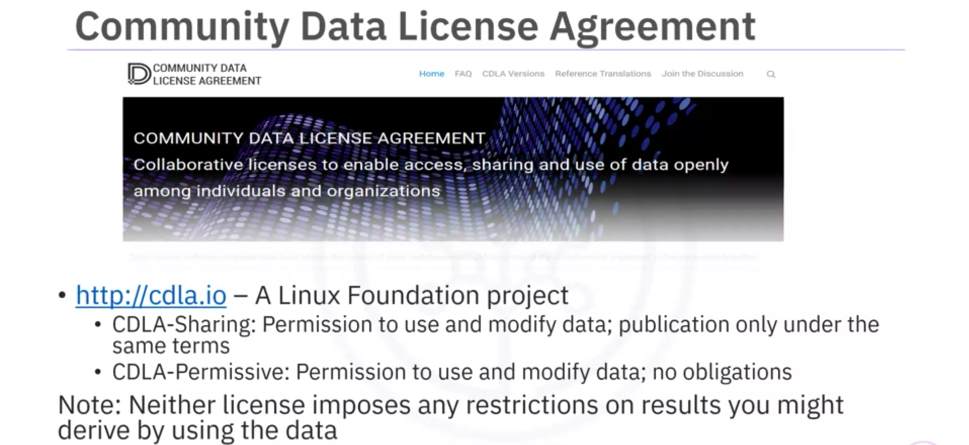

- Additional Sources of Datasets (Find data here)
Link

- Sharing Enterprise Data – Data Asset eXchange
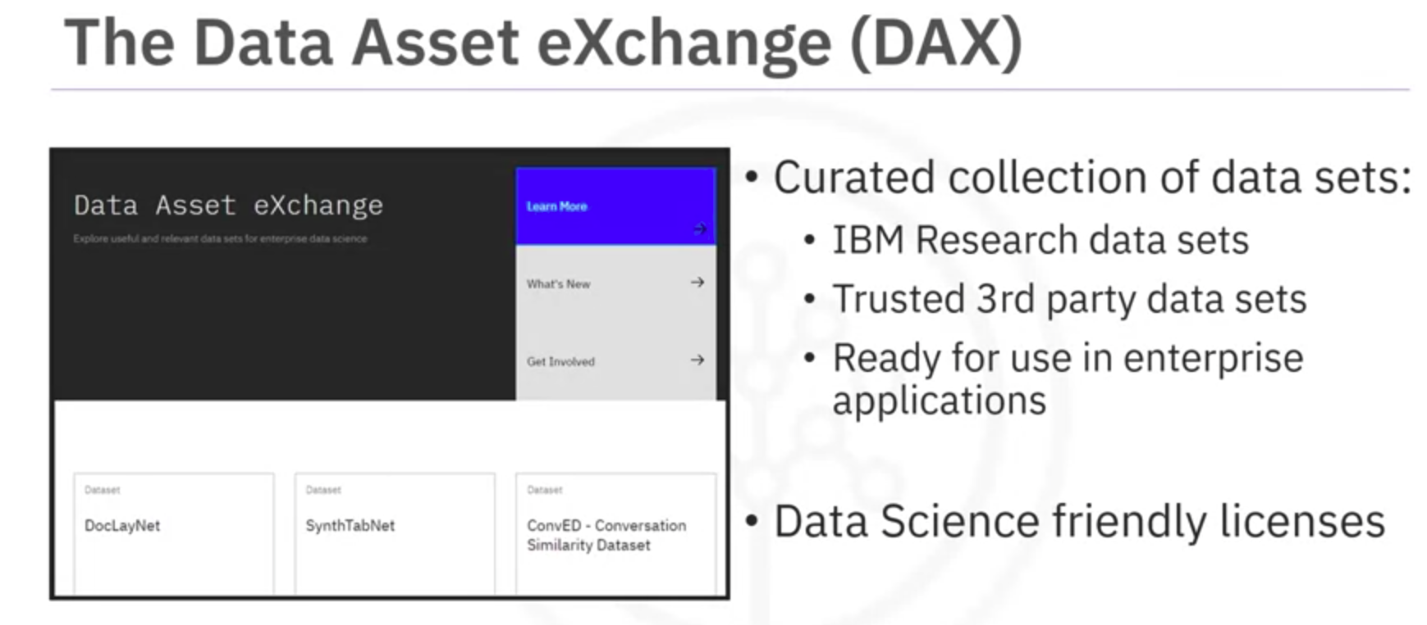
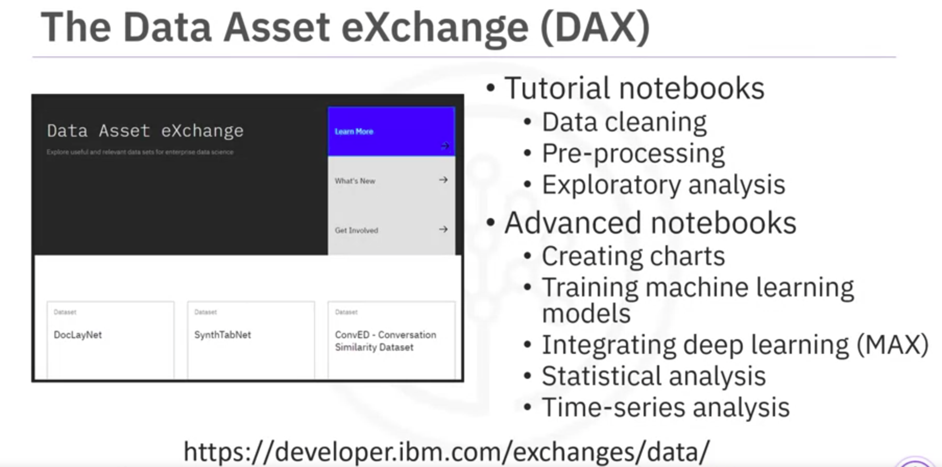
Full guide: Link

- Machine Learning Models – Learning from Models to Make Predictions
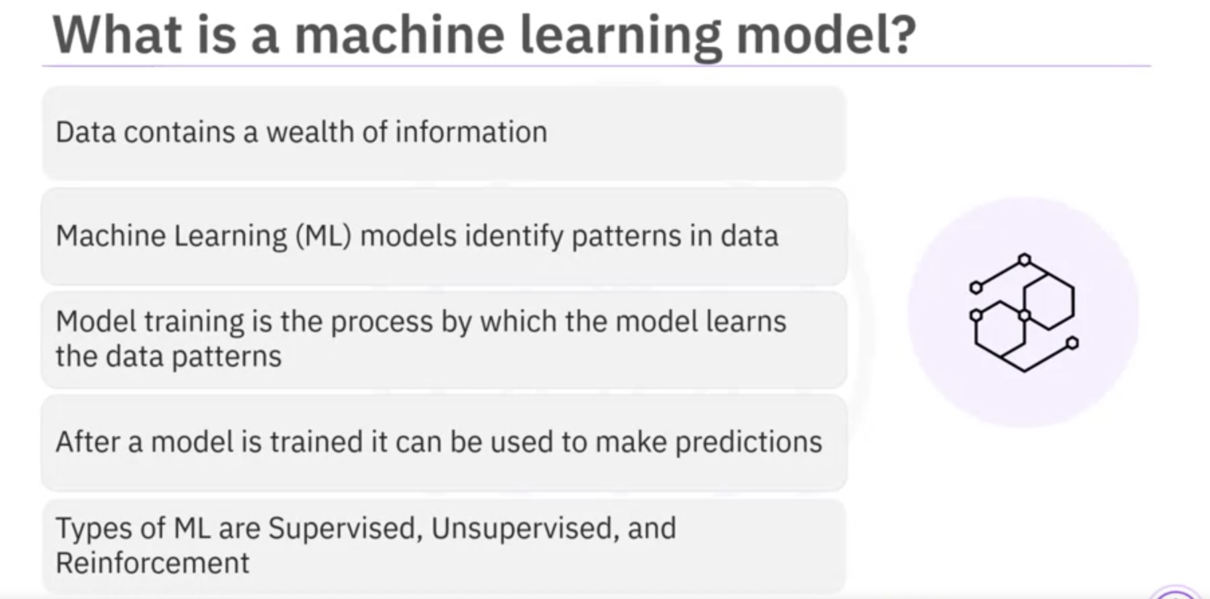
Supervised Learning
The Supervised Learning model identifies relationships and dependencies between the input data and the correct output.
- Regression: To predict real numerical values
  - Examples: home sales prices, stock market prices
- Classification: To classify data into categories
  - Examples: email spam filters, fraud detection, image classification
Unsupervised Learning
- Data is not labeled
- Models tries to identify patterns without external help
  - Clustering divides each records of a dataset into one of similar group
  - Anomaly detection identifies outliers in a dataset
Reinforcement Learning
- Conceptually similar to human learning processes
- Examples: Mouse and maze, robot learning to walk, chess, Go, and other board games of skill
Deep Learning
- Tries to loosely emulate show the human brain works
- Applications:
  - Natural Language Processing
  - Image, audio, and video analysis
  - Time series forecasting
- Requires large datasets of labeled data and is compute intensive
- Requires special purpose hardware
Deep Learning Models
- Build from scratch or download from public model repositories
- Built using frameworks, such as
  - TensorFlow
  - PyTorch
  - Keras
- Provide Python API and support C++ and JavaScript
- Popular model repositories
  - Most frameworks provides a “model zoo”
  - TensorFlow, PyTorch, Keras, and ONNX model zoos

VII. The model Asset eXchange
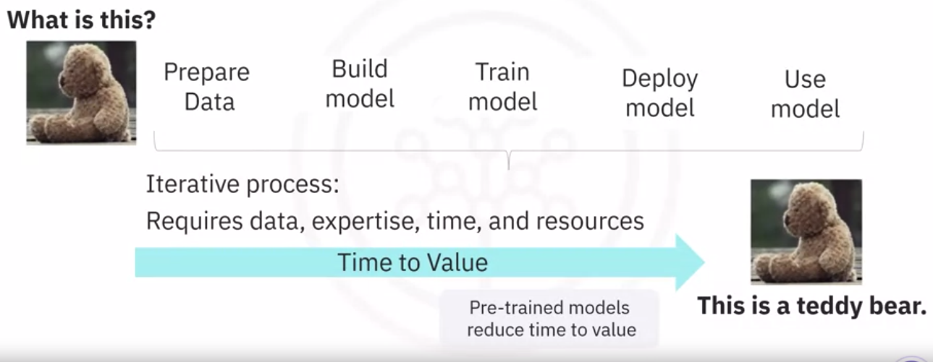
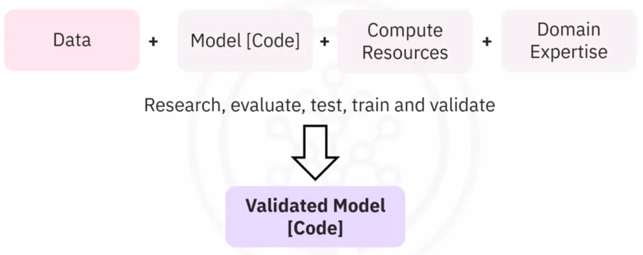
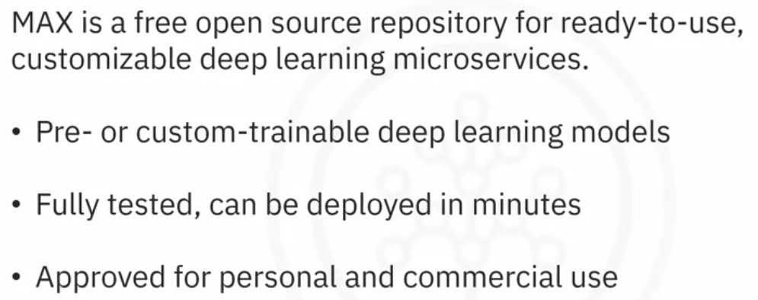
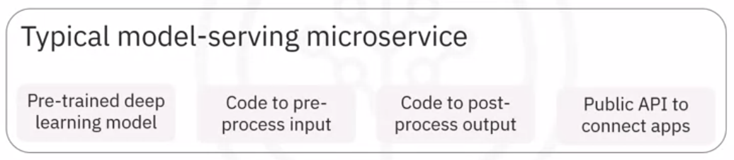
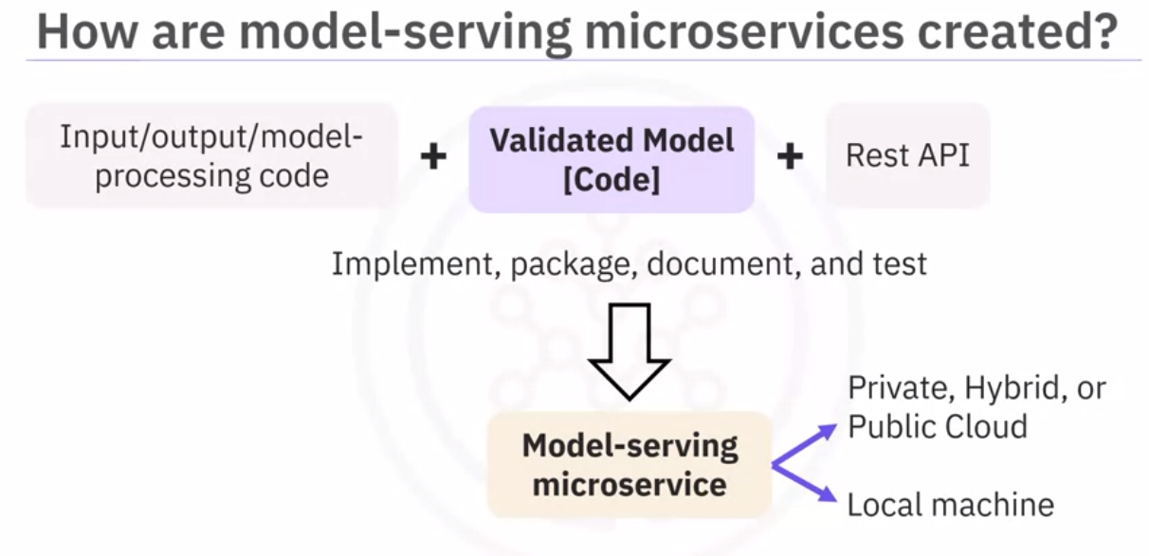
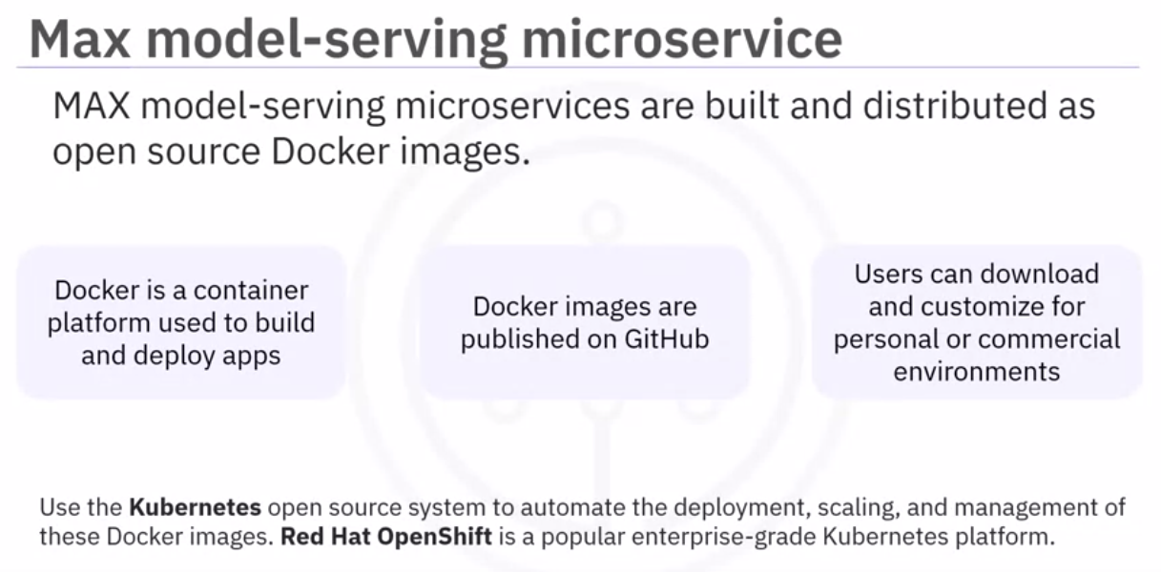
Guided video: Link

