DATA SCIENCE METHODOLOGY

From Problem to Approach and From Requirements to Collection
Problem to Approach
- Data Science Methodology Overview
Addressing data science challenges
- Data Science combines statistics, technology, and domain expertise to extract insights from vast data.
- Challenges:
  - Resolve the problem of Misunderstanding of the business questions
  - Not knowing how to apply the data to resolve the business problem correctly
- Adopting a methodology can help address this issues
What is a Methodology?
- A system of methods
- A guideline for decision-making during the scientific process
- Data Science Methodology guides data scientists in solving complex problems with data
Applying data science methodology
- Perform data collection
- Creation of measurements strategies
- Comparisons of data analysis methods
Addressing data science challenges
- Applying practical guidance
- Avoid the mistakes that can happen by jumping to solutions before the analysis

Data Science Methodology by John Rollins
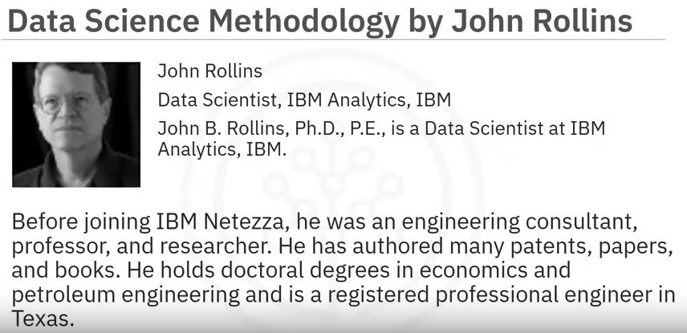

Data Methodology Stages
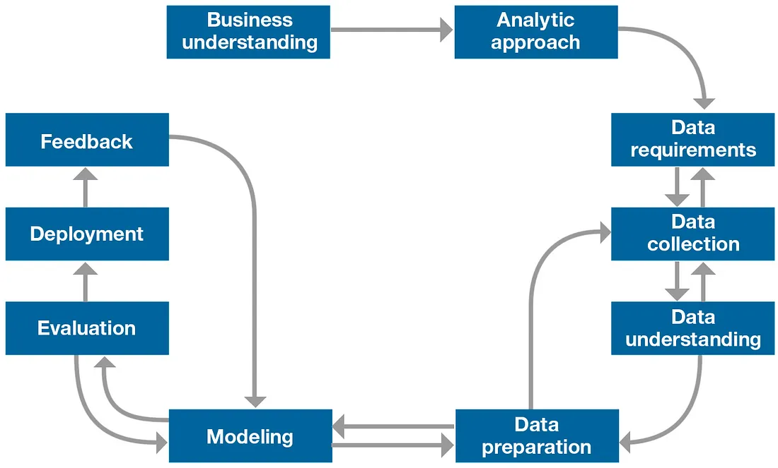
- Business understanding: Define the issue. What is the problem that you are trying to solve?
- Analytic approach: Determine your approach. How can you use data to answer business question?
- Data requirements: What data do you need to answer the question?
- Data collection: Where is the data sourced from, and how will you receive the data?
- Data understanding: Does the data you collected represent the problem to be solved?
- Data preparation: What additional work is required to manipulate and work with the data?
- Modeling: When you apply data visualizations, do you see answers that address the business problem?
- Evaluation: Does the data model answer the initial business question, or must you adjust the data?
- Deployment: Can you put the model into practice?
- Feedback: Can you get constructive feedback from the data and the stakeholder to answer the business question?

- Business Understanding
What is the problem that you are trying to solve?
- Seeking clarification: What’s the goal?
- Supporting the goal with objectives
- Getting stakeholder buy-in and support
Case study: Applying the concepts
What is the best way to allocate the limited healthcare budget to maximize its use in providing quality care?
- Define the GOALS: To provide quality care without increasing costs
- Define the OBJECTIVES: To review the process to identify inefficiencies
- Examine “patient readmissions” as an effective area for review.
Result: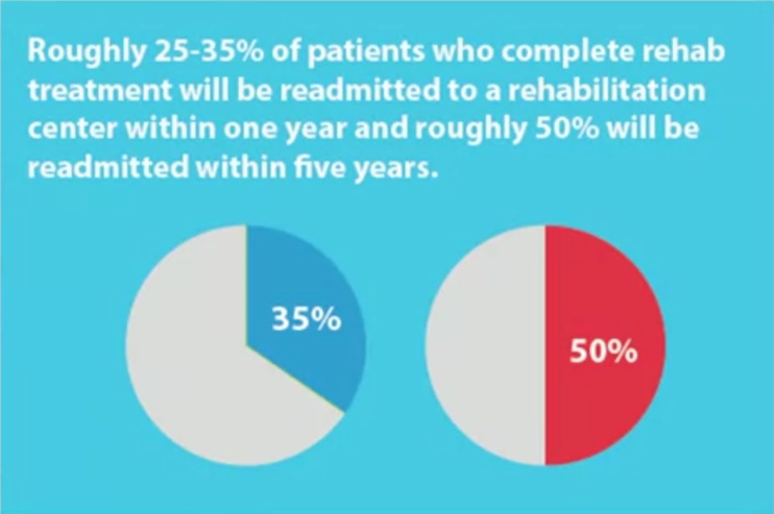
- Patients with congestive heart failure were at the top of the readmission list
- A decision-tree model could be applied to review this scenario, to determine why this is occurring.

- Analytic Approach
How can you use data to answer the question?
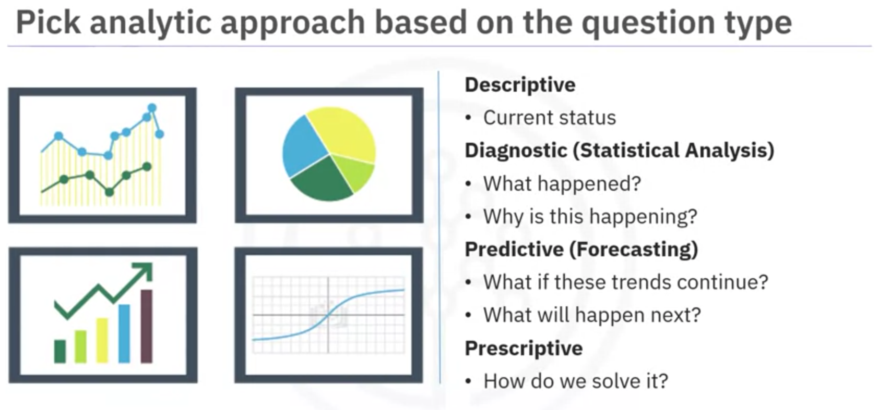
The correct approach depends on business requirements for the model
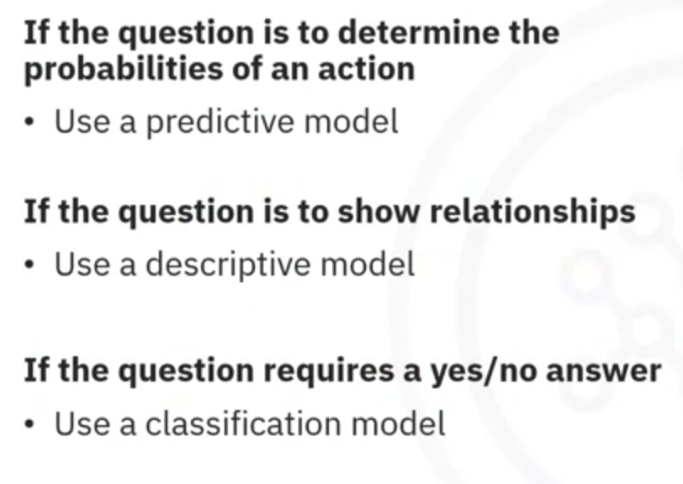
Case Study Link
IV. Business Understanding: Asking Questions
Link
V. Analytical Approach: Identifying the Pattern to Address the Question
Link
VI. Summary
Link
VII. Glossary
Link

From Requirements to Collection
- Data Requirements
Data Requirements: Cooking with data. Identify which data is required, how to source and collect them, how to understand and work with them, and how to prepare the data to meet the desired outcome.
Building the understanding of the problem at hand, and then using the analytical approach selected, the Data Scientist is ready to get started.
- Data Collection
In this phase the data requirements are revised and decisions are made as to whether or not the collection requires more or less data. Once the data ingredients are collected, then in the data collection stage, the data scientist will have a good understanding of what they will be working with.
Techniques such as descriptive statistics and visualization can be applied to data set, to access the content, quality, and initial insights about the data. Gaps in the data will be identified and plans to either fill or make substitutions will have to be made.
- From Requirements to Collection
- Summary
Link
- Glossary
Link

From Understanding to Preparation and From Modeling to Evaluation
From Understanding to Preparation
- Data Understanding
Data Understanding encompasses all activities related to constructing the data set.
Is the data that you collected representative of the problem to be solved?
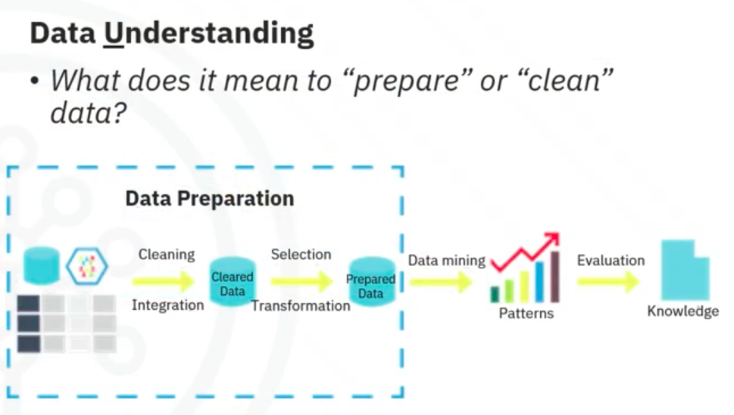

Descriptive Statistics
In order to understand the data, Descriptive Statistics needed to be run against the data columns that would become variables in the model
- Univariate statistic: mean, median, minimum, maximum, and standard deviation.
- Pairwise correlations: to see how closely certain variables were related. And which one, if any, were very highly correlated, meaning that they would be essentially redundant. Thus making only one relevant for modeling
- Histogram: Histograms are a good way to understand how values or a variable are distributed, and which sort of data preparation may be needed to make the variable more useful in a model. For example, for a categorical variable that has too many distinct values to be informative in a model, the histogram would help them decide how to consolidate those values.

Data Quality
- Missing values
- Invalid or misleading values
The univariates, statistics, and histograms are also used to assess data quality. From the information provided, certain values can be re-coded or dropped, such as when a variable has missing values.
Does “missing” mean anything? It can be either “no”, or “0”, or “we don’t know”. If a variable contains invalid or misleading values, such as a numeric variable called “age” that contains 0 to 100 and also 999 (means “missing”).
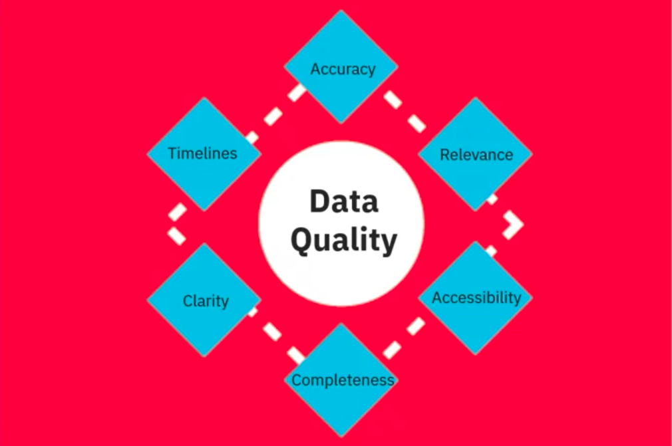

- Data Preparation – Concepts
Cleansing data
Data preparation is the most time-consuming phase of a data science project, typically taking 70-90% of the overall project time.
Automating some of the data collection and preparation processes in the database, can reduce this time to 50%. Time savings translates to increased time for data scientists to focus on creating models.
To work effectively with the data, it must be prepared in a way that addresses:
- Missing Data
- Invalid Values
- Remove Duplicates
- Formatting
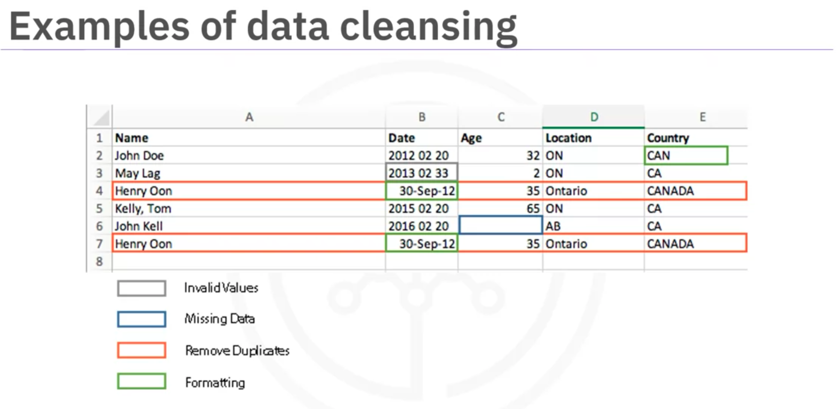

Transforming data
Transforming data in the data preparation phase is the process of getting the data into a state where it maybe easier to work with.
Data preparation: What are the ways in which data is prepared?
Feature Engineering:
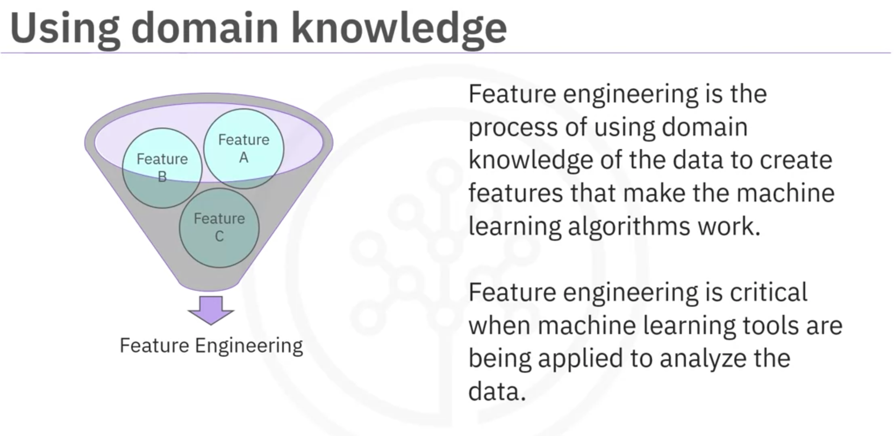

- Data Preparation – Case Study

- Hands-on Lab: From Understanding to Preparation
- Summary
Link

- Glossary
Link

From Modeling to Evaluation
Modeling: In what way can the data be visualized to get to the answer that is required?
Evaluation: Does the model used really answer the initial question or does it need to be adjusted?
- Modeling Concepts
Data Modeling focuses on developing models that are either descriptive or predictive.
- Descriptive model examples:
  - If a person did this, then they’re likely to prefer that
  - Tries to yield yes/no or stop/go type outcomes.
  - These models are based on the analytic approach that was taken, either statistically driven or machine learning driven.
- Predictive model:
  - A training set will be used for predictive modeling
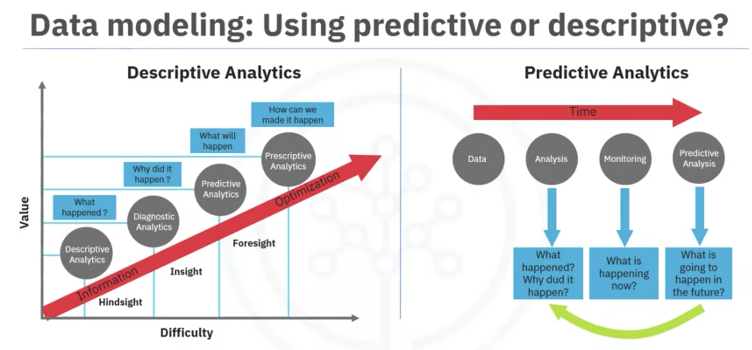

The success of data compilation, preparation, and modeling depends on:
- Understanding the question at hand
- Selecting an analytical approach or method to solve the problem
- Obtain, understand, prepare, and model the data.
- Modeling – Case Study
- Analyzing the first model
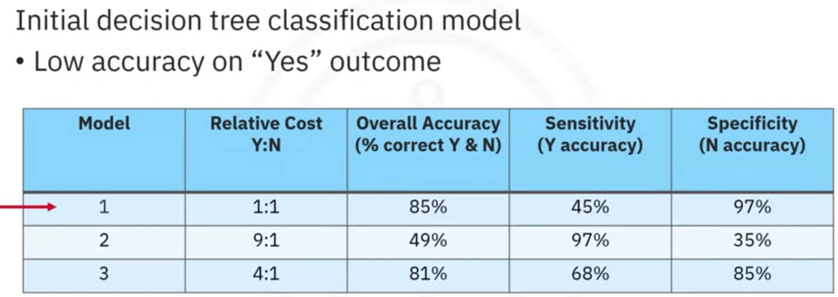
- Evaluation
A model evaluation goes hand-in-hand with model building as such, the modeling and evaluation stages are done iteratively. Model evaluation is performed during model development and before the model is deployed. Evaluation allows the quality of the model to be assessed but it’s also an opportunity to see if it meets the initial request.
Does the model used really answer the initial question or does it need to be adjusted?

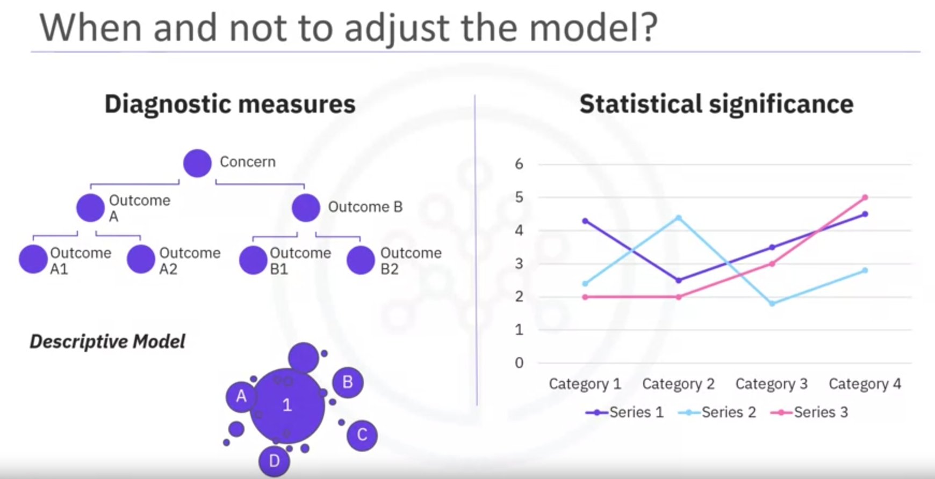
Model evaluation can have two main phases:
- Diagnostic measures
  - Is used to ensure the model is working as intended.
  - If the model is a predictive model, a decision tree can be used to evaluate if the answer the model can output, is aligned to the initial design. It can be used to see where there are areas that require adjustments.
  - If the model is a descriptive model, one in which relationships are being assessed, then a testing set with known outcomes can be applied, and the model can be refined as needed.
- Statistical significance
  - To ensure that the data is properly handled and interpreted within the model.
  - To avoid unnecessary second guessing when the answer is revealed.
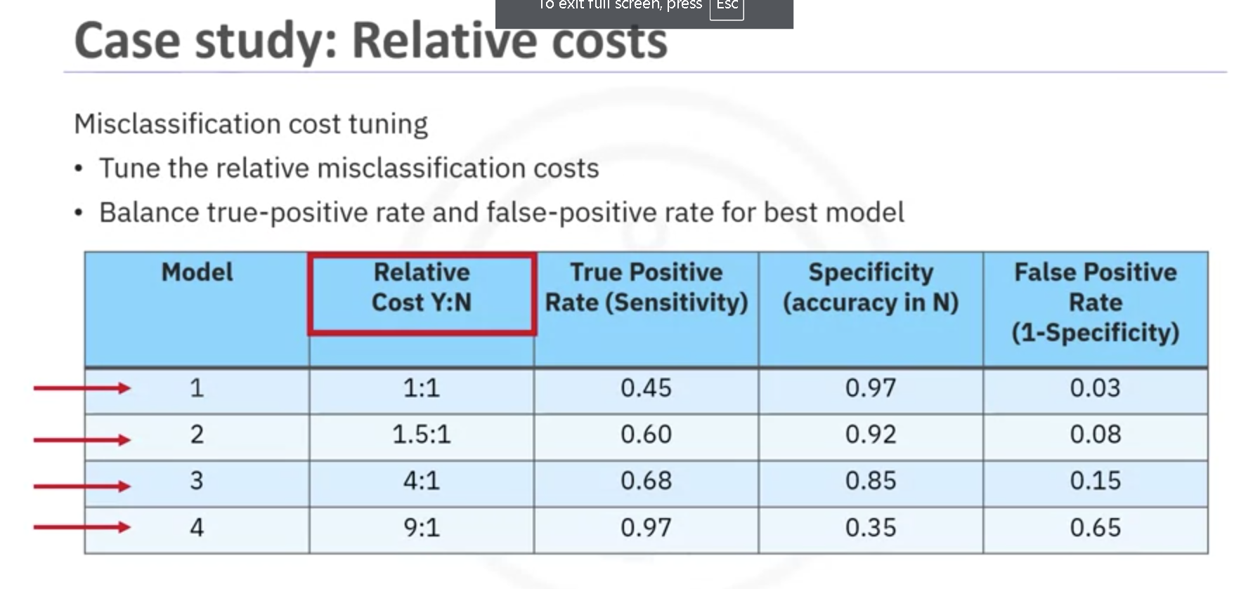

- Hands-on Lab: From Modeling to Evaluation
- Summary
Link
- Glossary
Link

From Deployment to Feedback
- Deployment
While a data science model will provide an answer, the key to making the answer relevant and useful to address the initial question, involves getting the stakeholders familiar with the tool produced.
In a business scenario, stakeholders have different specialties that will help make this happen, such as solution owner, marketing, application developers, and IT administration.
Once the model is evaluated and the data scientist is confident it will work, it is deployed and put to the ultimate test. Depending on the purpose of the model, it may be rolled out to a limited group of users or in a test environment, to build up confidence in applying the outcome for use across the board.
- Feedback
Once in play, feedback from the users will help to refine the model and assess it for performance and impact. The value of the model will be dependent on successfully incorporating feedback and making adjustments for as long as the solution is required.
- Storytelling
- Storytelling with data is a critical skill for Data Analysts
- It’s important to tell a clear, concise, and compelling story to convince people to take action
- Develop a story for your data set to understand your data better
- Find the balance between telling a simple story and conveying the complexities of the data.
- It doesn’t matter what information you have if you can’t communicate it effectively to your audience
- The best way to communicate your information is through visuals and telling a story.
- Storytelling is an essential skill set-the last mile in delivery
- The ability to extract value from data to tell a compelling story with data is critical

- Summary
From problem to approach
- Thinking like a data scientist
  - Forming a concrete business or research problem
  - Collecting and analyzing data
  - Building a model
  - Understanding the feedback after model deployment
- Learned the importance of:
  - Understanding the question
  - Picking the most effective analytic approach.
To working with the data
- Learned to work with data
  - Determining the data requirements
  - Collecting the appropriate data
  - Understanding the data
  - Preparing the data for modeling
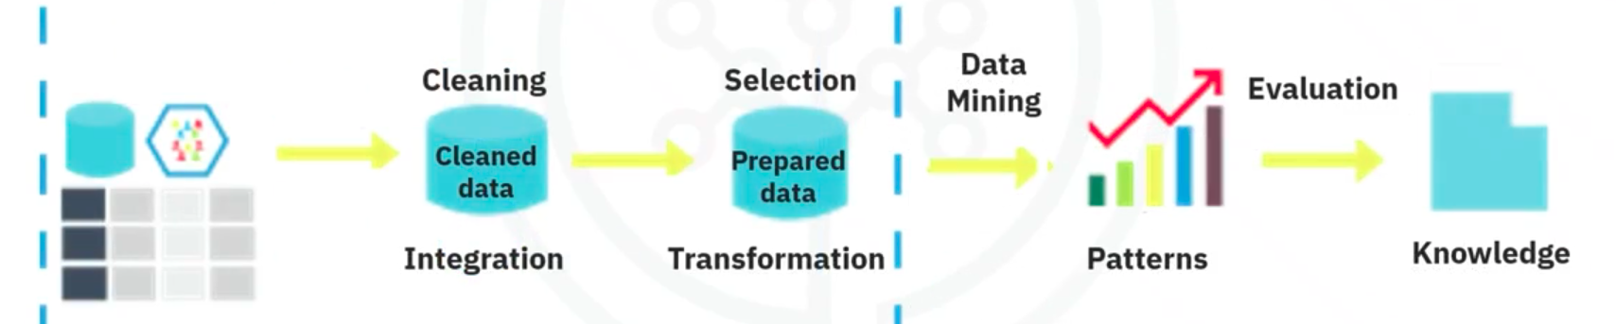

To delivering the answer
- Once the analytic approach is selected, learn how to derive the answer:
  - Evaluating the deploying the model
  - Getting feedback on it
  - Using that feedback constructively so as to improve the model
- Remember that the stages of this methodology are iterative
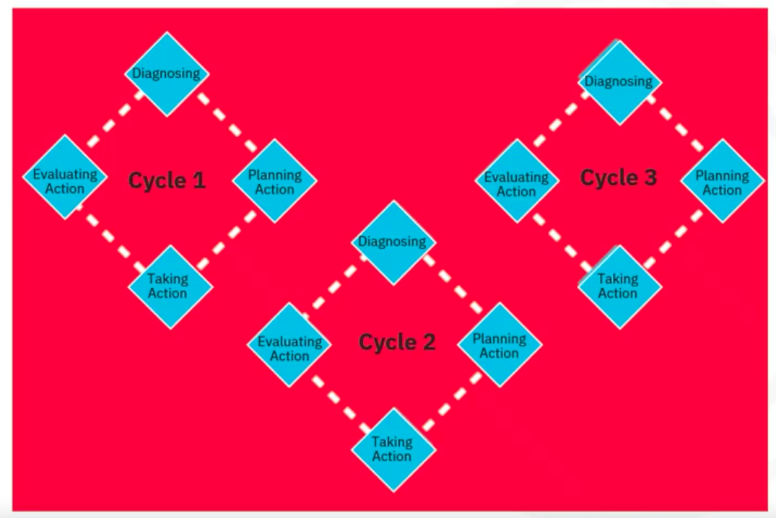
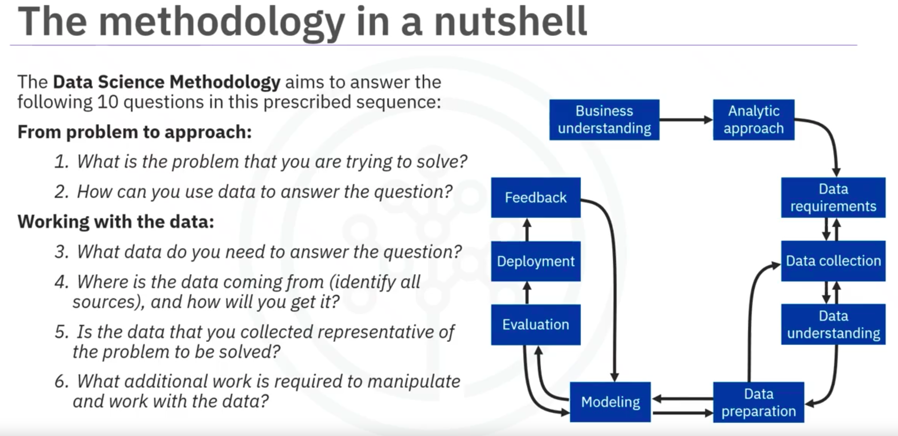
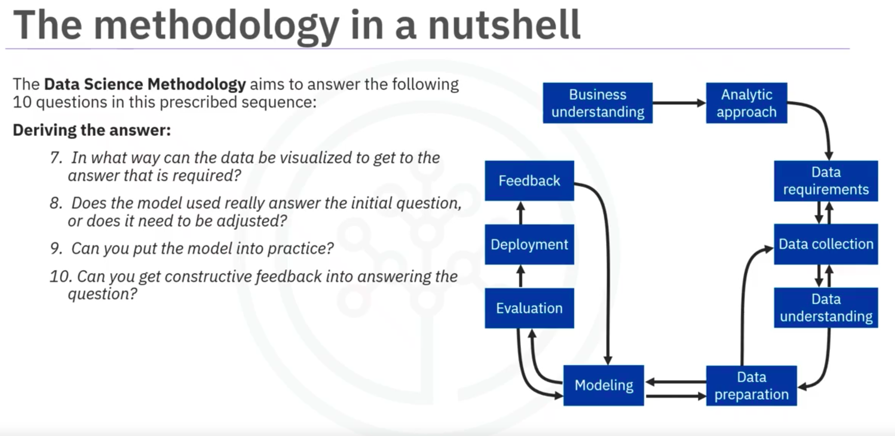

- Glossary
Link

CRISP-DM
CRISP-DM: Cross-Industry Standard Process for Data Mining.


