Python for Data Science, AI & Development
Python Basics
Self-taught
Pandas
- Pandas: Loading Data

Importing Pandas:
CSV:
import pandas as pd
csv_path=”file1.csv”
df=pd.read_csv(csv_path)
XLSX:
import pandas as pd
xlsx_path=”file1.xlsx”
df=pd.read_excel(xlsx_path)
Dataframes:
df.head()
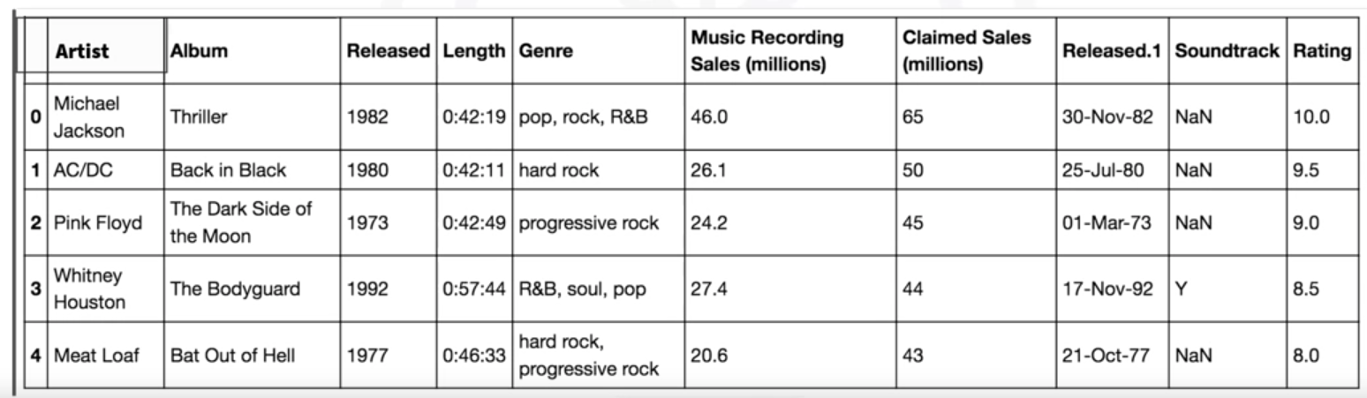
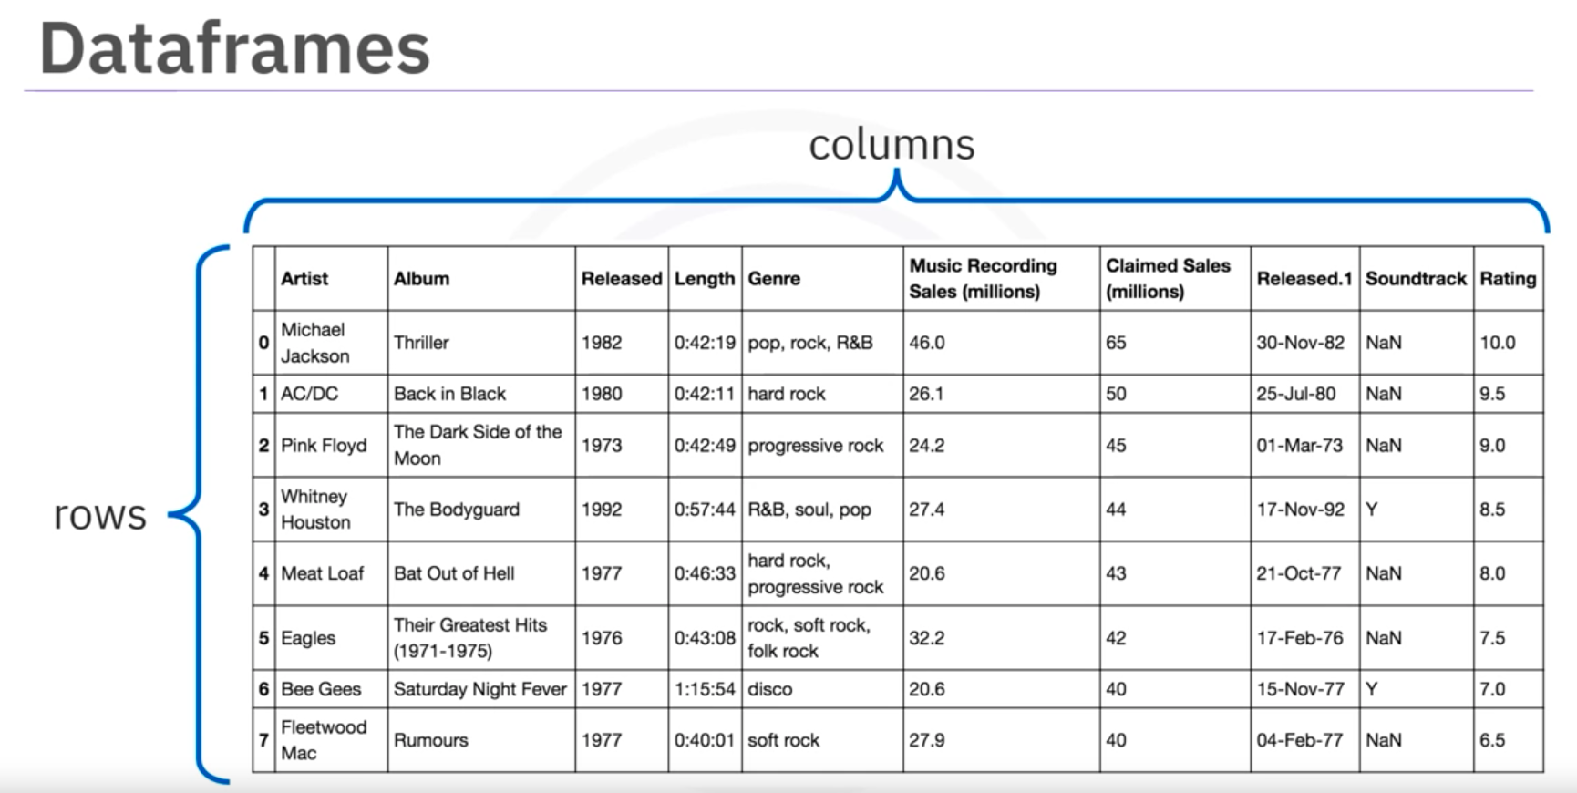

Dataframes from dictionary:
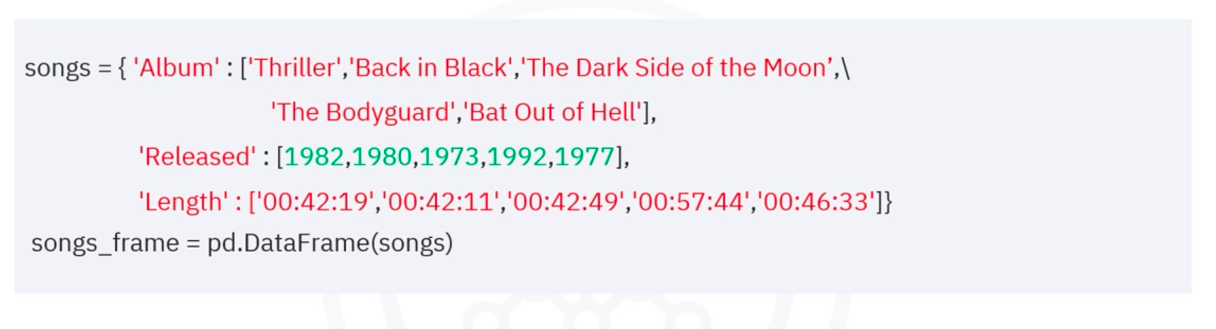
song_frame.head()
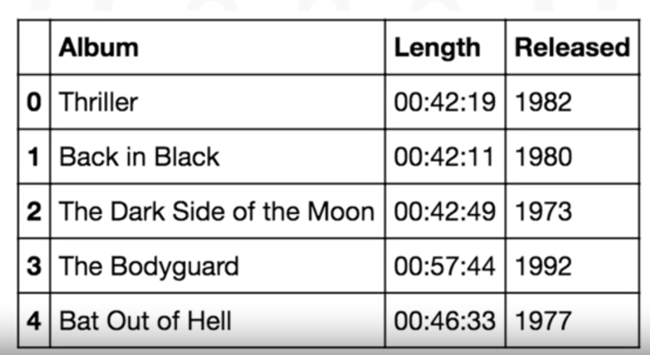

Using Dataframes
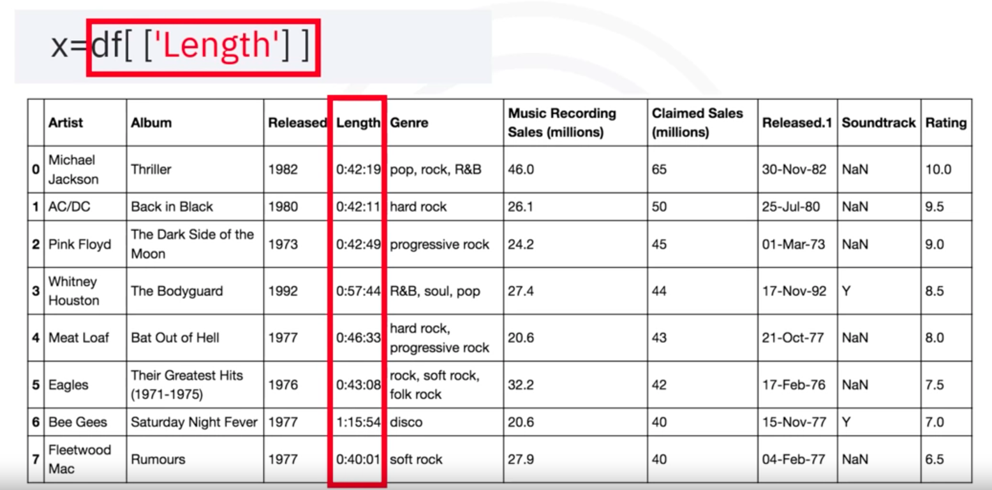
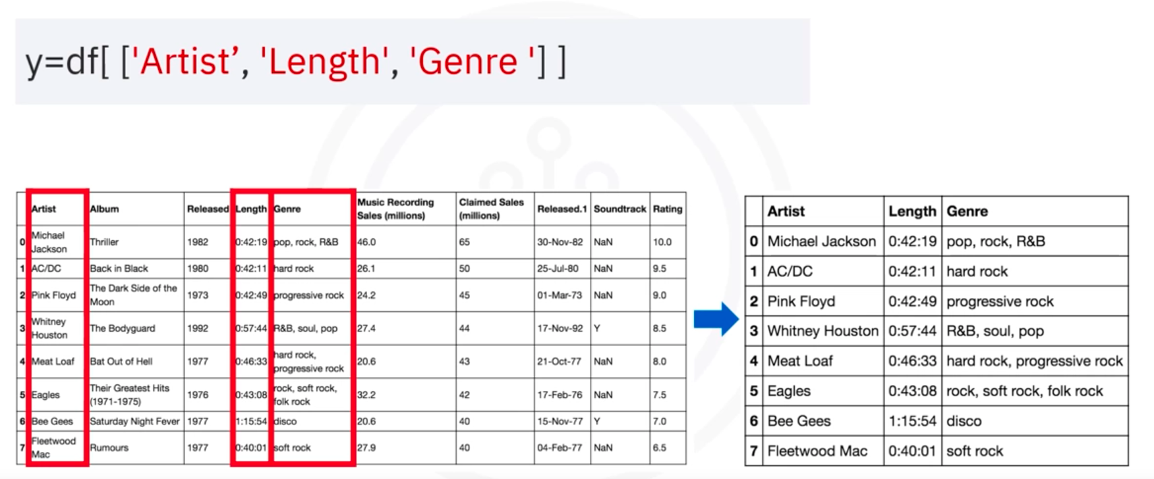
x and y are new dataframes consist of the original columns

Indexing in Pandas
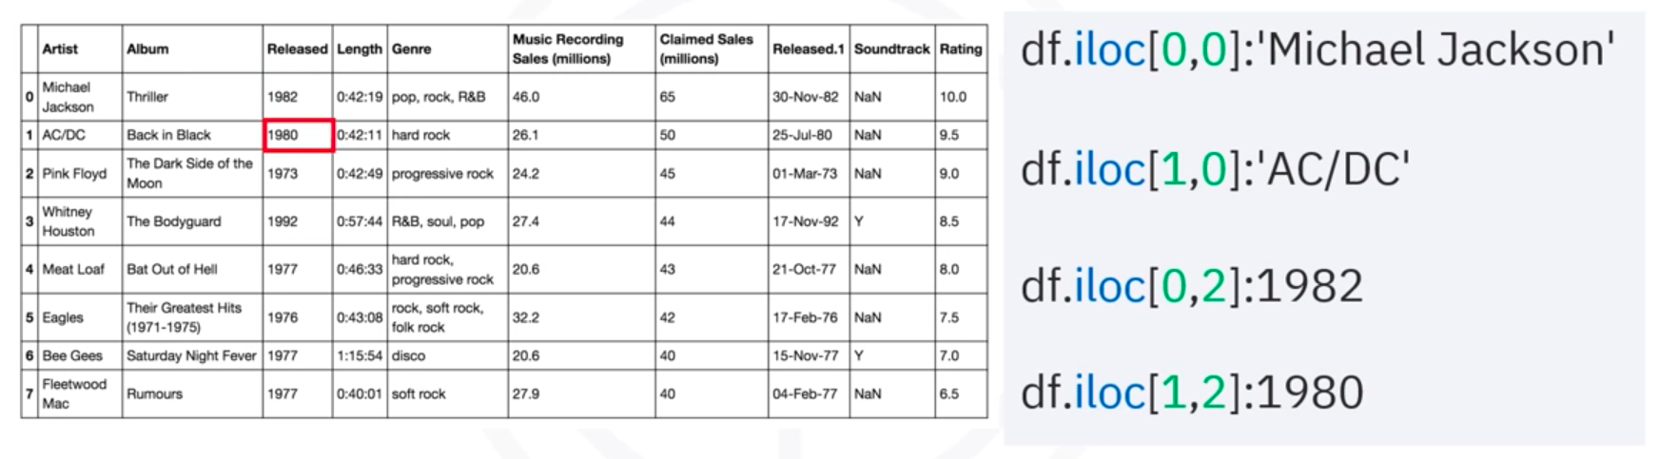
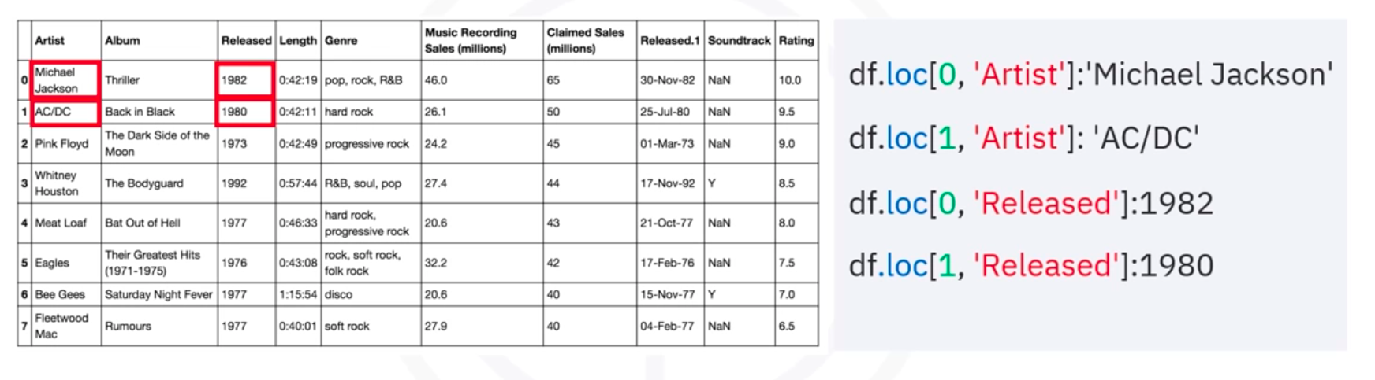
Assign character to indexes
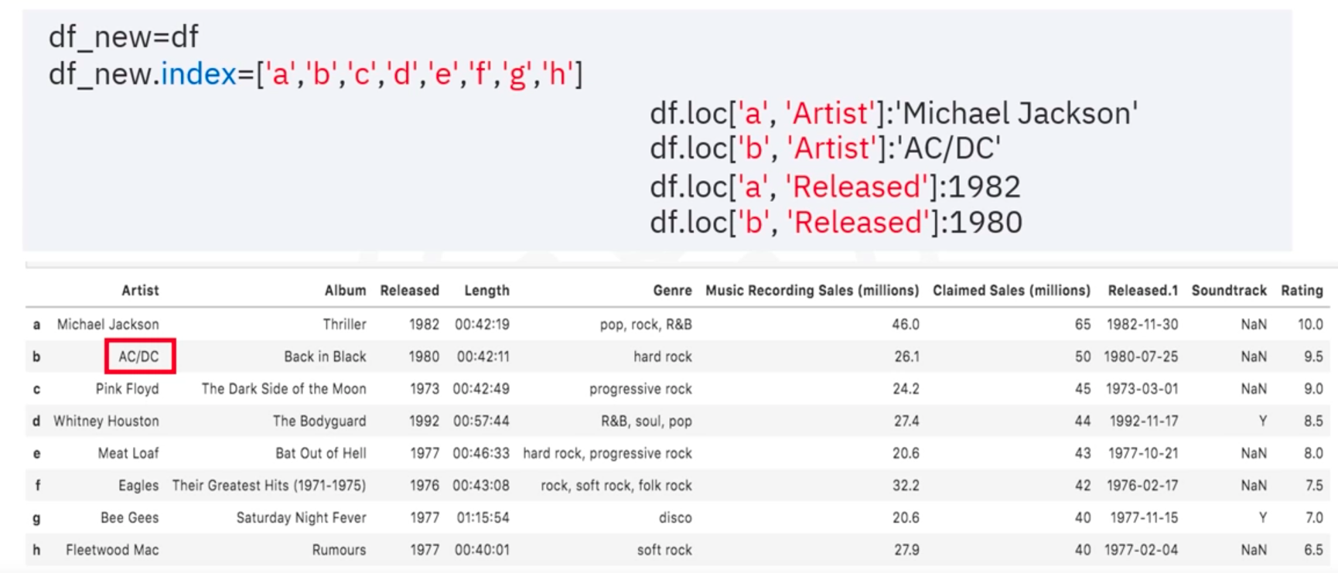
Slicing Dataframe into new Dataframes
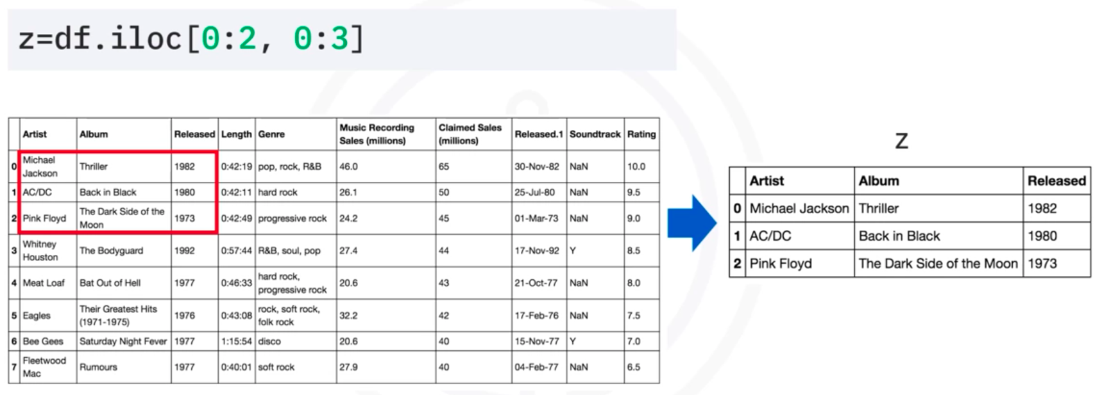
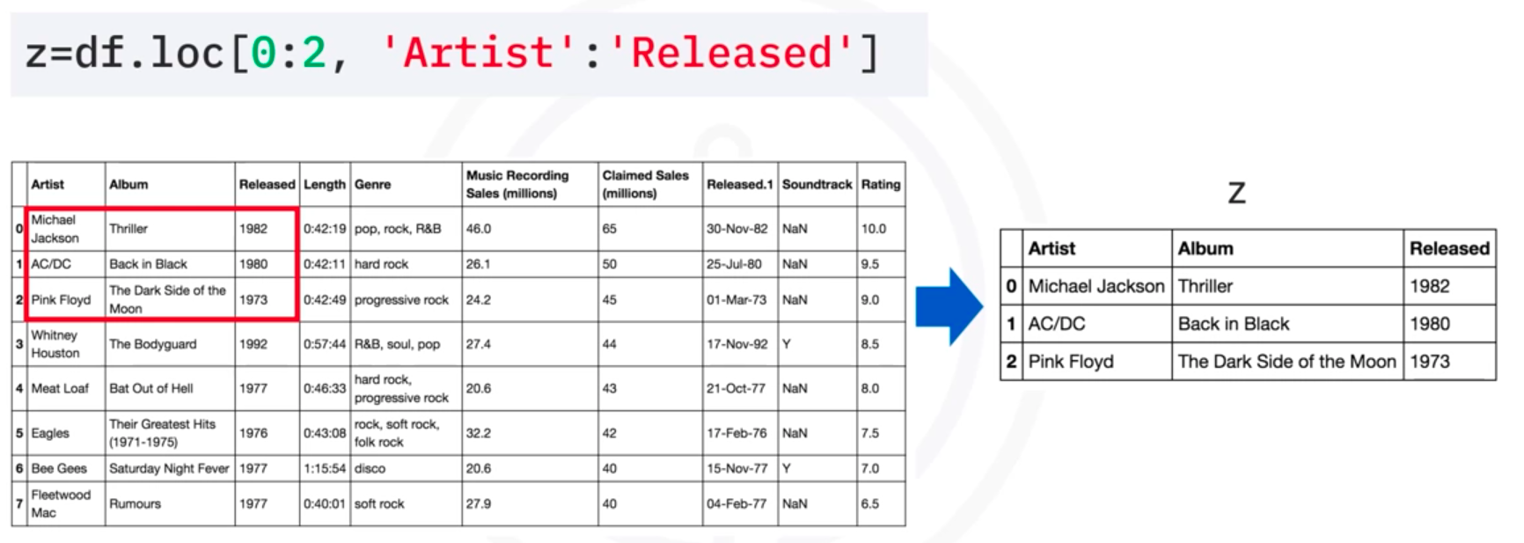

- Pandas: Working with and Saving Data
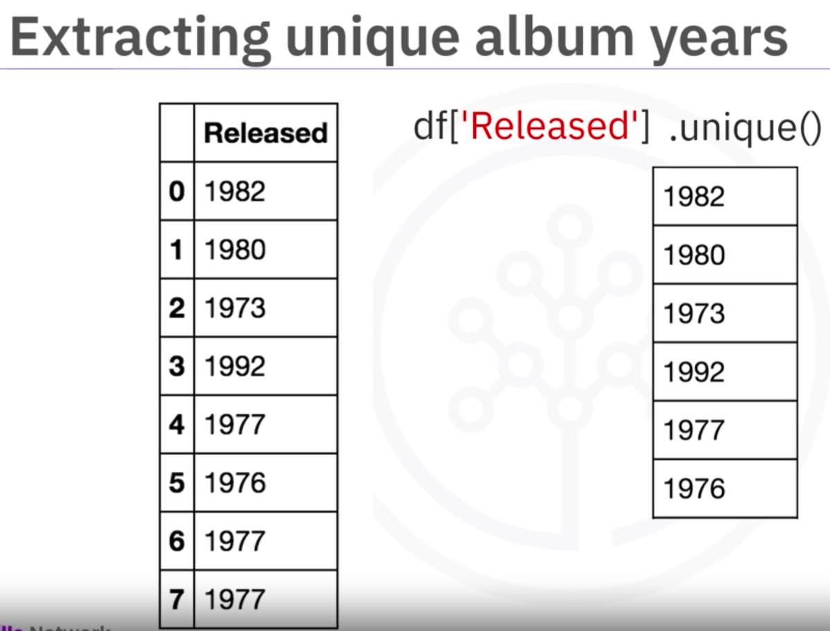
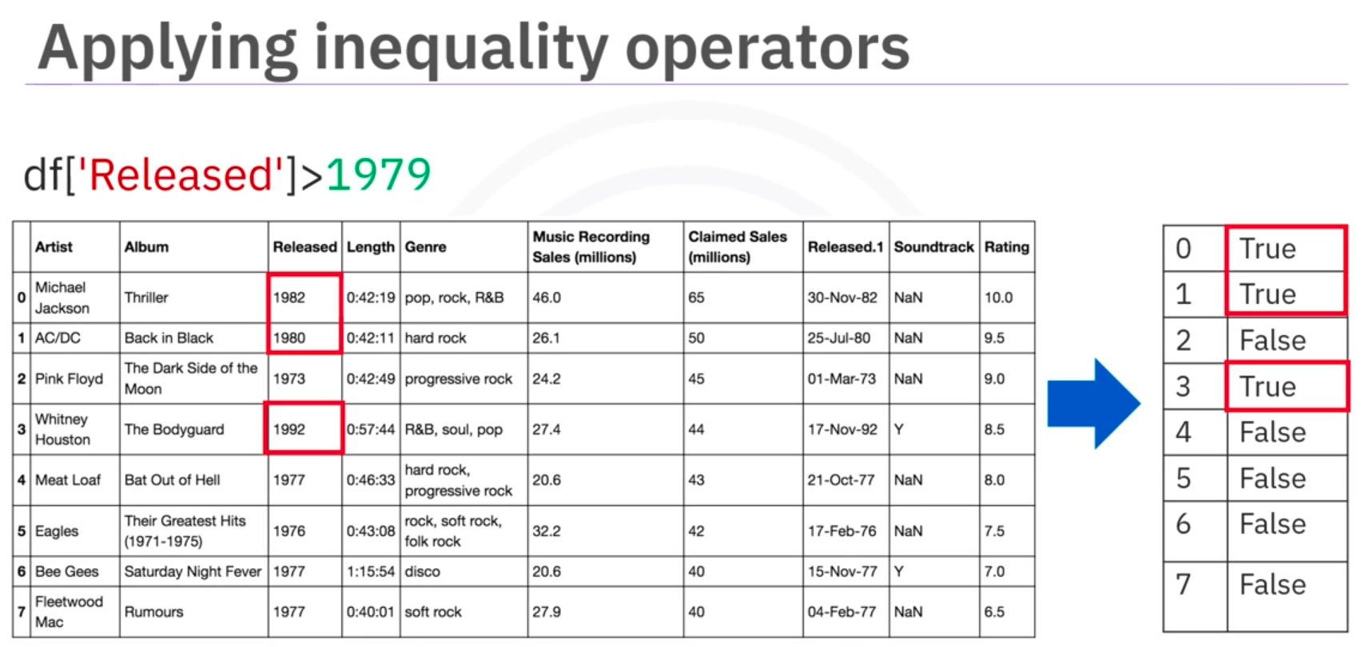
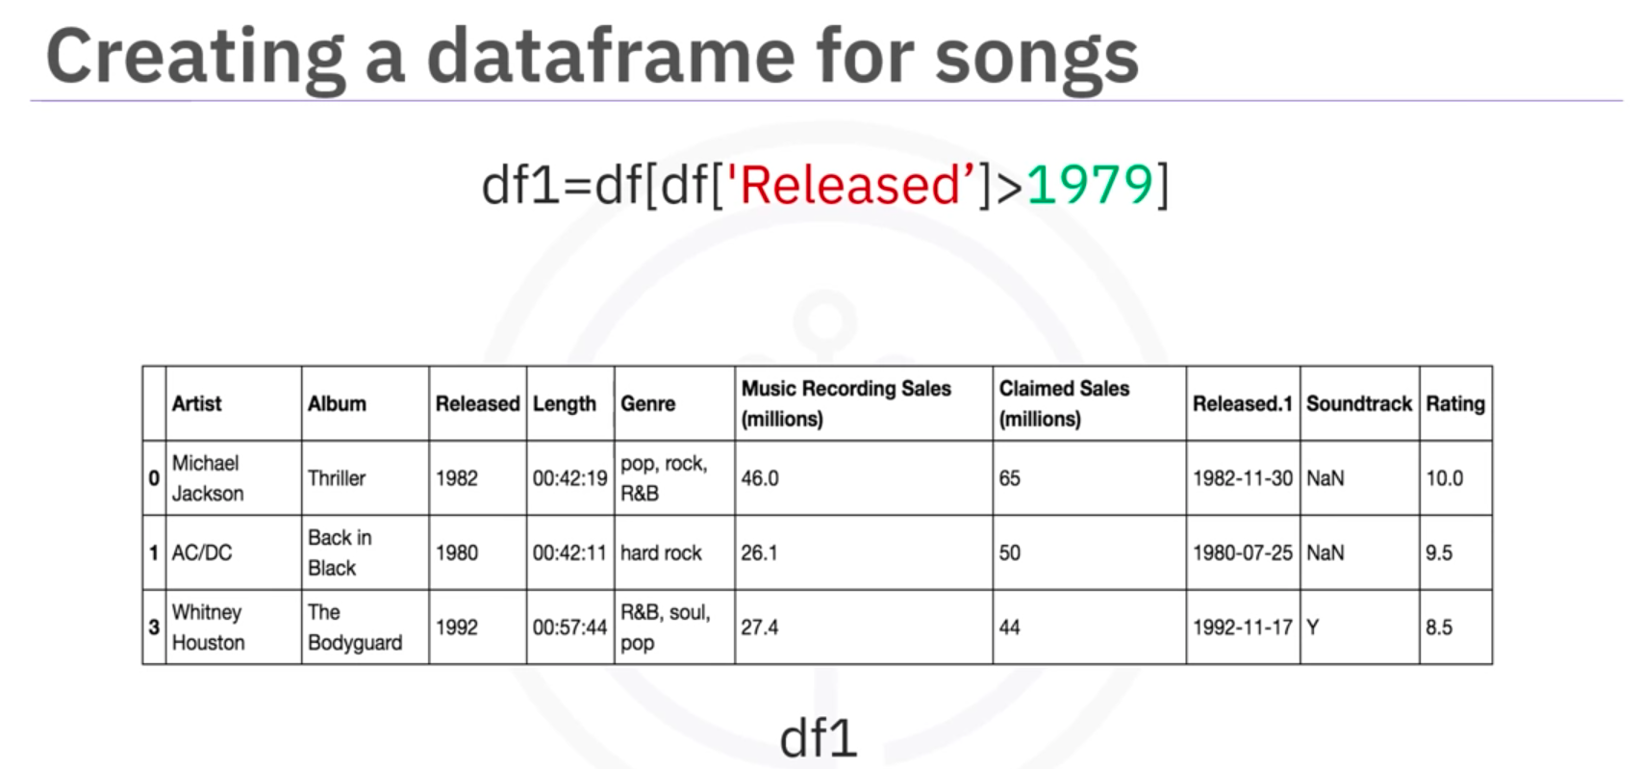
Save as CSV
df1.to_csv(“new_songs.csv”)

III. Introduction to Pandas for Data Analysis
Link

Numpy
- One Dimensional Numpy
The basics and array creation
import numpy as np
a=np.array([0,1,2,3,4])
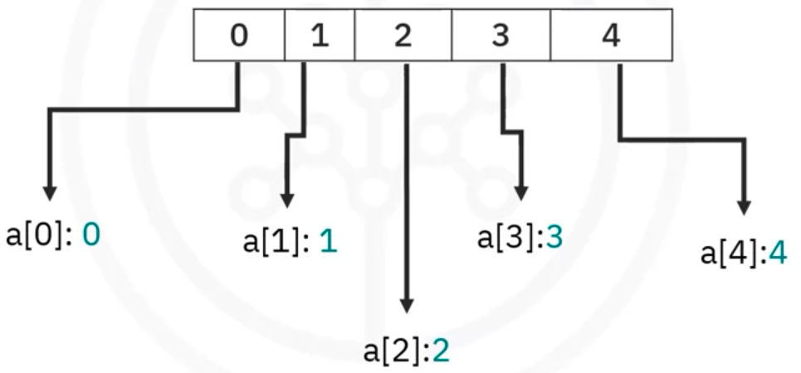

Indexing and slicing
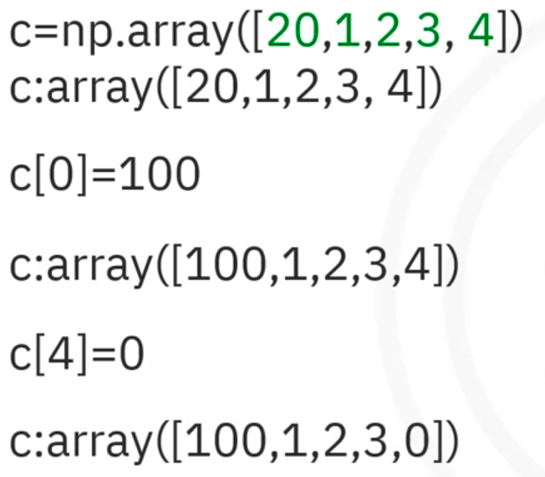

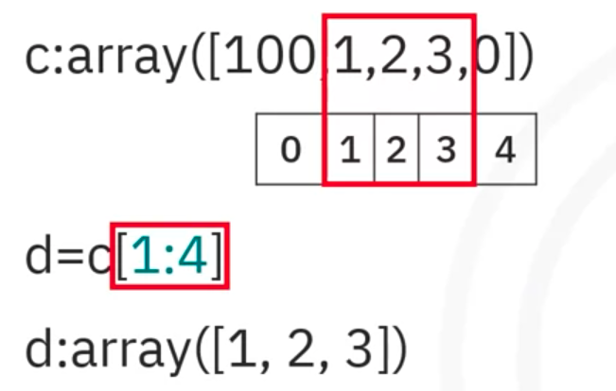

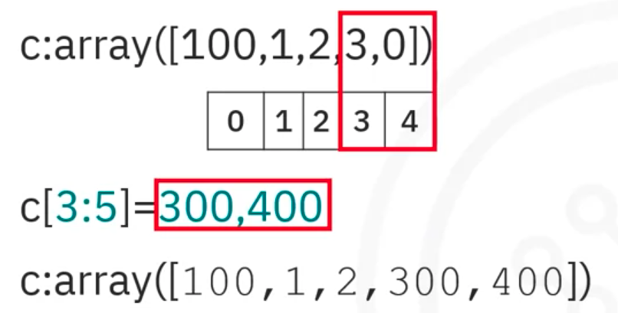

Vector addition and subtraction
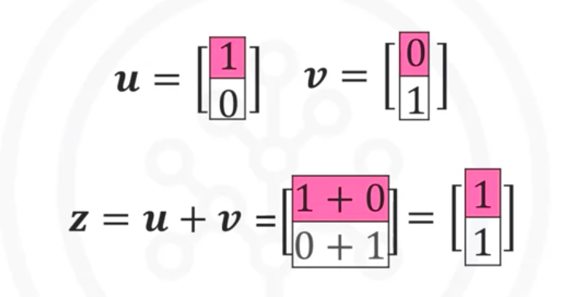
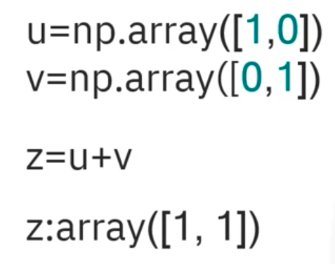

Array multiplication with scalar
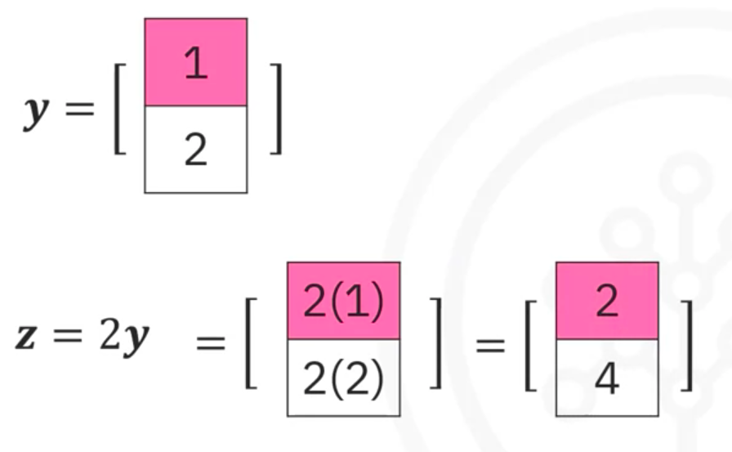

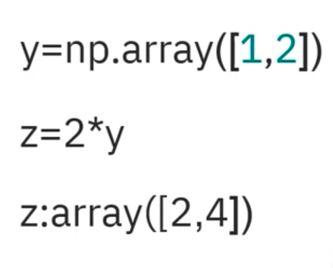

Product of two numpy arrays
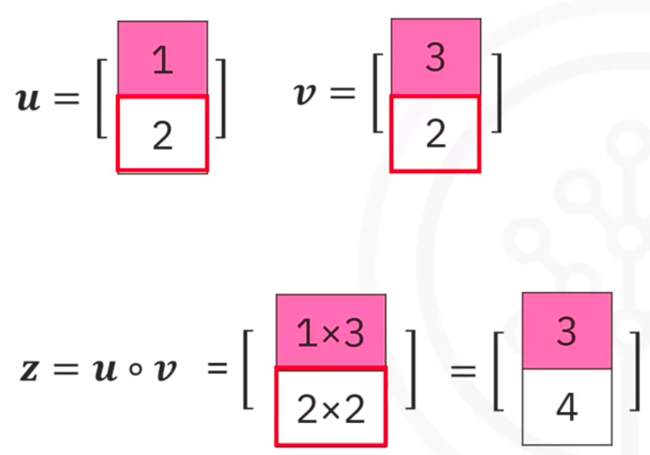

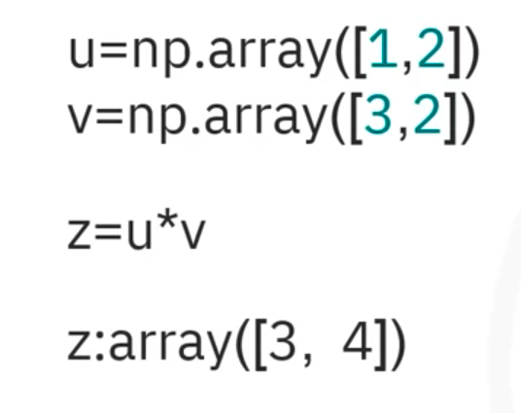

Dot product
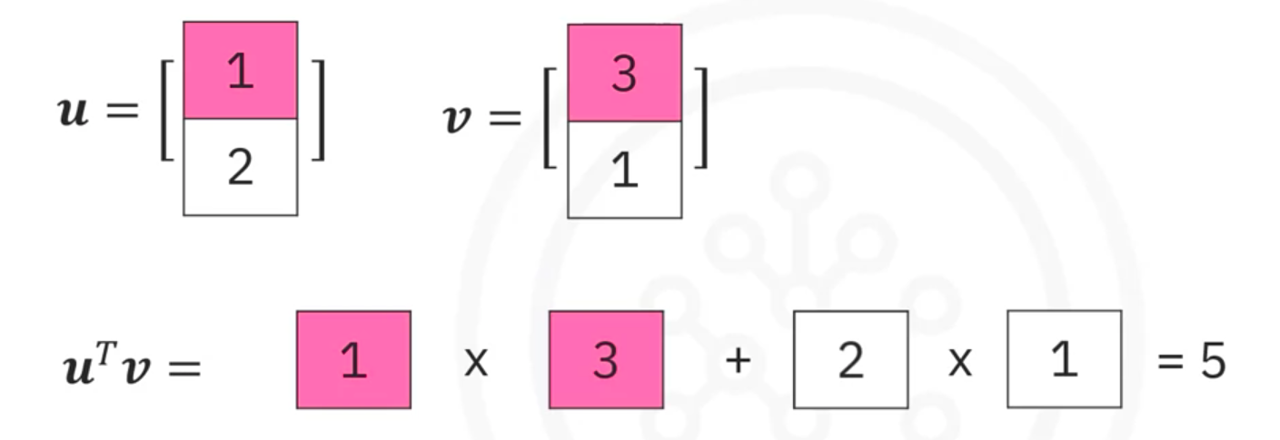

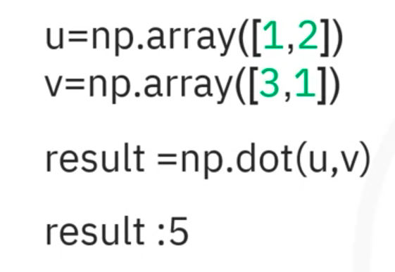

Adding constant to a numpy array
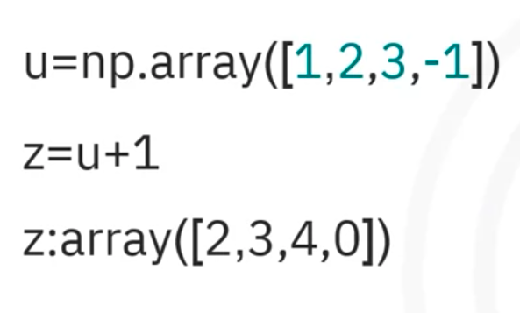

Universal function
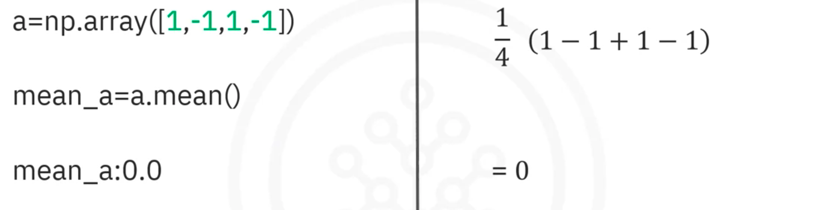
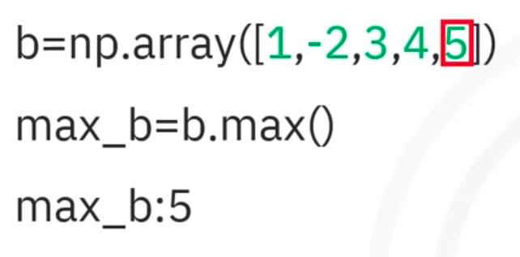

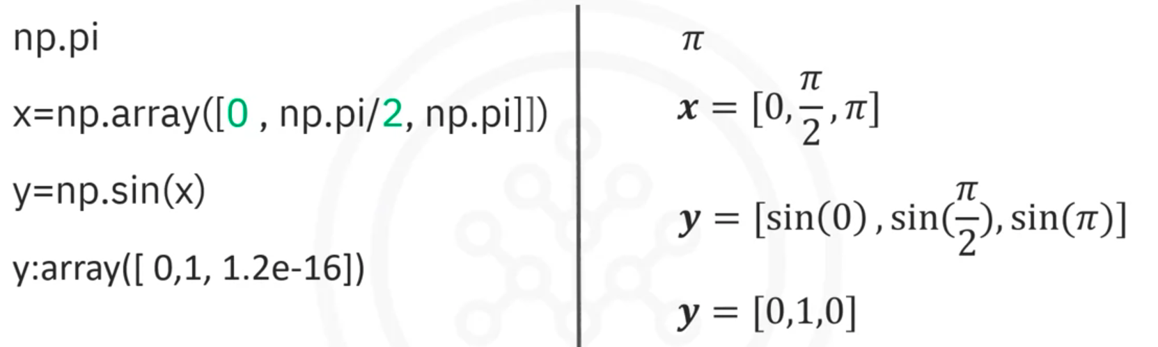

linspace
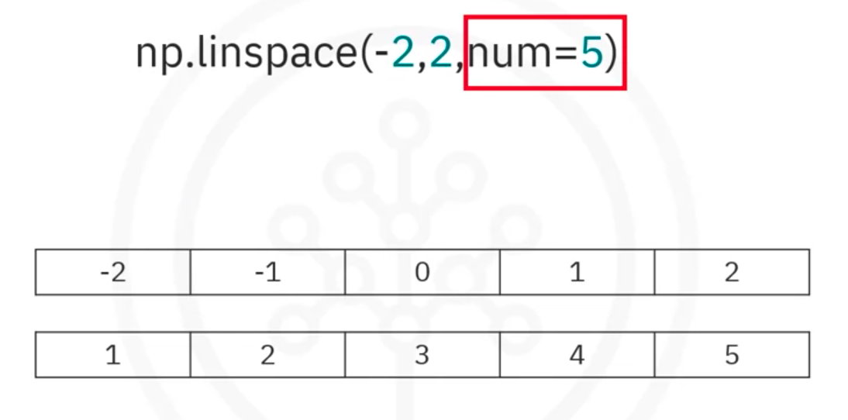

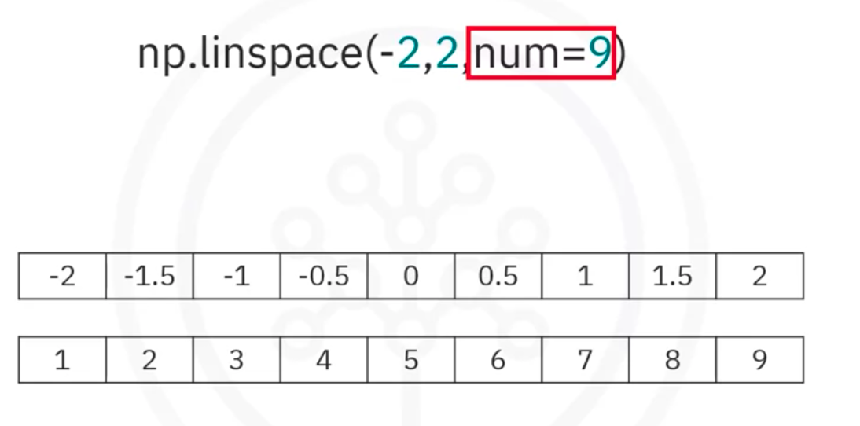

Plotting mathematical functions
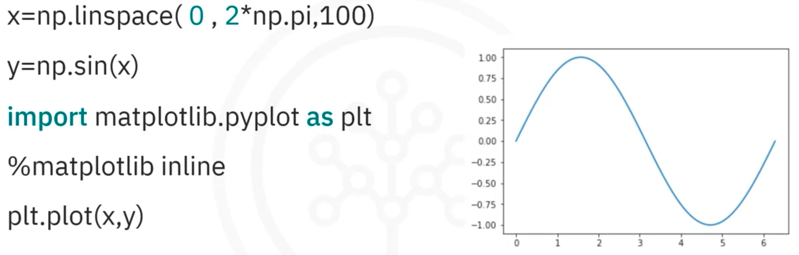

- Matrix Mathematics
Link
- Two Dimensional Numpy
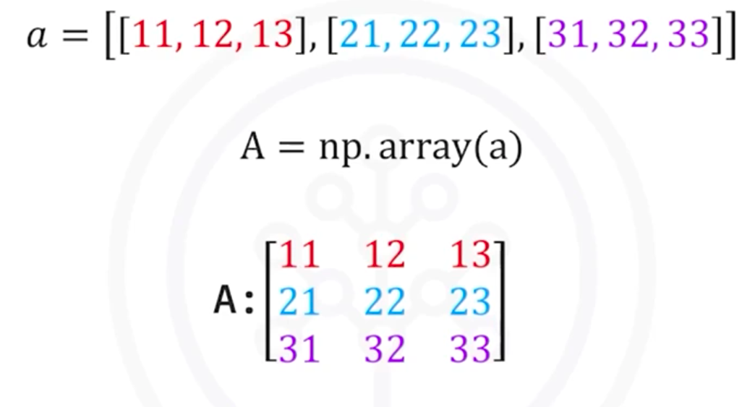
Indexing (2 ways)
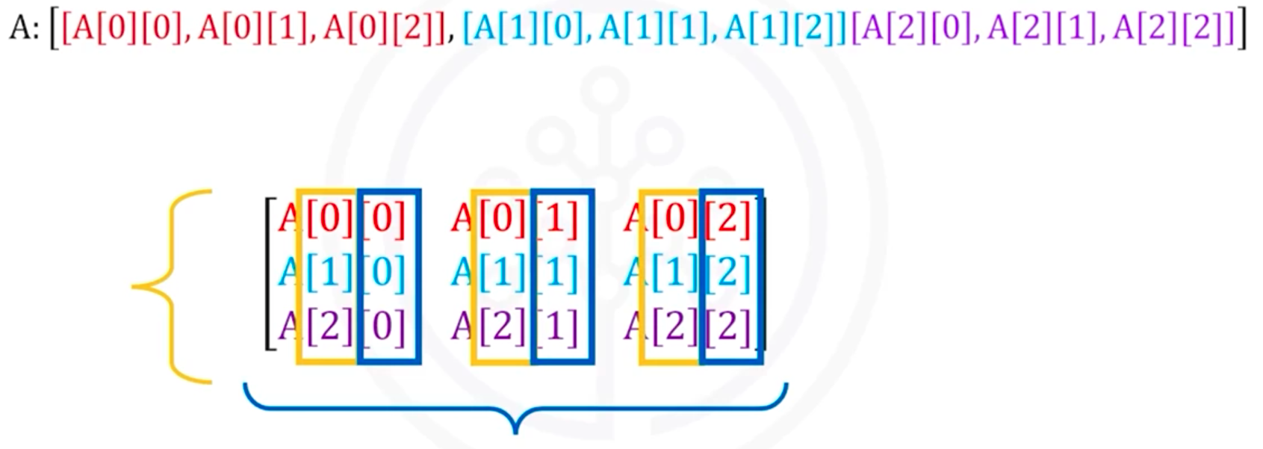
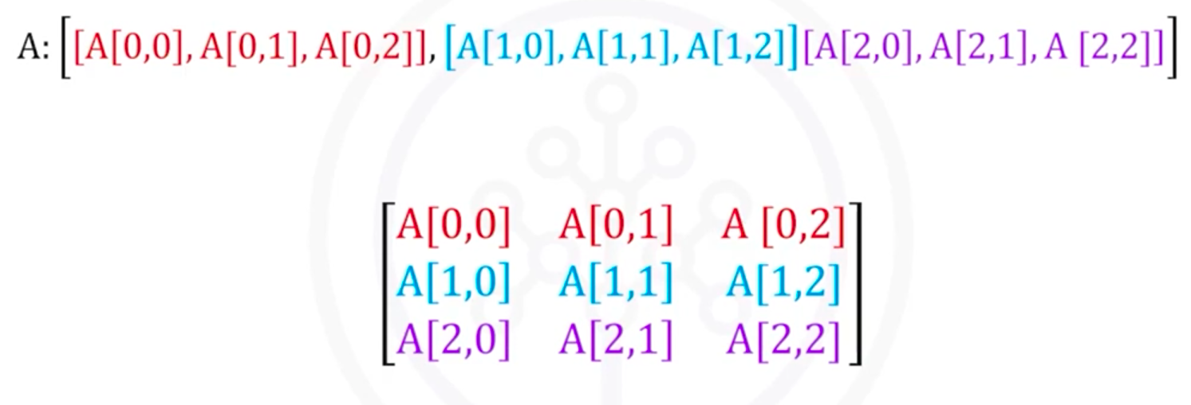

Slicing
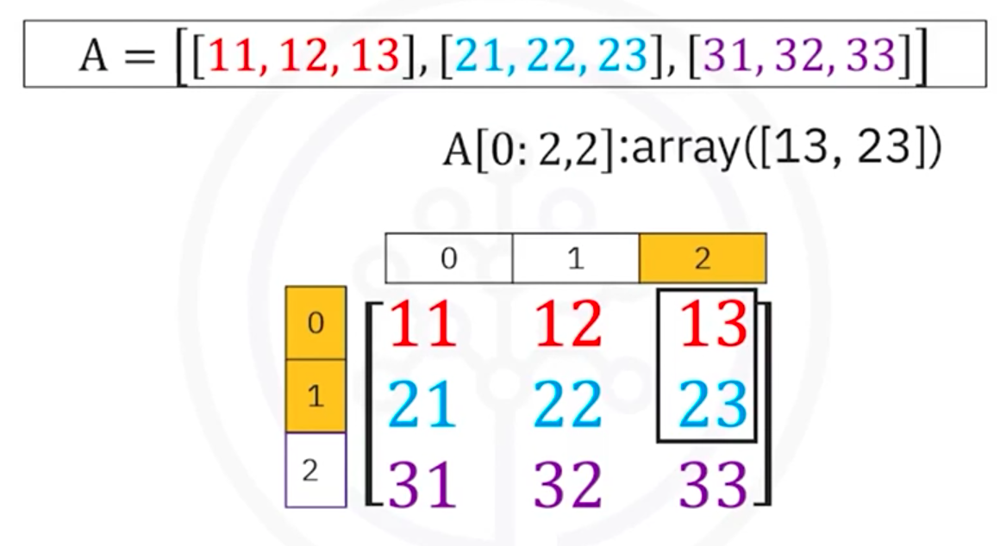

Addition
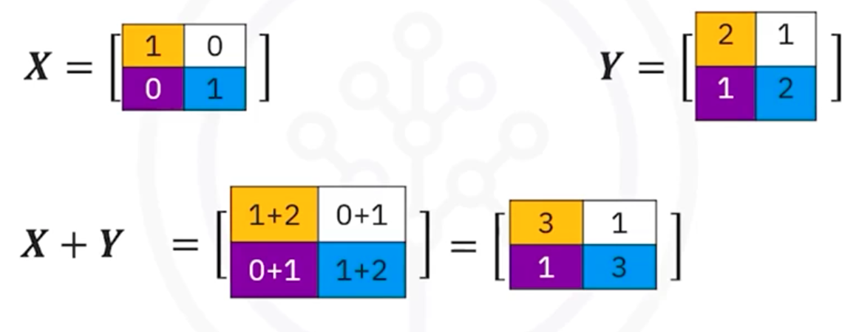

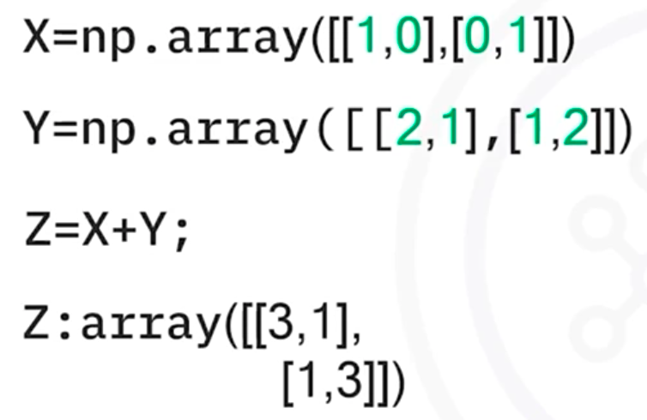

Multiplication
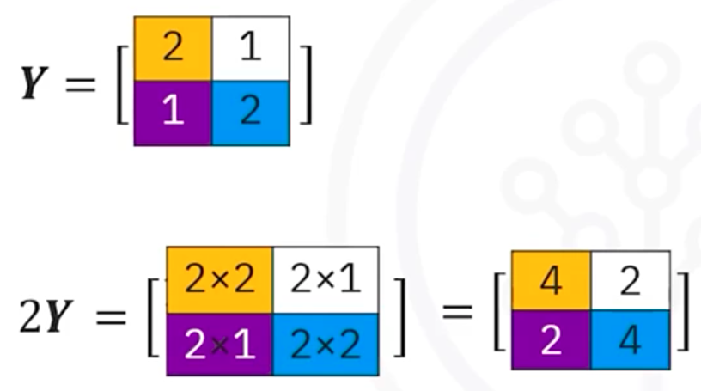
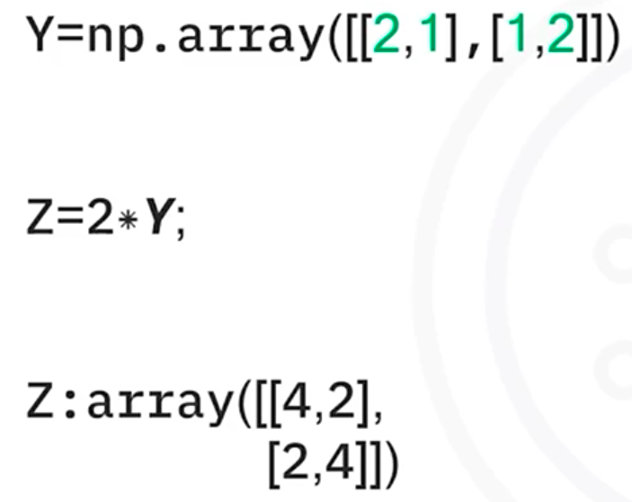

Multiplication of two arrays/element-wise product/Hadamard product
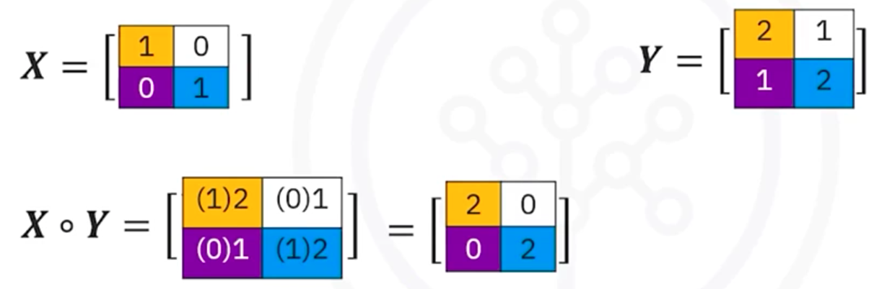

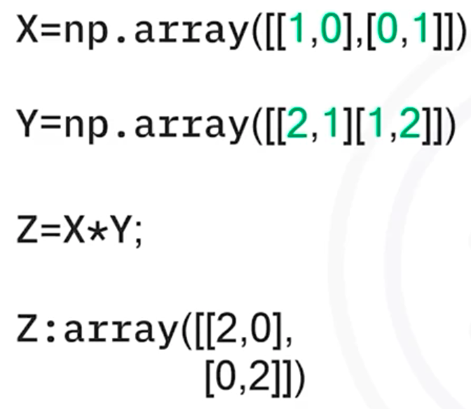

Matrix multiplication
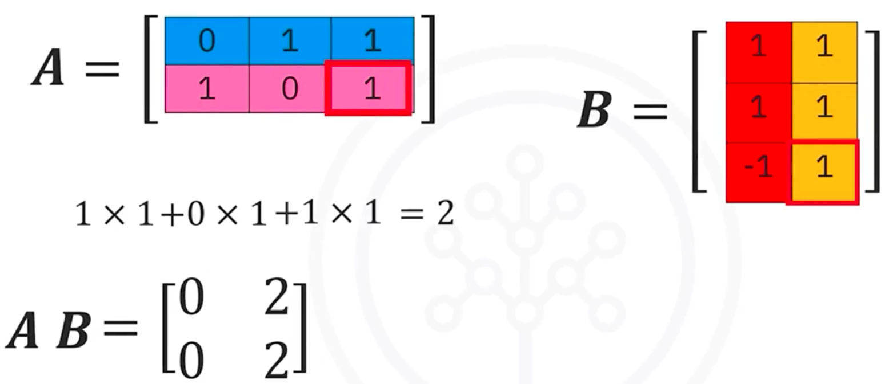

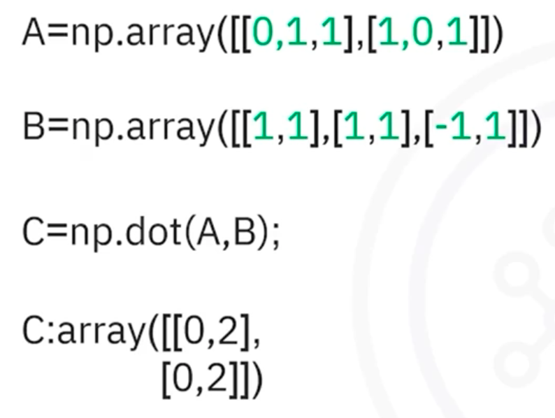

- Beginner’s Guide to NumPy
Link
- Some Context on APIs
Link
- Glossary
Link

APIs and Data Collection
Simple APIs
- Application Program Interface
An API lets two software talk to each other
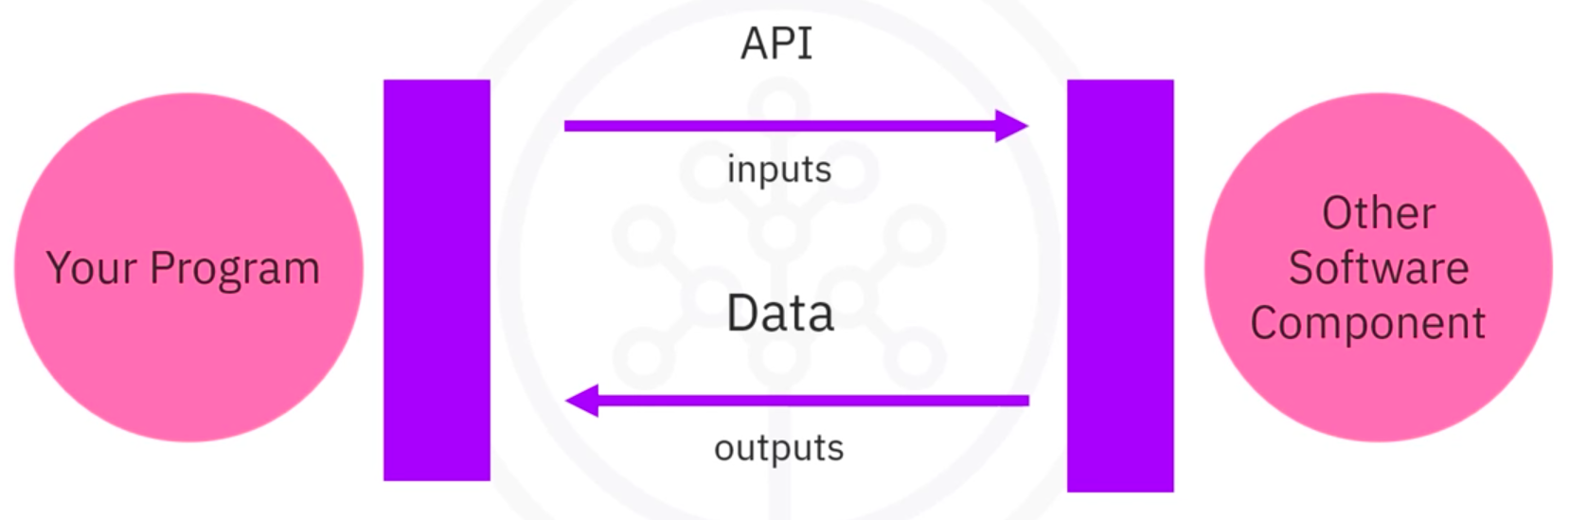

A REST API let you communicate with the internet and take advantages of resources like storage, access more data, artificial intelligence algorithms, and much more.
REST API: REpresentational State Transfer API

REST APIs, Web Scraping, and Working with Files
- REST APIs & HTTP Requests
HTTP Protocol
HTTP Protocol is a general protocol of transferring information through the web. This includes many types of REST APIs. REST APIs function by sending a request and a request is communicated via HTTP message (the message usually contains a JSON file).
HTTP Request
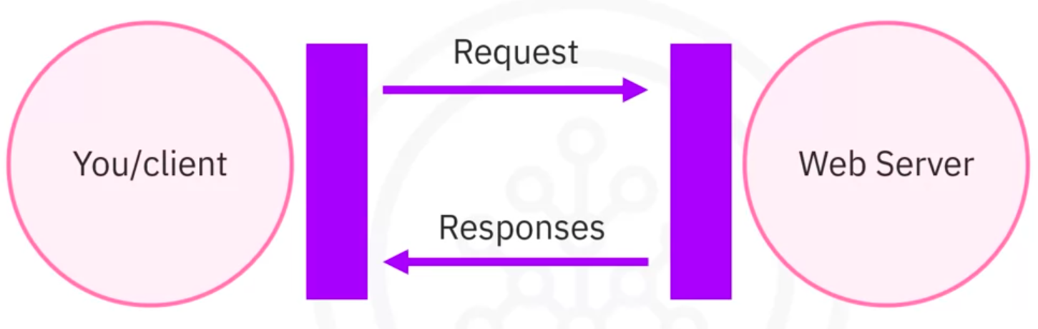

A Uniform Resource Locator (URL) is the most popular way to find resources on the web
Overview of HTTP
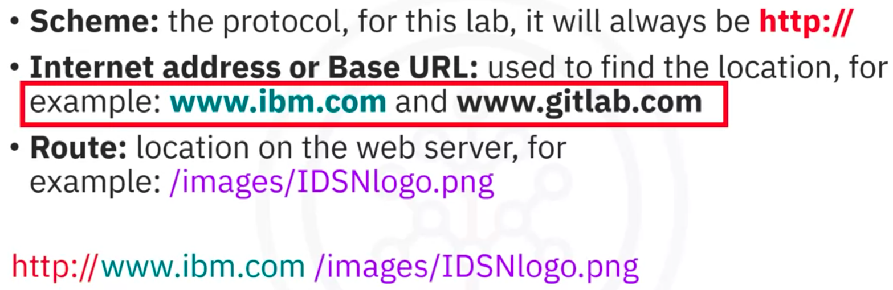

Request and Response
Request Message:
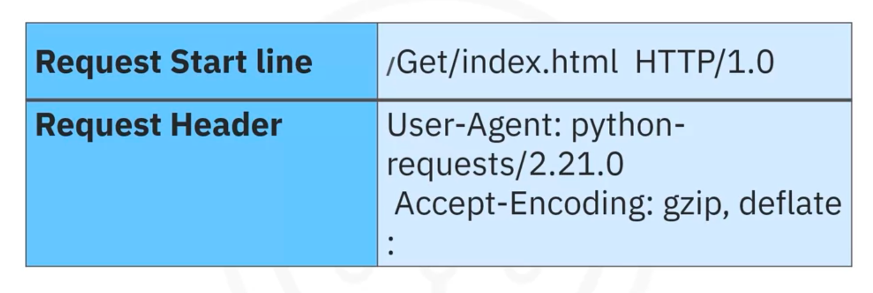

Response Message:
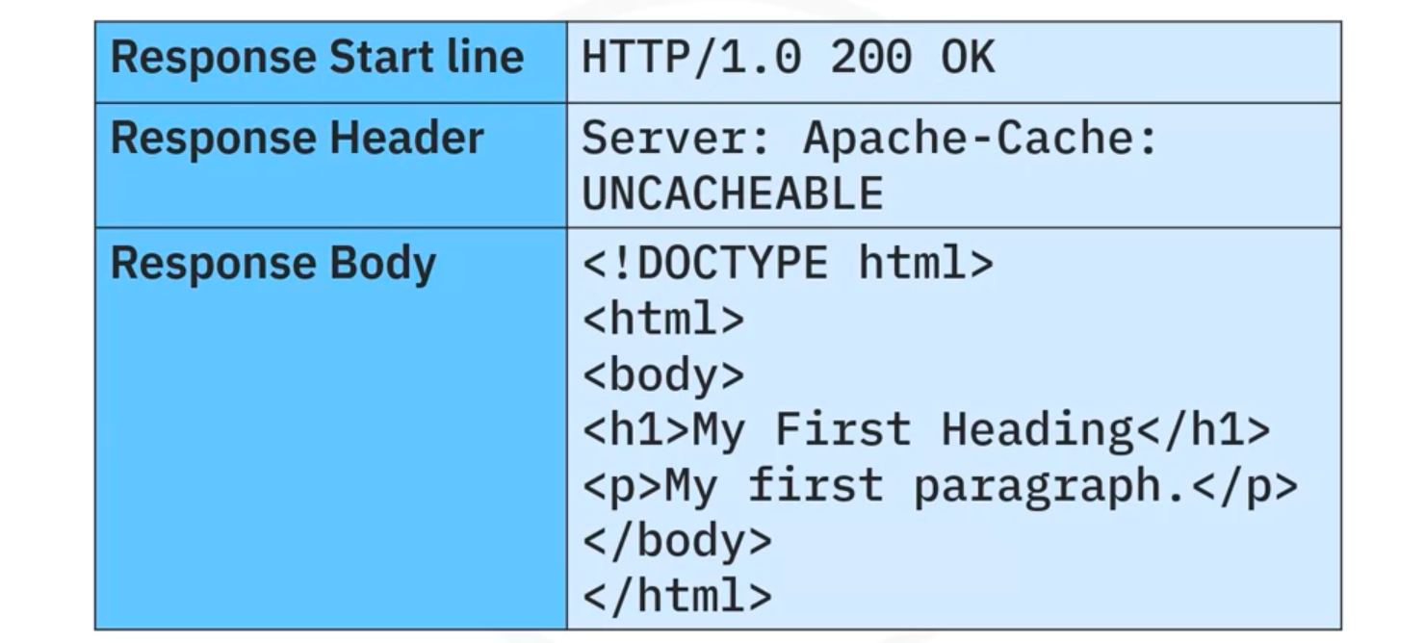

Status Code:
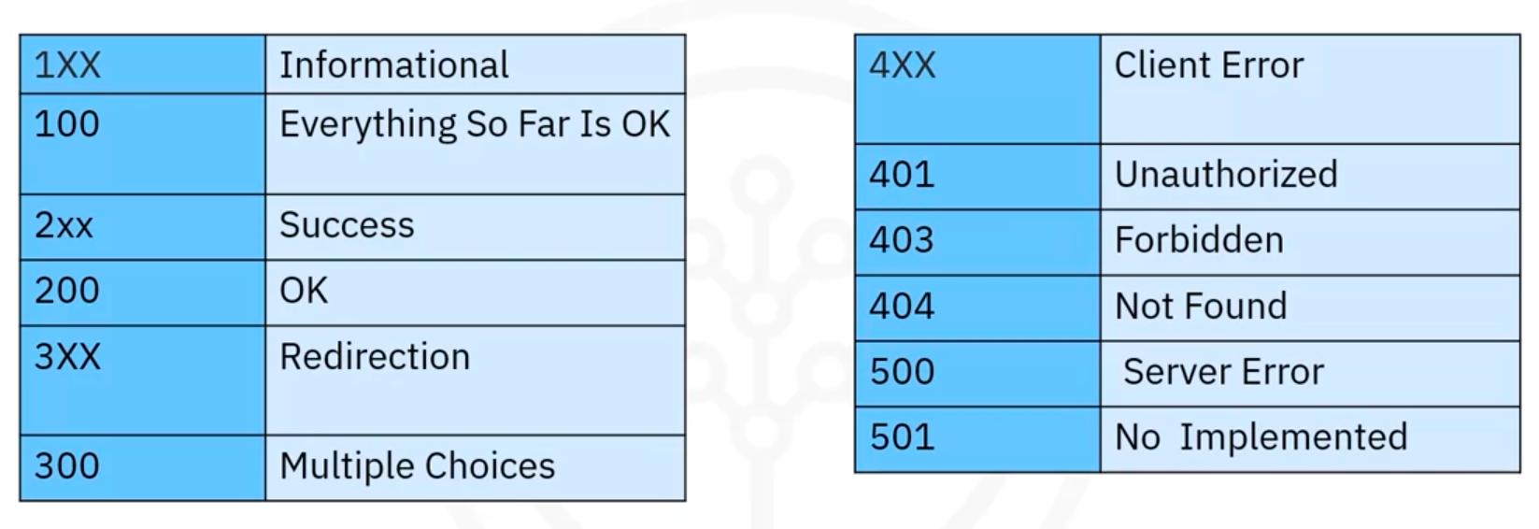

HTTP Methods
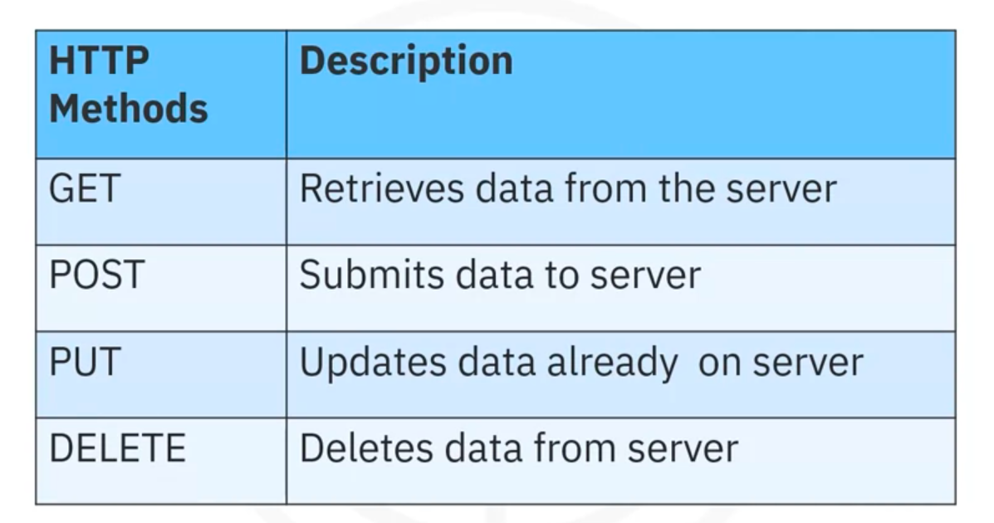

HTTP Using the Requests Library in Python
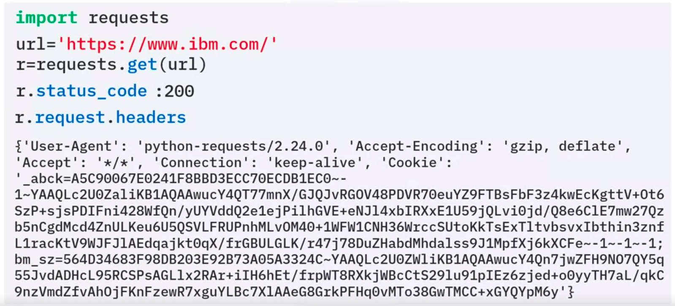
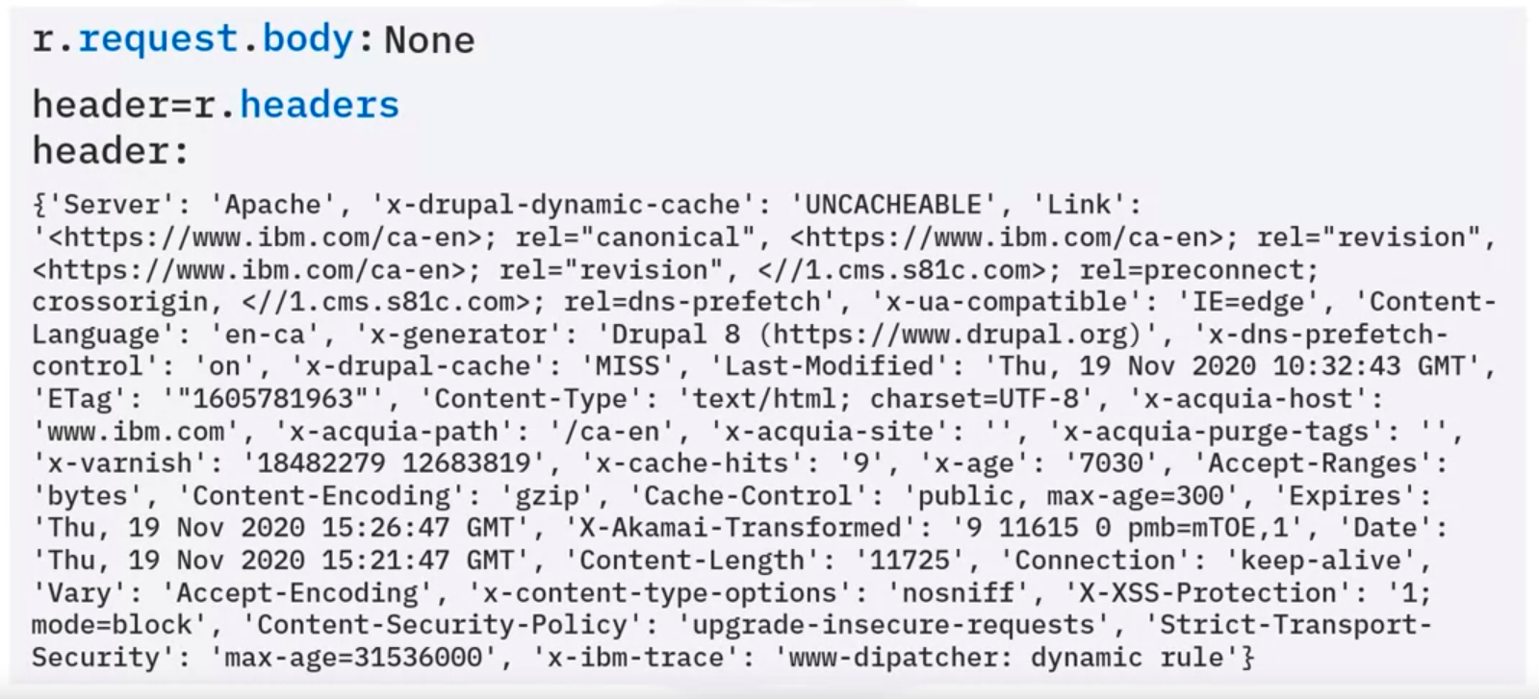
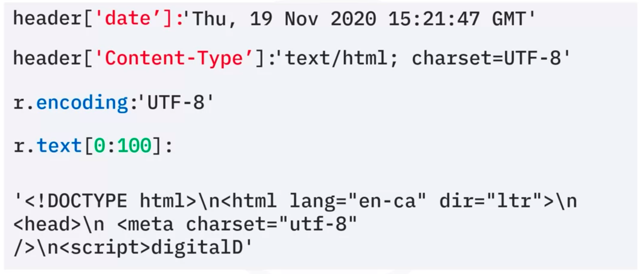

Get request with URL parameters
- GET request
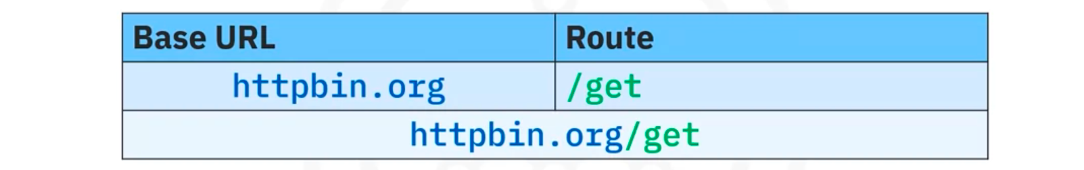
- Query string
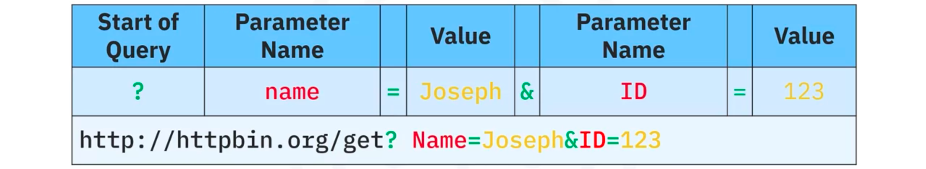
- Create query string
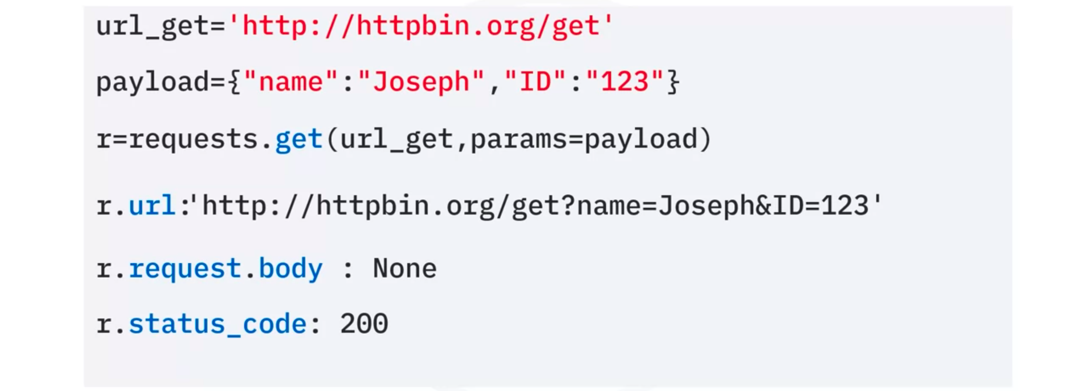
- Content-Type
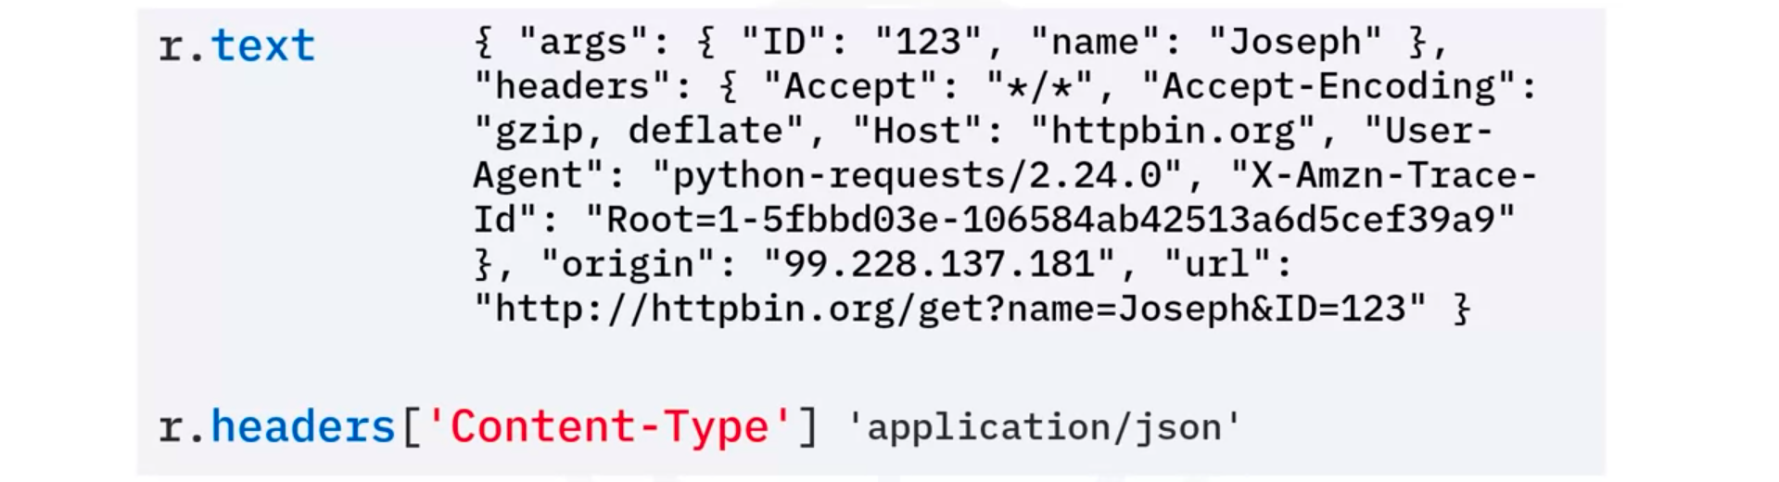
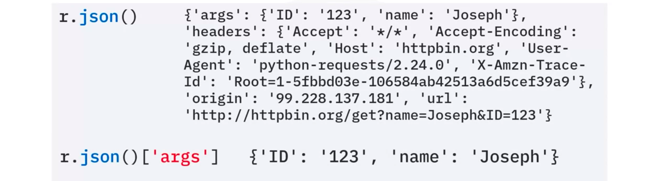

Post Requests
Like a GET request, a POST request is also used to send data to a server, but the POST request sends the data in a request body, not the URL
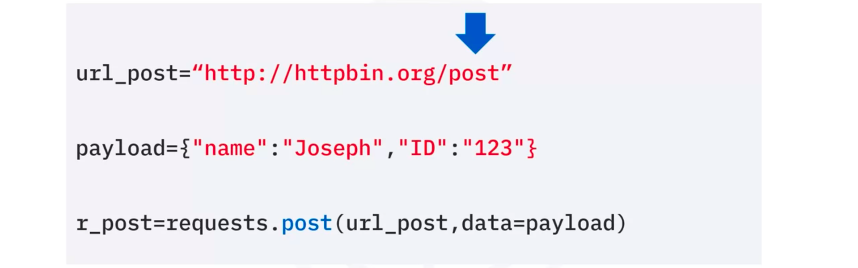
Compare POST and GET
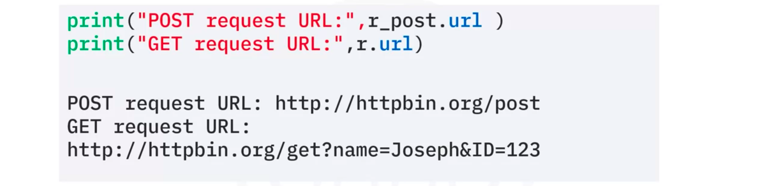
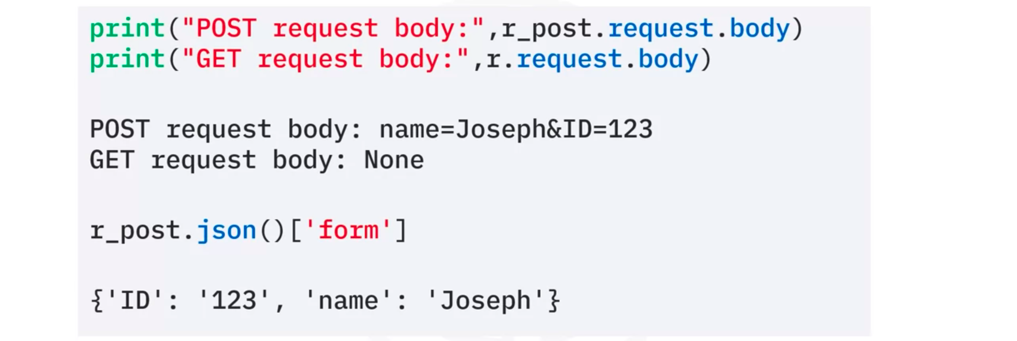

- Web Scraping and HTML Basics
Link

- HTML for Web Scraping
- Web Scraping
Web scraping is a process that can be used to automatically extract information from a website, and can easily be accomplished within a matter of minutes and not hours.

Example:
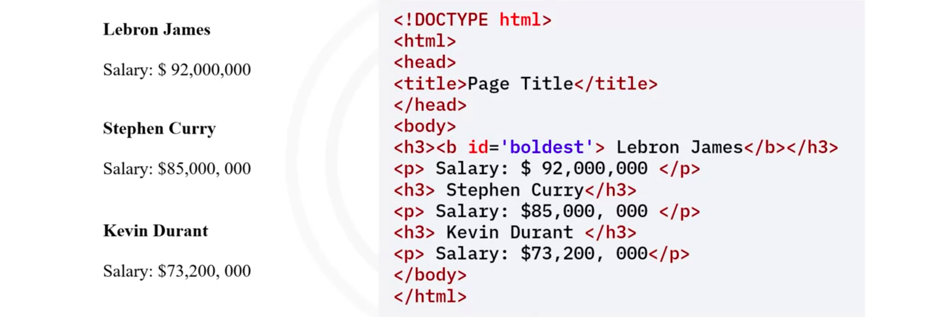
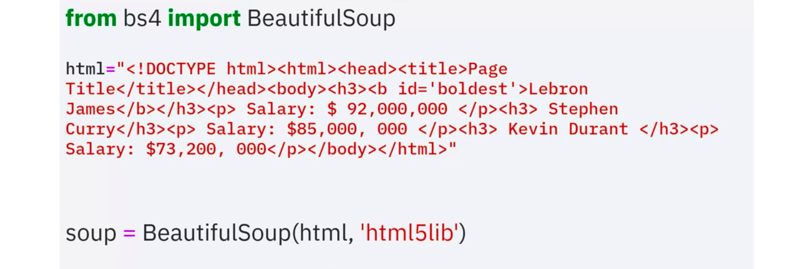
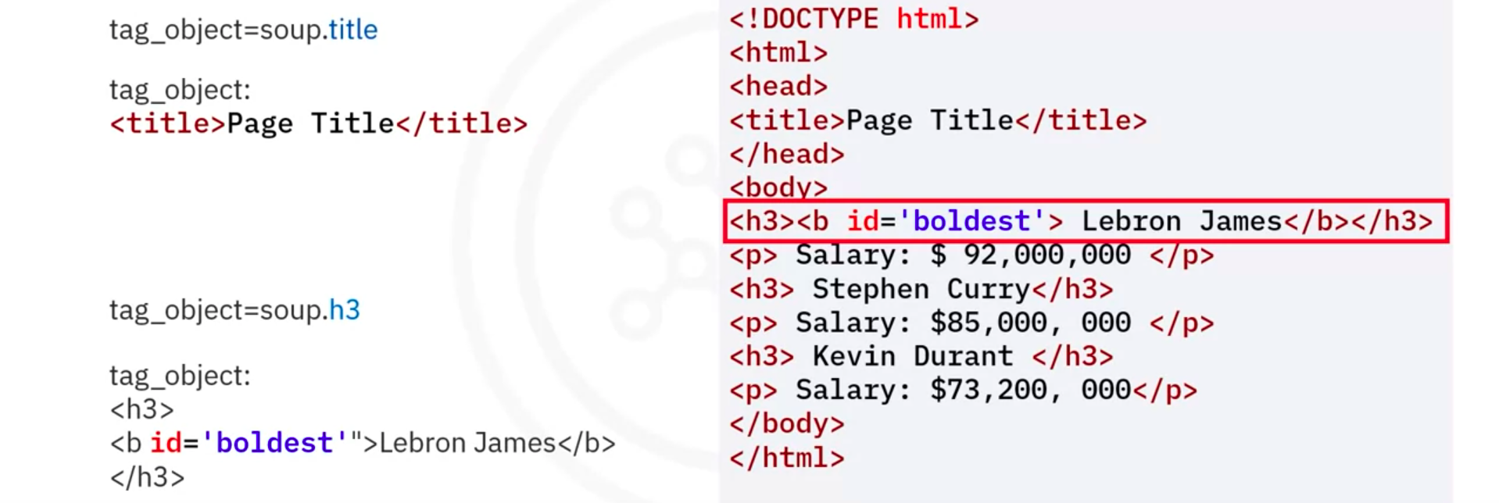
Access Child
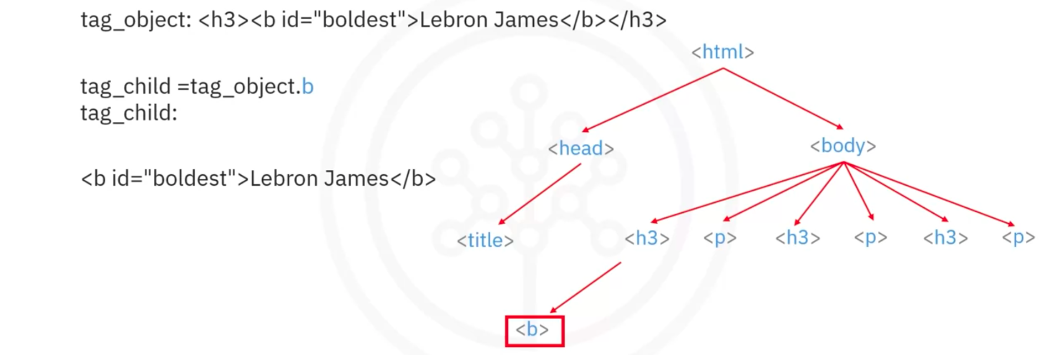
Access Parent
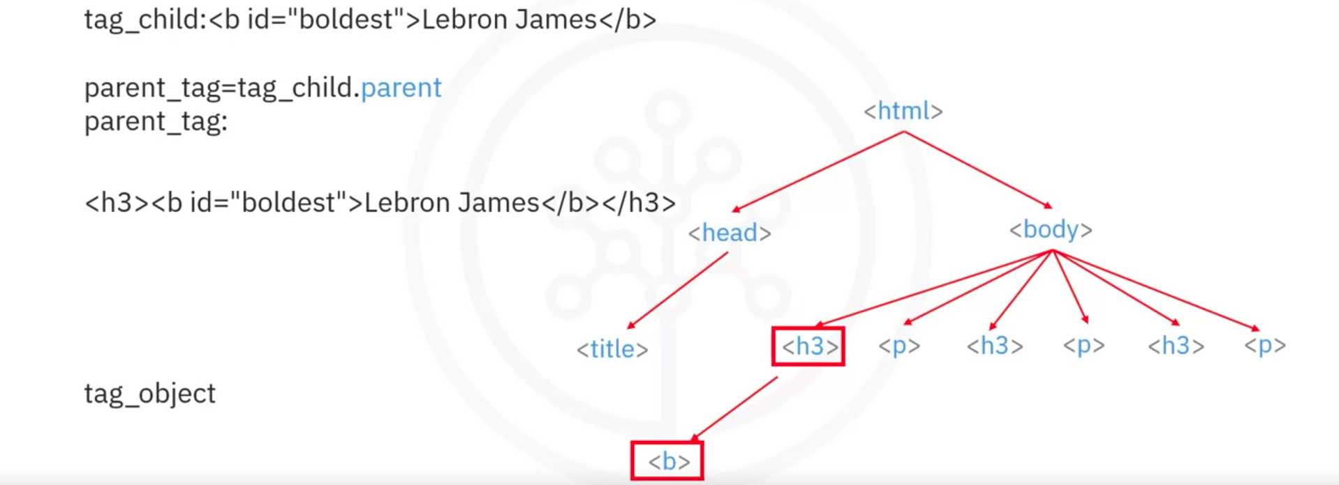
Access Next-sibling
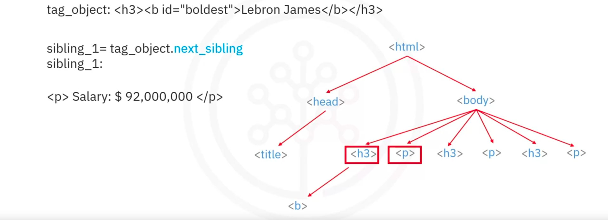

Access Attributes and Strings
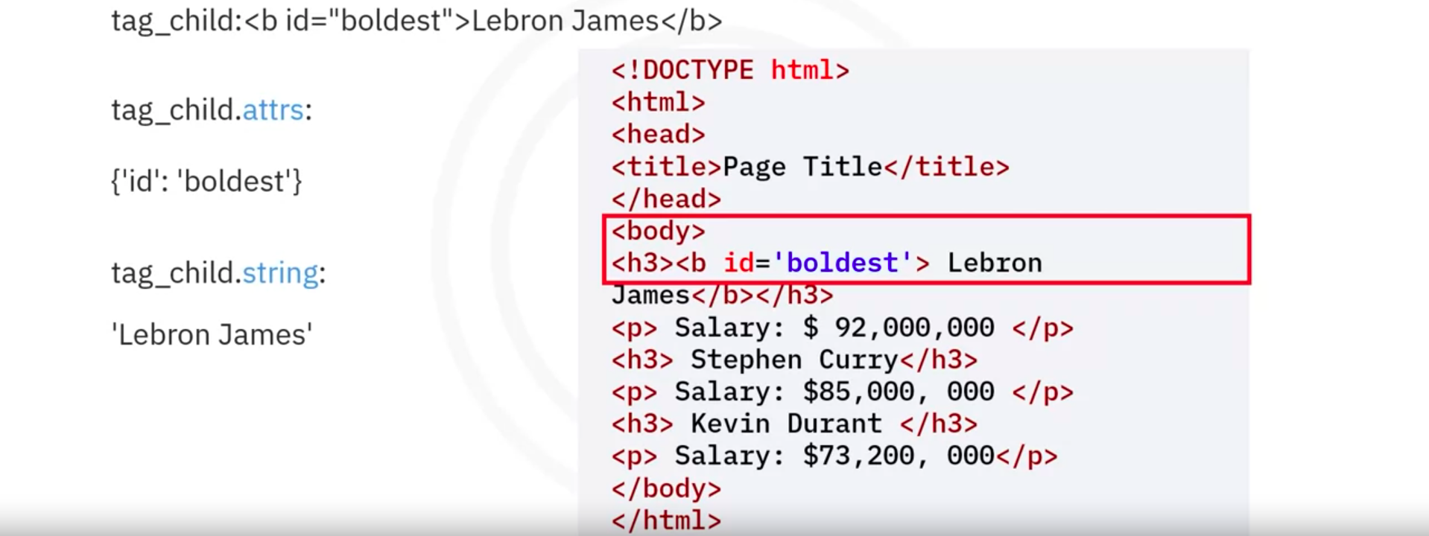

find_all (from tables on websites to pandas DataFrames)
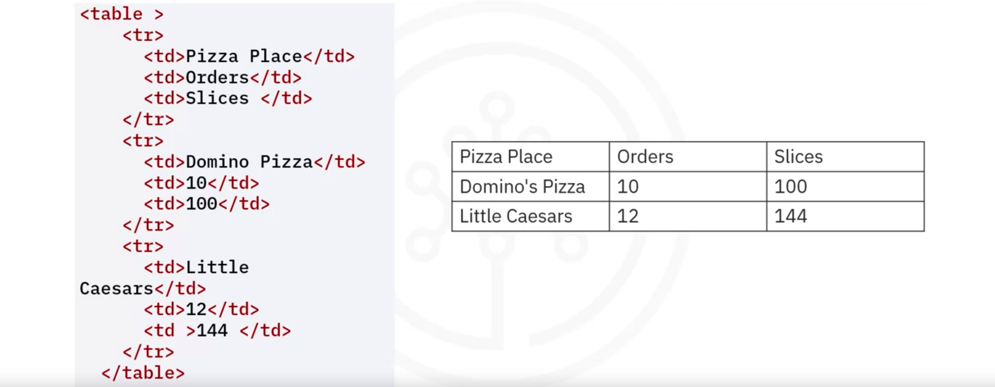
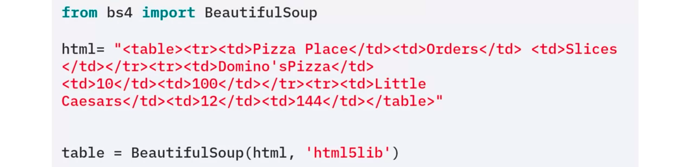
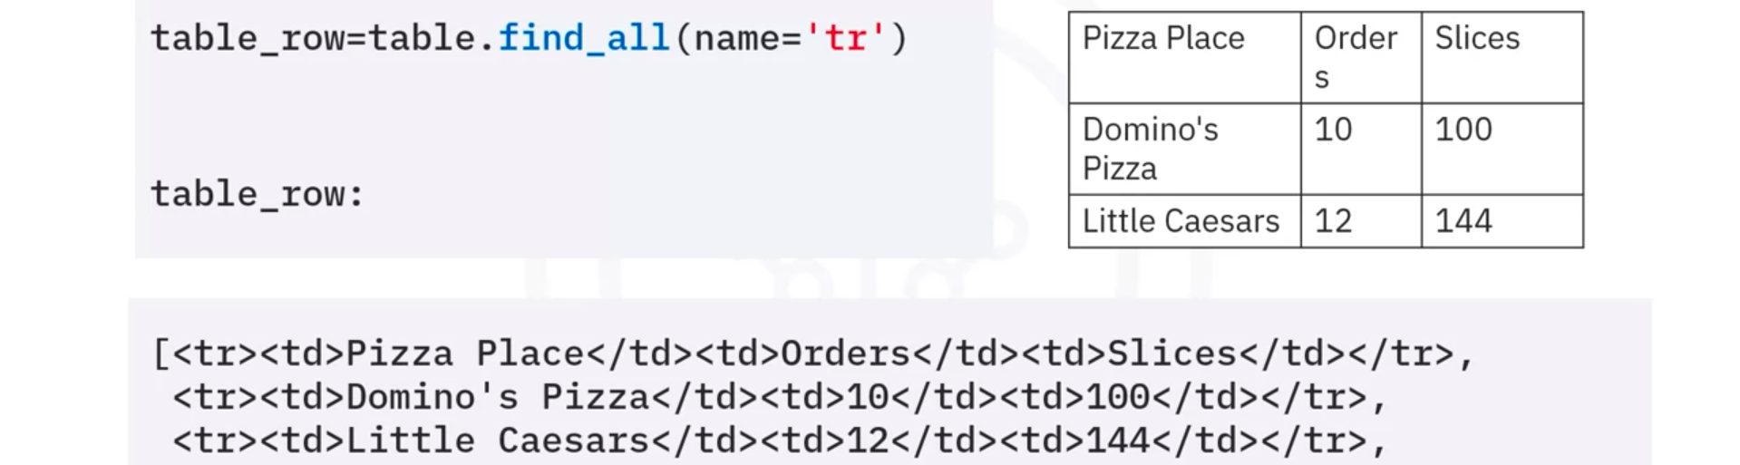
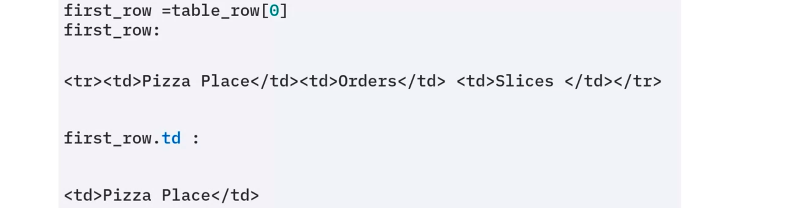
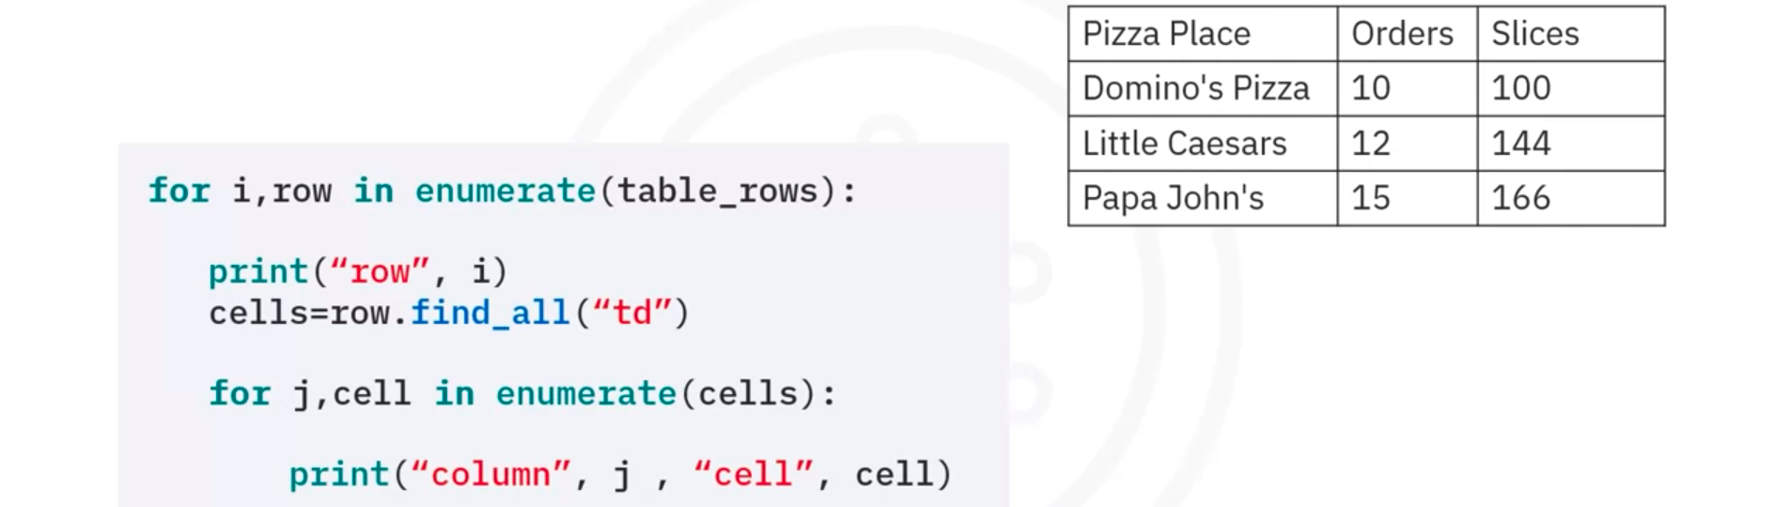
- Web Scraping – A Key Tool in Data Science
Link
- Web Scraping Tables using Pandas
Link
- Glossary
Link

