Getting Started with SQL
- Introduction to Databases
What is SQL?
Structure Query Language, a language used for relational databases and query data.
What is RDBMS?
Relational Data Base Management System, is a set of software tools that controls the data:
- Access, organization, and storage
Famous RDBMS: MySQL, Oracle Database, IBM Db2, etc.
Basic SQL Commands
- Create a table
- Insert
- Select
- Update
- Delete
- Select Statement
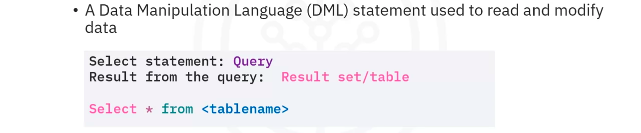
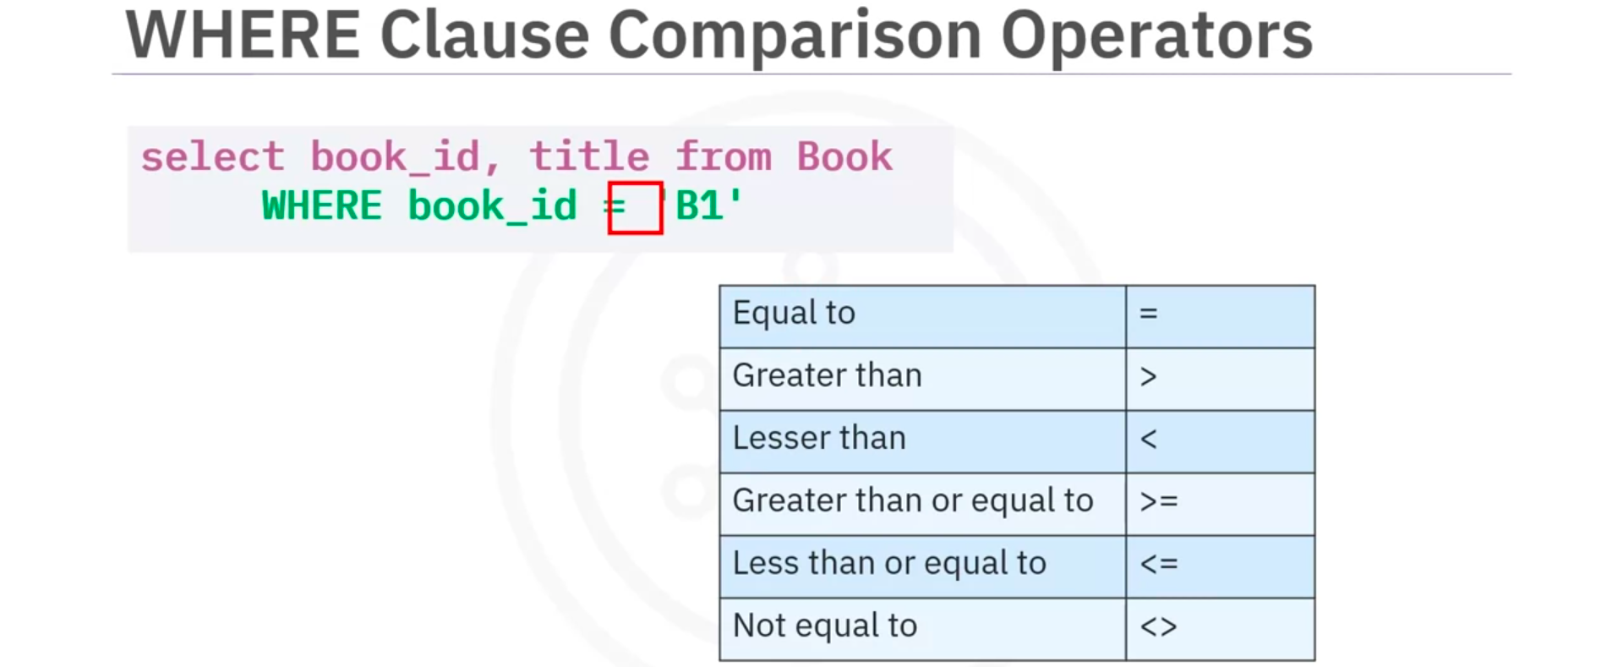

- COUNT, DISTINCT, LIMIT

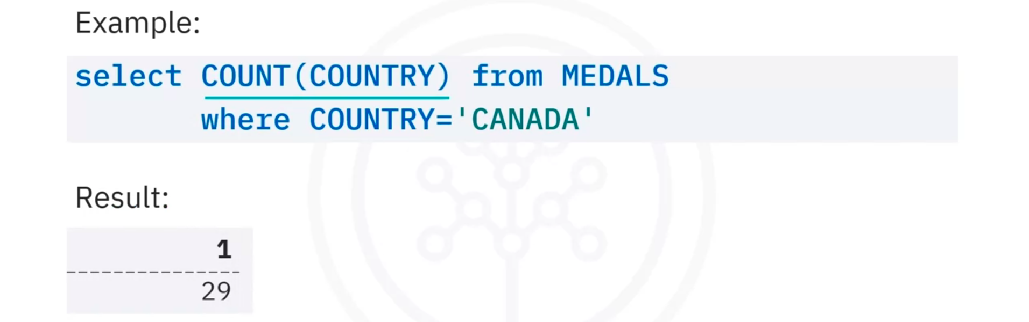

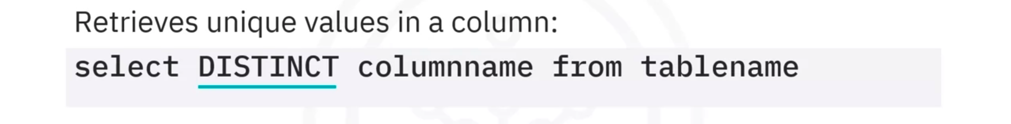


- INSERT Statement
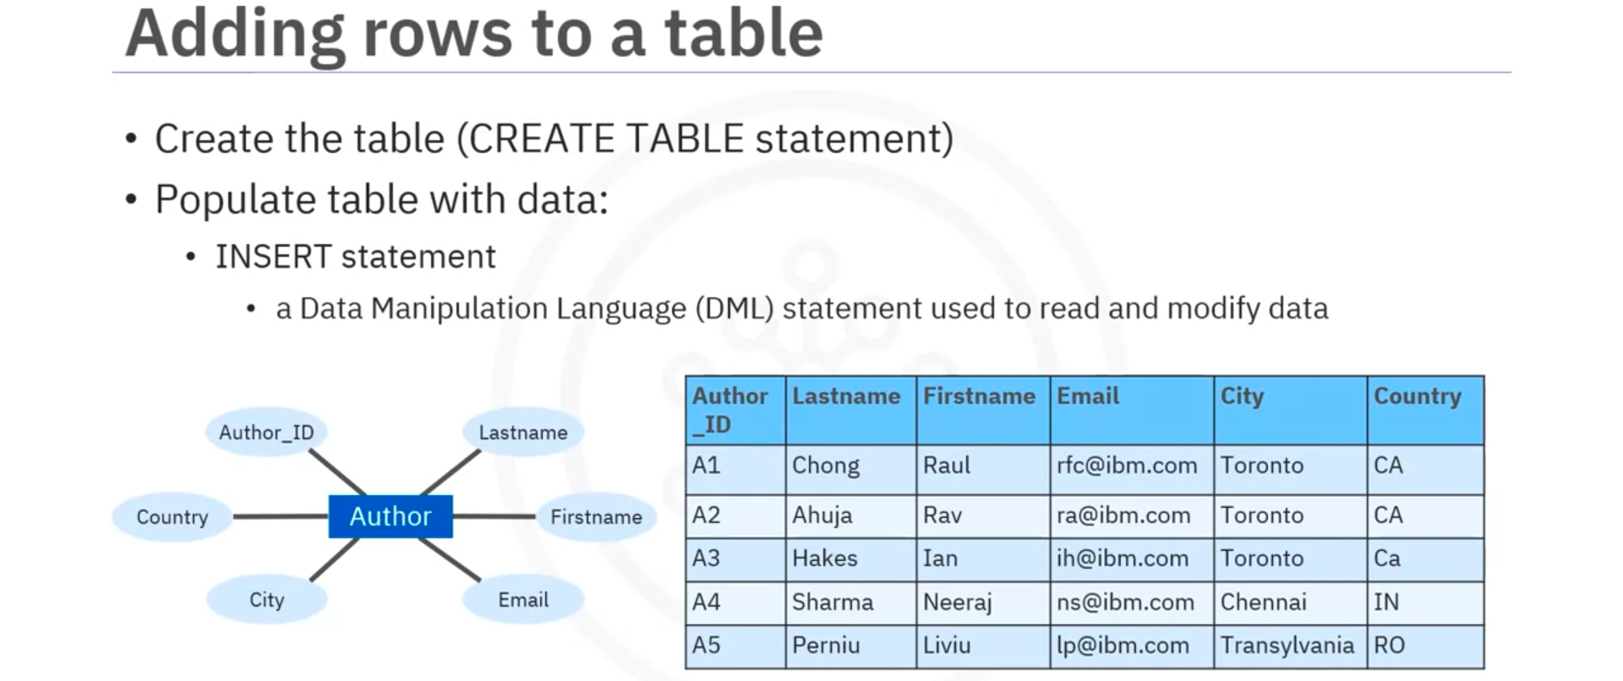
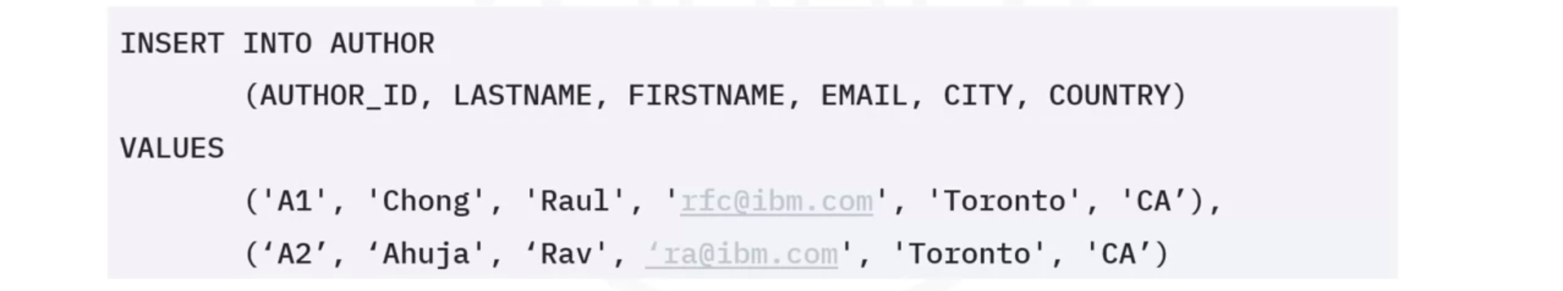
- UPDATE and DELETE Statement
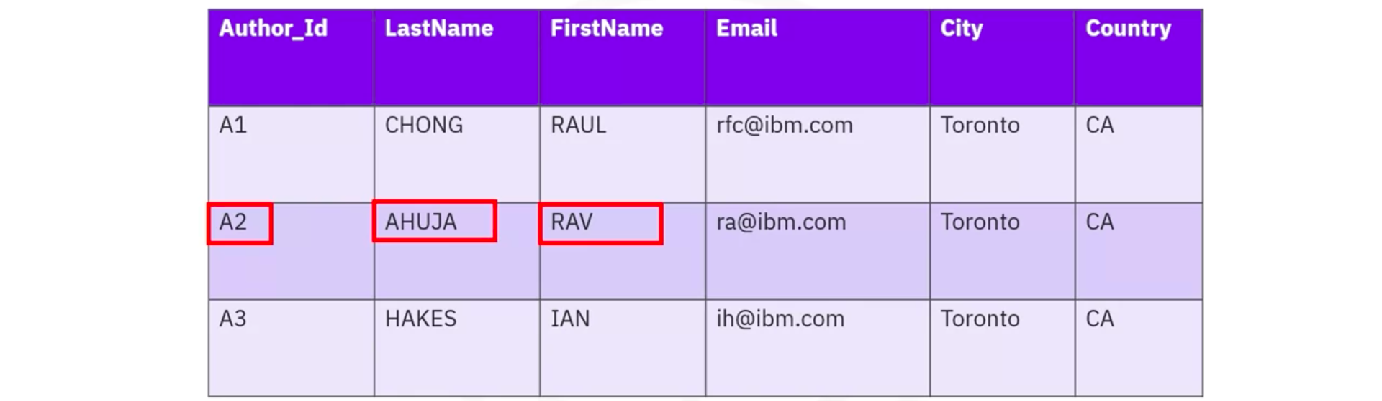


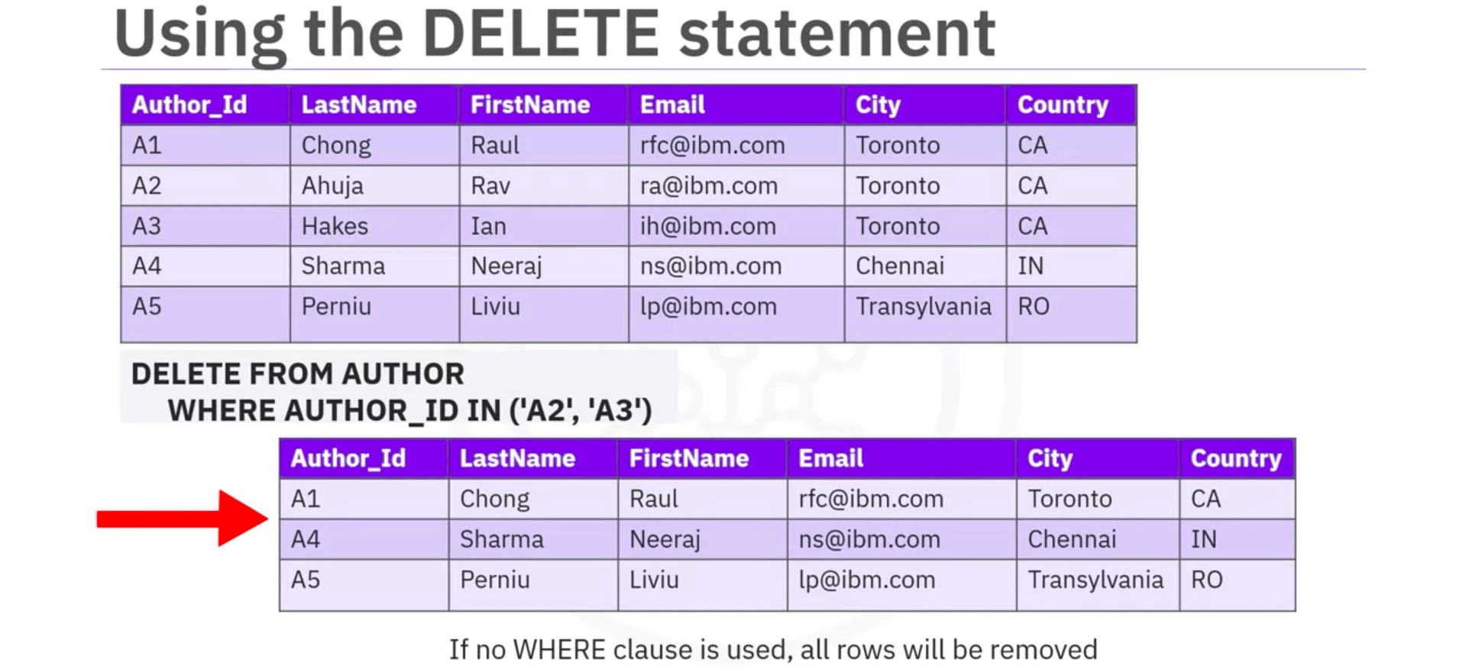

- Summary

