Introduction to Relational Databases and Tables
- Relational Database Concepts
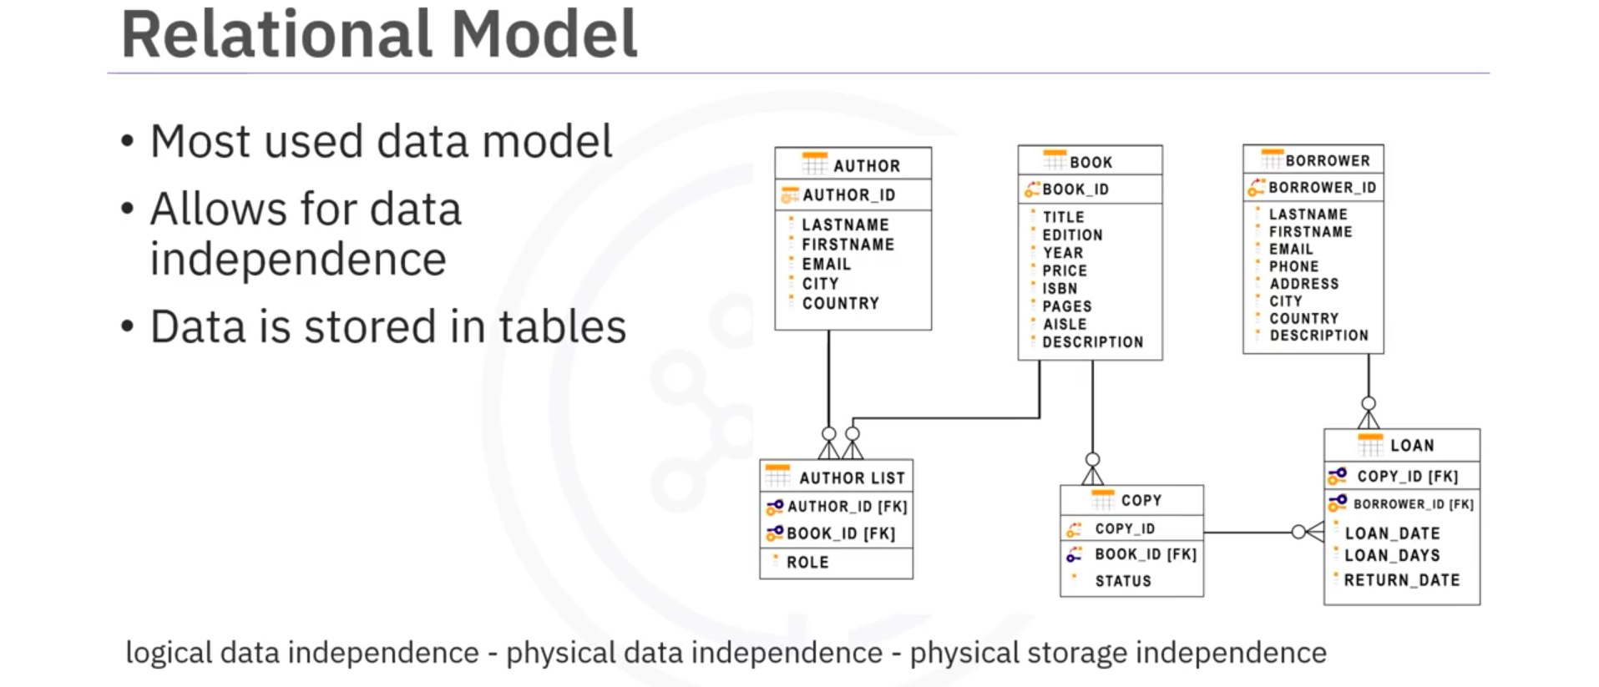
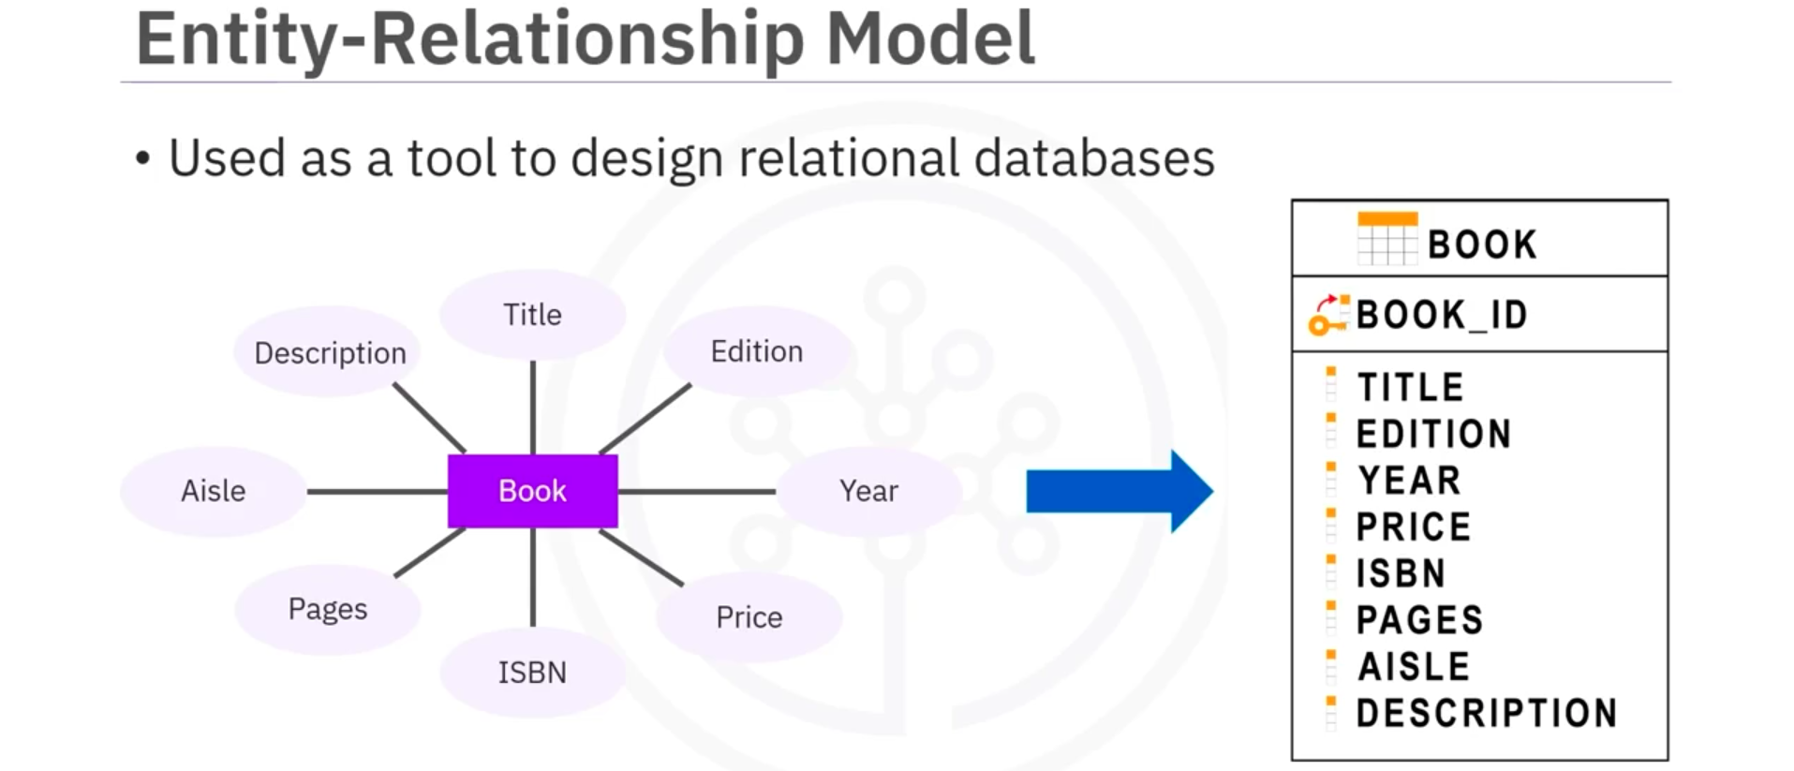
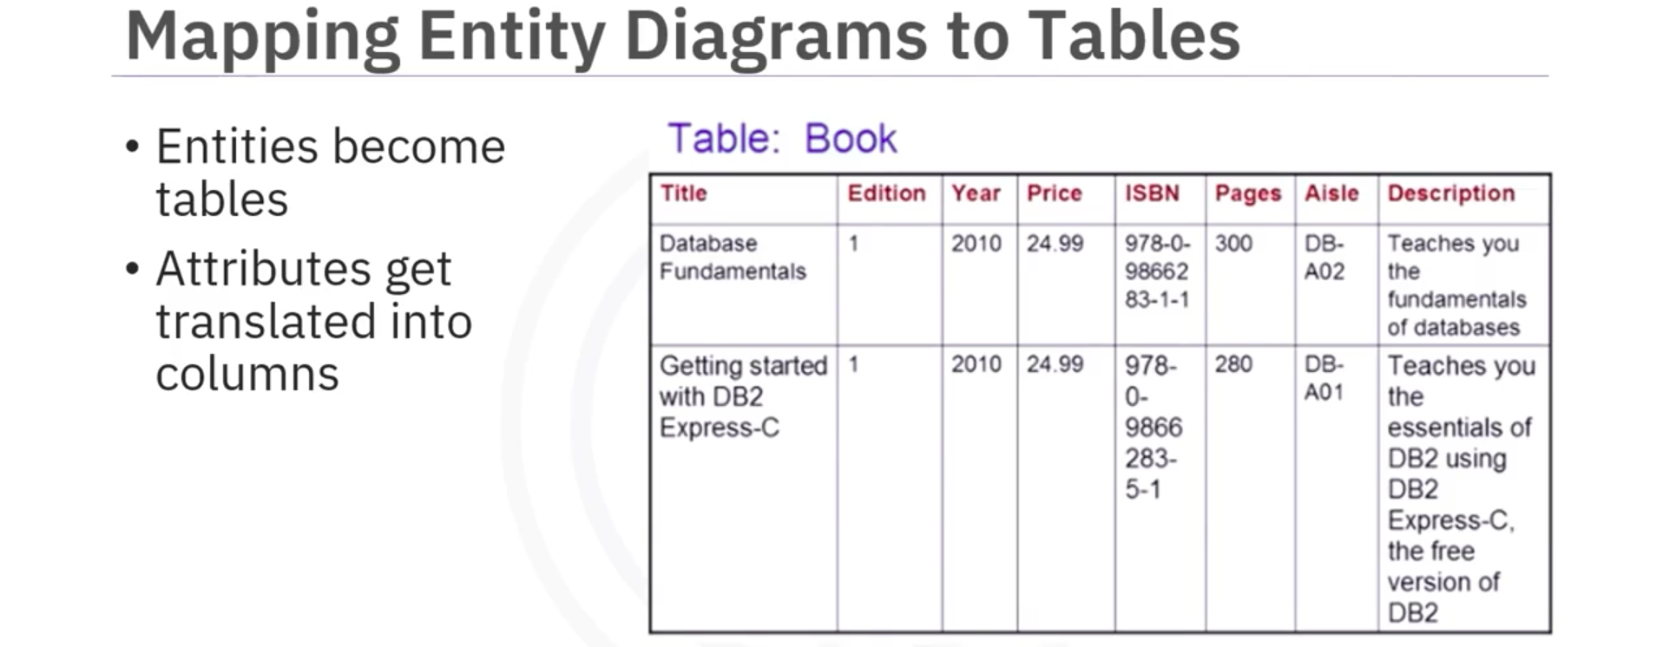
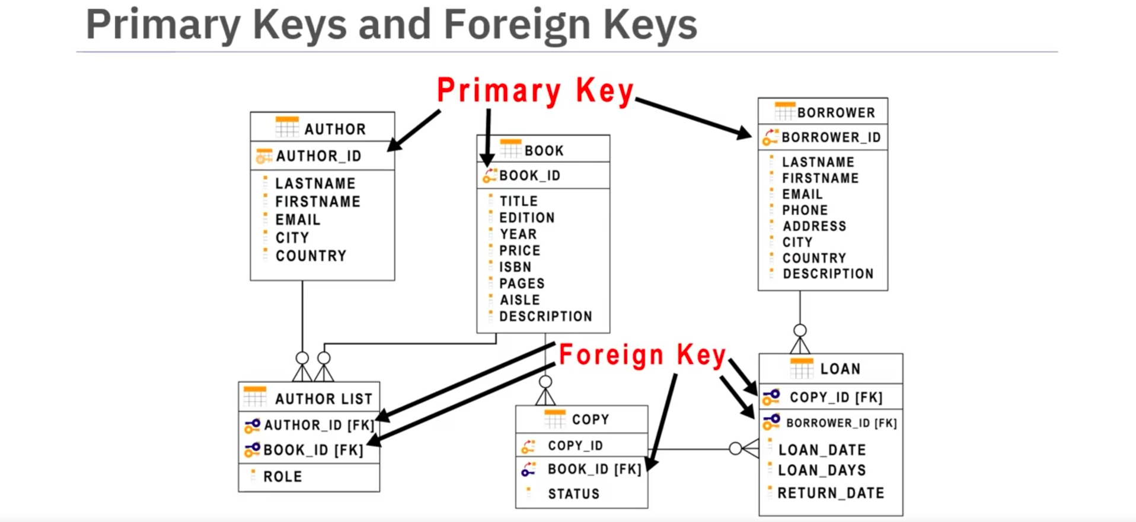
- Types of SQL statements (DDL vs DML)
DDL (Data Definition Language) statements:
- Define, change, or drop data
- Common DDL:
  - CREATE: used for creating tables and defining its columns
  - ALTER: used for altering tables including adding and dropping columns and modifying their data types
  - TRUNCATE: used for deleting data in the table but not the table itself
  - DROP: used for deleting tables
DML (Data Manipulation Language) statements:
- Read and modify data
- CRUD operations (Create, Read, Update, and Delete rows)
- Common DML:
  - INSERT: used for inserting a row or several rows of data into a table
  - SELECT: reads or selects row or rows from a table
  - UPDATE: adds a row or rows in a table
  - DELETE: removes a row or rows in a table

- CREATE TABLE Statement
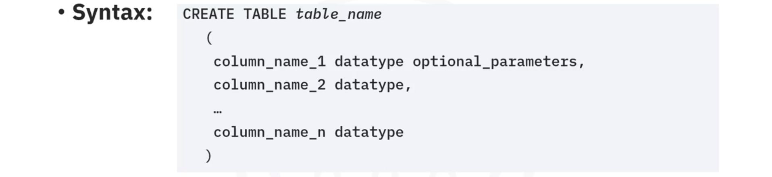
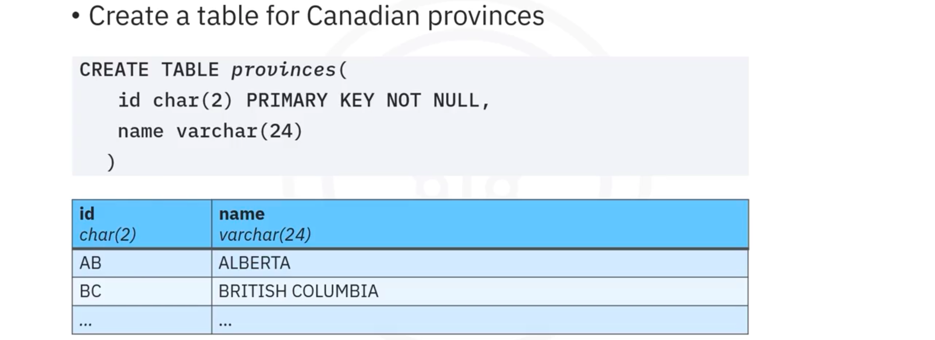

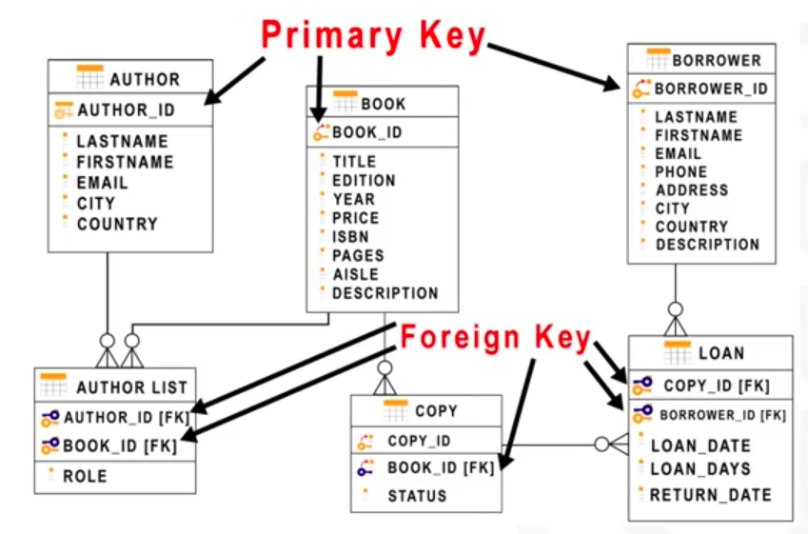
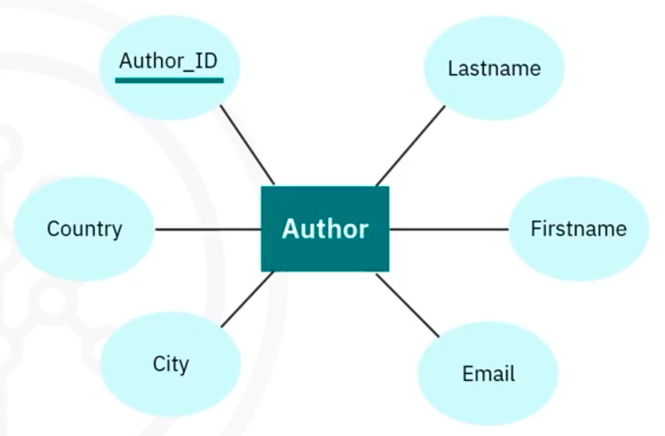
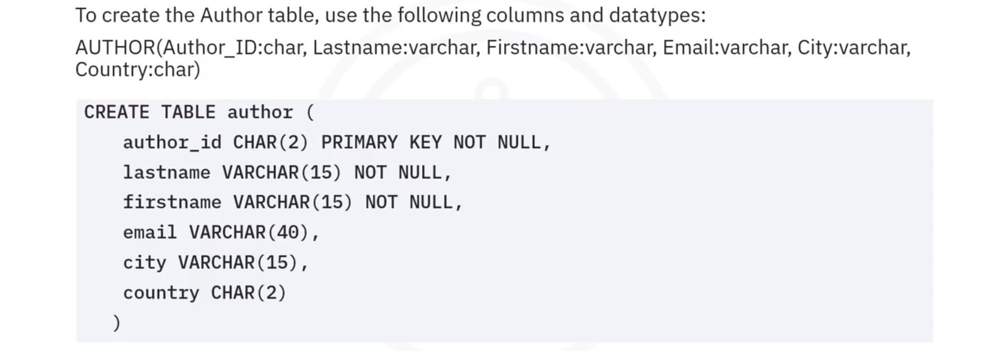

- ALTER, DROP, and Truncate Tables
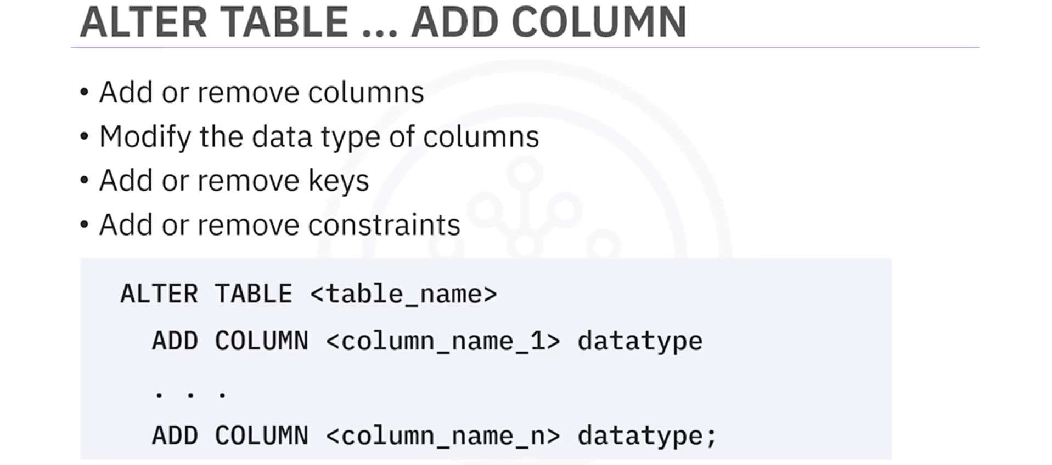
MODIFY: Change the datatype of a column
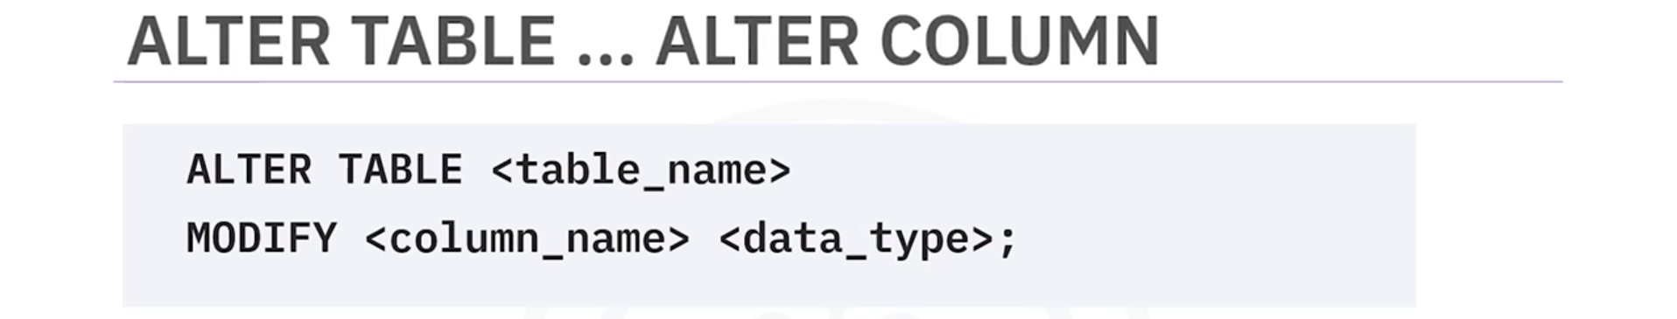
DROP COLUMN: Delete a column in a table
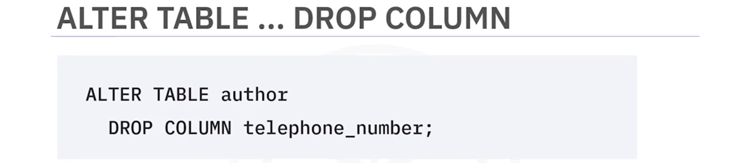
DROP TABLE: Delete the table and its content
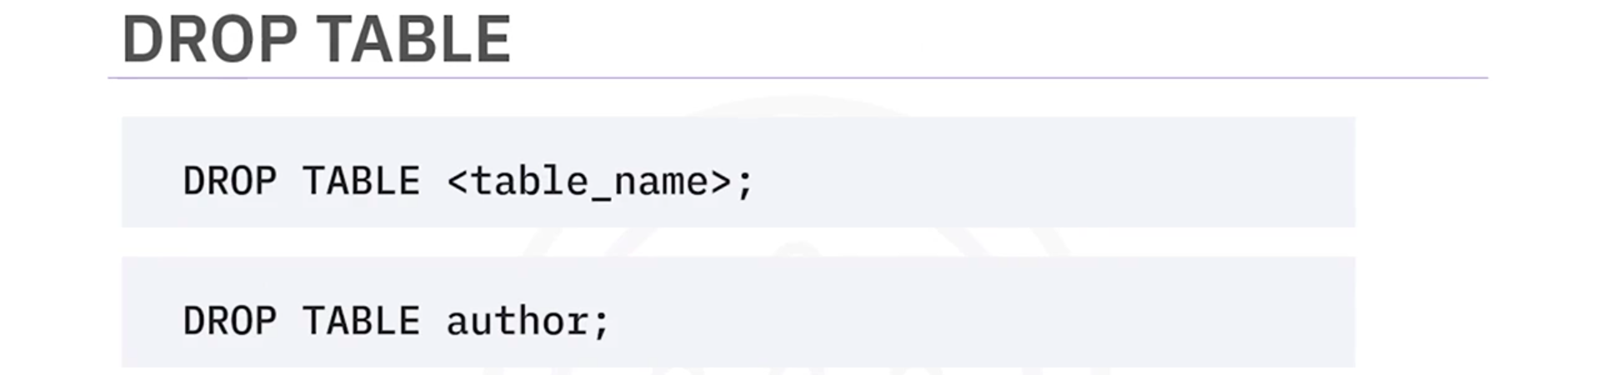
TRUNCATE TABLE: Delete the content of the table but not the table
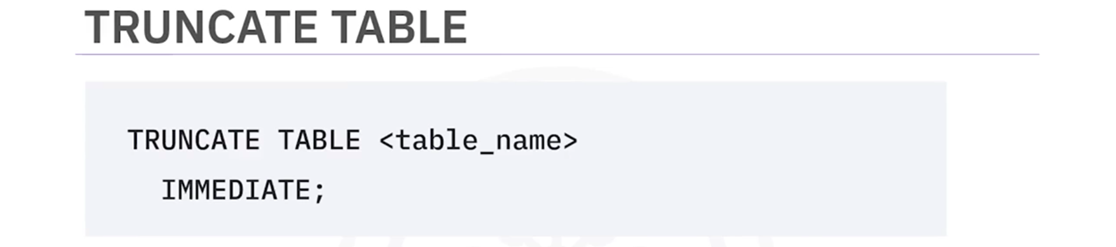

- SQL Scripts – Uses and Applications
Link
- SQL Cheat Sheet: CREATE TABLE, ALTER, DROP, TRUNCATE
Link

