Exploratory Data Analysis
- Exploratory Data Analysis
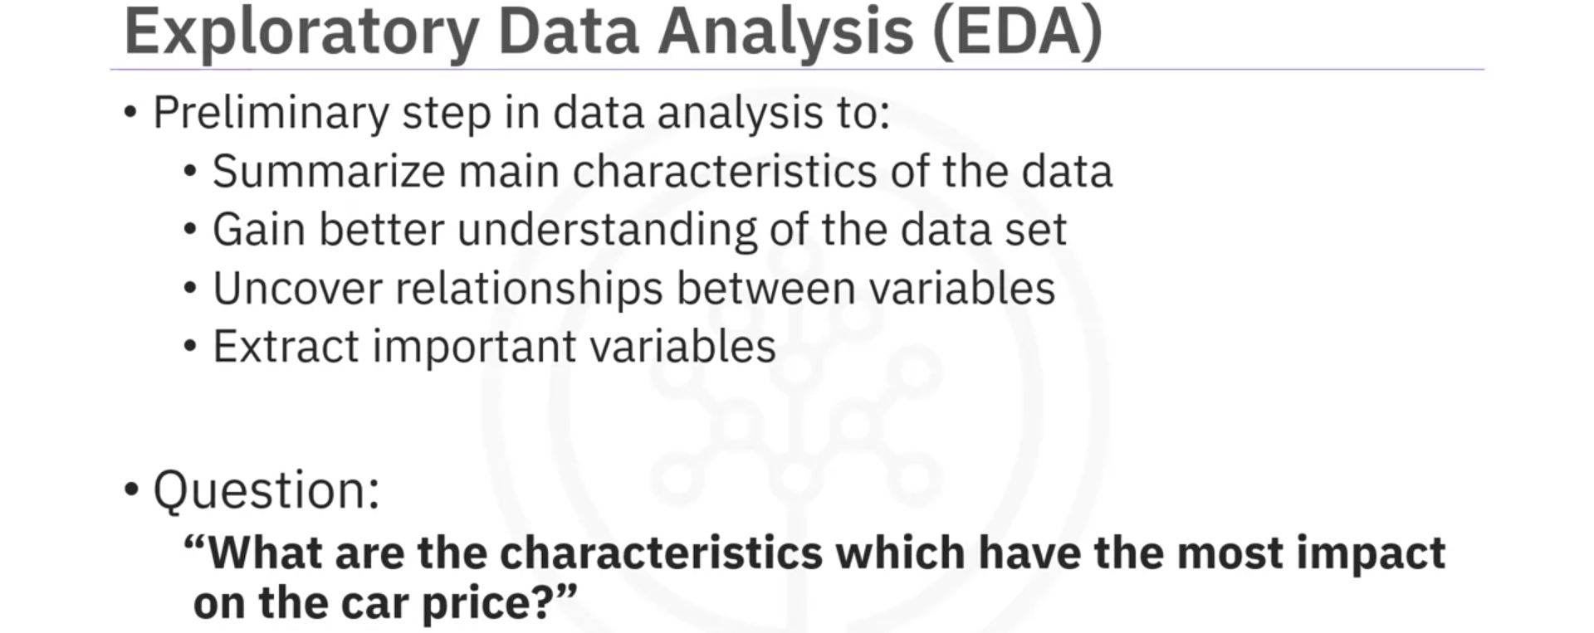

- Descriptive Statistics
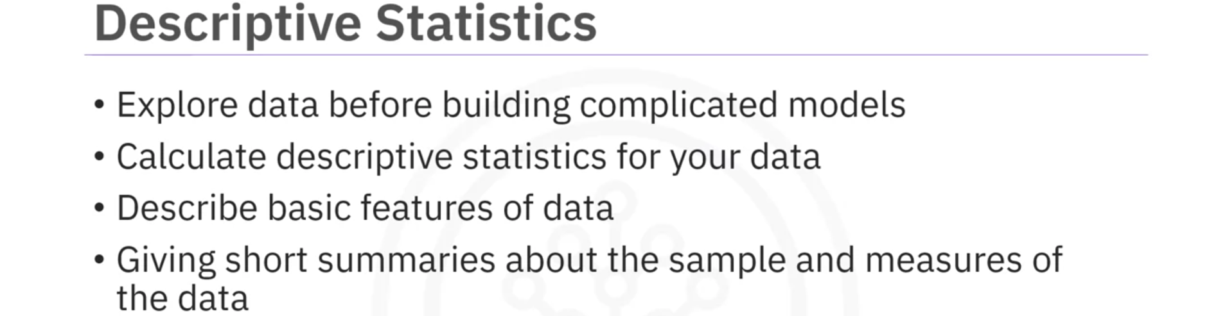
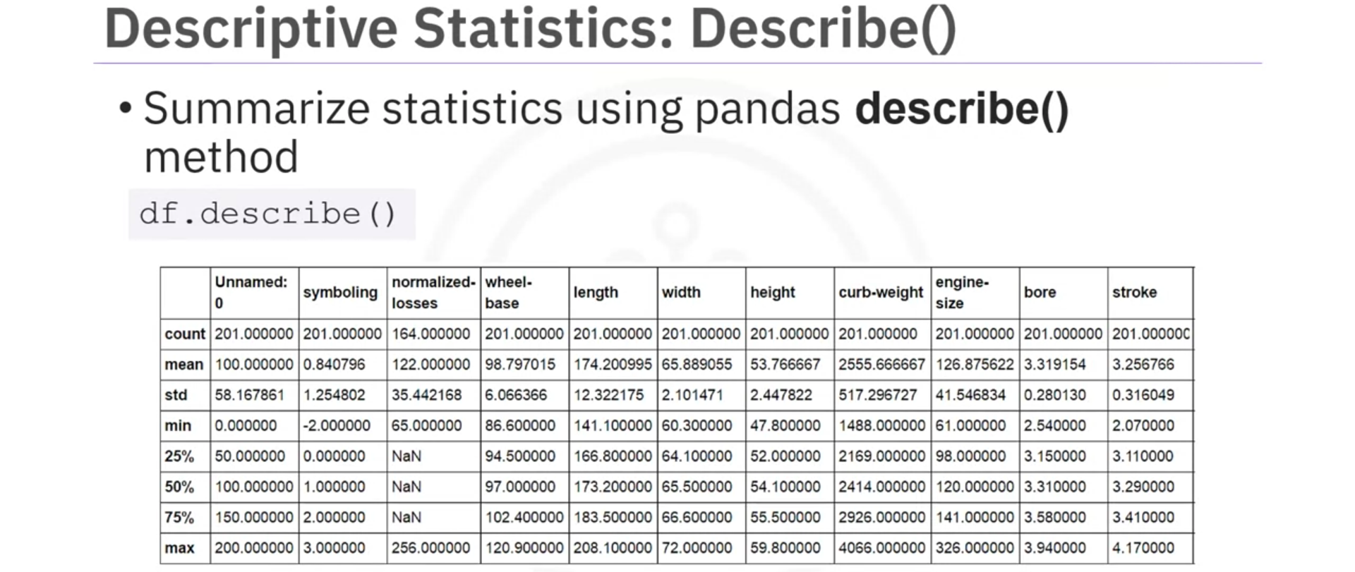
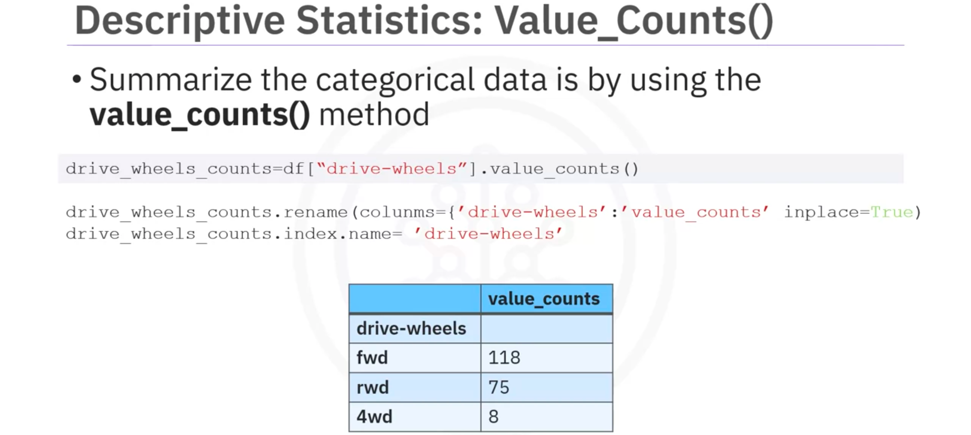
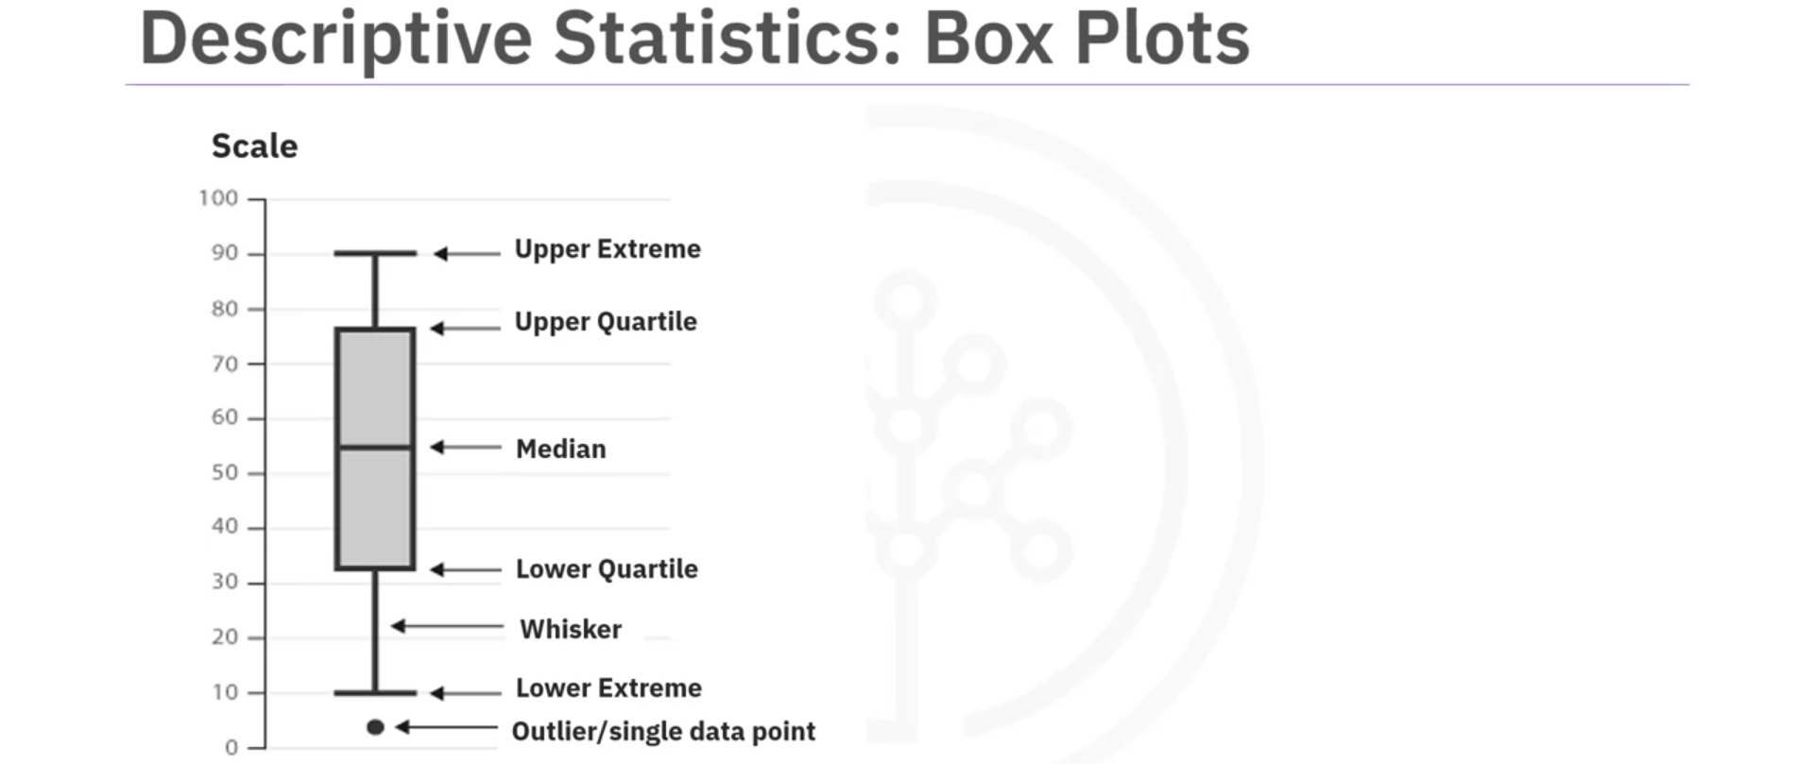
- Median: represents where the middle data point is
- Upper Quartile: shows where the 75th percentile is
- Lower Quartile: shows where the 25th percentile is
- Inter-quartile Range (IQR): represents the data between the Upper and Lower Quartile
- Lower/Upper Extremes: These are calculated as 1.5 times the IQR above the 75th percentile and as 1.5 times the IQR below the 25th percentile
- Outliers: Individual dots that occur outside the upper and lower extremes.
=> With Box Plot, you can easily spot outliers and also see the distribution and skewness of the data.
Box Plots make it easy to compare between groups
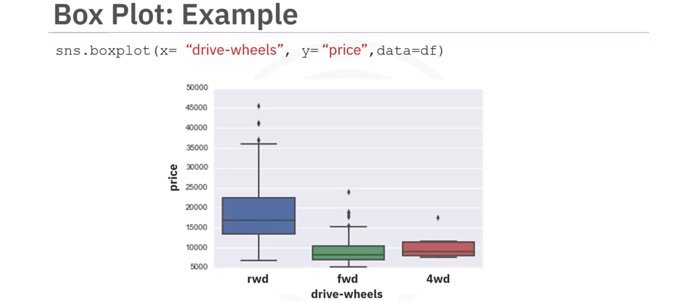
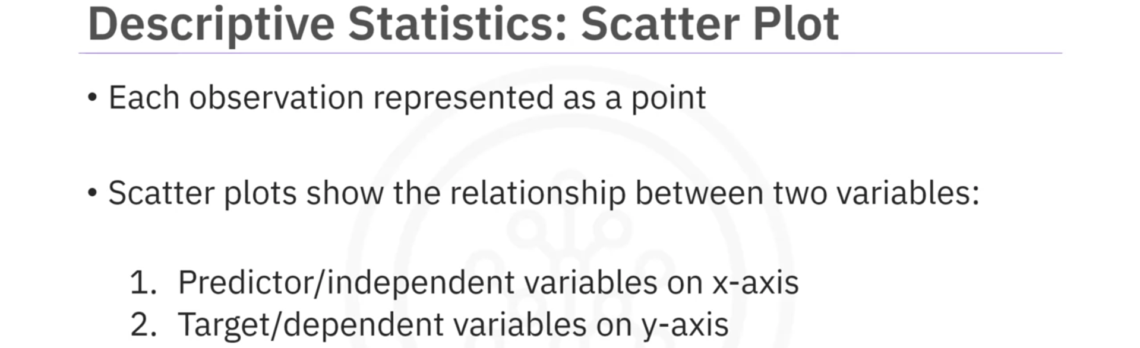
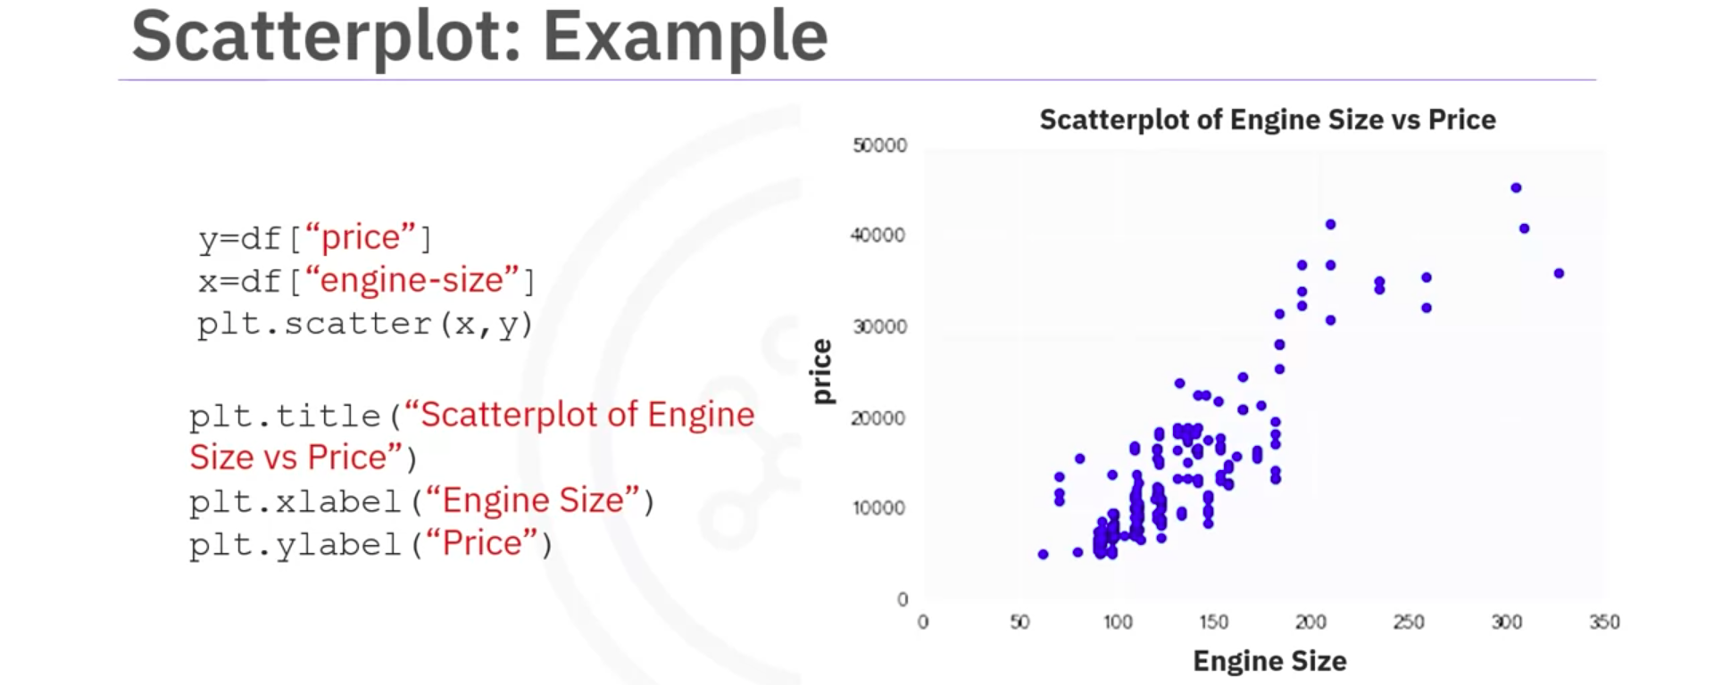

- GroupBy in Python
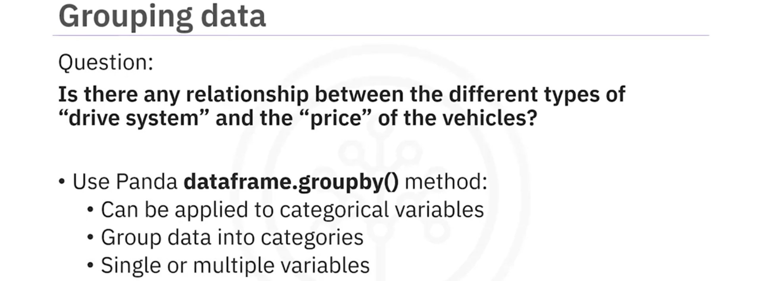
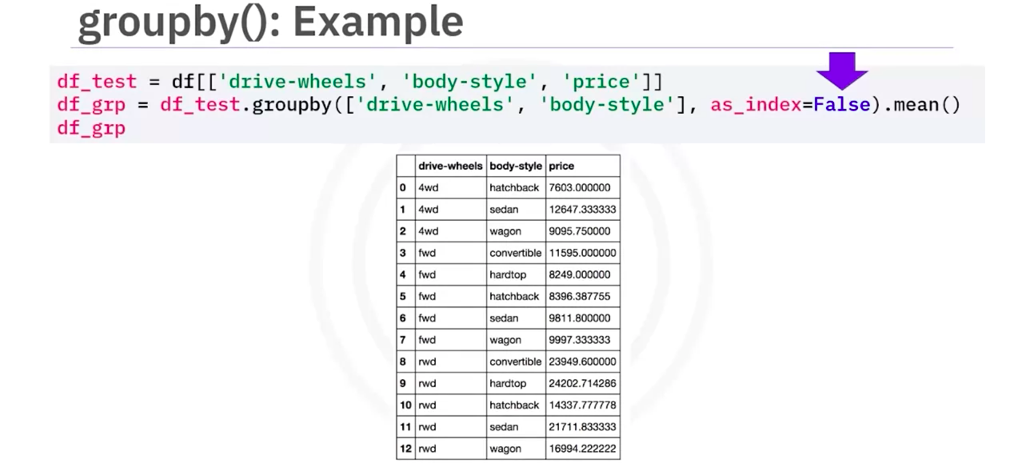
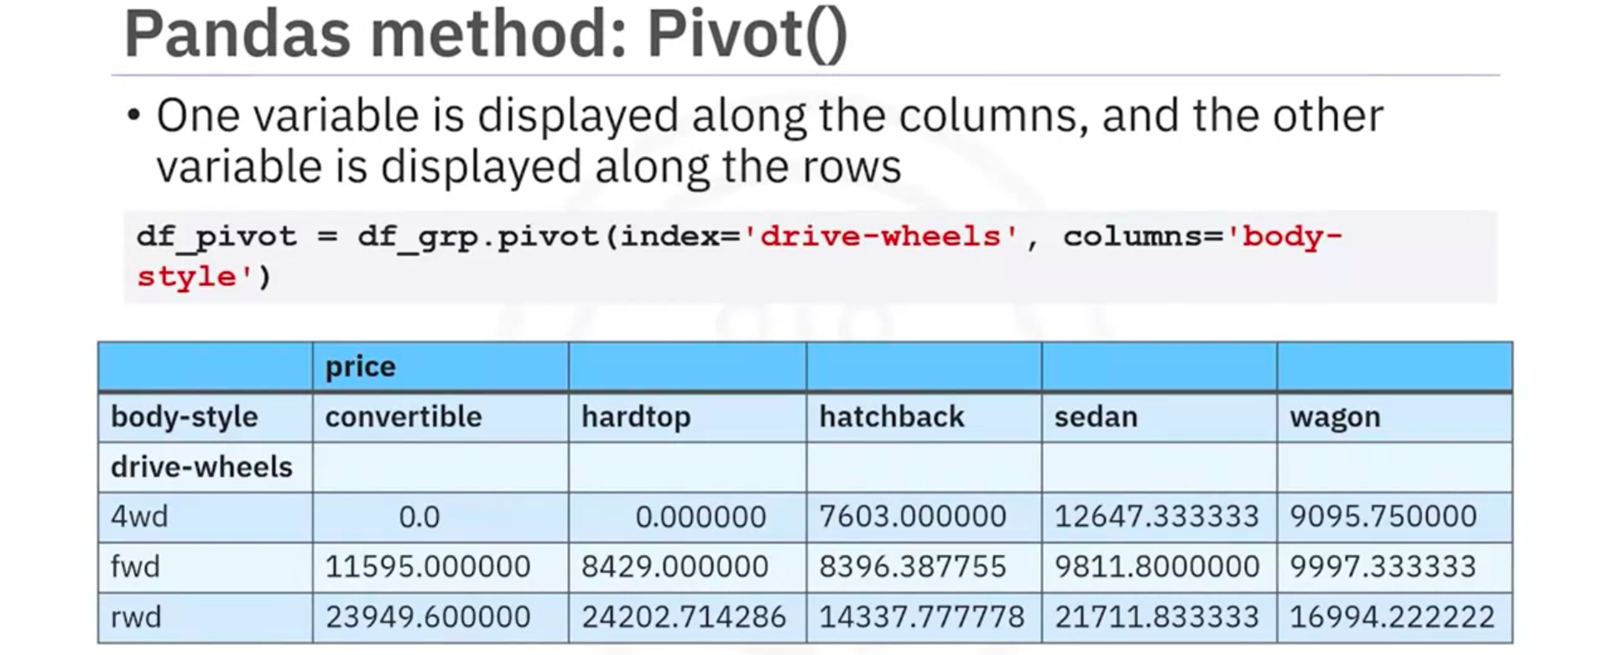
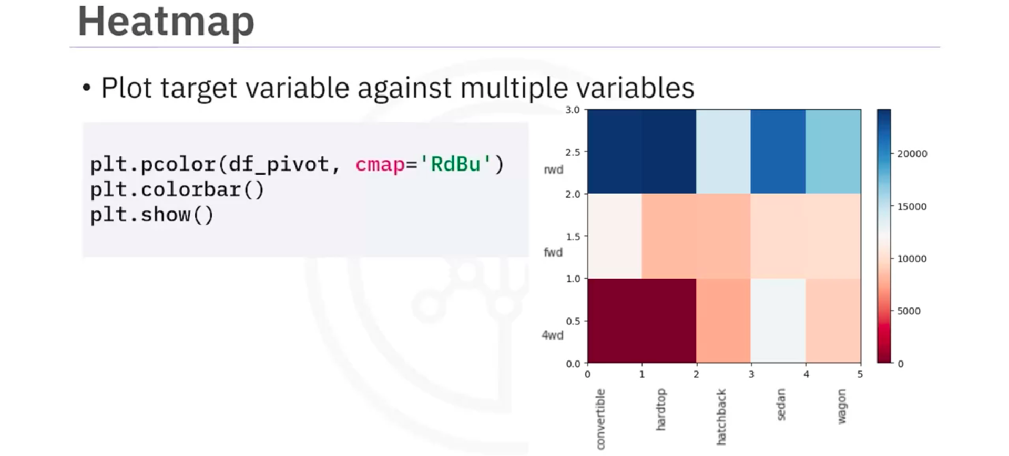

- Creating Different Types of Plots in Python
Link
- Correlation
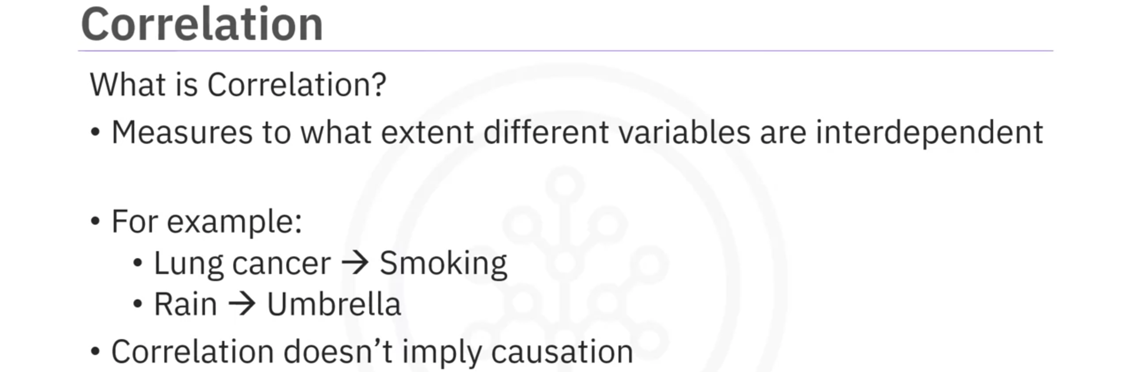
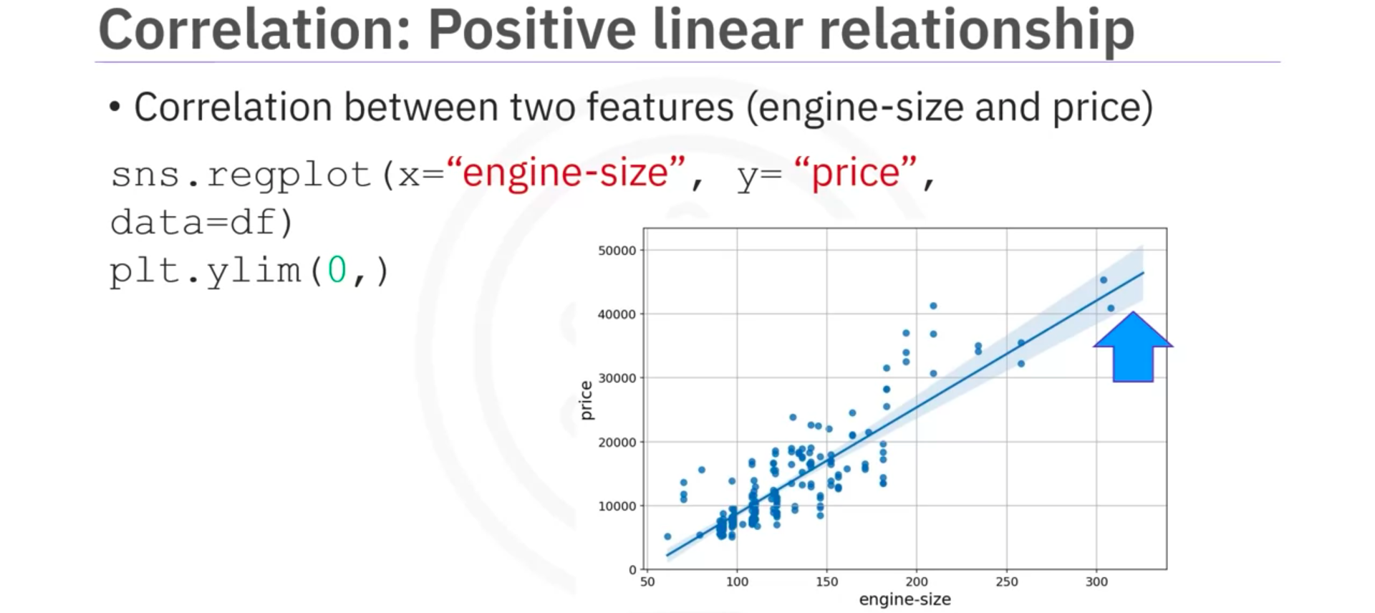
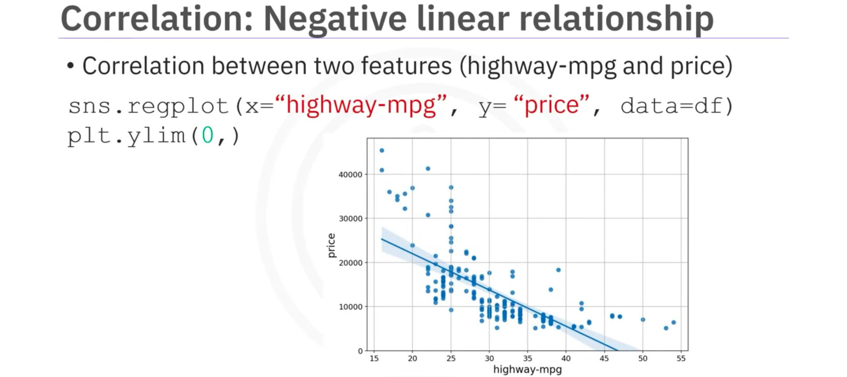
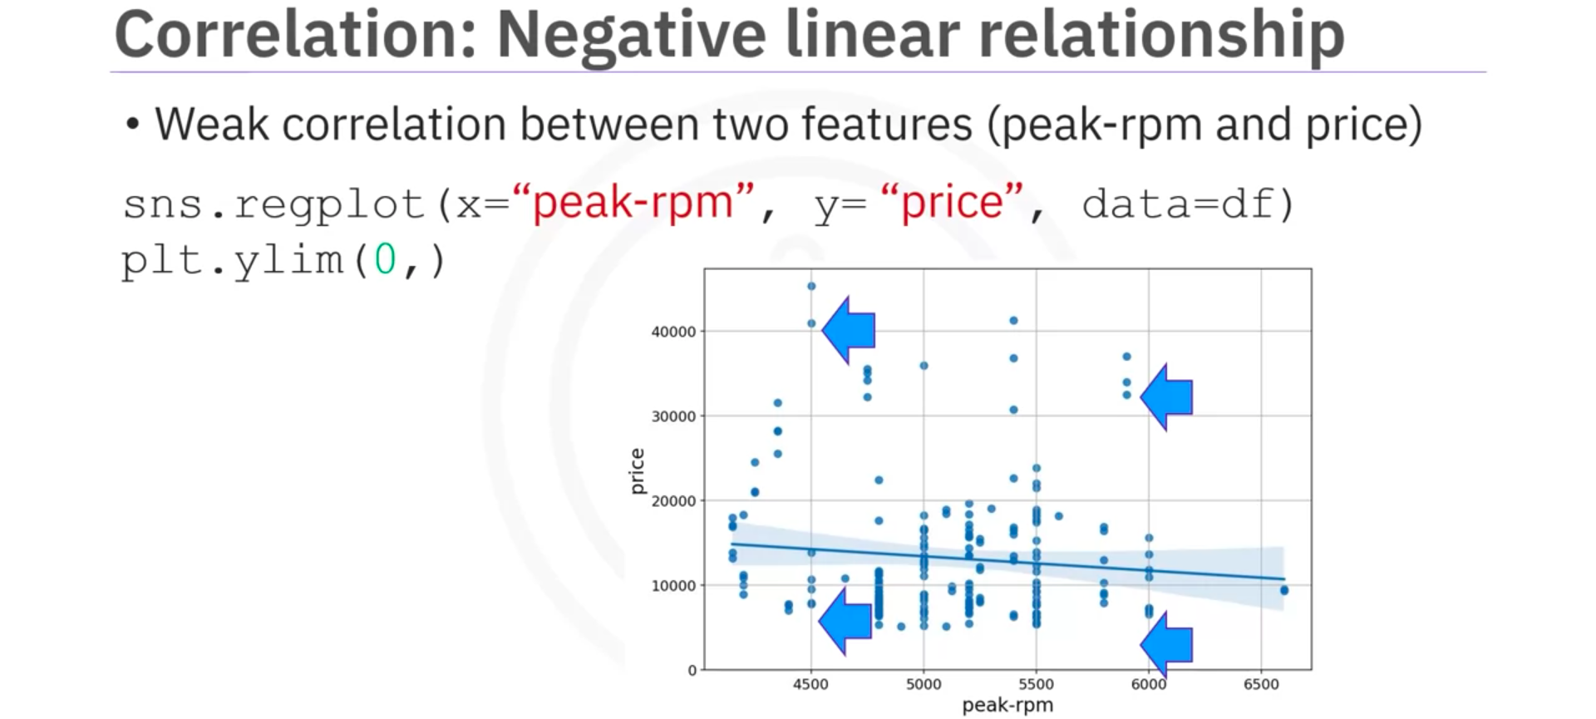

- Correlation – Statistics
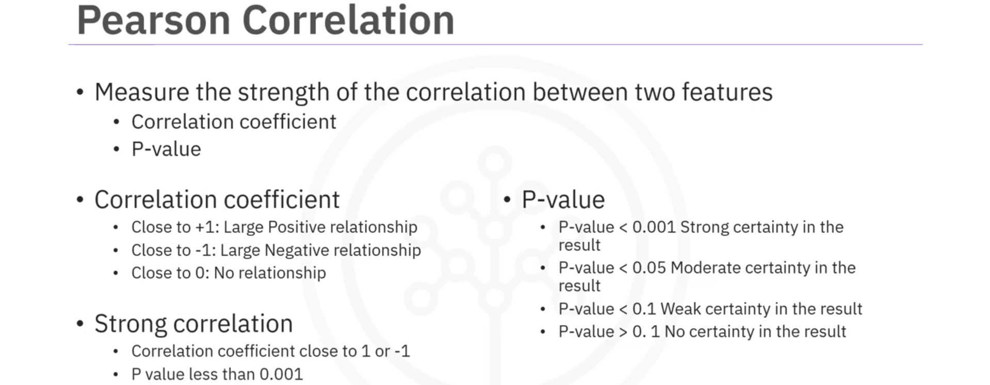
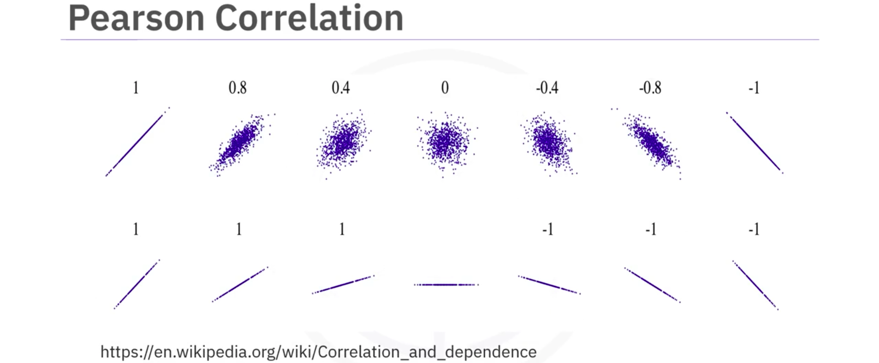
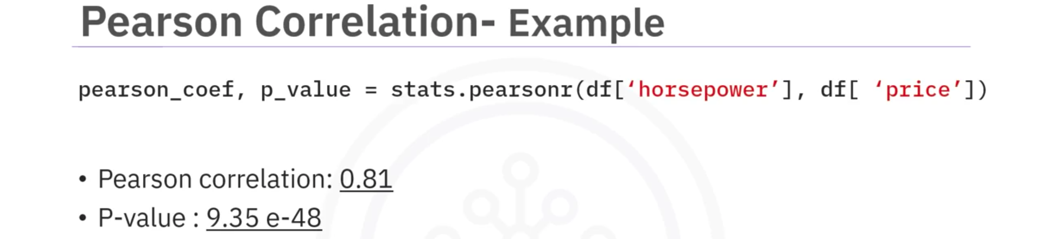
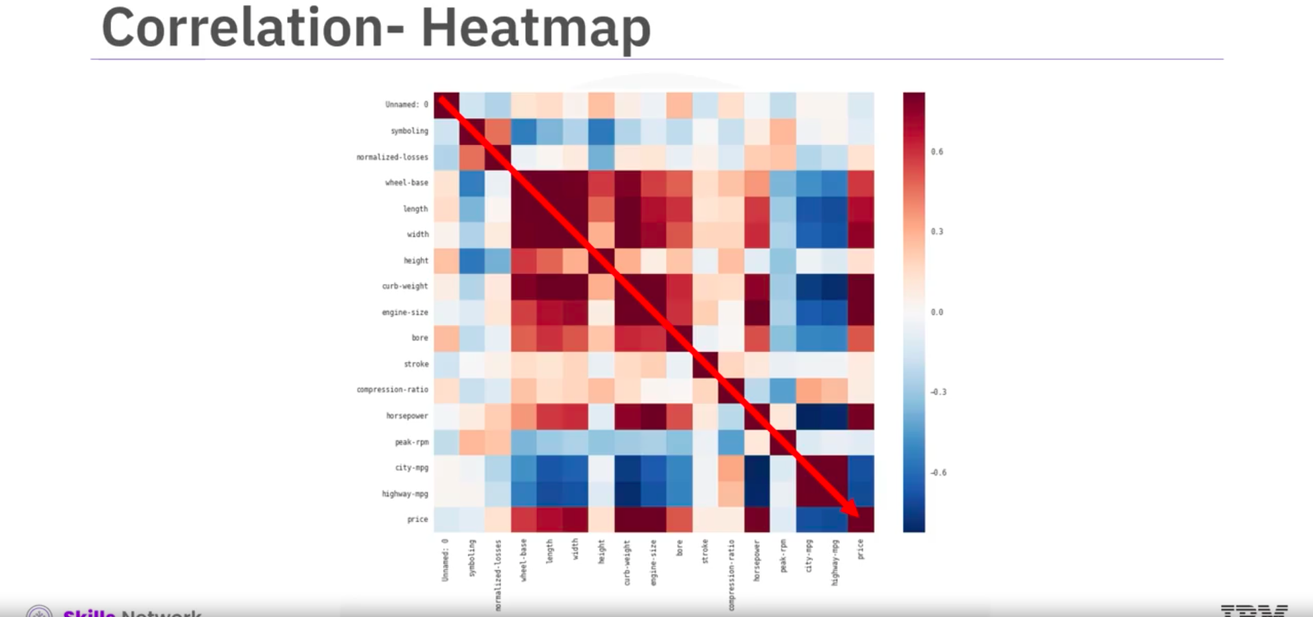

- Chi-square Test for Categorical Variables
Link

