Model Evaluation and Refinement
- Model Evaluation and Refinement
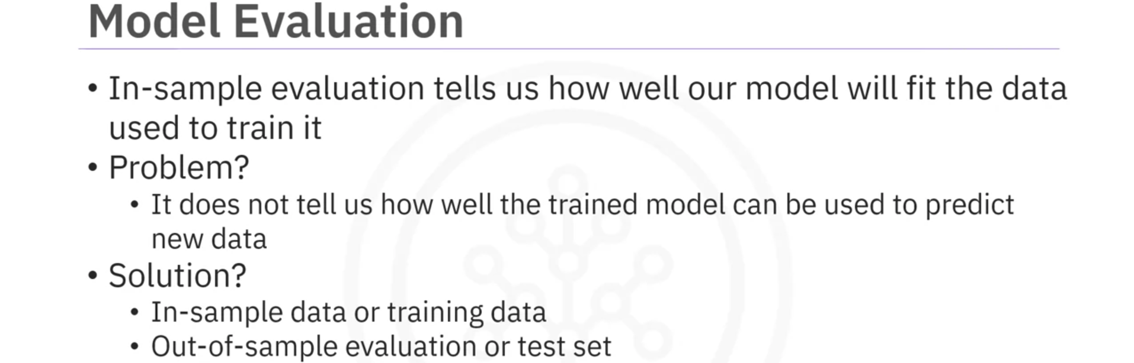
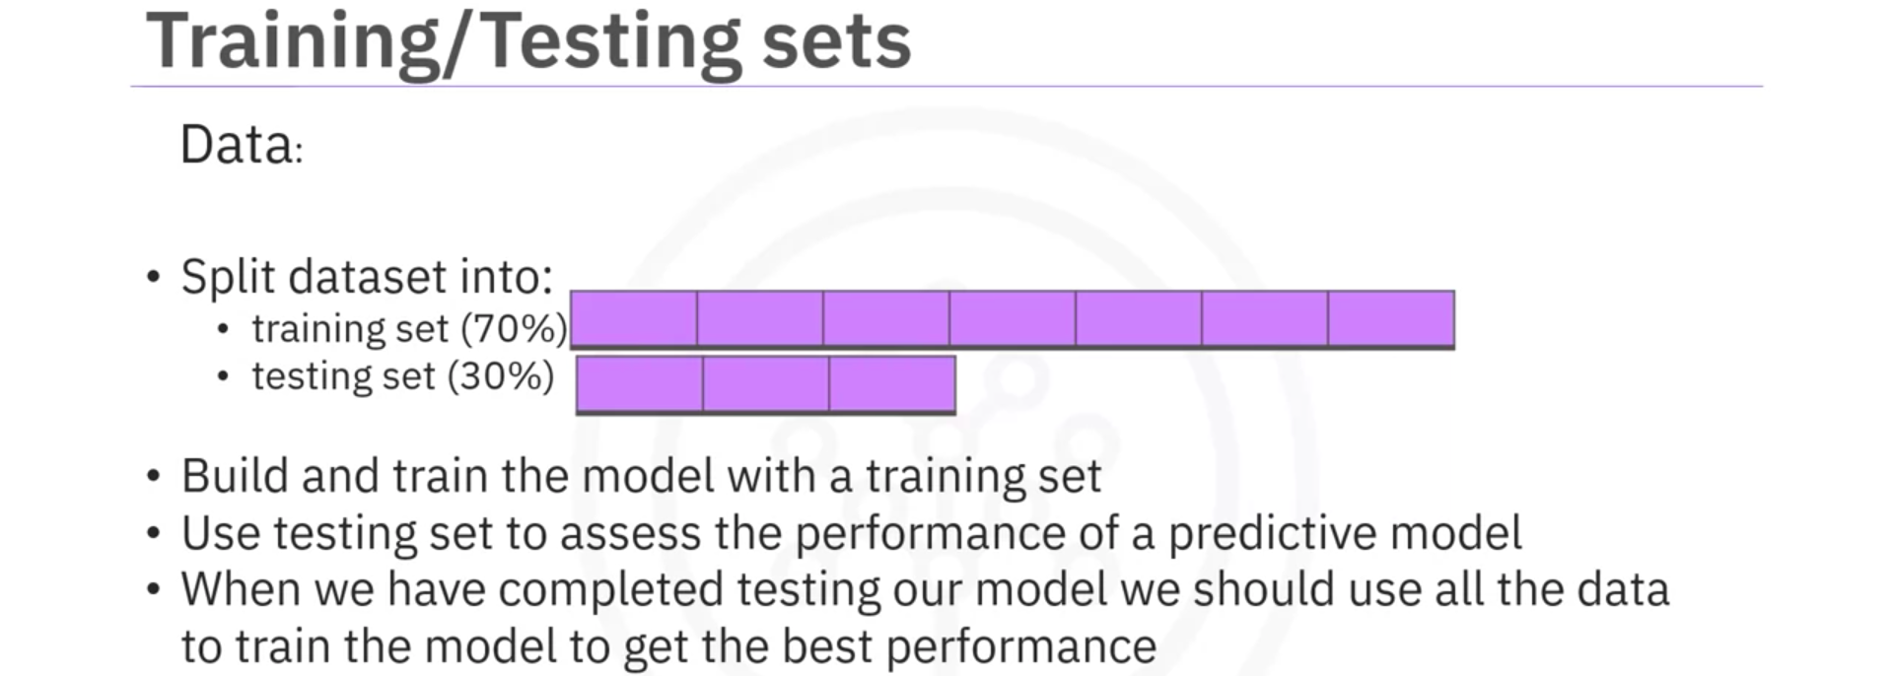
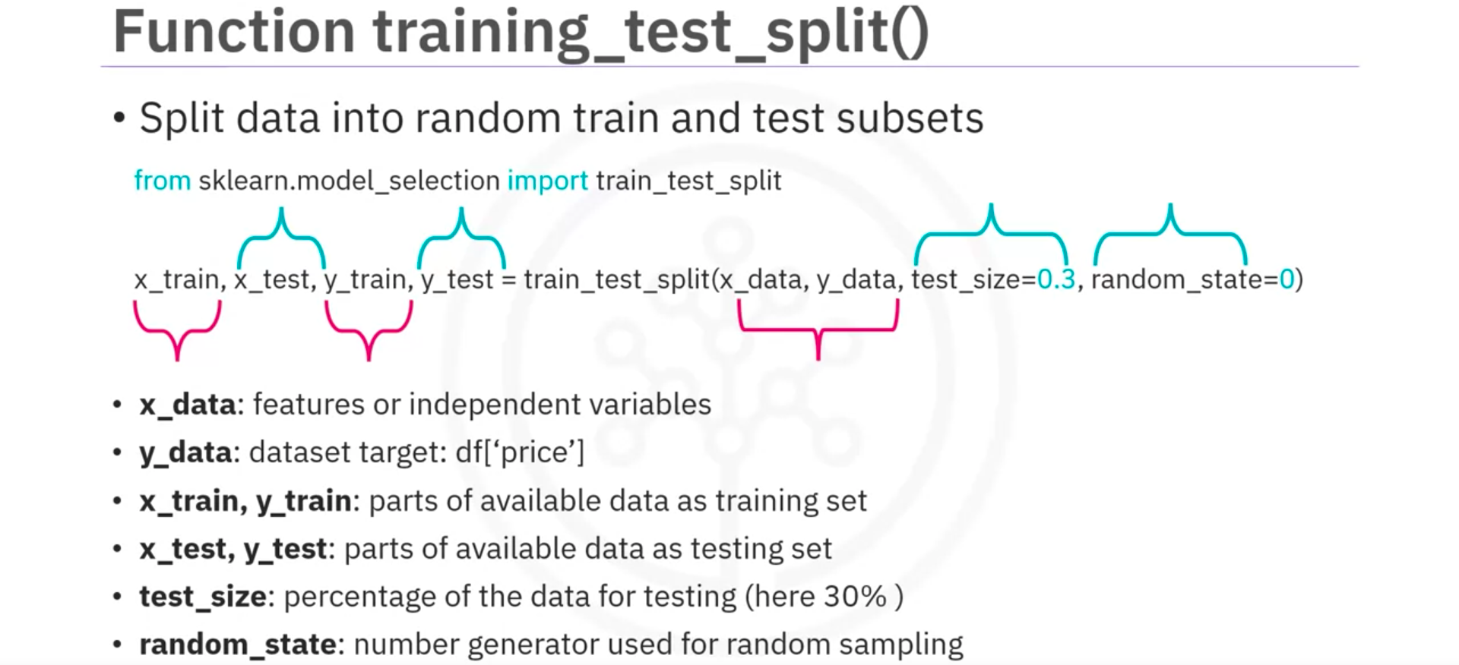
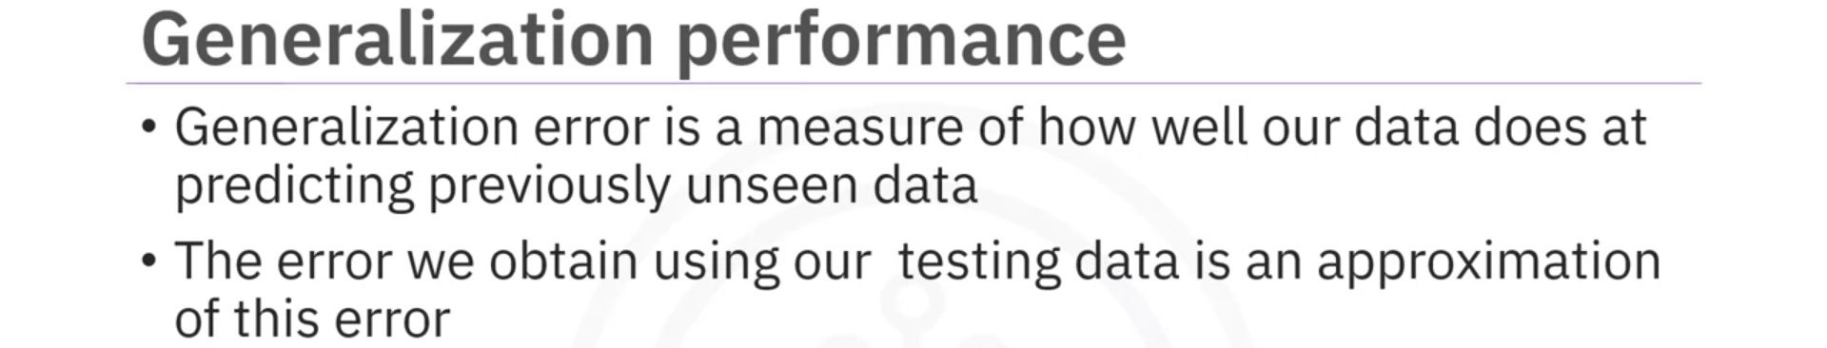
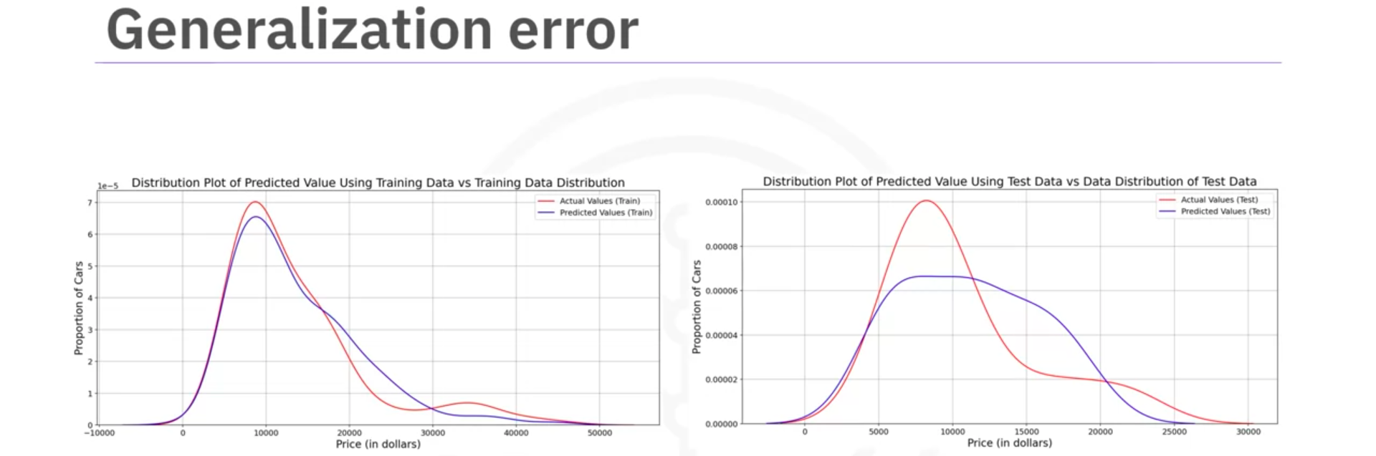
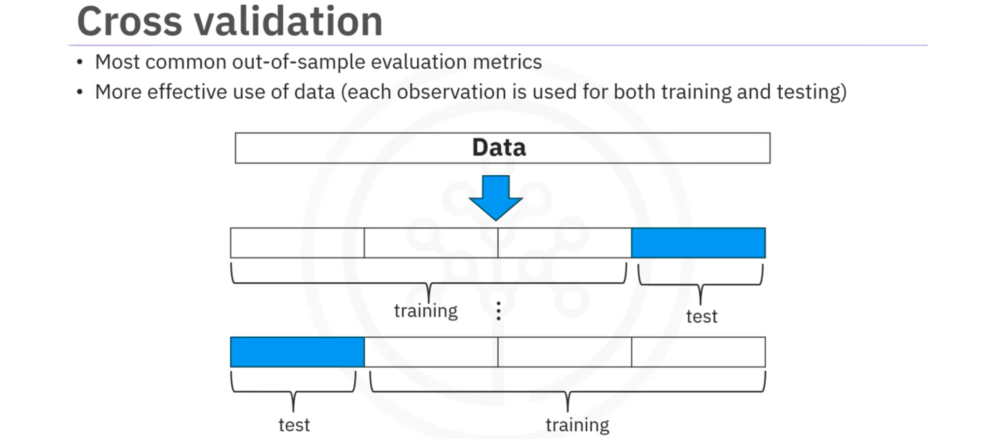
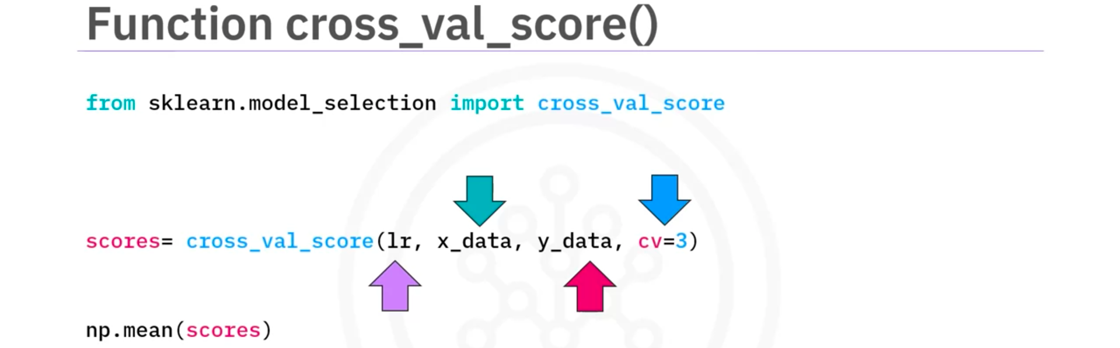
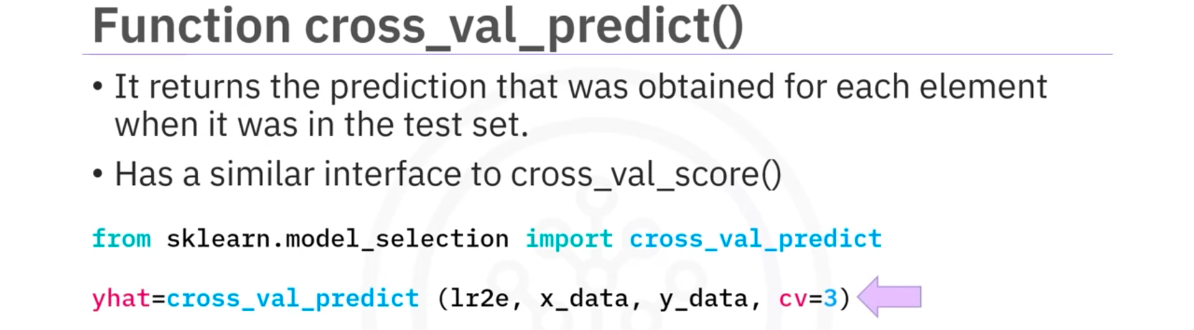

- Overfitting, Underfitting and Model Selection
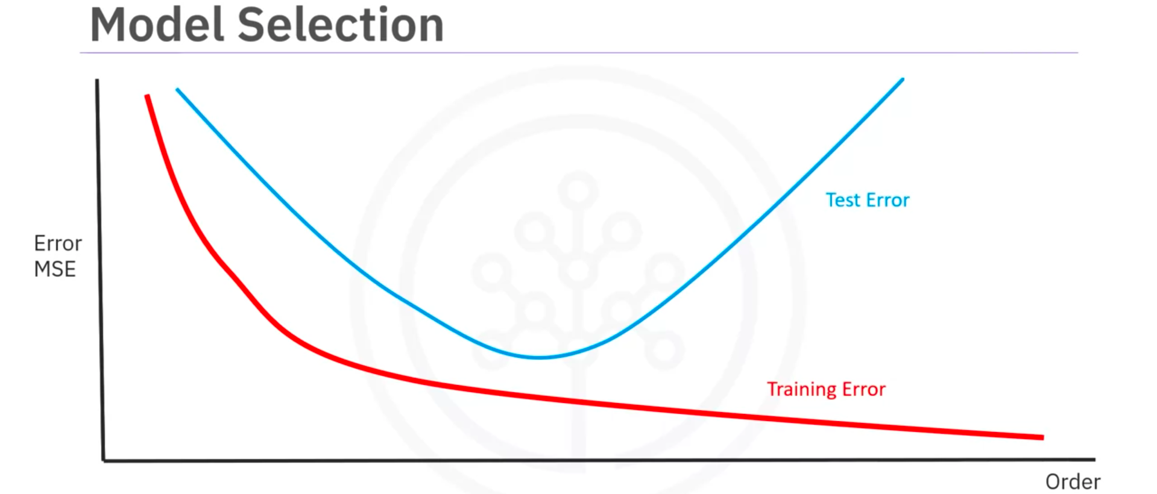
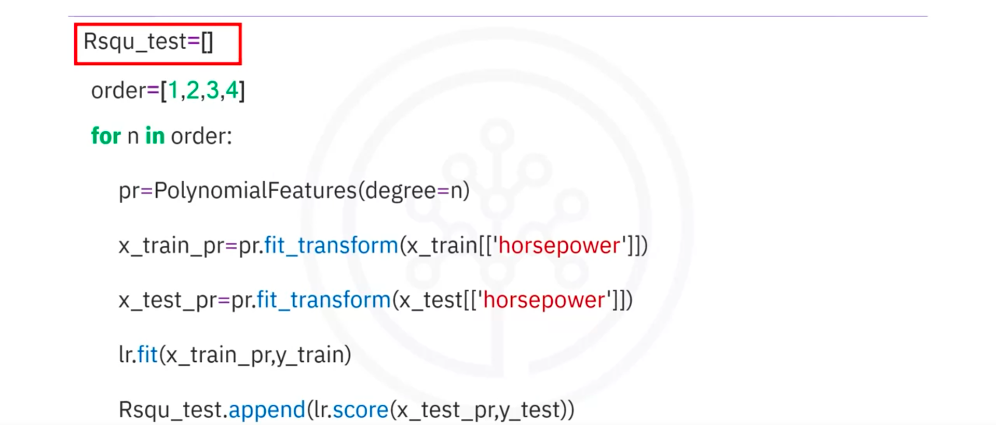

- Introduction to Ridge Regression
For models with multiple independent features and ones with polynomial feature extrapolation, it is common to have colinear combinations of features. Left unchecked, this multicollinearity of features can lead the model to overfit the training data. To control this, the feature sets are typically regularized using hyperparameters.

Ridge regression is the process of regularizing the feature set using the hyperparameter alpha. The upcoming video shows how Ridge regression can be utilized to regularize and reduce standard errors and avoid over-fitting while using a regression model.

- Ridge Regression
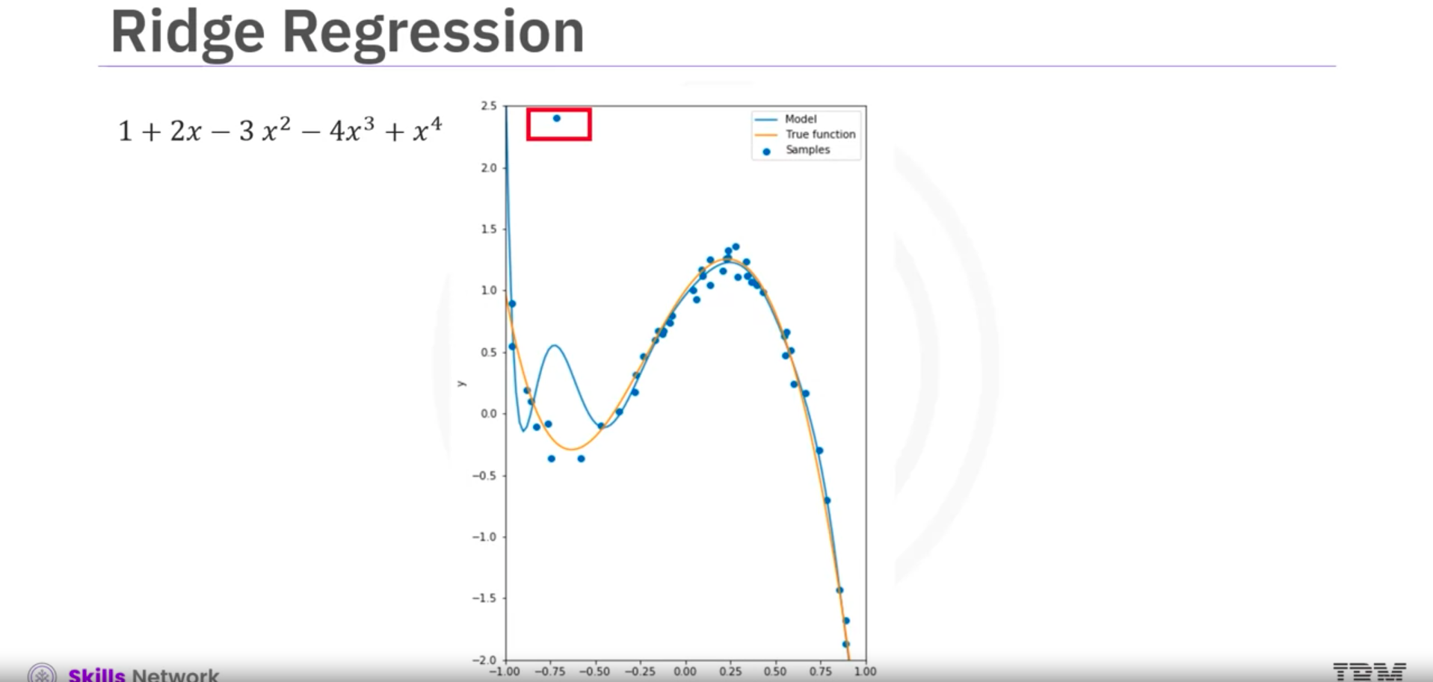
Real life data has outliers that can screw up the prediction model. The blue function doesn’t closely resemble the orange function.
If we examine the expression of the estimated function, we see the estimated polynomial coefficients have a very large magnitude.
Ridge Regression controls these polynomial coefficients by introducing the parameter Alpha. Alpha is a parameter we select before fitting or training the model.
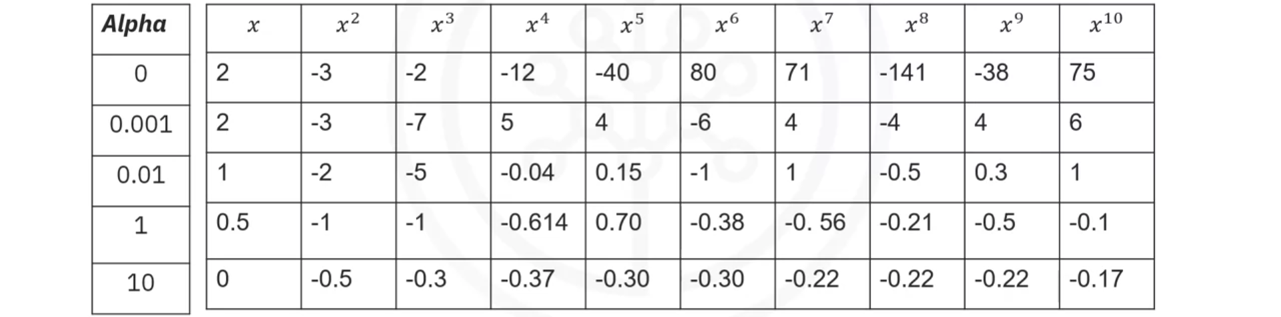
As Alpha increases, the parameters get smaller. But Alpha must be select carefully. If Alpha is too large, the coefficient will approach zero and and underfit the data. To select the Alpha, we use Cross Validation
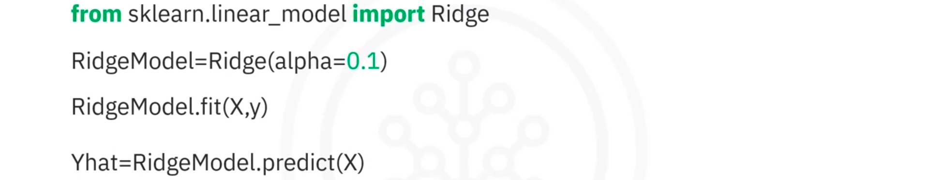
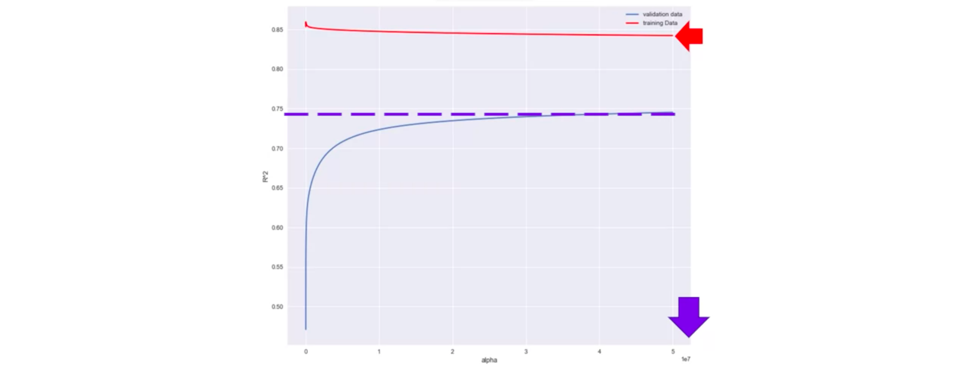

- Grid Search
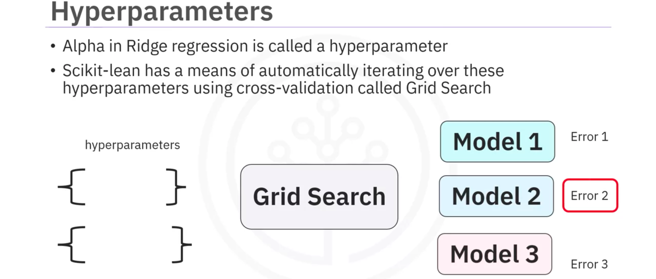
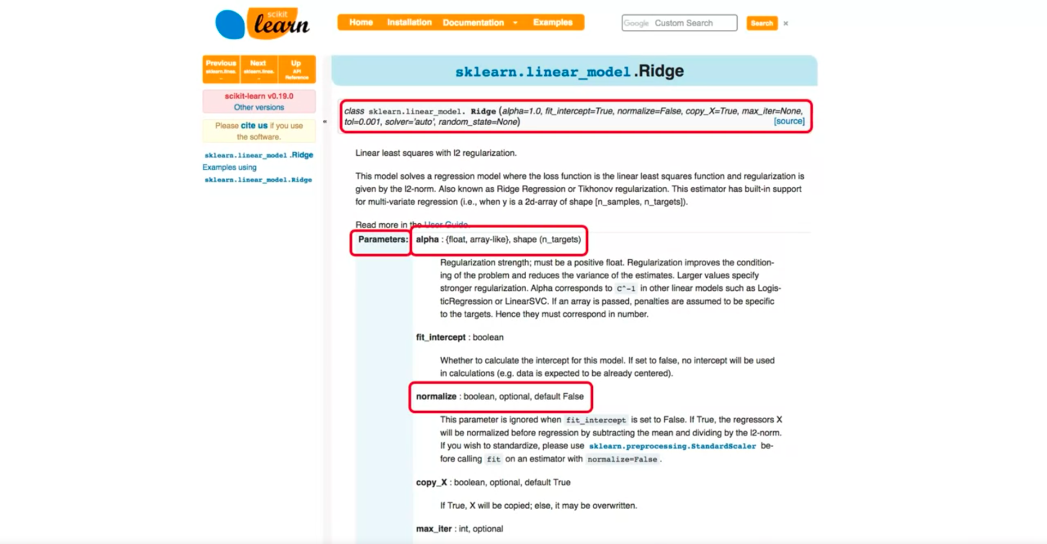
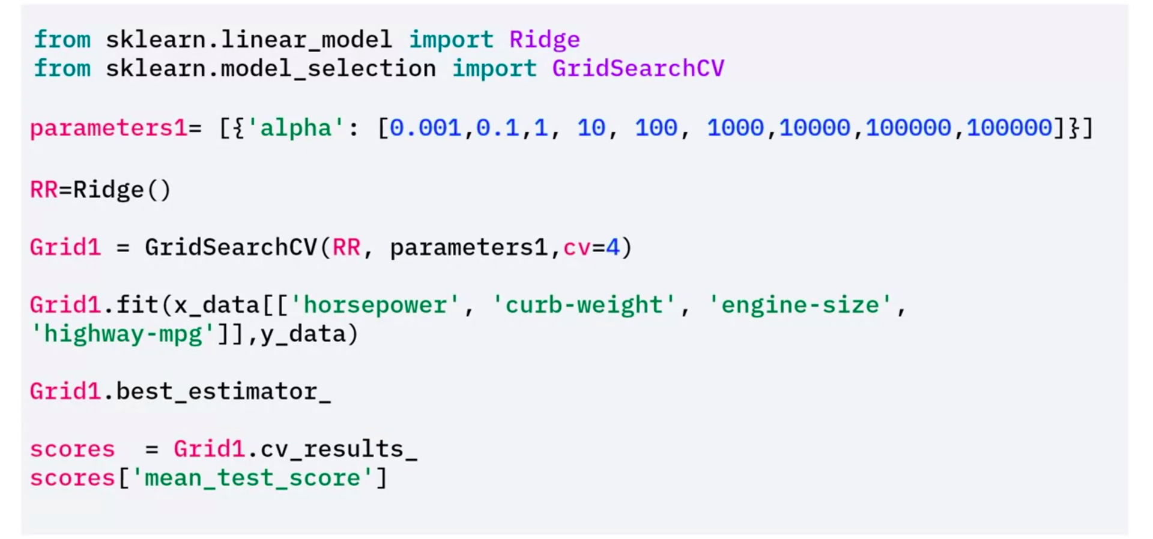
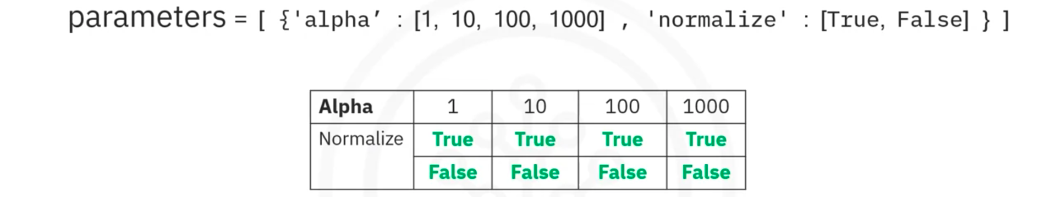
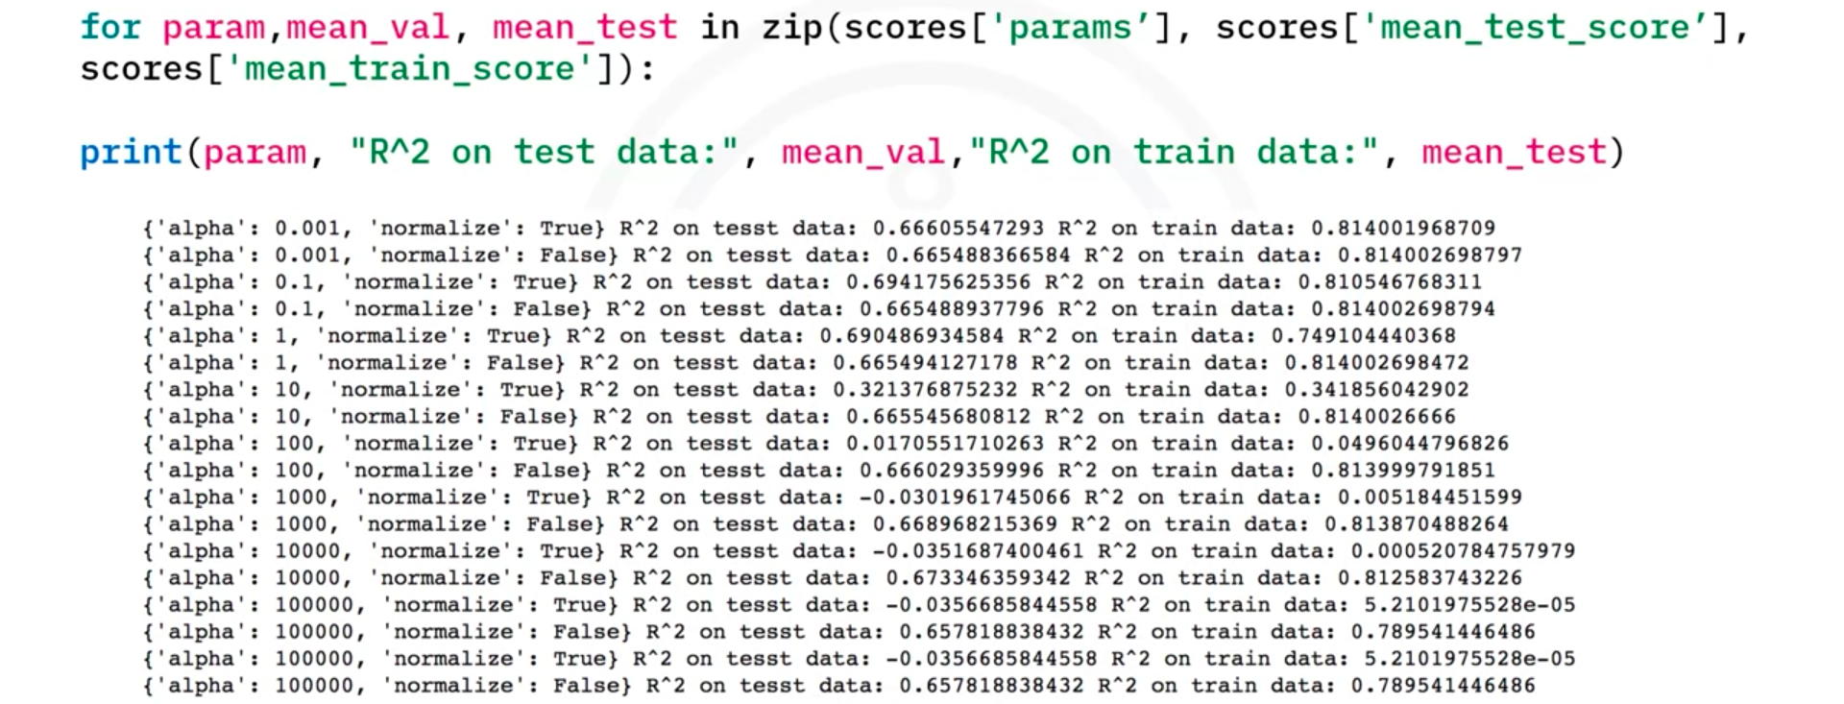

- Summary

