Snake: Personal Project - Simple Micro-controller
Architecture and Implementation

Change History
Date | Revision | Change | Author
... | 1.0 | First release | Long Nguyen

Contents

List of Figures

List of Tables

Preface
This document describes the architecture, operation and the implementation of a simple micro-controller which is built for personal study purpose.

Chapter 1: Introduction

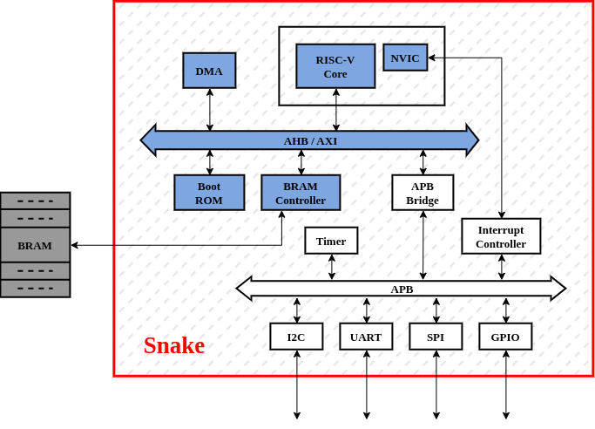
Table 1 - Snake Top block diagram
<Some introductions about main function>
Features:
- RISC-V privileged M-mode 32I core
- DMA supports
- Peripherals: I2C, UART, SPI, GPIO
- Resuable modules (each section in chapter ... can be reused as an independent design document of the corresponding top module mentioned in that section)

Chapter 2: Design Configurations
- Defines
Define | Detail | *Status
USE_AXI | Turn on this to switch to use AXI as the main bus  (currently use AHB) | Off

*Note: To ON/OFF these defines, modify ‘$PROJ_ROOT/rtl/snk_define_pkg.sv’
- Parameters
Parameter | Detail | Value

These parameters are defined in ‘$PROJ_ROOT/rtl/snk_param_pkg.sv’.

Chapter 3: Architechture and Implementation

Note: each section () in this chapter can be reused as an independent design document of the corresponding top module mentioned in that section.

<Top block diagram, more detail, focus on clk & rstn>
- Clock and Reset

- Port List
Port name | I/O | Clock | Detail
rstn | Input | --------- | Asynchronous reset, active low
clk | Input | --------- | MCU clock - 500MHz
BRAM interface --------------------------------------------------------------------------------------------------
 | Input
 | Ouput
UART interface --------------------------------------------------------------------------------------------------
 | Input
 | Ouput
I2C interface ------------------------------------------------------------------------------------------------------
 | Input
 | Ouput
SPI interface ------------------------------------------------------------------------------------------------------
 | Input
 | Ouput
GPIO interface ---------------------------------------------------------------------------------------------------
 | Input
 | Ouput

- ...

- Addressmap

