Personal Project - Simple MCU
Architecture and Implementation

Change History
Date | Revision | Change | Author
... | 1.0 | First release | Long Nguyen

Contents

List of Figures

List of Tables

Chapter 1: Introduction
<Some introductions about main function>
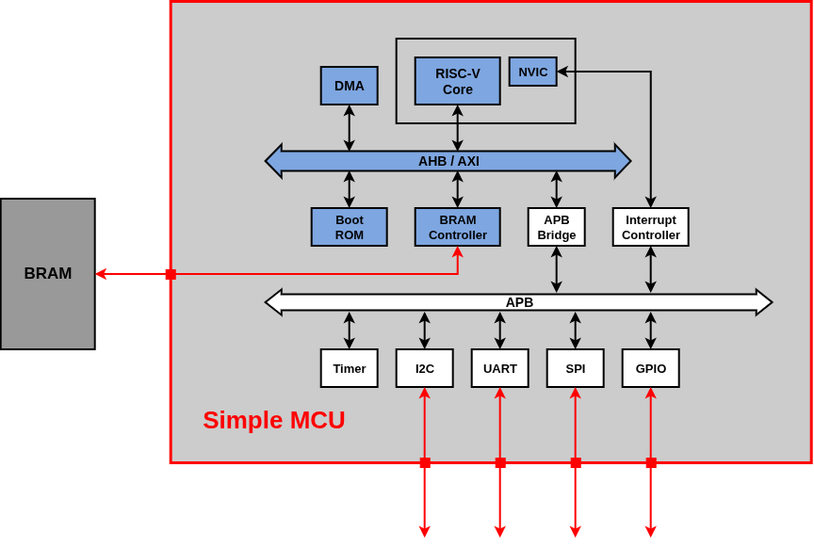
Figure 1 - Top block diagram
Features:
- RISC-V privileged M-mode 32I core
- DMA supports
- Peripherals: I2C, UART, SPI, GPIO

Chapter 2: Design Configurations
- Defines
Table 1 - Top define macros
Define | Detail | *Status
USE_AXI | Turn on this to switch to use AXI as the main bus  (currently use AHB) | Off

*Note: To ON/OFF these defines, modify ‘${PROJ_ROOT}/rtl/spmcu_define_pkg.sv’
- Parameters
Table 2 - Top parameters
Parameter | Detail | Value

These parameters are defined in ‘${PROJ_ROOT}/rtl/spmcu_param_pkg.sv’.

Chapter 3: Architechture and Implementation

Note: For reuse purpose - each section (from section 4 to 8) in this chapter can be reused as an independent design document of the corresponding top module mentioned in that section.

<Top block diagram, more detail, focus on clk & rstn>
- Clock and Reset

- Port List
Table 3 - Top port list
Port name | I/O | Clock | Detail
rstn | Input | --------- | Asynchronous reset, active low
clk | Input | --------- | MCU clock - 500MHz
BRAM interface --------------------------------------------------------------------------------------------------
 | Input
 | Ouput
UART interface --------------------------------------------------------------------------------------------------
 | Input
 | Ouput
I2C interface ------------------------------------------------------------------------------------------------------
 | Input
 | Ouput
SPI interface ------------------------------------------------------------------------------------------------------
 | Input
 | Ouput
GPIO interface ---------------------------------------------------------------------------------------------------
 | Input
 | Ouput

- Addressmap
- RISC-V Core
  - Boot ROM
  - BRAM Controller
- DMA
- AHB

The block diagram in figure below describe how three top module (AHB Interconnect, AHB Master, AHB Slave) are connected together to form a comprehensive bus system which support high performance communicating between several AHB Master devices (CPU, DMA,...) and Slave devices (BRAM Controller, APB bridge,...).

<Con gi nua khong, gioi thieu vay da dung chua>
  - AHB Interconnect
Release directory: | “${PROJ_ROOT}/rtl/ahb/interconnect/”
Top module: | “spmcu_ahb_interconnect.sv”

<Introduction>
    - Design Configurations
Table 4 - AHB Interconnect define macros
Define | Detail | *Status
 |  | Off

Table 5 - AHB Interconnect parameters
Parameter | Detail | Default Value | Config ability

    - Port List
Port name | I/O | Clock | Detail
rstn | Input | --------- | Asynchronous reset, active low
clk | Input | --------- | MCU clock - 500MHz
AHB Master side -------------------------------------------------------------------------------------------------
 | Input
 | Ouput
AHB Slave side ---------------------------------------------------------------------------------------------------
 | Input
 | Ouput

    - Operation

    - Implementation

  - AHB Master
  - AHB Slave
- AXI
  - AXI Interconnect
  - AXI Master
  - AXI Slave
- APB Sub-system
  - Addressmap
  - Timer
  - I2C
  - UART
  - SPI
  - GPIO

