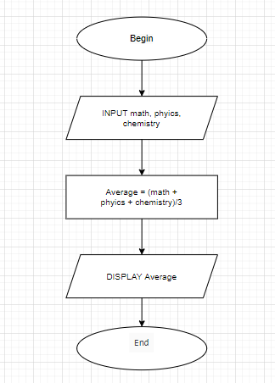

BEGIN

INPUT math, phyics, chemistry

Average = (math + phyics + chemistry)/3

DISPLAY “Average”

End