**DESIGN**

1. **Software architecture**

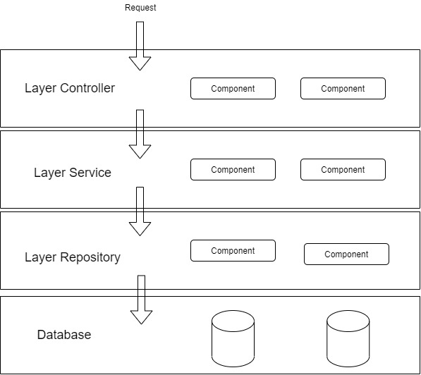

1. **Architectural design**
   1. **Login**

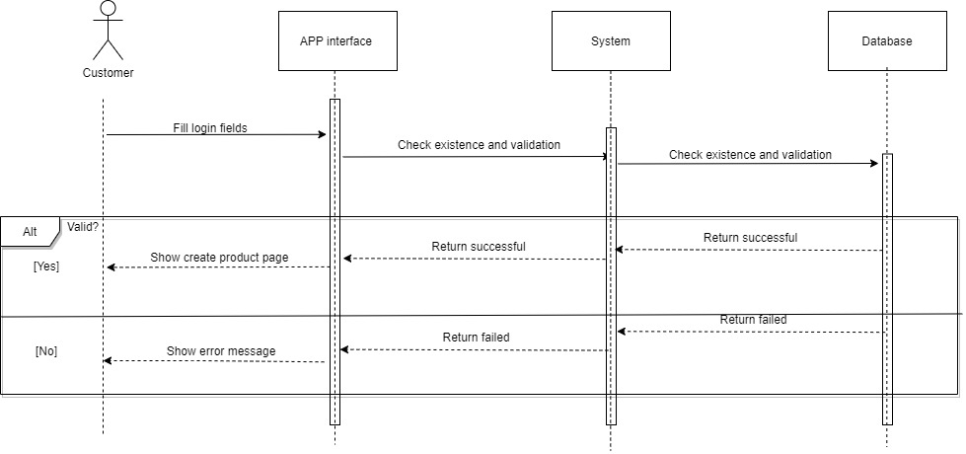

* 1. **Create product**

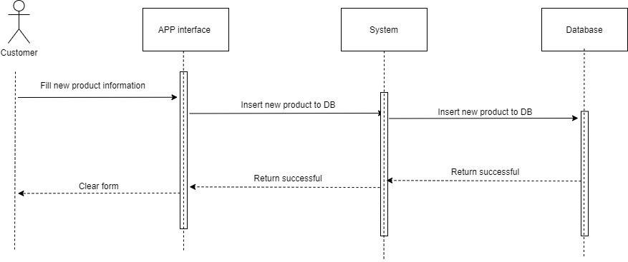

* 1. **Add product to cart**

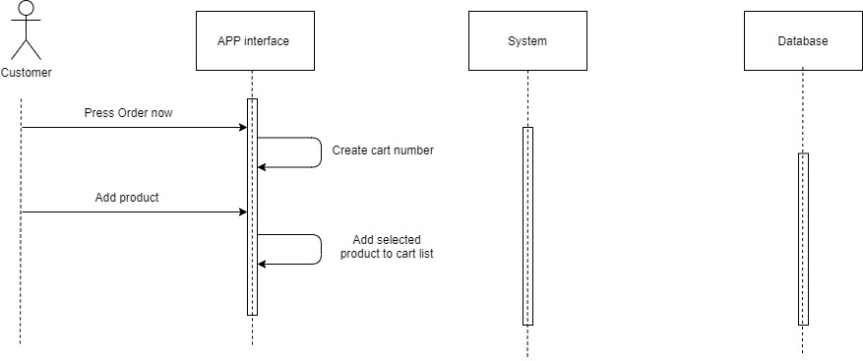

* 1. **Edit cart**

