## Original inspection result

The total number of defects shown is 1345

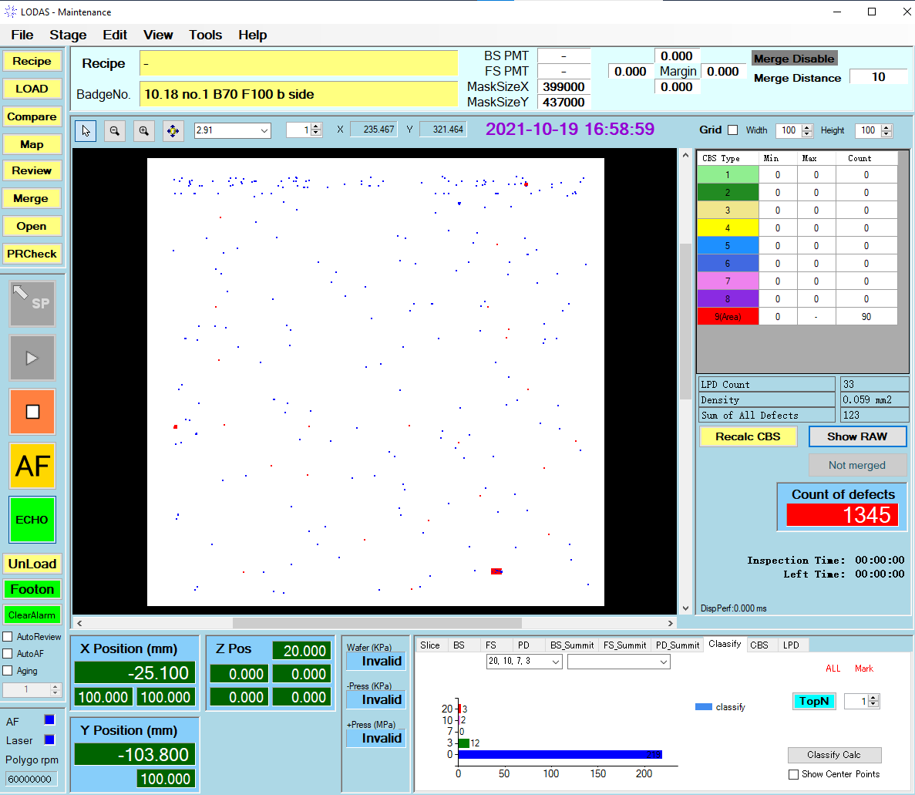

## After defect classification

Algorithm principle ： Defect classification is to classify two relatively close defects into one class

### **If only top1 is displayed**

There is only one big defect shown in the map，The total number of defects is 858，That is to say, the largest defect after this classification is composed of 858 small defects.

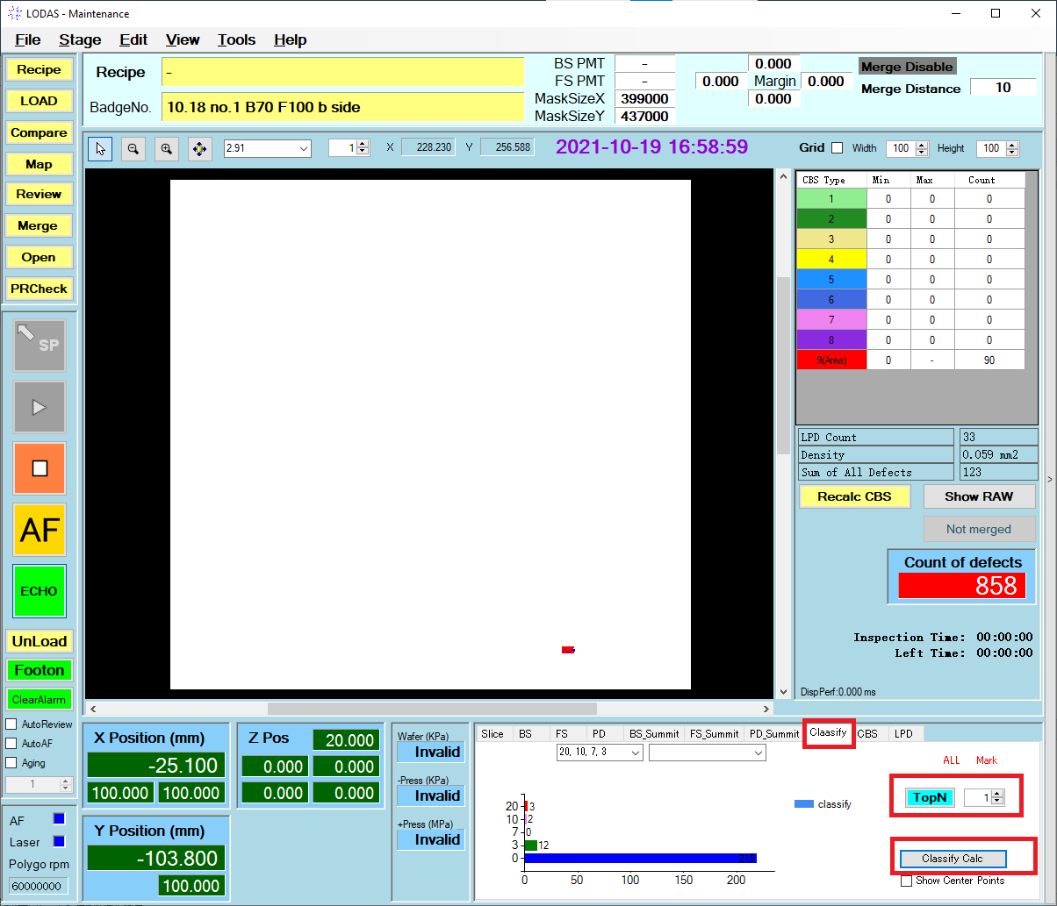

**The red box points out how to use the classify function and how to set topN**

### **If only top5 is displayed**

Only 5 large defects are shown on the map. The total number of defects is 1042，That is, the 5 large defects consist of a total of 1042 small defects

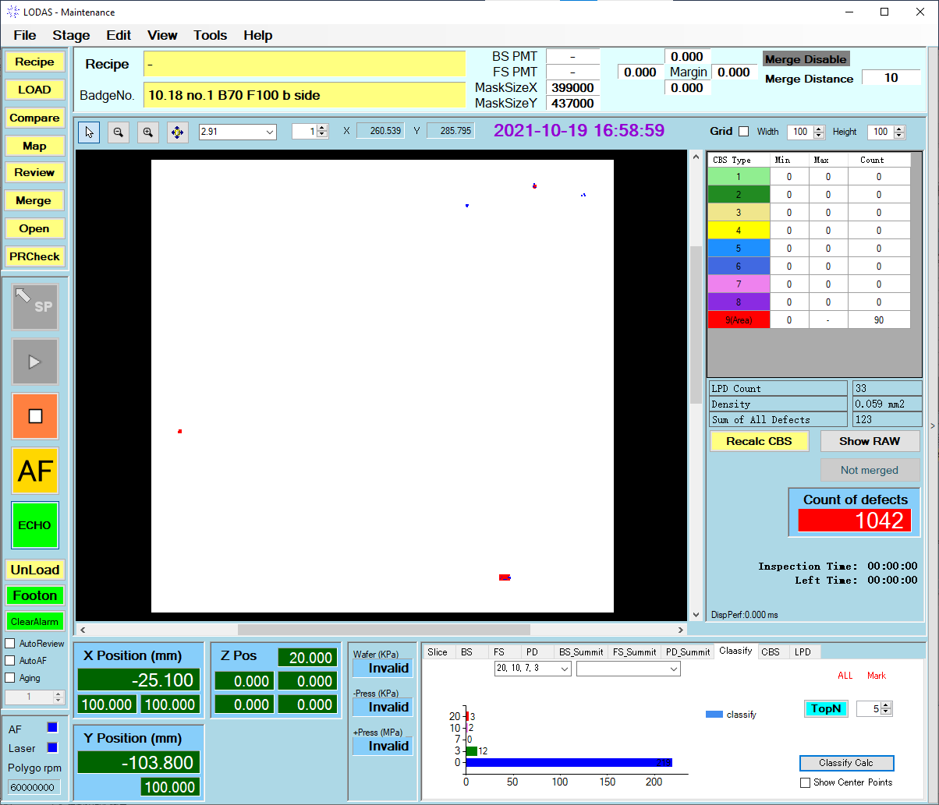

### **top30 is displayed**

