# CBD

Classify Based on Distance

## Function Description

Defect classification is to classify two relatively close defects into one class

## Original inspection result

The total number of defects shown is 1345

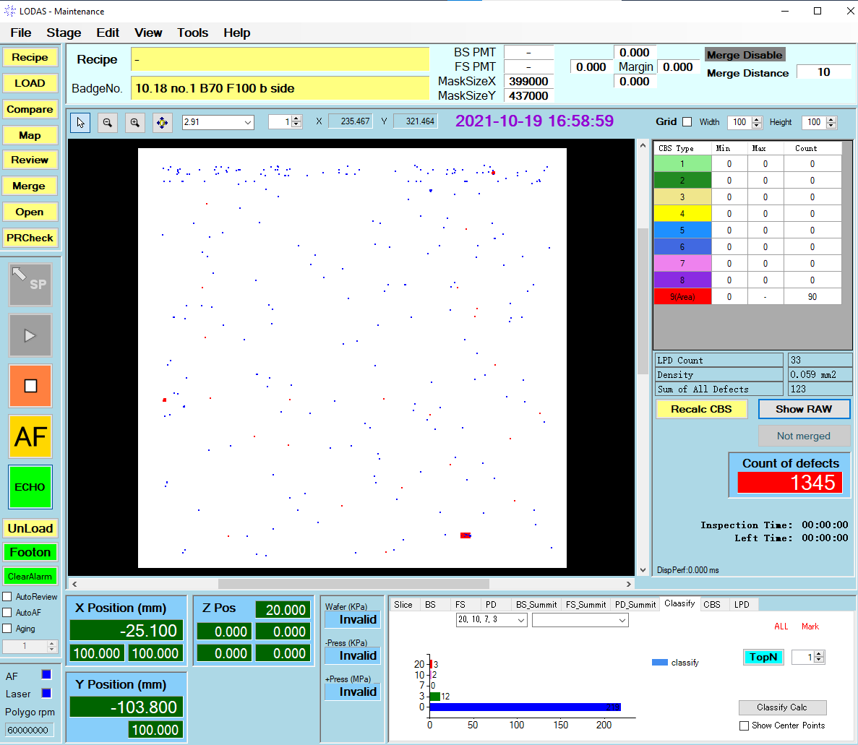

## CBD calculate result

### **If only top1 is displayed**

There is only one big defect shown in the map，The total number of defects is 858，That is to say, the largest defect after this classification is composed of 858 small defects.

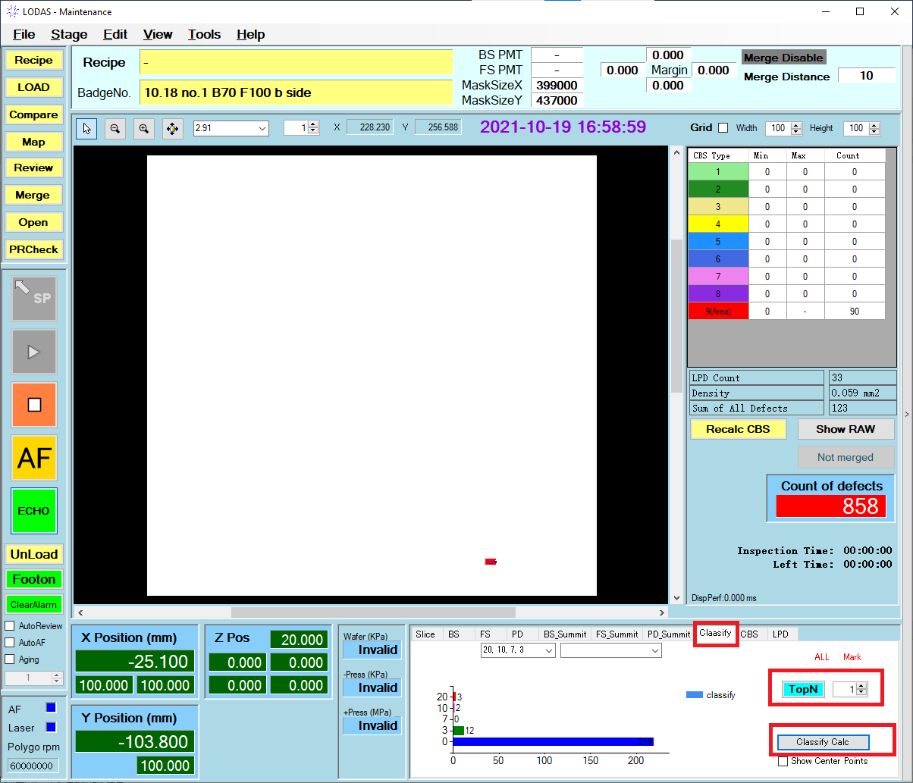

**The red box points out how to use the classify function and how to set topN**

### **If only top5 is displayed**

Only 5 large defects are shown on the map. The total number of defects is 1042，That is, the 5 large defects consist of a total of 1042 small defects

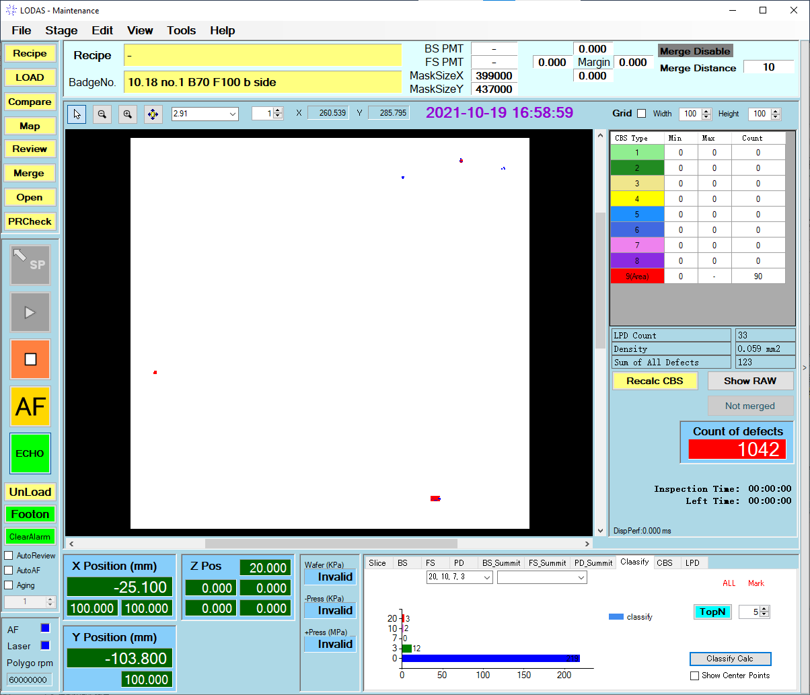

### **top30 is displayed**

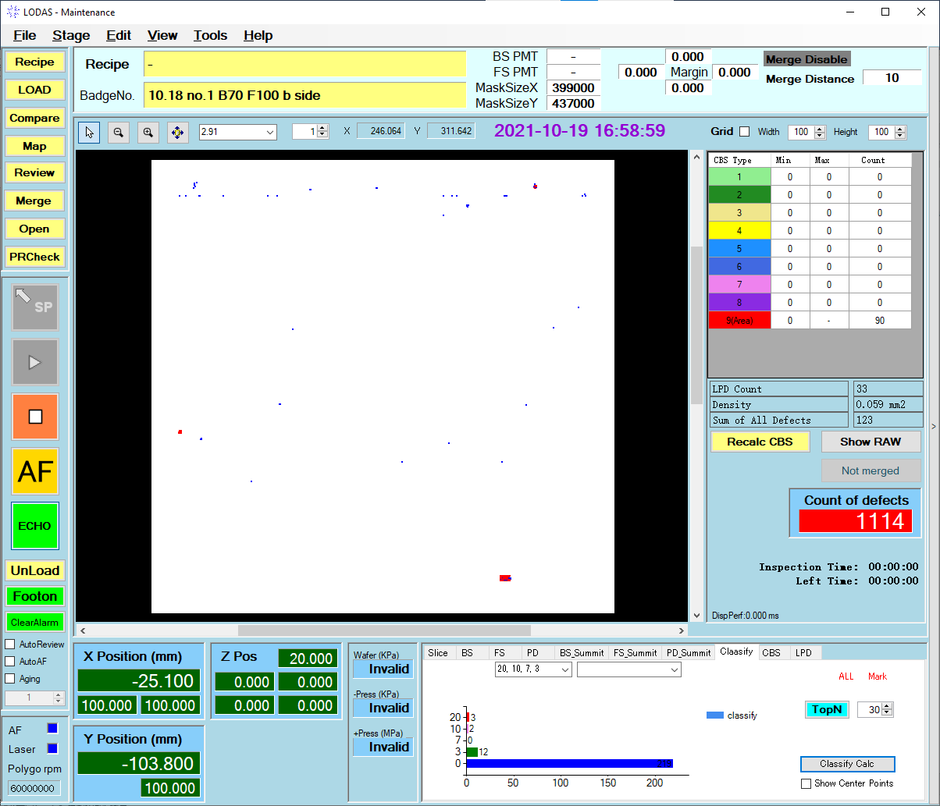

# CBS

Classify Based on Signal strength.

## Function Description

There is a certain relationship between Signal strength and defect size, So it can also be interpreted as Classify Based on Size.

The relationship between signal strength (also called slice) and defect size (also called CBS value, Units are microns) is as follows

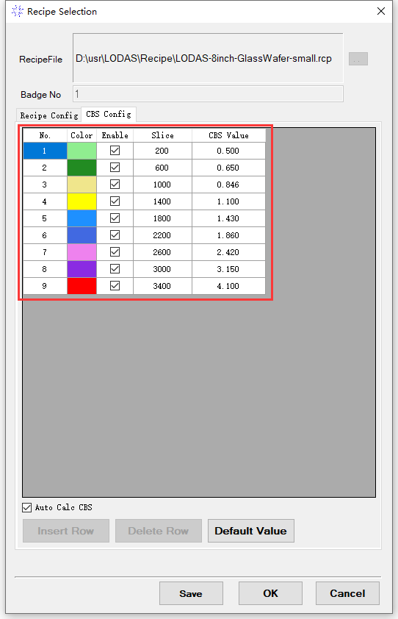

## Original inspection result

After inspection, Defects are only divided into BS FS PD.

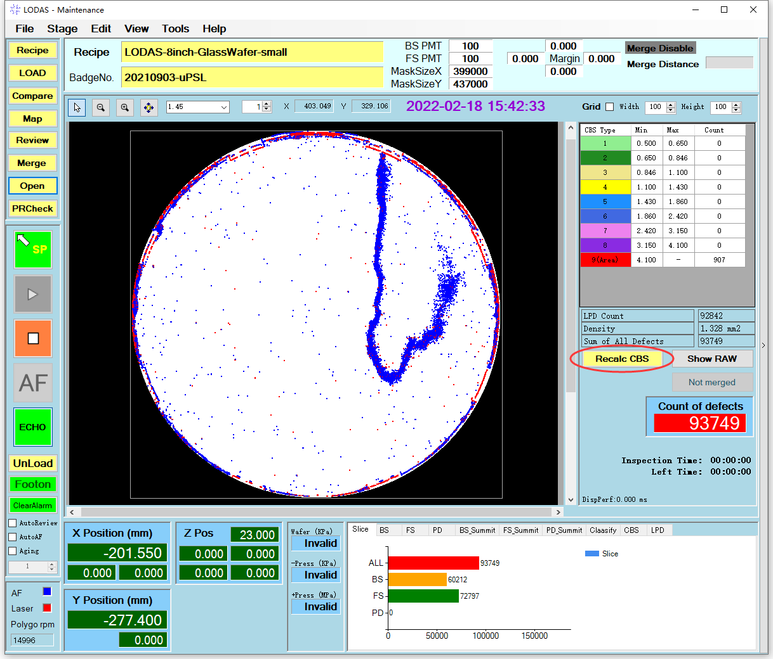

## CBS calculate result displayed

After using the CBS function for classification, A histogram representation of each intensity magnitude is displayed.

