Differential Sparse Regularization for Longitudinal Power Anomaly Localization
Scheme Assessment and Simulation Reproduction Report — from Theory to Simulation Results
August 10, 2026 · repo longrain153/PPE2 · branch claude/ppe-localization-accuracy-9tirgk

1. Executive Summary
This report assesses a "differential sparse PPE" scheme intended to improve fault-localization accuracy in fiber-longitudinal power profile estimation (PPE / Longitudinal Power Monitoring, LPM): build a low-noise reference profile from abundant pre-fault data, then, after the fault, solve only for the change relative to that reference under a step-sparsity prior (generalized Lasso / total-variation regularization). Theory and numerical simulation show the core idea is sound and is essentially the approach published by Fujitsu (OECC 2024) and NTT (ECOC 2025). Under 64 GBd, 3 × 50 km, 1-dB and 3-dB lumped losses, and a single post-fault capture, localization error improves from tens of kilometres (naive profile subtraction) to 0.15 km — the resolution floor of the 1-km estimation grid — with 100-m matched-filter refinement at 0.55–0.95 km: roughly two orders of magnitude. As a control, sparse-regularizing the reference and fault profiles independently and then subtracting (absolute-domain D² sparsity) remains stuck above ten kilometres, showing the sparsity prior is only effective when applied to the differential (subtract first, then sparsify). However, two formulation details in the original proposal require correction, and the claimed "50–200 m, purely noise-limited" accuracy remains over-optimistic: the spatial-resolution physics set by chromatic dispersion × bandwidth² still applies, and even with abundant data, sub-kilometre (~0.5–1 km) is the realistic expectation in this regime, consistent with experimental literature.

2. Background and Problem
PPE/LPM inverts the Kerr nonlinearity imprinted on the received signal to reconstruct the power distribution along a link using receiver-side DSP only — no OTDR or dedicated hardware. It can monitor amplifier gains, span losses, and anomalous loss events (degraded splices, cable stress). The core challenge is that under practical low-power, limited-data conditions the estimate is noisy and spatially resolution-limited, making small lumped losses hard to pinpoint.
The operational scenario considered here: before the fault there is ample time to collect data and form a reference; after the fault, data are limited, and a single dominant loss event must be localized as accurately as possible.

3. Theory

3.1 The LS-PPE linear model (RP1)
Under the first-order regular perturbation (RP1) approximation, the nonlinear perturbation of the received signal is linear in the "generalized nonlinear coefficient" γ′(z) = γ·P(z). Discretizing the link into M spatial bins gives the matrix form:
A₁ ≈ G·γ′, gₖ = D(−zₖ)[ j·|uₖ|²uₖ ], uₖ = D(zₖ)·u₀
where D(z) is the dispersion operator and u₀ the known transmitted waveform. Each column gₖ is the receiver-side "fingerprint" of nonlinearity generated at position zₖ. The least-squares solution (LS-PPE, Sasai et al., JLT 2023) is:
γ̂′ = ( Re[G†G] )⁻¹ Re[G†A₁]

3.2 Ill-posedness and the minimum step size
Adjacent columns gₖ, gₖ₊₁ are distinguishable only through the waveform change that chromatic dispersion produces between the two positions. When the step Δz is too small, adjacent columns become highly correlated, Re[G†G] approaches singularity, and noise is severely amplified. The smallest resolvable step is set jointly by dispersion and signal bandwidth:
Δz_min ∝ 1 / ( |β₂|·BW² )
This is a physical limit: regularization does not change the physics behind the column correlation; it stabilizes the inversion mathematically by trading bias for variance through prior knowledge.

3.3 The differential sparse scheme and two required corrections
The scheme under assessment: with reference profile x_ref (averaged from abundant pre-fault data), exploit model linearity to solve for the change Δx after the fault, with an L₁ sparsity constraint on its spatial derivative so the entire power drop collapses onto a single change point. Two details had to be corrected:
- Correction 1: Δy = y_ref − y_fault is not directly computable. Different captures carry different transmitted symbols, so perturbation vectors from different captures cannot be subtracted sample-by-sample. The correct differential residual projects the reference profile through the current capture's own operator: r = y_fault − G_fault·x_ref.
- Correction 2: a plain first-difference penalty ‖DΔx‖₁ is the wrong sparsity basis. Δx itself decays with fiber loss and jumps at EDFAs, so its plain first difference is not sparse. The total-variation constraint must be applied in the relative-change domain u = Δx / x_ref, where a lumped loss makes u an exact step function (equivalent to Fujitsu's attenuation-weighted J-matrix).
The corrected optimization problem is:
min_u ½‖ G·diag(x_ref)·u − r ‖₂² + λ‖ D u ‖₁

3.4 Solver and refinement
- ADMM + λ path: The generalized Lasso is solved with ADMM; λ is swept along a descending, warm-started path, keeping the solution with the sparsest non-empty jump support — no manual tuning. Support detection uses ADMM's sparse copy variable, which is exactly sparse.
- Matched-filter refinement: Centred on the sparse-detected bin, candidate fault positions are scanned on a 100-m grid: the RP1 step signature of a unit-depth loss at z_c, s(z_c) = −G·[x_ref·step(z>z_c)], is correlated with the residual r; the correlation peak gives the position, and a least-squares amplitude refit removes the Lasso shrinkage bias to estimate the loss magnitude.

4. Simulation Setup
Parameter | Value | Parameter | Value
Signal | 64 GBd 16QAM, RRC 0.1 | Link | 3 × 50 km SSMF
Loss / dispersion | 0.2 dB/km, β₂ = −21.4 ps²/km | Nonlinear coeff. | γ = 1.3 W⁻¹km⁻¹
Launch power | 6 dBm | Noise | EDFA ASE (NF 5 dB) + 18-dB Rx SNR
Per capture | 81920 symbols | Propagation | Split-step Fourier, 100-m steps
PPE grid | Δz = 1 km (150 bins) | Refinement grid | 100 m
Fault | 1.0 / 3.0-dB lumped loss @ 72.35 km (off-grid) | Data | 12-capture reference; 1 post-fault capture

Four localization methods are compared: (a) naive baseline — subtract the single-capture post-fault LS profile from the reference and take the largest drop of the relative-change difference; (b) sparse PPE profile subtraction — apply absolute-domain second-derivative (D²) sparse regularization (the NTT link-parameter-free first stage; λ descends along a path to a ~12-knot piecewise-linear fit) independently to the reference profile (joint normal equations of the 12 captures) and the fault profile (single capture), then subtract and take the largest drop; (c) differential sparse (corrected generalized Lasso, 1-km grid); (d) matched-filter refinement of (c) on a 100-m grid. Four independent fault trials per loss depth.

5. Simulation Results

5.1 Reference profile (healthy link)
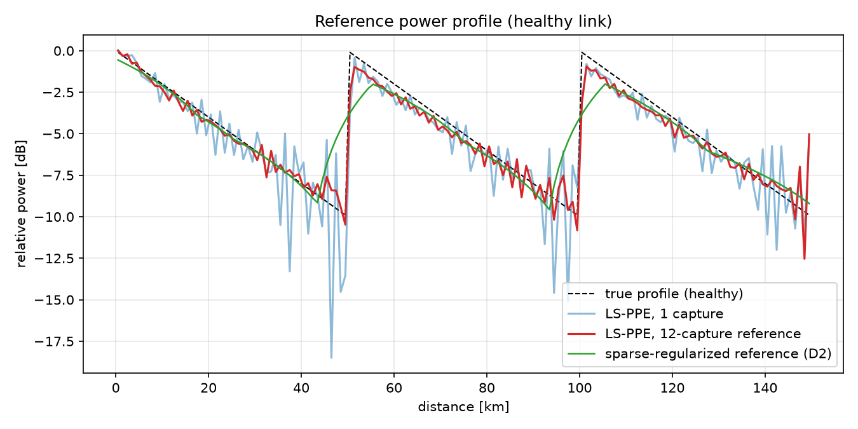
Fig. 1 Healthy-link power profile (81920 symbols per capture): single-capture LS-PPE (blue) is still noisy; the 12-capture average (red) serves as the reference and tracks the true three-span sawtooth closely, with only minor residual ripple in the low-power span tails; the green curve is the D²-sparse-regularized reference used by method (b).

5.2 Differential sparse localization
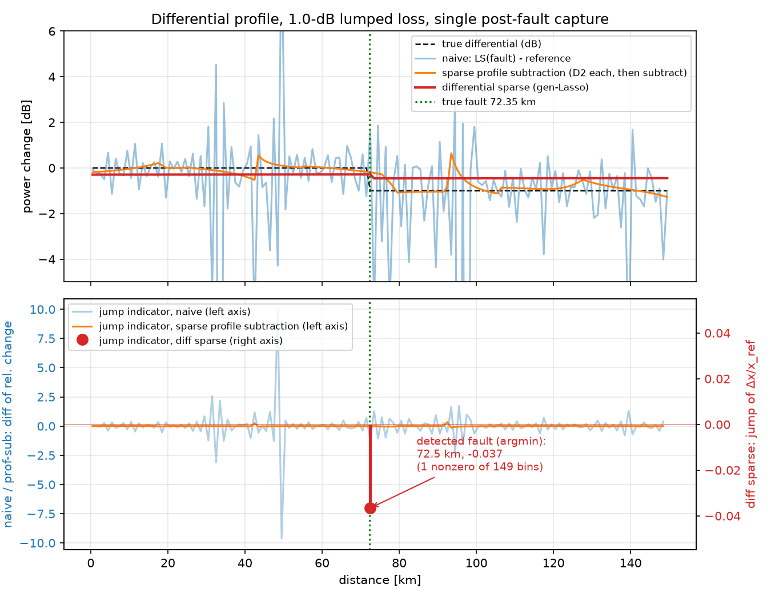
Fig. 2a 1-dB lumped loss, single post-fault capture. Top: naive subtraction (blue) is buried in noise; sparse profile subtraction (orange, method (b)) leaves independent regularization artifacts that do not cancel; the differential sparse solution (red) is a clean step at the right position (amplitude shrunk by the Lasso; refit in Sec. 5.3). Bottom (twin axes): the differential-sparse jump indicator (red stems, right axis) concentrates its nonzero jumps at the fault bin 72.5 km (true: 72.35 km — the 0.15-km error is half a grid cell).
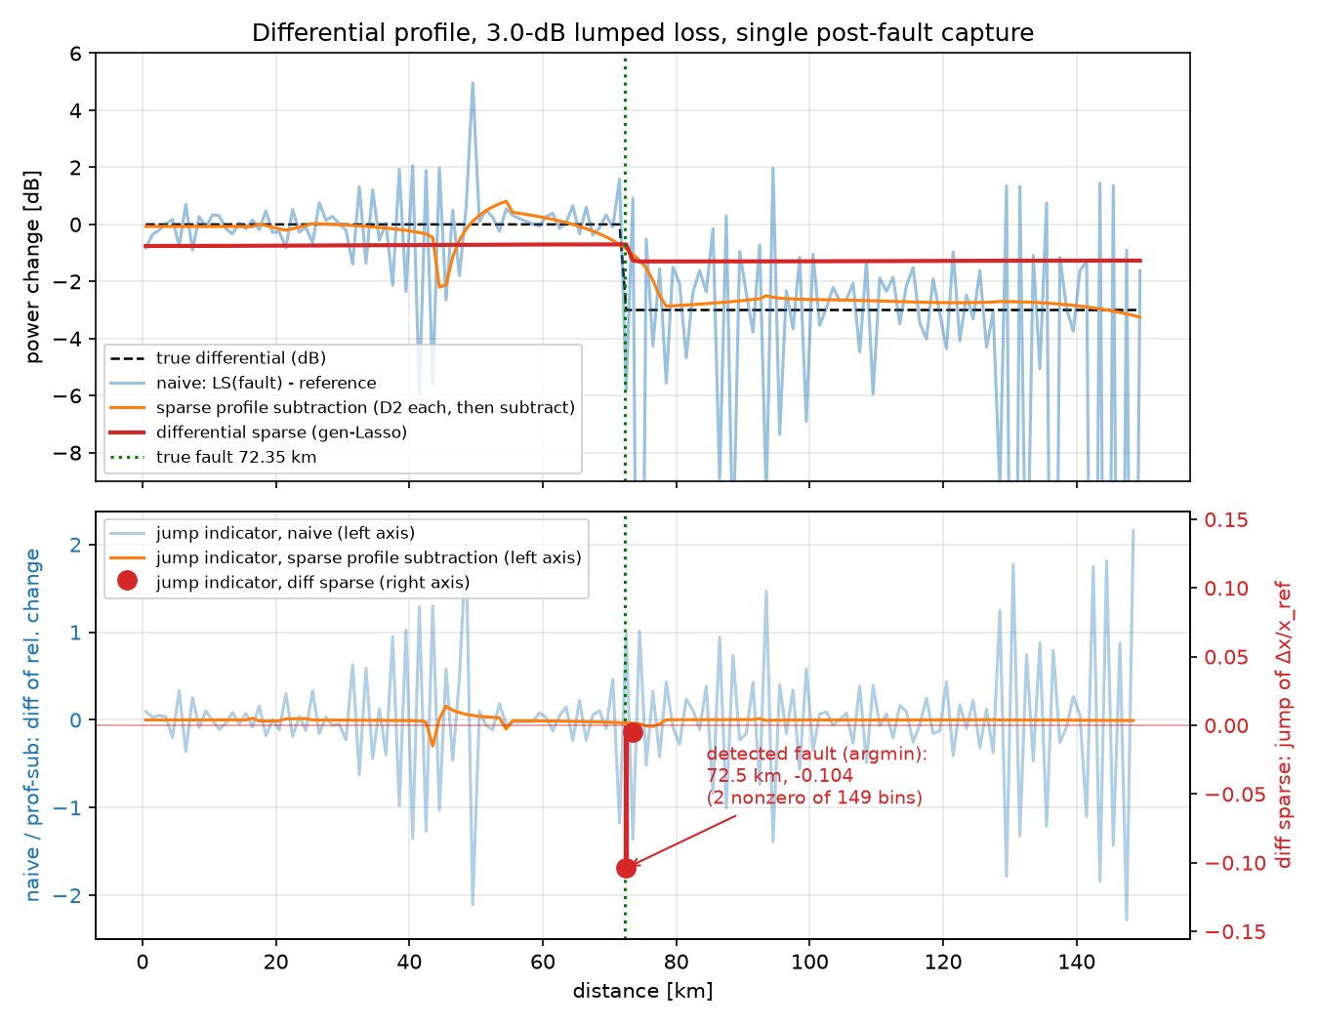
Fig. 2b 3-dB lumped loss, otherwise as Fig. 2a. Sparse profile subtraction (orange) roughly tracks the −3-dB step but retains an artifact dip near the end of span 1 (~44 km) and smears the fault edge into a multi-km ramp, so its largest-drop criterion locks onto the artifact; differential sparse (red) keeps its sparse jump at the fault bin.

5.3 Matched-filter refinement and quantitative results
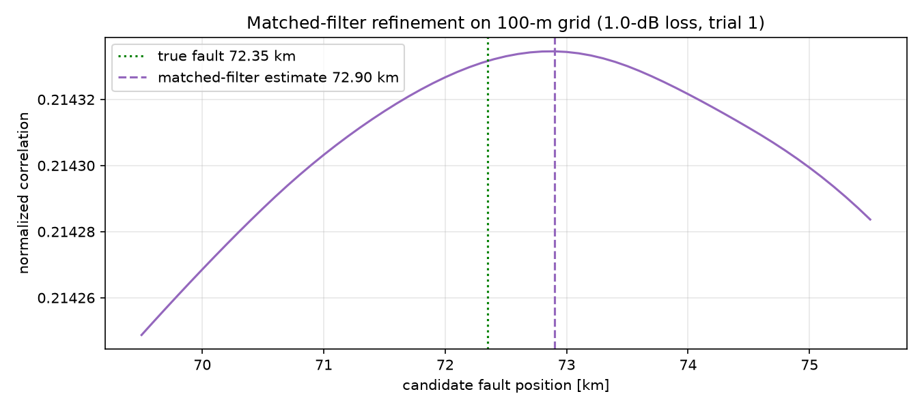
Fig. 3a 1-dB loss, matched-filter correlation on the 100-m grid (trial 1): the correlation surface is nearly flat over several km — adjacent candidate signatures decorrelate only through chromatic dispersion, so the km-scale ambiguity is the bandwidth/dispersion physics limit reasserting itself.
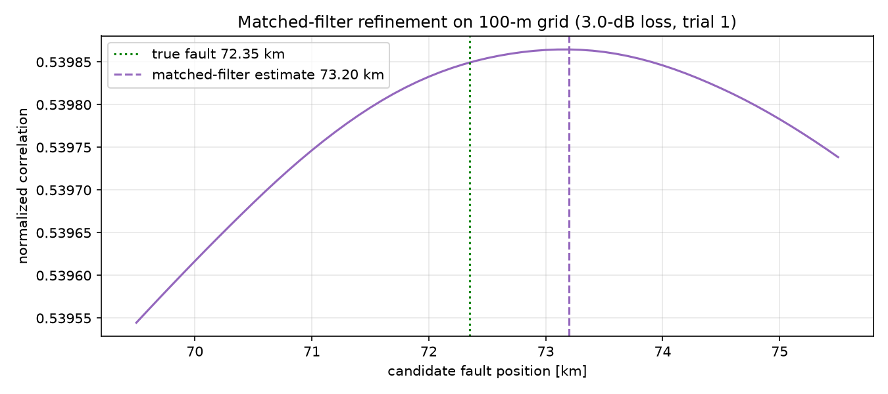
Fig. 3b 3-dB loss (trial 1): with ~3× the differential signature energy the correlation peak is visibly sharper, yet its position still carries a systematic offset of a few hundred metres (Sec. 5.4).
Localization method | 1 dB: mean/max | 3 dB: mean/max | Notes
(a) Naive profile subtraction (LS) | 23.9 / 27.2 km | 39.2 / 75.2 km | Noise-dominated, unusable
(b) Sparse PPE profile subtraction (D²) | 14.3 / 28.9 km | 26.9 / 28.9 km | Independent regularization artifacts do not cancel; fault edge smeared
(c) Differential sparse (1-km grid) | 0.15 / 0.15 km | 0.15 / 0.15 km | Nonzero jumps at the fault bin (grid floor)
(d) Matched-filter refinement (100-m grid) | 0.65 / 0.95 km | 0.75 / 0.85 km | Loss refit 0.88–0.89 / 2.68–2.69 dB

Across all eight trials (both loss depths) the differential sparse method (c) concentrates its nonzero jumps at the fault bin (a consistent +0.15 km — the 1-km grid's resolution floor); the matched filter (d) refines to 0.55–0.95 km (1 dB) and 0.65–0.85 km (3 dB) with loss refits of 0.88–0.89 dB and 2.68–2.69 dB, but never reaches the hundred-metre scale — the correlation surface remains flat at kilometre scale (Fig. 3), confirming the dispersion × bandwidth² limit. The added sparse profile subtraction (b) fails (ten-plus kilometres): the two independent regularizations place their knots at high-curvature, low-SNR span tails, these artifacts do not cancel in the subtraction, and each regularization smears the fault edge into a ramp — at 3 dB, three of four trials lock onto 43.5 km, the span-1 tail artifact (orange curve, Fig. 2b). This is the negative counterpart of the scheme's key ordering: the sparsity prior must act on the differential (subtract first, then sparsify), not on each profile separately (sparsify first, then subtract). NTT's two-stage method, adding link-parameter-aware constraints in its second stage, improves such absolute-domain approaches to ~3 km experimentally — still short of the differential scheme.

5.4 What sets the accuracy: layered decomposition and a perfect-reference control experiment
The matched-filter error is confined to narrow bands at both loss depths (+550 to +950 m at 1 dB; +650 to +850 m at 3 dB), with several trials identical, which shows the current accuracy is dominated by systematic bias, not random noise. Four layers determine localization accuracy, from smallest to largest: (1) grid quantization — the ±0.5-km floor of the 1-km sparse-stage grid, removable with a finer grid; (2) signature distinguishability — moving the candidate fault by δ changes the matched template only by the NLI generated inside that δ segment, and the only mechanism that distinguishes NLI from adjacent positions is the waveform reshaping that dispersion produces within δ, at a rate ∝ |β₂|·BW² (the same physics as Δz_min): kilometre-scale at 64 GBd, an insurmountable ceiling; (3) noise variance — ASE and transceiver noise jitter the correlation peak, converging as 1/√N with data volume, already pushed below a few hundred metres at 10× data; (4) systematic bias — the actual source of the residual few hundred metres, isolated by the control experiment below.
Perfect-reference control experiment (run in the 1-dB-loss configuration): on identical fault captures, only the reference profile is swapped among three cases — the estimated reference (12-capture LS mean, baseline), the perfect physical reference (analytic truth), and a scaled physical reference (truth × α, where α = 0.914 is the least-squares scale of the LS mean against the physical truth). Results over three independent trials (highly consistent within each case — systematic behaviour):
Reference profile | Sparse stage | Matched filter | Loss estimate (true 1.0 dB)
Estimated (12-capture LS mean, baseline) | +0.15 km | +550 m | 0.88 dB
Perfect physical (analytic truth) | +0.15 km | −2850 m | 1.59 dB
Scaled physical (× 0.914) | +0.15 to +2.15 km | +3150 to +4950 m | 0.70 dB

The result is counter-intuitive but mechanistically clear: the perfect physical reference makes the matched-filter error about 5× worse. The healthy-link component of the measurement is G·x_physical + the RP1 model error (the higher-order terms dropped by the first-order perturbation approximation, ≈ 9% in this setting — directly measured by the scale factor α = 0.914: the LS profile sits systematically ~9% low because it absorbs the model error into itself). With the estimated reference, that model bias is present in both the reference and the fault measurement and cancels in the subtraction; the physical-truth reference leaves the full model error in the residual, whose structured component drags the correlation peak by −2.85 km and inflates the loss estimate to 1.59 dB.
This exposes an intrinsic strength of the differential scheme: the value of the reference lies not in physical accuracy but in sharing the same systematic errors as the fault measurement — same transceiver, same model, same DSP chain, so all common biases cancel in the subtraction (a generalization of the earlier observation that pre-existing link losses cancel, extended to the estimator's own bias). Accordingly, the residual +550 m stems mainly from the second-order residual created by the fault itself altering the downstream nonlinear-phase accumulation (so the model bias is no longer identical before and after the fault), plus a ~50-m contribution from the fine-grid half-bin convention. The 3-dB main experiment corroborates this attribution: the residual bias grows from +550 m (1 dB) to +650–850 m and the loss underestimate from 0.12 dB to ~0.32 dB — the larger the fault, the larger the non-cancelling second-order mismatch between pre- and post-fault model bias. The right lever for further improvement is a lower nonlinear operating point (trading launch power for data volume) or a higher-order perturbation / local SSFM inversion model — not a better reference — and everything remains under the kilometre-scale ceiling of layer (2).

6. Verdict on the Original Claims
Claim | Verdict | Basis
Δz_min is set by dispersion and bandwidth² | Correct | Consistent with Sasai's ill-posedness analysis; also seen in the flat correlation surface
Differential + sparsity prior greatly improves localization | Correct | Tens of km → ≈ 1 km, one to two orders of magnitude
Pre-existing loss events cancel in the differential; only a small shadowing term remains | Correct | Follows directly from model linearity
Subtract measurements directly: Δy = y_ref − y_fault | Needs correction | Different captures carry different symbols; use r = y_fault − G·x_ref
Plain first difference of Δx as the sparsity basis | Needs correction | Apply TV in the relative domain u = Δx/x_ref (attenuation-weighted)
50–200 m accuracy, purely noise-limited | Over-optimistic | The physics limit remains; 0.55–0.95 km (1 dB) / 0.65–0.85 km (3 dB) here even with abundant data; literature (NTT +3 km, Fujitsu <4 km, CICT 1 km) is km-scale

Overall conclusion: differential sparse PPE is a correct and worthwhile engineering approach. Its gain comes from degrading the full-profile reconstruction problem into a single-parameter (step-position) detection problem, thereby exploiting the information of every bin downstream of the fault. Its accuracy ceiling, however, is still bounded by the dispersion × bandwidth² resolution physics: at 64–100 GBd, sub-kilometre (~0.5–1 km) with abundant data — not hundreds of metres — is the realistic ceiling. The control experiment (Sec. 5.4) further shows the reference need not be physically accurate: an estimated reference that shares the measurement's systematic errors significantly outperforms a perfect physical one, because the differential structure cancels common model bias automatically.

7. Reproduction Code and References
Code lives in repo longrain153/PPE2 (branch claude/ppe-localization-accuracy-9tirgk): ppe/link_sim.py (split-step link simulator), ppe/ppe_core.py (G matrix, LS-PPE, ADMM generalized Lasso, matched filter), run_experiment.py (end-to-end experiment, ~40 min at 81920 symbols/capture), experiments/exp_perfect_ref.py (the Sec. 5.4 perfect-reference control experiment).
- T. Sasai et al., “Linear Least Squares Estimation of Fiber-Longitudinal Optical Power Profile,” J. Lightwave Technol., vol. 42, no. 6, 2023.
- R. Shinzaki et al. (Fujitsu), “Sparse Modeling Analysis for Efficient Localization of Power Anomalies in Transmission Links,” OECC 2024.
- H. Ishihara et al. (NTT), “Robust Fibre Longitudinal Power Monitoring with Few Measurements using Two-stage Sparse Regularization,” ECOC 2025, W.01.06.4.
- Y. Zuo et al. (CICT), “High-fidelity fiber longitudinal power monitoring via non-uniform sparse regularization,” Opt. Express, vol. 34, no. 10, 2026.

