SFF specifications are available at http://www.snia.org/sff/specifications
or ftp://ftp.seagate.com/sff
This specification was developed by the SFF Committee prior to it
becoming the SFF TA (Technology Affiliate) TWG (Technical Working
Group) of SNIA (Storage Networking Industry Association).
The information below should be used instead of the equivalent herein.
POINTS OF CONTACT:
Chairman SFF TA TWG
Email: SFF-Chair@snia.org
If you are interested in participating in the activities of the SFF TWG, the
membership application can be found at:
http://www.snia.org/sff/join
The complete list of SFF Specifications which have been completed or are currently
being worked on can be found at:
http://www.snia.org/sff/specifications/SFF-8000.TXT
The operations which complement the SNIA's TWG Policies & Procedures to guide the SFF
TWG can be found at:
http://www.snia.org/sff/specifications/SFF-8032.PDF
Suggestions for improvement of this specification will be welcome, they should be
submitted to:
http://www.snia.org/feedback

Published
SFF-8679 Rev 1.7
SFF Committee documentation may be purchased in electronic form.
SFF specifications are available at ftp://ftp.seagate.com/sff
SFF Committee
SFF-8679
Specification for
QSFP+ 4X Base Electrical Specification
Rev 1.7
August 12, 2014
Secretariat: SFF Committee
Abstract: This specification defines the contact pads, the electrical (copper), the power
supply, the ESD and the thermal characteristics of the pluggable QSFP10/14/28
Module/Direct Attach cable plug and connector.
This document provides a common specification for systems manufacturers, system
integrators, and suppliers. This is an internal working document of the SFF Committee, an
industry ad hoc group.
This specification is intended to supersede and extend INF-8438 QSFP (Quad SFP) 4 Gb/s 4X
Transceiver and SFF-8436 QSFP+ 10 Gb/s 4X Pluggable Transceiver by adding support for
higher transfer rates and higher power classes.
This specification is made available for public review, and written comments are
solicited from readers. Comments received by the members will be considered for inclusion
in future revisions of this specification.
Support: This specification is supported by the identified member companies of the SFF
Committee.
POINTS OF CONTACT:
Tom Palkert
David Lewis
I. Dal Allan
Molex
2222 Wellington Court
Lisle, IL 60532
JDSU
430 North McCarthy Blvd
Milpitas, CA 95035
Chairman SFF Committee
14426 Black Walnut Ct
Saratoga CA 95070
Ph: 952-200-8542
Ph: 408-546-5448
Ph: 408-867-6630
tpalkert at molex dot com David dot lewis at jdsu dot com
endlcom at acm dot org
QSFP+ 4X Base Electrical Specification
Page 1

Published
SFF-8679 Rev 1.7
EXPRESSION OF SUPPORT BY MANUFACTURERS
The following member companies of the SFF Committee voted in favor of this industry
specification.
Avago
EMC
Finisar
Foxconn
HGST
MGE
Molex
NetApp
Oclaro
Panduit
TE Connectivity
Volex
The following member companies of the SFF Committee voted against this industry
specification.
Hewlett Packard
The following member companies of the SFF Committee voted to abstain on this industry
specification.
Amphenol
Dell Computer
IBM
LSI
Luxshare-ICT
Pioneer
Sandisk
Seagate
Toshiba
Change History
Rev 1.5:
- Moved referenced SFF specs to 2.1 Industry Documents and expanded the list.
Rev 1.6:
- Updated Figure 1 to show retimers.
- Removed two-wire interface timing diagram which is now in SFF-8636.
- Complete rewrite of power supply section to add support for power classes 5 to 7.
- Added section 8 "Timing Requirements".
Rev 1.7
- Editorial only, no technical changes.
QSFP+ 4X Base Electrical Specification
Page 2

Published
Foreword
SFF-8679 Rev 1.7
The development work on this specification was done by the SFF Committee, an industry
group. The membership of the committee since its formation in August 1990 has included a
mix of companies which are leaders across the industry.
When 2 1/2" diameter disk drives were introduced, there was no commonality on external
dimensions e.g. physical size, mounting locations, connector type, and connector
location, between vendors.
The first use of these disk drives was in specific applications such as laptop portable
computers and system integrators worked individually with vendors to develop the
packaging. The result was wide diversity, and incompatibility.
The problems faced by integrators, device suppliers, and component suppliers led to the
formation of the SFF Committee as an industry ad hoc group to address the marketing and
engineering considerations of the emerging new technology.
During the development of the form factor definitions, other activities were suggested
because participants in the SFF Committee faced more problems than the physical form
factors of disk drives. In November 1992, the charter was expanded to address any issues
of general interest and concern to the storage industry. The SFF Committee became a forum
for resolving industry issues that are either not addressed by the standards process or
need an immediate solution.
Those companies which have agreed to support a specification are identified in the
first pages of each SFF Specification. Industry consensus is not an essential
requirement to publish an SFF Specification because it is recognized that in an
emerging product area, there is room for more than one approach. By making the
documentation on competing proposals available, an integrator can examine the
alternatives available and select the product that is felt to be most suitable.
SFF Committee meetings are held during T10 weeks (see www.t10.org), and Specific Subject
Working Groups are held at the convenience of the participants. Material presented at SFF
Committee meetings becomes public domain, and there are no restrictions on the open
mailing of material presented at committee meetings.
Most of the specifications developed by the SFF Committee have either been incorporated
into standards or adopted as standards by EIA (Electronic Industries Association), ANSI
(American National Standards Institute) and IEC (International Electro technical
Commission).
If you are interested in participating or wish to follow the activities of the SFF
Committee, the signup for membership and/or documentation can be found at:
www.sffcommittee.com/ie/join.html
The complete list of SFF Specifications which have been completed or are currently being
worked on by the SFF Committee can be found at:
ftp://ftp.seagate.com/sff/SFF-8000.TXT
If you wish to know more about the SFF Committee, the principles which guide the
activities can be found at:
ftp://ftp.seagate.com/sff/SFF-8032.TXT
Suggestions for improvement of this specification will be welcome. They should be sent to
the SFF Committee, 14426 Black Walnut Ct, Saratoga, CA 95070.
QSFP+ 4X Base Electrical Specification
Page 3

Published
SFF-8679 Rev 1.7
TABLE OF CONTENTS
1 Scope
6
2 References
6
6
6
7
7
7
2.1
2.2
2.3
2.4
2.5
Industry Documents
SFF Specifications
Sources
Conventions
Acronyms
3 General Description
4 Compliance Testing
9
10
5 Electrical Specification
11
11
16
16
16
16
16
16
17
17
17
17
17
18
18
18
20
24
24
24
24
5.1
5.2
Electrical Connector
Low Speed Pin Descriptions
5.2.1 ModSelL
5.2.2 ResetL
5.2.3 LPMode
5.2.4 ModPrsL
5.2.5 IntL
5.3
Low Speed Pin Electrical Specifications
5.3.1 Low Speed Signaling
5.3.2 Low Speed Pin Timing
5.4
High Speed Pin Electrical Specifications
5.4.1 Rx(n)(p/n)
5.4.2 Tx(n)(p/n)
5.5
Power Supply Pins
5.5.1 Power Classes and Maximum Power Consumption
5.5.2 Module Power Supply Specification
5.5.3 Host Board Power Supply Noise Output
5.5.4 Module Power Supply Noise Output
5.5.5 Module Power Supply Noise Tolerance
5.6
ESD
6 Mechanical and Board Definition
24
24
25
26
26
27
6.1
6.2
6.3
Introduction
Color Coding and Labeling of Modules
Optical Interface
6.3.1 MPO Optical Cable Connection
6.3.2 Dual LC Optical Cable Connection
7 Environmental and Thermal
28
28
7.1
Thermal Requirements
8 Timing Requirements
28
29
30
8.1
8.2
Soft Control and Status Timing Requirements
Squelch and TxRx Disable Assert, Deassert and Enable/Disable Timing
FIGURES
Figure 3-1 Application Reference Model
Figure 4-1 Reference Points and Compliance Boards
Figure 5-1 Module Pad Layout
Figure 5-2 Example: Host Board Schematic for Optical Modules
Figure 5-3 Example: Host Board Schematic for Passive Copper Cables
Figure 5-4 Example: Schematic of multiple qsfp28 power supply arrangement
Figure 5-5 QSFP28 Inrush Current Timing
10
11
12
14
15
20
22
25
Figure 6-1 Pluggable and Direct Attach Module Rendering
QSFP+ 4X Base Electrical Specification
Page 4

Published
SFF-8679 Rev 1.7
26
Figure 6-2 Optical Receptacle and Channel Orientation for MPO connector
Figure 6-3 Optical Receptacle and Channel Orientation for Dual LC Connector
Figure 6-4 MPO Optical Patch Cord
Figure 6-5 Dual LC Optical Patch Cord
26
27
27
28
Figure 8-1 block diagram of module control signals
TABLES
Table 4-1 Reference Points
Table 5-1 Pin Function Definition
11
13
17
18
21
21
23
28
29
30
Table 5-2 Low Speed Pin Electrical Specifications
Table 5-3 QSFP28 - Maximum Power Classes
Table 5-4 Power Mode Control Bits (See SFF-8636)
Table 5-5 Power Mode Truth Table
Table 5-6 QSFP28 Module Power Supply Specification
Table 7-1 Temperature Range Class of Operation
Table 8-1 Soft Control and status timing requirements
Table 8-2 QSFP28 Squelch and TxRx Disable timing
QSFP+ 4X Base Electrical Specification
Page 5

Published
SFF-8679 Rev 1.7
SFF Committee --
QSFP+ 4X Base Electrical Specification
1
Scope
This document specifies the electrical requirements for the QSFP10/14/28 pluggable 4-lane
interfaces, hereafter referred to as QSFP28. The scope includes: electrical contacts for
the host connector; fiber positions for optical interfaces; power supply requirements;
ESD and thermal characteristics of pluggable QSFP28 modules and direct attach cables. The
mechanical requirements are specified by reference.
This specification supersedes and extends the applications supported by INF-8438 QSFP
(Quad SFP) 4 Gb/s 4X Transceiver and SFF-8436 QSFP28 10 Gb/s 4X Pluggable Transceiver by
supporting higher transfer rates.
2
References
2.1 Industry Documents
The following interface standards and specifications are relevant to this Specification.
- GR-253-CORE
- ESD specifications EN61000-4-2, JEDEC JESD22-A114-B
- Optical Connectors: MPO:IEC 61754-7, Dual LC: IEC 61754-20
- Aligned key (Type B) MPO patch cords: TIA-568
- Dual LC optical patch cord: TIA/EIA-604-10A
- Thermal specifications: NEBS GR-63
- IEEE Std 802.3-2012, 802.3bj and 802.3bm
- InfiniBand Architecture Specifications FDR and EDR
- INCITS 479-2011
- INCITS 512-2014
- T10 2212-D
FC-PI-5 (Fibre Channel Physical Interface -5)
FC-PI-6 (Fibre Channel Physical Interface -6)
SAS-3
- T11-533-201x
FC-PI-6P (Fibre Channel Physical Interface -6
128GFC Four Lane Parallel)
- SFF-8635
- SFF-8665
- SFF-8685
QSFP+ 10 Gb/s 4X Pluggable Transceiver Solution (QSFP10)
QSFP+ 28 Gb/s 4X Pluggable Transceiver Solution (QSFP28)
QSFP+ 14 Gb/s 4X Pluggable Transceiver Solution (QSFP14)
2.2 SFF Specifications
There are several projects active within the SFF Committee. The complete list of
specifications which have been completed or are still being worked on are listed in the
specification at ftp://ftp.seagate.com/sff/SFF-8000.TXT. The specifications relevant to
the various QSFP generations are listed below.
INF-8438
SFF-8024
SFF-8436
SFF-8635
SFF-8636
SFF-8661
SFF-8662
SFF-8663
SFF-8665
SFF-8672
SFF-8679
SFF-8682
SFF-8683
QSFP (Quad Small Formfactor Pluggable) Transceiver
SFF Committee Cross Reference to Industry Products
QSFP+ 10 Gb/s 4X Pluggable Transceiver - Standardized as EIA-964
QSFP+ 10 Gb/s 4X Pluggable Transceiver Solution (QSFP10)
Common Management Interface
QSFP+ 28 Gb/s 4X Pluggable Module
QSFP+ 28 Gb/s 4X Connector (Style A)
QSFP+ 28 Gb/s Cage (Style A)
QSFP+ 28 Gb/s 4X Pluggable Transceiver Solution (QSFP28)
QSFP+ 28 Gb/s 4X Connector (Style B)
QSFP+ 4X Base Electrical Specification
QSFP+ 14 Gb/s 4X Connector (Style B)
QSFP28 14 Gb/s Cage
QSFP+ 4X Base Electrical Specification
Page 6

Published
SFF-8679 Rev 1.7
2.3 Sources
Those who join the SFF Committee as an Observer or Member receive electronic copies of
the minutes and SFF specifications (http://www.sffcommittee.com/ie/join.html).
Copies of ANSI standards may be purchased from the InterNational Committee for
Information Technology Standards (http://www.techstreet.com/incitsgate.tmpl).
2.4 Conventions
The ISO convention of numbering is used i.e., the thousands and higher multiples are
separated by a space and a period is used as the decimal point. This is equivalent to the
English/American convention of a comma and a period.
American
0.6
French
0,6
ISO
0.6
1,000
1 000
1 000
1,323,462.9
1 323 462,9
1 323 462.9
2.5 Acronyms
The following acronyms are used in this specification.
ANSI
ASIC
ATM
CML
CORE
DC
American National Standards Institute
Application Specific Integrated Circuit
Asynchronous Transfer Mode
Current Mode Logic
Central Office Relay Equipment
Direct Current
DDR
EDR
EIA
EMI
ESD
FC
Double Data Rate
Enhanced Data Rate
Electronic Industries Alliance
Electro Magnetic Interference
Electro Static Discharge
Fibre Channel
FDR
Gb/s
GbE
GFC
HCB
IEC
IEEE
ISO
ITU
JEDEC
kHz
km
Fourteen Data Rate
Gigabits per second
Gigabit Ethernet
Gigabit Fibre Channel
Host Compliance Board
International Electrotechnical Commission
Institute for Electrical and Electronics Engineers
Organization for International Standards
International Telecommunications Union
Joint Electron Device Engineering Council
kiloHertz
kilometer
LVCMOS
LVTTL
MCB
MHz
MIB
MPO
MSA
NAS
NAT
NEBS
OC
Low Voltage Complementary Metal Oxide Semiconductor
Low Voltage Transistor Transistor Logic
Module Compliance Board
MegaHertz
Management Information Base
Multi-fiber Push On
Multiple Source Agreement
Network-Attached Storage
Network Address Translation
Network Equipment Building System
Optical Carrier
OEM
Original Equipment Manufacturer
QSFP+ 4X Base Electrical Specification
Page 7

Published
SFF-8679 Rev 1.7
OMA
Open Mobile Alliance
PCB
PDH
PI
Printed Circuit Board
Plesiochronous Digital Hierarchy
Physical Interface
PON
QDR
QSFP
Rx
Passive Optical Network
Quad Data Rate
Quad SFP
Receiver
SAS
SDH
SDR
SerDes
SFP
SM
Serial Attached SCSI
Synchronous Digital Hierarchy
Software Defined Receiver
Serializer-Deserializer
Small Formfactor Pluggable
Single Mode
SNMP
SONET
STM
TIA
TTL
Tx
Simple Network Management Protocol
Synchronous Optical NETwork
Synchronous Transfer Mode
Telecommunications Industry Association
Transistor-Transistor Logic
Transmitter
XFP
10 Gigabit Small Formfactor Pluggable
QSFP+ 4X Base Electrical Specification
Page 8

Published
SFF-8679 Rev 1.7
3
General Description
This specification covers the following items:
a) Electrical specification. including connector contact assignments for data control,
status, configuration and test signals) and the electrical connector and
recommended host PCB layout requirements.
b) Mechanical and board definition.
c) Environmental and thermal. requirements (case temperatures). Electromagnetic
interference (EMI) recommendations (including necessary shielding features to seal
the OEM chassis front panel output with and without the module installed in the
cage). Electrostatic discharge (ESD) requirements solely to the extent disclosed in
the specification where the sole purpose of such disclosure is to enable products
to operate, connect or communicate as defined within the specifications.
d) Timing requirements.
The overall package dimension shall conform to the required dimensions and tolerances.
- The mounting features shall be located such that the products are mechanically
interchangeable with the cage and connector system.
- The overall dimensions and mounting requirements for the cage and connector system
on a circuit board shall be configured such that the products are mechanically and
electrically interchangeable.
- The overall dimensions and insertion requirements for the optical connector and
corresponding fiber optic cable plug shall be such that the products are
mechanically and optically interchangeable.
These electrical and optical specifications may be compatible with those enumerated in
the following:
ITU-T Recommendation G.957
Telcordia Technologies GR-253-CORE
Ethernet IEEE 802.3
Infiniband Architecture Specifications
SFF Committee
STM-1, STM-4, STM-16
OC-3, OC-12, OC-48, OC-192
10 GbE, 40 GbE, 100 GbE
SDR, DDR, QDR, FDR, EDR
SFF-8436 QSFP+
Fibre Channel
FC-PI-3/4/5/6, 2G, 4G, 8G, 10G, 16G, 32G
The specifications will provide a common solution for combined four-channel ports that
support SONET/SDH and/or Ethernet and/or Infiniband and/or Fibre Channel and/or SAS
specifications. This specification encompasses design(s) capable of supporting multimode
and single mode modules, passive copper, active copper and active optical cables.
An Application Reference Model, See Figure 3-1, shows the high-speed data interface
between an ASIC (SerDes) and the module. Only one data channel of the interface is shown
for simplicity. Either parallel MPO or duplex LC fiber connectors can be used for the
optical interface.
QSFP+ 4X Base Electrical Specification
Page 9
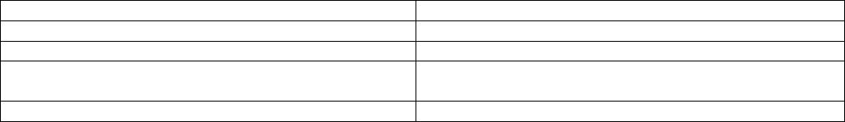

Published
SFF-8679 Rev 1.7
HOST BOARD
(Only one channel shown for simplicity)
RX_OUT_P
RX
Retimer
DRVR
RX
TX
RX_OUT_N
HOST
ASIC
QSFP28 MODULE
TX_IN_P
TX_IN_N
TX
CTLE
Retimer
FIGURE 3-1 APPLICATION REFERENCE MODEL
4
Compliance Testing
The module electrical interface test points are intended to be measured using compliance
boards as shown in Figure 4-1. These compliance boards are intended to connect the module
under test to test equipment for verification of compliance to the appropriate standard.
The Module Compliance Board is used to test the module. The electrical parameters of the
compliance boards should be specified by the appropriate standard. The Module Compliance
Board and Host Compliance Board can be plugged together for calibration of compliance
signals and to check the electrical parameters of the compliance boards.
QSFP+ 4X Base Electrical Specification
Page 10
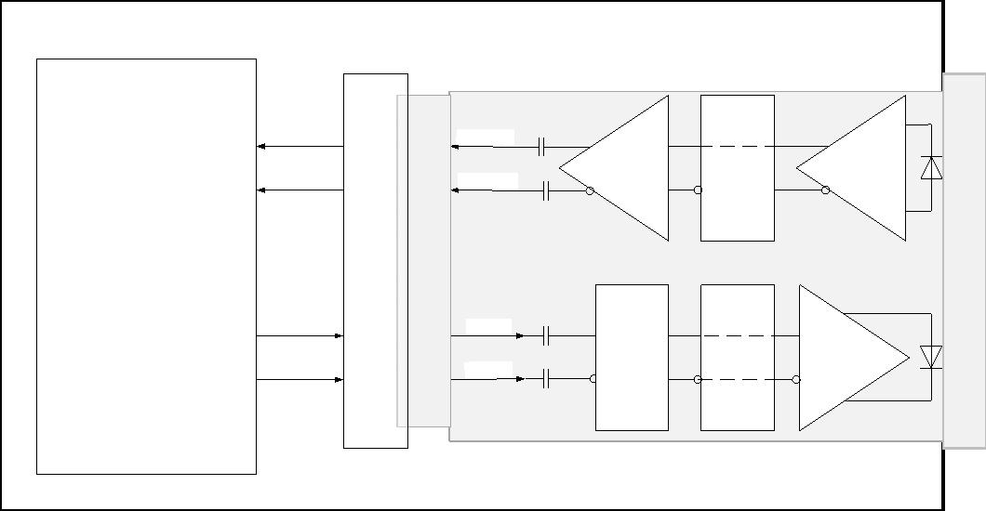

Published
SFF-8679 Rev 1.7
FIGURE 4-1 REFERENCE POINTS AND COMPLIANCE BOARDS
The reference points are defined in Table 4-1.
TABLE 4-1 REFERENCE POINTS
Host ASIC transmitter output at ASIC package pin on a DUT board
Input to module compliance board through mated module compliance board and
module connector. Used to test module input
TP0
TP1
TP1A Host ASIC transmitter output across the Host Board and Host Edge Card
connector at the output of the host compliance board
TP4
Module output through mated module and host edge card connector through module
compliance board
TP4A Input to host compliance board through mated host compliance board and host
edge card connector. Used to test host input
TP5
Input to host ASIC
Note: Individual standards may specify unique reference points
5
Electrical Specification
This clause contains pin definition data for the module. The pin definition data is
generic for gigabit-per-second datacom applications such as Fibre Channel, Ethernet and
SONET/ATM applications. Compliance Points for high-speed signal electrical measurements
are defined in Figure 4-1. Compliance Points for all other electrical signals are at
comparable points at the host edge card connector.
5.1 Electrical Connector
Figure 5-1 shows the signal symbols and contact numbering for the module edge connector.
The diagram shows the module PCB edge as a top and bottom view. There are 38 contacts
intended for high speed signals, low speed signals, power and ground connections. Table
5-1 provides more information about each of the 38 contacts.
QSFP+ 4X Base Electrical Specification
Page 11
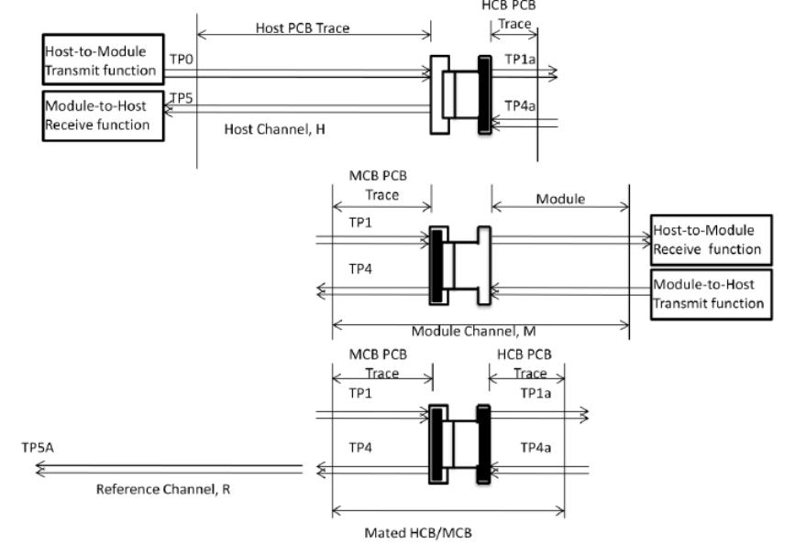
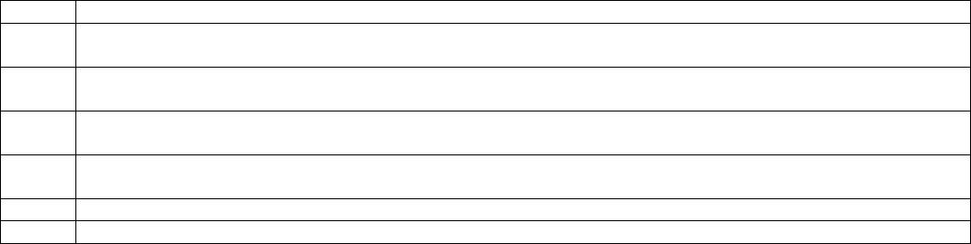

Published
SFF-8679 Rev 1.7
The module contains a printed circuit board that mates with the electrical connector. The
pads are designed for a sequenced mating:
First mate - ground contacts
Second mate - power contacts
Third mate - signal contacts
For EMI protection the signals to the connector should be shut off when the module is
removed. Standard board layout practices such as connections to Vcc and GND with Vias,
use of short and equal-length differential signal lines, use of microstrip-lines and 50
Ohm terminations are recommended. The chassis ground (case common) of the module should
be isolated from the module's circuit ground, GND, to provide the equipment designer
flexibility regarding connections between external electromagnetic interference shields
and circuit ground, GND, of the module.
FIGURE 5-1 MODULE PAD LAYOUT
QSFP+ 4X Base Electrical Specification
Page 12
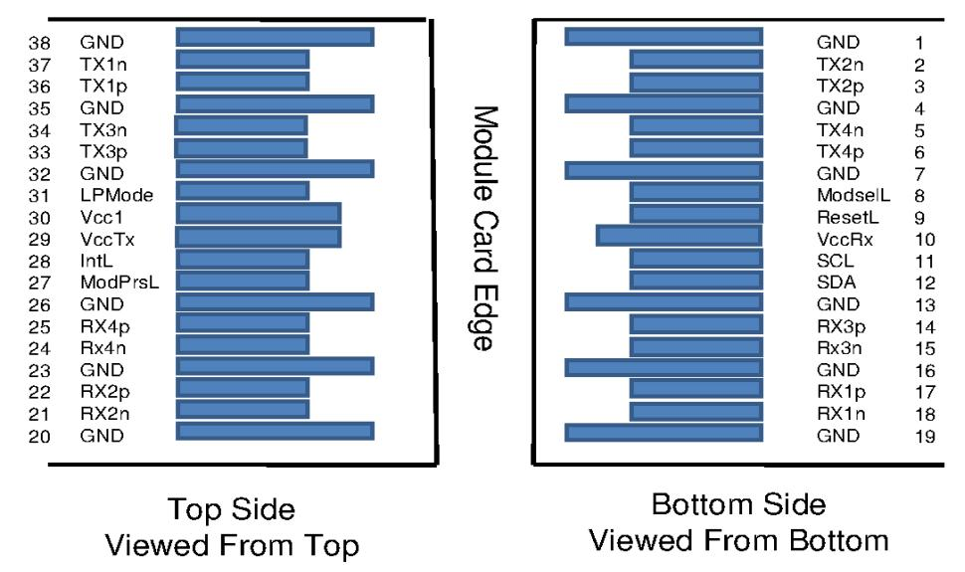

Published
SFF-8679 Rev 1.7
TABLE 5-1 PIN FUNCTION DEFINITION
Pin
Logic
Symbol
Description
Plug
Notes
Sequence
1
2 CML-I
3 CML-I
GND
Tx2n
Tx2p
Ground
Transmitter Inverted Data Input
Transmitter Non-Inverted Data
1
3
3
1
Input
4
5 CML-I
6 CML-I
GND
Tx4n
Tx4p
Ground
Transmitter Inverted Data Input
Transmitter Non-Inverted Data
1
3
3
1
Input
7
GND
ModSelL Module Select
ResetL
Vcc Rx
Ground
1
3
3
2
3
3
1
3
1
2
1
8 LVTTL-I
9 LVTTL-I
10
11 LVCMOS-I/O SCL
12 LVCMOS-I/O SDA
Module Reset
+3.3V Power Supply Receiver
2-wire serial interface clock
2-wire serial interface data
Ground
Receiver Non-Inverted Data
Output
13
14 CML-O
GND
Rx3p
15 CML-O
16
17 CML-O
Rx3n
GND
Rx1p
Receiver Inverted Data Output
Ground
Receiver Non-Inverted Data
Output
3
1
3
1
18 CML-O
19
20
21 CML-O
22 CML-O
Rx1n
GND
GND
Rx2n
Rx2p
Receiver Inverted Data Output
Ground
Ground
Receiver Inverted Data Output
Receiver Non-Inverted Data
Output
3
1
1
3
3
1
1
23
24 CML-O
25 CML-O
GND
Rx4n
Rx4p
Ground
1
3
3
1
1
Receiver Inverted Data Output
Receiver Non-Inverted Data
Output
26
GND
ModPrsL Module Present
IntL
Vcc Tx
Vcc1
LPMode
GND
Tx3p
Ground
1
3
3
2
2
3
1
3
27 LVTTL-O
28 LVTTL-O
29
30
31 LVTTL-I
32
Interrupt
+3.3V Power supply transmitter
+3.3V Power supply
Low Power Mode
Ground
Transmitter Non-Inverted Data
Input
Transmitter Inverted Data Input
Ground
Transmitter Non-Inverted Data
Input
Transmitter Inverted Data Input
Ground
2
2
1
1
1
33 CML-I
34 CML-I
35
36 CML-I
Tx3n
GND
Tx1p
3
1
3
37 CML-I
38
Tx1n
GND
3
1
Note 1: GND is the symbol for signal and supply (power) common for the
module. All are common within the module and all module voltages are
referenced to this potential unless otherwise noted. Connect these directly
to the host board signal-common ground plane.
Note 2: Vcc Rx, Vcc1 and Vcc Tx shall be applied concurrently. Requirements
defined for the host side of the Host Edge Card Connector are listed in Table
5-6. Vcc Rx Vcc1 and Vcc Tx may be internally connected within the module in
QSFP+ 4X Base Electrical Specification
Page 13
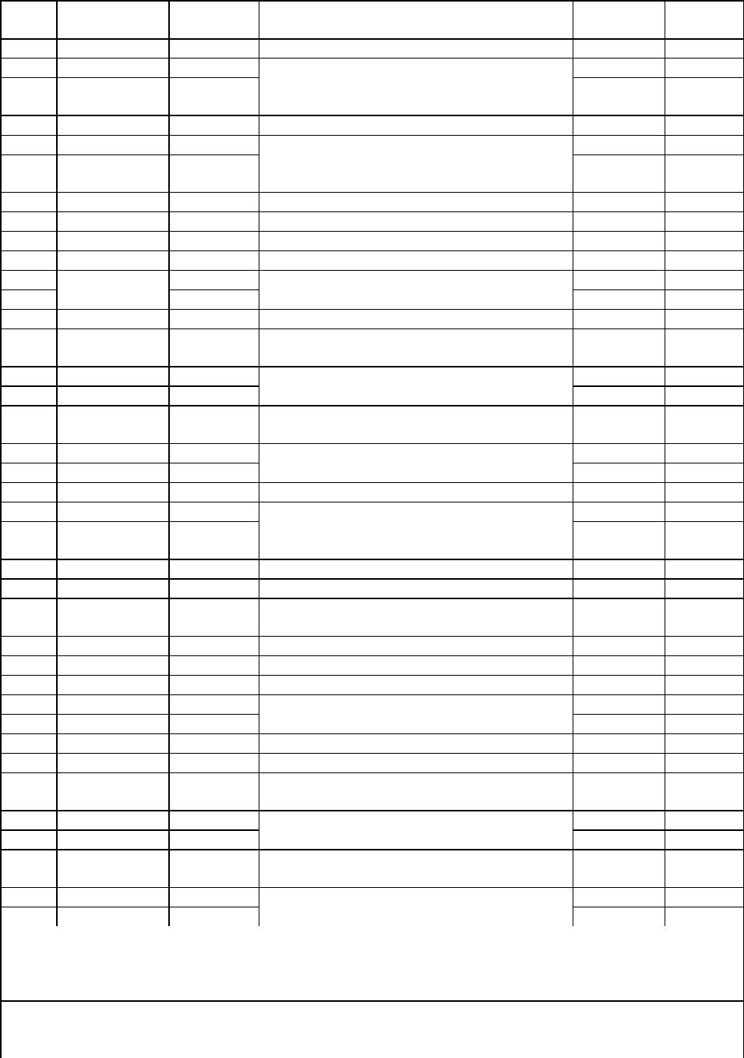

Published
SFF-8679 Rev 1.7
any combination. The connector pins are each rated for a maximum current of
1000 mA.
FIGURE 5-2 EXAMPLE: HOST BOARD SCHEMATIC FOR OPTICAL MODULES
QSFP+ 4X Base Electrical Specification
Page 14
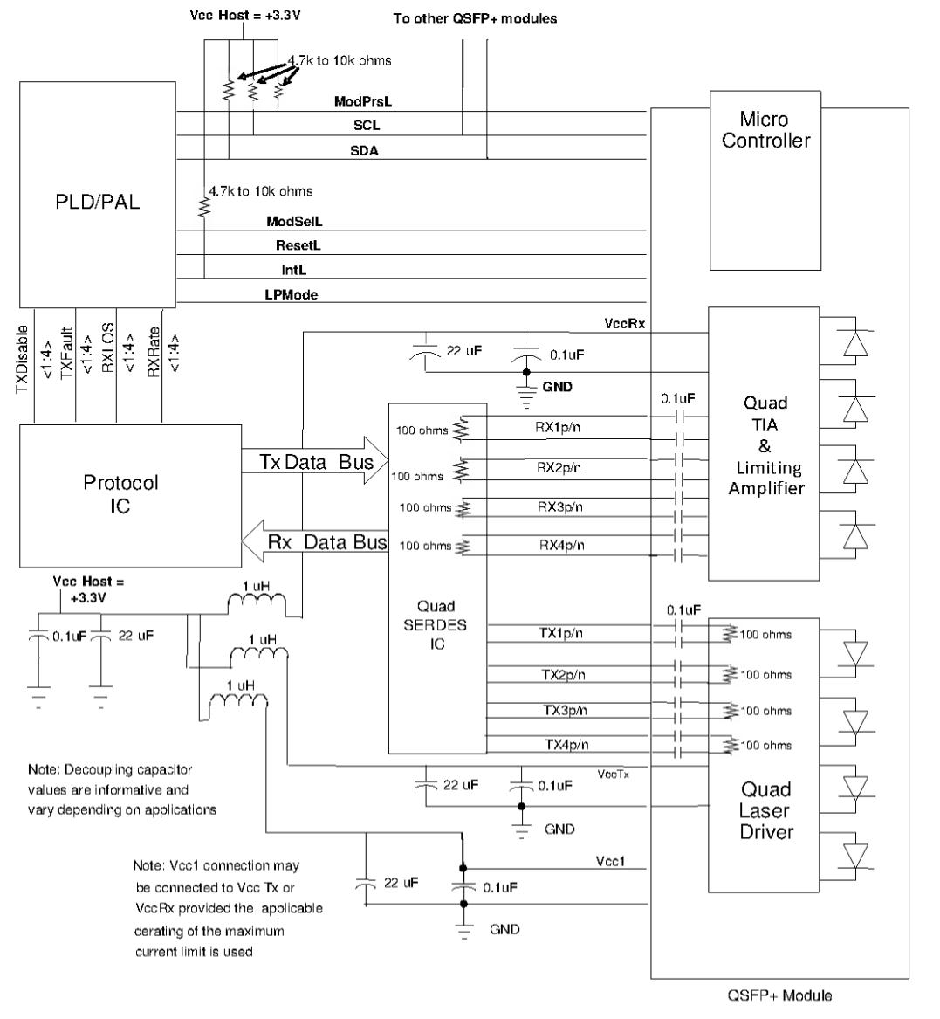

Published
SFF-8679 Rev 1.7
FIGURE 5-3 EXAMPLE: HOST BOARD SCHEMATIC FOR PASSIVE COPPER CABLES
QSFP+ 4X Base Electrical Specification
Page 15
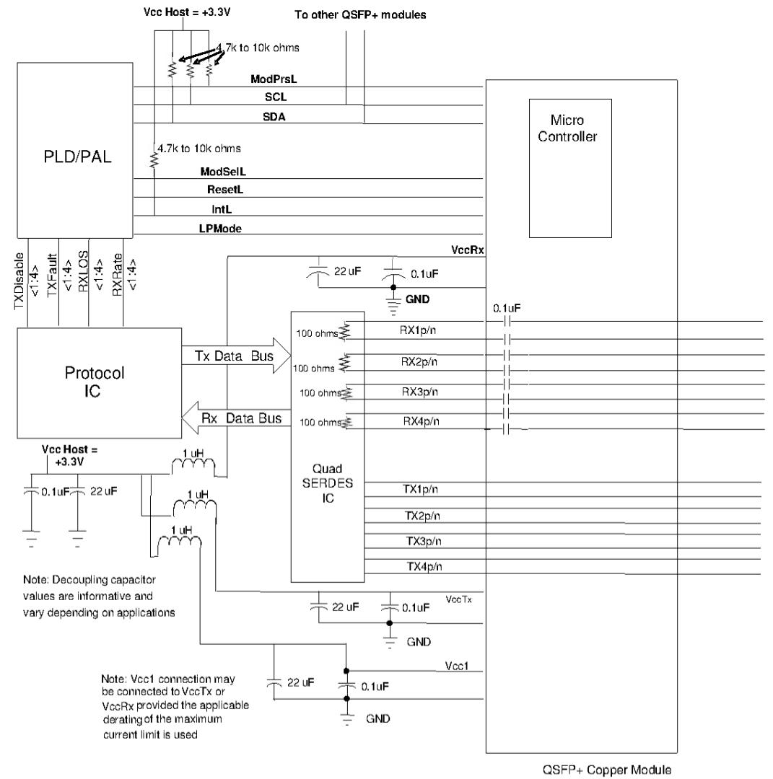

Published
SFF-8679 Rev 1.7
5.2 Low Speed Pin Descriptions
In addition to the 2-wire serial interface the module has the following low speed pins
for control and status:
ModSelL
ResetL
LPMode
ModPrsL
IntL
5.2.1 ModSelL
The ModSelL is an input pin. When held low by the host, the module responds to 2-wire
serial communication commands. The ModSelL allows the use of multiple modules on a single
2-wire interface bus. When the ModSelL is "High", the module shall not respond to or
acknowledge any 2-wire interface communication from the host. ModSelL signal input node
shall be biased to the "High" state in the module.
In order to avoid conflicts, the host system shall not attempt 2-wire interface
communications within the ModSelL de-assert time after any modules are deselected.
Similarly, the host shall wait at least for the period of the ModSelL assert time before
communicating with the newly selected module. The assertion and de-asserting periods of
different modules may overlap as long as the above timing requirements are met.
5.2.2 ResetL
The ResetL pin shall be pulled to Vcc in the module. A low level on the ResetL pin for
longer than the minimum pulse length (t_Reset_init) initiates a complete module reset,
returning all user module settings to their default state. Module Reset Assert Time
(t_init) starts on the rising edge after the low level on the ResetL pin is released.
During the execution of a reset (t_init) the host shall disregard all status bits until
the module indicates a completion of the reset interrupt. The module indicates this by
asserting "low" an IntL signal with the Data_Not_Ready bit negated. Note that on power up
(including hot insertion) the module should post this completion of reset interrupt
without requiring a reset.
5.2.3 LPMode
The LPMode pin shall be pulled up to Vcc in the module. The pin is a hardware control
used to put modules into a low power mode when high. By using the LPMode pin and a
combination of the Power_override, Power_set and High_Power_Class_Enable software control
bits (Address A0h, byte 93 bits 0,1,2), the host controls how much power a module can
dissipate.
See section 5.5 for more details on the power supply specifications.
5.2.4 ModPrsL
ModPrsL is pulled up to Vcc_Host on the host board and grounded in the module. The
ModPrsL is asserted "Low" when inserted and deasserted "High" when the module is
physically absent from the host connector.
5.2.5 IntL
IntL is an output pin. When IntL is "Low", it indicates a possible module operational
fault or a status critical to the host system. The host identifies the source of the
interrupt using the 2-wire serial interface. The IntL pin is an open collector output and
shall be pulled to host supply voltage on the host board. The INTL pin is deasserted
"High" after completion of reset, when byte 2 bit 0 (Data Not Ready) is read with a value
of '0' and the flag field is read (see SFF-8636).
QSFP+ 4X Base Electrical Specification
Page 16

Published
SFF-8679 Rev 1.7
5.3 Low Speed Pin Electrical Specifications
5.3.1 Low Speed Signaling
Low speed signaling other than SCL and SDA is based on Low Voltage TTL (LVTTL) operating
at Vcc. Vcc refers to the generic supply voltages of VccTx, VccRx, Vcc_host or Vcc1.
Hosts shall use a pull-up resistor connected to Vcc_host on each of the 2-wire interface
SCL (clock), SDA (data), and all low speed status outputs.
The SCL and SDA is a hot plug interface that may support a bus topology. During module
insertion or removal, the module may implement a pre-charge circuit which prevents
corrupting data transfers from other modules that are already using the bus.
Compliance with Table 5-3 provides compatibility between host bus masters and the 2-wire
interface.
TABLE 5-2 LOW SPEED PIN ELECTRICAL SPECIFICATIONS
Parameter
SCL and SDA
Symbol
VOL
Min
0
Max
0.4
Unit Condition
V IOL(max)=3.0mA
VOH
VIL
Vcc-0.5
-0.3
Vcc+0.3
Vcc*0.3
V
V
SCL and SDA
VIH
Ci
Vcc*0.7 Vcc + 0.5
14
V
pF
Capacitance for SCL
and SDA I/O pin
Total bus
capacitive load for
SCL and SDA
Cb
100
200
pF 3.0 k Ohms pullup
resistor, max
pF 1.6 k Ohms pullup
resistor max
V |Iin|<=125 uA for
0V<Vin,Vcc
LPMode, Reset and
ModSelL
VIL
-0.3
0.8
VIH
VOL
VOH
2
0
Vcc-0.5
Vcc+0.3
0.4
Vcc+0.3
V
V IOL=2.0mA
V
ModPrsL and IntL
5.3.2 Low Speed Pin Timing
Timing for SCL, SDA and ModSelL is defined in the common management interface document
SFF-8636. Timing of the hardware control functions is specified in section 8.
5.4 High Speed Pin Electrical Specifications
5.4.1 Rx(n)(p/n)
Rx(n)(p/n) are module receiver data outputs. Rx(n)(p/n) are AC-coupled 100 Ohm
differential lines that should be terminated with 100 Ohm differentially at the Host
ASIC(SerDes). The AC coupling is inside the module and not required on the Host board.
For operation at 28 Gb/s the relevant standards (e.g., OIF CEI v3.1) define the signal
requirements on the high-speed differential lines. For operation at lower rates, refer to
the relevant standards.
Note: Due to the possibility of insertion of legacy QSFP and QSFP+ modules into a host
designed for higher speed operation, it is recommended that the damage threshold of the
host input be at least 1600 mV peak to peak differential.
Output squelch for loss of optical input signal, hereafter Rx Squelch, is required and
shall function as follows. In the event of the optical signal on any channel becoming
equal to or less than the level required to assert LOS, then the receiver data output for
that channel shall be squelched or disabled. In the squelched or disabled state output
impedance levels are maintained while the differential voltage swing shall be less than
QSFP+ 4X Base Electrical Specification
Page 17
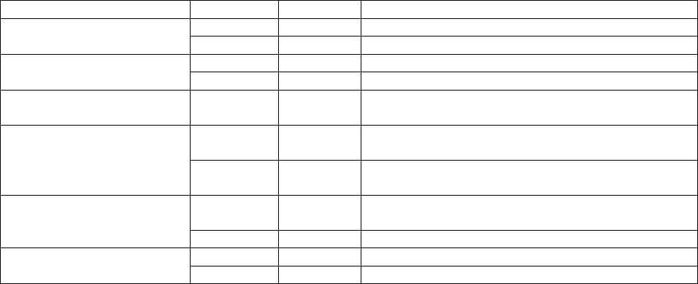

Published
SFF-8679 Rev 1.7
50 mVpp.
In normal operation the default case has Rx Squelch active. Rx Squelch can be deactivated
using Rx Squelch Disable through the 2-wire serial interface. Rx Squelch Disable is an
optional function. For specific details refer to SFF-8636.
5.4.2 Tx(n)(p/n)
Tx(n)(p/n) are module transmitter data inputs. They are AC-coupled 100 Ohm differential
lines with 100 Ohm differential terminations inside the module. The AC coupling is inside
the module and not required on the Host board. For operation at 28 Gb/s the relevant
standards (e.g., OIF CEI v3.1) define the signal requirements on the high-speed
differential lines. For operation at lower rates, refer to the relevant standards.
Due to the possibility of insertion of modules into a host designed for lower speed
operation, the damage threshold of the module input shall be at least 1600 mV peak to
peak differential.
Output squelch, hereafter Tx Squelch, for loss of input signal, hereafter Tx LOS, is an
optional function. Where implemented it shall function as follows. In the event of the
differential, peak-to-peak electrical signal on any channel becomes less than 50 mVpp,
then the transmitter optical output for that channel shall be squelched or disabled and
the associated TxLOS flag set.
Where squelched, the transmitter OMA shall be less than or equal to -26 dBm and when
disabled the transmitter power shall be less than or equal to -30 dBm. For applications,
e.g. Ethernet, where the transmitter off condition is defined in terms of average power,
disabling the transmitter is recommended and for applications, e.g. InfiniBand, where the
transmitter off condition is defined in terms of OMA, squelching the transmitter is
recommended.
In module operation, where Tx Squelch is implemented, the default case has Tx Squelch
active. Tx Squelch can be deactivated using Tx Squelch Disable through the 2-wire serial
interface. Tx Squelch Disable is an optional function. For specific details refer to SFF-
8636.
5.5 Power Supply Pins
The circuit card in a QSFP28 module has three designated power pins, labeled VccTx, VccRx
and Vcc1. When the QSFP28 module is "hot plugged" into a connector with power already
present, the three pins have power applied concurrently. The module is responsible for
limiting the inrush current surge during a hot plug event. The host power supply is
responsible for supplying up to the maximum inrush current limits during a hot plug event
without causing disturbance to other modules and components on the same power supply.
5.5.1 Power Classes and Maximum Power Consumption
QSFP28 modules are categorized into several power classes as listed in Table 5-3. Power
Classes are advertised in upper page 00h of the management interface, byte 129 (81h).
TABLE 5-3 QSFP28 - MAXIMUM POWER CLASSES
Power Class
Maximum power dissipation
per module (W)
1.5
1
2
3
4
5
6
2.0
2.5
3.5
4.0
4.5
QSFP+ 4X Base Electrical Specification
Page 18
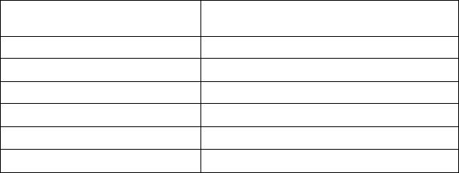

Published
SFF-8679 Rev 1.7
7
5.0
The specification of the host power supply filtering network is beyond the scope of this
specification, particularly because of the wide range of QSFP28 module power classes. An
example current waveform into a host filter, labeled I1 in Figure 5-4, is plotted in
Figure 5-5. Each power connection has a supply filter for the purpose of filtering out
high frequency noise and ripple from host-to-module. During a hot-plug event, the filter
network limits any voltage drop on the host supply so that neighboring modules sharing
the same supply stay within their specified supply voltage limits.
A host board together with the QSFP28 module(s) forms an integrated power system. The
host supplies stable power to the modules. Each module limits electrical noise coupled
back into the host system and limits inrush charge/current during hot plug insertion. All
specifications shall be met at the maximum power supply current. No power sequencing of
the power supply is required of the host system since the module sequences the contacts
in the order of ground, supply and signals during insertion. Any voltage drop across a
filter network on the host is counted against the host DC set point accuracy
specification.
QSFP+ 4X Base Electrical Specification
Page 19

Published
SFF-8679 Rev 1.7
FIGURE 5-4 EXAMPLE: SCHEMATIC OF MULTIPLE QSFP28 POWER SUPPLY ARRANGEMENT
5.5.2 Module Power Supply Specification
In order to avoid exceeding the host system power capacity, upon hot-plug, power cycle or
reset, all QSFP28 modules shall power up in power class 1, designated as "Low Power
Mode". QSFP28 modules that are class 1 will be fully functional after initialization and
remain in low power mode during system operation. All other QSFP28 modules will only
reach fully functional operation after the host system enables "High Power Mode".
High power mode is defined as the maximum power class as advertised in page 00, byte 129
and will only be enabled by the host if the host can supply sufficient power to the
module. The host system controls whether a particular power class is enabled using the
LPMode input pin and by writing to 3 control bits in byte 93. The management interface
specification, SFF-8636 provides complete details but for explanation of power supply
control, the bits are listed in Table 5‐4.
QSFP+ 4X Base Electrical Specification
Page 20
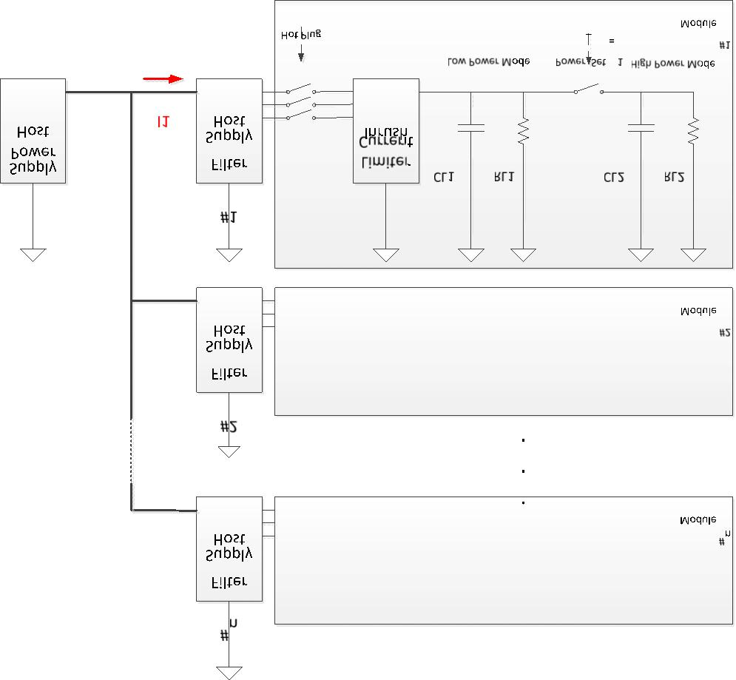

Published
SFF-8679 Rev 1.7
TABLE 5-4 POWER MODE CONTROL BITS (SEE SFF-8636)
Addrs
Bit
Name
Description
93
7-3 Reserved
2
High_Power_Class_Enable
(Classes 5-7)
When set (=1b) enables power classes 5 to 7 if
listed in address 129d. When cleared (=0b),
modules with power classes 5 to 7 shall dissipate
less than 3.5W, but are not required to be fully
functional. Default = 0.
1
0
Power_set
Power set to Low Power Mode (class 1). Default =
0.
Override of LPMode pin to allow power mode setting
by software.
Power_override
A truth table showing the allowed power classes is shown in Table 5-5.
TABLE 5-5 POWER MODE TRUTH TABLE
High_Power_
LPMode pin
Power_override
Power_set
Module Power
Class_Enable bit
state
bit
bit
Classes Allowed
0
0
0
0
1
1
1
1
1
0
X
X
1
0
X
X
0
0
1
1
0
0
1
1
X
X
1
0
X
X
1
0
1
2 to 4
1
2 to 4
1
2 to 7
1
2 to 7
QSFP28 modules operate from the host supplied voltage at the three power pins. To protect
the host and system operation, each QSFP28 module during hot plug and normal operation
shall follow the requirements listed in Table 5-5 and illustrated in Figure 5-5.
The test configuration for measuring the supply current is a module compliance board
(MCB) with reference power supply filters, similar to the circuit shown in SFF-8431,
Appendix D, and Figure 56. The QSFP28 MCB can have a single filter per module card or
separate filters for each power pin on each module card, depending on the power class and
module design. The current limits in Table 5-6 refer to the currents through each
inductor.
An example current waveform into a host filter, labeled I1 in Figure 5-4, is plotted in
Figure 5-5. This figure also shows the timing of the initial module turn-on in low power
mode, and the later transition to full power mode after the host system has enabled it
via the two-wire interface.
QSFP+ 4X Base Electrical Specification
Page 21

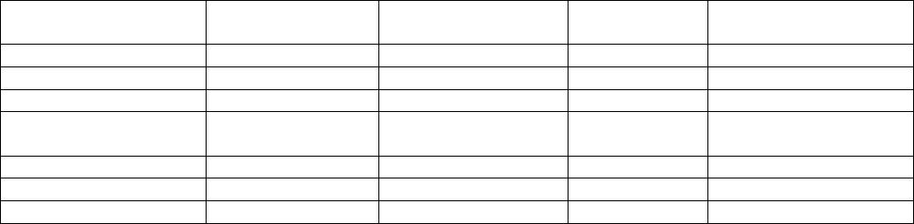

Published
SFF-8679 Rev 1.7
LOW POWER MODE
HIGH POWER MODE
I1 (mA)
Instantaneous peak
duration, max
Instantaneous peak,
max
Sustained peak, max
Steady state, max
Instantaneous peak
duration, max
Instantaneous peak,
max
Sustained peak, max
Steady state, max
t (ms)
Initialization time, max
Initialization time, max
High Power
Mode
Hot Plug
Instant
Enabled
FIGURE 5-5 QSFP28 INRUSH CURRENT TIMING
QSFP+ 4X Base Electrical Specification
Page 22
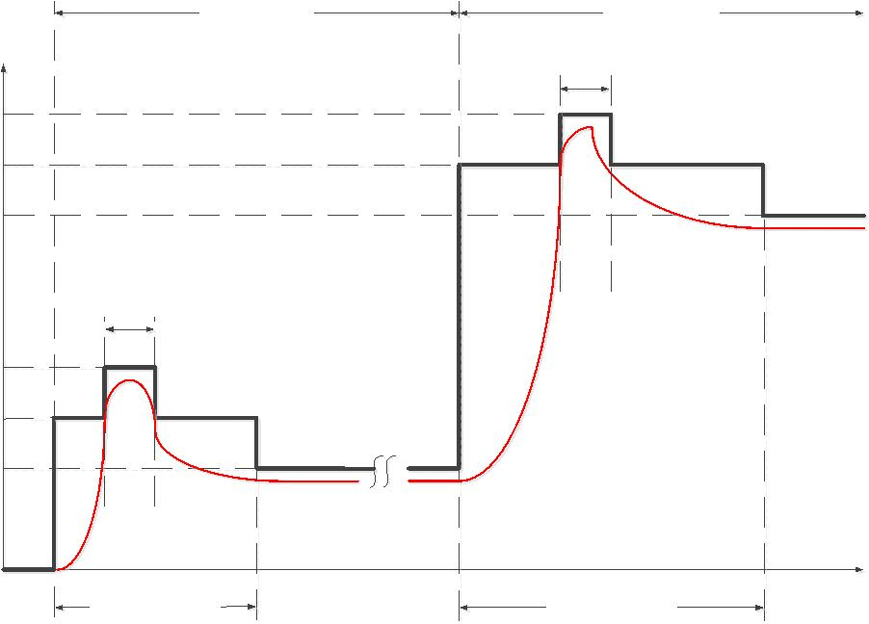

Published
SFF-8679 Rev 1.7
TABLE 5-6 QSFP28 MODULE POWER SUPPLY SPECIFICATION
Parameter
Symbol
Min
Nom
Max
Unit
Host power supply voltages including ripple, Vcc_Host 3.135
droop and noise below 100 kHz
3.3
3.465
V
Host RMS noise output 10 Hz-10 MHz
Module RMS noise output 10 Hz - 10 MHz
Module power supply noise tolerance 10 Hz -
10 MHz (peak-to-peak)
e
e
PSNR
25
15
66
mV
mV
mV
N_Host
N_Mod
_Mod
Module inrush - instantaneous peak duration
Module inrush - initialization time
T_ip
T_init
-
-
-
-
50
500
μs
ms
Power Class 1 module and low power mode for other modules
Power consumption
P_1
-
-
-
-
-
-
-
-
1.5
600
495
W
Instantaneous peak current at hot plug
Sustained peak current at hot plug
Steady state current
Icc_ip_1
Icc_sp_1
Icc_1
mA
mA
mA
432.9
Power Class 2 module
Power consumption
P_3
-
-
-
-
-
-
-
-
2.0
800
660
W
Instantaneous peak current at hot plug
Sustained peak current at hot plug
Steady state current
Icc_ip_3
Icc_sp_3
Icc_3
mA
mA
mA
577.2
Power Class 3 module
Power consumption
P_4
-
-
-
-
-
-
-
-
2.5
1000
825
W
Instantaneous peak current at hot plug
Sustained peak current at hot plug
Steady state current
Icc_ip_4
Icc_sp_4
Icc_4
mA
mA
mA
721.5
Power Class 4 module
Power consumption
P_5
-
-
-
-
-
-
-
-
3.5
1400
1155
W
Instantaneous peak current at hot plug
Sustained peak current at hot plug
Steady state current
Icc_ip_5
Icc_sp_5
Icc_5
mA
mA
mA
1010.1
Power Class 5 module
Power consumption
P_6
-
-
-
-
-
-
-
-
4.0
1600
1320
W
Instantaneous peak current at hot plug
Sustained peak current at hot plug
Steady state current
Icc_ip_6
Icc_sp_6
Icc_6
mA
mA
mA
1154.4
Power Class 6 module
Power consumption
P_7
-
-
-
-
-
-
-
-
4.5
1800
1485
W
Instantaneous peak current at hot plug
Sustained peak current at hot plug
Steady state current
Icc_ip_7
Icc_sp_7
Icc_7
mA
mA
mA
1298.7
Power Class 7 module
Power consumption
P_8
-
-
-
-
-
-
-
-
5.0
2000
1650
W
Instantaneous peak current at hot plug
Sustained peak current at hot plug
Steady state current
Icc_ip_8
Icc_sp_8
Icc_8
mA
mA
mA
1443.0
QSFP+ 4X Base Electrical Specification
Page 23
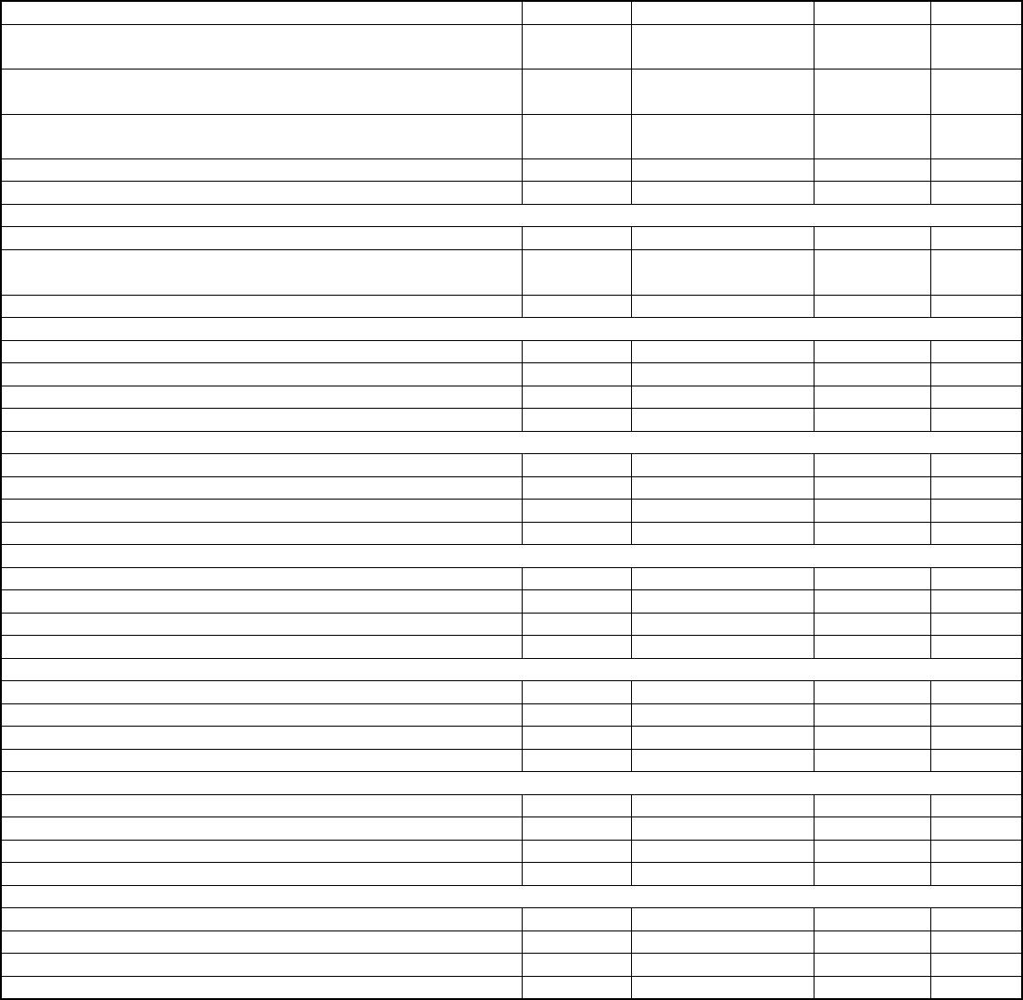

Published
SFF-8679 Rev 1.7
5.5.3 Host Board Power Supply Noise Output
The host shall generate an effective weighted integrated spectrum RMS noise less than the
value in Table 5-6 when tested by the methods of SFF-8431, section D.17.1.
5.5.4 Module Power Supply Noise Output
The QSFP28 module shall generate less than the value in Table 5-6 when tested by the
methods of SFF-8431, section D.17.2.
5.5.5 Module Power Supply Noise Tolerance
The QSFP28 module shall meet all requirements and remain fully operational in the
presence of a sinusoidal tolerance signal of amplitude given by Table 5-6, swept from 10
Hz to 10 MHz according to the methods of SFF-8431, section D.17.3. This emulates the
worst case noise output of the host.
5.6 ESD
Where ESD performance is not otherwise specified, e.g. in the InfiniBand specification,
the module shall meet ESD requirements given in EN61000-4-2, criterion B test
specification when installed in a properly grounded cage and chassis. The units are
subjected to 15kV air discharges during operation and 8kV direct contact discharges to
the case.
The module and host high speed signal contacts shall withstand 1000 V electrostatic
discharge based on Human Body Model per JEDEC JESD22-A114-B.
6
Mechanical and Board Definition
6.1 Introduction
The overall module defined in this clause is illustrated in Figure 6-1. All Pluggable
modules and direct attach cable plugs must mate to the connector and cage design defined
in this specification. The optical interface shall meet the dimensional specifications of
IEC 61754-7 interface 7-3, the MPO adapter interface, and shall optically mate with the
plug on the optical fiber cabling. Several cage-to-bezel options are possible. Both metal
spring finger and elastomeric EMI solutions are permitted but must pass customer defined
requirements. Heat sink/clip thermal designs are application specific and not defined by
this specification; however a general design is given as an example.
QSFP+ 4X Base Electrical Specification
Page 24

Published
SFF-8679 Rev 1.7
FIGURE 6-1 PLUGGABLE AND DIRECT ATTACH MODULE RENDERING
6.2 Color Coding and Labeling of Modules
An exposed feature of the module (a feature or surface extending outside of the bezel)
shall be color coded as follows:
Beige for 850nm
Blue for 1310nm
White for 1550nm
Each module shall be clearly labeled. The complete labeling need not be visible when the
module is installed and the bottom of the device is the recommended location for the
label. Labeling shall include:
Appropriate manufacturing and part number identification
Appropriate regulatory compliance labeling
A manufacturing traceability code
QSFP+ 4X Base Electrical Specification
Page 25
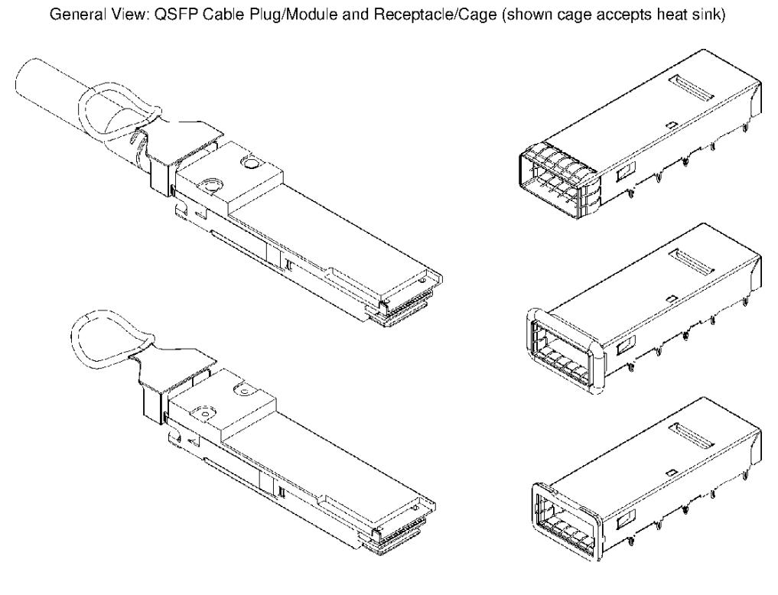

Published
SFF-8679 Rev 1.7
The label should also include clear specification of the external port characteristics
such as:
Optical wavelength
Required fiber characteristics
Operating data rate
Interface standards supported
Link length supported
The labeling shall not interfere with the mechanical, thermal or EMI features.
6.3 Optical Interface
The optical interface port shall be either a male MPO connector as specified in IEC
61754-7 (see Figure 6-4) or a dual LC as specified in IEC 61754-20 (see Figure 6-5).
The four fiber positions on the left as shown in Figure 6-2, with the key up, are used
for the optical transmit signals (Channel 1 through 4). The fiber positions on the right
are used for the optical receive signals (Channel 4 through 1).
The central four fibers may be physically present.
Two alignment pins are present.
FIGURE 6-2 OPTICAL RECEPTACLE AND CHANNEL ORIENTATION FOR MPO CONNECTOR
FIGURE 6-3 OPTICAL RECEPTACLE AND CHANNEL ORIENTATION FOR DUAL LC CONNECTOR
6.3.1 MPO Optical Cable Connection
Aligned key (Type B) MPO patch cords should be used to ensure alignment of the signals
between the modules. The aligned key patch cord is defined in TIA-568 and shown in Figure
6-4. The optical connector is orientated such that the keying feature of the MPO
QSFP+ 4X Base Electrical Specification
Page 26
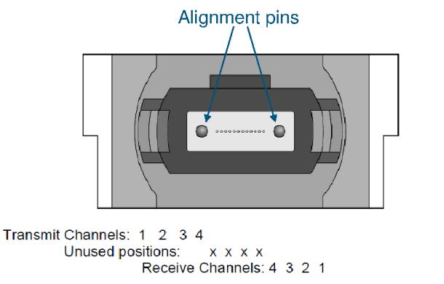
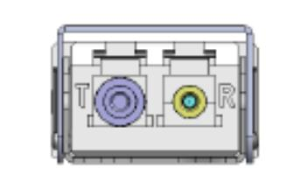

Published
SFF-8679 Rev 1.7
receptacle is on the top.
FIGURE 6-4 MPO OPTICAL PATCH CORD
6.3.2 Dual LC Optical Cable Connection
The Dual LC optical cable patch cord is defined in TIA/EIA-604-10A and shown in Figure
6-5.
FIGURE 6-5 DUAL LC OPTICAL PATCH CORD
QSFP+ 4X Base Electrical Specification
Page 27
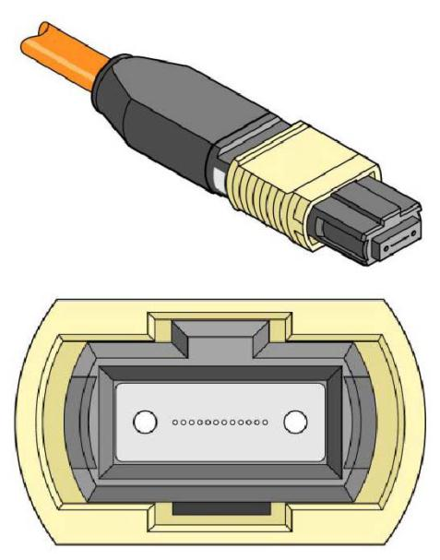
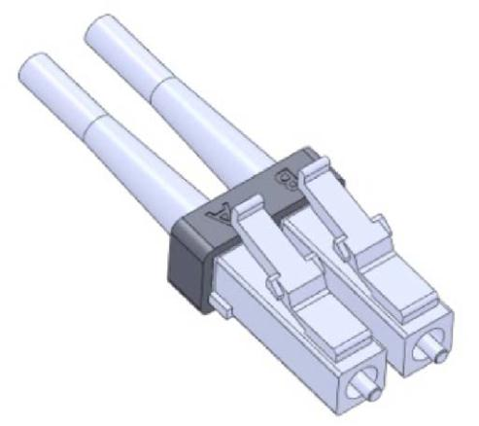

Published
SFF-8679 Rev 1.7
7
Environmental and Thermal
7.1 Thermal Requirements
The module shall operate within one or more of the case temperatures ranges defined in
Table 7-1. The temperature ranges are applicable between 60m below sea level and 1800m
above sea level, (Ref. NEBS GR-63) utilizing the host systems designed airflow.
TABLE 7-1 TEMPERATURE RANGE CLASS OF OPERATION
Class
Case Temperature Range
0 through 70C
-5 through 85C
Standard
Extended
Industrial
-40 through 85C
The design allows for up to 16 adjacent modules, ganged and/or belly-to-belly, with the
appropriate thermal design for cooling / airflow. (Ref. NEBS GR-63)
8
Timing Requirements
A block diagram illustrating the control and status signals between a host system and a
QSFP28 module is shown in Figure 8-1. Timing requirements for the signals SCL, SDA and
ModSelL are provided in the SFF-8636 Common Management Interface specification. Timing
requirements for the hardware signals ResetL, LPMode and IntL are provided in this
section. In addition the timing of control and status functions implemented via the two-
wire interface are provided.
FIGURE 8-1 BLOCK DIAGRAM OF MODULE CONTROL SIGNALS
QSFP+ 4X Base Electrical Specification
Page 28
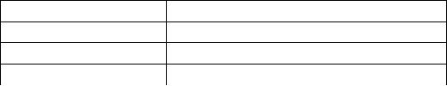
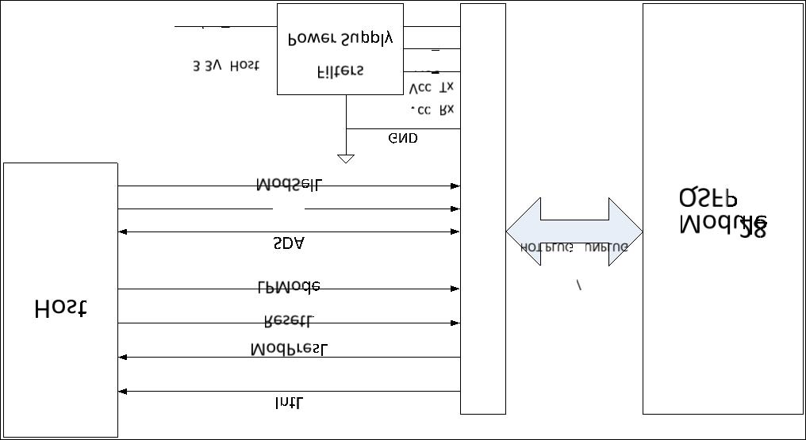

Published
SFF-8679 Rev 1.7
8.1 Soft Control and Status Timing Requirements
TABLE 8-1 SOFT CONTROL AND STATUS TIMING REQUIREMENTS
Parameter
Initialization
time
Symbol
t_init
Max
2000 ms Time from power on*2, hot plug or rising edge
of reset until the module is fully
Unit
Conditions
functional*3. This time does not apply to
non-Power level 0 modules in Low Power State.
Reset Init
Assert Time
t_reset_init
t_serial
2
us A Reset is generated by a low level longer
than t_reset_init present on the ResetL
input.
Serial Bus
Hardware Ready
Time
2000 ms Time from power on*2 until the module
responds to data transmission over the two-
wire serial bus.
Monitor Data
Ready Time
Reset Assert
Time
LPMode Assert
Time
t_data
2000 ms Time from power on*2 to DataNotReady, byte 2
bit 0, deasserted and IntL output asserted.
2000 ms Time from a rising edge on the ResetL input
until the module is fully functional*3.
100 us Time from assertion of LPMode (Vin:LPMode =
Vih) until module power consumption reaches
Power Level 1.
t_reset
ton_LPMode
LPMode Deassert toff_LPMode
Time
IntL Assert Time ton_IntL
300 ms Time from deassertion of LPMode (Vin:LPMode =
Vil) until module is fully functional*3,*5.
200 ms Time from occurrence of condition triggering
IntL until Vout:IntL=Vol.
IntL Deassert
Time
toff_IntL
500 us Time from clear on read*4 operation of
associated flag until Vout:IntL=Voh. This
includes deassert times for Rx LOS, Tx Fault
and other flag bits.
Rx LOS Assert
Time
ton_LOS
100 ms Time from Rx LOS state to Rx LOS bit set
(value = 1b) and IntL asserted.
Tx Fault Assert ton_Txfault
Time
200 ms Time from Tx Fault state to Tx Fault bit set
(value = 1b) and IntL asserted.
Flag Assert Time ton_flag
200 ms Time from condition triggering flag to
associated flag bit set (value = 1b) and IntL
asserted.
Mask Assert Time ton_mask
100 ms Time from mask bit set (value = 1b)*1 until
associated IntL assertion is inhibited.
100 ms Time from mask bit cleared (value = 0b)*1
until associated IntL operation resumes.
100 ms Time from change of state of Application or
Rate Select bit*1 until transmitter or
receiver bandwidth is in conformance with
appropriate specification.
Mask Deassert
Time
toff_mask
t_ratesel
Application or
Rate Select
Change Time
Power_override
or Power_set
Assert Time
ton_Pdown
100 ms Time from P_Down bit set (value = 1b)*1 until
module power consumption reaches Power Level
1.
Power_override
or Power_set
Deassert Time
toff_Pdown
300 ms Time from P_Down bit cleared (value = 0b)*1
until module is fully functional.
*1 Measured from falling clock edge after STOP bit of write transaction.
*2 Power on is defined as the instant when supply voltages reach and remain at or above
the minimum level specified in Table 6.
*3 Fully functional is defined as IntL asserted due to DataNotReady, bit 0 byte 2,
deasserted. The module should also meet optical and electrical specifications.
*4 Measured from falling clock edge after STOP bit of read transaction.
*5 Does not apply to Power Level 1 modules.
QSFP+ 4X Base Electrical Specification
Page 29


Published
SFF-8679 Rev 1.7
8.2
Squelch and TxRx Disable Assert, Deassert and Enable/Disable Timing
Table 8-2 lists the required timing performance for assert, deassert, enable and disable
of the Tx Squelch, Rx Squelch, Tx Disable and Rx Output Disable functions.
TABLE 8-2 QSFP28 SQUELCH AND TXRX DISABLE TIMING
Parameter
Symbol
Max
Unit
Conditions
Rx Squelch Assert ton_Rxsq
Time
80
us Time from loss of Rx input signal until the
squelched output condition is reached. See
Subclause 4.1.3.1.
Rx Squelch
Deassert Time
toff_Rxsq
80
us Time from resumption of Rx input signals
until normal Rx output condition is
reached. See Subclause 4.1.3.1.
Tx Squelch Assert ton_Txsq
Time
400
400
100
400
100
100
100
100
ms Time from loss of Tx input signal until the
squelched output condition is reached. See
Subclause 4.1.3.2.
ms Time from resumption of Tx input signals
until normal Rx output condition is
reached. See Subclause 4.1.3.2.
ms Time from Tx Disable bit set (value = 1b)*1
until optical output falls below 10% of
nominal.
ms Time from Tx Disable bit cleared (value =
0b)*1 until optical output rises above 90%
of nominal.
ms Time from Rx Output Disable bit set (value
= 1b)*1 until Rx output falls below 10% of
nominal.
ms Time from Rx Output Disable bit cleared
(value = 0b)*1 until Rx output rises above
90% of nominal.
ms This applies to Rx and Tx Squelch and is
the time from bit cleared (value =0b)*1
until squelch functionality is enabled.
ms This applies to Rx and Tx Squelch and is
the time from bit set (value =1b)*1 until
squelch functionality is disabled.
Tx Squelch
toff_Txsq
Deassert Time
Tx Disable Assert ton_TxDis
Time
Tx Disable
toff_TxDis
Deassert Time
Rx Output Disable ton_RxDis
Assert Time
Rx Output Disable toff_RxDis
Deassert Time
Squelch Disable
Assert Time
ton_sqDIS
Squelch Disable
Deassert Time
toff_RxDis
*1 Measured from falling clock edge after STOP bit of write transaction.
QSFP+ 4X Base Electrical Specification
Page 30


