Application Note:
HFAN-2.0
Rev 0; 5/00
Interfacing Maxim Laser Drivers with Laser Diodes
[An abridged version of this application note first appeared in the
August, 2000 issue of Lightwave magazine.]
MAXIM High-Frequency/Fiber Communications Group
hfan2_v8.doc
09/01/00




Table of Contents
I. Overview.................................................................................................................................................................1
II. Laser Diode Characteristics...................................................................................................................................1
III. Laser Driver Output Structure..............................................................................................................................2
IV. The PC Board Interface........................................................................................................................................3
A. Headroom Issues with DC-Coupling.................................................................................................................3
B. AC-Coupling......................................................................................................................................................4
C. Interfacing a Laser to a Driver...........................................................................................................................5
D. Additional Board Design Considerations.........................................................................................................7
V. Troubleshooting.....................................................................................................................................................7
A. Waveform Compression (Figure 12).........................................................................................................8
B. Relaxation Oscillation (Figure 13).............................................................................................................8
C. Overshoot (Figure 14)................................................................................................................................9
D. Undershoot (Figure 15) .............................................................................................................................9
E. Ringing (Figure 16)..................................................................................................................................10
F. Reflections (Figure 17).............................................................................................................................10
G. Double-Line Pattern on Eye Diagram (Pattern-Dependent Jitter) (Figure 18)........................................11
H. Asymmetrical Eye Diagram (Figure 21) ................................................................................................12
Customer Applications
Maxim Integrated
Application Note HFAN-2.0 (Rev. 0, 5/00)

Interfacing Maxim Laser Drivers with Laser Diodes
I. Overview
PO
V
在高数据速率下将激光驱动器电路与市售激光二极管接口可能是一项复杂且令人沮丧的任务。本应用笔记旨在简要介绍这一主题，目的是为光学系统设计人员提供有用的参考资料，以尽可能简化这一过程。
V
T1
T2
激光接口难题的三个主要部分包括：（1）激光驱动器的输出电路，（2）激光二极管的电特性，以及（3）它们之间的接口（其通常在印刷电路板上实现）。 在本应用笔记中，将首先讨论激光二极管和激光驱动器的特性，然后将它们汇集在一起讨论印刷电路板接口。 还包括一个优化部分，说明了一些常见接口问题的可能解决方案。
T1 < T2
Ith
Laser current
I
Figure 1. Laser current, forward
voltage, and optical output
图1表示典型激光二极管的电压 - 电流特性和光输出 - 驱动电流关系。
随着温度的升高，阈值电流（Ith）的上升量与工作温度（T）呈指数函数关系，这可以通过下式估算
尽管本应用笔记本质上是通用的，但具体的例子将集中在Maxim的2.5 Gbps通信激光器驱动器，如MAX3867和MAX3869。
T
Ith(T) = I0 + K I •eTI
(1)
II. Laser Diode Characteristics
其中I0，KI和TI是激光专用常数。 DFB激光器的示例常数I0 = 1.8mA，KI = 3.85mA，TI = 40°C。
通常，当激光电流高于其阈值时，相干光输出只能在半导体激光二极管中产生并保持。 为了快速切换操作，通常将激光二极管偏置在阈值以上以避免导通和关断延迟。 激光器的光输出取决于驱动电流幅度和激光二极管的电流 - 光转换效率或斜率。 阈值电流和斜率都与激光器结构，制造工艺，制造材料和工作温度密切相关。
激光斜率（S）是光输出功率（以毫瓦为单位）与输入电流（以毫安）的比值。 温度升高导致斜率下降。 以下公式提供了斜率与温度的函数的良好估计：
T
S(T) = S0 −KS •eTS
(2)
对于与上述相同的DFB示例激光器，特征温度TS接近40°C，另外两个激光常数S0 = 0.485mW / mA和KS = 0.033mW / mA。
Customer Applications
Maxim Integrated
Application Note HFAN-2.0 (Rev. 0, 5/00)
Page 1
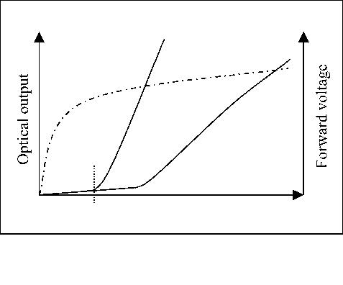

VCC
激光工作电压（正向电压，V）和激光电流（I）之间的关系可以使用二极管电压 - 电流特性模型
V
I ≈ IS ⋅e⎜⋅VT
(3)
其中IS是二极管饱和电流，VT是热电压，并且是制造常数。 当激光二极管被驱动接近并超过阈值时，电压 - 电流关系近似线性，如图1所示。
在图2中示出了激光二极管的简化模型。在该图中，DC偏移电压VBG与激光二极管的带隙电压相关联，RL表示二极管的动态电阻。 当把激光器驱动到阈值以上时，激光二极管的光输出P0（如图2所示）可以用下式来估算
PO
(a) Functional diagram
P0 = S ⋅(I − Ith)
(4)
I
+
V
−
I
RL
Ith
Laser current
PO = S·(I-Ith)
VBG
IBIAS*
IMOD
*图片显示了直流耦合偏置电流。
Figure 2. Simplified laser diode equivalent circuit
(b) Input-output characteristics
Figure 3. Laser driver functionality
在建模封装激光器时应考虑寄生元件（即焊线电感），这一点很重要。
理想情况下，偏置电流应跟踪阈值电流的变化，调制电流应跟踪斜率的变化。
III. Laser Driver Output Structure
激光驱动器的主要功能是为激光二极管的偏置和调制提供适当的电流（图3）。 偏置是一个恒定的电流，将激光二极管的工作范围推到阈值以上并进入线性区域。 调制是一种与输入电压波形同步开关的交流电。
Customer Applications
Maxim Integrated
Application Note HFAN-2.0 (Rev. 0, 5/00)
Page 2
*图片显示了直流耦合偏置电流。
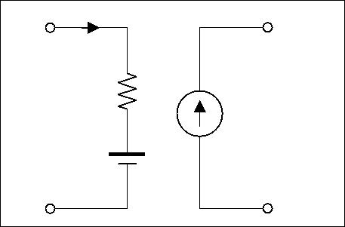

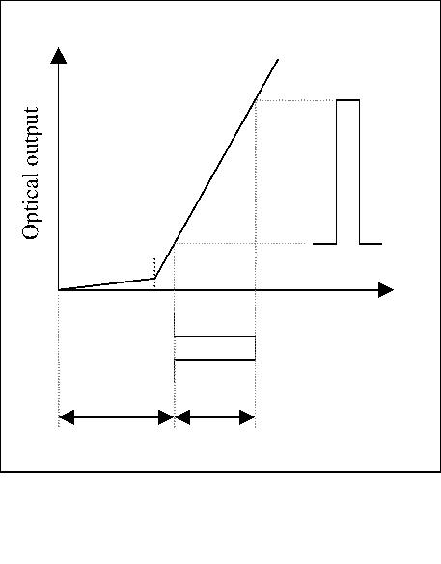
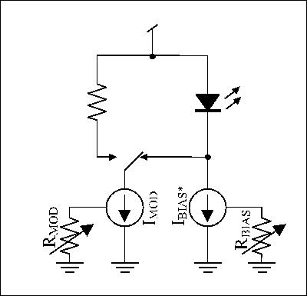
*图片显示了直流耦合偏置电流。

诸如MAX3867和MAX3869等激光驱动器设计用于驱动共阳极激光二极管。 偏置电流可以通过使用外部电阻设置在最小值（通常为1-5mA）和最大值（通常为60-100mA）之间。
IV. The PC Board Interface
当今的光通信系统需要提高运行速度，传输距离和降低功耗。 这些提升要求提高边缘速度，增加调制电流和降低电源电压。 因此，激光驱动器的设计和激光二极管的相应接口是高速光纤通信设计的重要课题。
在激光二极管的阴极保持恒定的阻抗是非常重要的，这样高速输出电路的负载对频率将保持稳定。 输出电路上的不稳定负载可能导致反射，振铃等，这会降低光学波形的质量。 与偏置电流源相关联的分流电容导致阻抗（ZBIAS），其是频率的函数。 为了最小化这种阻抗变化的影响，通常在激光二极管的阴极和偏置电路之间连接外部隔离电感器（或者铁氧体磁珠）。 该电感器对直流偏置电流没有影响，但对调制电流呈现高阻抗。
A. Headroom Issues with DC-Coupling
驱动器和激光器之间的直流耦合提供了一个简单而直接的接口解决方案，如图5所示。但是，当电源电压降至+ 3.3V时，驱动器的余量可能不足以实现快速切换。 （“余量headroom”是指VCC电源电压与沿着单个电路路径的各独立电压降之和之间的差值）。包含激光二极管的电路的余量计算必须包括由激光本身引起的电压降，以及 由激光器封装的寄生电感引起的瞬态电压降以及阻尼电阻器RD两端的电压降。
调制电流的大小由外部电阻RMOD决定（图4）。 该电阻控制与差分输出级相关的电流源。 激光驱动器输出连接到输出级晶体管的集电极。 在大多数情况下，用于集电极开路输出的上拉元件（电阻或电感）置于激光驱动器的外部（上拉的注意事项在PCB接口部分讨论）。
Laser driver
OUT-
IL
IMOD
RD
OUT+
OUT-
Laser driver
IBIAS
OUT+
BIAS
LB
RF
CF
IMOD
IBIAS
Figure 5. DC-coupled interface circuit
典型的长波长法布里 - 珀罗型激光二极管需要正向偏置电压为1.2V至1.8V。 这个正向偏置需求是带隙电压和激光二极管等效串联电阻上的电压降之和（见图2）。 这种类型的激光器的等效串联电阻通常是4欧姆到6欧姆。
Figure 4. Typical Maxim laser driver
modulation output structure
Customer Applications
Maxim Integrated
Application Note HFAN-2.0 (Rev. 0, 5/00)
Page 3
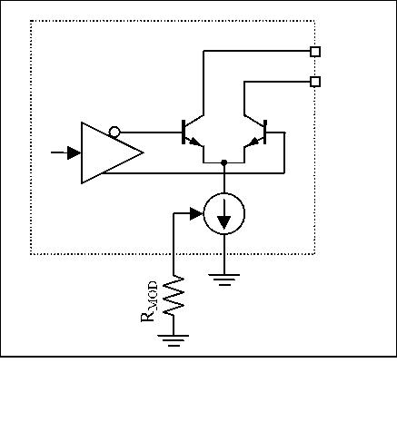
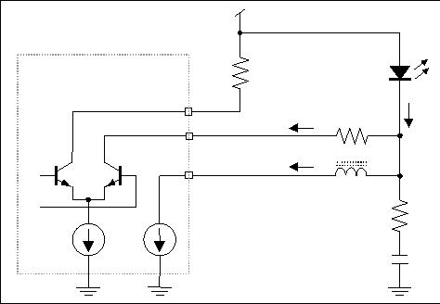
+3.3V

瞬态电压下降是由于与激光器封装相关的寄生电感上的快速开关电流。 它的大小可以松散地近似为VL = LΔi/Δt。 如果我们假设一个典型的激光器封装具有大约1.5nH的寄生电感，60mA的最大调制电流和80ps（对于2.5Gbps）的20％到80％的上升/下降时间，那么我们可以计算出近似值VL。 （请注意，20％到80％上升时间内的Δi大约是总调制电流的60％，或0.6x60mA= 36mA。）使用上述假定值，VL≈（1.5nH）（36mA / 80ps）=0.68V。
交流耦合电压降如下：（1）激光二极管两端的交流电压降仅是等效串联电阻（而不是带隙）两端电压降的函数，等于调制电流乘以等效串联电阻; （2）由DC寄生电感引起的瞬态电压降不变; （3）串联阻尼电阻RD上的电压降等于调制电流乘以RD的一半。
前一段中的最后一点（RD上的压降）可以通过考虑通过交流耦合电容器CD的电流和包括激光二极管阴极的电路节点处的电流来理解（参见图6和7 ）。通过CD的电流必须具有零的平均值和IMOD的总峰 - 峰电流摆幅。为了满足这些条件，在光学高输出期间，一半的IMOD必须流入CD（来自激光器），而在光学低输出期间，一半的IMOD必须流出CD（朝向激光器）。流过激光器的电流IL等于在激光二极管的阴极流出电路节点的电流之和。这意味着在光学高输出IL = IBIAS + IMOD / 2期间以及在光学低输出IL = IBIAS-IMOD / 2期间。 （IBIAS + IMOD / 2） - （IBIAS-IMOD / 2）= IMOD（在光学高输出期间的IL与IL在光学低输出期间的差异）
对于示例余量计算（对于图5的DC耦合接口），考虑具有1.6V的最大正向电压VF（图2中的VBG + IRL）的封装激光二极管。 我们还假定封装寄生电感为1.5nH，60mA调制电流，80ps的20%到80%边沿速率，导致VL = 0.68V（见前段）。 最后，我们必须包括串联阻尼电阻RD上的电压降，即IMODRD = 1.2V（假设RD =20Ω）。 驱动器输出引脚产生的电压可能低至VLOW = VCC - 1.2V - 0.68V - 1.6V = VCC - 3.48V，使3.3V工作非常困难。
B. AC-Coupling
如图6所示，通过将驱动器交流耦合到激光二极管，可以改善上述的余量问题。这可以通过增加串联电容器CD和上拉电感LP来实现。
DC-Coupled AC-Coupled
VOUT+
VOUT+
VF
VCC
VLOW
+3.3V
VMOD = IMOD(RD + RL)
IL
IL
LP
LP
IBIAS + IMOD
Laser driver
IBIAS
IL
IMOD
IBIAS
CD
RD
OUT-
OUT+
IBIAS
Figure 7. Output voltage (VOUT+) and laser current
(IL) for DC- and AC-coupled interface circuits
BIAS
LB
RF
CF
The example headroom calculation for the DC-
coupled interface can now be modified using the AC-
coupled changes. For the AC-coupled case, we
assume the equivalent series resistance of the laser is
Figure 6. AC-coupled interface circuit
5Ω, and the resulting headroom calculation is VLOW
=
Customer Applications
Maxim Integrated
Application Note HFAN-2.0 (Rev. 0, 5/00)
Page 4
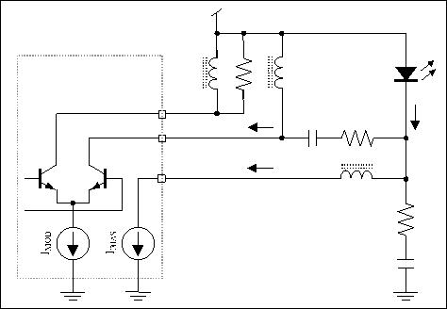
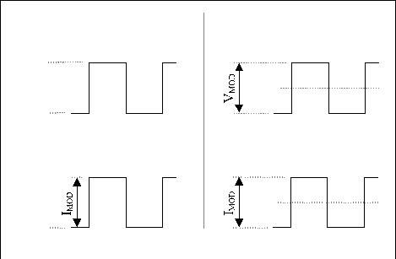

VCC – (60mA)(5Ω) – 0.68V – (60mA/2)(20Ω) = VCC
–
1.58V.
串联阻尼电阻（RD）用于阻尼反射（导致输出失真）和产生稳定负载的双重目的。负载稳定性得到了改善，因为激光器提供的负载可以从大约5Ω（±1Ω/5Ω ±20％）的标称值变化±20％或更多，而由激光器和RD仅变化±4％（±1Ω/25Ω≈±4％）。对于封装的MAX3867和MAX3869，假设同轴式封装激光器，这些元件的初始值为RD =20Ω，RF =75Ω，CF = 3pF。由于不同激光器的封装电感会有所不同，分流网络的元件值可能需要调整以获得最佳性能。此外，重要的是要注意，偏置电感直接连接到激光的阴极（而不是RD的另一端），以使RD不会在驱动器的偏置阶段引起余量问题。
For VCC = 3.3V, this leaves 1.72V of
headroom for the driver, which enables fast current
switching in the driver output stage.
The disadvantage of the AC-coupling approach is that
additional discrete components are required. These
additional components include a coupling capacitor
and pullup inductors or resistors for driver transistor
biasing (as shown in Figure 6). Because these
components are in the high–speed signal path, they
can cause signal distortion. For this reason, the use of
good high-frequency PC board layout techniques is
critical (this subject is addressed in more detail later).
The AC-coupling capacitor will introduce a low-
frequency cutoff, which can impact the pattern-
dependent jitter performance of the system. To reduce
the pattern-dependent jitter caused by long strings of
consecutive identical bits, the value of the AC-
coupling capacitor should be as large as possible.
Designs that include Maxim’s 2.5Gbps laser drivers
generally use an AC-coupling capacitance value
between 0.056∝F and 0.1∝F.
When the interconnection distance becomes greater
than a couple of millimeters, an impedance-controlled
transmission line is required to interface the laser to
the driver (Figure 9). Figure 8 represents the cross
section of a microstrip line, which is commonly used
The pullup inductor or resistor is required in AC-
coupled laser interfaces in order to keep the output
driver transistor biased properly. (Small ferrite beads
are generally used for the inductive pullup.) The
disadvantages of using a resistor (versus an inductor)
in this application are as follows: (1) A resistive
pullup (Rpullup) creates a current divider with the rest of
the laser circuit, taking part of the modulation current
from the laser. This does not happen with an inductor.
(2) Inductive pullups increase the headroom by
allowing the average voltage at the output to be VCC
(as in Figure 7) instead of VCC – (IMOD/2)Rpullup, as
would occur with a resistive pullup.
in
printed
circuit
boards.
The
characteristic
impedance, Z0, is estimated by
87
 5.98⋅H 
⋅ln
0.8⋅W +T
Z0 ≈

(5)
∑ r +1.41

where W is the width of the top conductor, T is the
thickness of the top conductor, H is the thickness of
the dielectric, and ∑r is the dielectric constant. For a
25Ω microstrip line built on conventional FR4
material (∑r = 4.7) with a height (H) of 356∝m, a line
width of approximately 1.3mm results.
C. Interfacing a Laser to a Driver
驱动器和激光二极管之间的互连细节取决于分离距离。如果这个距离小于几个毫米（对于2.5Gbps），则不需要传输线，并且优先尽可能地减少寄生元件。由激光器封装的引线和键合线电感引起的感性负载可能需要一个由电阻器（RF）和电容器（CF）组成的补偿RC分流网络（见图6）。 RC并联网络的目的是消除寄生电感，从而保持恒定的负载阻抗，从而减少过冲和振铃。
W
T
Dielectric Material (∑r)
H
Figure 8. Cross section of microstrip line
Customer Applications
Maxim Integrated
Application Note HFAN-2.0 (Rev. 0, 5/00)
Page 5
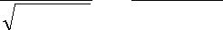
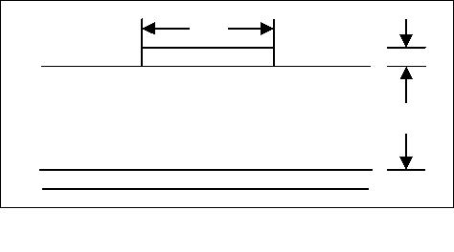

Vcc
Vcc
Driver
ZL
CD
RD
OUT-
OUT+
25Ω
BIAS
Laser
Module
Figure 9. Interfacing a driver to a laser module with transmission line
25Ω
VCC
OUT-
Ground plane
H
G
RD = 20 Ω
VCC
OUT+
Top Conductor
F
B
A
C
E
D
Driver
interface
Figure 10. High-frequency signal path between a driver and a laser diode
Customer Applications
Maxim Integrated
Application Note HFAN-2.0 (Rev. 0, 5/00)
Page 6
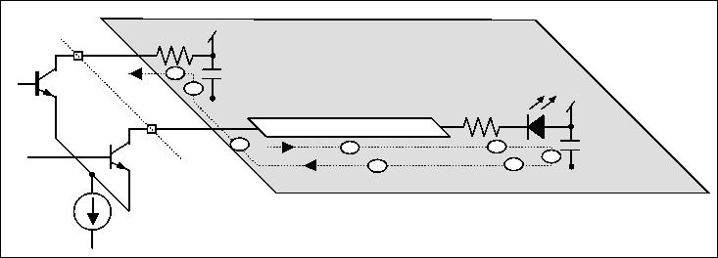
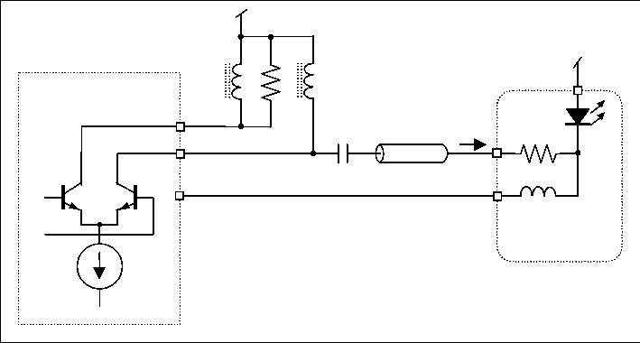

D. Additional Board Design Considerations
contact of the decoupling capacitors as close to the
transmission line as possible. It is also necessary to
minimize the length of the nontransmission line
portion of the printed circuit board at the driver output
pins.
For high-speed differential drivers, it is important to
maintain a balance between the loads on the two
outputs. The loads must be balanced in both the
magnitude and the phase of the load impedances
(Figure 9). To maintain balanced load impedance,
each output is set up to drive an equivalent 25Ω load;
the positive output drives a transmission line
terminated on the load end to VCC through a matching
resistor/laser diode (a 25Ω combined load), and the
negative output of the driver is connected to VCC
through a 25Ω resistor. Decoupling capacitors provide
AC shorts from the laser anode to ground and from
the 25Ω resistor on the negative output to ground.
V. Troubleshooting
Experience has shown that, despite the most careful
design of the interface between the laser driver and the
laser diode, the optical output is generally less than
optimum when the system is powered up initially.
This leads to the need for troubleshooting (or at least
minor adjustments) of the interface in almost all cases.
This section is intended to give the engineer quick
solutions to the most common interface problems.
The high-frequency path can be divided into several
portions (refer to Figure 10): Portion A is from the
driver positive output through the top conductor of the
transmission line to the termination resistor; portion B
is the termination resistor and the laser diode; portion
C is the decoupling capacitor to ground; portion D is
from the decoupling capacitor ground contact to the
transmission line image; portion E is the transmission
line image on the ground plane; portion F is from the
transmission line image to the ground contact of the
DC-coupling capacitor at the negative output; portion
G is the decoupling capacitor at the negative output;
and portion H is the resistor at the negative output.
The following optimization guidelines are based on
the visual output of an oscilloscope connected via an
optical-to-electrical (O/E) converter to the output of
the laser diode. The input to the laser driver is
assumed to be a pseudo-random bit stream (PRBS).
The oscilloscope output can be displayed as a
waveform (when the oscilloscope is triggered by a
pattern clock) or as an eye diagram (when the
oscilloscope is triggered by the bit clock).
The following are descriptions of eight common laser
interface problems, along with waveform illustrations,
a list of possible causes, and suggestions for possible
solutions. Refer to the interface circuit shown in
Figure 11 for all troubleshooting examples.
Because the high-frequency return path includes the
ground plane, it is important to provide good
decoupling from VCC to ground at both the positive
output and the negative output. The decoupling at the
positive output (C) ensures a return current (along the
transmission line image) for proper transmission line
operation, and the decoupling at the negative output
(G) enables a current return to the negative output. It
is always a good practice to use physically small
capacitors for high-frequency performance in these
decoupling elements. It is also important to maintain
an uninterrupted ground connection between these
two capacitors (D, E, F).
VCC
LP2
VCC
LP1
RP
CD
RD
OUT+
It is desirable to keep portions B, D, F, and H (which
are not transmission lines) as short as possible to
reduce the propagation delay between the two driver
outputs. This is because the propagation delay can be
translated into unbalanced phase termination between
the outputs of the differential pair. One way to
improve this situation is to select physically small
termination resistors in order to keep the ground
RF
CF
Figure 11. Interface circuit
Customer Applications
Maxim Integrated
Application Note HFAN-2.0 (Rev. 0, 5/00)
Page 7
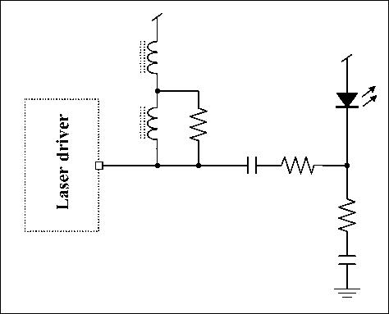

A. Waveform Compression (Figure 12)
B. Relaxation Oscillation (Figure 13)
100 ps/div
100 ps/div
(a)
Figure 12. Eye diagram showing waveform
compression
Problem Description: No clearly distinguishable eye
diagram. Dark horizontal line at the lower extreme of
displayed eye diagram. Decreasing the bias current
can compress the top of the displayed waveform to
move down on the oscilloscope display, but the
bottom of the waveform is stationary.
Possible Causes: Bias current is set too low. The
digital zero level is below the threshold of the laser.
1 ns/div
(b)
Potential Solutions: Increase the laser bias current
until the bottom of the waveform begins to move up
on the oscilloscope display (indicating that the digital
zero level has been raised above the laser threshold).
Figure 13. Relaxation oscillation
(a) Eye diagram, (b) Waveform
Problem Description: Large overshoot evident in
displayed waveform. Dark horizontal line at the lower
extreme of displayed eye diagram. Decreasing the
bias current can cause the digital one level to move
down on the display, while the overshoot remains
constant or even increases in amplitude. The bottom
of the waveform (the digital zero level) remains
stationary as the bias current is decreased.
The
eye
diagram
should
become
clearly
distinguishable as the bias current is increased.
Possible Causes: Bias current is set too low. The
digital zero level is below the threshold of the laser.
Extra time is required to switch the laser from below
threshold to a high level, causing a delayed rising
edge. The delay in switching results in an increased
buildup in potential that causes the laser to overshoot
the digital one level once the threshold is overcome
(known as “relaxation oscillation”).
Potential Solutions: Increase the laser bias current
until the bottom of the waveform begins to move up
on the oscilloscope display (indicating that the digital
Customer Applications
Maxim Integrated
Application Note HFAN-2.0 (Rev. 0, 5/00)
Page 8
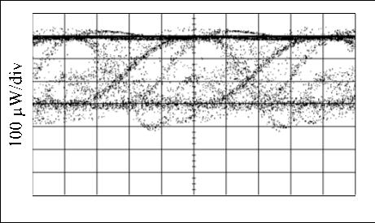
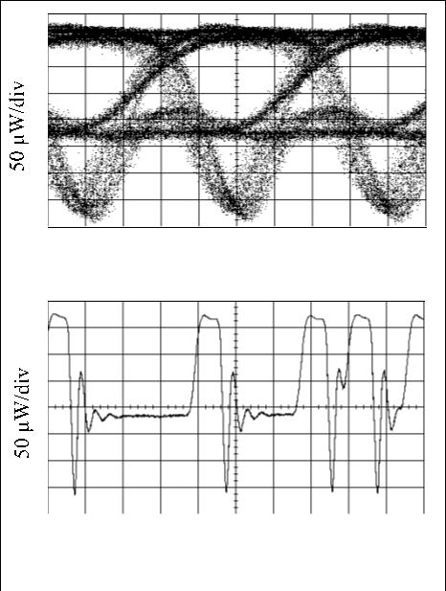

zero level has been raised above the laser threshold).
The overshoot should decrease significantly as the
digital zero level is increased past the threshold value.
D. Undershoot (Figure 15)
C. Overshoot (Figure 14)
Overshoot
Undershoot
50 ps/div
Figure 15. Eye diagram showing undershoot
100ps/div
Problem Description: Rising and/or falling edges do
not reach high or low level within the first half of the
unit interval.
Figure 14. Eye diagram showing overshoot
Problem Description: The rising edge of the
Possible Causes: Overdamped output circuit.
In
waveform overshoots the digital one level.
The
Figure 15, the undershoot was caused by a 0.5pF
capacitor that was placed between OUT+ and OUT-
(this was done to damp out some ringing).
relative amplitude of the overshoot remains almost
constant as the bias and modulation currents are
adjusted. No noticeable ringing is evident.
Potential Solutions: (a) Reduce capacitance between
OUT+ and OUT-, if possible. (b) Reduce load
capacitance on OUT+. (c) Reduce the value of the
series damping resistor (RD in Figure 11).
Possible Causes: (a) Rising edges too fast; (b) ferrite
beads (used as pullups) have excessively high Q
factor.
Potential Solutions: (a) Insert a low-pass filter with a
frequency cutoff at 75% of the data rate. This will
slow the rising and falling edges and decrease the
overshoot. (b) Decrease the value of the resistor in
parallel with the ferrite bead (RP in Figure 11) to damp
out the Q. (c) Adjust the value of the series damping
resistor (RD in Figure 11).
Customer Applications
Maxim Integrated
Application Note HFAN-2.0 (Rev. 0, 5/00)
Page 9
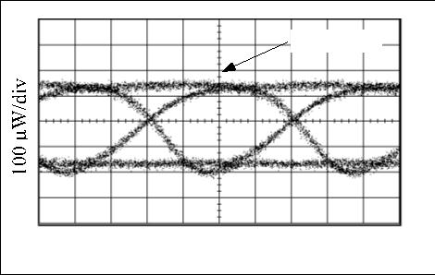
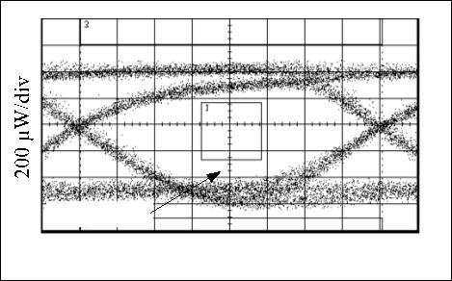

E. Ringing (Figure 16)
F. Reflections (Figure 17)
1 ns/div
100 ps/div
(a)
(a)
200 ps/div
(b)
2 ns/div
(b)
Figure 17. Eye diagrams showing reflections at
(a) 2.5 Gbps, (b) 800Mbps
Figure 16. Ringing on (a) Eye diagram,
(b) Conventional waveform
Problem
Description:
Reflections
due
to
transmission-line
impedance
discontinuities
can
Problem Description: Rising and/or falling edges
exhibit ringing relative to the correct levels in a
damped oscillation pattern.
appear as overshoot, undershoot, ringing, or other
distortions to the eye diagram. One way to verify that
the problem is the result of reflections is to decrease
the bit rate in order to expand the time scale on the
oscilloscope, as in Figure 17.
Possible
Causes:
Impedance
discontinuities,
excessive inductance in the circuit, resonance effects
of circuit components. In Figure 16, the ringing was
caused by removing the resistor in parallel with the
ferrite bead (RP in Figure 11).
Possible Causes: Impedance discontinuities in the
interface circuit.
Potential Solutions: (a) Make sure that the distance
between the laser driver and the laser diode is as short
as possible. (b) Ensure proper controlled-impedance
techniques are used in PC board layout. (c) Use a
time-domain reflectometer (TDR) to help identify
locations of impedance discontinuities; then improve
Potential Solutions:
(a) Eliminate impedance
discontinuities as much as possible. (b) Reduce
parasitic inductance by decreasing the lead length on
the laser diode as much as possible. (c) Decrease the
value of the resistor in parallel with the ferrite bead
(RP in Figure 11). (d) The values of RF and CF (see
Figure 11) can be adjusted to compensate for
parasitics of the laser package.
the PC board layout.
(d) Adjust values of
compensation network components (RF and CF in
Figure 11) in order to obtain a better impedance match
at the load end of the transmission line.
Customer Applications
Maxim Integrated
Application Note HFAN-2.0 (Rev. 0, 5/00)
Page 10
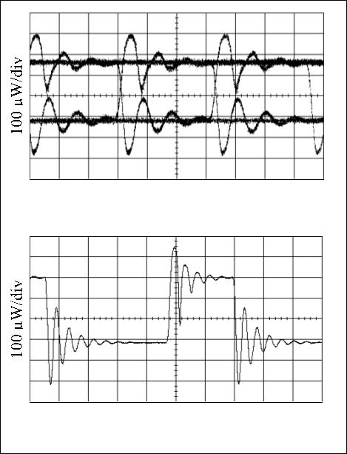
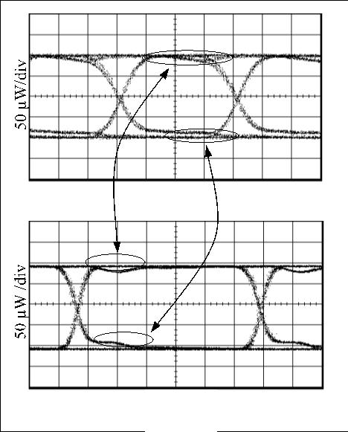


G. Double Line Pattern on Eye Diagram (Pattern
Dependent Jitter) (Figure 18)
50 ps/div
Figure 18. Eye Diagram Showing Double Line
Pattern
Figure 19. Pattern-Dependent Jitter Due to
Low-Frequency Cutoff
Problem Description: Portions of the eye diagram
separate into two distinct lines. The double line effect
may vary when the input data pattern is changed.
Possible Causes: Pattern Dependent Jitter (PDJ)
results from wide variations in the number of
consecutive bits contained in NRZ data streams
working against the available bandwidth. There are a
number of conditions that can cause this effect.
The distortions in Figure 18 were caused by
increasing the modulation current until the output
transistor began to saturate, limiting its high-speed
switching capabilities. The decreased switching speed
limits the bandwidth during the rising edge.
Figure 20. Pattern-Dependent Jitter Due to
High-Frequency Rolloff
The location of the lower -3dB cutoff frequency is
important, and must be set to pass the low frequencies
associated with long consecutive bit streams (Figure
19) in order to eliminate PDJ.
Potential Solutions: (a) Increase the value of the AC
coupling capacitor (CD in Figure 11). (b) Increase the
value of the series damping resistor (RD in Figure 11).
(c) Increase VCC. (d) Decrease the modulation
current.
PDJ can also be present due to insufficient high-
frequency bandwidth (Figure 20). If the amplifiers are
not fast enough to allow for complete transitions
during single-bit patterns, or if the amplifier does not
allow adequate settling time, high-frequency PDJ can
result.
Customer Applications: 1-800-998-9872
Maxim Integrated
Application Note HF-2 (Rev. 0, 12/99)
Page 11
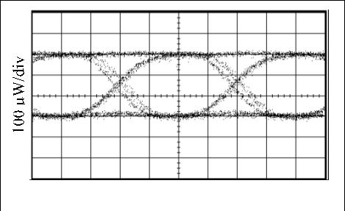

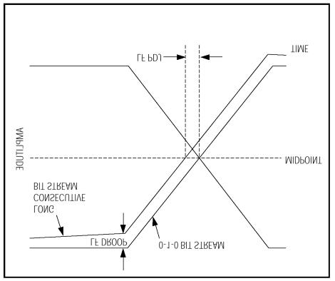
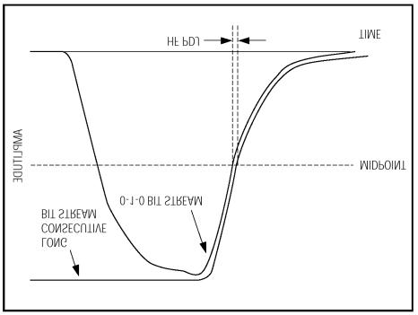

H. Asymmetrical Eye Diagram (Figure 21)
100 ps/div
Figure 22. Pulse-Width Distortion
Figure 21. Asymmetrical Eye Diagram
Problem Description: Rise time may be significantly
different from fall time (as in Figure 21) and/or the
zero crossings of the eye diagram may be shifted
above or below the midpoint (pulse-width distortion
or PWD).
Potential Solutions:
(a) Eliminate distortions
inherent in input datastream (one way to do this is to
clock and latch input data), (b) Use a laser with equal
rise and fall times, (c) Adjust values of damping
resistors (R and R in Figure 11), (d) Slow the faster
P D
edge down by using a low-pass filter with frequency
cutoff at 75% of the data rate.
Possible Causes: Asymmetrical rise and fall times
may be caused by differences in the current paths
during the rise and fall times. (This happens because
each path may present unique charging/discharging
characteristics.) PWD results when the midpoint
crossing of a 0–1 transition and a 1–0 transition do not
occur at the same level due to DC offsets (Figure 22).
Unequal rising and falling edge speeds and DC offsets
both contribute to asymmetrical eye diagrams.
Customer Applications: 1-800-998-9872
Maxim Integrated
Application Note HF-2 (Rev. 0, 12/99)
Page 12
