Part# 39755
GP-QSFP-40GE-PSM4-LEG
D ELL FORCE 10 COMPATIBLE 40GBASE-LR4 QSFP+ SMF
1310NM 10KM REACH MPO DOM PARALLEL

GP-QSFP-40GE-PSM4-LEG
40Gbase QSFP+ Transceiver

Features
•
•
•
•
•
•
•
•
•
•
•
•
Four-Channel full-duplex transceiver modules
Transmission data rate up to 11.2Gbit/s per channel
Aggregate bandwidth of up to 44.0G
QSFP+ MSA compliant
Applications
Up to 10km transmission on single mode fiber (SMF)
Maximum power consumption 3.5W
Single +3.3V power supply
•
•
•
40G Ethernet
Infiniband QDR, DDR and SDR
Data Center and Enterprise
networking
Operating case temperature: 0 to 70°C
RoHS-6 compliant
Built-in digital diagnostic functions
TX: 1310nm DFB
RX: PIN

Product Description
Legrand’s GP-QSFP-40GE-PSM4-LEG Quad Small Form Factor Pluggable (QSFP+) transceivers are compatible with
the Small Form Factor Pluggable Multi-Sourcing Agreement (MSA). The QSFP+ transceivers are high
performance, cost effective modules supporting 40 Gigabit Ethernet and up to 10km transmission distance with
SMF.

Legrand’s QSFP+ transceivers are RoHS compliant and lead-free.

Absolute Maximum Ratings
Parameter
Symbol
Vcc
Min.
-0.3
-0.3
-20
0
Typ.
Max.
3.6
Unit
V
Supply Voltage

Input Voltage
Vin
Vcc+0.3
85
V
Storage Temperature
Case Operating Temperature
Humidity (non-condensing)
Tst
°C
°C
%
Top
Rh
70
5
95

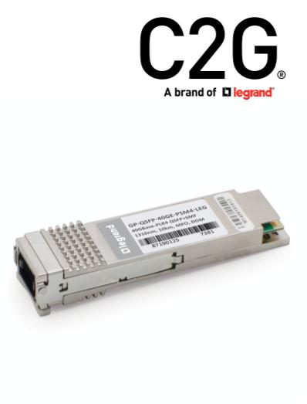


Recommended Operating Conditions
Parameter
Symbol
Min.
3.13
0
Typ.
Max.
3.47
70
Unit
V
Supply Voltage
Vcc
Tca
fd
3.3
Operating Case Temperature
Data Rate Per Lane
Humidity

°C
2.5
5
14.025
85
Gbps
%
Rh
Pm
Rb
Power Dissipation
Fiber Bend Radius

1.5

W
3
cm

Electrical Characteristics
Parameter
Symbol
Zin
Min.
90
Typ.
Max.
110
Unit
ohm
Notes

Differential Input impedance
100
100
Differential Output impedance
Zout
ΔVin
ΔVout
Sw
90
300
500

110
1100
800
300
ohm
mVp-p
mVp-p
ps

Differential Input Voltage
amplitude

Differential output voltage
amplitude
Skew
Bit Error Rate
BR

E-12
VCC
0.8

Input Logic Level High
Input Logic Level Low
Output Logic Level High
VIH
VIL
2.0
0
V
V
VOH
VOL
VCC-0.5
0

VCC
0.4
V
V

Output Logic Level Low

Optical Characteristics
Parameter
Symbol
Min.
Typ.
Max.
Unit
Notes
Transmitter
Center Wavelength
λC
1260
30

1310
1355

nm
dB

Side Mode Suppression Ratio
Average Launch Power
SMSR
PT

7.5
1.5
2.5
6.5

Average Optical Power per Channel PAVG

-5.5
-4.5

dBm
dBm
dB
Optical Modulation Amplitude
(OMA), each lane
POMA

Difference in launch power
between any two lanes (OMA)





Launch Power in OMA minus
Transmitter and Dispersion Penalty
(TDP), each Lane

-5.5

dBm

TDP, each Lane
TDP
ER

3.2

dB

Extinction Ratio
3.5
dB
Relative Intensity Noise
Optical Return Loss Tolerance
Transmitter Reflectance
RIN
TOL
RT

-128
12
-12
-30
dB/Hz
dB
dB
Average Launch Power OFF
Transmitter, each Lane
Poff

dBm

Eye Mask Coordinates:
X1, X2, X3, Y1, Y2, Y3
Specification Values
{0.25, 0.4, 0.45, 0.25, 0.28, 0.4}
Receiver
Center Wavelength
λC
1260
1310
1355

nm

Damage Threshold, each Lane
THd

3.3

dBm
dBm
dB
Average Receive Power, each
Lane
-12.6
1.5
-12
2.5
-12.6
7.5

Receiver Reflectance
Peak power, each lane

dBm
dBm
dB
Receiver Sensitivity (OMA),
each Lane
SEN
Prx,diff
LOSA
LOSD
LOSH
Fe

Difference in Receive Power
between any Two Lanes (OMA)

LOS Assert
-30
dBm
dBm
dB
LOS Deassert
LOS Hysteresis

-15

0.5

Receiver Electrical 3 dB upper
Cutoff Frequency, each Lane
12.3
GHz

Note:
1. Measured with conformance test signal at TP3 for BER = 10e-12



Pin Descriptions
Pin
Logic
Symbol
Name/Descriptions
Ref.
1

GND
Tx2-
Module Ground
1

2
CML-I
Transmitter inverted data input
Transmitter non-inverted data input
Module Ground
3
CML-I
Tx2+
GND
Tx4-

4

1

5
CML-I
Transmitter inverted data input
Transmitter non-inverted data input
Module Ground
6
CML-I
Tx4+
GND
MODSEIL
ResetL
VCCRx
SCL

7

1
2
2

8
LVTTL-I
Module Select
9
LVTTL-I
Module Reset
10
11
12
13
14
15
16
17
18
19
20
21
22
23
24
25
26
27
28
29
30
31
32
33

+3.3v Receiver Power Supply
2-wire Serial interface clock
2-wire Serial interface data
Module Ground
LVCMOS-I
2
2
1

LVCMOS-I/O
SDA

GND
RX3+
RX3-
CML-O
Receiver non-inverted data output
Receiver inverted dta output
Module Ground
CML-O

GND
RX1+
RX1-
1

CML-O
Receiver non-inverted data output
Receiver inverted data output
Module Ground
CML-O

GND
GND
RX2-
1
1

Module Ground
CML-O
Receiver inverted data output
Receiver non-inverted data output
Module Ground
CML-O
RX2+
GND
RX4-

1

CML-O
Receiver inverted data output
Receiver non-inverted data output
Module Ground
CML-O
RX4+
GND
ModPrsL
IntL

1

LVTTL-O
Module Present, internal pulled down to GND
Interrupt output, should be pulled up on host board
+3.3v Transmitter Power Supply
+3.3v Power Supply
LVTTL-O
2

VCCTx
VCC1
LPMode
GND
Tx3+

LVTTL-I

Low Power Mode
2
1

Module Ground
CML-I
Transmitter non-inverted data input



34
35
36
37
38
CML-I
Tx3-
GND
Tx1+
Tx1-
GND
Transmitter inverted data input
Module Ground

1

CML-I
CML-I

Transmitter non-inverted data input
Transmitter inverted data input
Module Ground

1

Note:
1. Module circuit ground is isolated from module chassis ground with in the module.
2. Open collector; should be pulled up with 4.7k-10k ohms on host board to a voltage between 3.15V and
3.6V.

Electrical Pin-out Details

ModSeIL Pin
The ModSelL is an input pin. When held low by the host, the module responds to 2-wire serial communication
commands. The ModSelL allows the use of multiple QSFP modules on a single 2-wire interface bus. When the
ModSelL is “High”, the module will not respond to any 2-wire interface communication from the host. ModSelL
has an internal pull-up in the module.

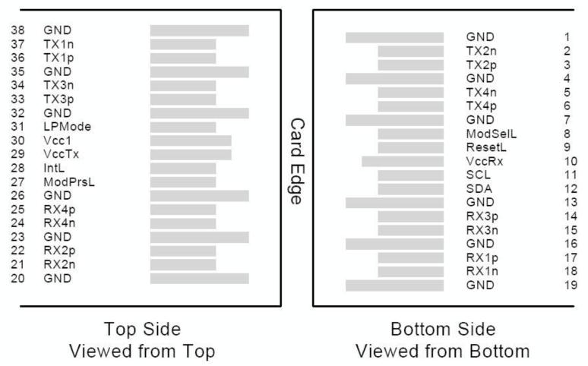
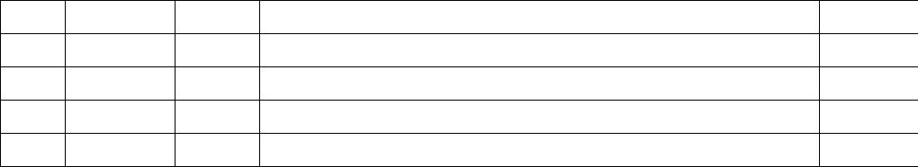

ResetL Pin
Reset. LPMode_Reset has an internal pull-up in the module. A low level on the ResetL pin for longer than the
minimum pulse length (t_Reset_init) initiates a complete module reset, returning all user module settings to
their default state. Module Reset Assert Time (t_init) starts on the rising edge after the low level on the ResetL
pin is released. During the execution of a reset (t_init) the host shall disregard all status bits until the module
indicates a completion of the reset interrupt. The module indicates this by posting an IntL signal with the
Data_Not_Ready bit negated. Note that on power up (including hot insertion) the module will post this
completion of reset interrupt without requiring a reset.

LPMode Pin
Operate in the low power mode (less than 1.5 W power consumption) This pin active high will decrease power
consumption to less than 1W.

ModPrsL Pin
ModPrsL is pulled up to Vcc on the host board and grounded in the module. The ModPrsL is asserted “Low”
when the module is inserted and de-asserted “High” when the module is physically absent from the host
connector.

IntL Pin
IntL is an output pin. When “Low”, it indicates a possible module operational fault or a status critical to the host
system. The host identifies the source of the interrupt by using the 2-wire serial interface. The IntL pin is an open
collector output and must be pulled up to Vcc on the host board.

Power Supply Filtering
The host board should use the power supply filtering shown below.

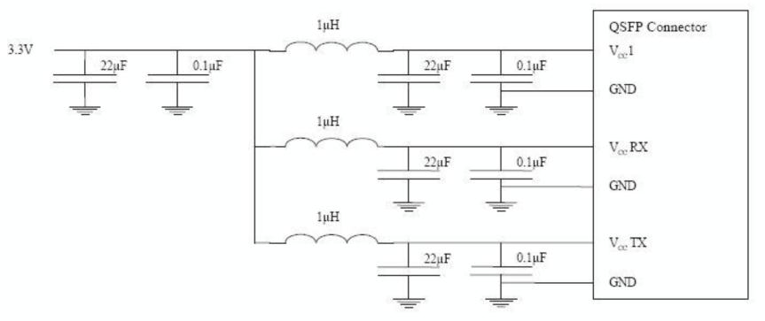

Optical Interface Lanes and Assignment
The optical interface port is a male MPO connector .The four fiber positions on the left as shown below, with the
key up, are used for the optical transmit signals (Channel 1 through 4). The fiber positions on the right are used
for the optical receive signals (Channel 4 through 1). The central four fibers are physically present.

Module Block Diagram

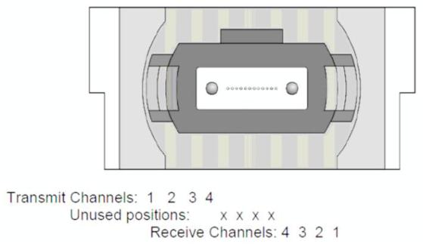
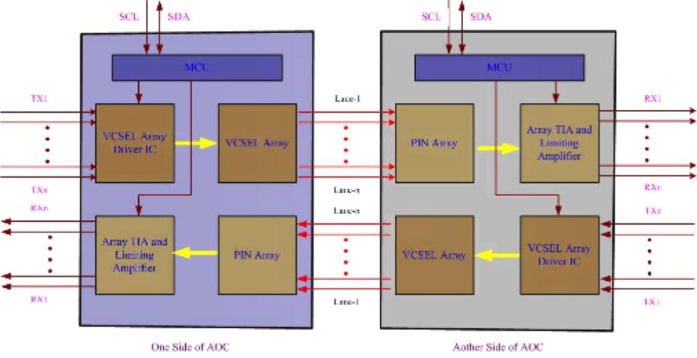

Mechanical Specifications

