40Gbps QSFP+ PSM LR4
SLQS-40G-PSM-LR4
receptacle. Proper alignment is ensured by the
guide pins inside the receptacle. The cable usually
cannot be twisted for proper channel to channel
alignment. Electrical connection is achieved through
a
z-pluggable
38-pin
connector
per
MSA
requirement.
The module operates with single +3.3V power
supply. LVCMOS/LVTTL global control signals, such
as Module Present, Reset, Interrupt and Low Power
Mode, are available with the modules. A 2-wire
serial interface is available to send and receive
more complex control signals, and to receive digital
diagnostic information. Individual channels can be
addressed and unused channels can be shut down
for maximum design flexibility.
Overview
SLQS-40G-PSM-LR4 is designed with form factor,
optical/electrical connection and digital diagnostic
interface according to the QSFP+ Multi-Source
Agreement (MSA). It has been designed to meet the
harshest external operating conditions including
temperature, humidity and EMI interference. The
module can be managed through the I2C two-wire
serial interface.
Features
♦ 4 Parallel lanes design
♦ Up to 11.2Gb/s data rate per channel
♦ Aggregate Bandwidth of up to 44.0G
♦ QSFP+ MSA compliant
♦ Up to 10km transmission on single mode fiber (SMF)
♦ Maximum power consumption 3.5W
♦ Single +3.3V power supply
This
product a parallel 40Gb/s Quad Small
Form-factor Pluggable (QSFP+) optical module. It
provides increased port density and total system
cost savings. The QSFP+ full-duplex optical module
offers 4 independent transmit and receive channels,
each capable of 10Gb/s operation for an aggregate
data rate of 40Gb/s on 10km of single mode fiber.
♦ Operating case temperature: 0~70oC
♦ RoHS-6 compliant
Applications
♦
♦
♦
40G Ethernet
Infiniband QDR, DDR and SDR
Datacenter and Enterprise networking
An optical fiber ribbon cable with an MTP/MPO
connector can be plugged into the QSFP+ module
Ordering Information
Part Number
Product Description
QSFP+ LR4 PSM 10km optical transceiver with full real-time digital diagnostic monitoring and
pull tab
SLQS-40G-PSM-LR4
1


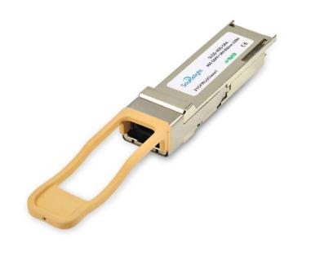

Module Block Diagram
Figure1. Module Block Diagram
Absolute Maximum Ratings
It has to be noted that the operation in excess of any absolute maximum ratings might cause permanent
damage to this module.
Parameter
Symbol
Vcc
Min
-0.5
-40
0
Max
3.6
85
Unit
V
Supply Voltage
Storage Temperature
Tst
ºC
Operating Case Temperature
Humidity(non-condensing)
Damage Threshold, each Lane
Top
70
ºC
Rh
0
85
%
THd
3.3
dBm
Recommended Operating Conditions
Parameter
Supply Voltage
Symbol
Min
3.135
0
Typical
Max
3.465
70
Unit
Vcc
TOP
fd
3.3
V
ºC
Operating Case temperature
Data Rate Per Lane
Control Input Voltage High
Control Input Voltage Low
Link Distance with G652
10.3125
11.2
Vcc
0.8
10
Gb/s
V
2
0
V
D
Km
Electrical Specifications
The following electrical characteristics are defined over the Recommended Operating Environment unless
otherwise specified.
Parameter
Symbol
Min
Typical
Max
Unit
Notes
Power Consumption
3.5
W
Supply Current
Icc
1.1
A
Transceiver Power-on
Initialization Time
2000
ms
1
2



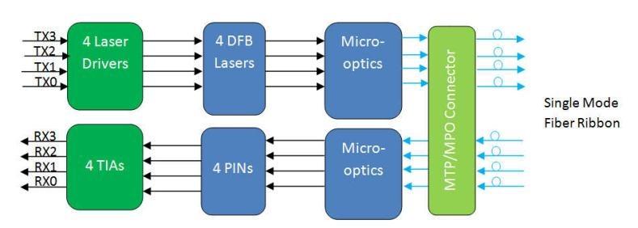

Transmitter (Each Lane)
Referred to
TP1 signal
common
Single-ended Input Voltage
Tolerance (Note 2)
-0.3
4.0
V
AC Common Mode Input
Voltage Tolerance
15
mV
RMS
Differential Input Voltage
Swing Threshold
LOSA
Threshold
50
mVpp
Differential Input Voltage Swing
Differential Input Impedance
Differential Input Return Loss
J2 Jitter Tolerance
Zin, pp
Zin
190
700
110
mVpp
ohm
dB
90
100
See IEEE 802.3ba 86A.4.11
10MHz - 11.1GHz
Jt2
Jt9
0.17
0.29
UI
J9 Jitter Tolerance
UI
Data Dependent Pulse Width
Shrinkage (DDPWS) Tolerance
0.07
UI
Eye Mask Coordinates
{X1, X2,
Y1, Y2}
0.11, 0.31,
95, 350
UI
mV
Hit Ratio =
5x10-5
Receiver (Each Lane)
Referred to signal
common
Single-ended Output Voltage
AC Common Mode Output Voltage
Differential Output Voltage Swing
-0.3
4.0
7.5
850
V
mV
RMS
Vout, pp
Zout
300
90
mVpp
Differential Output Impedance
Termination Mismatch at 1MHz
Differential Output Return Loss
Common Mode Output Return Loss
Output Transition Time
100
110
5
ohm
%
See IEEE 802.3ba 86A.4.2.1
See IEEE 802.3ba 86A.4.2.2
dB
dB
ps
10MHz - 11.1GHz
10MHz - 11.1GHz
20% to 80%
28
J2 Jitter Output
Jo2
Jo9
0.42
0.65
UI
J9 Jitter Output
UI
Eye Mask Coordinates
{X1, X2
Y1, Y2}
0.29, 0.5
150, 425
UI
mV
Hit Ratio =
5x10-5
Note：
1.
Power-on Initialization time is the time from when the power supply voltages reach and remain above the minimum recommended
operating supply voltages to the time when the module is fully functional.
2.
The single ended input voltage tolerance is the allowable range of the instantaneous input signals.
3


Optical Characteristics
All parameters are specified under the recommended operating conditions with PRBS31 data pattern unless
otherwise specified.
Parameter
Symbol
Min
Typical
Max
Unit
Notes
Transmitter
1260
30
Center Wavelength
Side Mode Suppression Ratio
Average Launch Power, each Lane
OMA, each Lane
λC
1310
1355
nm
dB
SMSR
PAVG
-6.0
1.5
3.0
dBm
dBm
1
2
POMA
-4.5
Difference in Launch Power
between any Two Lanes (OMA)
Ptx,diff
6.5
dB
Launch Power in OMA minus
Transmitter and Dispersion
Penalty (TDP), each Lane
OMA-TDP
-5.5
3.5
dBm
TDP, each Lane
Extinction Ratio
TDP
ER
3.2
dB
dB
12dB
reflection
Relative Intensity Noise
RIN
-128
dB/Hz
Optical Return Loss Tolerance
Transmitter Reflectance
TOL
RT
12
dB
dB
-12
Transmitter Eye Mask Definition
{X1, X2, X3, Y1, Y2, Y3}
{0.25, 0.4, 0.45, 0.25, 0.28, 0.4}
Average Launch Power OFF
Transmitter, each Lane
Poff
-30
dBm
Receiver
Center Wavelength
λC
1260
3.3
1310
1355
nm
Damage Threshold, each Lane
THd
dBm
3
Average Receive Power, each
Lane
-12.7
2.3
-12
dBm
dB
Receiver Reflectance
RR
Receiver Sensitivity (OMA), each
Lane
SEN
-12.6
dBm
Informative
Difference in Receive Power
between any Two Lanes (OMA)
Prx,diff
7.5
-15
dB
LOS Assert
LOS Deassert
LOS Hysteresis
LOSA
LOSD
LOSH
-30
0.5
dBm
dBm
dB
Receiver Electrical 3 dB upper
Cutoff Frequency, each Lane
Fc
12.3
GHz
Note：
1.
The maximum transmitter average optical power of 1.5 dBm is well within the guardband of receiver overload specifications of
commercially available 10GBASE-LR SFP+ transceivers offered by Sourcelight and other vendors.
2.
3.
Even if the TDP < 1 dB, the OMA min must exceed the minimum value specified here.
The receiver shall be able to tolerate, without damage, continuous exposure to a modulated optical input signal having this power
level on one lane. The receiver does not have to operate correctly at this input power.
4


Pin Descriptions
Pin
1
Logic
Symbol
GND
Name/Description
Ground
Ref.
1
2
CML-I
CML-I
Tx2n
Tx2p
GND
Transmitter Inverted Data Input
Transmitter Non-Inverted Data output
Ground
3
4
1
1
2
5
CML-I
CML-I
Tx4n
Tx4p
GND
Transmitter Inverted Data Input
Transmitter Non-Inverted Data output
Ground
6
7
8
LVTLL-I
LVTLL-I
ModSelL
ResetL
VccRx
SCL
Module Select
9
Module Reset
10
11
12
13
14
15
16
17
18
19
20
21
22
23
24
25
26
27
28
29
30
31
32
33
34
35
36
37
38
+3.3V Power Supply Receiver
2-Wire Serial Interface Clock
2-Wire Serial Interface Data
Ground
LVCMOS-I/O
LVCMOS-I/O
SDA
GND
CML-O
CML-O
Rx3p
Rx3n
GND
Receiver Non-Inverted Data Output
Receiver Inverted Data Output
Ground
1
CML-O
CML-O
Rx1p
Rx1n
GND
Receiver Non-Inverted Data Output
Receiver Inverted Data Output
Ground
1
1
GND
Ground
CML-O
CML-O
Rx2n
Rx2p
GND
Receiver Inverted Data Output
Receiver Non-Inverted Data Output
Ground
1
1
CML-O
CML-O
Rx4n
Rx4p
GND
Receiver Inverted Data Output
Receiver Non-Inverted Data Output
Ground
1
LVTTL-O
LVTTL-O
ModPrsL
IntL
Module Present
Interrupt
VccTx
Vcc1
LPMode
GND
+3.3 V Power Supply transmitter
+3.3 V Power Supply
Low Power Mode
2
2
LVTTL-I
Ground
1
1
1
CML-I
CML-I
Tx3p
Tx3n
GND
Transmitter Non-Inverted Data Input
Transmitter Inverted Data Output
Ground
CML-I
CML-I
Tx1p
Tx1n
GND
Transmitter Non-Inverted Data Input
Transmitter Inverted Data Output
Ground
5


Notes:
1.
GND is the symbol for signal and supply (power) common for QSFP+ modules. All are common within the QSFP+ module and all
module voltages are referenced to this potential unless otherwise noted. Connect these directly to the host board signal common
ground plane.
2.
VccRx, Vcc1 and VccTx are the receiver and transmitter power suppliers and shall be applied concurrently. Recommended host board
power supply filtering is shown in Figure 3 below. Vcc Rx, Vcc1 and VccTx may be internally connected within the QSFP+ transceiver
module in any combination. The connector pins are each rated for a maximum current of 500mA.
Figure2. Electrical Pin-out Details
Recommended Power Supply Filter
Figure3. Recommended Power Supply Filter
6
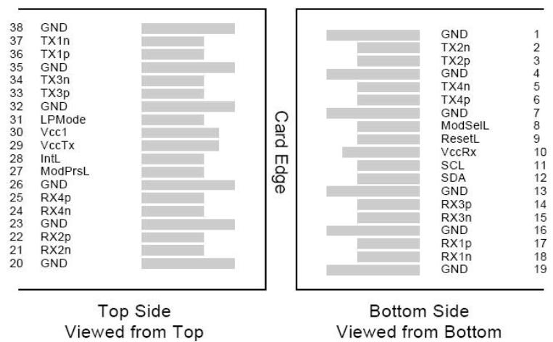
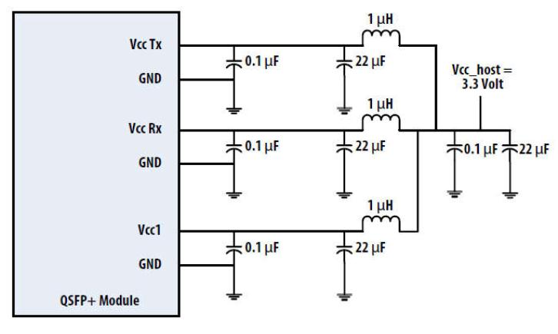

Digital Diagnostic Functions
The following digital diagnostic characteristics are defined over the normal operating conditions unless
otherwise specified.
Parameter
Symbol
Min
Max
Unit
Notes
Over operating
temperature
Temperature monitor absolute error
DMI_Temp
-3
3
degC
Full operating
range
Supply voltage monitor absolute error
DMI _VCC
-0.1
0.1
V
Channel RX power monitor absolute error
Channel Bias current monitor
DMI_RX_Ch
DMI_Ibias_Ch
DMI_TX_Ch
-2
-10%
-2
2
10%
2
dB
mA
dB
1
1
Channel TX power monitor absolute error
Notes:
1.
Due to measurement accuracy of different single mode fibers, there could be an additional +/-1 dB fluctuation, or a +/- 3 dB total
accuracy.
Mechanical Dimensions
Figure4. Mechanical Specifications
Attention: To minimize MPO connection induced reflections, an MPO receptacle with 8-degree angled end-face is
utilized for this product. A female MPO connector with 8-degree end-face should be used with this product as
illustrated in Figure 5.
7

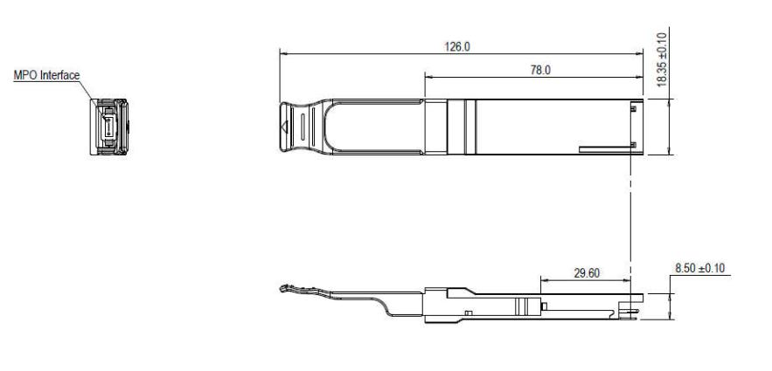

Figure5. Female MPO Connector with 8-degree End-face
ESD
This transceiver is specified as ESD threshold 1KV for high speed data pins and 2KV for all others electrical input
pins, tested per MIL-STD-883, Method 3015.4 /JESD22-A114-A (HBM). However, normal ESD precautions are
still required during the handling of this module. This transceiver is shipped in ESD protective packaging. It
should be removed from the packaging and handled only in an ESD protected environment.
Laser Safety
This is a Class 1 Laser Product according to IEC 60825-1:2007. This product complies with 21 CFR 1040.10 and
1040.11 except for deviations pursuant to Laser Notice No. 50, dated (June 24, 2007).
Shenzhen Sourcelight Technology Co., Ltd
Sourcelight Technology reserves the right to make changes to or discontinue any optical link product or service identified in
this document without notice in order to improve design and/or performance. If you have any question regarding this
specification sheet, please contact our sales representative or send email to sales@sourcelight.com.cn
8
