
P46.
13.
股价的均值是： 17.0
股价的中位数是： 12.0
股价的众数是： 12

import pandas as pd
import numpy as np

measurements = np.array([10,7,20,12,75,15,9,18,4,12,8,14])
print("股价的均值是：",str(np.mean(measurements)))
print("股价的中位数是：",str(np.median(measurements)))
counts = np.bincount(measurements)
np.argmax(counts)
print("股价的众数是：",str(np.argmax(counts)))

14.
股价的标准差是： 18.027756377319946
反应股价的离散程度，即风险
print("股价的标准差是：",np.std(measurements))
15.
0.22535211267605634
(20-measurements.min())/(measurements.max()-measurements.min())
16.
12.0
np.median(measurements)
17.
0.16641005886756874
(20-measurements.mean())/measurements.std()
18.
0.2
d=len(str(int(measurements.max())))
20/np.power(10,d)
24.
A.
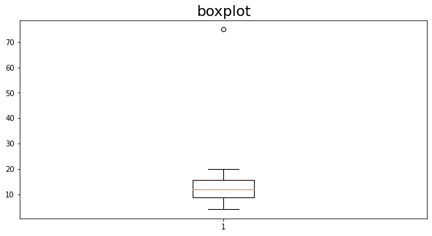
离群值是75.
import matplotlib.pyplot as plt
plt.figure(figsize=(10,5))#设置画布的尺寸
plt.title('boxplot',fontsize=20)#标题，并设定字号大小
plt.boxplot(measurements)#grid=False：代表不显示背景中的网格线
# data.boxplot()#画箱型图的另一种方法，参数较少，而且只接受dataframe，不常用
plt.show()#显示图像
B.
75是异常值
mean=np.mean(measurements)
std=np.std(measurements)
for i in measurements:
if i>(mean+3*std) or i<(mean-3*std):
print(str(i)+"是异常值")
C.
75
from scipy.stats import iqr
iqr(measurements, rng=(25, 75))
25.
75是异常值
mean=np.mean(measurements)
std=np.std(measurements)
for i in measurements:
if i>(mean+3*std) or i<(mean-3*std):
print(str(i)+"是异常值")
75
from scipy.stats import iqr
iqr(measurements, rng=(25, 75))
26.
A.
measurements1 = np.array([10,7,20,12,15,9,18,4,12,8,14])
mean1=np.mean(measurements)
median1=np.median(measurements)
mean2=np.mean(measurements1)
median2=np.median(measurements1)
display(mean1)
display(median1)
display(mean2)
display(median2)
有离群值，均值为17.0
有离群值，中位数为12.0
没有离群值，均值为11.727272727272727
没有离群值，中位数为12.0
B.
离群值对均值的影响更大，因为均值的计算要用到离群值，中位数的计算不用到离群值。
38.
A.
倾斜度是：-0.029063979518119797。
from scipy.stats import kurtosis
from scipy.stats import skew
df=pd.read_csv("churn.txt")
df.head()
skew(df['Day Mins'])
B.
倾斜度是：-0.029063979518119797。
zscore=(df['Day Mins']-df['Day Mins'].mean())/df['Day Mins'].std()
skew(zscore)
即使经过了zscore标准化，倾斜度不变。
C.
倾斜度接近于0，但是是负的。几乎完全对称。
39.
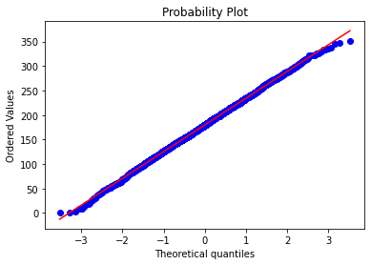
实际累积概率分布与理论累积概率分布是否吻合，若吻合，则散点应围绕在一条直线周围，或者实际概率与理论概率之差分布在对称于以0为水平轴的带内（这种称为去势P-P图），故符合正态分布。
P82.
22.
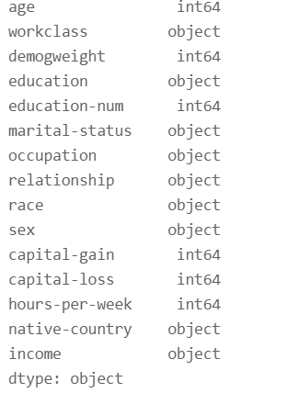
df=pd.read_csv("adult.zip")
df.head()
df.dtypes
23.
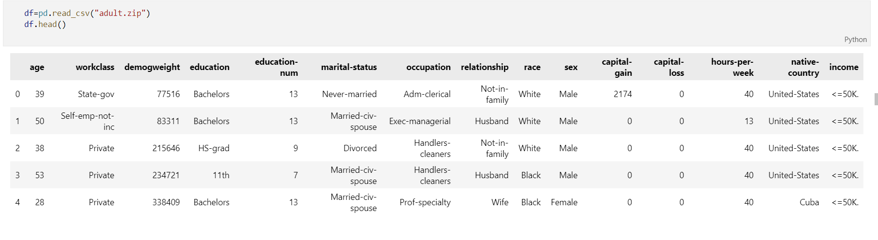
df=pd.read_csv("adult.zip")
df.head()
29.
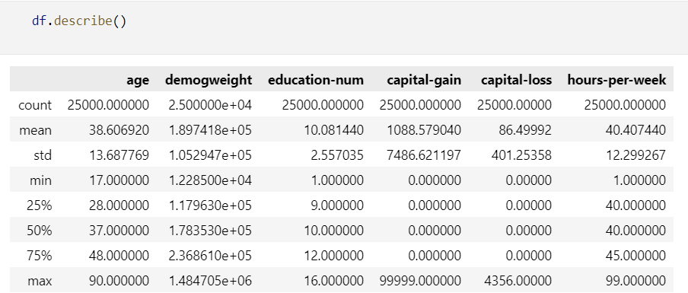
P112.
11.
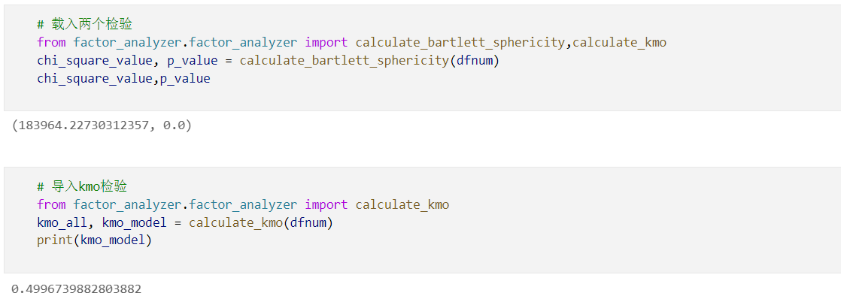
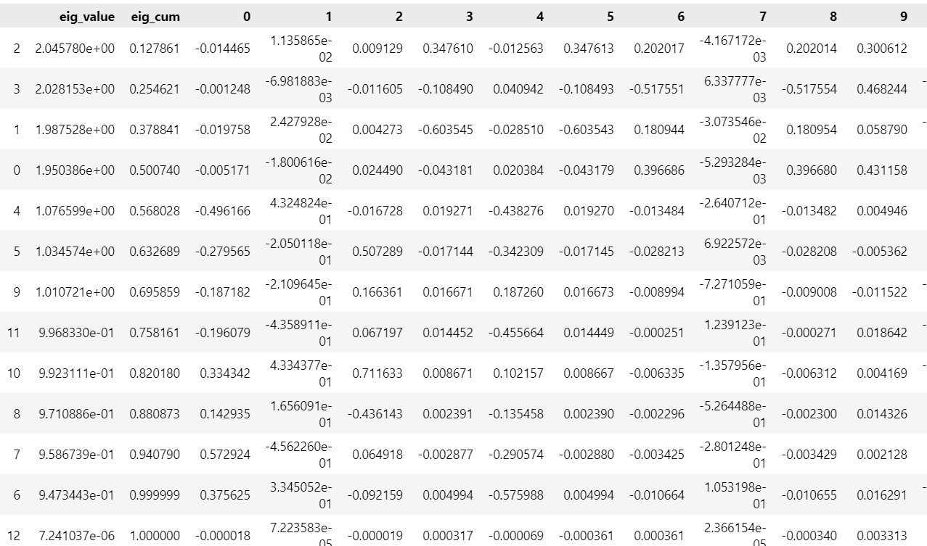
除'VMail Message', 'Day Mins', 'Area Code', 'Account Length', 'Day Calls','Day Charge', 'Night Mins'以外的变量都应该删除。
import pandas as pd
import numpy as np
df=pd.read_csv("churn.txt")
df.head()
dfnum=df.select_dtypes("number")
# 载入两个检验
from factor_analyzer.factor_analyzer import calculate_bartlett_sphericity,calculate_kmo
chi_square_value, p_value = calculate_bartlett_sphericity(dfnum)
chi_square_value,p_value
# 导入kmo检验
from factor_analyzer.factor_analyzer import calculate_kmo
kmo_all, kmo_model = calculate_kmo(dfnum)
print(kmo_model)
import numpy as np
import pandas as pd
import matplotlib.pyplot as plt
#中文文字显示问题
from pylab import mpl
# 指定默认字体
mpl.rcParams['font.sans-serif'] = ['FangSong']
# 解决保存图像是负号'-'显示为方块的问题
mpl.rcParams['axes.unicode_minus'] = False
from sklearn.decomposition import PCA

df_std = (dfnum - dfnum.mean())/dfnum.std()
df_corr = df_std.corr()
df_corr
eig_value,eig_vector=np.linalg.eig(df_corr)
#特征值

#特征值排序
eig=pd.DataFrame({"eig_value":eig_value})
eig=eig.sort_values(by=["eig_value"], ascending=False)
#获取累积贡献度
eig["eig_cum"] = (eig["eig_value"]/eig["eig_value"].sum()).cumsum()
#合并入特征向量
eig=eig.merge(pd.DataFrame(eig_vector).T, left_index=True, right_index=True)

eig
dfnum.iloc[:,[2,3,1,0,4,5,9]].columns

12.
（a）以特征值标准来看，应该提取前5个主成分，因为他们的方差贡献都大于1.

（b）以变异解释比例标准来看，应该选择前9个主成分，这样累计变异解释比例标准就达到了80%以上.
p130.
17.
A.
(9.680507191859897, 30.319492808140105)
import numpy as np, scipy.stats as st

st.t.interval(0.95, 25-1, loc=20, scale=5)
B.
(10.078915242456587, 29.92108475754341)
st.t.interval(0.95, 100-1, loc=20, scale=5)

C.
(10.170363520395956, 29.829636479604044)
st.t.interval(0.95, 400-1, loc=20, scale=5)

25.
(9.680507191859897, 30.319492808140105)

15在区间内，不区别于置信区间

20在区间内，不区别于置信区间

25在区间内，不区别于置信区间

26.
p_value=0.5025133031242532
0.6705404915520525 0.5025133031242532
无差异
from statsmodels.stats.proportion import proportions_ztest

z_score, p_value = proportions_ztest(
[707, 215], [2529, 804], alternative='two-sided')
print('p_value={}'.format(p_value))
print(z_score, p_value)

P206.
5.
杠杆率是：0.09090909090909091
x=np.array([2,2,3,4,4,5,6,7,8,9])
y=np.array([10,11,12,13,14,15,20,18,22,25])
mean=np.mean(x)
gangganlv=1/(len(x)+1)+(5-mean)**2/np.sum((x-mean)**2)
gangganlv

标准残差是：2.2204580152671753
x1=np.array([2,2,3,4,4,5,6,7,8,9,5])
y1=np.array([10,11,12,13,14,15,20,18,22,25,20])
import statsmodels.api as sm
model = sm.OLS(y1,sm.add_constant(x1))
results = model.fit()
results.summary()
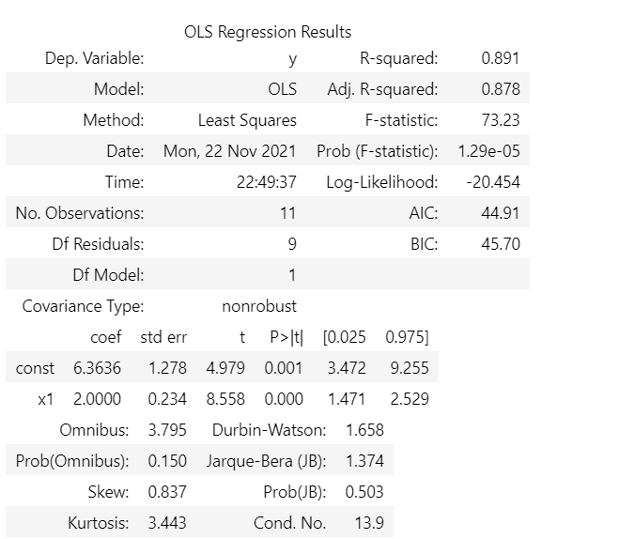
sde=1.71741*np.sqrt(1-gangganlv)
sde
sdre=(20-16.364)/1.6375
sdre
kuked=(20-16.364)**2/((1+1)*1.71741**2)*(0.0909/(1-0.0909)**2)
kuked

库克距离是：0.24649626690670345

6.
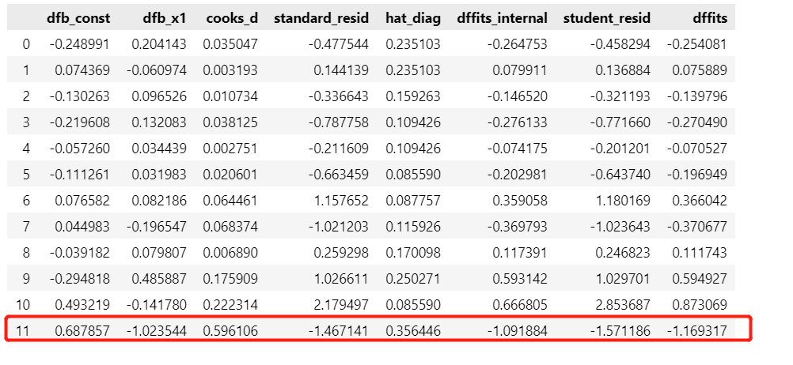
x2=np.array([2,2,3,4,4,5,6,7,8,9,5,10])
y2=np.array([10,11,12,13,14,15,20,18,22,25,20,23])
import statsmodels.api as sm
model = sm.OLS(y2,sm.add_constant(x2))
results = model.fit()

infl = results.get_influence()
sm_fr = infl.summary_frame()
sm_fr
因为观察对象与回归直线拟合度高，所以是一个有影响力的点。
P287.
13.
bad loss
import numpy as np
import pandas as pd

df=pd.read_csv("ClassifyRisk")
display(df.head())
df["mortgage"]=np.where(df["mortgage"]=="y",1,0)
df["risk"]=np.where(df["risk"]=="good risk",1,0)
x=df.loc[:,['mortgage', 'age', 'income']]
y=df.loc[:,['risk']]
x=(x-x.min())/(x.max()-x.min())
from sklearn.neighbors import KNeighborsClassifier
neigh = KNeighborsClassifier(n_neighbors=2)
neigh.fit(x, y)
neigh.predict(x)[0]

14.
bad loss
from sklearn.neighbors import KNeighborsClassifier
neigh = KNeighborsClassifier(n_neighbors=2,p=1, metric='minkowski')
neigh.fit(x, y)
neigh.predict(x)[0]

P382.
25.
从上可知，年龄的系数为正且显著，所以说明年龄为32的人群能获得比年龄为20岁的人群更高的高收入概率估计。
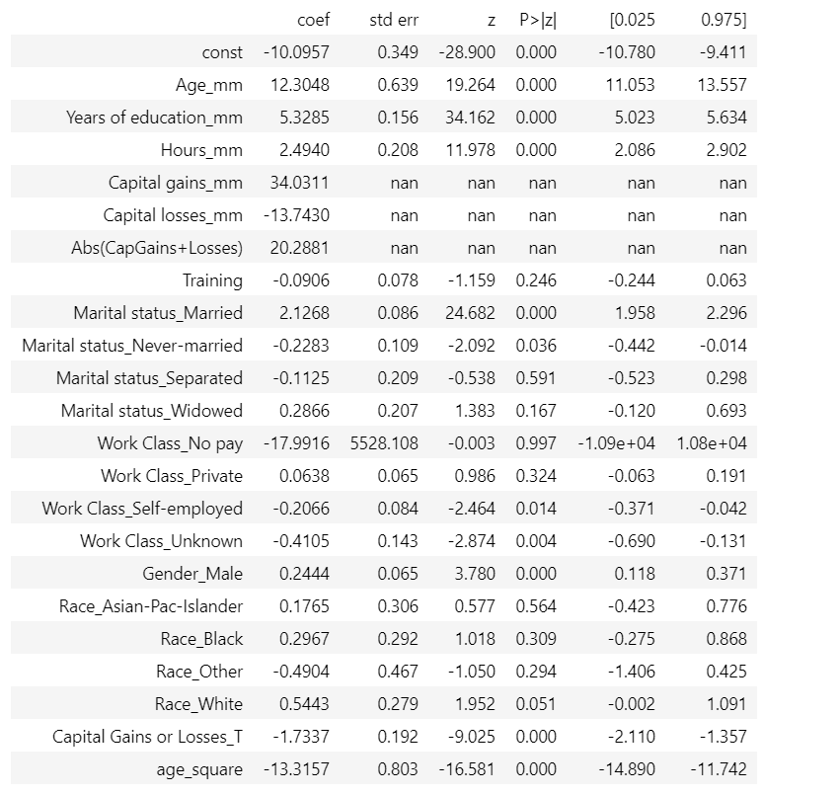

P418.
18.
df=pd.read_csv("churn.txt")
df.head()
x=df.select_dtypes("number")
y=df.iloc[:,-1]
y=np.where(y=='True.',1,0)
x=(x-x.min())/(x.max()-x.min())
from sklearn.naive_bayes import GaussianNB
gnb = GaussianNB()
y_pred = gnb.fit(x, y).predict_proba(x)[:,1]
y_pred

p504.6.7.8
6.
array([[2.83333333, 3.83333333],
- , 1.5 ]])
import pandas as pd
import numpy as np

df=np.array([[2,0],[1,2],[2,2],[3,2],[2,3],[3,3],[2,4],[3,4],[4,4],[3,5]])
df
from sklearn.cluster import KMeans

kmeans = KMeans(init=np.array([[2.83333333, 3.83333333],[2,1.5]]),n_clusters=2, random_state=0).fit(df)
kmeans.cluster_centers_

7.
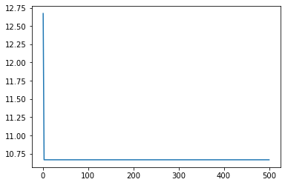
centers=np.array([[2.83333333, 3.83333333],[0,0]])
inertia=[]
for i in range(1,501):
kmeans = KMeans(init=centers,n_clusters=2, random_state=0,max_iter=1).fit(df)
centers=kmeans.cluster_centers_
inertia.append(kmeans.inertia_)
import matplotlib.pyplot as plt

plt.plot(range(1,501),inertia)

8.
array([[3. , 4. ],
[2. , 2.25],
[2. , 0. ]])

from sklearn.cluster import KMeans

kmeans = KMeans(init=np.array([[2.83333333, 3.83333333],[2,1.5],[0,0]]),n_clusters=3, random_state=0).fit(df)
kmeans.cluster_centers_

