MATH36032 Project 3
Student ID: 10402040

Content
MATH36032 Project 3 1
1 Question 1 1
1.1 Problem statement 1
1.2 Method description 1
1.3 Algorithm 1
1.4 Results 2
2 Question 2 2
2.1 Problem statement 2
2.2 Method description 2
2.3 Algorithm 2
2.4 Results 3
3 Question 3 4
3.1 Problem statement 4
3.2 Method description 4
3.3 Algorithm 4
3.4 Results 5
4 Question 4 5
4.1 Problem statement 5
4.2 Method description 5
4.3 Algorithm 5
4.4 Results 6

Question 1

Problem statement
The table of raw data lists the prices of bananas from different regions at different times. Question 1 requires that the prices of bananas from different regions in the raw table are counted separately at different times, i.e. the bananas from different regions need to be grouped.

Method description
First, I checked that the units of banana prices were all the same with the function unique, so I did not consider the units of banana prices in the subsequent analysis.
Use the “datetime” function to transform the Date column in the original data table into a datetime array.
Unstack banana dataset array from 'Origin' variable into multiple variables of variety of bananas.U = unstack(bananas,'Price','Origin') unstacks 'Price' variable in dataset bananas into multiple variables of variety of bananas in U. U contains more variables, but fewer observations, than dataset bananas.
'Price' specifies the data variable in dataset bananas to unstack 'Origin' specifies an indicator variable in dataset bananas that determines which variable in U each value in 'Price' is unstacked into. unstack treats the remaining variables in dataset bananas as grouping variables. Each unique combination of their values defines a group of observations in dataset bananas that will be unstacked into a single observation in U.
I then used the writetable function to write the grouped results to excel.

Algorithm
clc;clear all;
load("bananas");
bananas.Origin = categorical(bananas.Origin);

%Use the unique function to determine if all banana prices have the same unit
banana_name=unique(bananas(:,1));
bananas.Date = datetime(bananas.Date);
%*************************************************************************
%1.Question 1
U = unstack(bananas,'Price','Origin');
filename = 'exercise1.xlsx';
writetable(U,filename,'Sheet',1,'Range','A1');

Results
Tab 1 Results for the grouping of banana prices by region
Serial  number | Date | acp_  bananas | all_bananas | belize | surinam | venezuela | windward_  isles | Units
1 | 2021/1/15 0:00 | 0.8 | 0.84 | 0.86 |  |  |  | ￡/kg
2 | 2021/1/8 0:00 | 0.81 | 0.84 | 0.86 |  |  |  | ￡/kg
3 | 2020/12/17 0:00 | 0.67 | 0.69 | 0.66 |  |  | 0.69 | ￡/kg
 | ... | ... | ... | ... | ... | ... | ... | ...
1302 | 1995/1/27 0:00 |  |  |  | 0.7 |  | 0.71 | ￡/kg
1303 | 1995/1/20 0:00 |  |  |  | 0.63 |  | 0.63 | ￡/kg
1304 | 1995/1/13 0:00 |  |  |  | 0.61 |  | 0.6 | ￡/kg
Note: An empty cell in the table means that the price of bananas is missing on that day

Question 2

2.1 Problem statement
Banana prices fluctuate a lot during the year. From which three countries is the average price lowest over the last 5 years of the data for that country, and for which three countries the average price highest over the last 5 years of data for that country. The average here is defined as the mean of the prices taken over the last 5 years of the data for that country. You may ignore the ‘all bananas’ entries here.

2.2 Method description
I use datetime('now') and years(5) to determine the time period contained in the last 5 years to filter the data, so the results may vary for each calculation.
I first used the mean function to find the mean value of the columns in Table 1 in question 1, except for the "date". Because there were missing values, the mean value was set to “omitnan” to ignore the missing values in the parameters.
Then, I found that there are some origins of bananas in the past 5 years for which there is no price data, so the average price of bananas in these origins in the past 5 years is NA. NA is greater than a constant, observe the number of NA, which is 3 in the title, and then use the sort function to remove the index corresponding to the largest first three values (i.e. NA), and then use the sort function to sort again.
The first three numbers are the three bananas with the lowest average price, and the last three are the three bananas with the highest average price.

2.3 Algorithm
%*************************************************************************
%2.Question 2
t1 = datetime('now');
t2 = t1 - years(5);
%Get data for the last 5 years to date
last_five_price=U(U.Date>=t2,:);

%Calculate the mean value of the data for the last 5 years
last_five_price_1=last_five_price(:,2:end)
last_five_price_mean_1=mean(table2array(last_five_price_1),'omitnan');
%Delete variables that are not useful for statistical purposes and those for which
%the mean is calculated to obtain na
[Values_1,Indexes_1] = sort(last_five_price_mean_1,'ascend');
last_five_price_2 = removevars(last_five_price_1,[2,Indexes_1(end-3:end)]);
%Calculate the mean value of the data for the last 5 years
last_five_price_mean_2=mean(table2array(last_five_price_2),'omitnan');
%See the top three bananas with the smallest average price
%ignore the ‘all bananas’ entries
%T2 = removevars(T1,{'Loss','Customers'});
%T3 = removevars(T2,[1 4]);
[Values_2,Indexes_2] = sort(last_five_price_mean_2,'ascend');
%Ranked in the top three from childhood to adulthood
last_five_price_2.Properties.VariableNames{1:3}
Values_2(1:3)
%Ranked in the top three from largest to smallest
last_five_price_2.Properties.VariableNames{end:-1:end-2}
Values_2(end:-1:end-2)

2.4 Results
The three bananas with the smallest average prices over the past five years are: 'acp_bananas' (0.4723), 'belize' (0.5300), 'brazil' (0.5543). (Prices are in brackets).
The three bananas with the largest average prices over the past five years are: 'acp_bananas' (0.4723), 'belize' (0.5300), 'brazil' (0.5543). (Prices are in brackets).
'windward_isles'(0.7901),'surinam'(0.7734),'st_vincent'(0.7509).
%The 3 smallest banana prices in the last 5 years were(Listed from smallest to largest):
ans =
'acp_bananas'
ans =
'belize'
ans =
'brazil'
%The average banana prices were:
ans =
0.4723 0.5300 0.5543
%The 3 biggest banana prices in the last 5 years were(Listed from largest to smallest):
ans =
'windward_isles'
ans =
'surinam'
ans =
'st_vincent'
%The average banana prices were:
ans =
0.7901 0.7734 0.7509

3 Question 3

3.1 Problem statement
Produce a plot comparing the variation of the prices of bananas with countries of origin ‘costa rica’, ‘windward isles’ and ‘ecuador’. On the same plot also plot the data for ‘all bananas’.This means that historical price data need to be extracted for bananas with origins in "Costa Rica", "Windward Islands" and "Ecuador". Because the data from several samples had to be plotted on the same graph, with different amounts of data for several samples, it was crucial that the data corresponded to their respective times.

3.2 Method description
The answer to question 3 can be plotted based on the results obtained from question 1, but the key point is that the four lines required for question 3 contain different numbers of samples, i.e., there are missing values. So, I first used the isfinite function to separate 'costa rica', 'windward isles', 'ecuador ' and 'all bananas' to remove the missing values, and then plot the four curves.

3.3 Algorithm
%3.Question 3
%‘costa_rica’, ‘windward_isles’ and ‘ecuador’

U_costa=U(:,{'Date','costa_rica'});
TF1 = isfinite(table2array(U_costa(:,2)));
U_costa=U_costa(TF1,:);

U_windward=U(:,{'Date','windward_isles'});
TF2 = isfinite(table2array(U_windward(:,2)));
U_windward=U_windward(TF2,:);

U_ecuador=U(:,{'Date','ecuador'});
TF3 = isfinite(table2array(U_ecuador(:,2)));
U_ecuador=U_ecuador(TF3,:);

U_all=U(:,{'Date','all_bananas'});
TF4 = isfinite(table2array(U_all(:,2)));
U_all=U_all(TF4,:);

plot(U_costa.Date,U_costa.costa_rica,U_windward.Date,U_windward.windward_isles,U_ecuador.Date,U_ecuador.ecuador,U_all.Date,U_all.all_bananas)
xlabel('time'); ylabel('Price(￡/kg)')
%legend('costa_rica','windward_isles','ecuador','all_bananas')
legend('costa rica','windward isles','ecuador','all bananas')
grid on

3.4 Results
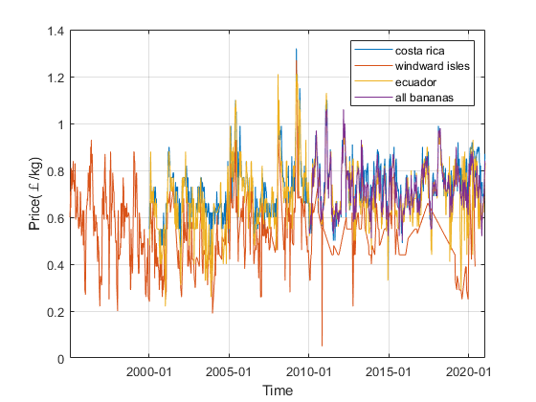
Fig 1 Price fluctuations of bananas over the last 30 years
The prices of bananas from 'costa rica', 'windward isles', 'Ecuador' and 'all bananas' over the last 30 years are shown in Figure 1 and I think they show regular fluctuations around 0.6 - 0.7.

4 Question 4

4.1 Problem statement
Produce a plot comparing the variation of the prices of bananas with countries of origin ‘costa rica’, ‘windward isles’ and ‘ecuador’ over the time period from 2016-01-01 to 2020-12-31. On the same plot also plot the data for ‘all bananas’. Comment on any seasonal trends that you spot.This means that historical price data need to be extracted for bananas with origins in "Costa Rica", "Windward Islands" and "Ecuador" and, at the same time, the data need to be filtered by time interval. Because the data from several samples had to be plotted on the same graph, with different amounts of data for several samples, it was crucial that the data corresponded to their respective times.

4.2 Method description
The answer to question 4 can be plotted based on the results obtained from question 1, but the key point is that the four lines required for question 4 contain different numbers of samples, i.e., there are missing values. So, I first filtered the data requested in question 4 using the date condition.Then,I used the isfinite function to separate 'costa rica', 'windward isles', 'ecuador ' and 'all bananas' to remove the missing values, and then plot the four curves.

4.3 Algorithm
%*************************************************************************
%4.Question 4
U_costa=U(:,{'Date','costa_rica'});
TF1 = isfinite(table2array(U_costa(:,2)));
U_costa=U_costa(TF1,:);
U_costa=U_costa(U_costa.Date>="2016-01-01"&U_costa.Date<="2020-12-31",:);

U_windward=U(:,{'Date','windward_isles'});
TF2 = isfinite(table2array(U_windward(:,2)));
U_windward=U_windward(TF2,:);
U_windward=U_windward(U_windward.Date>="2016-01-01"&U_windward.Date<="2020-12-31",:);

U_ecuador=U(:,{'Date','ecuador'});
TF3 = isfinite(table2array(U_ecuador(:,2)));
U_ecuador=U_ecuador(TF3,:);
U_ecuador=U_ecuador(U_ecuador.Date>="2016-01-01"&U_ecuador.Date<="2020-12-31",:);

U_all=U(:,{'Date','all_bananas'});
TF4 = isfinite(table2array(U_all(:,2)));
U_all=U_all(TF4,:);
U_all=U_all(U_all.Date>="2016-01-01"&U_all.Date<="2020-12-31",:);

plot(U_costa.Date,U_costa.costa_rica,U_windward.Date,U_windward.windward_isles,U_ecuador.Date,U_ecuador.ecuador,U_all.Date,U_all.all_bananas)
xlabel('time'); ylabel('Price(￡/kg)')
%legend('costa_rica','windward_isles','ecuador','all_bananas')
legend('costa rica','windward isles','ecuador','all bananas')
grid on

4.4 Results
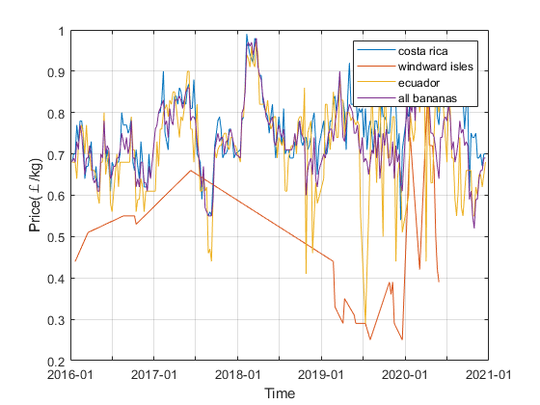
Fig 2 Price fluctuations of bananas over the last 5 years

The four lines are plotted in one graph, and the seasonal trend in banana prices is not obvious, so I have plotted four additional graphs for each of the three origins and the average price of bananas.

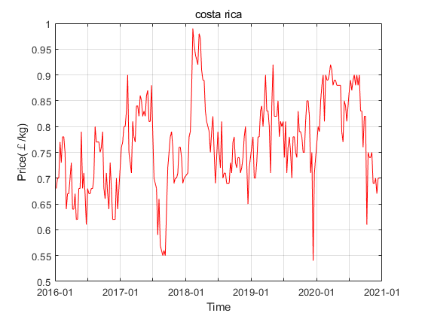
Fig 3 Price fluctuations of bananas in the costa rica over the last 5 years

- The price fluctuations over the last five years for bananas of costa rica origin
show that there have been at least two significant price increases in a year, suggesting that bananas are grown at least twice in a year in the costa rica region and that prices are higher for bananas harvested in the first half of the year than in the second.The price of bananas in the costa rica region fluctuates around €0.75 per kg for the past five years.

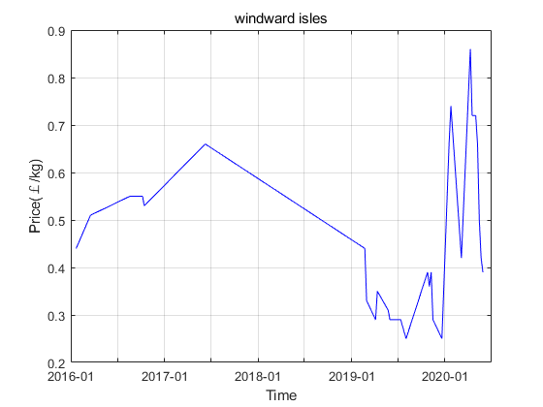
Fig 4 Price fluctuations of bananas in the ecuador over the last 5 years

- There is a high level of missing data on banana prices in the ecuador region for the last 5 years. It is difficult to see seasonal trends. The trend in banana price changes in 2020 alone. From the beginning to the end of spring banana prices are on an upward trend. In the summer banana prices fall. At the beginning and end of autumn, respectively, there will be a peak in banana prices.
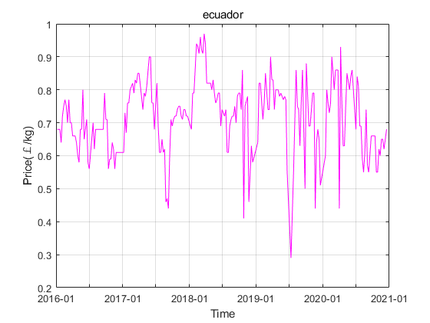
Fig 5 Price fluctuations of bananas in the ecuador over the last 5 years

- Spring and summer banana prices in the ecuador region have been higher than autumn and winter banana prices for the past five years.The price of bananas in the ecuador region has fluctuated around €0.7 per kg for the past five years.

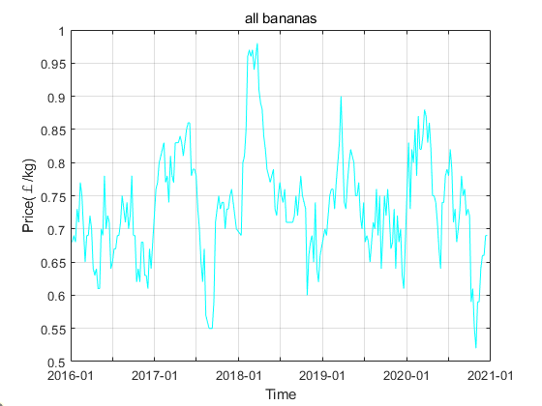
Fig 6 Average price fluctuations of all bananas over the last 5 years

- During 2016 the price of bananas had a peak in the spring, summer and autumn respectively. From 2017-2020, the trend for banana prices is roughly that they reach their highest value in the spring and their lowest value around October.The average price of all bananas has fluctuated around €0.7 per kg for the past five years.

