1. Database model

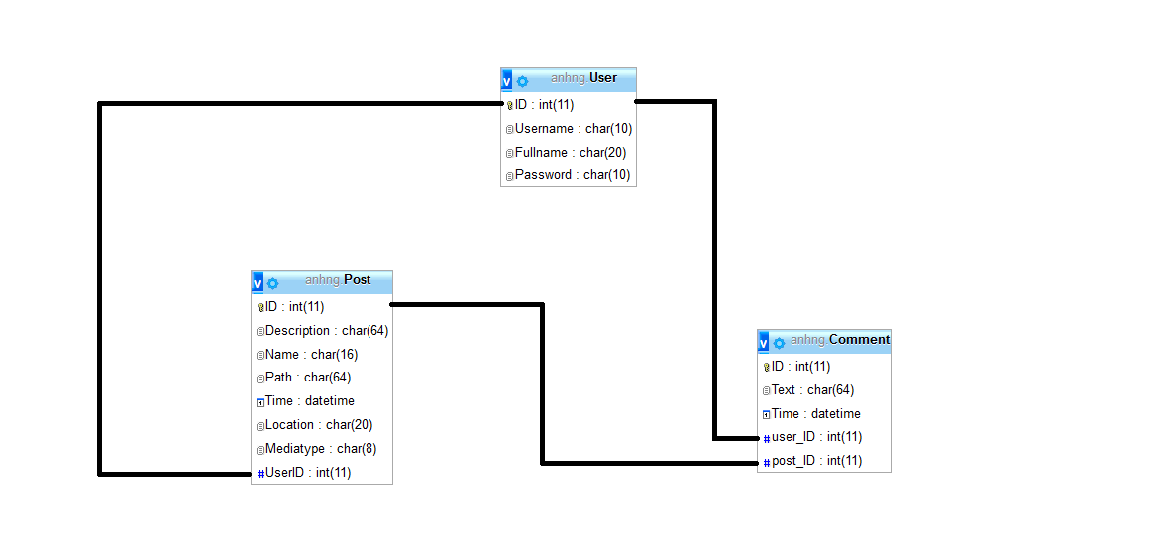

1. MySQL code:

REATE TABLE User (

ID INT NOT NULL PRIMARY KEY AUTO_INCREMENT,

Username CHAR(10),

Fullname CHAR(20),

Password CHAR(10)

)ENGINE=MYISAM;

CREAT TABLE Post (

ID INT PRIMARY KEY AUTO_INCREMENT,

Description CHAR(64),

Name CHAR(16),

Path CHAR(64),

Time DATETIME,

Location CHAR(20),

Mediatype CHAR(8),

UserID INT,

FOREIGN KEY (UserID) REFERENCES User(ID)

)ENGINE=MYISAM;

CREATE TABLE Comment (

ID INT PRIMARY KEY AUTO_INCREMENT,

Text CHAR(64),

Time DATETIME,

user_ID INT,

post_ID INT,

FOREIGN KEY (user_ID) REFERENCES User(ID),

FOREIGN KEY (post_ID) REFERENCES Post(ID)

)ENGINE=MYISAM;