**Assignment 01 - Summer 2023 HCM**

**Building a Project Management Application with Windows Forms**

# Introduction

Imagine you're an employee of a company named **FProjectManagement**. Your manager has asked you to develop a Windows Forms application for project management. The information of project includes: **ProjectID, ProjectName, EstimatedStartDate, EstimatedEndDate ProjectDescription, ProjectContact, EstimatedProjectValue (tổng tiền dự kiến cho dự án), ProjectAddress, ProjectCity, ProjectSponsor**.

The application has a default account whose email is “**admin@fprojectmanagement.com**” and password is “**admin@@**” that stored in the **appsettings.json.**

The application has to support adding, viewing, modifying, and removing project(s)—a standardized usage action verbs better known as Create, Read, Update, Delete (CRUD). This assignment explores creating an application using Windows Forms with .NET Core, and C#. An "in-memory database" will be created to persist the project's data, so a collection is called **List** will be used for reading and managing data.

# Assignment Objectives

In this assignment, you will:

* Use the Visual Studio.NET to create Windows Forms and Class Library (.dll) project.
* Create a List of persisting projects
* Using LINQ to Object to query data
* Apply passing data in WinForms application
* Apply 3-layers architecture to develop an application
* Apply MPV (Model-Presenter-View) pattern in Winforms application
* Apply Repository pattern and Singleton pattern in a project
* Add CRUD and searching actions to WinForms application.
* Apply to validate data type for all fields
* Run the project and test the WinForms actions.

# Main Functions

* Member authentication by Email and Password. If the user is “**Admin**” *(get from appsettings.json file)* then allows to perform all actions.
* Project management: Read *(the project list should sort by descending order by ProjectName),* Create *(with data validation),* Update*(with data validation)* and Delete *(with confirmation)* actions. Creating and Updating project must be performed by popup dialog.
* Search project by ProjectID or ProjectName.
* Filter projects by ProjectCity *(maybe use ComboBox to filter).*

# Guidelines

# Activity 01: Build a solution

Create a Blank Solution named ***Ass01Solution_ClassCode_StudentName*** that includes Class Library Project: **DataAccessObjects, BusinessObjects, Repositories** and a Windows Forms project named **ProjectManagementWinApp_StudentName**

**Step 01**. Create a Blank solution.

* Open the Visual Studio .NET application and performs steps as follows:

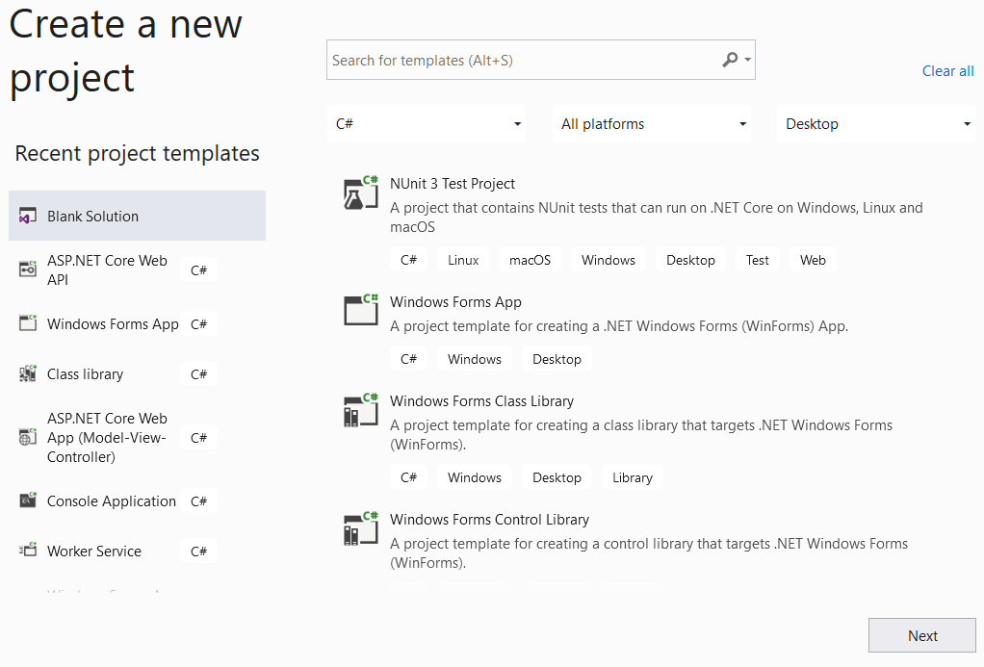

**Step 02.** Create a Class Library project named **BusinessObjects**

**Step 03.** Repeat **Step 02** to create **DataAccessObjects** project.

**Step 04.** Repeat **Step 02** to create **Repositories** project.

**Step 05.** Create a Windows Forms project named **ProjectManagementWinApp_StudentName**

* From the File menu | Add | New Project, on the Add New Project dialog, select “Windows Forms App” and performs steps as follows:

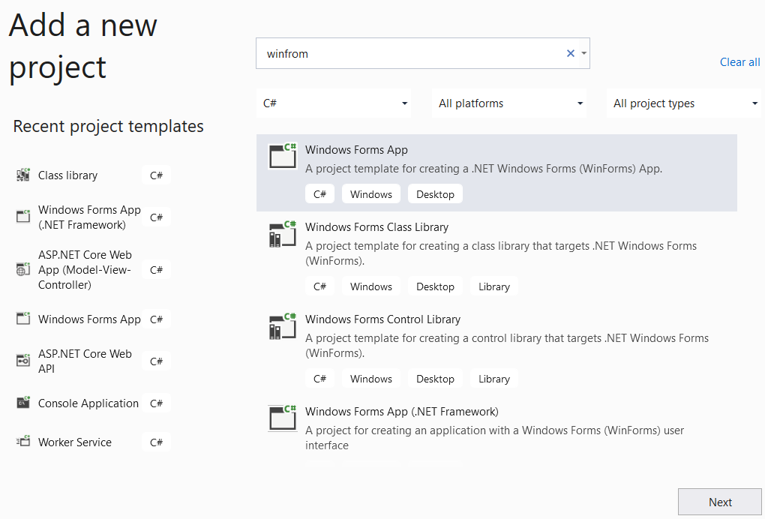

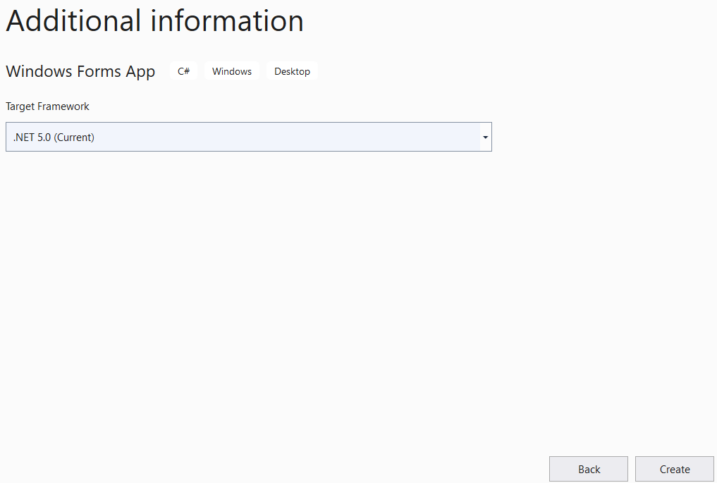

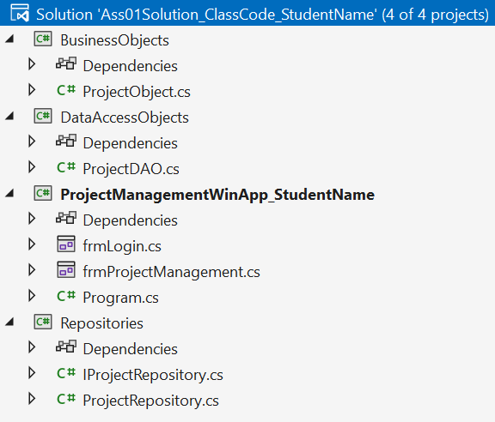

# Activity 02: Develop BusinessObjects project

# Activity 03: Develop DataAccessObjects project

# Activity 03: Develop Repositories project

# Activity 04: Develop ProjectManagementWinApp_StudentName project

**Step 01**. Add a reference to **Repositories** project

**Step 02**. Design UI for **frmLogin.cs** form and write codes to perform authentication by **email** and **password.** If login is successful then show **frmProjectManagements.cs** formotherwise show an error message

**Step 03**. Design UI for **frmProjectManagements.cs** form and write codes to performs CRUD actions, Search action and Filter action, etc.

# Activity 05: Run the WinForms project and test all actions