Link github: https://github.com/psssssa/INF205_ASSIGNMENT_NHOM5

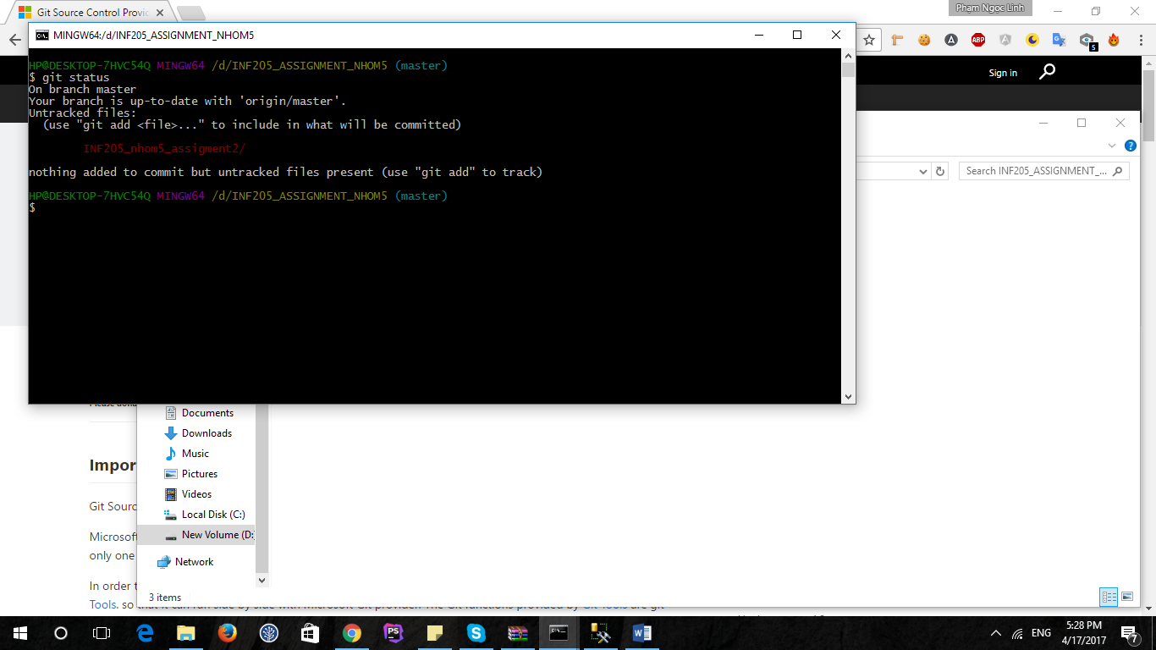

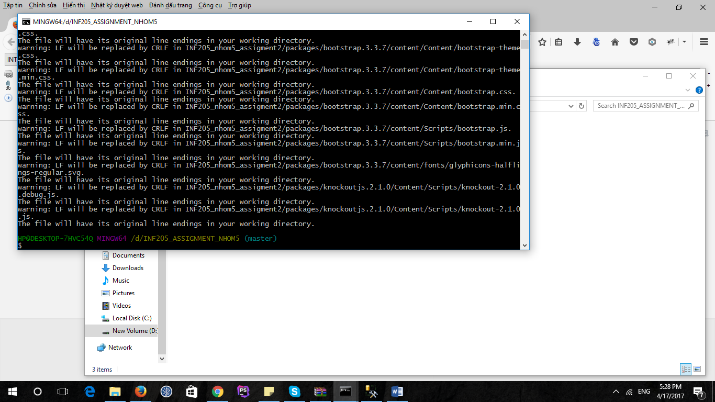

Git add *

Git commit and push master

