Link github: <https://github.com/psssssa/INF205_ASSIGNMENT_NHOM5>

# **Tạo database trên** [**http://www.vertabelo.com/**](http://www.vertabelo.com/)

B1: Chọn register **Student or lecturer?:**

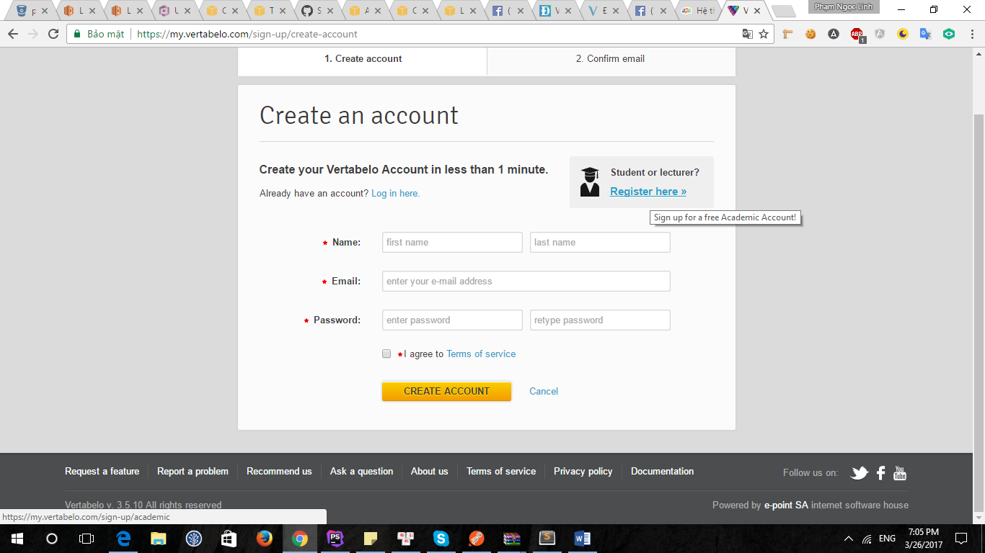

B2: Điền đầy đủ thông tin: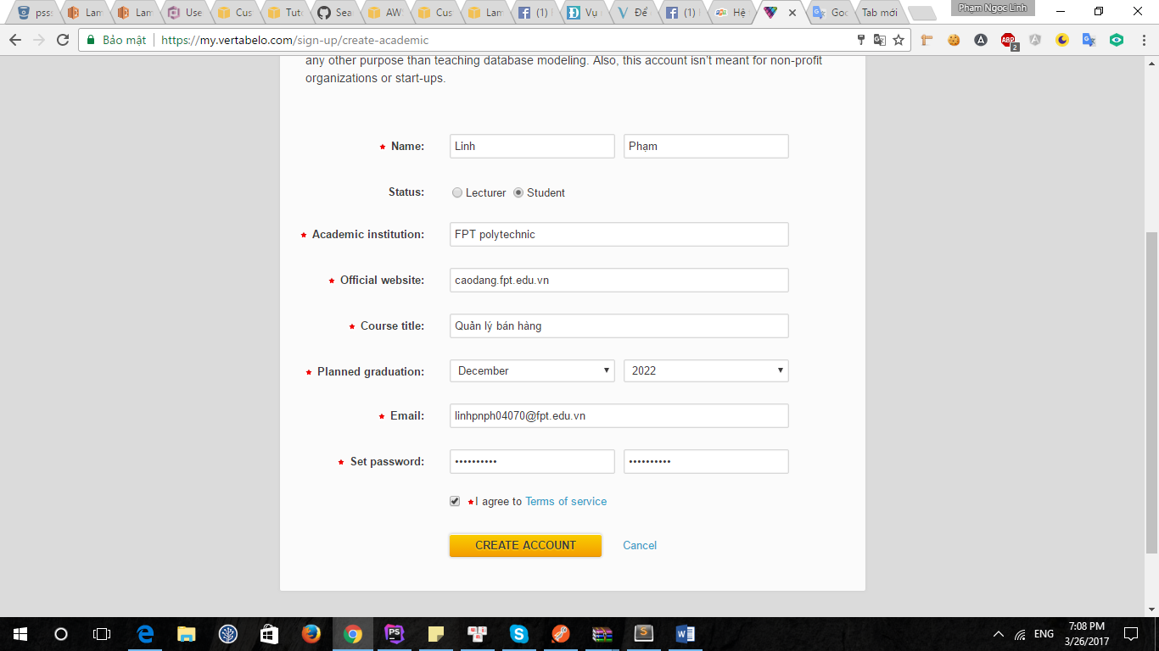

B3: Xác nhận tài khoản

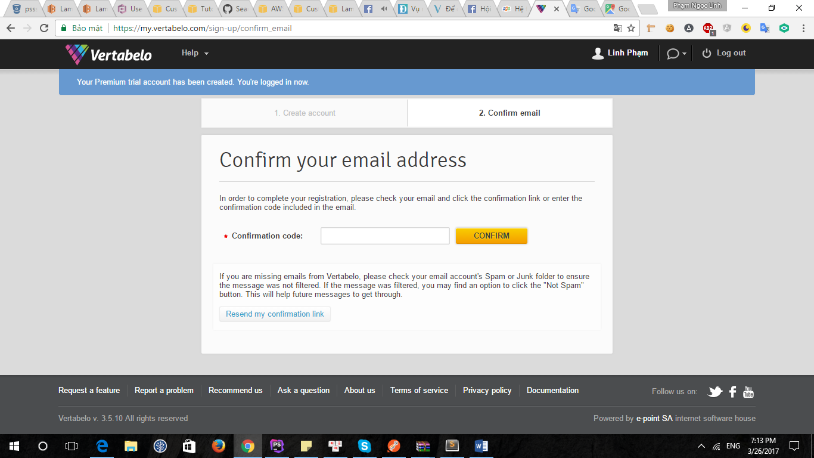

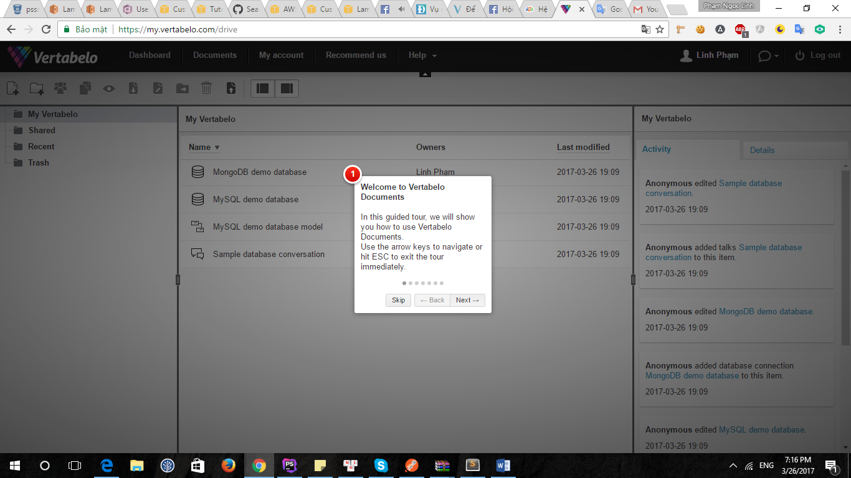

Chọn skip

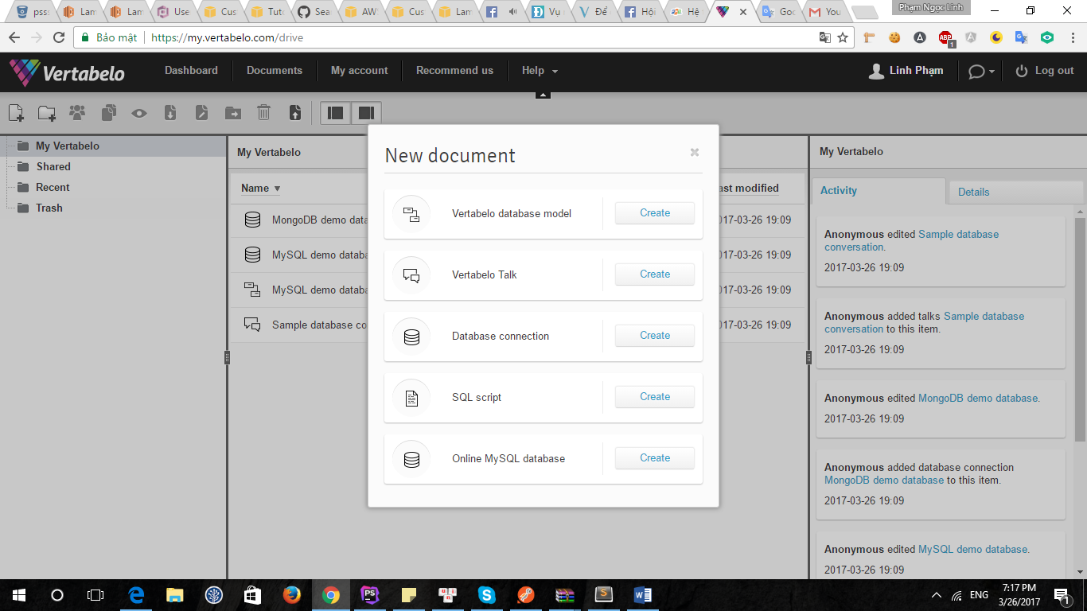

Chọn database model

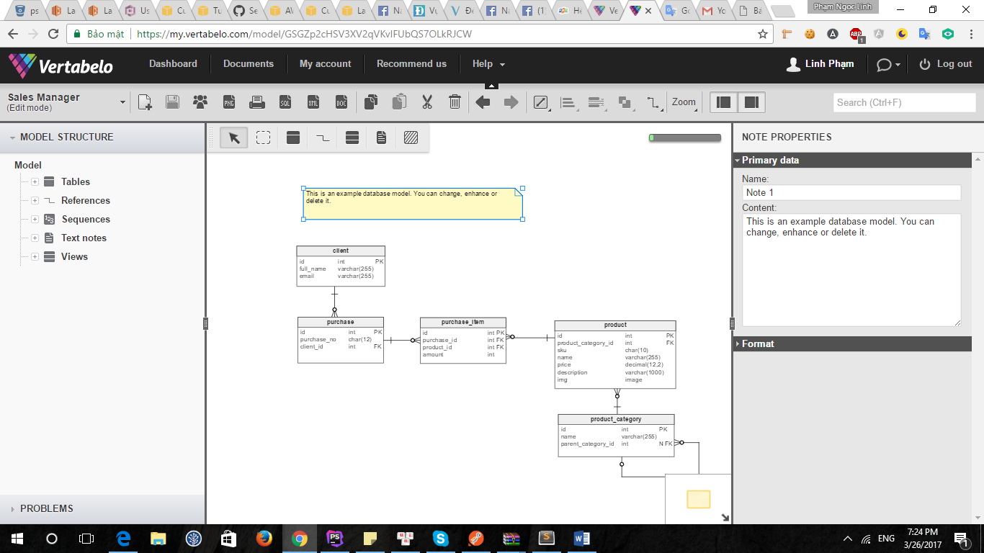

# 2. Tables

## 2.1. Table invoice

2.1.1. Columns

|  |  |  |  |
| --- | --- | --- | --- |
| **Column name** | **Type** | **Properties** | **Description** |
| id | int |  |  |
| invoice_name | varchar(12) |  |  |
| total_price | int |  |  |
| unit | int |  |  |
| user_id | int |  |  |
| create_at | datetime |  |  |
| status | int |  |  |
| customer_id | int |  |  |

## 2.2. Table product

2.2.1. Columns

|  |  |  |  |
| --- | --- | --- | --- |
| **Column name** | **Type** | **Properties** | **Description** |
| id | int |  |  |
| category_id | int |  |  |
| sku | char(10) |  |  |
| name | varchar(255) |  |  |
| price | decimal(12,2) |  |  |
| description | varchar(1000) |  |  |
| img | image |  |  |
| weight | int |  |  |
| unit | varchar(255) |  |  |
| status | int |  |  |
| quantity | int |  |  |
| sale_price | int |  |  |

## 2.3. Table invoice_detail

2.3.1. Columns

|  |  |  |  |
| --- | --- | --- | --- |
| **Column name** | **Type** | **Properties** | **Description** |
| id | int |  |  |
| invoice_id | int |  |  |
| product_id | int |  |  |
| quantity | int |  |  |

## 2.4. Table category

2.4.1. Columns

|  |  |  |  |
| --- | --- | --- | --- |
| **Column name** | **Type** | **Properties** | **Description** |
| id | int |  |  |
| name | varchar(255) |  |  |
| parent_category_id | int | null |  |

## 2.5. Table customer

**Description:**this is table for customer

2.5.1. Columns

|  |  |  |  |
| --- | --- | --- | --- |
| **Column name** | **Type** | **Properties** | **Description** |
| id | int |  |  |
| name | varchar(255) |  |  |
| email | varchar(255) |  |  |
| phone | int |  |  |
| address | text |  |  |
| sex | tinyint |  |  |
| job | varchar(255) |  |  |

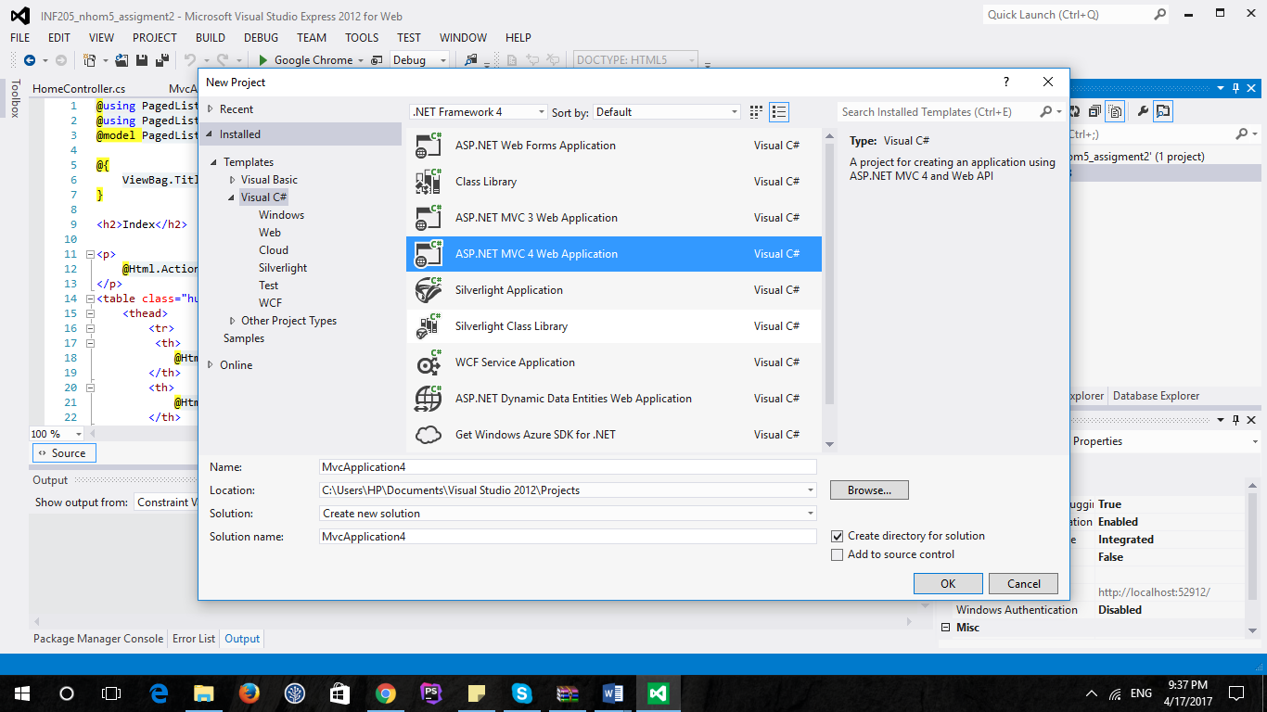

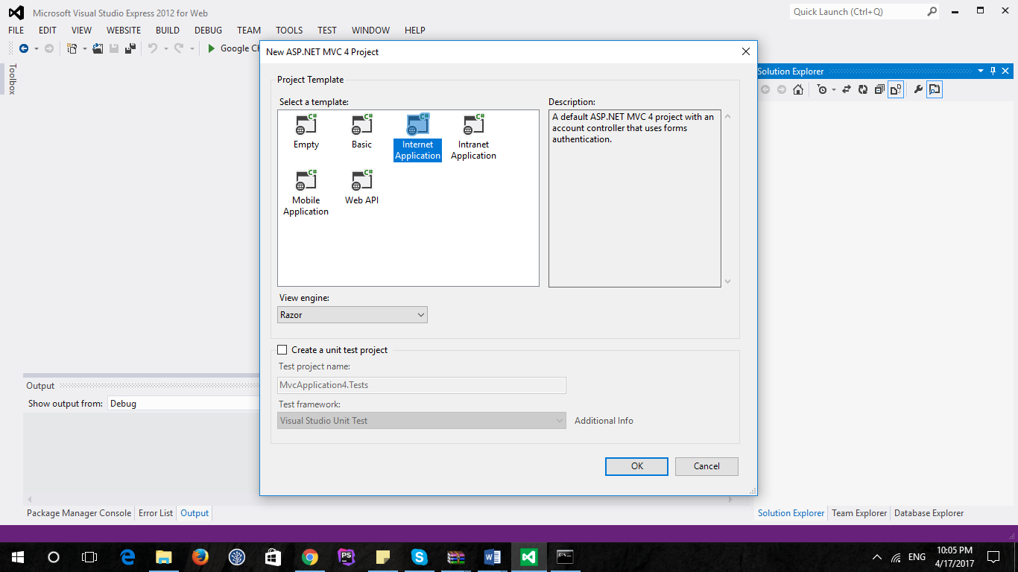

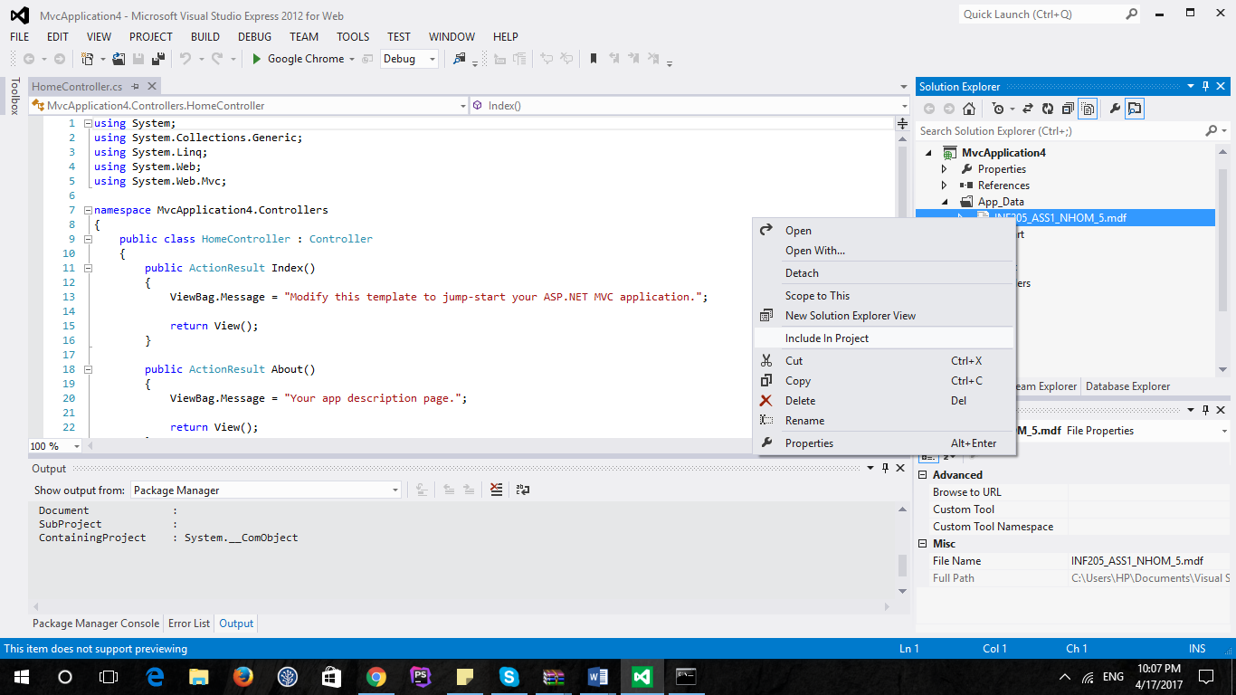

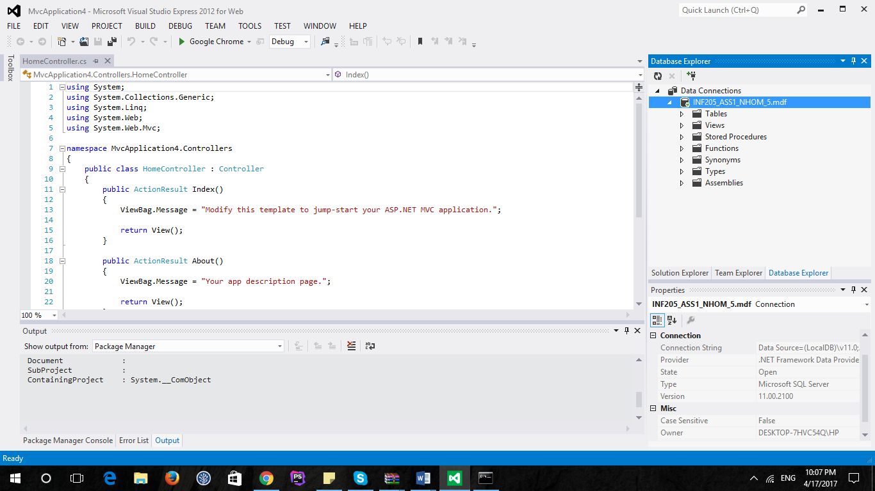

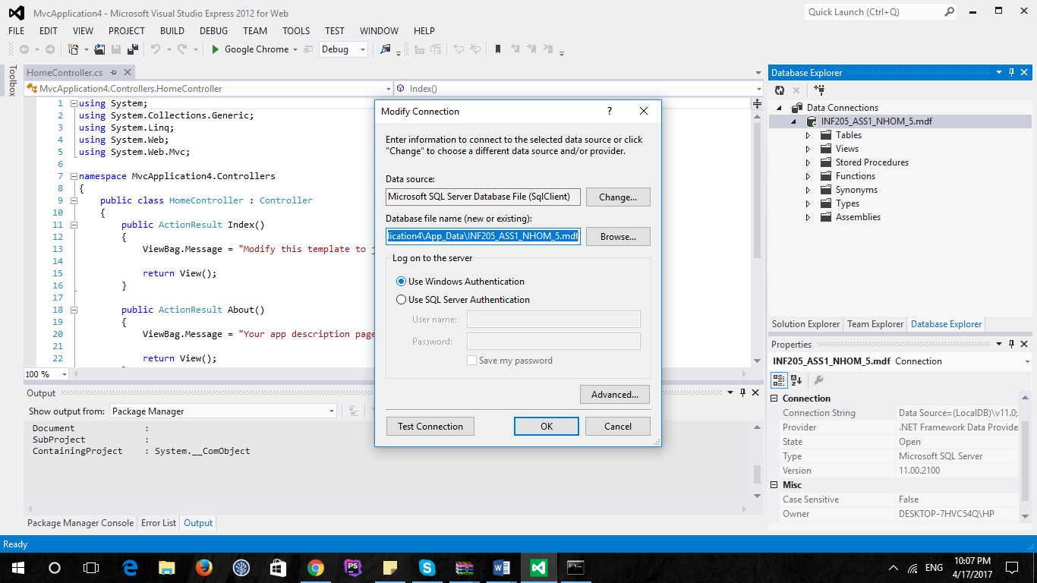

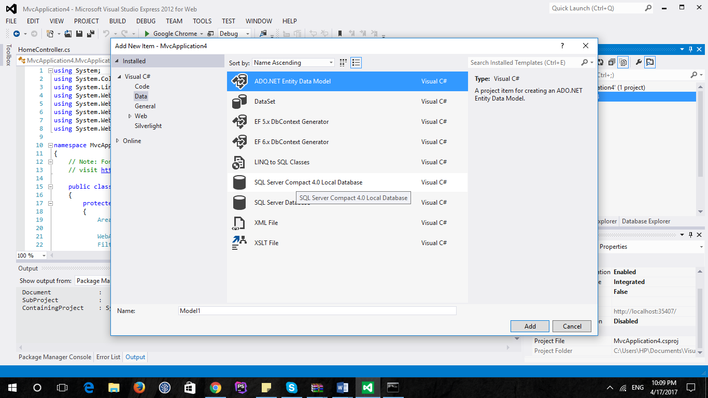

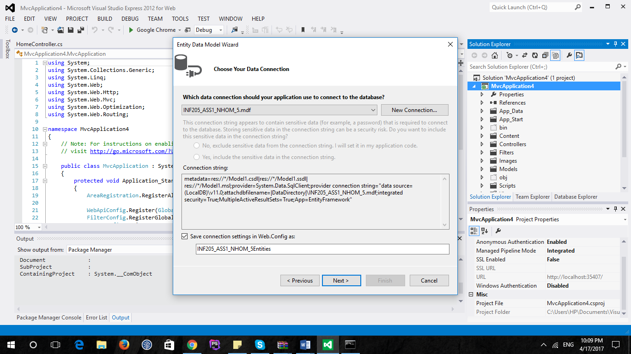

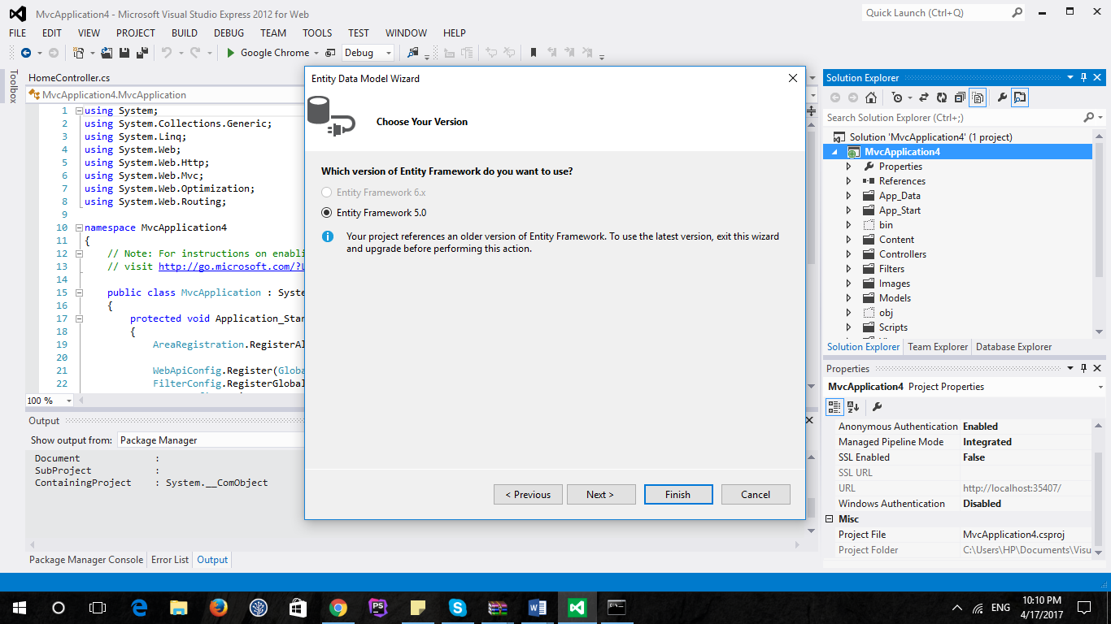

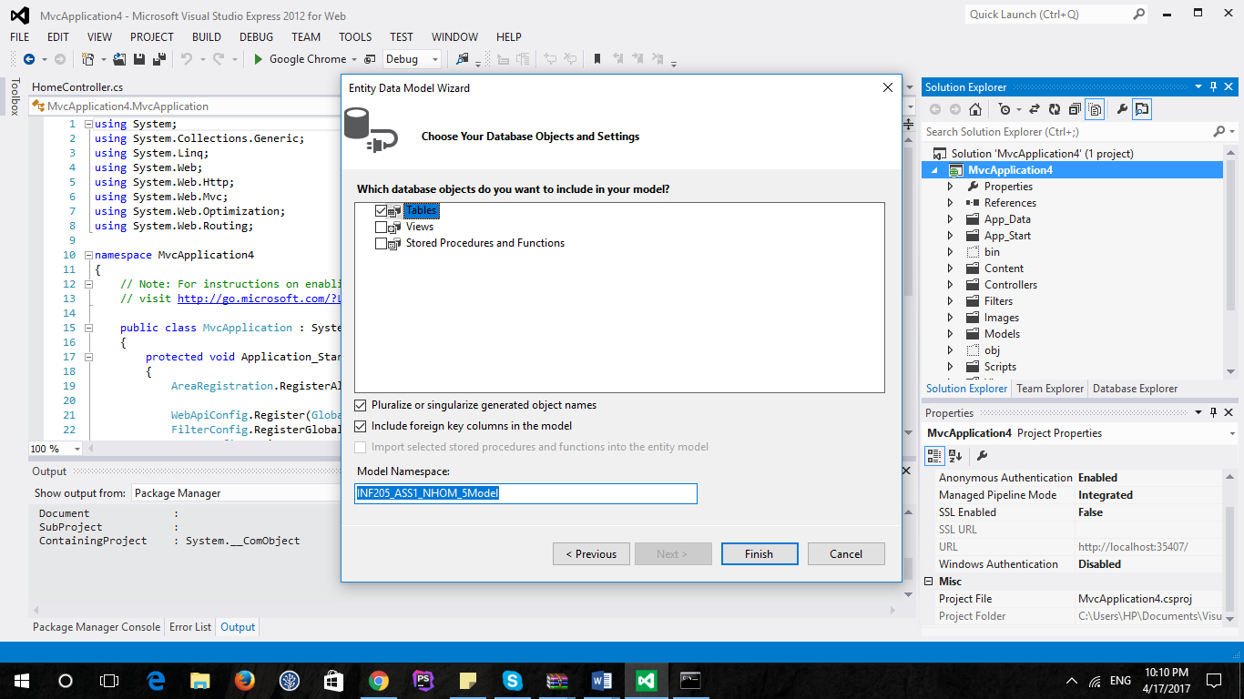

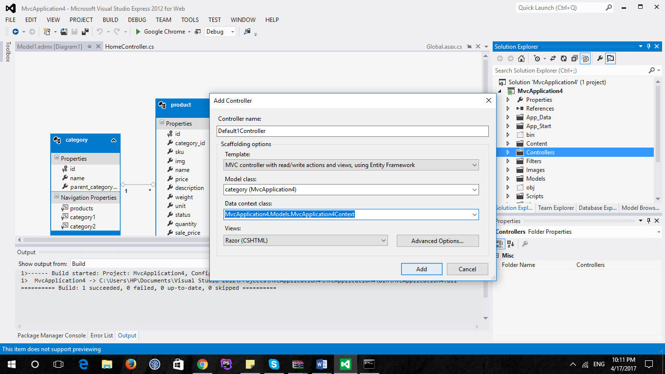

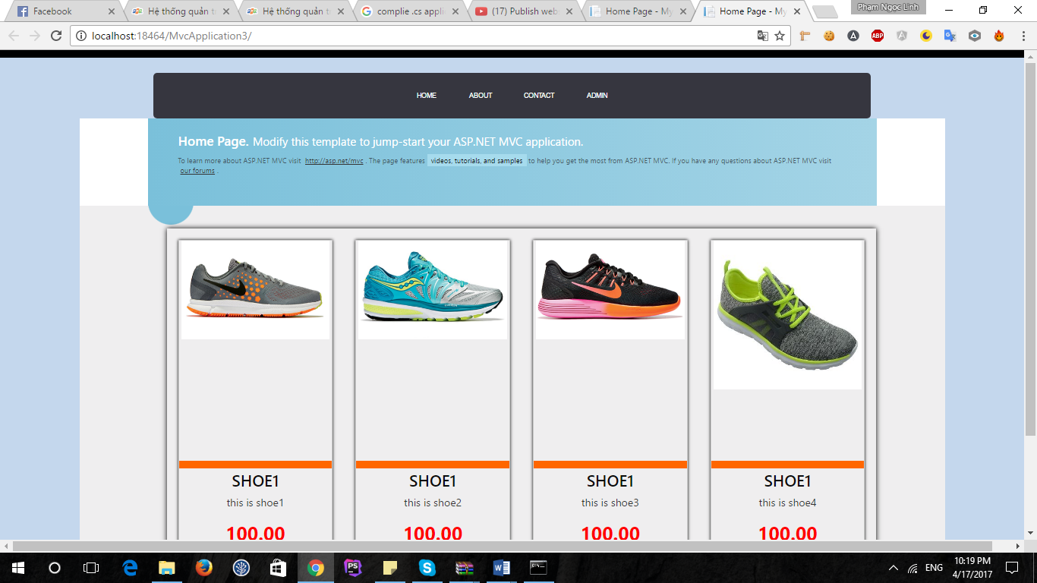

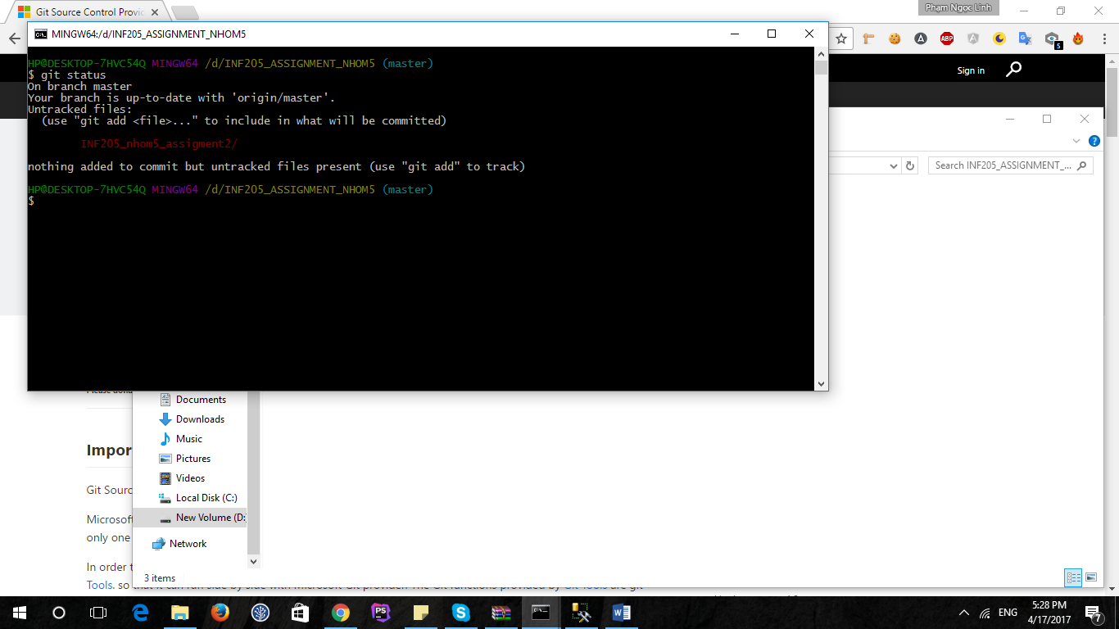

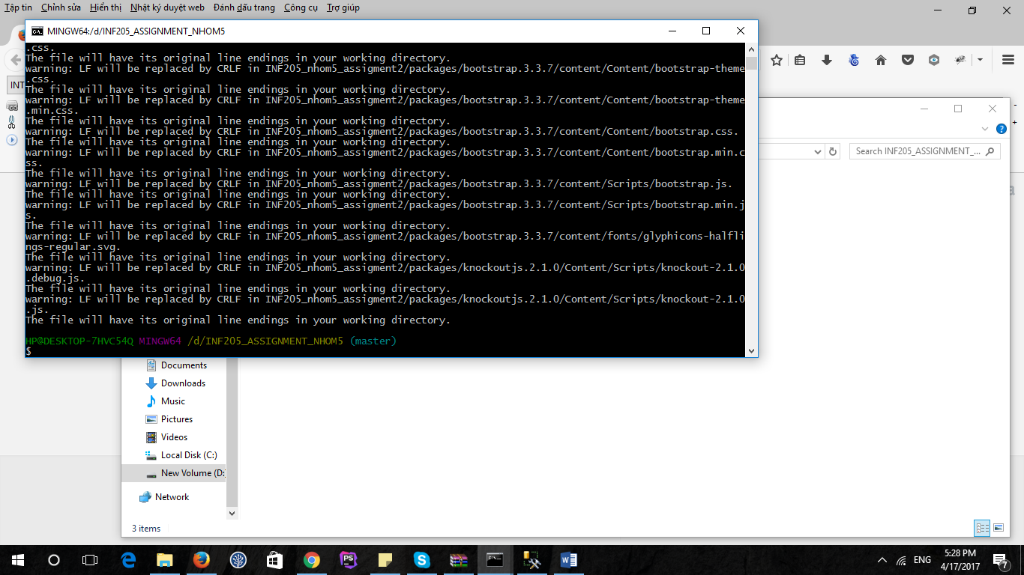

Git add *

Git commit and push master

