Setup Sercive in Angular
- Create service
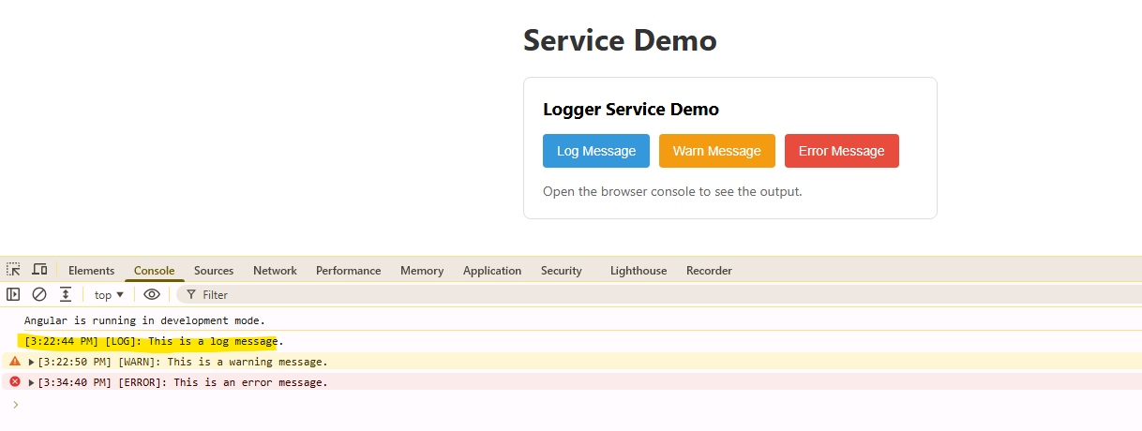

- Servier logger
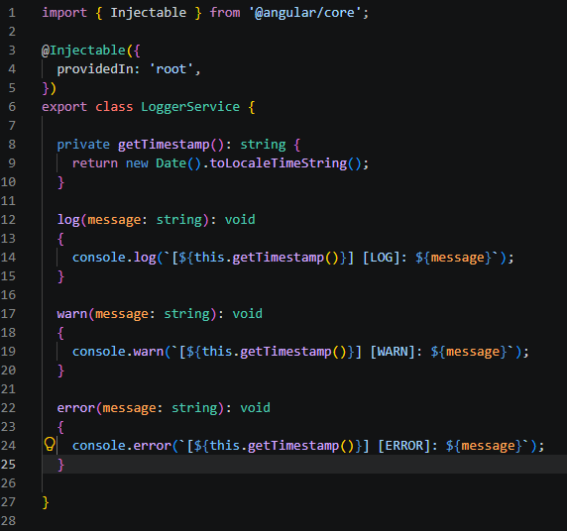

[3:22:44 PM] [LOG]: This is a log message.
[3:22:50 PM] [WARN]: This is a warning message.
[3:34:40 PM] [ERROR]: This is an error message.

- Component call the service

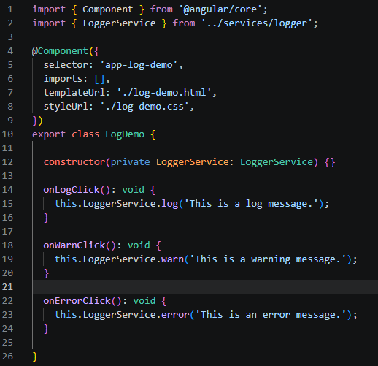

- constructor(private LoggerService: LoggerService) {} យើងដាក់ service វាចូលទៅក្នុង constructor when the component start it will call the service
- onLogClick(): void {
- this.LoggerService.log('This is a log message.');
- }

Dependency Injection: DI
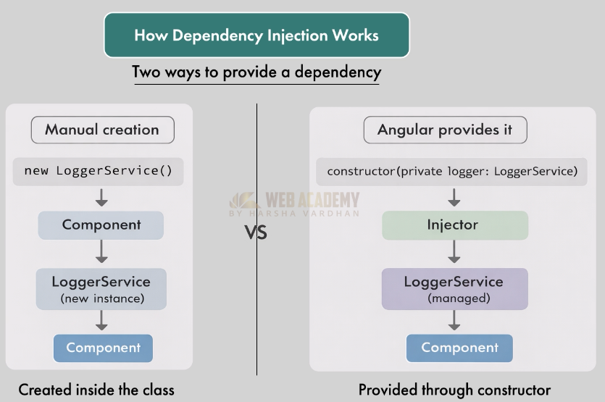
យើងមានវីធីពីរដើម្បីធ្វើការ Inject the server to the component

- Use new key work (meaning every create instance will difference)
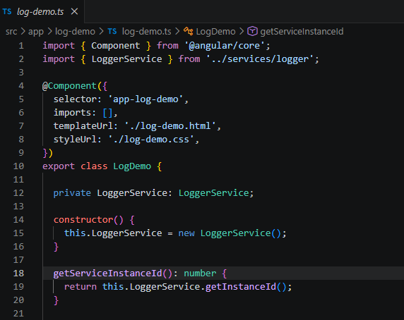

- We use private to create the instance:

private LoggerService: LoggerService;

constructor() {
this.LoggerService = new LoggerService();
}
- When the component starts it will create the new instance
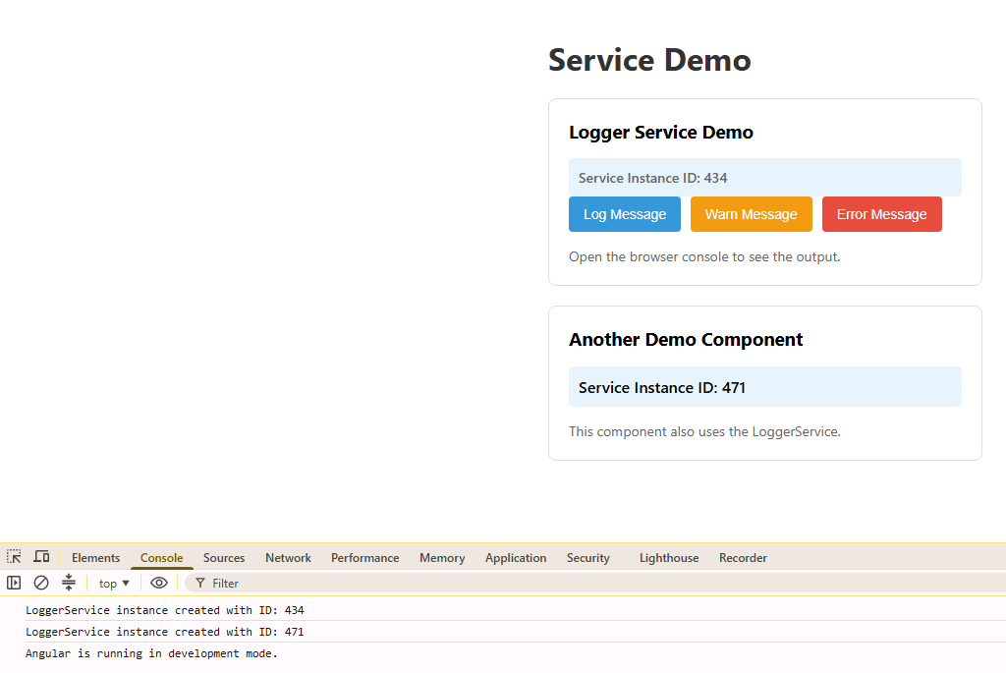

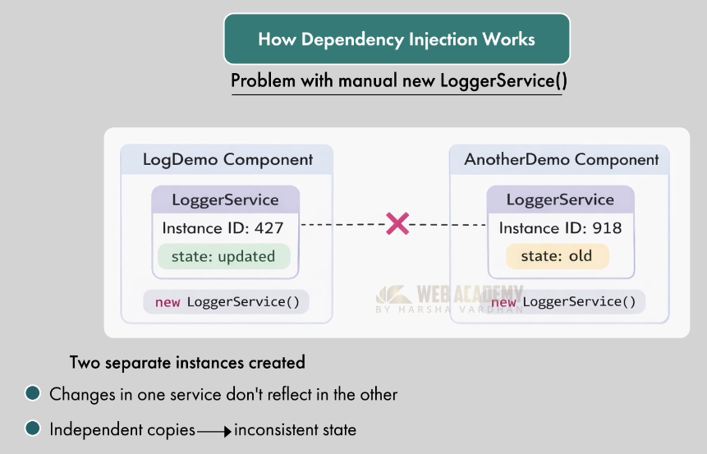

- Create with injections
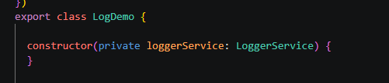

We create the parameter inside the constructor.

Then the result will be the same random number because it is single ton

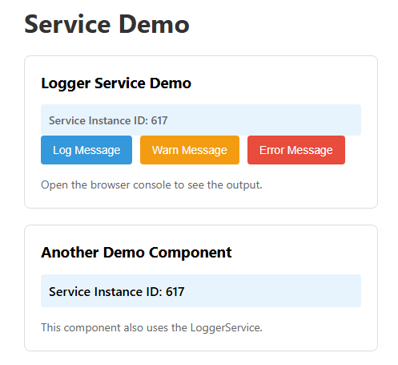

សោយសារតែវានៅក្នុង root level ចឹងពេលដែលមានអ្វីដែល Request the service it will check the instance first does it have create it yet. បើមានគេបង្កើតហើយ វាយកអានឹងមកប្រើតែម្តង់ បើមិនមានវាបង្កើតថ្មី។
- This is Singleton pattern = one instance reused across the app

