Angular 20.3.10
Routing Fundamentals

- Create route in : app.routes.ts
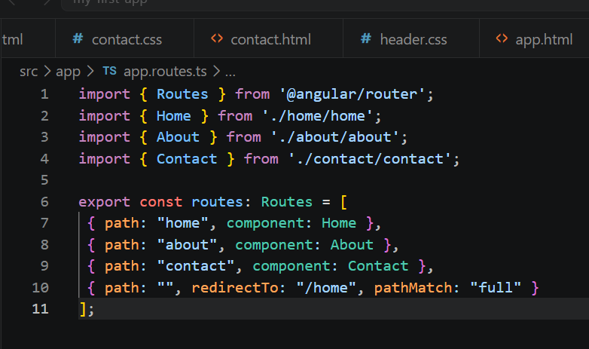

- App.ts : Add RouterOutlet
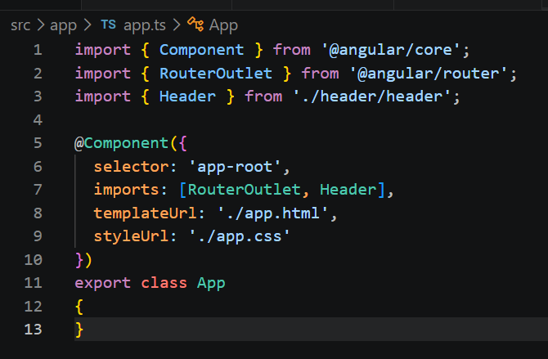

- App.html : add router-outlet
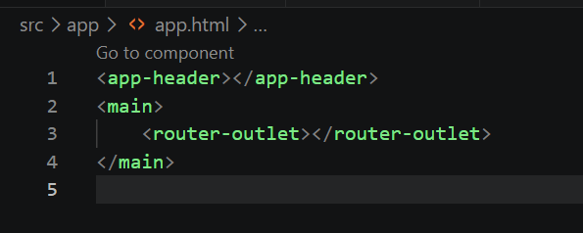

- Template in the html : routerLink and routerLinkActive

<li><a routerLink="/home" routerLinkActive="active">Home</a></li>
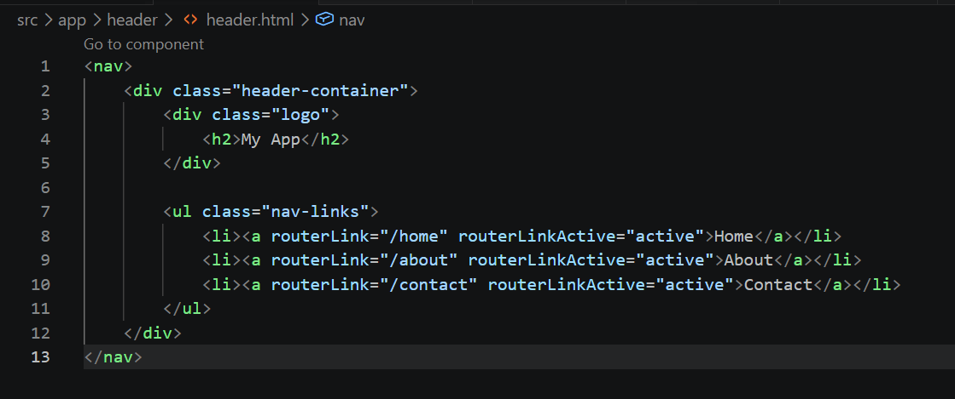

- routerLink : កន្លែងដែលយើងអោយធ្វើការទៅ
- routerLinkActive = សម្រាប់ប្រាប់ថាវានៅលើ link ណា​
- header.ts ( We need to add RouterLink, and RouterLinkActive)
