Factory

- Factory: Hide the object creation process. Example: Car Factory, Chocolate Factory, Toy Factory
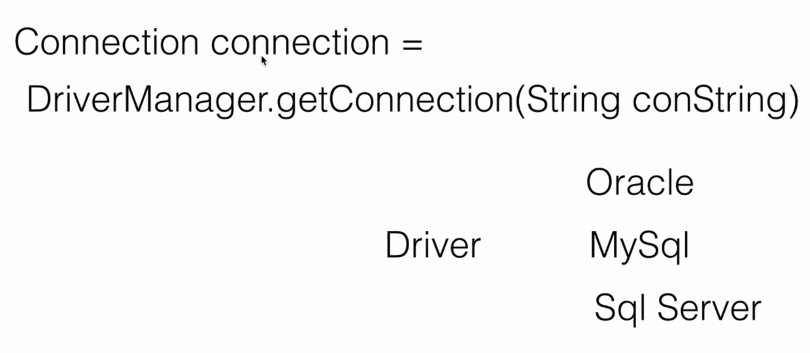

In JDBC, the DriverManager act like the factory then it can connection to the different database such as Oracle, MySql, Sql Server or something else.
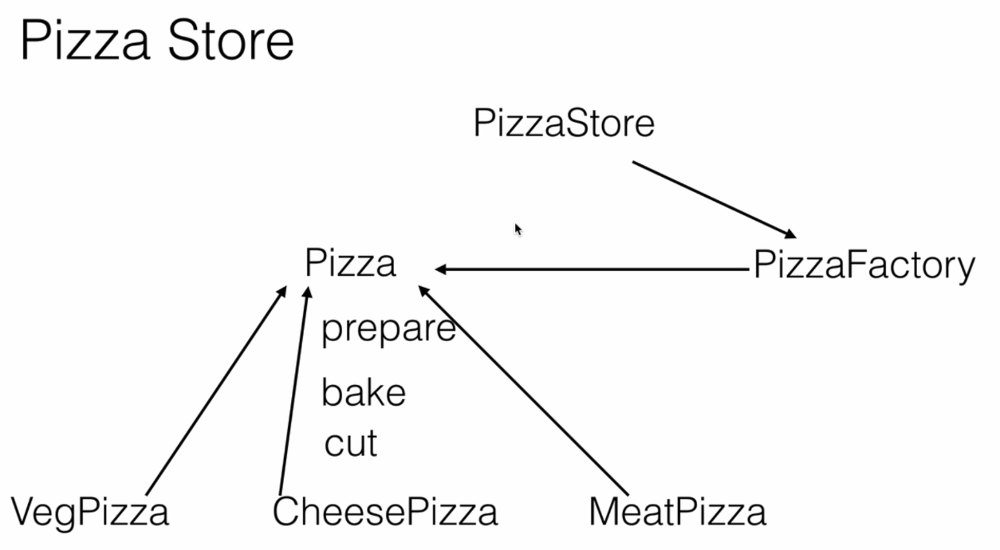

Pizza Store គឺមិនចាំបាច់ដឹងពីការផលិតនោះទេ វាពឹងទៅលើ PizzaFactory class that create object from interface Pizza. Pizza is the Interface that have method prepare, bake, and cut so the implementation from Pizza need to have that method.

