OAuth In MVC Web App

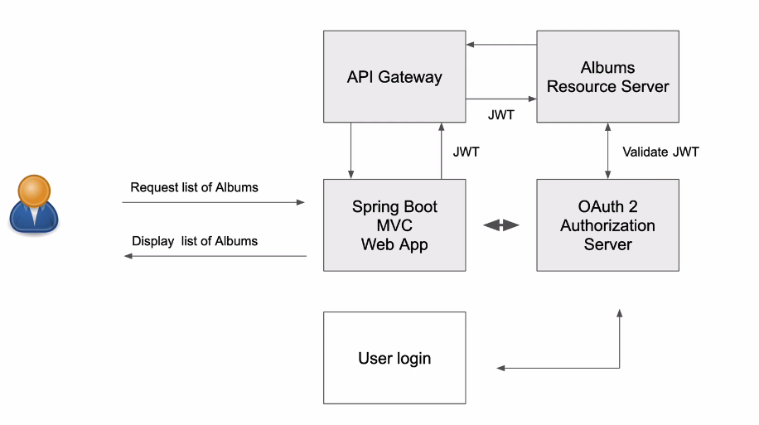
យើងមាន Website មួយពេលគេចង់ចូលទៅកាន់ Url យើងចឹង ដំបូងឡើយយើងអោយគេ​ Log in ចូលសិន បើមានសិទ្ធអាចអោយចូលមើបាន

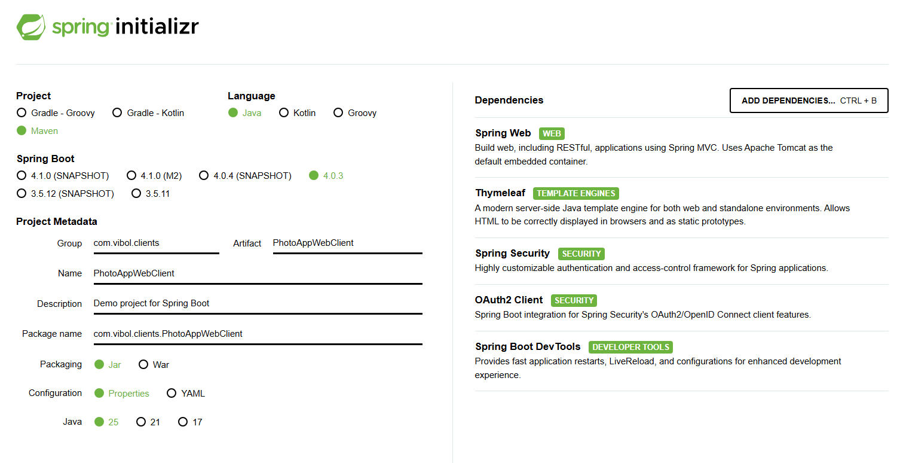
- Create spring boot

- Dependency

<?xml version="1.0" encoding="UTF-8"?>
<project xmlns="http://maven.apache.org/POM/4.0.0"
xmlns:xsi="http://www.w3.org/2001/XMLSchema-instance"
xsi:schemaLocation="http://maven.apache.org/POM/4.0.0 https://maven.apache.org/xsd/maven-4.0.0.xsd">
<modelVersion>4.0.0</modelVersion>

<parent>
<groupId>org.springframework.boot</groupId>
<artifactId>spring-boot-starter-parent</artifactId>
<version>4.0.3</version>
<relativePath/>
</parent>

<groupId>com.vibol.clients</groupId>
<artifactId>PhotoAppWebClient</artifactId>
<version>0.0.1-SNAPSHOT</version>
<name>PhotoAppWebClient</name>
<description>Demo project for Spring Boot</description>

<properties>
<java.version>25</java.version>
</properties>

<dependencies>
<!-- MVC + Thymeleaf -->
<dependency>
<groupId>org.springframework.boot</groupId>
<artifactId>spring-boot-starter-webmvc</artifactId>
</dependency>
<dependency>
<groupId>org.springframework.boot</groupId>
<artifactId>spring-boot-starter-thymeleaf</artifactId>
</dependency>

<!-- Security + OAuth2 Login (Keycloak redirect) -->
<dependency>
<groupId>org.springframework.boot</groupId>
<artifactId>spring-boot-starter-security</artifactId>
</dependency>
<dependency>
<groupId>org.springframework.boot</groupId>
<artifactId>spring-boot-starter-oauth2-client</artifactId>
</dependency>

<!-- Devtools -->
<dependency>
<groupId>org.springframework.boot</groupId>
<artifactId>spring-boot-devtools</artifactId>
<scope>runtime</scope>
<optional>true</optional>
</dependency>

<!-- Configuration metadata generation -->
<dependency>
<groupId>org.springframework.boot</groupId>
<artifactId>spring-boot-configuration-processor</artifactId>
<optional>true</optional>
</dependency>

<!-- Tests -->
<dependency>
<groupId>org.springframework.boot</groupId>
<artifactId>spring-boot-starter-webmvc-test</artifactId>
<scope>test</scope>
</dependency>
<dependency>
<groupId>org.springframework.boot</groupId>
<artifactId>spring-boot-starter-thymeleaf-test</artifactId>
<scope>test</scope>
</dependency>
</dependencies>

<build>
<plugins>
<plugin>
<groupId>org.springframework.boot</groupId>
<artifactId>spring-boot-maven-plugin</artifactId>
</plugin>
</plugins>
</build>

</project>

- Controller :/albums

package com.vibol.clients.PhotoAppWebClient.controller;

import java.util.Arrays;
import java.util.List;

import org.springframework.security.core.annotation.AuthenticationPrincipal;
import org.springframework.security.oauth2.core.oidc.OidcIdToken;
import org.springframework.security.oauth2.core.oidc.user.OidcUser;
import org.springframework.stereotype.Controller;
import org.springframework.ui.Model;
import org.springframework.web.bind.annotation.GetMapping;

import com.vibol.clients.PhotoAppWebClient.controller.response.AlbumRest;

@Controller
public class AlbumsController {

@GetMapping("/albums")
public String getAlbums(Model model, @AuthenticationPrincipal OidcUser principal) {

System.out.println("Principal = " + principal);

OidcIdToken idToken = principal.getIdToken();
String idTokenValue = idToken.getTokenValue();

System.out.println("idTokenValue = " + idTokenValue);

AlbumRest album = new AlbumRest();

album.setAlbumId("albumOne");
album.setAlbumTitle("Album one title");
album.setAlbumUrl("http://localhost:8082/album/1");

AlbumRest album2 = new AlbumRest();

album2.setAlbumId("albumTwo");
album2.setAlbumTitle("Album two title");
album2.setAlbumUrl("http://localhost:8082/album/2");

/*
// create list with two object album1 and album2
List returnValue = Arrays.asList(album, album2);
//disply to the model
model.addAttribute("albums",returnValue);
*/

model.addAttribute("albums", Arrays.asList(album, album2));
return "albums";
}

}
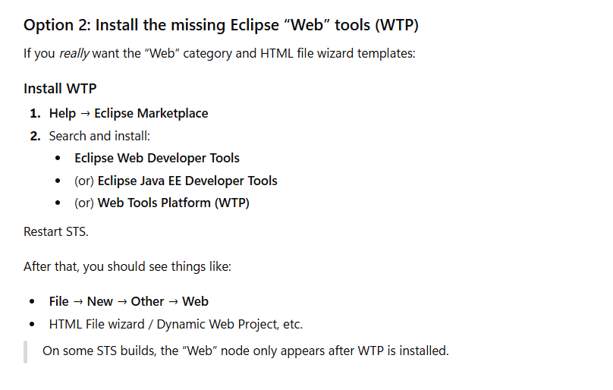

- Create Template: Thymeleaf


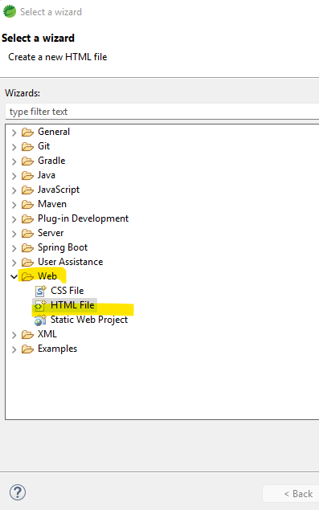

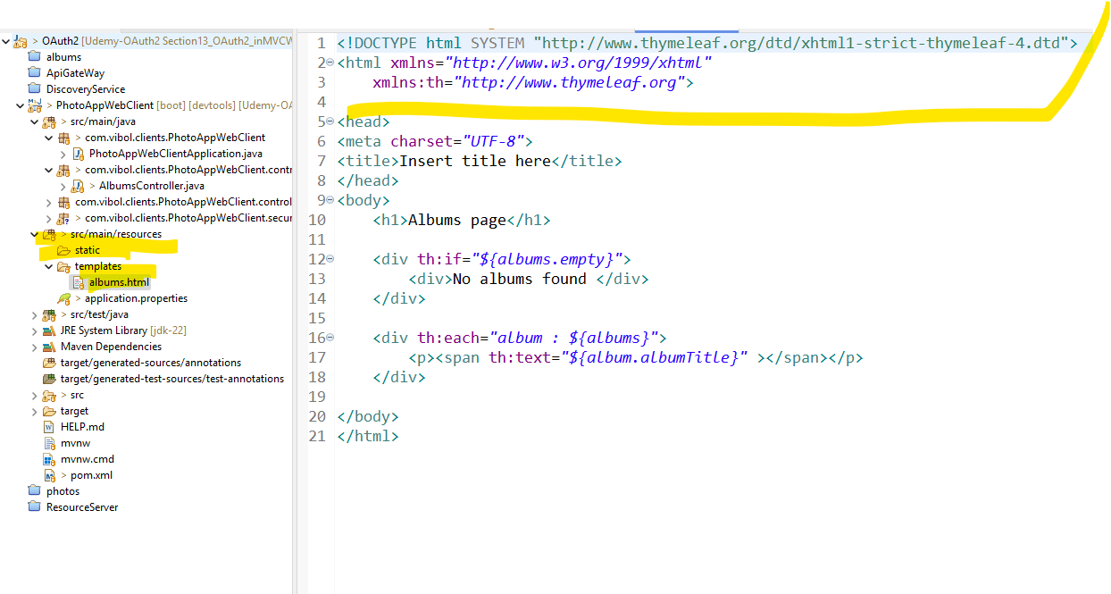

<!DOCTYPE html SYSTEM "http://www.thymeleaf.org/dtd/xhtml1-strict-thymeleaf-4.dtd">
<html xmlns="http://www.w3.org/1999/xhtml"
xmlns:th="http://www.thymeleaf.org">

<head>
<meta charset="UTF-8">
<title>Insert title here</title>
</head>
<body>
<h1>Albums page</h1>

<div th:if="${albums.empty}">
<div>No albums found </div>
</div>

<div th:each="album : ${albums}">
<p><span th:text="${album.albumTitle}" ></span></p>
</div>

</body>
</html>

- Application.properties

spring.security.oauth2.client.registration.mywebclient.client-id=photo-app-webclient
spring.security.oauth2.client.registration.mywebclient.client-secret=i27W6rABxAnvbnmwzebLFwJRKlElV12N
spring.security.oauth2.client.registration.mywebclient.scope=openid,profile,roles
spring.security.oauth2.client.registration.mywebclient.authorization-grant-type=authorization_code
spring.security.oauth2.client.registration.mywebclient.redirect-uri=http://localhost:8087/login/oauth2/code/mywebclient

spring.security.oauth2.client.provider.mywebclient.authorization-uri=http://localhost:8080/realms/mywebclient/protocol/openid-connect/auth
spring.security.oauth2.client.provider.mywebclient.token-uri=http://localhost:8080/realms/mywebclient/protocol/openid-connect/token
spring.security.oauth2.client.provider.mywebclient.jwk-set-uri=http://localhost:8080/realms/mywebclient/protocol/openid-connect/certs
spring.security.oauth2.client.provider.mywebclient.user-info-uri=http://localhost:8080/realms/mywebclient/protocol/openid-connect/userinfo
spring.security.oauth2.client.provider.mywebclient.user-name-attribute=preferred_username
spring.security.oauth2.client.provider.mywebclient.issuer-uri=http://localhost:8080/realms/mywebclient

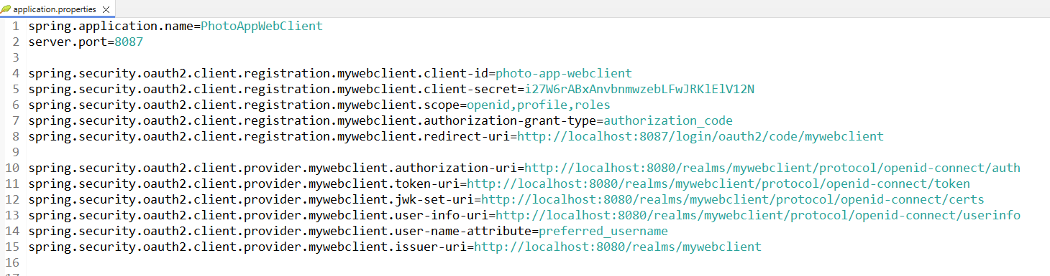

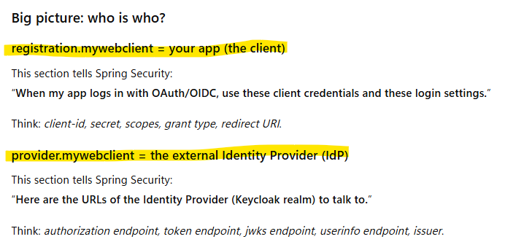

Keyload Create Client

- Create reamls

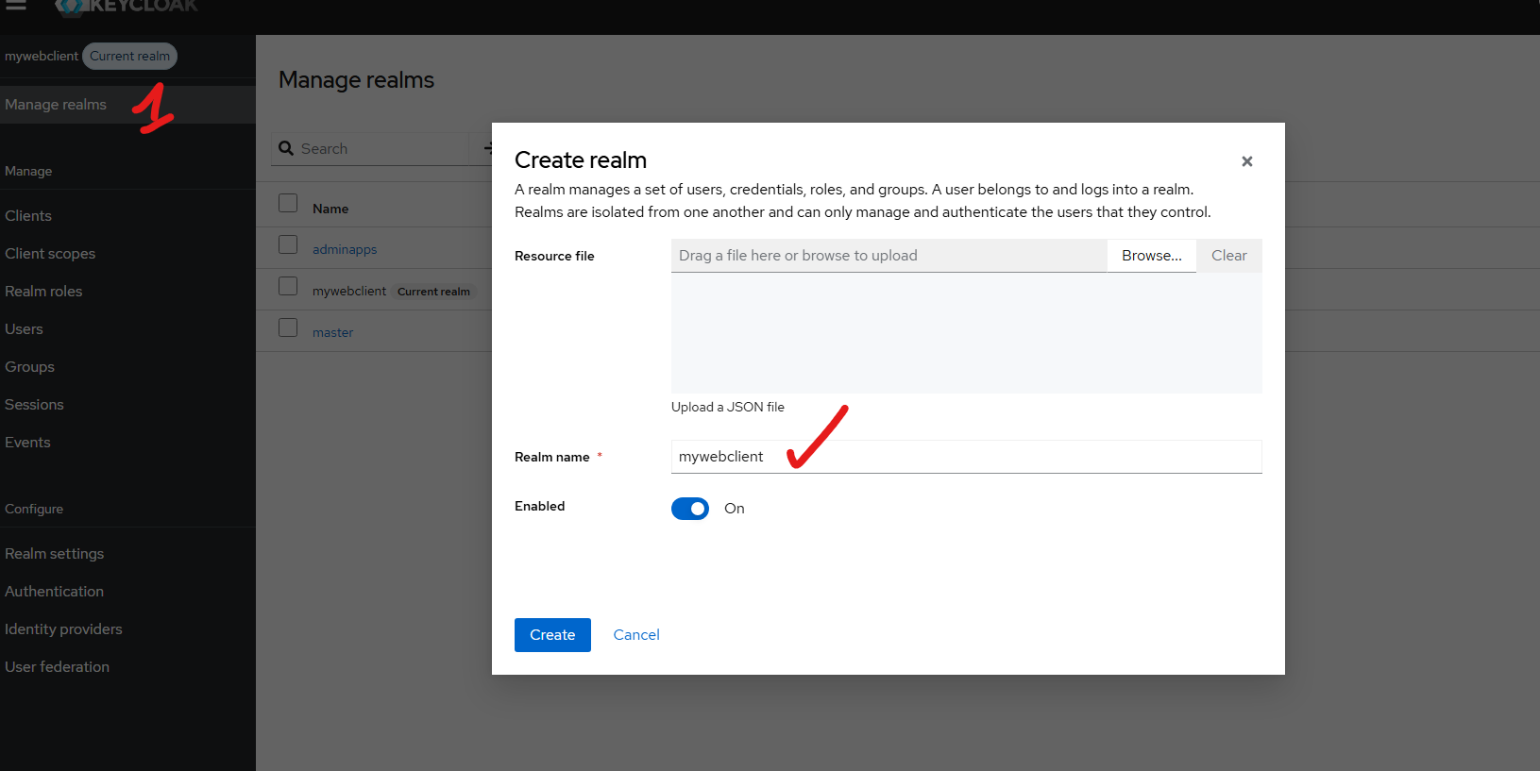

- Create client

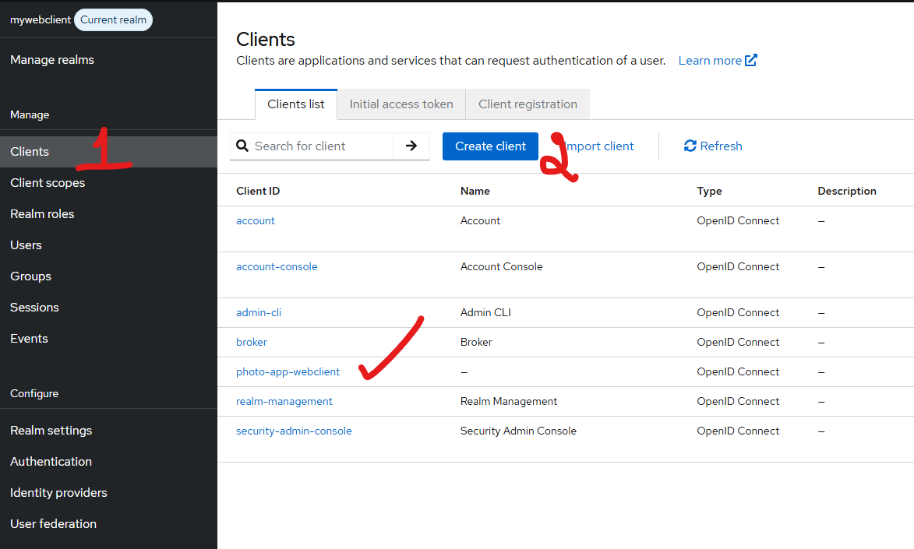

Setting in client:

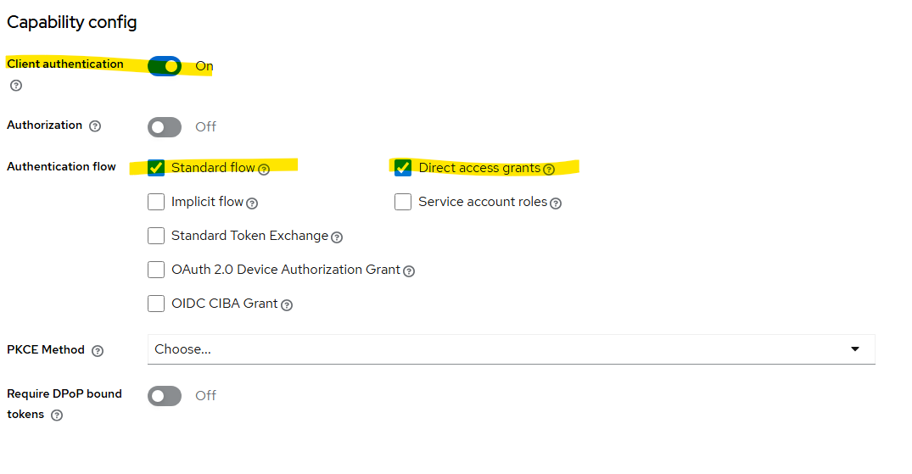
- Create standard login

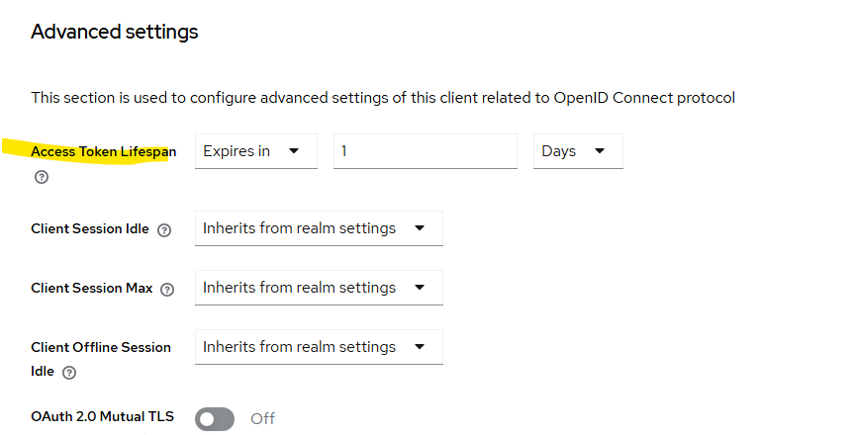
- Keep the Access Token longer

- Create user

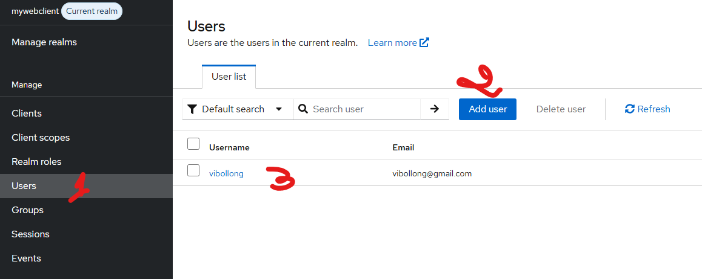

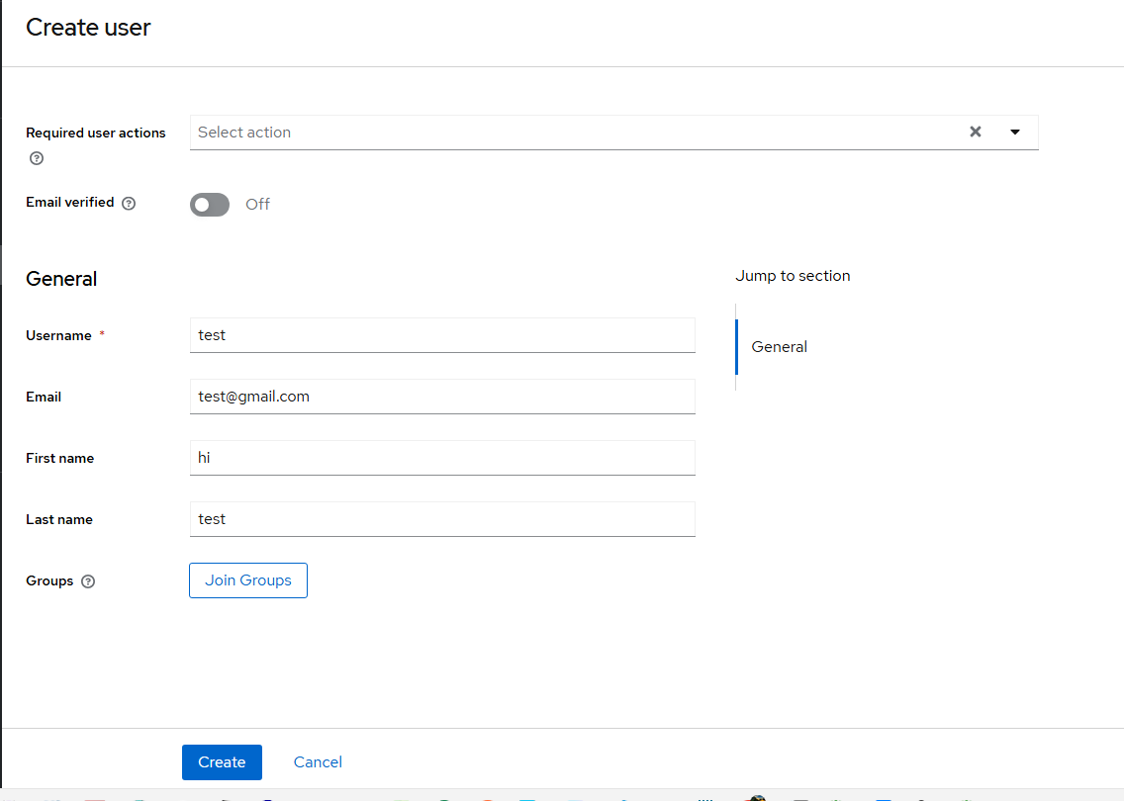

Assign role:

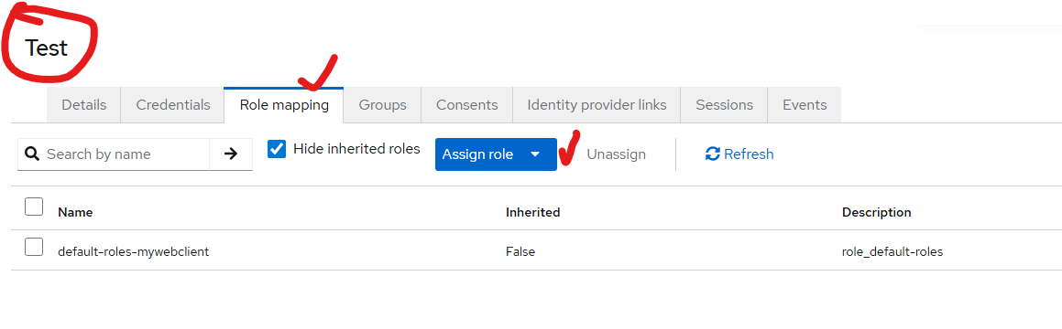

Crete role:

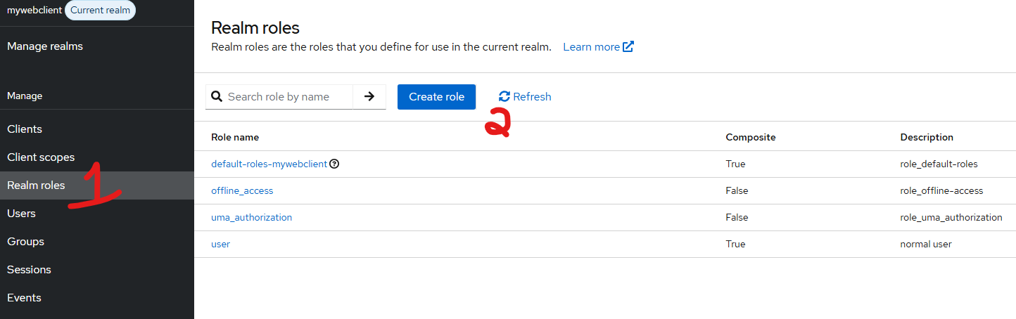

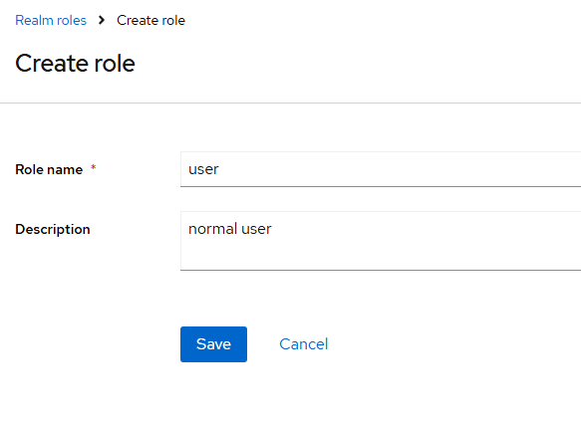

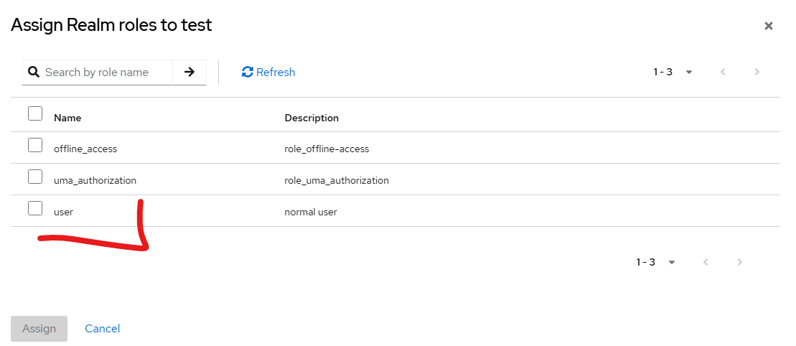

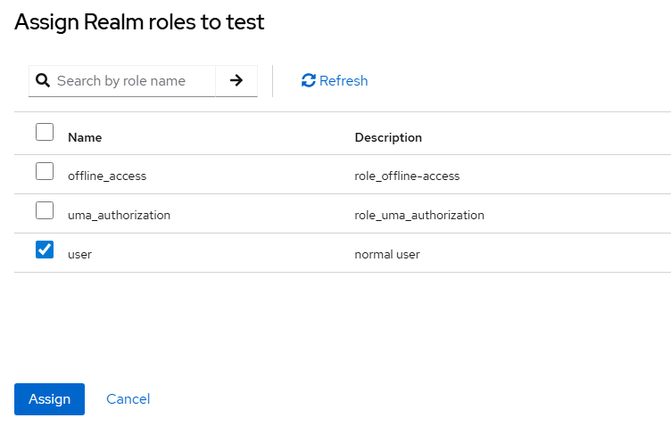

We can assign new role to it!

Default user:
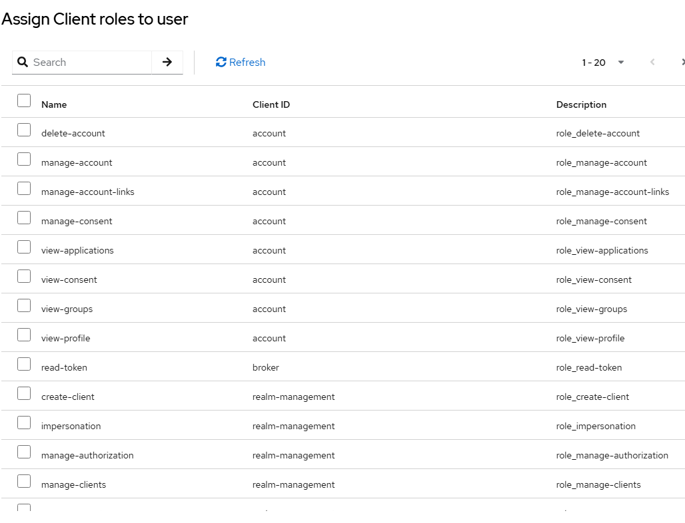

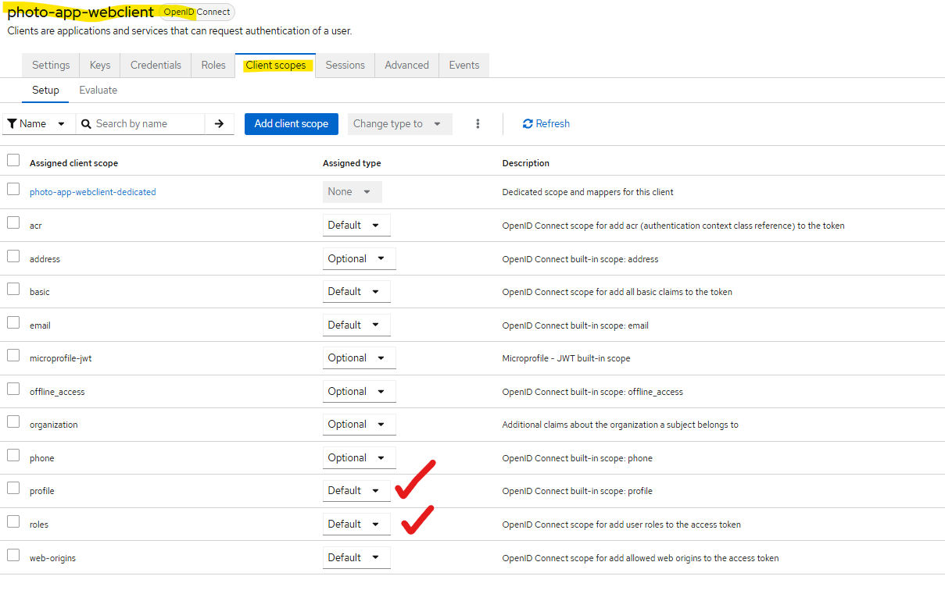

Testing With Login

@Controller
public class AlbumsController {

@GetMapping("/albums")
public String getAlbums(Model model, @AuthenticationPrincipal OidcUser principal) {

System.out.println("Principal = " + principal);

OidcIdToken idToken = principal.getIdToken();
String idTokenValue = idToken.getTokenValue();

System.out.println("idTokenValue = " + idTokenValue);

- We check the user login Token by creating object from
OidcUser

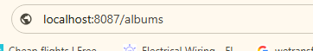

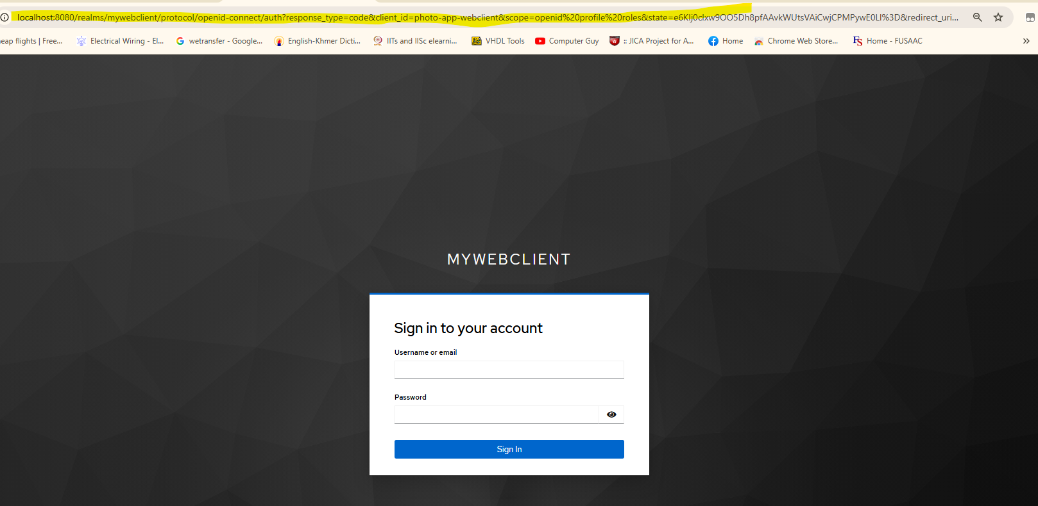

ចំណាំ វានឹងចូលទៅកាន់​​ Keyload login page!
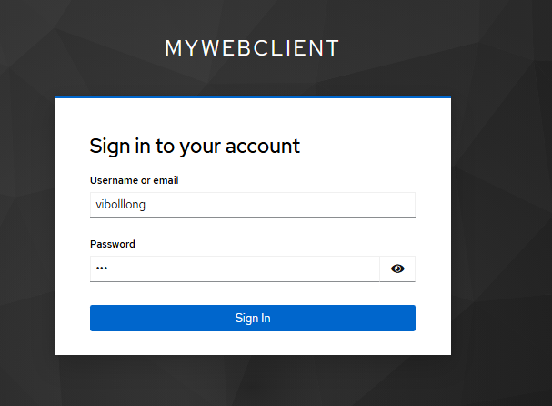

- After successfully logging in it will directly to our Web MVC
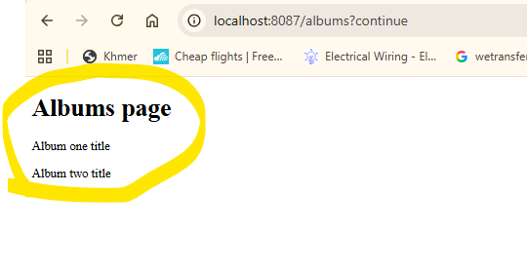

ចំណាំ បើវាអត់ដើរពេល login to :localhost:8087/login : អានឹងវាចូលទៅកាន់ Spring security ទេ

Token id:
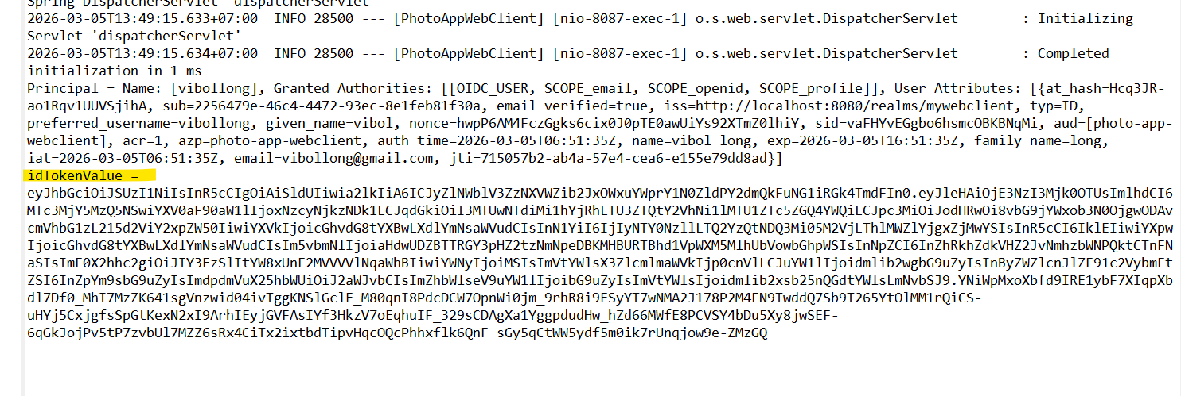

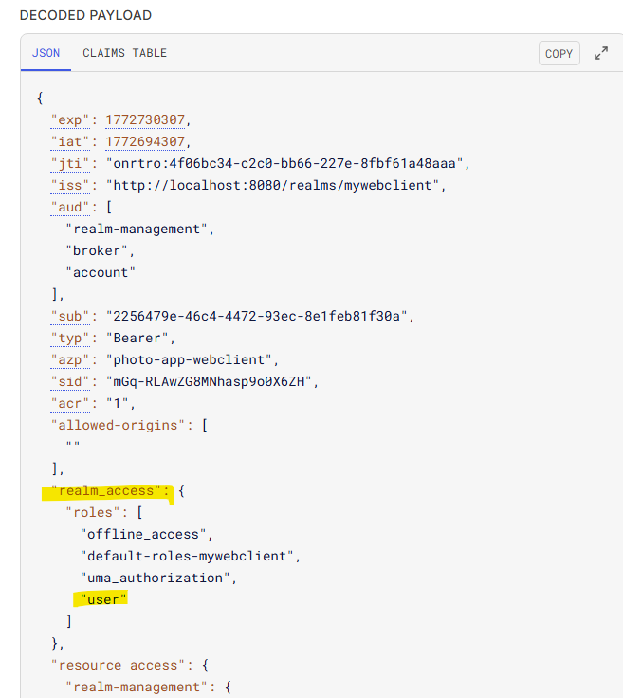

Error Show

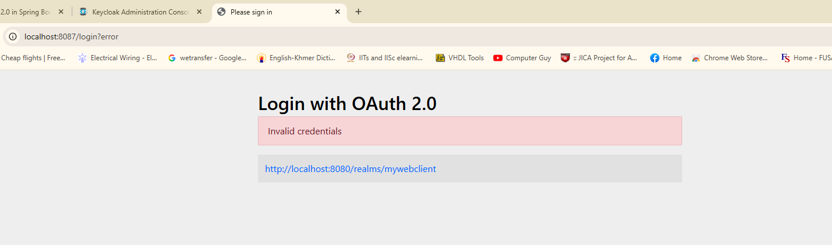

Neee Client Secret again

