How PreAutheri Annotaion work

- Put the annotation in the configuration
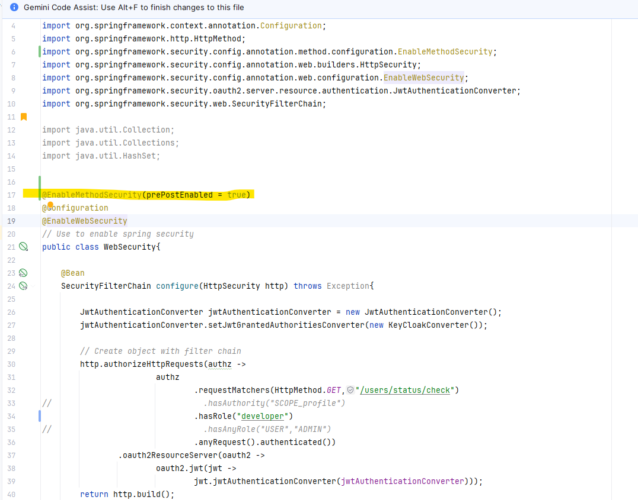

@EnableMethodSecurity(prePostEnabled = true)

- In the controller
@PreAuthorize("hasRole('developer')")

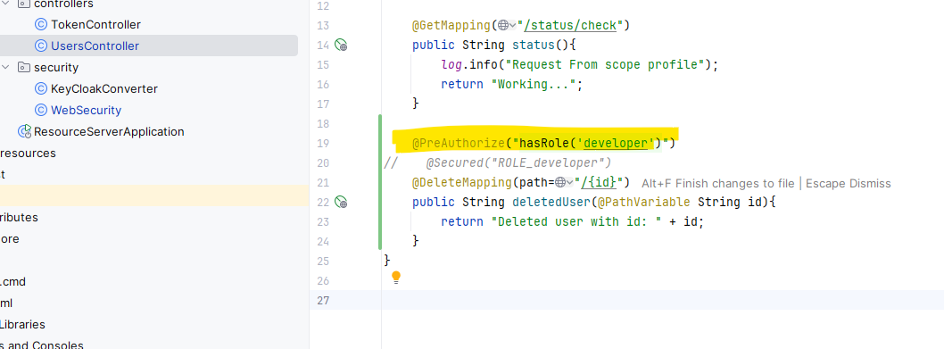

Or we can put

@PreAuthorize("hasAuthority('ROLE_developer')")

