Implement with WebClient
ពេលដែលយើងចង់ប្តូរ Resource Server we need to hardcoding
- We manually change the resource server:
Ex: String url = "http://localhost:8082/albums";
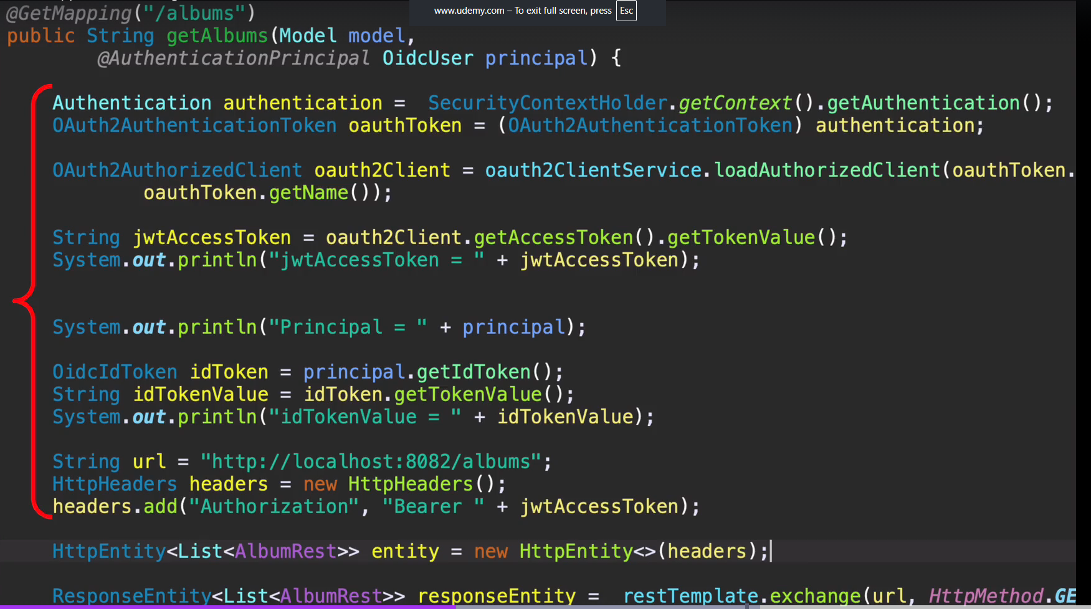

- WebClient : in spring we automatically let spring get the resource server for us : it is the part of Reactive framework

- Add dependencies

<!-- Webclient -->
<dependency>
<groupId>org.springframework</groupId>
<artifactId>spring-webflux</artifactId>
</dependency>

<!-- server Netty -->
<dependency>
<groupId>io.projectreactor.netty</groupId>
<artifactId>reactor-netty</artifactId>
</dependency>

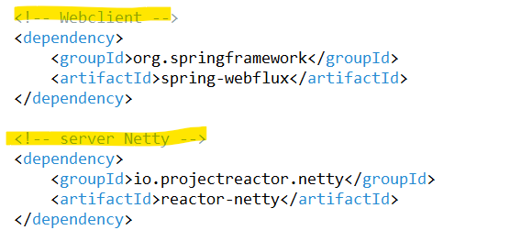

- Create been

@Bean
public WebClient webClient(
ClientRegistrationRepository clientRegistrationRepository,
OAuth2AuthorizedClientRepository authorizedClientRepository) {

ServletOAuth2AuthorizedClientExchangeFilterFunction oauth2 =
new ServletOAuth2AuthorizedClientExchangeFilterFunction(
clientRegistrationRepository,
authorizedClientRepository
);

oauth2.setDefaultOAuth2AuthorizedClient(true);

return WebClient.builder()
.apply(oauth2.oauth2Configuration())
.build();
}
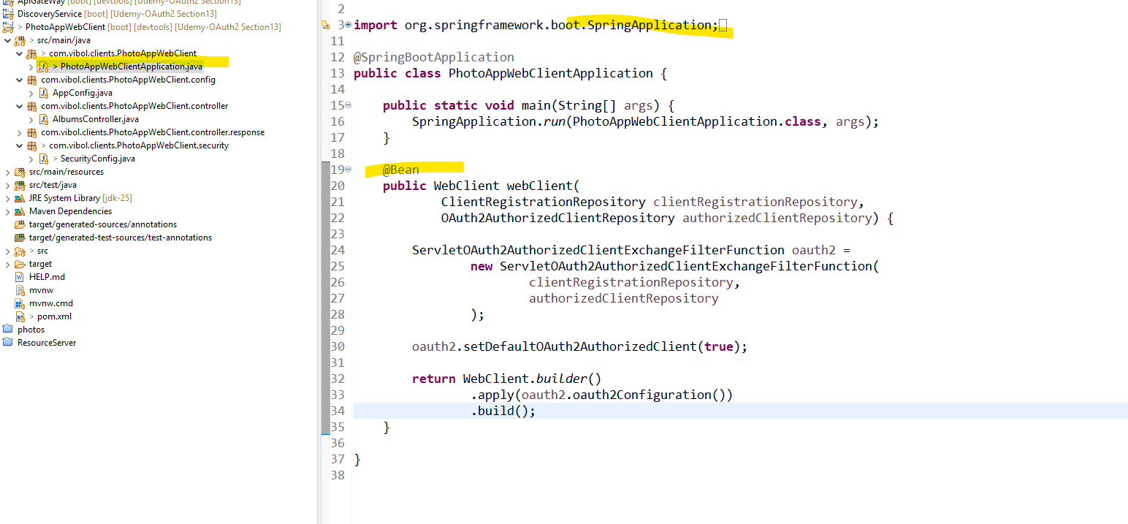

- In the controller

We autowire for Webclient (អ្នកប្រើប្រាស់ដែលចូលទៅកាន់ Resource server របស់ហើយដើម្បីធ្វើការ Access)
ចឹងមានន័យថា អា WebClient នឹងធ្វើនឹងធ្វើការនាំមកនូវ Access Token to each Http Request for us. So all of this code that I have that reads an access token and adds an access token to a Http header,

What we want:

This is all I needed to do to make my web client send the Http request to a protected albums resource

server and fetch a list of albums.

