Reservation FE
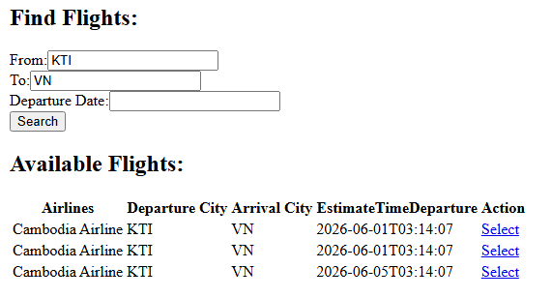

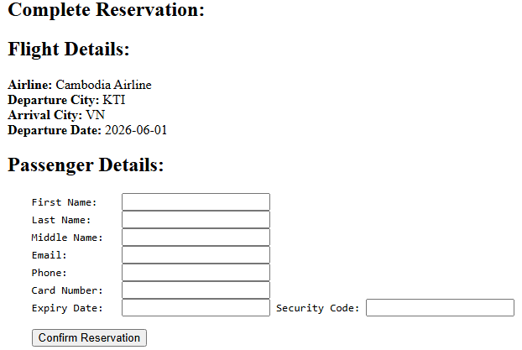

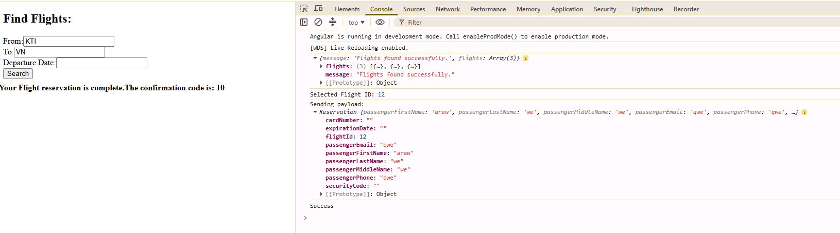

- Create service​ Reservation
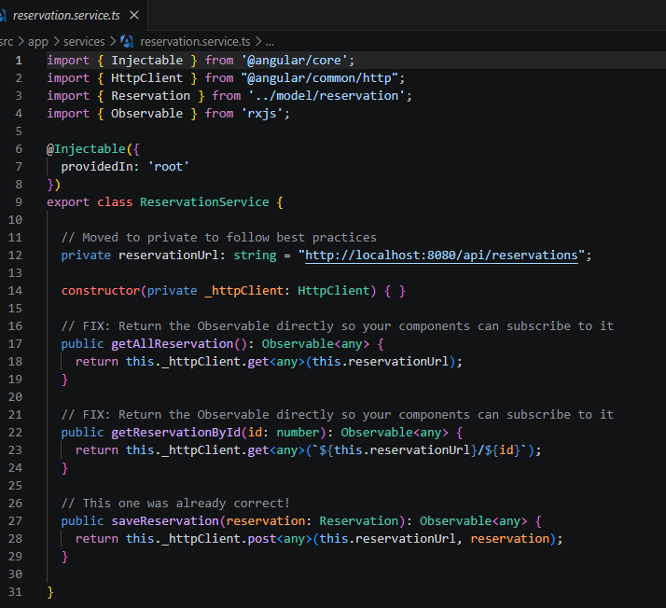

- Import httpClient : សម្រាប់ Http Method GET, POST, PUT, Delete
- constructor(private _httpClient: HttpClient) { } ពេលបង្កើត object នឹងមកអោយវាហៅ Http មកប្រើប្រាស់
- បន្ទាប់មកយើងបង្កើត Method ដើម្បីធ្វើការប្រើប្រាស់ : getAllReservation(), and getReservationById(id: number), saveReservation(reservation: Reservation).
- Observable<any> យើង Return វាជា Observable ព្រោះយើងគិតវាដូចជា អ្នកបំរើចឹង វាអ្នកទៅយកពីខាងក្រោយ API
- សម្រាប់ subscribe យើងជាអ្នកប្រើប្រាស់
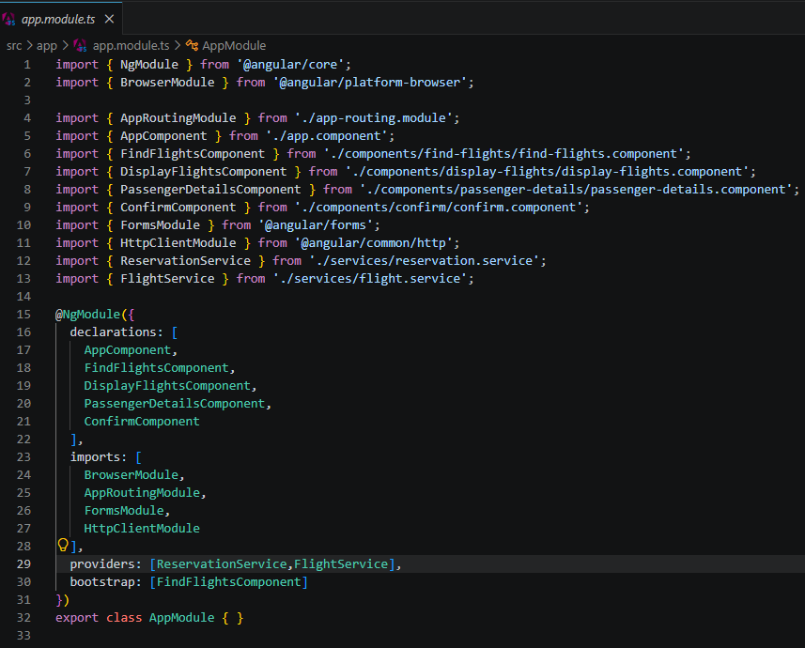
សំខាន់ដើម្បីប្រើប្រាស់ HttpClient បានយើងត្រូវ ដាក់ HttpClientModule to the app.module.ts

- នឹងត្រូវដាក់ FormsModule ដើម្បីធ្វើការប្រើប្រាស់ form បាន
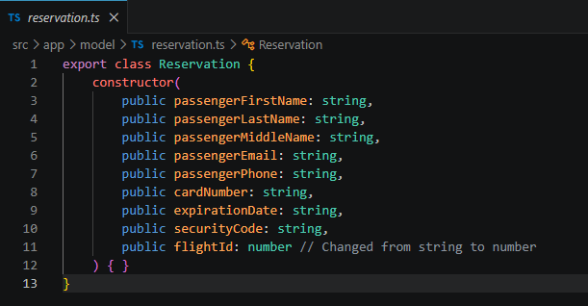
- បង្កើត model

ពេលយើងចង់បង្កើត object from our model we use “new” keyword
- reservation:Reservation = new Reservation​​("","","","","","","","",0);

- ហៅ Server Reservation មកប្រើប្រាស់
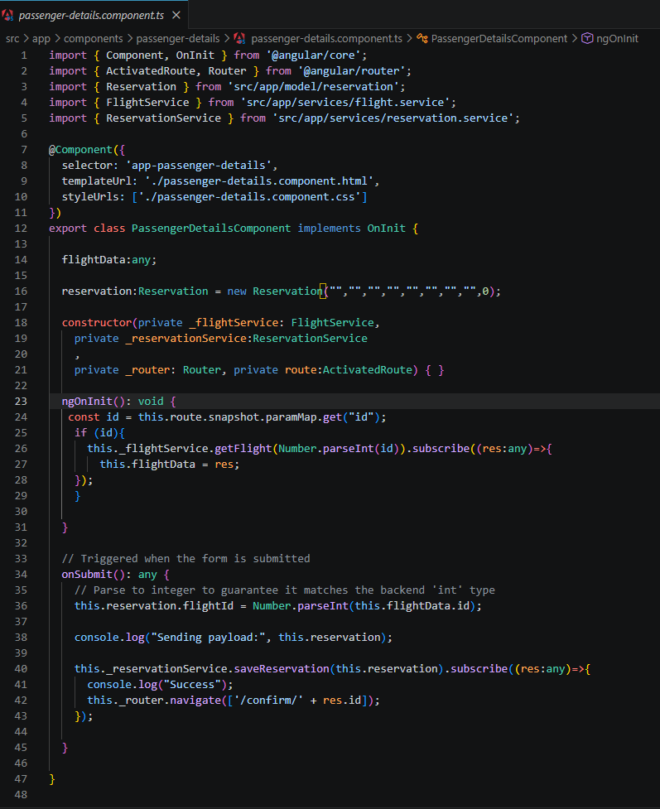

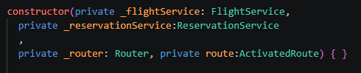
- ហៅ Service មកប្រើប្រាស់ មុនគេ: ActivatedRoute ប្រើប្រាស់ដើម្បីធ្វើការចាប់យក ទិន្នន័យពី url ដែលបានបោះមក (http://localhost:4200/confirm/10) យើងចង់បាន id លេខ 10 នឹងចឹងយើងត្រូវប្រើប្រាស់ const id = this.route.snapshot.paramMap.get("id");

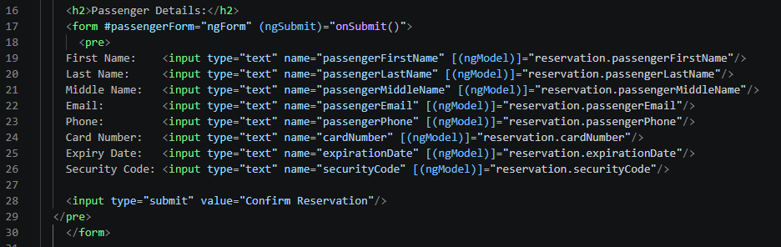
- onSubmit(): គឺជា function ដែលយើងធ្វើការ submit form from temple

- name="passengerFirstName" [(ngModel)]: គេធ្វើ two way property binding ដែលវាធ្វើការភ្ជាប់ ពី Template to the ts variable.

- Router
- យើងធ្វើការបង្កើតដើម្បីប្រាប់ URL ថាវាទៅណា { path: '', redirectTo: '', pathMatch: 'full' },

ALL Code in FE:

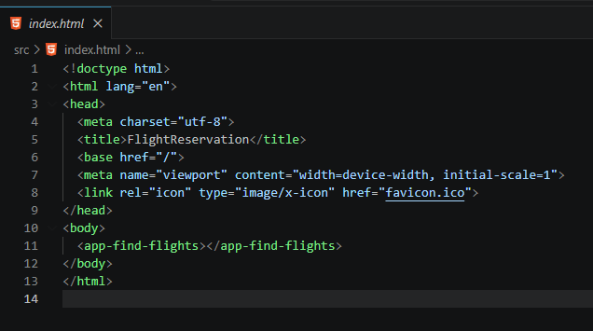

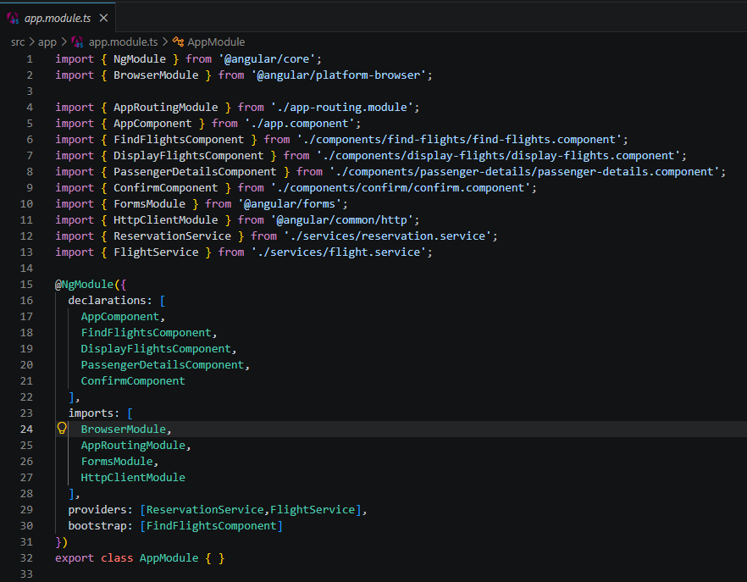

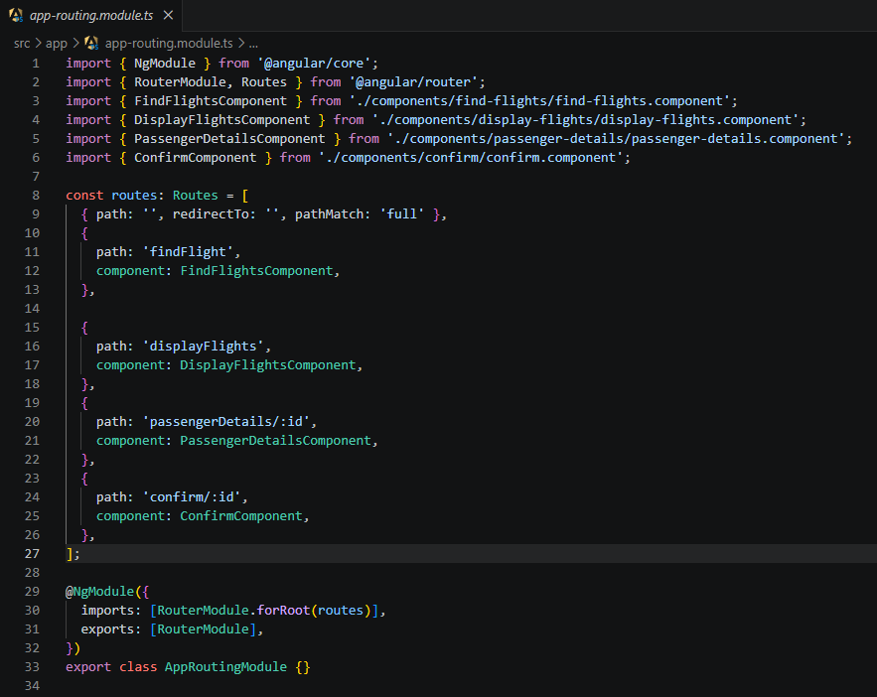

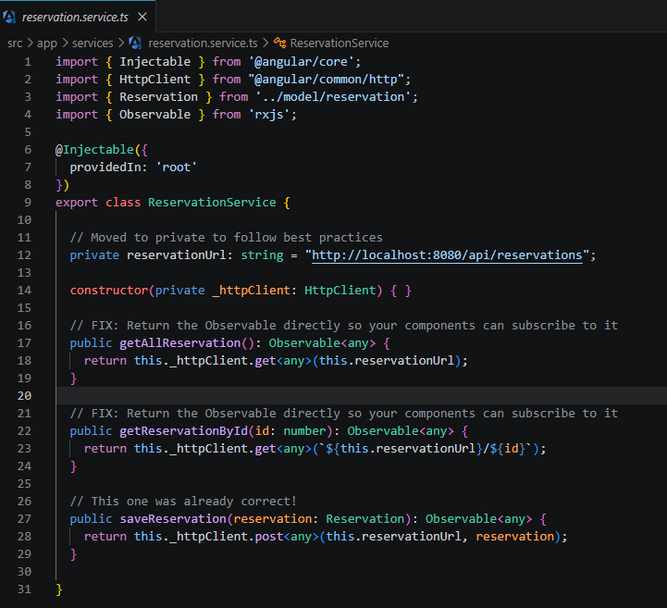

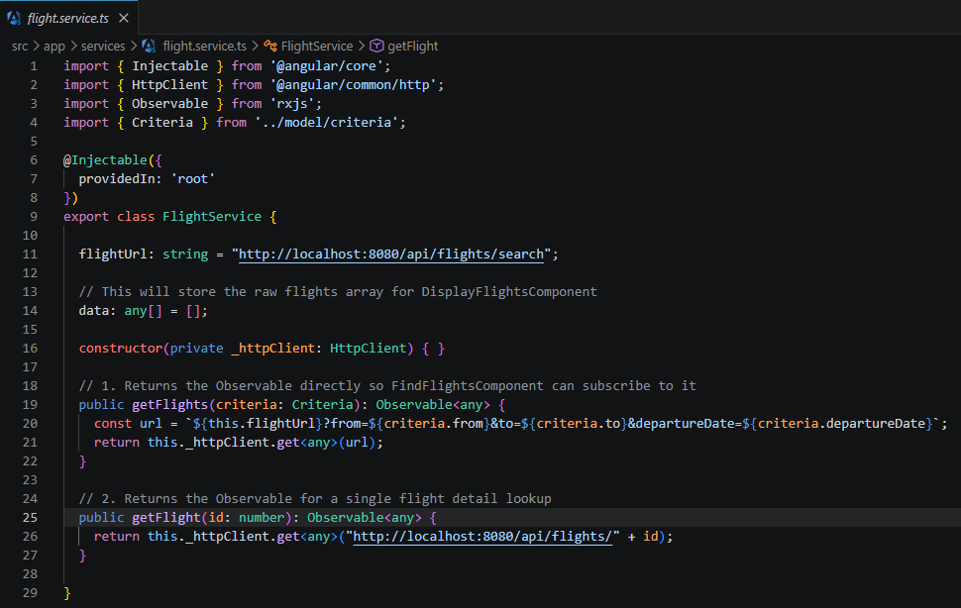

- Model
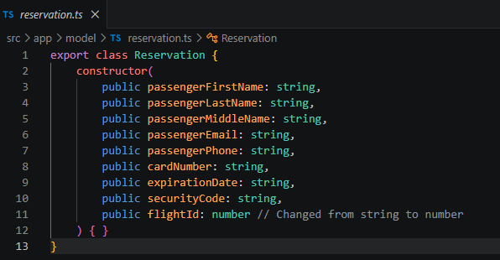

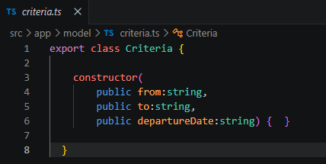

- Display Component
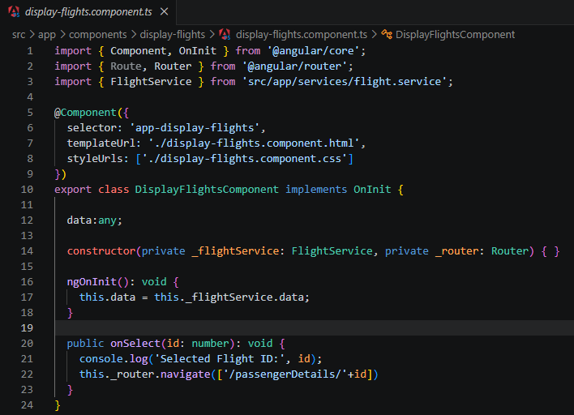

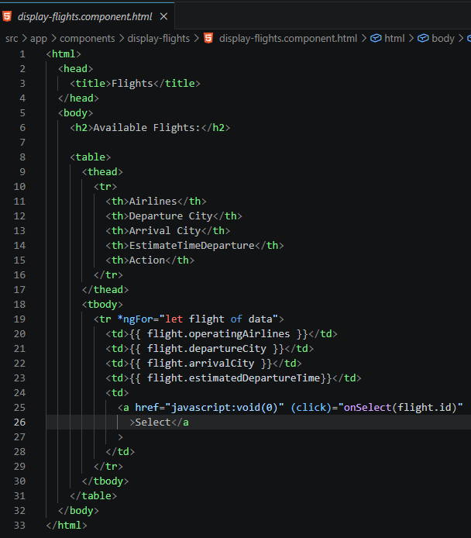

- Find-flight component
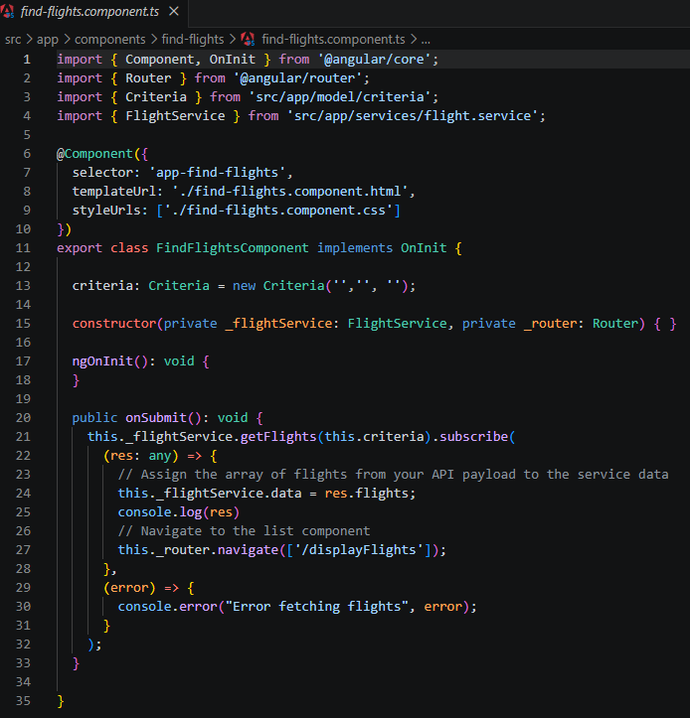

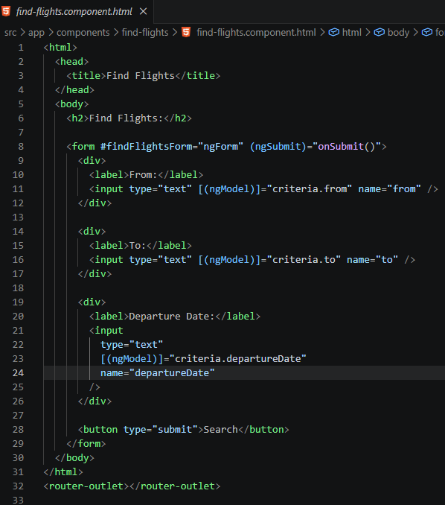

- Passenger-detail

import { Component, OnInit } from '@angular/core';
import { ActivatedRoute, Router } from '@angular/router';
import { Reservation } from 'src/app/model/reservation';
import { FlightService } from 'src/app/services/flight.service';
import { ReservationService } from 'src/app/services/reservation.service';

@Component({
selector: 'app-passenger-details',
templateUrl: './passenger-details.component.html',
styleUrls: ['./passenger-details.component.css']
})
export class PassengerDetailsComponent implements OnInit {

flightData:any;

reservation:Reservation = new Reservation​​("","","","","","","","",0);

constructor(private _flightService: FlightService,
private _reservationService:ReservationService
,
private _router: Router, private route:ActivatedRoute) { }

ngOnInit(): void {
const id = this.route.snapshot.paramMap.get("id");
if (id){
this._flightService.getFlight(Number.parseInt(id)).subscribe((res:any)=>{
this.flightData = res;
});
}

}

// Triggered when the form is submitted
onSubmit(): any {
// Parse to integer to guarantee it matches the backend 'int' type
this.reservation.flightId = Number.parseInt(this.flightData.id);

console.log("Sending payload:", this.reservation);

this._reservationService.saveReservation(this.reservation).subscribe((res:any)=>{
console.log("Success");
this._router.navigate(['/confirm/' + res.id]);
});

}

}

------------------------------

<html>
<head>
<title>Complete Reservation</title>
</head>
<body>
<h2>Complete Reservation:</h2>

<h2>Flight Details:</h2>
<p>
<strong>Airline:</strong> {{ flightData?.operatingAirlines }}<br />
<strong>Departure City:</strong> {{ flightData?.departureCity }}<br />
<strong>Arrival City:</strong> {{ flightData?.arrivalCity }}<br />
<strong>Departure Date:</strong> {{ flightData?.dateOfDeparture }}<br />
</p>

<h2>Passenger Details:</h2>
<form #passengerForm="ngForm" (ngSubmit)="onSubmit()">
<pre>
First Name: <input type="text" name="passengerFirstName" [(ngModel)]="reservation.passengerFirstName"/>
Last Name: <input type="text" name="passengerLastName" [(ngModel)]="reservation.passengerLastName"/>
Middle Name: <input type="text" name="passengerMiddleName" [(ngModel)]="reservation.passengerMiddleName"/>
Email: <input type="text" name="passengerEmail" [(ngModel)]="reservation.passengerEmail"/>
Phone: <input type="text" name="passengerPhone" [(ngModel)]="reservation.passengerPhone"/>
Card Number: <input type="text" name="cardNumber" [(ngModel)]="reservation.cardNumber"/>
Expiry Date: <input type="text" name="expirationDate" [(ngModel)]="reservation.expirationDate"/>
Security Code: <input type="text" name="securityCode" [(ngModel)]="reservation.securityCode"/>

<input type="submit" value="Confirm Reservation"/>
</pre>
</form>

</body>
</html>

- Confirm-detail
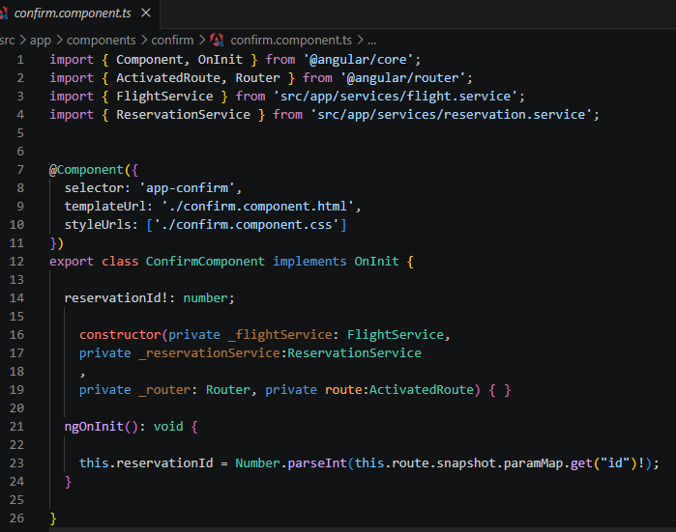

<b>Your Flight reservation is complete.The confirmation code is: {{reservationId}}</b>

