Flight Reservation Front End Angular

- What we will build:
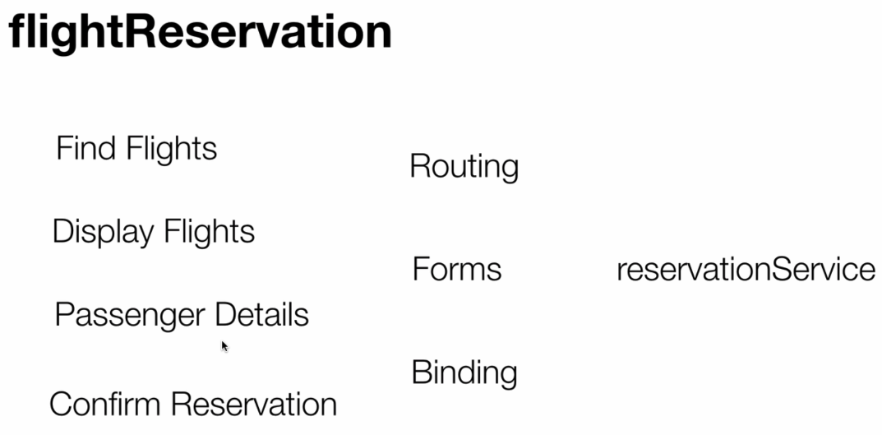

- Interface looks like: Search Flight
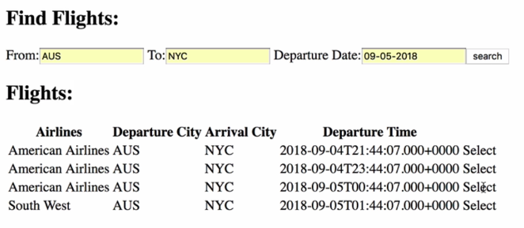

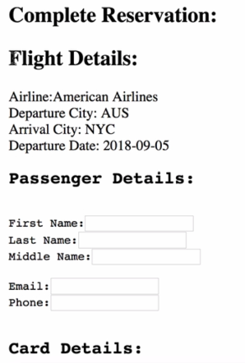
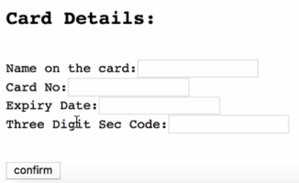

- Create Project

We will create four components: Find Flight, Display Flights, Passenger Details, Confirm Reservation.

>> ng g c components/findFlights
>> ng g c components/displayFlights
>> ng g c components/passengerDetails
>> ng g c components/confirm
>> ng g s services/reservation

