2-Create POST Request

- Create service
>> ng g s services/uppercaseConverter
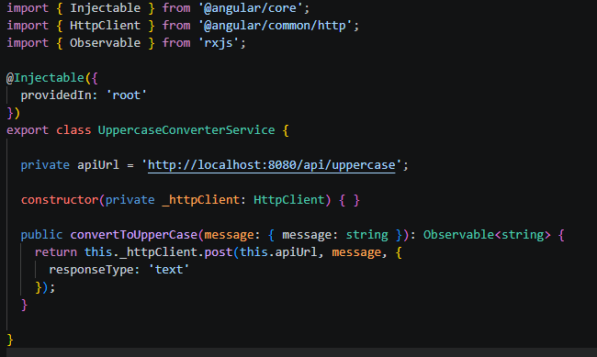

Code:

import { Injectable } from '@angular/core';
import { HttpClient } from '@angular/common/http';
import { Observable } from 'rxjs';

@Injectable({
providedIn: 'root'
})
export class UppercaseConverterService {

private apiUrl = 'http://localhost:8080/api/uppercase';

constructor(private _httpClient: HttpClient) { }

public convertToUpperCase(message: { message: string }): Observable<string> {
return this._httpClient.post(this.apiUrl, message, {
responseType: 'text'
});
}

}

- Create Component
>> ng g c components/countriesUpdate

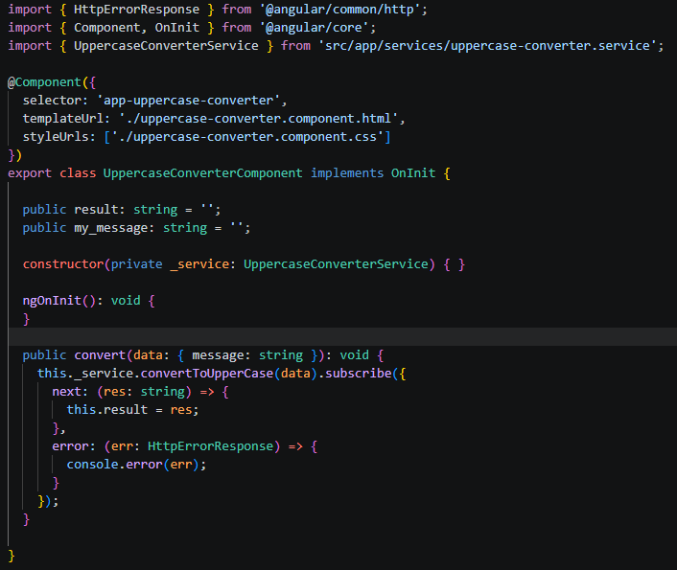

Code:

import { HttpErrorResponse } from '@angular/common/http';
import { Component, OnInit } from '@angular/core';
import { UppercaseConverterService } from 'src/app/services/uppercase-converter.service';

@Component({
selector: 'app-uppercase-converter',
templateUrl: './uppercase-converter.component.html',
styleUrls: ['./uppercase-converter.component.css']
})
export class UppercaseConverterComponent implements OnInit {

public result: string = '';
public my_message: string = '';

constructor(private _service: UppercaseConverterService) { }

ngOnInit(): void {
}

public convert(data: { message: string }): void {
this._service.convertToUpperCase(data).subscribe({
next: (res: string) => {
this.result = res;
},
error: (err: HttpErrorResponse) => {
console.error(err);
}
});
}

}

- HTML
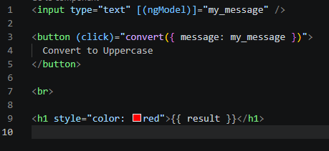

Code:

<input type="text" [(ngModel)]="my_message" />

<button (click)="convert({ message: my_message })">
Convert to Uppercase
</button>

<br>

<h1 style="color: red">{{ result }}</h1>

Package.json

{
"name": "post-service",
"version": "0.0.0",
"scripts": {
"ng": "ng",
"start": "ng serve",
"build": "ng build",
"test": "ng test",
"lint": "ng lint",
"e2e": "ng e2e"
},
"private": true,
"dependencies": {
"@angular/animations": "11.1.2",
"@angular/common": "11.1.2",
"@angular/compiler": "11.1.2",
"@angular/core": "11.1.2",
"@angular/forms": "11.1.2",
"@angular/platform-browser": "11.1.2",
"@angular/platform-browser-dynamic": "11.1.2",
"@angular/router": "11.1.2",
"rxjs": "6.6.0",
"tslib": "2.0.0",
"zone.js": "0.11.3"
},
"devDependencies": {
"@angular-devkit/build-angular": "0.1101.2",
"@angular/cli": "11.1.4",
"@angular/compiler-cli": "11.1.2",
"@types/jasmine": "3.6.0",
"@types/node": "12.11.1",
"codelyzer": "6.0.0",
"jasmine-core": "3.6.0",
"jasmine-spec-reporter": "5.0.0",
"karma": "5.2.0",
"karma-chrome-launcher": "3.1.0",
"karma-coverage": "2.0.3",
"karma-jasmine": "4.0.0",
"karma-jasmine-html-reporter": "1.5.0",
"protractor": "7.0.0",
"ts-node": "8.3.0",
"tslint": "6.1.0",
"typescript": "4.1.2"
}
}

Backend
- Request responds

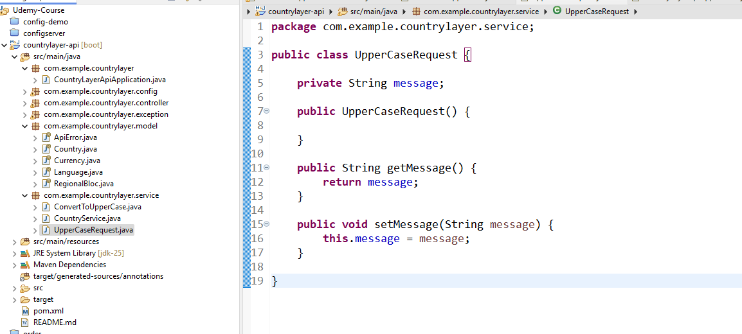

- Service
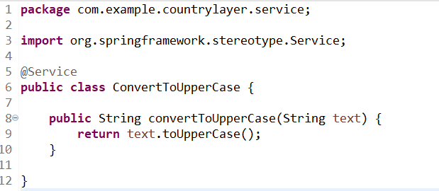

- Controller
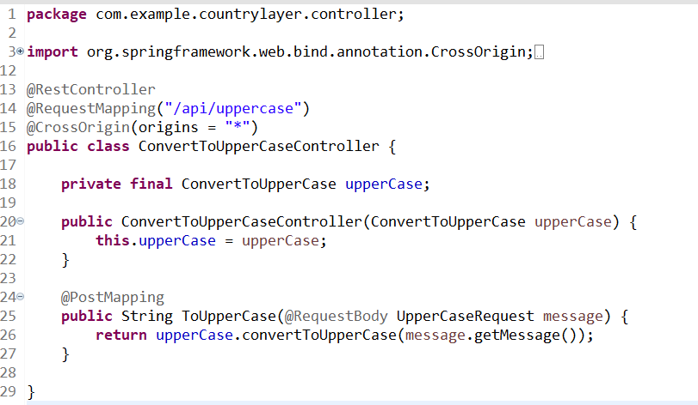

Code:

package com.example.countrylayer.controller;

import org.springframework.web.bind.annotation.CrossOrigin;
import org.springframework.web.bind.annotation.PostMapping;
import org.springframework.web.bind.annotation.RequestBody;
import org.springframework.web.bind.annotation.RequestMapping;
import org.springframework.web.bind.annotation.RequestParam;
import org.springframework.web.bind.annotation.RestController;

import com.example.countrylayer.service.ConvertToUpperCase;
import com.example.countrylayer.service.UpperCaseRequest;

@RestController
@RequestMapping("/api/uppercase")
@CrossOrigin(origins = "*")
public class ConvertToUpperCaseController {

private final ConvertToUpperCase upperCase;

public ConvertToUpperCaseController(ConvertToUpperCase upperCase) {
this.upperCase = upperCase;
}

@PostMapping
public String ToUpperCase(@RequestBody UpperCaseRequest message) {
return upperCase.convertToUpperCase(message.getMessage());
}

}

