RestClient
- Create RestClientController
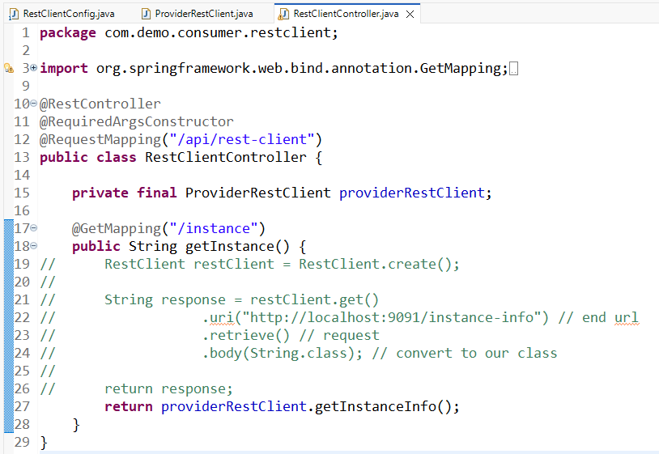

- Create spring bean
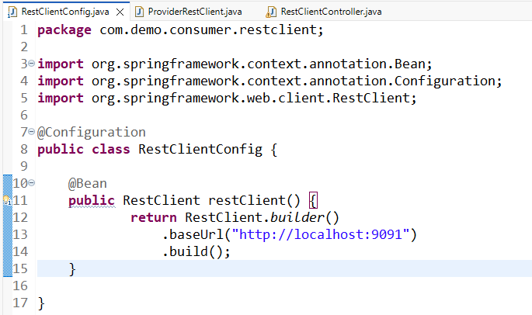

- Create provider
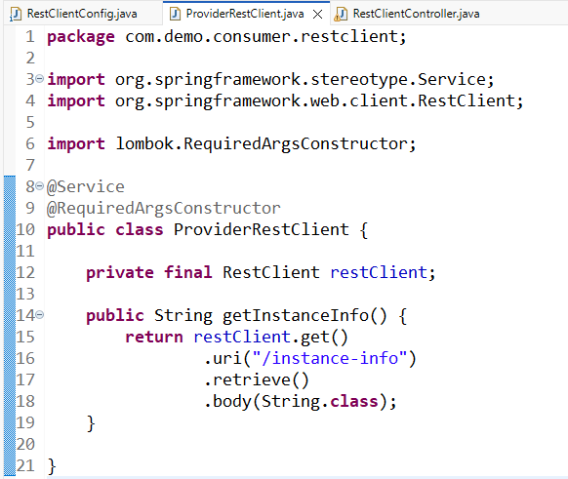

http://localhost:9090/api/rest-client/instance

