File Base Configuration

- Config Server

server:
port: 8888

spring:
application:
name: configserver
profiles:
active: native
cloud:
config:
server:
native:
search-locations: classpath:/config

- យើងដាក់វាជា active: native វិញ
- search-locations: classpath:/config ទីតាំងរបស់ File config

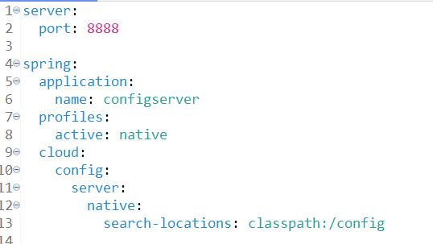

- location : src/main/resources/config

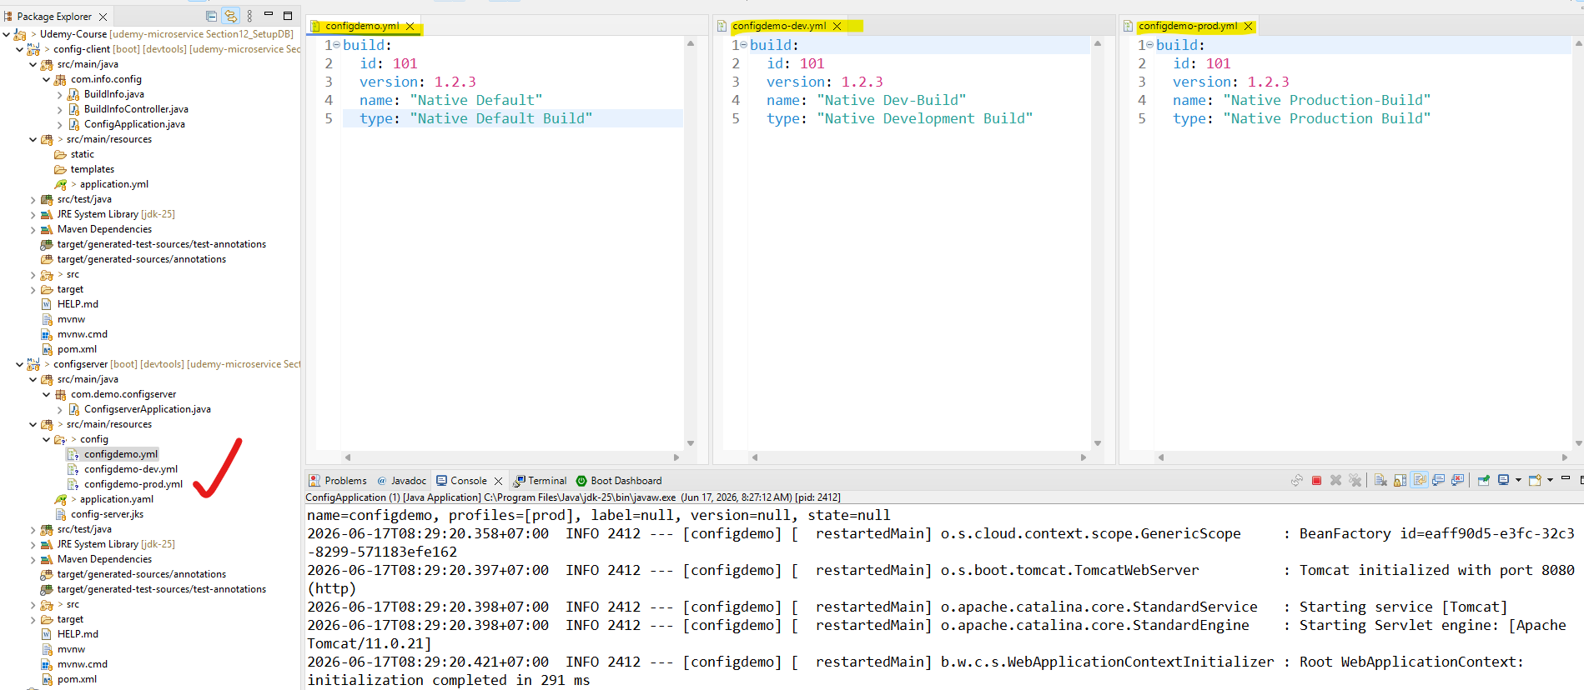

- Client Side

spring:
application:
name: configdemo
profiles:
active: dev
config:
import: optional:configserver:http://localhost:8888

build:
id: ${ID}
version: ${VERSION}
name: ${NAME}

- import: optional:configserver:http://localhost:8888 កន្លែងដែលយើងធ្វើការភ្ជាប់ទៅ configser
