AES Encrypted

- AES is a secure way to lock and unlock data using a secret key.
- យើងមាន Key ហើយយើងធ្វើការ encrypt បន្ទាប់មកយើងត្រូវធ្វើការ decrypted ឡើងវិញដោយប្រើប្រាស់ Key នឹងវិញ
- AES is commonly used in Spring Cloud Config Server to protect sensitive configuration value like passwords and API keys!
- it is working with spring cloud config server

- In the config server (application.yaml)
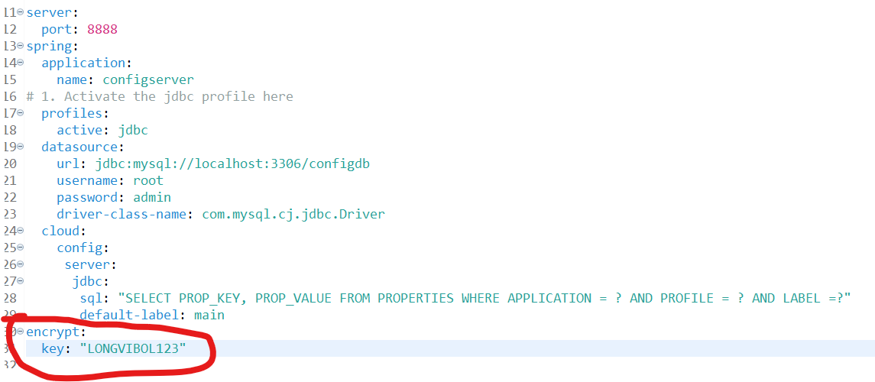

- How to get encrypted
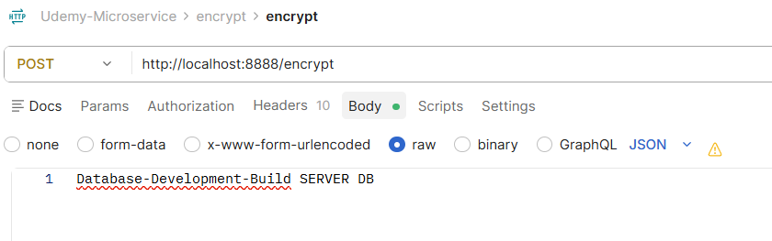

- We use : {cipher} ប្រាប់ថាវា encryted
{cipher}ebd3d8e6e6c336f733f5f3a5737cb1217050424d14989f8ec607e000fbf94718f260a247d2f788c9b8c2bdd6dd6a9c8470da486b11093ef0a8ffe841d36a3479
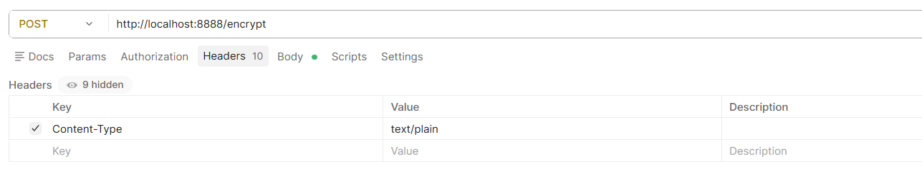

- When decrypted
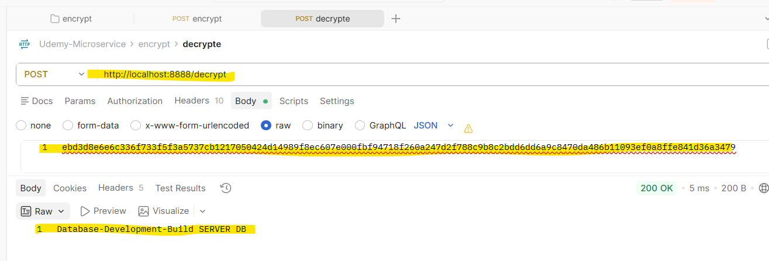

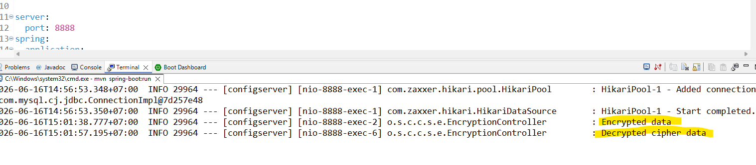

In the spring cloud it will do this AES

- We can save the
encrypt:
key: "LONGVIBOL123"

or we can use the variable to the spring boot

