**Chapter1:**

1. **Why testing is necessary** (tại sao kiểm thử lại cần thiết)

- Because software is likely to have faults

- To learn about the reliability of the software

- Because failures can be very expensive

- To avoid being sued by customers

- To stay in business

1. **What is testing**

**+ What is a “bug(**lỗi**)”?**

- Error: a human action that produces an incorrect result

- Fault: a manifestation of an error in software

+ also known as a defect or bug

+ if executed, a fault may cause a failure

- Failure: deviation of the software from its expected delivery or service

**Error - Fault - Failure**

* Reliability: the probability that software will not cause the failure of the system for a specified time under specified conditions

+ Can a software system be reliable but still have faults?

* **Why do faults occur in software?**

+ software is written by human beings

+ under increasing pressure to deliver to strict deadlines

1. **Testing principles**

**+ Seven Testing Principles**

-Testing shows the presence of defects

-Exhaustive testing is impossible

-Early testing

-Defect clustering

-Pesticide paradox

-Testing is context dependent

-Absence-of-errors fallacy

1. **Fundamental test process**
2. **Psychology of testing**
3. **Code of Ethics**

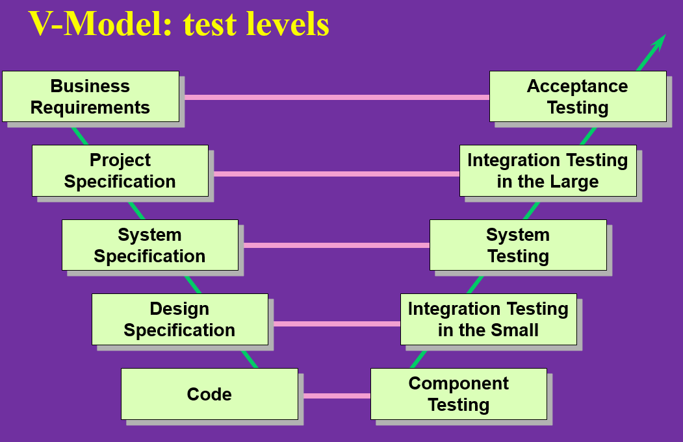

**+ Early test design**

* Test design finds faults
* Faults found early are cheaper to fix(giảm chi phí)
* Most significant faults found first (tìm lỗi quan trọng sớm)

- Faults prevented, not built in

- No additional effort, re-schedule test design

- Changing requirements caused by test design

=> Early test design helps to build quality, stops fault multiplication

Verification

the process of evaluating a system or component to determine whether the products of the given development phase satisfy the conditions imposed at the start of that phase

Validation

determination of the correctness of the products of software development with respect to the user needs and requirements

Testing

the process of exercising software to verify that it satisfies specified requirements and to detect faults

**“Black box”**

* + Equivalence partitioning(kiểm thử tương đương)
  + Boundary value analysis
  + State transition testing
  + Cause-effect graphing

**“White box”**

* + Statement testing
  + Branch / Decision testing
  + Data flow testing
  + Branch condition testing
  + Branch condition combination testing
  + Modified condition decision testing
  + LCSAJ testing