GENERAL SYSTEM
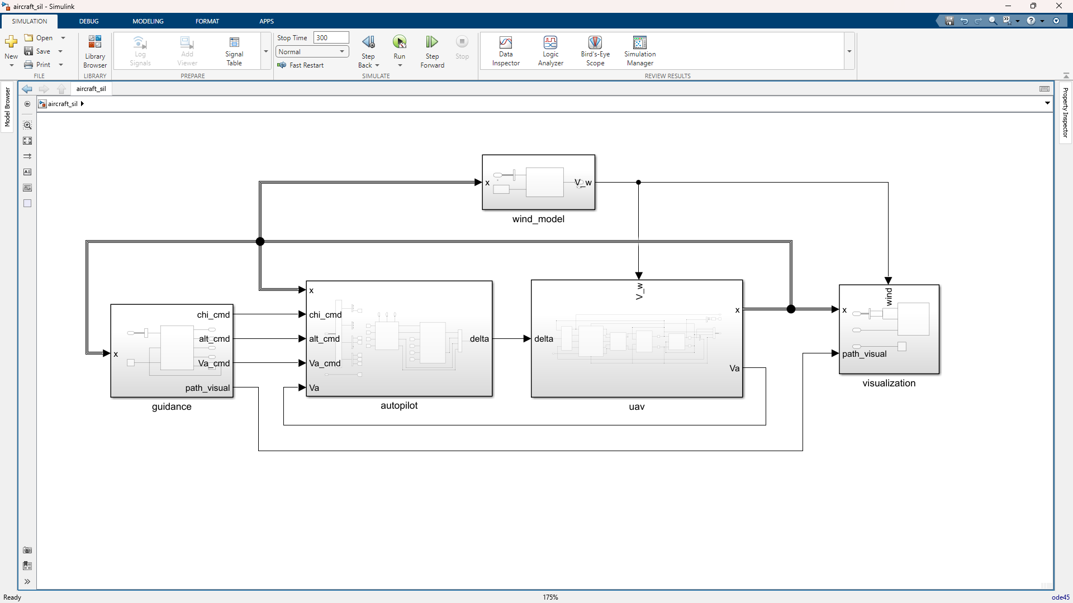

aerosonde_uav (Plant SubSystem)
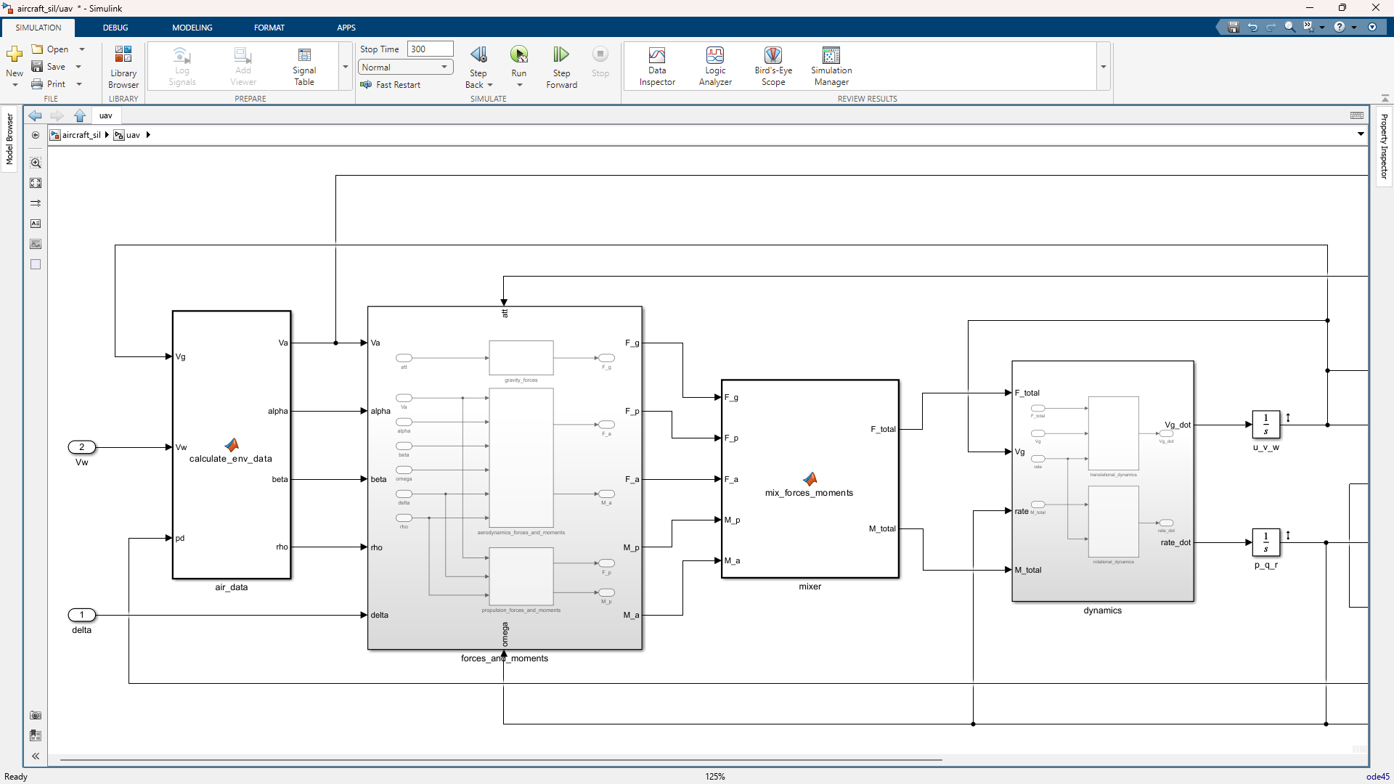
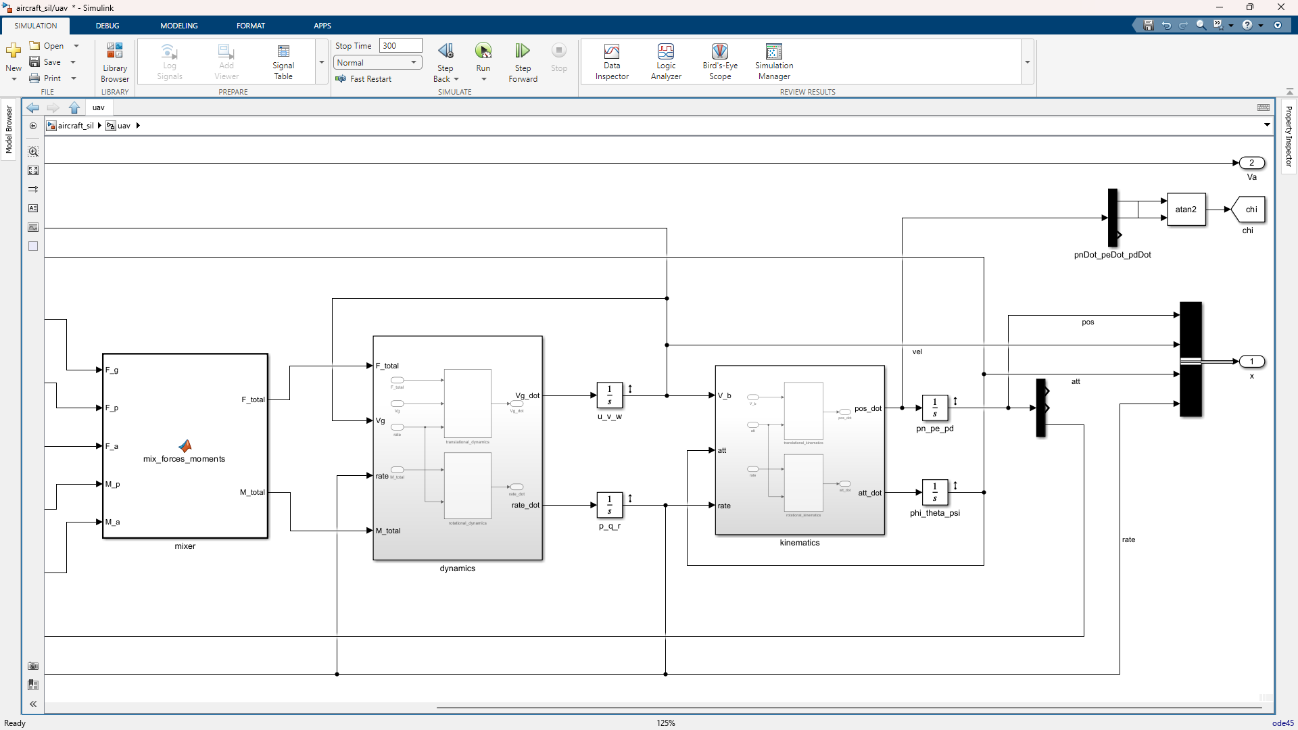
air_data
function [Va, alpha, beta, rho] = calculate_env_data(V_b, V_w, pd, P)
% inputs:
% V_b: [3x1] body-frame ground velocity [u; v; w] (m/s)
% V_w: [3x1] body-frame wind velocity [uw; vw; ww] (m/s)
% pd: [1x1] down position (negative of altitude) (m)
% outputs:
% Va: [1x1] airspeed magnitude (m/s)
% alpha: [1x1] angle of attack (rad)
% beta: [1x1] sideslip angle (rad)

% current height
h = -pd;

% temperature and pressure at altitude h
T = P.T0 + P.L0 * h;
p = P.p0 * (P.T0 / T)^((P.g * P.Molar) / (P.R * P.L0));

% dynamic density using ideal gas law
rho = (p * P.Molar) / (P.R * T);

% airspeed vector
V_r = V_b - V_w;

% airspeed magnitude
Va = norm(V_r);

% angle of attack and sideslip
if Va == 0 % prevent to divide by zero
alpha = 0;
beta = 0;
else
alpha = atan2(V_r(3), V_r(1));
beta = asin(V_r(2) / Va);
end
end

forces_and_moments
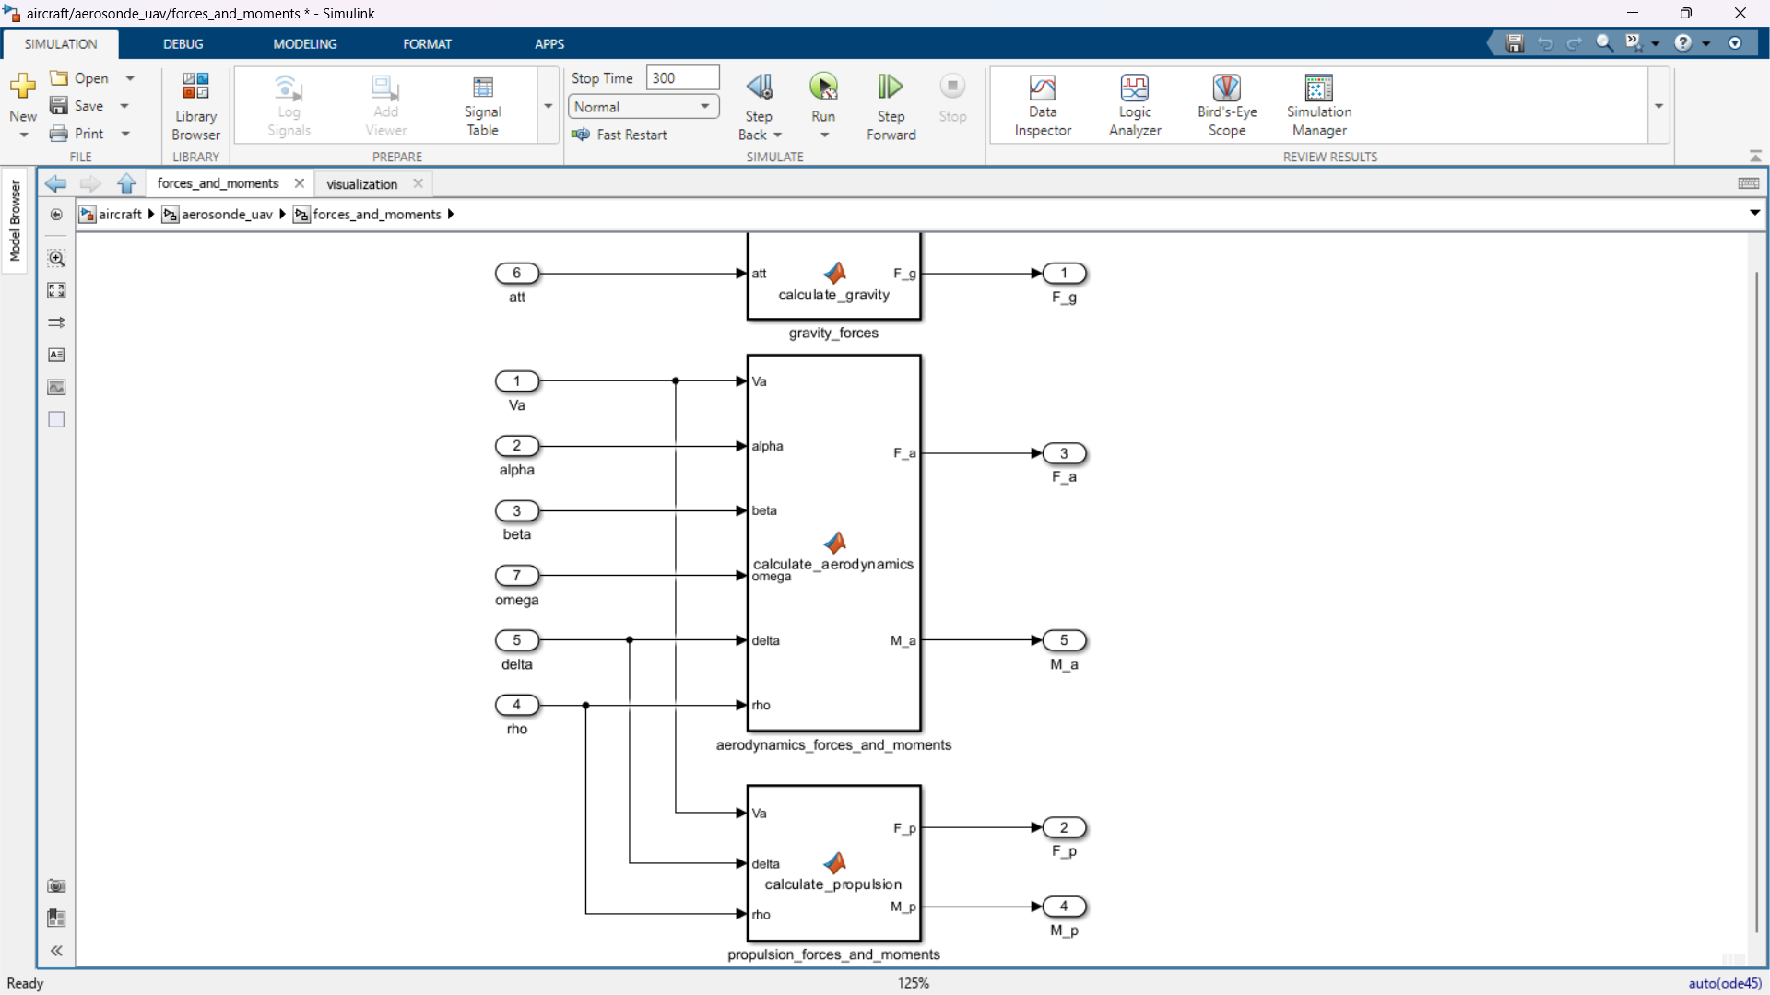
function F_g = calculate_gravity(att, P)
% inputs:
% att: [3x1] euler angles [phi; theta; psi] (rad)
% mass: [1x1] uav mass (kg)
% g: [1x1] gravitational constant (m/s^2)
% outputs:
% F_g: [3x1] gravity forces [fx; fy; fz] (n)

phi = att(1);
theta = att(2);

% project gravity to body frame
F_g = P.mass * P.g * [-sin(theta);
cos(theta) * sin(phi);
cos(theta) * cos(phi)];
end
function [F_a, M_a] = calculate_aerodynamics(Va, alpha, beta, ...
omega, delta, rho, P)
% inputs:
% Va: [1x1] airspeed (m/s)
% alpha: [1x1] angle of attack (rad)
% beta: [1x1] sideslip angle (rad)
% omega: [3x1] body angular rates [p; q; r] (rad/s)
% delta: [4x1] control signals [da; de; dr; dt]
% rho: [1x1] air density (kg/m^3)
% P: [1x1 struct] aerodynamic parameters
% outputs:
% F_a: [3x1] aerodynamic forces [fax; fay; faz] (n)
% M_a: [3x1] aerodynamic moments [max; may; maz] (n-m)

p = omega(1);
q = omega(2);
r = omega(3);

da = delta(1);
de = delta(2);
dr = delta(3);

% prevent division by zero at rest
if Va == 0
F_a = [0; 0; 0];
M_a = [0; 0; 0];
return;
end

% sigmoid blending function for non-linear stall
sig_num = 1 + exp(-P.M * (alpha - P.alpha0)) + ...
exp(P.M * (alpha + P.alpha0));
sig_den = (1 + exp(-P.M * (alpha - P.alpha0))) * ...
(1 + exp(P.M * (alpha + P.alpha0)));
sigma_alpha = sig_num / sig_den;

% non-linear lift coefficient
CL_linear = P.C_L0 + P.C_Lalpha * alpha;
CL_flat = 2 * sign(alpha) * sin(alpha)^2 * cos(alpha);
CL_alpha = (1 - sigma_alpha) * CL_linear + sigma_alpha * CL_flat;

% non-linear drag coefficient (quadratic)
AR = (P.b^2) / P.S;
CD_alpha = P.C_D0 + (CL_linear^2) / (pi * P.e * AR);

% longitudinal aerodynamic coefficients
cx = -CD_alpha * cos(alpha) + CL_alpha * sin(alpha);
cx_q = -P.C_Dq * cos(alpha) + P.C_Lq * sin(alpha);
cx_de = -P.C_Dde * cos(alpha) + P.C_Lde * sin(alpha);

cz = -CD_alpha * sin(alpha) - CL_alpha * cos(alpha);
cz_q = -P.C_Dq * sin(alpha) - P.C_Lq * cos(alpha);
cz_de = -P.C_Dde * sin(alpha) - P.C_Lde * cos(alpha);

% dynamic pressure terms
q_bar = 0.5 * rho * Va^2 * P.S;
c_2v = (P.c * q) / (2 * Va);
b_2v_p = (P.b * p) / (2 * Va);
b_2v_r = (P.b * r) / (2 * Va);

% compute forces
fax = q_bar * (cx + cx_q * c_2v + cx_de * de);
fay = q_bar * (P.C_Y0 + P.C_Ybeta * beta + P.C_Yp * b_2v_p + ...
P.C_Yr * b_2v_r + P.C_Yda * da + P.C_Ydr * dr);
faz = q_bar * (cz + cz_q * c_2v + cz_de * de);

% compute moments
max = q_bar * P.b * (P.C_Mx0 + P.C_Mxbeta * beta + ...
P.C_Mxp * b_2v_p + P.C_Mxr * b_2v_r + ...
P.C_Mxda * da + P.C_Mxdr * dr);
may = q_bar * P.c * (P.C_My0 + P.C_Myalpha * alpha + ...
P.C_Myq * c_2v + P.C_Myde * de);
maz = q_bar * P.b * (P.C_Mz0 + P.C_Mzbeta * beta + ...
P.C_Mzp * b_2v_p + P.C_Mzr * b_2v_r + ...
P.C_Mzda * da + P.C_Mzdr * dr);

F_a = [fax; fay; faz];
M_a = [max; may; maz];
end
function [F_p, M_p] = calculate_propulsion(Va, delta, rho, P)
% calculates propulsion forces and moments[cite: 1]
% inputs:
% Va: [1x1] airspeed (m/s)
% delta:[4x1] control signals [da; de; dr; dt]
% rho: [1x1] air density (kg/m^3)
% P: [1x1 struct] physical parameters
% outputs:
% F_p: [3x1] propulsive force [fx; fy; fz] (n)
% M_p: [3x1] propulsive moment [mx; my; mz] (n-m)

dt = delta(4);
if dt == 0
F_p = [0; 0; 0];
M_p = [0; 0; 0];
return;
end

v_in = P.V_max * dt;

a = (rho * P.D_prop^5) / ((2 * pi)^2) * P.C_Q0;
b = (rho * P.D_prop^4) / (2 * pi) * P.C_Q1 * Va + ...
(P.k_Q * P.k_V) / P.R_motor;
c = rho * P.D_prop^3 * P.C_Q2 * Va^2 - ...
(P.k_Q / P.R_motor) * v_in + P.k_Q * P.i0;

omega_p = (-b + sqrt(b^2 - 4 * a * c)) / (2 * a);

t_p = (rho * P.D_prop^4) / ((2 * pi)^2) * omega_p^2 * P.C_T0 + ...
(rho * P.D_prop^3) / (2 * pi) * omega_p * Va * P.C_T1 + ...
rho * P.D_prop^2 * Va^2 * P.C_T2;

q_p = (rho * P.D_prop^5) / ((2 * pi)^2) * omega_p^2 * P.C_Q0 + ...
(rho * P.D_prop^4) / (2 * pi) * omega_p * Va * P.C_Q1 + ...
rho * P.D_prop^3 * Va^2 * P.C_Q2;

F_p = [t_p; 0; 0];
M_p = [-q_p; 0; 0];
end

mixer
function [F_total, M_total] = mix_forces_moments(F_g, F_p, F_a, M_p, M_a)
% sums all forces and moments[cite: 1]
% inputs:
% F_g: [3x1] gravity force (n)
% F_p: [3x1] propulsive force (n)
% F_a: [3x1] aerodynamic force (n)
% M_p: [3x1] propulsive moment (n-m)
% M_a: [3x1] aerodynamic moment (n-m)
% outputs:
% F_total: [3x1] total body frame force (n)
% M_total: [3x1] total body frame moment (n-m)

F_total = F_g + F_p + F_a;
M_total = M_p + M_a;
end

dynamics
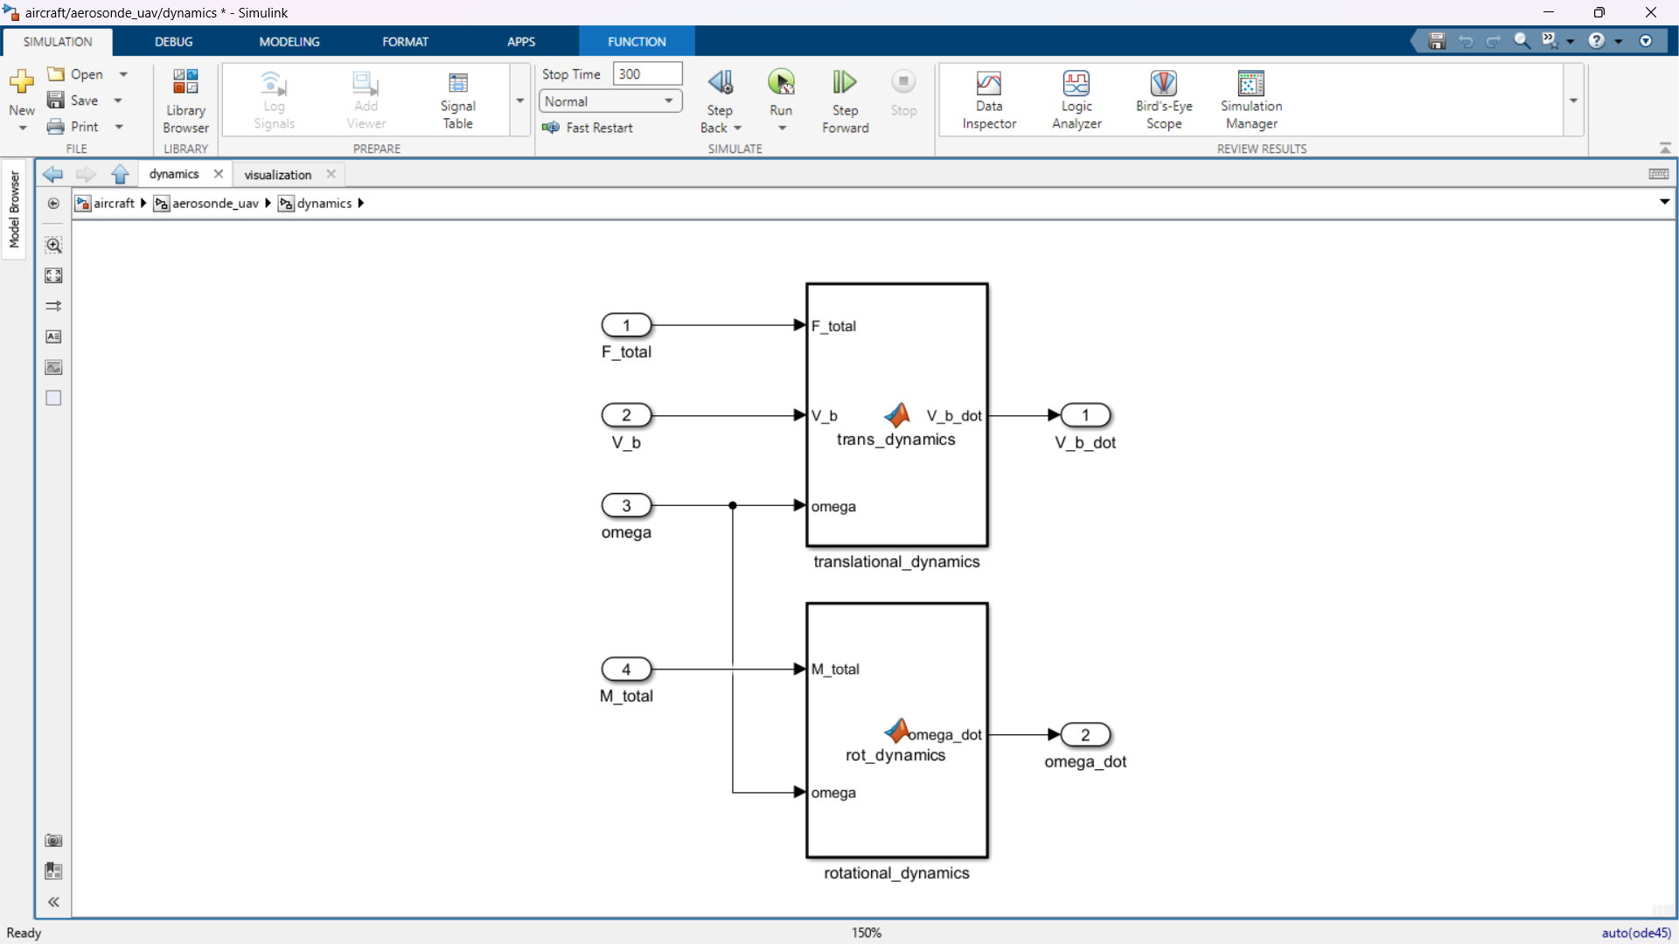
function V_b_dot = trans_dynamics(F_total, V_b, omega, P)
% inputs:
% F_total: [3x1] total forces [fx; fy; fz] (n)
% V_b: [3x1] body velocities [u; v; w] (m/s)
% omega: [3x1] angular rates [p; q; r] (rad/s)
% P: [1x1 struct] physical parameters
% outputs:
% V_b_dot: [3x1] velocity derivatives [u_dot; v_dot; w_dot] (m/s^2)

u = V_b(1); v = V_b(2); w = V_b(3);
p = omega(1); q = omega(2); r = omega(3);
fx = F_total(1);
fy = F_total(2);
fz = F_total(3);

u_dot = r*v - q*w + fx / P.mass;
v_dot = p*w - r*u + fy / P.mass;
w_dot = q*u - p*v + fz / P.mass;

V_b_dot = [u_dot; v_dot; w_dot];
end
function omega_dot = rot_dynamics(M_total, omega, P)
% inputs:
% M_total: [3x1] total moments [mx; my; mz] (n-m)
% omega: [3x1] angular rates [p; q; r] (rad/s)
% P: [1x1 struct] physical parameters
% outputs:
% omega_dot: [3x1] angular rate derivatives [p_dot; q_dot; r_dot] (rad/s^2)

p = omega(1); q = omega(2); r = omega(3);
mx = M_total(1); my = M_total(2); mz = M_total(3);

p_dot = P.Gamma1*p*q - P.Gamma2*q*r + P.Gamma3*mx + P.Gamma4*mz;
q_dot = P.Gamma5*p*r - P.Gamma6*(p^2 - r^2) + my / P.Jy;
r_dot = P.Gamma7*p*q - P.Gamma1*q*r + P.Gamma4*mx + P.Gamma8*mz;

omega_dot = [p_dot; q_dot; r_dot];
end

kinematics
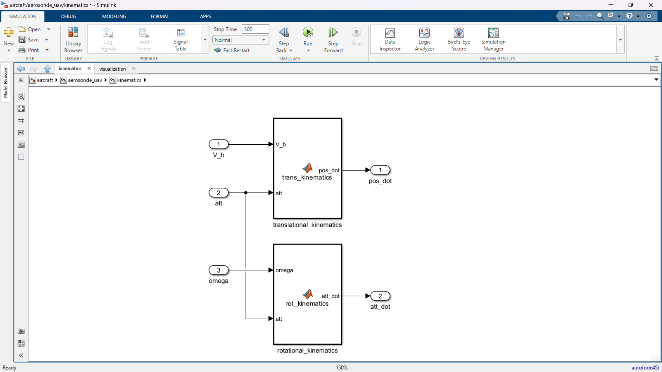
function pos_dot = trans_kinematics(V_b, att)
% inputs:
% V_b: [3x1] body velocities [u; v; w] (m/s)
% att: [3x1] euler angles [phi; theta; psi] (rad)
% outputs:
% pos_dot: [3x1] inertial pos derivatives [pn_dot; pe_dot; pd_dot] (m/s)

u = V_b(1); v = V_b(2); w = V_b(3);
phi = att(1); theta = att(2); psi = att(3);

cphi = cos(phi); sphi = sin(phi);
cthe = cos(theta); sthe = sin(theta);
cpsi = cos(psi); spsi = sin(psi);

R_b_v = [cthe*cpsi, sphi*sthe*cpsi - cphi*spsi, cphi*sthe*cpsi + sphi*spsi;
cthe*spsi, sphi*sthe*spsi + cphi*cpsi, cphi*sthe*spsi - sphi*cpsi;
-sthe, sphi*cthe, cphi*cthe];

pos_dot = R_b_v * [u; v; w];
end
function att_dot = rot_kinematics(omega, att)
% inputs:
% omega: [3x1] angular rates [p; q; r] (rad/s)
% att: [3x1] euler angles [phi; theta; psi] (rad)
% outputs:
% att_dot: [3x1] euler angle derivatives [phi_dot; theta_dot; psi_dot] (rad/s)

p = omega(1); q = omega(2); r = omega(3);
phi = att(1); theta = att(2);

cphi = cos(phi); sphi = sin(phi);
cthe = cos(theta); tthe = tan(theta);

R_rot = [1, sphi*tthe, cphi*tthe;
0, cphi, -sphi;
0, sphi/cthe, cphi/cthe];

att_dot = R_rot * [p; q; r];
end

initial condition
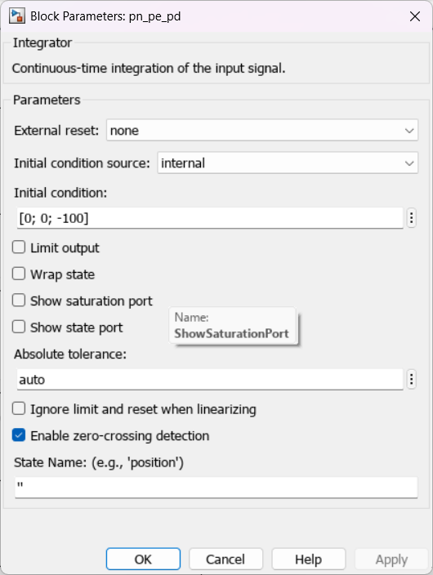
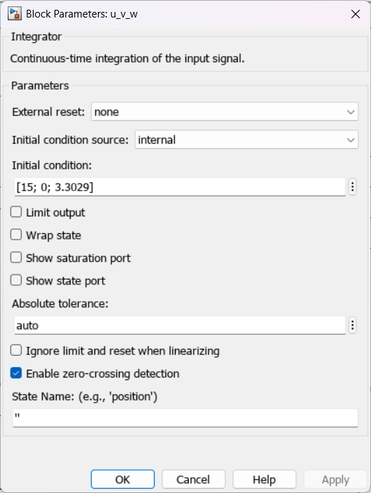
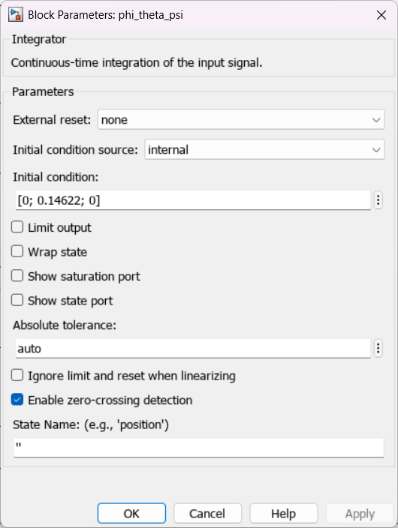
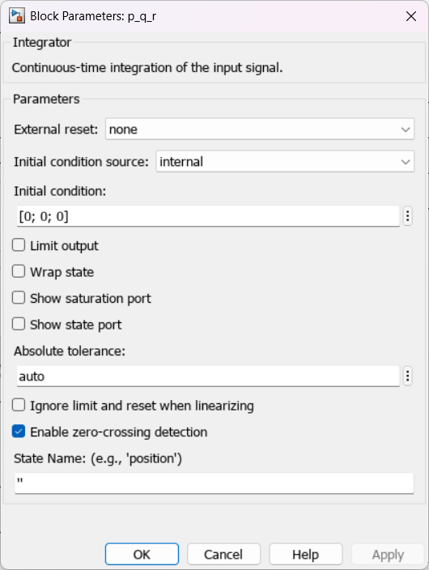

successive_loop_closure (Controller SubSystem)
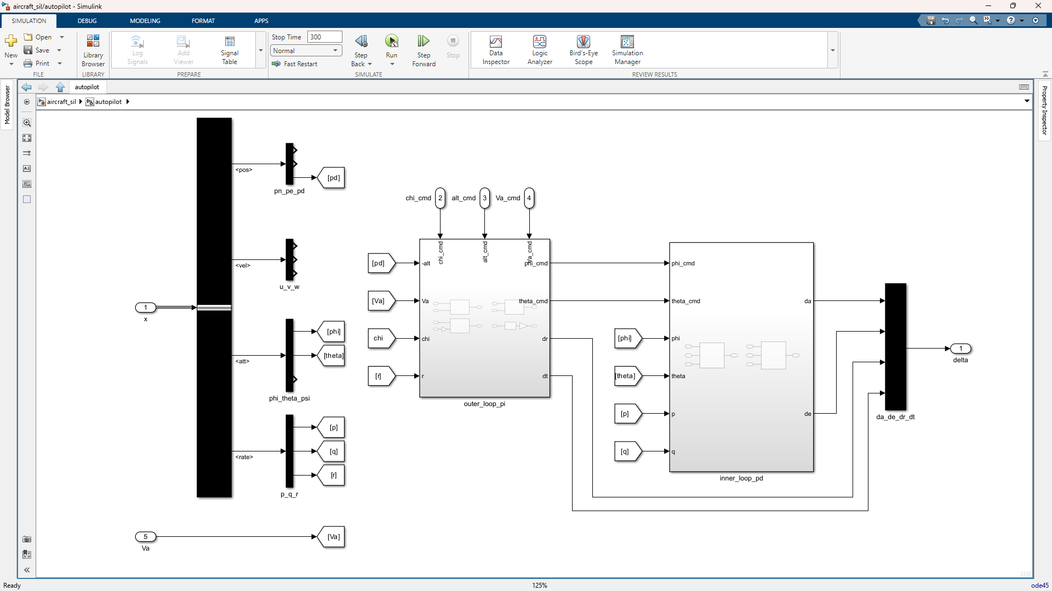
inner_loop_pd
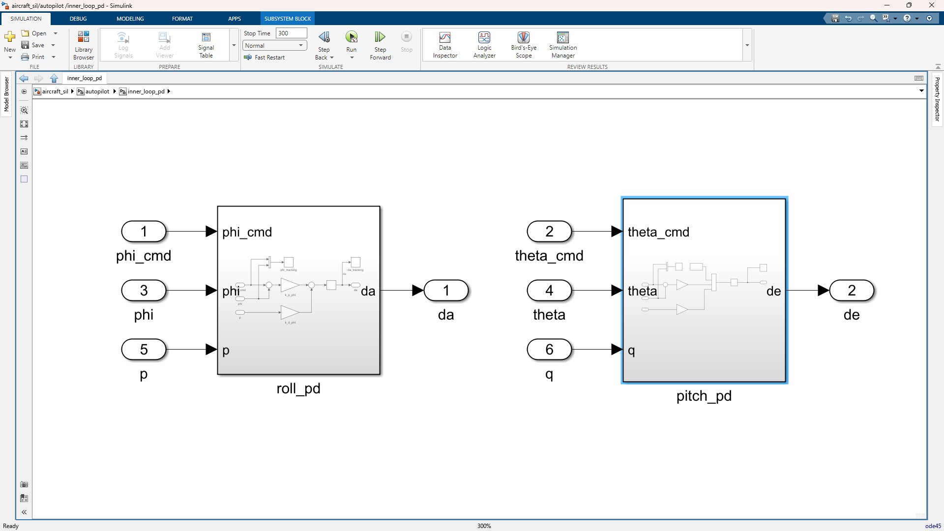

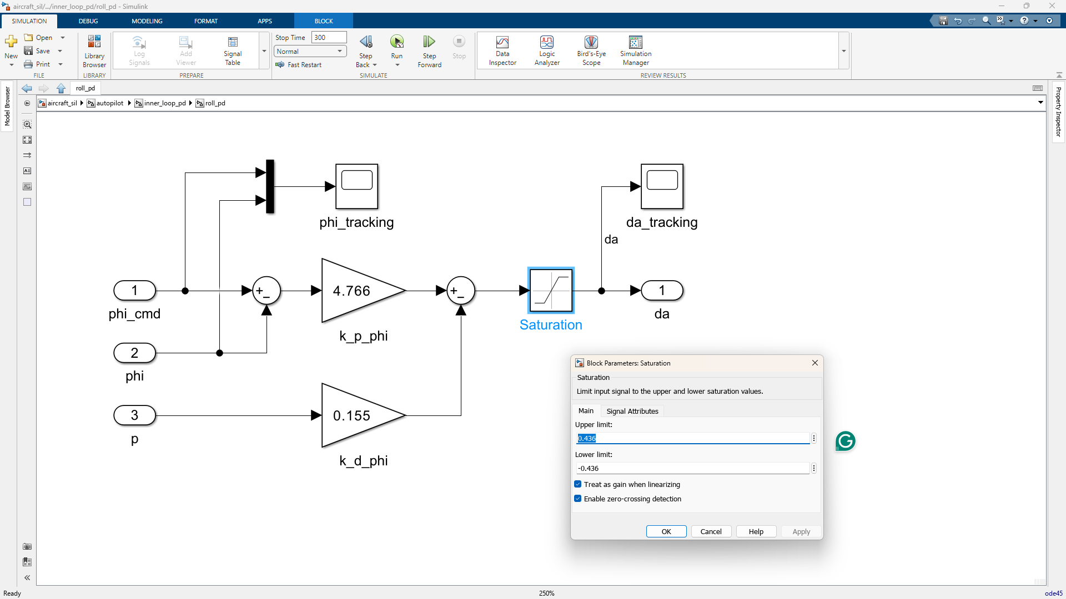
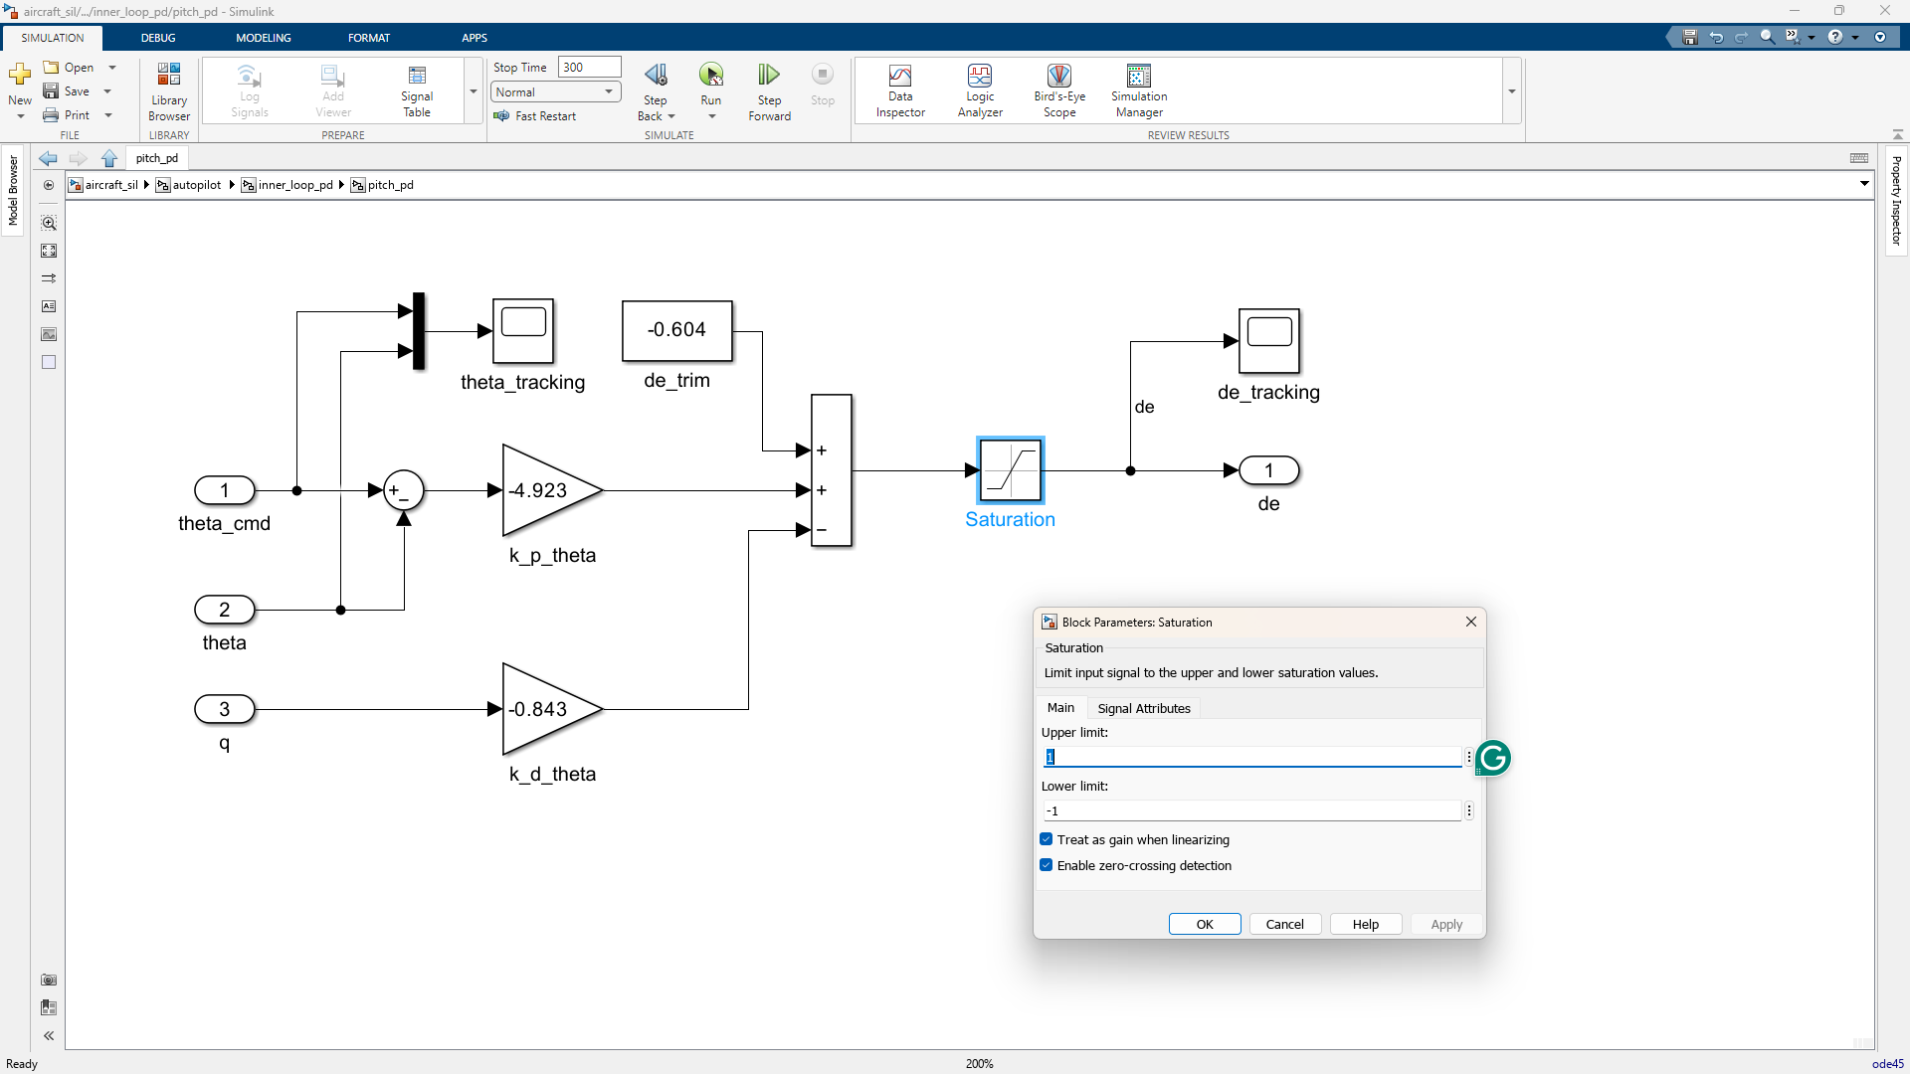

outer_loop_pi
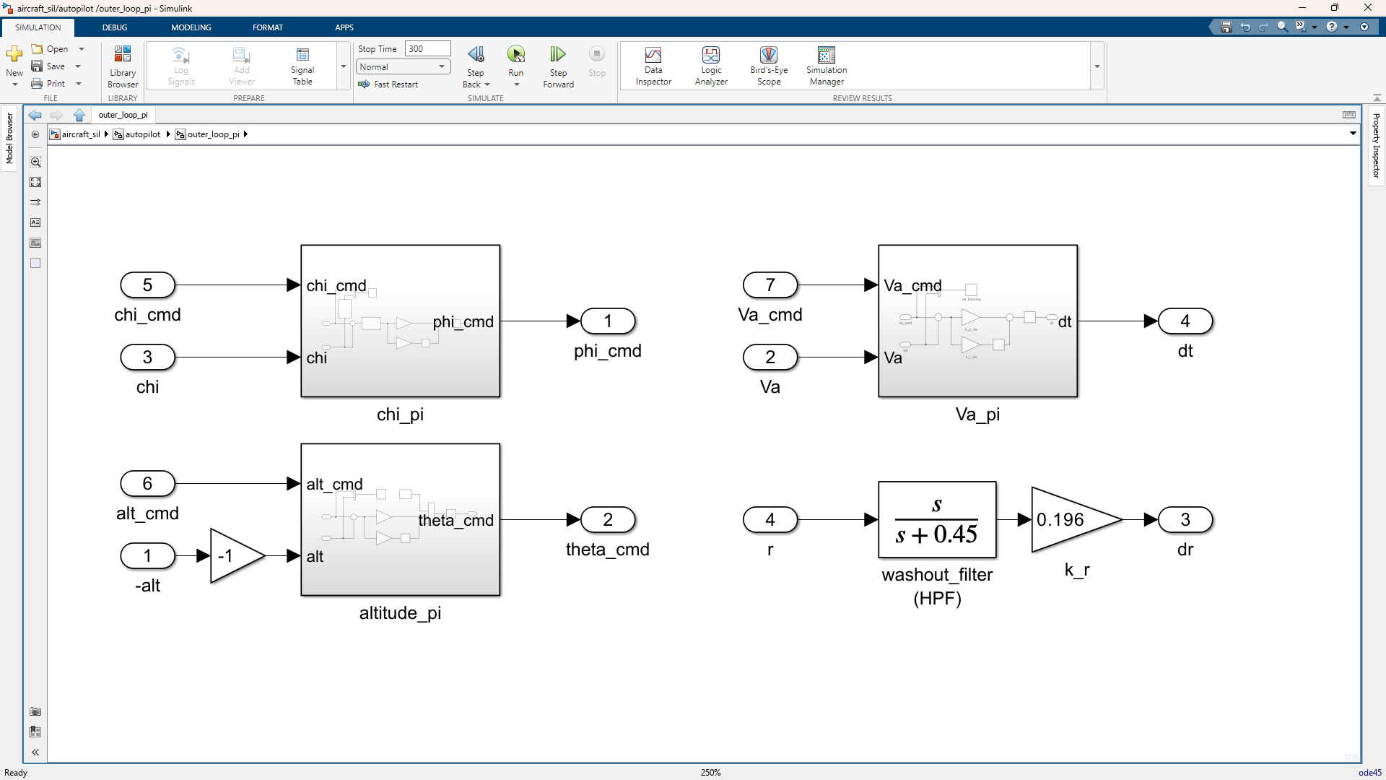
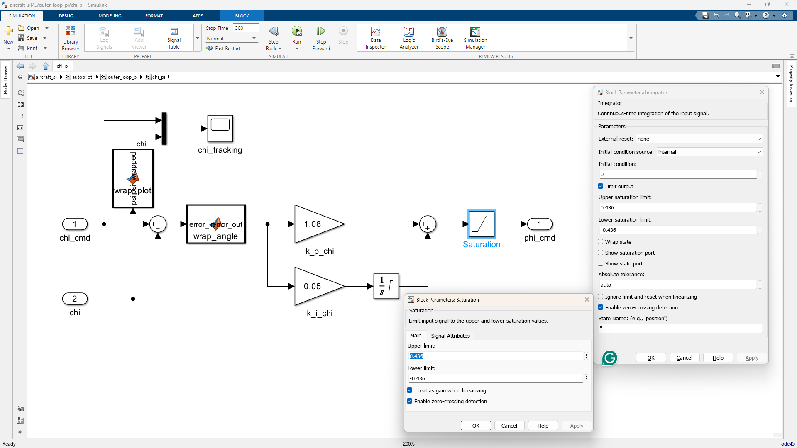
function error_out = wrap_angle(error_in)
% wraps any angle to strictly [-pi, pi]
error_out = mod(error_in + pi, 2*pi) - pi;
end
function psi_wrapped = wrap_plot(psi)
psi_wrapped = mod(psi + pi, 2*pi) - pi;
end

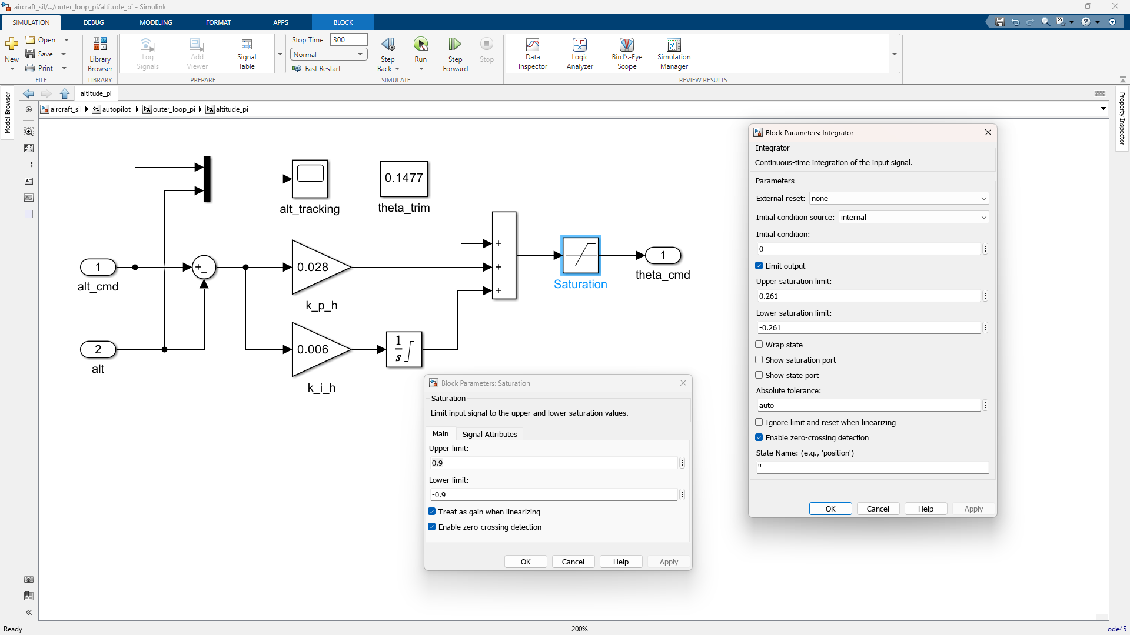
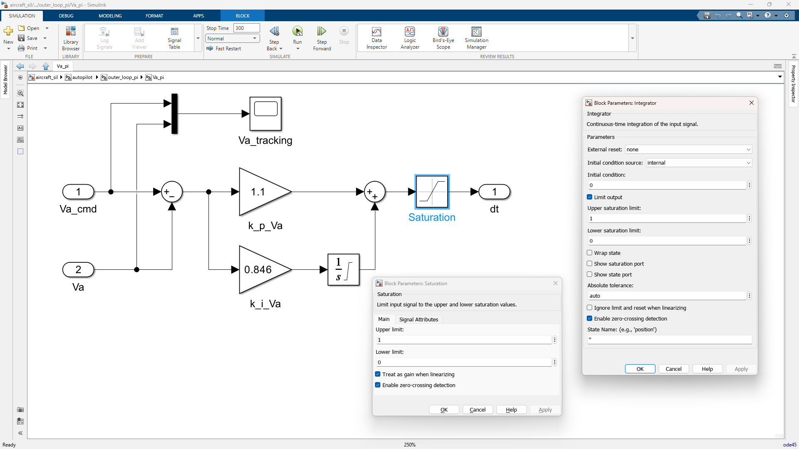

guidance (Guidance SubSystem)
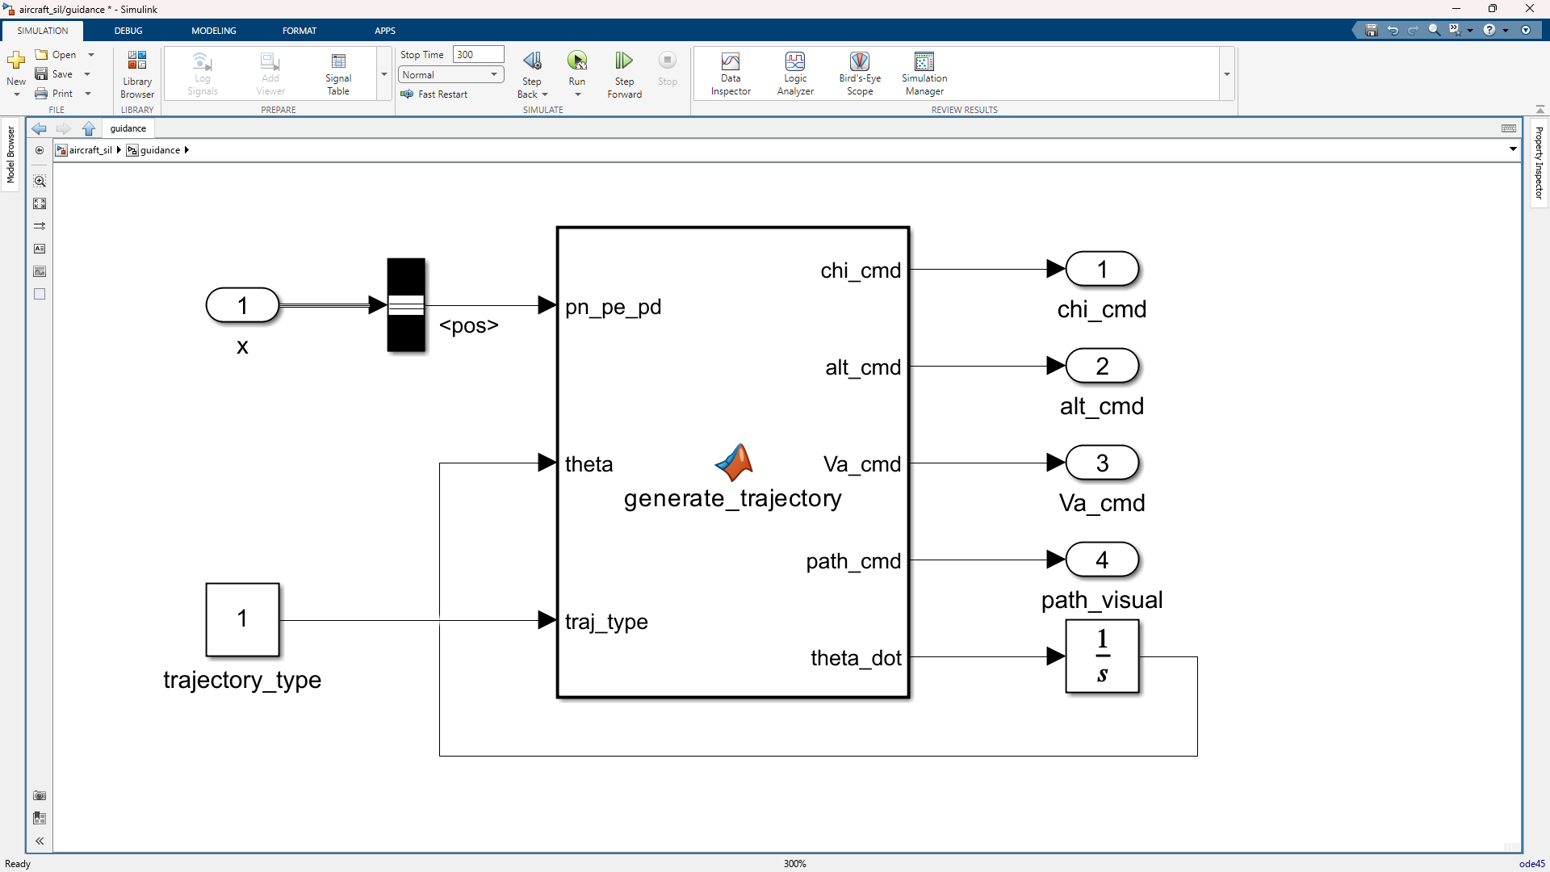
function [chi_cmd, alt_cmd, Va_cmd, path_cmd, theta_dot] = ...
generate_trajectory(pn_pe_pd, theta, traj_type)
%% extract current UAV position
pn = pn_pe_pd(1);
pe = pn_pe_pd(2);

A = 300;
V_uav = 15.0;
N_center = 500;
E_center = 500;

if traj_type == 1
% figure-8
% theta represents the carrot's current position
n_carrot = N_center + A * sin(theta) * cos(theta);
e_carrot = E_center + A * sin(theta);
alt_carrot = 100;

% calculate path gradients at the carrot
dN_dtheta = A * cos(2 * theta);
dE_dtheta = A * cos(theta);

else
% helix
n_carrot = N_center + A * cos(theta);
e_carrot = E_center + A * sin(theta);
alt_carrot = 100 + (13.0 * theta);

dN_dtheta = -A * sin(theta);
dE_dtheta = A * cos(theta);
end

%% virtual target feedback loop
% calculate actual physical distance between UAV and carrot
d_actual = sqrt((n_carrot - pn)^2 + (e_carrot - pe)^2);

% enforce a strict lookahead tether (e.g., exactly 40 meters)
L_desired = 40.0;

% carrot speed controller:
% if d_actual < 40, carrot speeds up
% if d_actual > 40, it slows down
k_carrot = 1.5; % tuning gain for target speed
V_carrot = V_uav + k_carrot * (L_desired - d_actual);

% saturation
if V_carrot > 25.0
V_carrot = 25.0; % max sprint speed
elseif V_carrot < 0.0
V_carrot = 0.0; % stop and wait for UAV
end

% convert linear carrot speed to angular geometric speed
gradient = sqrt(dN_dtheta^2 + dE_dtheta^2);
theta_dot = V_carrot / gradient;

%% guidance law
chi_los = atan2(e_carrot - pe, n_carrot - pn);
chi_q = atan2(dE_dtheta, dN_dtheta);

error_los = mod((chi_los - chi_q) + pi, 2*pi) - pi;

% heading command = path tangent + proportional correction
k_path = 1.2;
chi_cmd = chi_q + (k_path * error_los);

alt_cmd = alt_carrot;

Va_cmd = V_uav;

% output for 3D visualization
path_cmd = [n_carrot; e_carrot; alt_carrot; traj_type];
end

wind_model (Disturbance SubSystem)
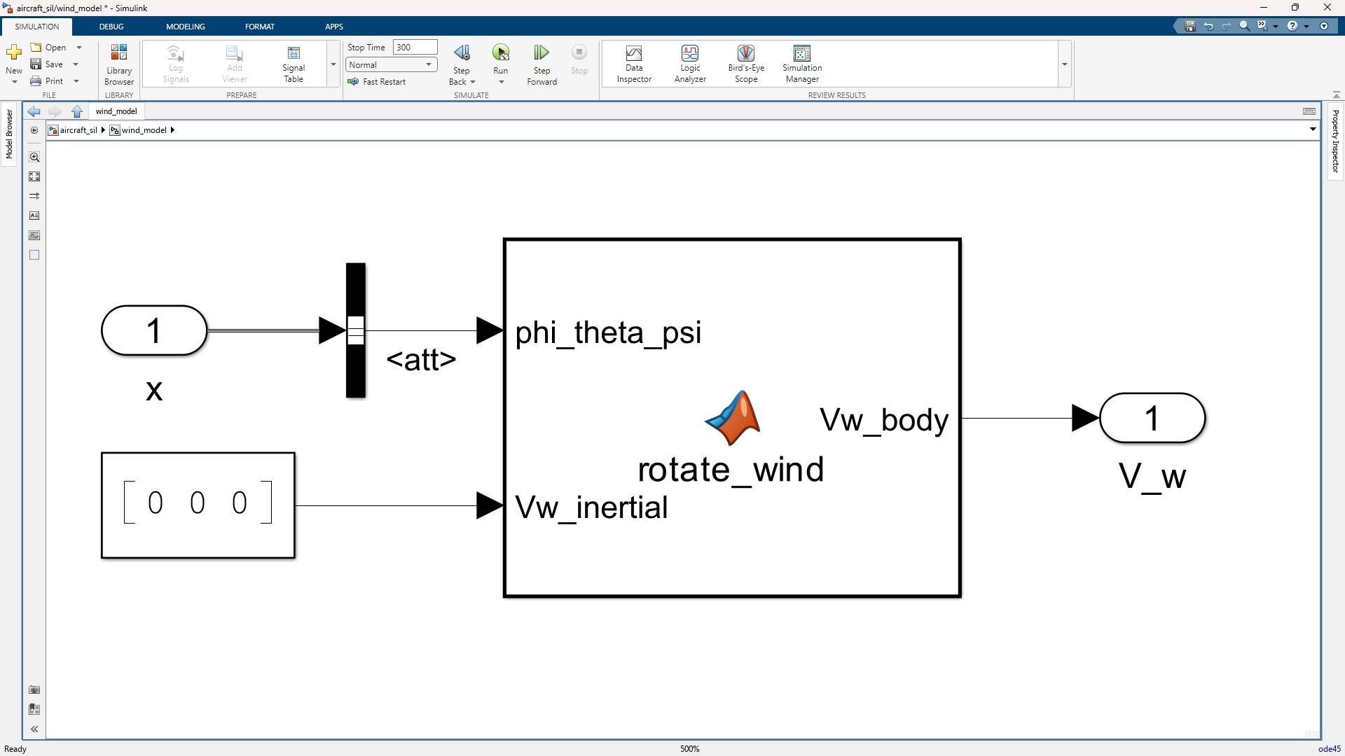
function Vw_body = rotate_wind(phi_theta_psi, Vw_inertial)
phi = phi_theta_psi(1);
theta = phi_theta_psi(2);
psi = phi_theta_psi(3);

% Rotation Matrix from Inertial to Body Frame (R_v^b)
R_yaw = [cos(psi), sin(psi), 0; -sin(psi), cos(psi), 0; 0, 0, 1];
R_pitch = [cos(theta), 0, -sin(theta); 0, 1, 0; sin(theta), 0, cos(theta)];
R_roll = [1, 0, 0; 0, cos(phi), sin(phi); 0, -sin(phi), cos(phi)];

R_v_to_b = R_roll * R_pitch * R_yaw;

% Total body frame wind (Ready for gusts to be added later)
Vw_body = R_v_to_b * Vw_inertial;
end

visualization (Visualization SubSystem)
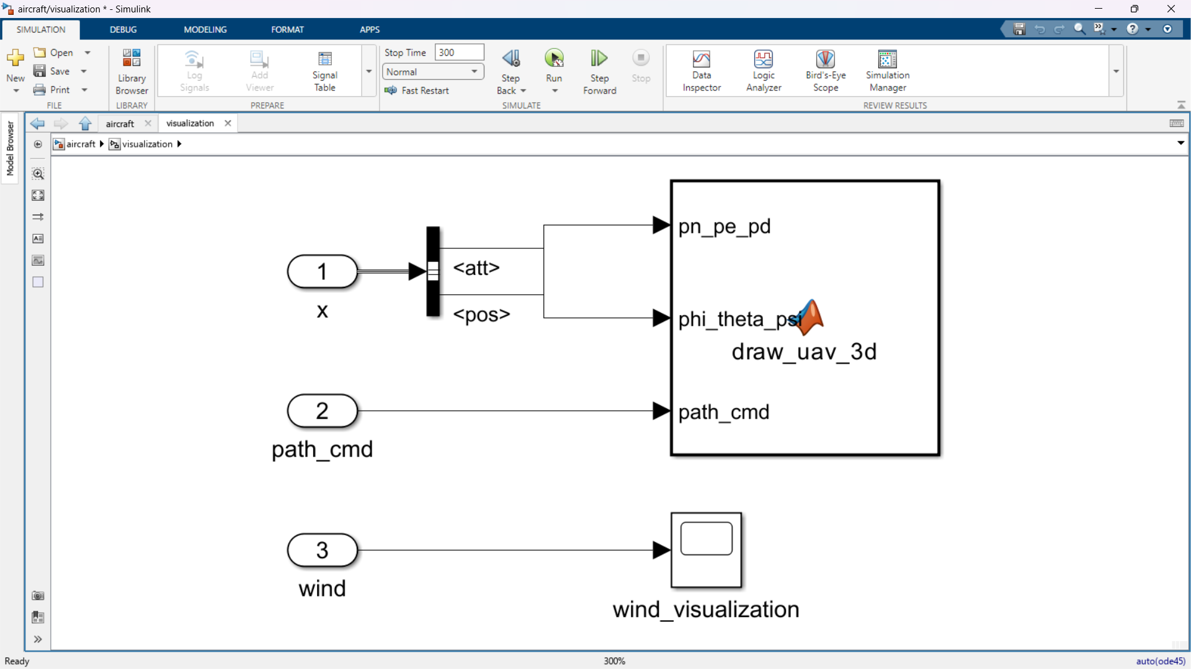
function draw_uav_3d(pn_pe_pd, phi_theta_psi, path_cmd)
coder.extrinsic('update_uav_plot');
update_uav_plot(pn_pe_pd, phi_theta_psi, path_cmd);
end

MATLAB CODE
load_uav_params.m
% =========================================================================
% AEROSONDE UAV PARAMETERS
% =========================================================================

%% --- GRAVITY AND MASS ---
P.g = 9.81; % Gravitational constant (m/s^2)
P.mass = 11.0; % Aircraft mass (kg)

%% --- MOMENTS AND PRODUCTS OF INERTIA ---
% These determine the aircraft's resistance to angular acceleration.
P.Jx = 0.824; % Roll moment of inertia (kg-m^2)
P.Jy = 1.135; % Pitch moment of inertia (kg-m^2)
P.Jz = 1.759; % Yaw moment of inertia (kg-m^2)
P.Jxz = 0.120; % Product of inertia (kg-m^2)

%% --- INERTIA KINEMATIC CONSTANTS ---
% Pre-computed constants used in the rigid-body rotational equations.
Gamma = P.Jx*P.Jz - P.Jxz^2;
P.Gamma1 = P.Jxz*(P.Jx - P.Jy + P.Jz) / Gamma;
P.Gamma2 = (P.Jz*(P.Jz - P.Jy) + P.Jxz^2) / Gamma;
P.Gamma3 = P.Jz / Gamma;
P.Gamma4 = P.Jxz / Gamma;
P.Gamma5 = (P.Jz - P.Jx) / P.Jy;
P.Gamma6 = P.Jxz / P.Jy;
P.Gamma7 = ((P.Jx - P.Jy)*P.Jx + P.Jxz^2) / Gamma;
P.Gamma8 = P.Jx / Gamma;

%% --- AIRCRAFT GEOMETRY ---
P.S = 0.55; % Wing planform area (m^2)
P.b = 2.9; % Wingspan (m)
P.c = 0.19; % Mean aerodynamic chord (m)

%% --- NONLINEAR STALL AND DRAG PARAMETERS ---
P.M = 50; % Stall blending function slope
P.alpha0 = 0.47; % Stall angle of attack (rad)
P.e = 0.9; % Oswald efficiency factor

%% --- LONGITUDINAL AERODYNAMIC COEFFICIENTS ---
% Subscripts:
% 0 = zero angle of attack
% alpha = angle of attack derivative
% q = pitch-rate derivative
% de = elevator deflection derivative

% Lift
P.C_L0 = 0.23;
P.C_Lalpha = 5.61;
P.C_Lq = 7.95;
P.C_Lde = 0.13;

% Drag
P.C_D0 = 0.0424;
P.C_Dalpha = 0.132;
P.C_Dq = 0;
P.C_Dde = 0.0135;
P.C_Dp = 0.043;

% Pitch moment
P.C_My0 = 0.0135;
P.C_Myalpha = -2.74;
P.C_Myq = -38.21;
P.C_Myde = -0.99;

%% --- LATERAL AERODYNAMIC COEFFICIENTS ---
% Subscripts:
% beta = sideslip angle
% p = roll rate
% r = yaw rate
% da = aileron deflection
% dr = rudder deflection

% Side force
P.C_Y0 = 0;
P.C_Ybeta = -0.83;
P.C_Yp = 0;
P.C_Yr = 0;
P.C_Yda = 0.075;
P.C_Ydr = 0.19;

% Roll moment
P.C_Mx0 = 0;
P.C_Mxbeta = -0.13;
P.C_Mxp = -0.51;
P.C_Mxr = 0.25;
P.C_Mxda = 0.17;
P.C_Mxdr = 0.0024;

% Yaw moment
P.C_Mz0 = 0;
P.C_Mzbeta = 0.073;
P.C_Mzp = -0.069;
P.C_Mzr = -0.095;
P.C_Mzda = -0.011;
P.C_Mzdr = -0.069;

%% --- PROPULSION PARAMETERS (MOTOR & BATTERY) ---
P.V_max = 44.4; % Maximum battery voltage (V)
P.k_V = 0.0659; % Motor constant (V·s/rad)
P.k_Q = 0.0659; % Motor torque constant (N·m/A)
P.R_motor = 0.042; % Motor winding resistance (Ohms)
P.i0 = 1.5; % No-load current (A)

%% --- PROPELLER AERODYNAMIC COEFFICIENTS ---
% Torque coefficient polynomial
P.C_Q0 = 0.005230;
P.C_Q1 = 0.004970;
P.C_Q2 = -0.01664;

% Thrust coefficient polynomial
P.C_T0 = 0.09357;
P.C_T1 = -0.06044;
P.C_T2 = -0.1079;

P.D_prop = 0.508; % Propeller diameter (m)

%% --- ATMOSPHERIC PARAMETERS ---
P.T0 = 288.15; % Standard temperature at sea level (K)
P.p0 = 101325; % Standard pressure at sea level (Pa)
P.L0 = -0.0065; % Temperature lapse rate (K/m)
P.R = 8.31432; % Universal gas constant (J/(mol·K))
P.Molar = 0.0289644; % Molar mass of air (kg/mol)
P.rho = 1.268; % Air density (kg/m^3)

compute_tf_coeffs.m
function TF = compute_tf_coeffs(Va, alpha, theta, de, dt, P)
% computes longitudinal and lateral transfer function coefficients
% inputs:
% Va: [1x1] trim airspeed (m/s)
% alpha: [1x1] trim angle of attack (rad)
% theta: [1x1] trim pitch angle (rad)
% de: [1x1] trim elevator (rad)
% dt: [1x1] trim throttle (unitless)
% P: [1x1 struct] physical parameters
% outputs:
% TF: [1x1 struct] transfer function coefficients

% 1. dynamic pressure and air density (assuming sea level for trim)
rho = P.rho;

% 2. lateral coefficients (roll subsystem)
cp_p = P.Gamma3 * P.C_Mxp + P.Gamma4 * P.C_Mzp;
cp_da = P.Gamma3 * P.C_Mxda + P.Gamma4 * P.C_Mzda;

TF.a_phi1 = -0.5 * rho * Va^2 * P.S * P.b * cp_p * (P.b / (2 * Va));
TF.a_phi2 = 0.5 * rho * Va^2 * P.S * P.b * cp_da;

% 3. longitudinal coefficients (pitch subsystem)
TF.a_theta1 = -(rho * Va^2 * P.c * P.S / (2 * P.Jy)) * P.C_Myq * (P.c / (2 * Va));
TF.a_theta2 = -(rho * Va^2 * P.c * P.S / (2 * P.Jy)) * P.C_Myalpha;
TF.a_theta3 = (rho * Va^2 * P.c * P.S / (2 * P.Jy)) * P.C_Myde;

% 4. longitudinal coefficients (airspeed subsystem)
eps_num = 1e-4;

% numerical derivative of thrust w.r.t airspeed (dTp_dVa)
[f_p_plus, ~] = get_propulsion(Va + eps_num, dt, rho, P);
[f_p_minus, ~] = get_propulsion(Va - eps_num, dt, rho, P);
dtp_dva = (f_p_plus(1) - f_p_minus(1)) / (2 * eps_num);

% numerical derivative of thrust w.r.t throttle (dTp_ddt)
[f_p_plus, ~] = get_propulsion(Va, dt + eps_num, rho, P);
[f_p_minus, ~] = get_propulsion(Va, dt - eps_num, rho, P);
dtp_ddt = (f_p_plus(1) - f_p_minus(1)) / (2 * eps_num);

% linear drag coefficient derivative
ar = (P.b^2) / P.S;
cd_alpha = 2 * (P.C_L0 + P.C_Lalpha * alpha) * P.C_Lalpha / (pi * P.e * ar);

TF.a_V1 = (rho * Va * P.S / P.mass) * (P.C_D0 + cd_alpha * alpha + P.C_Dde * de) - (1 / P.mass) * dtp_dva;
TF.a_V2 = (1 / P.mass) * dtp_ddt;
TF.a_V3 = P.g * cos(theta - alpha);
end

function [F_p, M_p] = get_propulsion(Va, dt, rho, P)
% localized propulsion logic for numerical derivative calculations
if dt == 0
F_p = [0;0;0]; M_p = [0;0;0]; return;
end
v_in = P.V_max * dt;
a = (rho * P.D_prop^5) / ((2 * pi)^2) * P.C_Q0;
b = (rho * P.D_prop^4) / (2 * pi) * P.C_Q1 * Va + (P.k_Q * P.k_V) / P.R_motor;
c = rho * P.D_prop^3 * P.C_Q2 * Va^2 - (P.k_Q / P.R_motor) * v_in + P.k_Q * P.i0;
omega_p = (-b + sqrt(b^2 - 4 * a * c)) / (2 * a);

t_p = (rho*P.D_prop^4)/((2*pi)^2)*omega_p^2*P.C_T0 + (rho*P.D_prop^3)/(2*pi)*omega_p*Va*P.C_T1 + rho*P.D_prop^2*Va^2*P.C_T2;
q_p = (rho*P.D_prop^5)/((2*pi)^2)*omega_p^2*P.C_Q0 + (rho*P.D_prop^4)/(2*pi)*omega_p*Va*P.C_Q1 + rho*P.D_prop^3*Va^2*P.C_Q2;
F_p = [t_p; 0; 0]; M_p = [-q_p; 0; 0];
end

update_uav_plot.m
function update_uav_plot(pn_pe_pd, phi_theta_psi, path_cmd)
% persistent variables keep the figure open and update it every step
persistent fig_handle patches traj_actual ...
traj_desired p_history last_update_time

% fps limiter (caps graphics to ~25 FPS to prevent lag)
if isempty(last_update_time)
last_update_time = tic;
elseif toc(last_update_time) < 0.04
return;
else
last_update_time = tic;
end

% extract states
pn = pn_pe_pd(1);
pe = pn_pe_pd(2);
alt = -pn_pe_pd(3);

phi = phi_theta_psi(1);
theta = phi_theta_psi(2);
psi = phi_theta_psi(3);

% initialize figure
if isempty(fig_handle) || ~isvalid(fig_handle)
fig_handle = figure('Name', '3D UAV Visualization', 'Color', ...
'w', 'NumberTitle', 'off');
ax = axes('Parent', fig_handle, 'Color', [0.98 0.98 0.98]);
hold(ax, 'on'); grid(ax, 'on'); view(ax, 3);

% scale to fit the figure-8 and helix
axis(ax, [100 900 100 900 -100 500]);
xlabel(ax, 'East (m)', 'FontWeight', 'bold');
ylabel(ax, 'North (m)', 'FontWeight', 'bold');
zlabel(ax, 'Altitude (m)', 'FontWeight', 'bold');

% generate and plot the full desired path
if length(path_cmd) >= 4
traj_type = path_cmd(4);
A = 300;
N_center = 500;
E_center = 500;

if traj_type == 1 % figure-8
theta_full = linspace(0, 2*pi, 200); % full geometric loop
N_full = N_center + A * sin(theta_full) .* cos(theta_full);
E_full = E_center + A * sin(theta_full);
Alt_full = 100 * ones(size(theta_full));
else % helix
theta_full = linspace(0, 8*pi, 400); % 4 spiral loops
N_full = N_center + A * cos(theta_full);
E_full = E_center + A * sin(theta_full);
Alt_full = 100 + (13.0 * theta_full);
end

% draw the full static path (red dashed line)
plot3(ax, E_full, N_full, Alt_full, 'r--', 'LineWidth', ...
1.5, 'DisplayName', 'Desired Path');

% initialize the moving target "carrot" (red dot)
traj_desired = plot3(ax, path_cmd(2), path_cmd(1), path_cmd(3), ...
'ro', 'MarkerSize', 6, ...
'MarkerFaceColor', 'r', ...
'DisplayName', 'Target');
end

% plot actual path (blue)
traj_actual = plot3(ax, pe, pn, alt, 'b-', 'LineWidth', 1.5, ...
'DisplayName', 'Actual Path');
p_history = [pe; pn; alt];

% enforce only the trajectory lines in the legend
legend(ax, 'Location', 'northeast');

% visualize the uav
S = 3.0; % size scale
uav_color = [0.6 0.6 0.6]; % grey color

% vertices (body frame: x-forward, y-right, z-down)
V_fuse = [1 0 0;
0 0.1 0.1;
0 -0.1 0.1;
0 0.1 -0.1;
0 -0.1 -0.1;
-3 0 0] * S;
F_fuse = [1 2 4;
1 4 3;
1 3 5;
1 5 2;
6 2 4;
6 4 3;
6 3 5;
6 5 2];

V_wing = [ 0 2 0;
-0.5 2 0;
-0.5 -2 0;
0 -2 0] * S;
F_wing = [1 2 3 4];

V_htail = [-2.5 0.7 0;
-3 0.7 0;
-3 -0.7 0;
-2.5 -0.7 0] * S;
F_htail = [1 2 3 4];

V_vtail = [-2.5 0 0;
-3 0 0;
-3 0 -1;
-2.5 0 -1] * S;
F_vtail = [1 2 3 4];

% save geometry
patches.v_fuse = V_fuse; patches.v_wing = V_wing;
patches.v_htail = V_htail; patches.v_vtail = V_vtail;

% render (HandleVisibility = 'off' keeps them out of the legend)
patches.h_fuse = patch(ax, 'Vertices', V_fuse, 'Faces', F_fuse, ...
'FaceColor', uav_color, 'EdgeColor', 'k', ...
'HandleVisibility', 'off');
patches.h_wing = patch(ax, 'Vertices', V_wing, 'Faces', F_wing, ...
'FaceColor', uav_color, 'EdgeColor', 'k', ...
'HandleVisibility', 'off');
patches.h_htail = patch(ax, 'Vertices', V_htail, 'Faces', F_htail, ...
'FaceColor', uav_color, 'EdgeColor', 'k', ...
'HandleVisibility', 'off');
patches.h_vtail = patch(ax, 'Vertices', V_vtail, 'Faces', F_vtail, ...
'FaceColor', uav_color, 'EdgeColor', 'k', ...
'HandleVisibility', 'off');

else
% update actual trajectory path line
p_history(:, end+1) = [pe; pn; alt];
set(traj_actual, 'XData', p_history(1,:), ...
'YData', p_history(2,:), ...
'ZData', p_history(3,:));

% update target carrot position
if length(path_cmd) >= 3
set(traj_desired, 'XData', path_cmd(2), ...
'YData', path_cmd(1), ...
'ZData', path_cmd(3));
end
end

% update uav 3d orientation
R_roll = [1 0 0; 0 cos(phi) -sin(phi); 0 sin(phi) cos(phi)];
R_pitch = [cos(theta) 0 sin(theta); 0 1 0; -sin(theta) 0 cos(theta)];
R_yaw = [cos(psi) -sin(psi) 0; sin(psi) cos(psi) 0; 0 0 1];
R_body2ned = R_yaw * R_pitch * R_roll;

% map NED body coordinates to plot axes (x=east, y=north, z=up)
C_ned2plot = [0 1 0; 1 0 0; 0 0 -1];
R_total = C_ned2plot * R_body2ned;

tf = @(v) (R_total * v')' + [pe, pn, alt];

% apply math to graphics objects
set(patches.h_fuse, 'Vertices', tf(patches.v_fuse));
set(patches.h_wing, 'Vertices', tf(patches.v_wing));
set(patches.h_htail, 'Vertices', tf(patches.v_htail));
set(patches.h_vtail, 'Vertices', tf(patches.v_vtail));

drawnow limitrate;
end

STM32
- Configuration
  - Project Manager


  - Clock Configuration
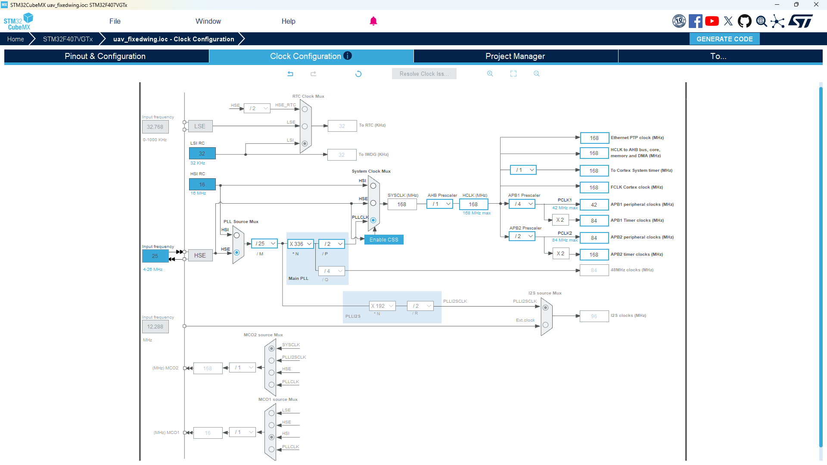
  - Pinout & Configuration

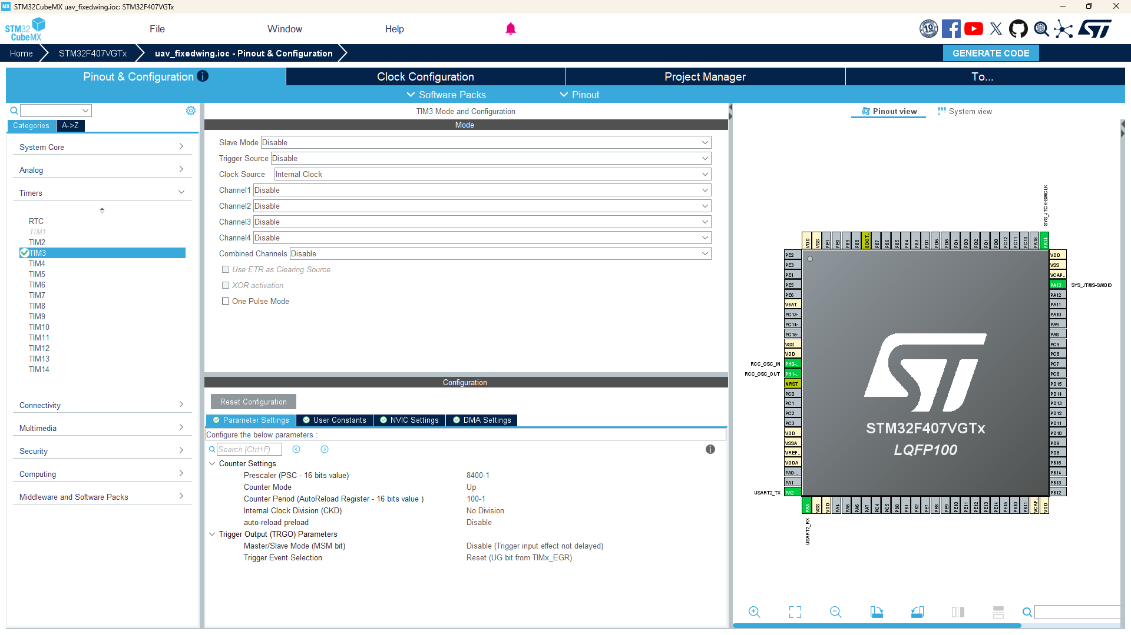
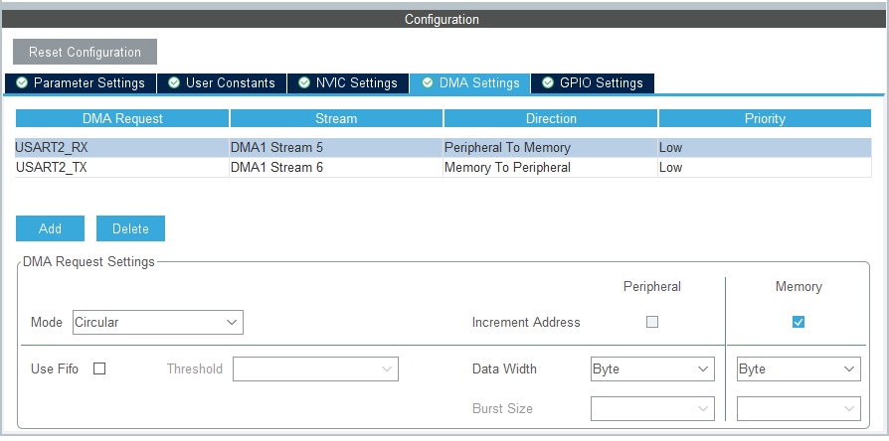
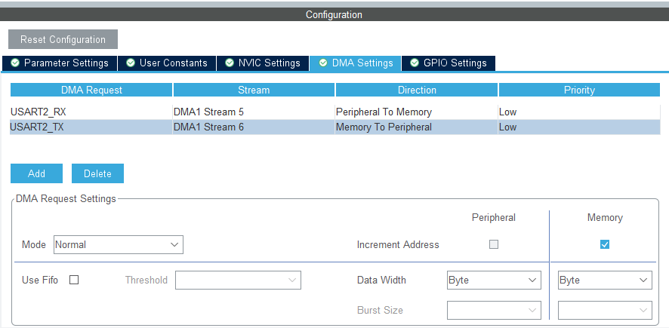
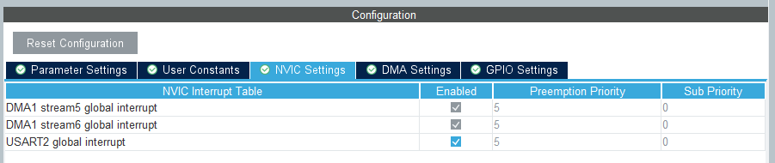
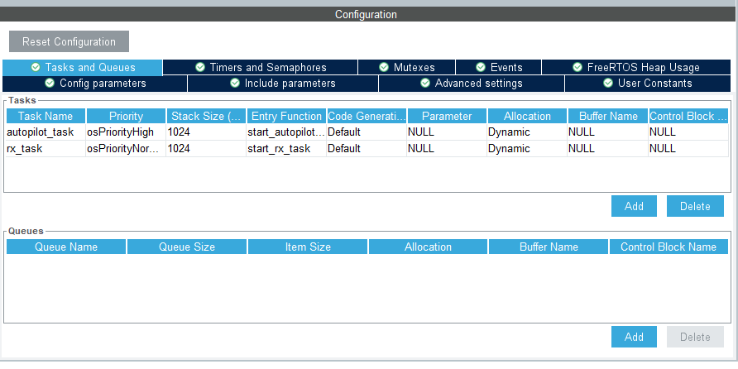
- Programming

