Table of Contents

Executive Summary 2

Scope of Work 3

Business Impact 5

Audience and Process Analysis 7

ER Diagram 11

Project  Plan 12

Project Resources 14

Project Budget 15

Data Access and Security 16

# Executive Summary

Client, David Bender, has requested improvements on the current development process of the Penn State Berks Campus’ scheduling system. Through our research, 6Bit Systems has identified several areas of possible improvement to the current business cycle used by the Client. 6Bit Systems can accomplish this through the use of a database system to centralize all data used for the design process. Not only will this allow for ease of use and accessibility it will also enable us to install greater and more efficient security measures. The system used will also be able to internalize, verify, and check the rules and conditions; this for semester schedules to not only be made more accurately but with greater efficiency. Our database will also have the capabilities of easily archiving all data making it simple to check all current and past data. Along with these major improvements 6Bit Systems design will provide many other tangible benefits to the design process – new policies to correct observed issues with currents polices, additional installed infrastructure, improved business cycle, new system will be integrated with current Penn State Berks systems, etc.

This report will provide additional detail into how our research and information of the Client’s work cycle was analyzed to find the aforementioned flaws. The possible impacts of implementing the new design and how 6Bit Systems plans to address these issues, along with a detailed document of the new design. The last pages of the report go on to describe our estimated development time and schedule, along with a full breakdown of development costs.

# Scope of Work

Client, David Bender, has requested improvements on the current scheduling system used for Pennsylvania State Berks Campus. Essentially the client wants to have a smooth running system in which he can then create a schedule within reasonable time with minimal errors. Based on the client’s description, the current system runs adequately, but it can run better. Going through the process:

1. Client receives emails from teaching staff about their preferred days, times, and courses
2. Client then compiles all of the staff preferential data
3. Drafts schedule based on recommended academic plans and information from schedules made in previous years and other scheduling priorities
4. Assigns courses and sections to teaching staff according to preferential data
5. Send draft schedule to teaching staff to check for errors in scheduling which are then sent back
6. Revisions are made and sent out for any more errors

(Steps 5 and 6 will repeat until all errors are resolved)

After reviewing the process of drafting a schedule, the issues in the system are quite clear. First is the issue with data input. Having to wait for the teaching staff to create and email their preferential information can take up a lot of time. This is not including the time it would take to compile all of the information. Rather than emailing to the client, create a form the teaching staff can use to input the data into a centralized database so that information can be gathered and compiled automatically for the client. Next issue is dealing with the recommended academic plan. This plan is offered to help students keep track and schedule classes for upcoming semesters. Before assigning the teaching staff to sections, the client must first figure out what courses to offer. This revolves around the recommended academic plan. There are certain guidelines the client must follow while drafting the schedule:

* Priority: At least one section of the courses listed on the academic roadmap
* Priority: All mandatory courses are offered according to academic roadmap
* Secondary Priority: courses required to declare a major is offered both semesters

Before adding any other courses, the client must follow these guidelines to offer all the priority courses before adding any supplementary courses for electives. Rather than having to take the time to look through all of the roadmaps for all the majors, with a new centralized system it should automatically include the minimum requirements for the roadmaps to set up for new drafts.

**Key Problems**

**Solutions**

1. Teaching Staff data input through emailed excel spreadsheets.
2. Having to include the recommended academic plan for every major offered at Penn State Berks
3. Create a form that will input preferential data into a centralized database to reducing the time to consolidate information gathered from the teaching staff
4. Include the academic road map into the system to automatically add the minimum required courses for each major

# Business Impact

Issues:

* Cost of resources in the development, integration, and maintenance of the new system.
* Adding new policies, training, and time for the users to familiarize themselves with the new system and its features.

Change Management: Moving to this new system will take some time as all old information has to be integrated into the new system as well as taking any hard/physical data and any statistical data from previous years. The system should also use old accounts to access the new system and augment the current capabilities of the old accounts. Slowly work towards the new system and make old accounts available for a short amount of time until full integration of the new system occurs.

Users: The major changes will mostly be on the back end rather than the front end of the system. Meaning that the changes will only affect how information is input into the system. Students will more than likely not notice any changes to the system. This new system will be aimed towards the course coordinators and teaching staff. Teaching staff will need to learn how to use the new system to post and find the courses they wish to teach along with entering their time preferences. Teaching staff may react negatively to the change as they now need to provide their schedule through a set medium instead of one of their choice which they might see as a time waste. In order to prevent this negative reactions provide training to the teaching and IT staff for the new system. The current teaching staff should learn how to use the new system and if there are problems they can consult the IT staff for any issues. The course coordinator should react positively due to having new tools that drastically reduce the amount time needed to draft a schedule.

Potential problems:

* Implementing security measure for the new system could be a challenge
* New system implies new potential areas to attack and thus new policies are needed to protect data and information
* Shifting from the old system to a new system
* Possible chance of data loss due to migration from the old system to the new system
* Sever scaling issues

Streamlining: With this database all information is consolidated into one system where it is easily accessible, usable, viewable, and editable by users. Requirements and rules will be easier to check and enforced reducing the number of mistakes. The turnover time will be faster as there are fewer areas where time can be wasted for the Drafter.

Improvements to current system:

* Less need for the user to move and consolidate information
* Ability to quickly survey the data using user made queries
* Rule checks minimize errors
* Easier to check information for all users.

Potential Benefits:

* Saves manpower and resources by making the process more efficient
* Easier to manage and secure data on one central system
* Moving to a newer system is also important in keeping practices up to date and eliminating old and bad practices in the current process.
  + Emailing preferences
  + Possible data redundancy

After weighing out the pros and cons of upgrading to a new centralized system, the benefits will most definitely outweigh any cost or problem that may occur during implementation. In the long run, the new system will decrease the amount of time needed to form a class schedule draft potentially giving the course coordinator more time to focus on other things like teacher preferences or offering a new course.

# Audience and Process Analysis

Users

* Faculty: Teaching Staff, Course Coordinator (Client), Division Head, the Dean, and Maintenance
  + Teaching Staff, rather than emailing an excel file with their preferred schedule, they will now input data into the new system for the course coordinator to compile. After the course coordinator creates a draft for the schedule, it is then up to the teaching staff to correct any errors or problems with the drafted schedule.
    - Input data
    - Data: Teaching Staff preferences and requirements
      * Preferred days
      * Preferred times
      * Preferred courses
      * Required Credits for tenure/fixed teaching
      * Extra work load
  + Registrar / Client (David Bender): With the new system the tasks of the course coordinator will not necessarily change, but it will be a lot more efficient than how it would have been done prior to the new system. With a quicker more efficient way of compiling information, the course coordinator will be able to create drafts more quickly. This in term means that less time will be wasted on compiling information and more time can be focused on meeting the preferences of the teaching staff.
    - Compiles teacher preferences and requirements
    - Follows specific guidelines for scheduling courses and sections (Number of credits, Teacher Workload, Fixed Term/Tenure Track, etc.)
    - Uses information from previous years to determine specific number of sections
    - Creates draft schedule as close to teaching staff preferences as possible while still meeting the requirements for fix/tenure
    - Makes revisions if there is conflict with drafted schedule
    - Makes all final decisions for scheduling
  + Division Head: The division head needs to have access to the system in order to determine which courses and sections will be open for the teaching staff.
  + Dean: Reviews the schedule while it is being creating
  + Maintenance Staff: Maintenance staff will be needed in order to keep the system up and running.
    - Configuring
    - Upgrading
    - Administration
    - Monitoring
    - Security
    - Maintenance
* Students: Won’t necessarily be inputting data into the system but will be taking the information already inputted by the teaching staff and compiled by the course coordinator and create a class schedule for the next semester.
* Business Process
  + Compiling Data: Teaching staff input preferential data. Course coordinator compiles the teaching preferential data along with scheduling data from previous years. After compiling both data sets, the course coordinator then applies any specific course priorities for each semester. Each priority goes as follows:
    - Priority: At least one section of the courses listed on the academic roadmap
    - Priority: All mandatory courses are offered according to academic roadmap
    - Secondary Priority: courses required to declare a major is offered both semesters
  + Drafting Schedule: After compiling all of the necessary data, the course coordinator creates a draft schedule.
    - Courses offered
    - Number of sections per course
    - Class times
    - Who is teaching each sections
  + Revising Schedule: Draft finished and sent to teaching staff and faculty to check for any conflicts. Revising may take several drafts before final product.
  + Finalizing Schedule: The revised draft is finalized with minimal errors/conflicts and is ready to be uploaded and available for student use.

**Data Analysis**

* Data gathered based from Client’s description of problem
  + Preferred schedules from teaching staff
    - Determines:
      * How many classes the teaching staff can teach?
      * Who teaches what class?
      * What day?
      * What time?
  + Information is gathered from how the current scheduling process works and scheduling data the client has gathered from previous years based on their past experience drafting a schedule. (Scheduling information: Which courses were open, numbers of sections in each, how many students applied for the section etc.)
    - Determines:
      * Number of sections to open per course
      * What courses to offer (New/old), that are not part of the academic roadmap
      * Is it worth it to open a new section?
      * Are there enough resources (Classrooms, equipment, teaching staff, etc.) to have multiple sections of a course to be open?
      * Depending on the course, certain classes can only be in certain classrooms and can have so many students per room
  + Must coincide with Recommended Academic Plan (Academic Roadmap) for every major
* Current system
  + The current system is put together pretty well, rather than creating a new system, modify the current system to meet the client’s needs.
    - Pros
      * Search option to find classes by what general education credits it may fulfill
    - Cons
      * Input of data is inefficient
      * Recommended Academic plan is not part of the search options
      * Not very user friendly for students because lack of inclusion for recommended academic plan
* New system
  + The system, rather than creating a new one, modify the current one to gather data more efficiently and provide an easier way to display the compiled data to students in the form of the course scheduler while still being user friendly.
    - Improvements
      * Include a form for teaching staff to input their preferential data
      * Include search option based on recommended academic plan
      * Include search option for major specific course

**Data Uses, Issues and Guidelines**

* Data Uses
  + Used to create course schedule for every semester
  + Course schedule draft will be made more quickly
  + Data will be input more efficiently
  + Time between drafts will decrease
  + More time for fine tuning a final draft of course schedule
* Issues
  + Transition to new system
  + Implementing system into Elion
  + Including automatic recommended academic roadmap towards new drafts will take time
  + Potential security issues
  + Hardware issues (Will there be a need to upgrade hardware? Will there be enough room on the server? Etc.)
  + If something changes in the courses offered (Will the academic roadmap change? Will it be needed? Will there be additional courses that Penn State will offer?)
* Guidelines
  + Straightforward input data to get output course schedule draft
  + Data input will stay close to faculty preferences as best as possible
    - Faculty: easier input for faster course schedule draft
    - Student: more user friendly and easier to find courses they need to take.
  + Allows for more time for fine tuning to teaching staff preferences
* System design
  + Not necessarily a new system
  + Modified old system into a newer more efficient model
  + Don’t fix what isn’t broken just improve
* Justification
  + Based on client description:
    - Time spent on data input of teacher preferences is inefficient
      * Many constraints that can be easily remedied through implementing a centralized database.
    - Rather than taking the time to creating a completely different system, take the old system and modify it to a more optimized efficient state.

# ER Diagram

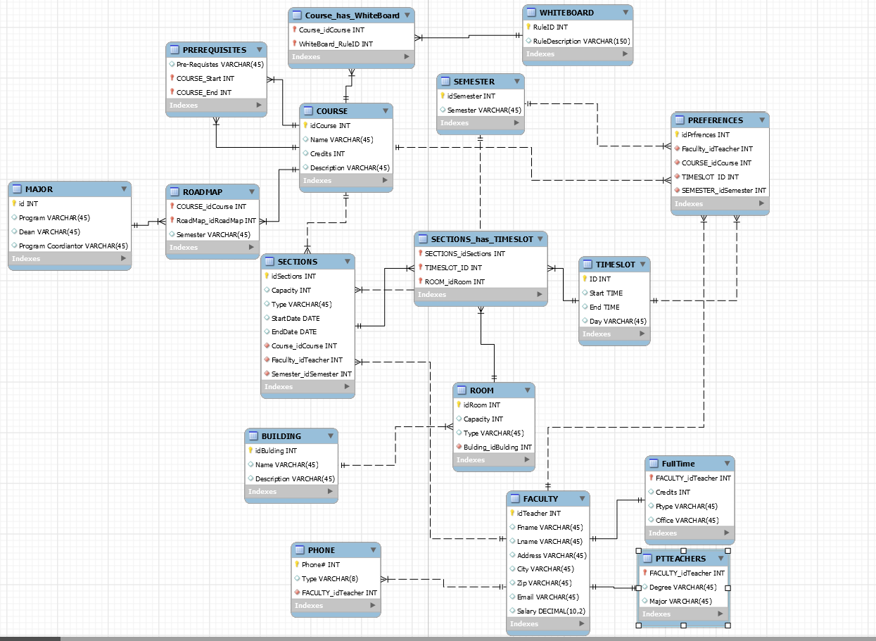

# Project Plan

The development of the database system will be accomplished in the following steps

* + - * + Information Gathering and Problem Analysis (07/6/15 -07/13/15) – During this task our group will collect data about current practices and policies used for the current and past business cycles of the product (in this case the schedule). We would also seek to talk with the users involved with the product or perform a survey to gain a further understanding of what the organization and the user needs. This information will then be cross-referenced with the information given to us by the client to refine our scope of work for the project.
        + Designing the ER Diagram (07/14/15 - 07/15/15) – Using the information attained a blueprint for the database system shall be created.
        + Implementing the Database in SQL (07/14/15 -07/15/15) – Using the completed ER diagram we will then code the database using MySQL.
        + Populating the Database (07/16/15 - Project end)– During this process our development team will transfer the data needed for the system; this includes data for past schedules as well as past data needed for documentation. Depending on the volume of data that needs to be moved this task could be an ongoing endeavor.
        + Creating a Front-end for the User (07/16/15 -07/27/15) – At this point a front-end for the users will be created. This will involve creating various forms for the users to input and update their data, implementing accounts, and allowing users to perform queries.(probably more to add) This will be done using a personally developed website that may later be integrated into the current web network of the organization.
        + Debugging and Quality Assurance (07/28/15 - 08/07/15)– Here all the past work will be thoroughly tested for bugs as well as determine if there are any further optimizations to be made to either the code or the design of the System.
        + Implementing the System Infrastructure (08/10/15 - 08/13/15) – This process will involve integrating the hardware and software needed for the System and then uploading the System onto the new infrastructure.
        + Further Debugging and QA (08/14/15 - 08/20/15 )- A second shorter testing phase to further debug the system as well as optimize the code for the System. At this QA phase limited users will use the system.
        + Full Implementation of the System (08/21/15 - 09/04/15) - After design and debugging, the system will be up and running for full use with minimal to no obvious bugs that will affect the users.
* Project Deliverables
* Project Report detailing the design process of the System

ER Diagram as a blueprint to the current database.

Database code as well as the front-end user interface and website to the database

Infrastructure for a database system.

New training for system users.

Major Milestones

Design ER Diagram

Populate Database

Design Front-end

Implementing System Infrastructure

Full Implementation

New System Training.

# Project Resources

* 1. Personnel
     1. Database Administrator
        1. Responsibilities include:
           1. Configuring
           2. Upgrading
           3. Administration
           4. Monitoring
           5. Security
           6. Maintenance

It is the administrator’s job to make sure that the new system is operational and functions properly according to the client’s needs of the system.

* + 1. Database Administrator Assistant(s)
       1. If needed, will aid the database administrator in testing and maintaining the system
    2. Client (David Bender)
       1. Other being a client, the client is necessary in the construction of the new system. It is the client’s job to provide information to the database administrator that they cannot acquire for themselves. For example, data necessary to populate the database to test for functionality or rules that are specific to the client’s needs for the system like the academic roadmap.
  1. Hardware, Software, and Other Peripherals
     1. Hardware
        1. Database Server Machine
           1. Machine that would be used to access the new database system created for the client. Machines can vary depending on the needs of the project.

[SPARC T5-8 Server](http://www.oracle.com/us/products/servers-storage/servers/sparc/oracle-sparc/t5-8/sparc-t5-8-ds-1922874.pdf)

* + 1. Software
       1. Database Management System
          1. In order to create and configure the new system, a DBMS is required

[Oracle Database](http://www.oracle.com/technetwork/database/enterprise-edition/overview/index.html)

* + - 1. Database security
         1. Protect information put into the new system

[Oracle Database Security](http://www.oracle.com/technetwork/database/options/advanced-security/index.html?ssSourceSiteId=ocomen)

* 1. Other Peripherals
     1. N/A

# Project Budget

|  |  |
| --- | --- |
| Project Items | Cost |
| Oracle Database | $350 USD per License |
| Oracle Database Advanced Security | $300 USD per License |
| SPARC T5-8 Server (Medium) Configuration | $270,384.00 USD (System List Price)  $32,446.08 USD (Oracle Premier Support) |
| Dell SonicWALL NSA 240 | $1,152.00 (Hardware Firewall) |
| 6Bit Systems Development Team | $820,034.00 (Team of 30 ) |
| Total Budget | $1,124,716.08 |

All hardware and software were chosen from one company out of convenience for the database administrator. The Oracle Corporation is able to provide all of the necessities needed for the current project.

http://www.cnet.com/products/dell-sonicwall-nsa-240-security-appliance-series/specs/

# Data Access and Security

***Data Access***

* Faculty – Will be able to able to view their own account information – this includes their own preferences and the information needed to make them (courses available, roadmap), they will also be able to view the preferences of other teachers in the department (possibly). The full schedule will be available to them to view at the Course Coordinators discretion by having the ability to grant those permissions.
* Course Coordinator – This user will have access to all the data in the system as hey must analyze all the information on the database to make the schedule.
* Registrar – Will have access to the roadmap and the whiteboard in order to change or update rules. The draft and completed schedules will also be available to them for rule checking.
* Division Head and Dean – These users are similar in that they must view all the information in the system in order to perform their duties and give the go-ahead on drafts. But these users should only be able to view the current schedule at the Course Coordinator’s discretion, they can access past schedules on their own.
* Students – Users typified as Students will not have access to data. They will only view information/premade queries.
* Maintenance – Will have access to all the data in the system, except the current schedule, as they will be responsible for maintaining and upgrading the system.

***Insert Permissions***

* Faculty – Faculty will be able to add and update their preferences, along with account information and settings.
* Course Coordinator – The Course Coordinator will have the ability to add and update all information in the database with the exception of account sensitive information and teacher preferences.
* Registrar – The registrar will be able to insert and update the rules and the roadmap in the database system.
* Division Head and Dean – These users are cannot add or update data pertaining to the current schedule without the Course Coordinator’s permission, but they may add or update to all other areas such as the road map or the whiteboard.
* Students – Students cannot add data to this system they can only update certain fields like class size.
* Maintenance – Maintenance must be granted permission to add or update data when it becomes necessary for their work but normally they will not be able to change the data in the database.

***Viewers of Information***

* Faculty – They may see other teacher’s preferences and the draft and full schedules when they become available.
* Course Coordinator – The Course Coordinator will be able to be view all the information in a table at all times.
* Registrar – Will have access to the draft and final schedules, as well as all iterations of the roadmaps and the rules.
* Division Head and Dean – These users will be able to view all information except for the current schedule being worked on by the Course Coordinator except by the user’s permission.
* Students – Students will view only the full schedule once it has been released.
* Maintenance – Will be able to see all the information on the system, except for the current schedule, at all times in order to complete their tasks.

***System Security***

* Keys - All users will make unique keys (alpha-numeric passwords in this case) which will be protected with SHA1 hashes. All stored data, along with stored keys, will be protected AES encryption. These keys will grant permissions based on a user type (faculty, drafter, student, dean) protecting sensitive information from unauthorized users.
* Training - There will also be a training program and guidelines developed to educate users on good practices with the new database system and website to minimize any threats from user negligence.
* Firewalls - To protect the system from outside malicious threats we will not only be integrating the database with the current protection in place for the Penn State Berks network but also a new hardware firewall. The firewall will be a SonicWALL NSA 240. This device was chosen due to its quality to cost performance, providing a myriad of features to protect the system (outgoing encryption, vpn, low maintenance requirements).