# 2019年9月大学英语B考前押题

**【注意】这是押题，非精简题库，非小抄！这里是根据9月电大统考服务器组卷策略，挑选出来的小范围考题，适合考前临时记忆！提高合格几率！有部分是临考才出来的新题目！**

**简单来说就是缩小了范围！适合考生考前突击，去背的！这是要背的哦！**

**这是要背的哦！**

**这是要背的哦！**

**这是要背的哦！**

**（重要的事情说三遍）**

**考试有一定几率会考到其中的部分题目，两手准备，一手背，一手带打印题库，如打印题库考场当中不能使用，就靠背的了！**

大学英语B统考共分六个题型

1、**交际英语（15分）重要**，务必背下**【重点】**

2、阅读判断（10分）全部选A，A.T和B.F判断正误的，至少答对2题，**得4分（不要去背）**

**【没复习的同学不要去复习这个了，考试不会全A就可以了】**

3、**阅读理解（10分）**建议考前利用技巧背下来，数量不多，考试有较大几率考到**【重点】**

**4、词汇与语法（10分）建议直接放弃**，**考试全部选C，至少可答对1题得2分**，考试时候不要浪费时间在这个题型里找题目，建议其他题型都做完后，还有时间再来看这个题型**【放弃】**

5、完形填空（15分）难度不高，全选C至少对1题，得3分（带精简题库做准备）

6、**英译汉（30分）考试重点**，务必背下，去记那些不认识的单词，难度不高，只要写上一段句子，即使有错误的，也会按照一个单词扣0.5分或者1分。写上大概意思就对！**【重点】**

7、**作文（10分）作文基本都在精简题库当中，建议如果条件可以，带作文进入考场，用到满分。大家也可以参考下面的万能模块，或者从阅读文章找些认识的单词写上。**

万能模板：适用所有作文类型：

I think （此处抄写作文题目）is an interesting topic. 我认为（作文题目）是一个有趣的话题Many people around me are talking about this. 我周围的许多人都在谈论这个。

In my opinion, we should understand 此处抄写作文题目 like this.在我看来，我们应该明白（作文题目）是这样的First, 此处翻译题目的中文提示1（如果实在不会写，可抄写阅读理解中的意义有关联的句子两到三个凑数，如能做适当修改更好）Second, 此处翻译题目的中文提示2（如果实在不会写，可抄写阅读理解中的意义有关联的句子两到三个凑数，如能做适当修改更好）

In conclusion, let’s pay more and more attention to this together from now on.总之，从现在开始，让我们越来越关注这个话题。

【注意】考前押题也为精简版，提供了题目和标准答案，死记硬背即可。

**再次强调：非小抄，非考试精简题库，为小范围押题，如不想背的直接打印精简题库！**

**如果有时间的，建议【英译汉】这部分多看看网页上的题库！**

**如果阅读文章类的需要看完整版，请登入题库查看！**

**注意，需要记忆正确答案，考试的时候ABCD选项可能调换。**

# 第一部分：交际英语（有时间最好背下来）

1、- I'm sorry totrouble you.

- __________.

A.The same to you

B.What a pity! I'm sorry to hear that

C.It doesn't matter

D.Thanks a lot

【百题斩答案】C

2、- Thank you for calling.

- _________

A.Don't mention it. B.That's fine.

C.Nice talking to you. D.Call back again.

【百题斩答案】C

3、- What day is today?

- _________

A.It's March 6. B.It's a fine day today.

C.It's March. D.It's Monday.

【百题斩答案】D

4、- Would you like something to drink? Whatabout a cup of tea?

- _________

A.No, thanks.

B.No, I wouldn't.

C.Yes, I want.

D.Yes, I like.

【百题斩答案】A

5、- Good-bye for now.

- _________

A.The same to you.

B.That's OK.

C.See you.

D.Long time no see.

【百题斩答案】C

6、- Tom told me that you collect stamps.

- _________

A.What do you mean?

B.I don't think so.

C.Why did he tell you?

D.Yes, I do. Do you?

【百题斩答案】D

7、- Come and see me if you have time.

- _________

A.I can't.

B.I'll think it over.

C.Thank you.

D.I will.

【百题斩答案】D

8、- Why did Mrs. Green go to the travel agency?

- _________

A.By car.

B.Yesterday afternoon.

C.In New York.

D.For some information about travel.

【百题斩答案】D

9、- Shall we have another cup of tea?

- _________

A.Do you like tea?

B.Why not?

C.Good tea.

D.I'm thirsty.

【百题斩答案】B

10、- Would you like to see the film with me tonight?

- ______.

A.Not at all

B.No, I don't

C.Yes, I'd love to

D.That's right

【百题斩答案】C

11、- Hello, I'm David Chen. Nice to meet you.

- _______

A.Are you?

B.Nice to meet you too.

C.Yes.

D.Very nice.

【百题斩答案】B

12、- Hello, could I speak to Mike please?

- _________

A.Who are you?

B.Who is speaking?

C.What's wrong?

D.Why?

【百题斩答案】B

13、-May I move your bag a little and take this seat?

-____________.

A.I don't mind

B.It doesn't matter

C.You do it please

D.Go ahead

【百题斩答案】D

14、- Let me help you carry the suitcase.

- _________

A.It's OK. I can manage.

B.It's not very light.

C.I can help you with it.

D.Put it down on the ground.

【百题斩答案】A

15、- I wish you success in your career.

- _________

A.You are welcome.

B.I think so.

C.Yes, please.

D.The same to you.

【百题斩答案】D

16、- Could you do me a favour and take these books to my office?

- Sure, _______.

A.for pleasure

B.I could

C.my pleasure

D.more pleasure

【百题斩答案】C

17、- I wonder if I could use your computer tonight?

- ___________ I'm not using it right now.

A.Sure, here you are.

B.I don't know.

C.It doesn't matter.

D.Who cares?

【百题斩答案】A

18、- Hey, Tom, what's up?

- __________

A.Yes, definitely!

B.Oh, not much.

C.What is happening in your life?

D.You are lucky.

【百题斩答案】B

19、- How are you, Bob?

- ________

A.How are you?

B.I'm fine. Thank you.

C.How do you do?

D.Nice to meet you.

【百题斩答案】B

20、- Hello, I'm Harry Potter.

- Hello, my name is Charles Green, but ______.

A.call my Charles

B.call me at Charles

C.call me Charles

D.call Charles me

【百题斩答案】C

21、- Paul, _______?

- Oh, that's my father!And beside him, my mother.

A.what is the person over there

B.who's talking over there

C.what are they doing

D.which is that

【百题斩答案】B

22、- It's rather cold in here. Do you mind if I close the window?

- ________

A.Yes, please.

B.No, please.

C.Sure, please.

D.I don't like it.

【百题斩答案】B

23、- May I see your tickets, please?

- ________

A.Sure.

B.No, you can't.

C.No, they are mine.

D.Yes, you can.

【百题斩答案】A

24、- I'm sorry. I am late due to the heavy traffic.

- ________

A.Well, it's OK.

B.No, it's all right.

C.You are welcome.

D.You are wrong.

【百题斩答案】A

25、- Could you help me with my physics, please?

- ________

A.No, no way.

B.No, I couldn't.

C.No, I can't.

D.Sorry I can't. I have to go to a meeting right now.

【百题斩答案】D

26、- Thank you ever so much for your lovely gift.

- _________

A.Never mind

B.I'm glad you like it.

C.Please don't say so.

D.No, It's not so good.

【百题斩答案】B

27、- Could I borrow your car for a few days?

- ________

A.Yes, you may borrow.

B.Yes, go on.

C.Sure, here is the key. Enjoy your journey.

D.It doesn't matter.

【百题斩答案】C

28、- Could I speak to Don Watkins, please?

- ________

A.Speaking, please.

B.Oh, how are you?

C.I'm listening.

D.I'm Don.

【百题斩答案】A

29、- Excuse me, how much is the jacket?

- It's 499 Yuan. ________

A.Oh, no. That's OK!

B.How do you like it?

C.Which do you prefer?

D.Would you like to try it on?

【百题斩答案】D

30、- What does Tom's wife do for a living?

- _________

A.She is a doctor.

B.Tom loves his wife.

C.She has a happy life.

D.She lives far from here.

【百题斩答案】A

31、- I didn't mean to do that. Please forgive me.

- _________

A.Not too bad.

B.That's all right.

C.It's a pleasure.

D.Thank you.

【百题斩答案】B

32、- Good morning, John. How are you doing?

- _________

A.I'm pleased.

B.Good night.

C.Not so bad. And you?

D.How do you do?

【百题斩答案】C

33、- What's the problem with your bike?

- _________

A.Not at all.

B.Good, thank you.

C.Nothing serious.

D.Sure

【百题斩答案】C

34、- What's wrong with you, dear?

- _________

A.I didn't go to school.

B.I have a terrible headache.

C.I took the kids shopping today.

D.It is a beautiful dress.

【百题斩答案】B

35、- What's the matter, John?

- _________

A.I failed my French test.

B.It doesn't matter.

C.Nothing's wrong with him.

D.I don't think I can.

【百题斩答案】A

36、- What do you think of this novel?

- _________

A.I've read it.

B.It's well-written.

C.It was written by my uncle.

D.I bought it yesterday.

【百题斩答案】B

37、- How tall is your sister?

- _________

A.She is not very well.

B.She is 28 years old.

C.She is very nice.

D.She is as tall as I am.

【百题斩答案】D

38、- Let's go to the library this afternoon.

- _________

A.Yes, that's right.

B.No. I can't.

C.What about you?

D.That's a good idea.

【百题斩答案】D

39、- How much is this necklace?

- _________

A.It's very nice.

B.It's a birthday present from my parents.

C.It costs fifty pounds.

D.It's a bargain.

【百题斩答案】C

40、- How can I get to the cinema?

- _________

A.It's very far.

B.Yes, there is a cinema near here.

C.It's well known.

D.Go down this street and turn left.

【百题斩答案】D

41、- How's your family?

- _________

A.Thanks all the same.

B.Thanks for calling.

C.Not too bad.

D.Don't mention it.

【百题斩答案】C

42、- Are you going on holiday for a long time?

- _________

A.It was a long time.

B.Two weeks ago.

C.No. Only a couple of days.

D.Not long time ago.

【百题斩答案】C

43、- What are you majoring in?

- _________

A.In a university.

B.Very hard.

C.Mathematics.

D.At nine in the morning.

【百题斩答案】C

44、- Is John there?

- _________

A.Speaking.

B.I'm not Mary.

C.Who are you?

D.Mary is well today.

【百题斩答案】A

45、- Is that seat taken?

- _________

A.Please don't worry.

B.I don't think so.

C.Why not?

D.It's very nice.

【百题斩答案】B

46、- How are you getting on today?

- _________

A.Very well.

B.How do you do?

C.I'm a doctor.

D.Nice to have known you.

【百题斩答案】A

47、Congratulations! You won the first prize in today’s speech contest.

- _________

A.Yes, I beat the others.

B.No, no, I didn’t do it well

C.Thank you.

D.It’s a pleasure.

【百题斩答案】C

48、Did you know that David injured his leg yesterday？

Really? ___________

A.Who did that?

B.What’s wrong with him?

C.How did that happen?

D.Why was he so careless?

【百题斩答案】C

49、Do you mind my smoking here?

- _________

A.No, thanks.

B.Yes, I do.

C.Yes. I’d rather not.

D.Good idea.

【百题斩答案】B

50、Excuse me, could you show me the way to the nearest post office?

-_______ Oh yes! Two blocks away from here at the Green Avenue. You can’t miss it.

A.I beg your pardon?

B.What do you mean?

C.You’re welcome.

D.Mm,let me think

【百题斩答案】D

51、- Good morning, may I speak to Mark, please?

- _________

A.Who's there?

B.Who's speaking?

C.Who are you?

D.Who wants to speak to Mark?

【百题斩答案】B

52、Hi, Tom, how's everything with you?

- ________ , and how are you?

A.Don't mention it.

B.Hm, not too bad.

C.Thanks

D.Pretty fast

【百题斩答案】B

53、How was your trip to London, Jane?

- _________.

A.Oh, wonderful indeed.

B.I went there alone.

C.The guide showed me the way.

D.By plane and by bus.

【百题斩答案】A

54、I didn’t mean to do that. Please forgive me.

- _______.

A.Not too bad.

B.That’s all right.

C.It’s a pleasure

D.Thank you

【百题斩答案】B

55、- I hear you got through your exam. Congratulations!

- _________

A.No. I didn't do well enough.

B.Who told you that?

C.Thanks

D.Yes, I got a good mark.

【百题斩答案】C

56、- I'm sorry I'm late.

- _________

A.No trouble.

B.All right

C.It doesn't matter

D.I don't matter

【百题斩答案】C

57、Is it possible for you to work late tonight?

- _________.

A.I like it.

B.I’ll do that.

C.I’d love to.

D.I think so.

【百题斩答案】D

58、Let me introduce myself. I’m Steward.

- ___________.

A.What a pleasure.

B.Pleased to meet you.

C.I don’t know.

D.Thanks a lot.

【百题斩答案】B

59、Let’s go to the library this afternoon.

- ____________

A.Yes, that’s right.

B.No. I can’t.

C.What about you?

D.That’s a good idea.

【百题斩答案】D

60、Must I take a taxi?

No, you _______. You can take my car.

A.had better to.

B.don’t

C.must not

D.don’t have to

【百题斩答案】D

61、Oh, sorry to bother you.

- __________.

A.That's Okay.

B.No, you can't

C.That's good

D.Oh, I don't know

【百题斩答案】A

62、Please help yourself to the seafood.

-_________.

A.No, I can’t.

B.Sorry, I can’t help

C.Well, seafood don’t suit for

D.Thanks, but I don’t like the seafood

【百题斩答案】D

63、Thank you for inviting me.

- __________.

A.I really had a happy time.

B.Oh, it’s too late.

C.Thank you for coming.

D.Oh, so slowly.

【百题斩答案】C

64、Thanks for your help.

- _________.

A.My pleasure.

B.Never mind.

C.Quite right.

D.Don’t thank me.

【百题斩答案】A

65、Unbelievable! I have failed the driving test again!

- _________.This is not the end of the world.

A.Good luck.

B.Cheer up

C.Go ahead

D.No problem

【百题斩答案】B

66、What’s the problem with your bike?

- __________

A.Not at all.

B.Good, thank you

C.Nothing serious.

D.Sure.

【百题斩答案】C

67、When are you going on holiday?

- _________

A.Last night.

B.Next week.

C.By plane.

D.With my brother.

【百题斩答案】B

68、Would you like to go to the concert with us this evening?

-_________.

A.No, I already have plans.

B.I’d love to, but I’m busy tonight.

C.No, I really don’t like being with you.

D.I’m ill, so I shouldn’t go out.

【百题斩答案】B

69、You know, I have three kids now.

- ______

A.Oh, I've heard a lot about you.

B.That's wonderful!

C.You've really changed your hair style.

D.Well, I gave up drinking.

【百题斩答案】B

70、Why didn't you come to my birthday party yesterday?

- ________.

A.Excuse me, my friend sent me a flower.

B.Fine, I never go to birthday parties

C.Well, I don't like birthday parties

D.Sorry, but my wife had a car accident

【百题斩答案】D

71、How do you like the movie we saw yesterday?

- _________.

A.You are welcome.

B.How about you?

C.I've never seen a better movie than it.

D.It is very expensive.

【百题斩答案】C

72、- ________

- He teaches physics in a school.

A.What does your father do?

B.Who is your father?

C.What is your father doing?

D.Where is your father now?

【百题斩答案】A

73、- I'm sorry I broke your mirror.

- _________

A.It's OK with me.

B.It doesn't matter.

C.You are welcome.

D.I don't care.

【百题斩答案】B

74、- Would you like to have some coffee?

- _________

A.No, please.

B.Yes, I like.

C.It is a pleasure.

D.No, thank you.

【百题斩答案】 D

75、- Wow! This is a marvelous room! I've never known you're so artistic.

- ______

A.Great, I am very art-conscious.

B.Don't mention it.

C.Thanks for your compliments.

D.It's fine.

【百题斩答案】C

76、- How is your headache?

- _________

A.Not at all.

B.Better now.

C.Thank you.

D.Nothing special.

【百题斩答案】B

77、- This box is too heavy for me to carry it upstairs.

- _______

A.You may ask for help.

B.I'll give you a hand.

C.Please do me a favor.

D.I'd come to help.

【百题斩答案】B

78、- We are going to have a singing party tonight. Would you like to join us?

- ________

A.I'm afraid not, because I have to go to an important meeting.

B.Of course not. I have no idea.

C.No, I can't.

D.That's all set.

【百题斩答案】A

79、- May I take your order now?

- _________

A.No, I'm in trouble now.

B.Yes, we take orders.

C.Yes, I'd like a dish of chicken.

D.No, I don't have an order.

【百题斩答案】C

80、- I'm looking for a shirt for my father.

- _________

A.What size do you wear?

B.What can I do for you?

C.How about this one?

D.What size does your father wear?

【百题斩答案】D

81、- Who's speaking?

- This is Tom ________.

A.speaks

B.spoken

C.speaking

D.saying

【百题斩答案】C

82、- Thank you very much.

- _________

A.It doesn't matter.

B.Yes, please.

C.You are welcome.

D.Forget it.

【百题斩答案】 C

# 第二部分，阅读判断和阅读理解

**阅读判断**

**此类非重点，考试的时候全部选择正确A，至少可以答对2题，得4分。**

**阅读理解：（A foreigner为文章开头第一句话，1、which……为题目，括号内的为正确答案）**

**【此部分为重点，90%的概率从中选中一遍文章，考到就是10分，要求掌握】**

**A foreigner’s first impression of the U.S. is likely to be that everyone is in a** ：

1、Which of the following statements （Americans are impolite ）

2、In the fourth paragraph （a first concern）

3、Americans evaluate a business （by learning about their）

4、This passage mainly talks about （how Americans treasure）

5、We can infer from the passage （appreciative）

**A characteristic of American culture that has become almost a tradition：**

1、From paragraph 1, we know （people tend to have a high opinion of the）

2、According to the passage, the （she takes pride in what she can do）

3、The expression “wait on table” （serve customers in a restaurant）

4、The author’s attitude towards （positive）

5、Which of the following may （American Attitude toward Manual Labor）

**Britain and France are separated by the English Channel ，a body of water** ：

1、For centuries, the relationship （a mixture of love and hate）

2、The war in Iraq does （both good and harm）

3、The British are not so friendly to （Germany; America）

4、__are more interested （British people … France）

5、What does the last （France and Britain are near neighbors）

**By definition, heroes and heroines are men and women distinguished**：

1、The passage mainly deals （heroes and icons）

2、Heroes and heroines are （all of the above）

3、Which of the following （Heroes and heroines can only emerge in war ）

4、Beautiful young Diana （just before her death）

5、What is more likely to （Tragic and early death）

**Community service is an important component of education here at our** ：

1、What is the purpose of the talk? （To interest students in a new）

2、What is the purpose of the （To offer tutorials to elementary）

3、What does Professor Dodge do （He advises students to participate）

4、What should students who （Talk to Professor Dodge）

5、Whom do you think the speaker （Students）

**How men first learnt to invent words is unknown**：

1、The origin of language is （a problem not yet solved）

2、What is true about words （They are simply sounds）

3、The real power of words lies （representative function）

4、By “association”, the author（a joining of ideas in the mind）

5、Which of the following （He is no more than a master of words）

**I often dreamed about Pisa when I was a boy**：

1、This passage is about __ （how the Leaning Tower of Pisa got its name）

2、The writer used to think Pisa （the same as pizza）

3、The Leaning Tower of Pisa is（600 years old）

4、The writer _（likes what the tower looks like）

5、The writer likes the Leaning Tower （it’s imperfect）

**If you do not use your arms or your legs for some time**：

1、Someone can't have a good （he doesn't make good use of his memory）

2、If you do not use your （they will become weak）

3、Which of the following （Your memory needs chance for practice）

4、Few people know that if （his own fault）

5、The writer wants to tell us （how to have a good memory）

**In England, people often talk about the weather because they can**：

1、Why do people in England （Because they may have four seasons in one ）

2、From the story we know that（black clouds）

3、People can also have summer in（warm）

4、In the sunny morning some English （it often rains in England）

5、The best title for this （The Weather in England）

**In the United States, it is not customary to telephone someone**：

1、What is the main idea （The role of time in social life）

2、What does it mean in （A matter of life or death）

3、Which of the following time （at 4:00 pm）

4、Which of the following statements （Promptness is valued highly）

5、From the passage we can （the meaning of time differs in different）

**It has been reported that in colleges across the United States**：

1、What is soap opera? （The daytime serial dramas on TV）

2、What can be the best title （Soap opera fans）

3、Which is NOT the reason why （Because the young people have）

4、What can we learn from the passage? （Young viewers have turned ）

5、What message does（The people’s favorites to drama works change along）

**Long, long ago there was no zero**：

1、Long, long ago people didn （write zero）

2、Long, long ago if they wrote （2 8）

3、Later __was used to mean （a dot）

4、People used circles （not to forget the space）

5、The story tells us _ （how zero came to be used）

**Look at the instructions on the bottle of the medicine and then**：

1、John should take ___（3 teaspoonfuls）

2、The medicine should be （a fridge）

3、John should __ before （shake the medicine well）

4、When people are __years old（two）

5、John will __the medicine （throw away）

**Linda and David have traveled by air from London to Sydney**：

1、Linda is telephoning （say that she and David have arrived safely）

2、Linda does not think （she will speak from one side of the word to the）

3、David says, Nearly four pounds（he wants to remind Linda of the cost of）

4、Mrs. Lee goes on talking for （she likes talking）

5、Linda tries to stop her （promising to write, and ringing off）

**Laws have been written to govern the use of American National Flag**：

1、How do Americans ensure （By making laws）

2、What is the regulation regarding （It should be raised quickly by hand）

3、How should the American （It should be carried high up）

4、What do we learn about （There are precise regulations）

5、What is Americans （Respect）

**Morgan Rees has always been a good businessman**：

1、The topic sentence of Para. 1 is （Morgan Rees has always been a good）

2、The topic sentence of Para. 2 is （he was unhappy after he got retired）

3、Which of the following statements （He bought a small crockery factory ）

4、What is the central idea of the （Since he started working again, Morgan）

5、The passage mainly deals with（how Morgan Rees lived his retired life）

**Mr. Tom Forester lived by himself a long way from town**：

1、Mr Forester lived ______.（alone in the countryside）

2、Tom ______ went into town.（almost never）

3、The old people in the restaurant（with glasses on）

4、The shop Tom went into sold（glasses for people who could not see well）

5、What kind of mistake did （He thought that a person whos）

**Many people who work in London prefer to live outside it** ：

1、Which of the following （All the people who work in London）

2、With the same money needed （renting a small flat without a garden）

3、When the garden is in blossom （having spent time working in the garden）

4、People who think happiness （their life was meaningless）

5、The underlined phrase （escape from）

**Once James Thornhill, a famous English painter**：

1、James Thornhill was an English （artist）

2、He was ordered to （paint some pictures on the wall of the palace）

3、It took them ______to finish （twelve months）

4、James Thornhill felt that the （father... more beautiful）

5、The worker threw some paint （save Jame’s life）

**One day a bookseller (书商) let a big box of books fall on his foot**：

1、What happened to the （His foot was wounded by a box of books）

2、The bookseller’s wife asked（to go to see the doctor）

3、The bookseller didn’t take his （he didn’t want to pay the doctor）

4、The doctor paid __ for the books. （nothing）

5、The bookseller paid __money for seeing（more）

**Paper is one of the most important products ever invented by man**：

1、What’s the meaning for the word （A kind of paper made from the skin of）

2、Which of the following is not （More jobs could be provided）

3、When did the Egyptians （Around 1400）

4、Which of the following countries （Sweden）

5、What is the main idea （The invention of paper is of）

**People used to say, "The hand that rocks (摇) the cradle (摇篮) rules the** ：

1、"The hand that rocks the （women do play an important part in men’s ）

2、"You’ve come a long way, （she was done a lot and succeeded greatly in）

3、"Not nearly as far as （"she isn’t so satisfied with success"）

4、According to the passage（is all for）

5、The best title of this passage （Women’s Liberation in the USA）

**Places to stay in Britain are as varied as the places you visit**：

1、In this passage the author （tells us where to stay while visiting Britain）

2、_______ are mainly built （Youth Hotels）

3、If you travel alone and （B&Bs）

4、If you are interested in （Hostels）

5、Which of the following is （All pubs and inns offer visitors）

**Shyness is the cause of much unhappiness for a great many people**：

1、What does the author try to （People’s shyness made them care too ）

2、According to the writer （a good quality）

3、When being praised, （unreal）

4、Which of the following （Shyness can block our chances for a rich life）

5、It can be inferred from （should understand themselves in the）

**Sixteen-year-old Maria was waiting in line at the airport in Santo Domingo**：

1、Maria’s story happened （when she arrived at the airport）

2、You believer that the work of the （check people’s luggage）

3、“Why are you so upset?” （unhappy ）

4、“Everyone was looking at him with （sorry for the man’s）

5、The author mentioned （she was young but）

**The French Revolution broke out in 1789. At the time France was in a crisis**：

1、What’s this passage about? （The French Revolution）

2、 Which did not happen in 1789? （The national economy was）

3、 Where were the political （In Bastille）

4、 What does the underlined word “abolished” mean? （Ended）

5、 What was NOT the effect of the （The king tried to control ）

**The residents of 24 Acacia Grove were dissatisfied with the condition**：

1、Why did John Preston call a （Because the residents were … of the flats）

2、Who elected John as （the residents）

3、What does the word “inactivity” （Lace of actions）

4、What does the word “due” （to be paid）

5、When did they agree to （When they were happy with the plans to ）

**There are three kinds of goals: short-term, medium-range**：

1、Our long-term goals mean a lot （If we complete the short-term goals）

2、New short-term goals are built （the goals that have been completed）

3、When we complete each step of （we should build up confidence of suc）

4、What is the main idea of t （Different kinds of goals in life）

5、Which of the following （Life is a static thing, thus we should never）

**The United States covers a large part of the North American continen**：

1、Which of the following is TRUE? （The United States lies next to Canada ）

2、After winning its independence, （mainly developed westward）

3、The United States didn’t have （fifty; 1959）

4、Why is English the language （Because most of the people who first sett）

5、The best title for the passage is （The United States of America）

**Today Newton is a very clean place. Many years ago**：

1、Newton is a place which （is very clean）

2、when the goverment first （Were too lazy to kill many rats）

3、The people killed rats （To get money from the goverment）

4、A deep hole was dug so that （nobody could take any rats from the pile）

5、What is the best topic for this （How Newton Became a Very Clean Place）

**What makes a person a scientist**：

1、What makes a scientist （The way he uses his tools）

2、The scientist, however, （the difference between scientists）

3、A sound scientific theory （works not only under one set of）

4、The author quotes the case （that the investigations are important）

5、What is the main idea of （Exactness and ways of using tools are the ）

**When I was a little girl, my brothers and i collected stamps**：

1、This passage mainly tell （The author and her brother had an unforget）

2、According to the passage, （On Saturdays）

3、Their mother told them to （She wanted to give them a surprise）

4、What does the sentence （We were extremely happy about it）

5、What is the best title （A memorable Experience in Collecting Stamps）

**When John and Victoria Falls arrived in New York City for one-year stay**：

1、Which of the following has （Renting home furnishings）

2、Why do some people prefer （Because it saves them much trouble）

3、What can you infer from （Renting furniture is not popular in the couple’s）

4、Which of the following can （A New Way of Getting Home Furnishings）

5、Young people liked renting （They don’t have much money and don’t wan）

**When weather is hot, you go to a lake or an ocean**：

1、The main idea of （scientists can explain many things）

2、You feel cool when （cool air from the water moves towards the land）

3、Now scientists know （what makes people feel cool near a lake or）

4、A rock cracks when （either B or C）

5、People are always curious（there are answers they do not have）

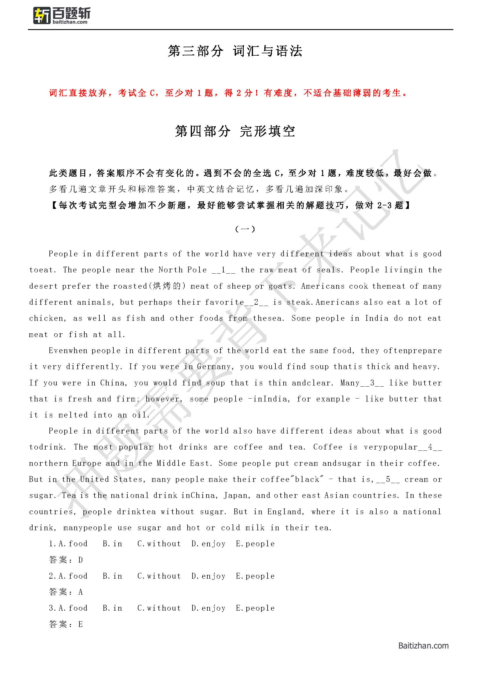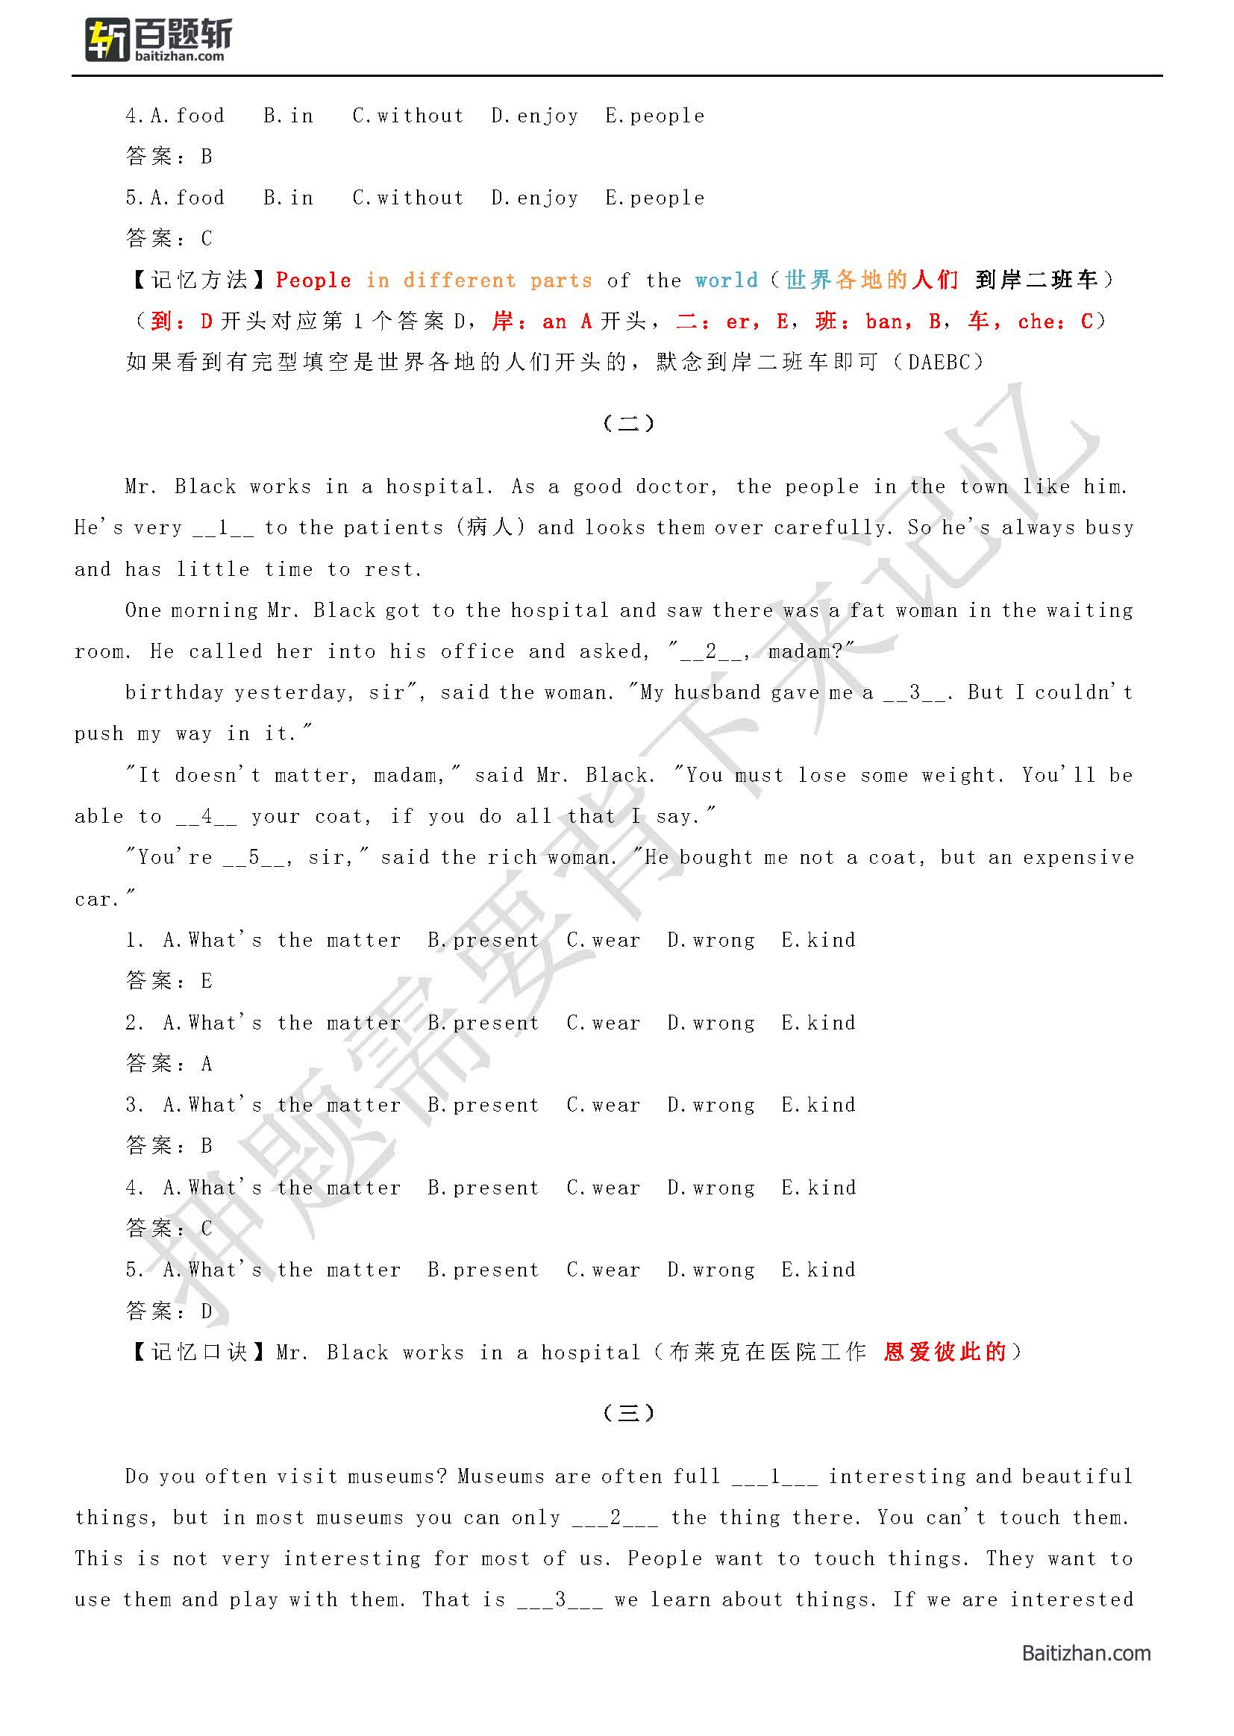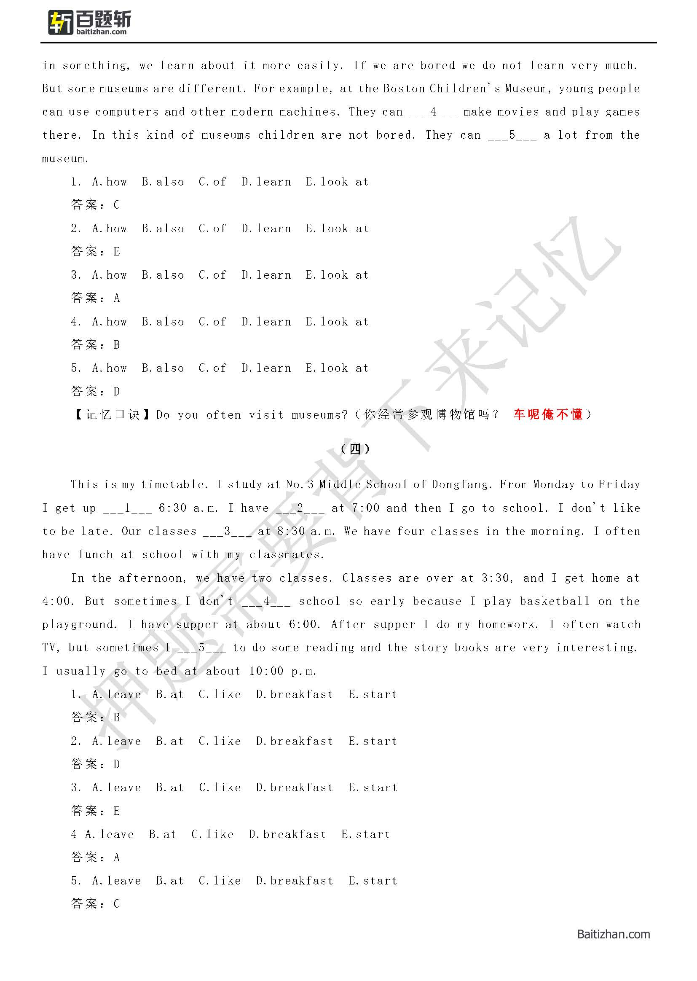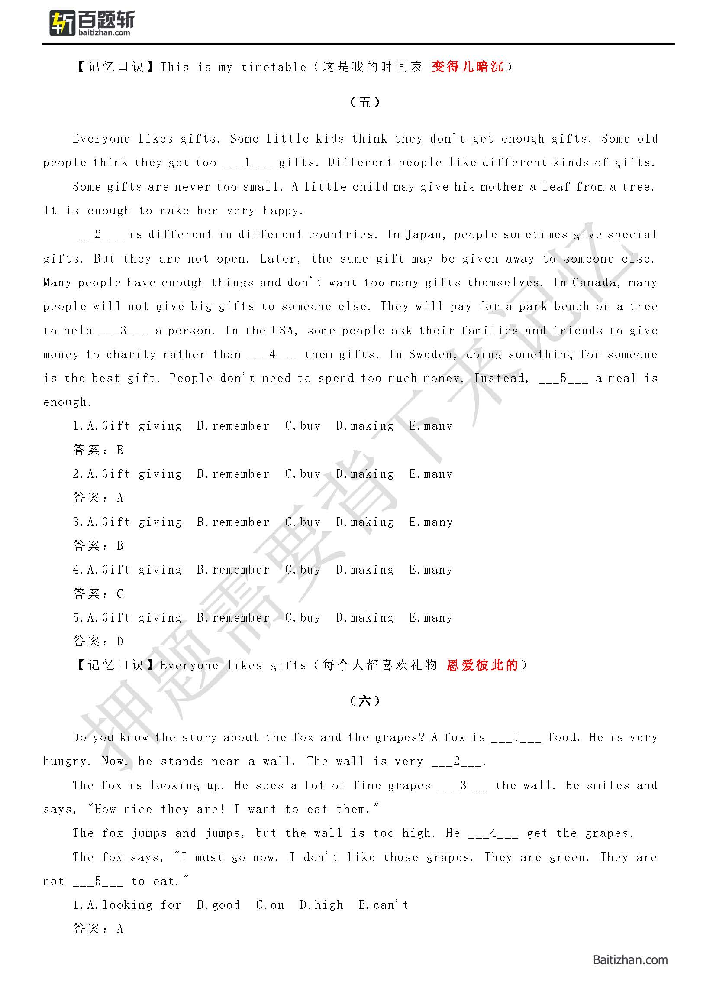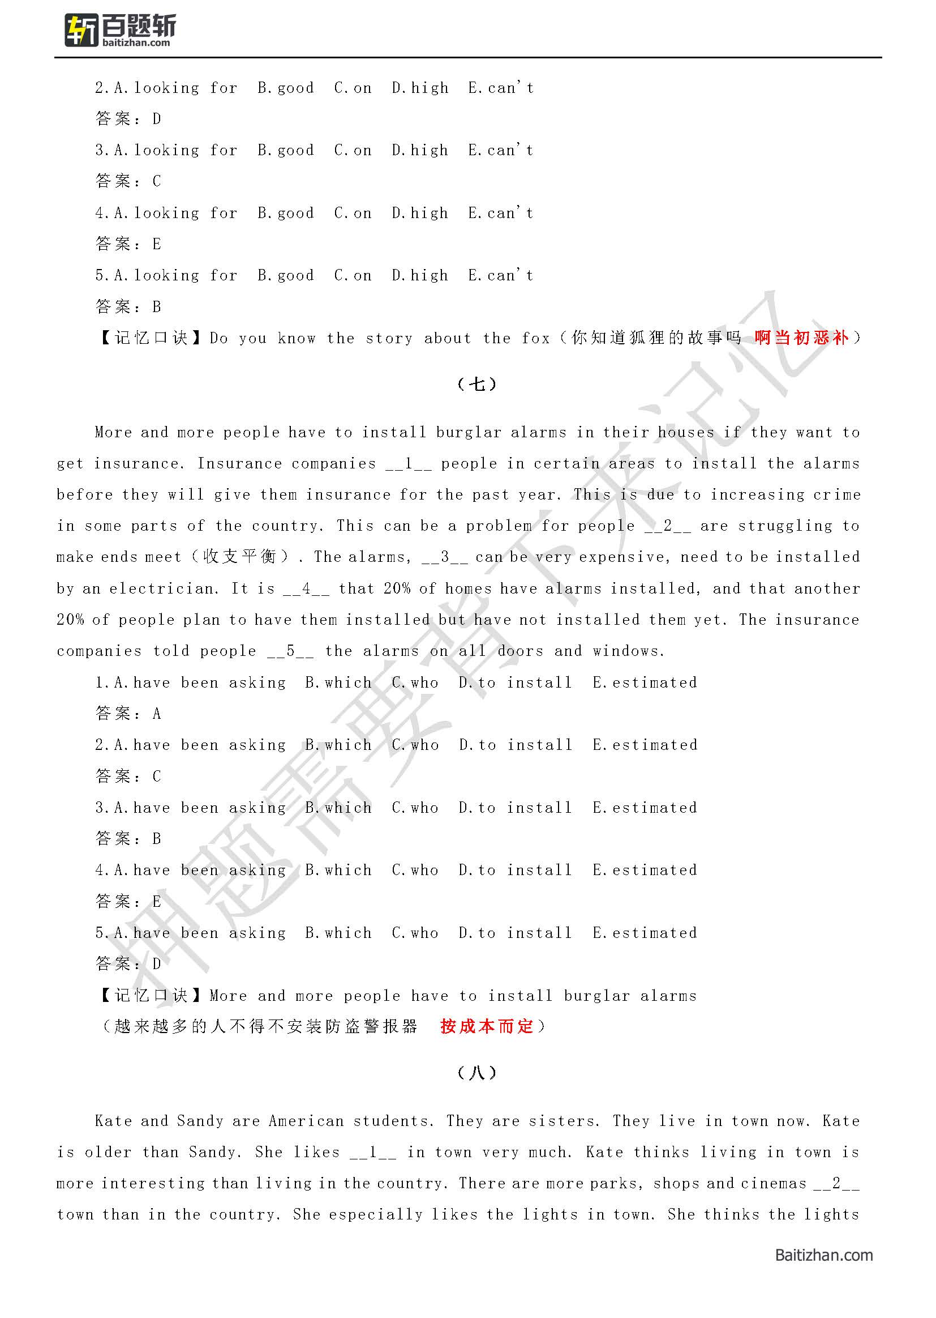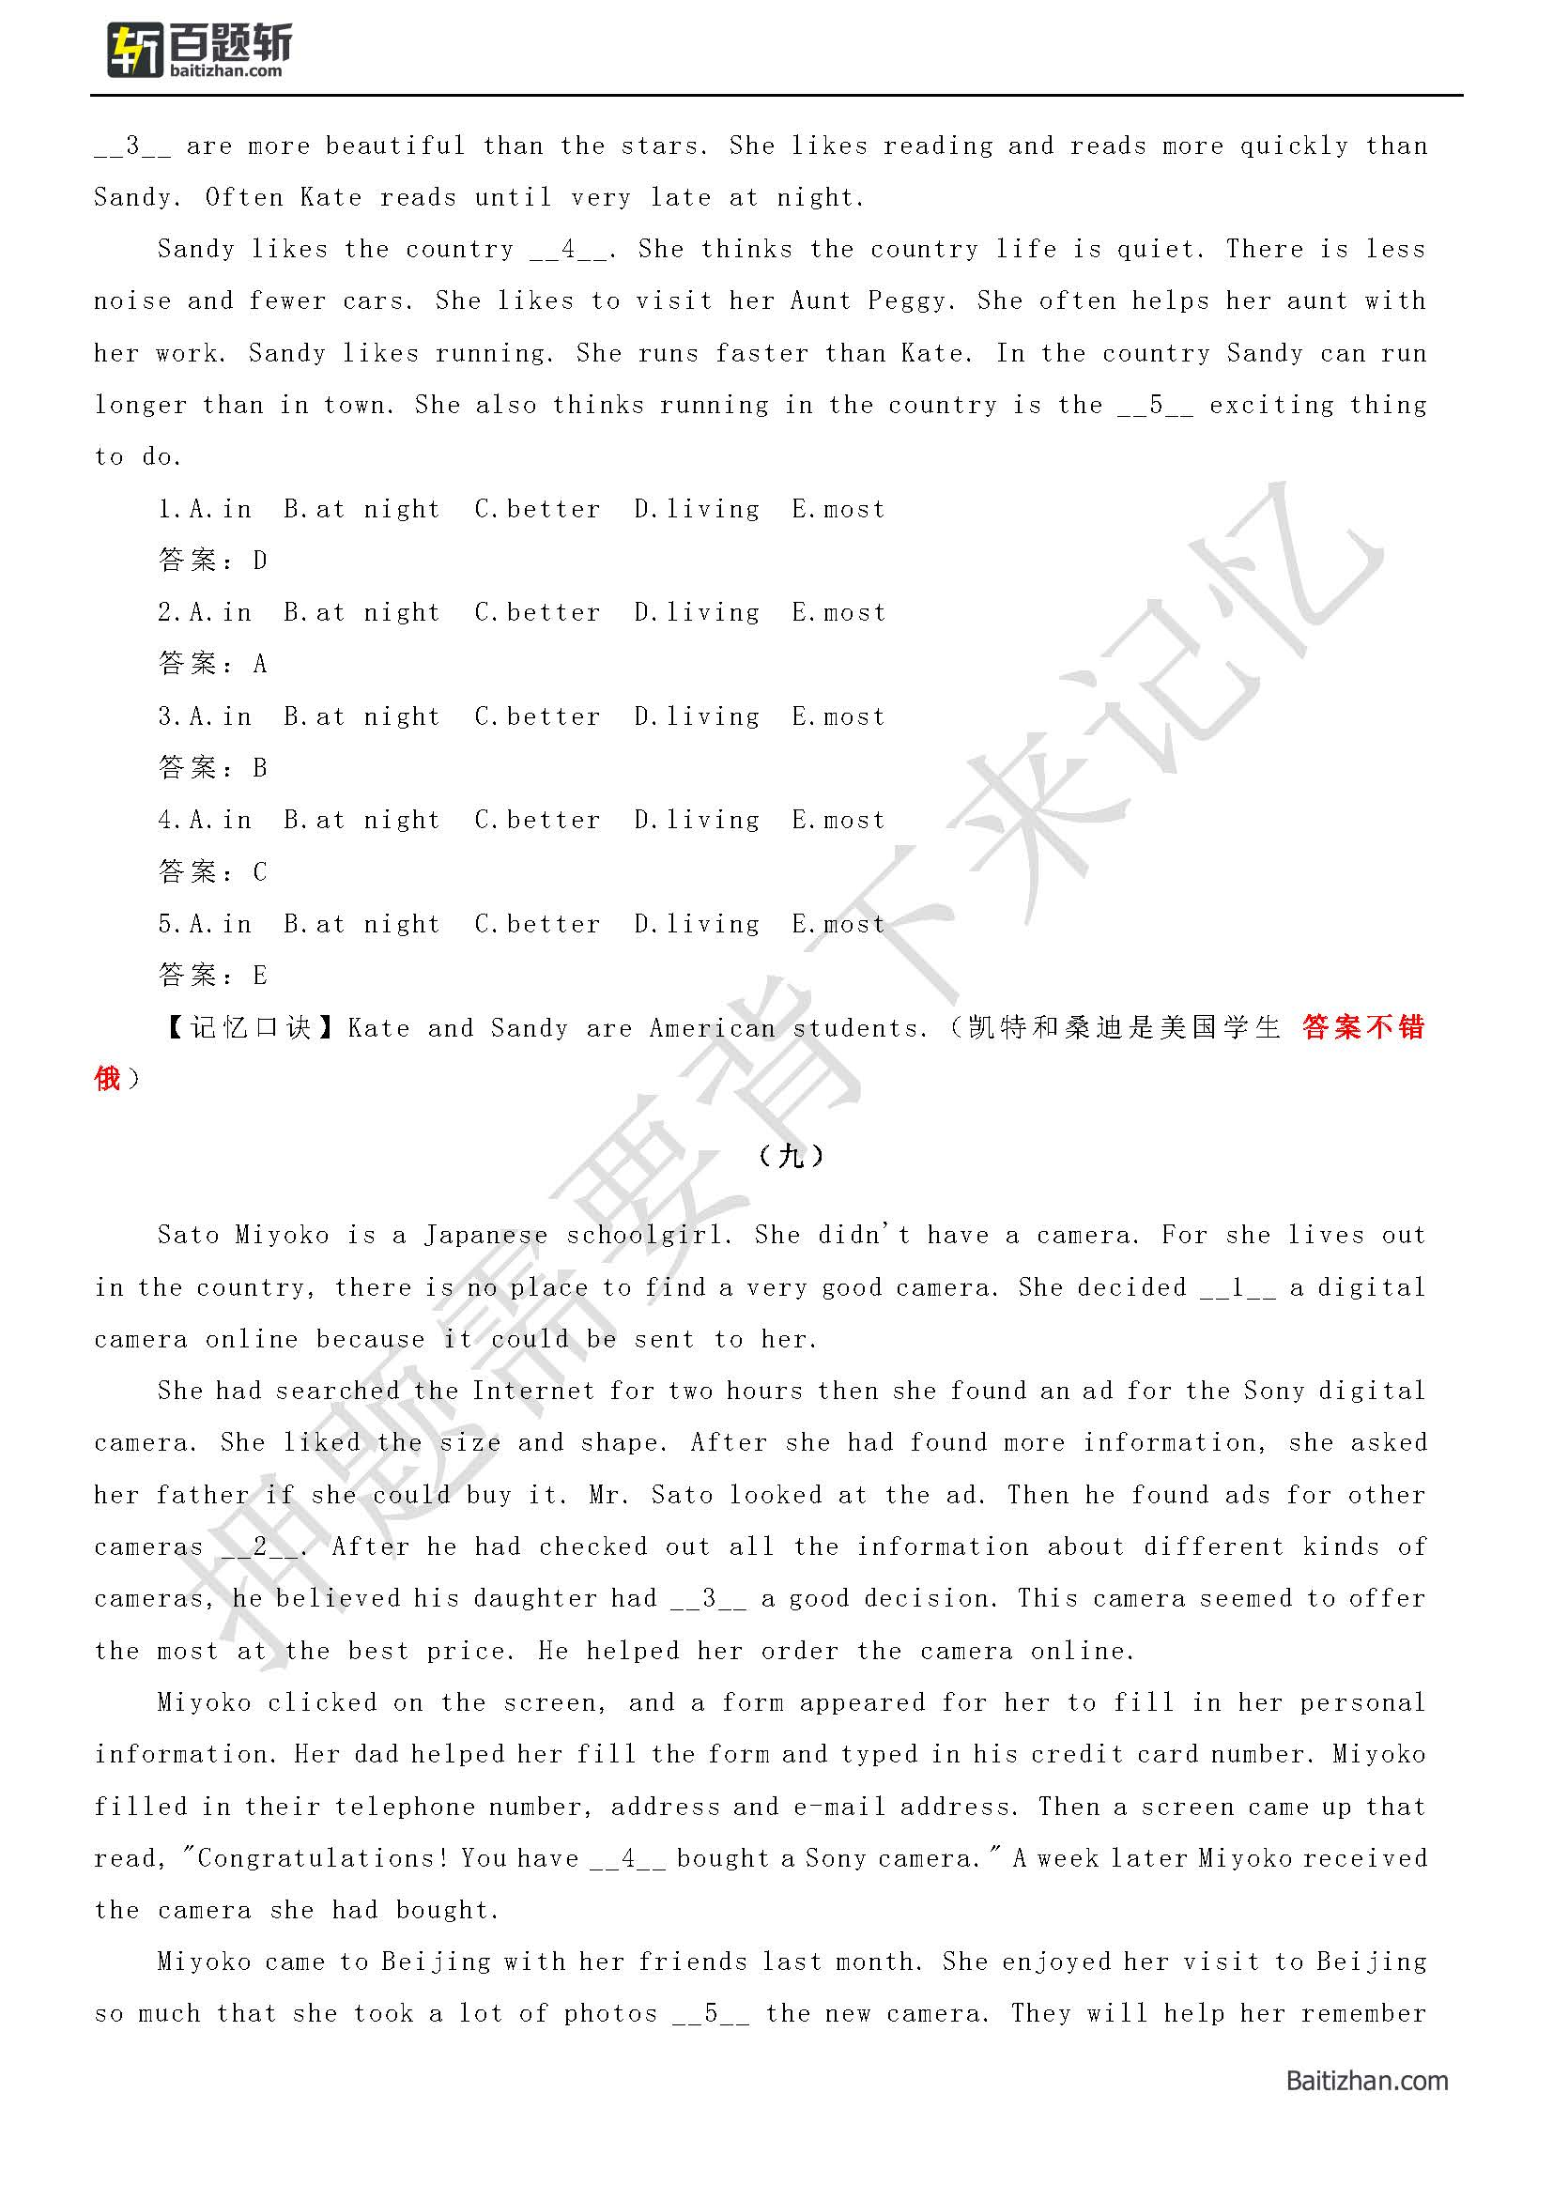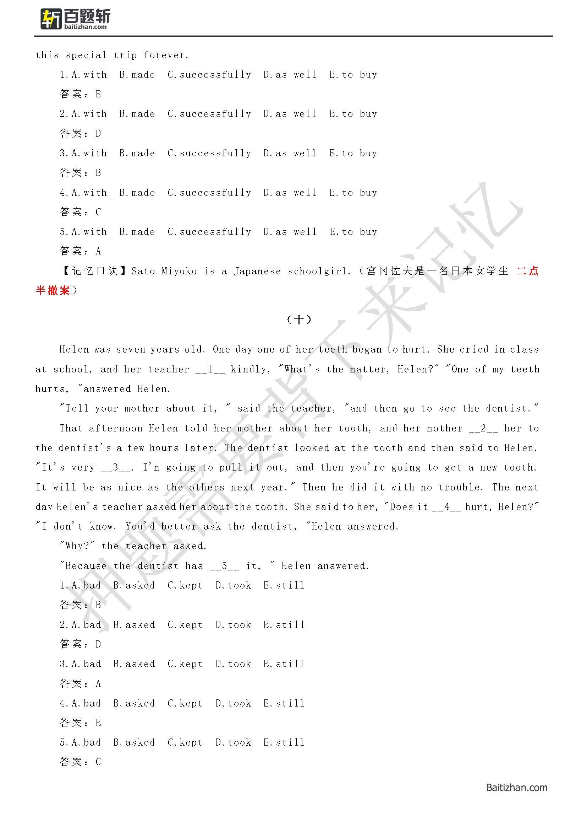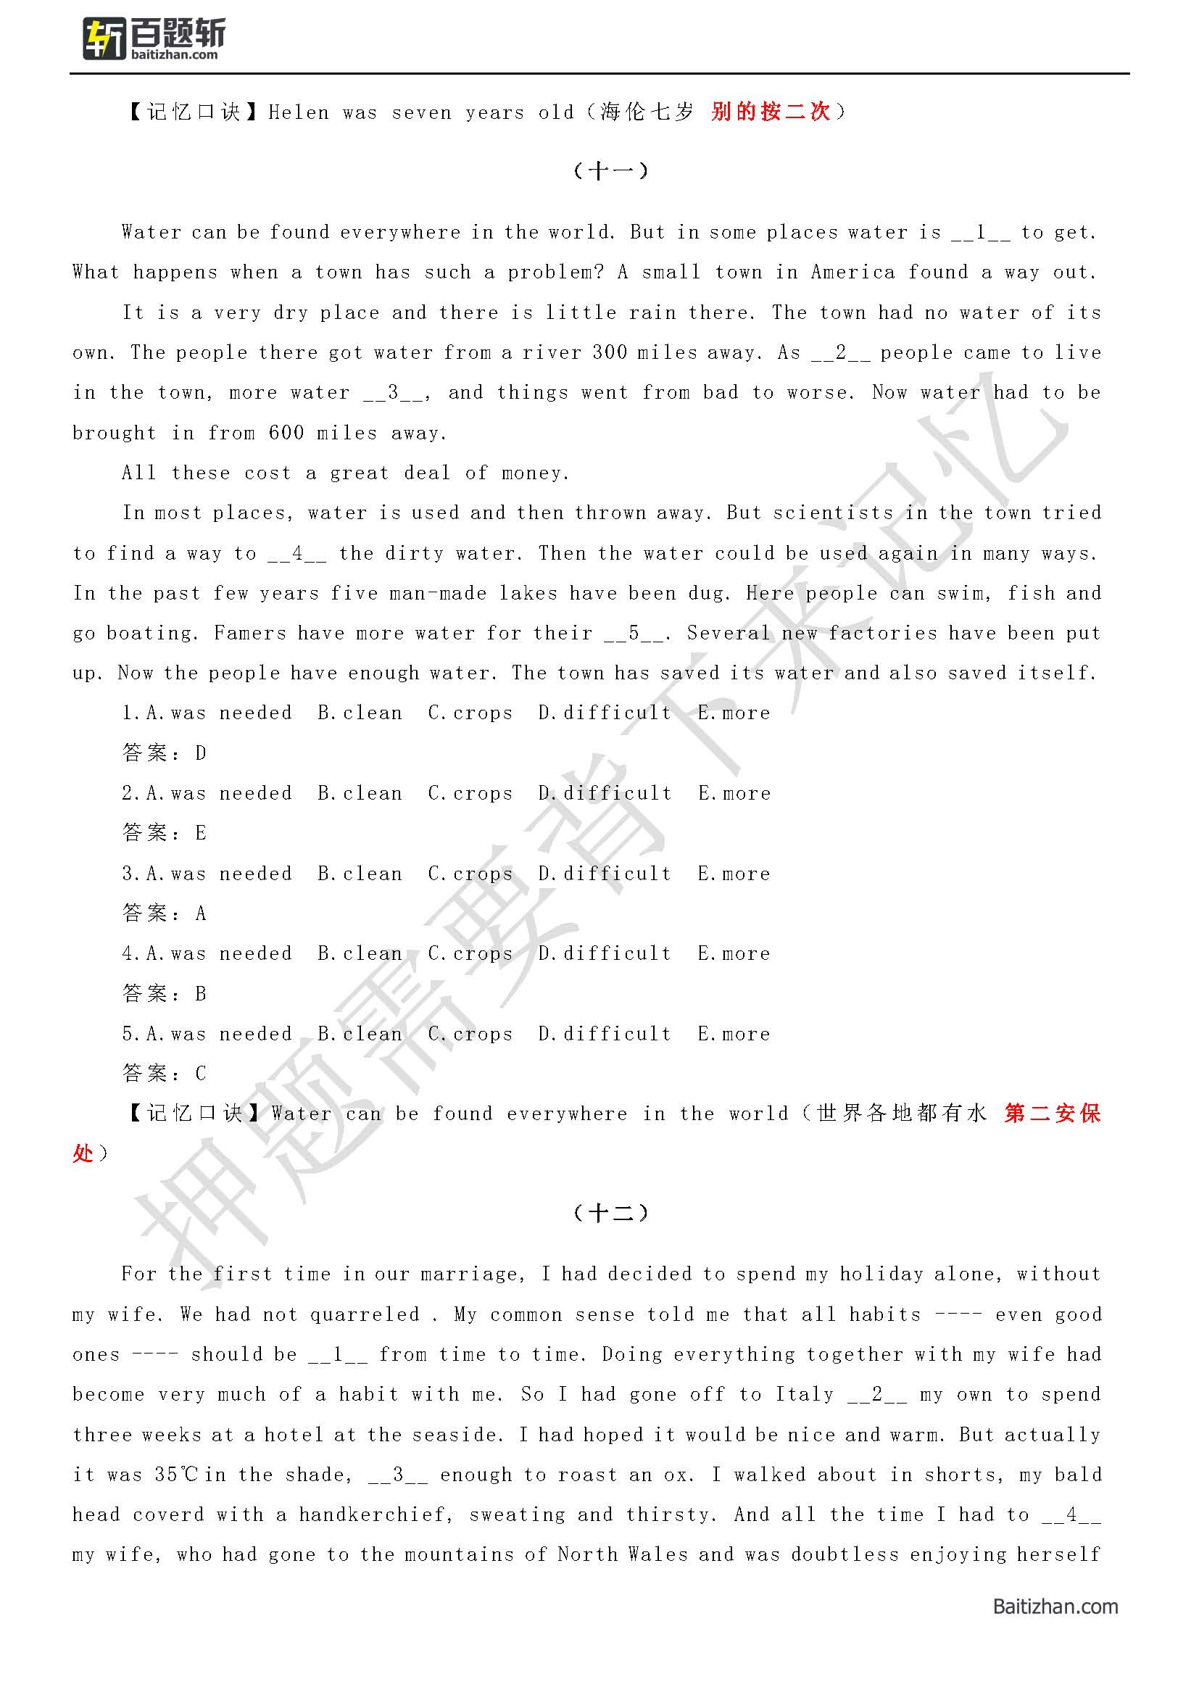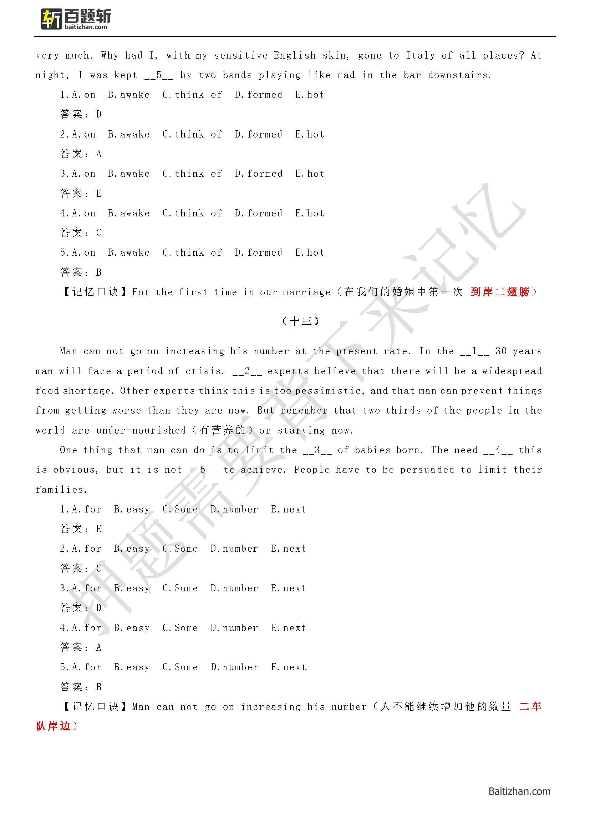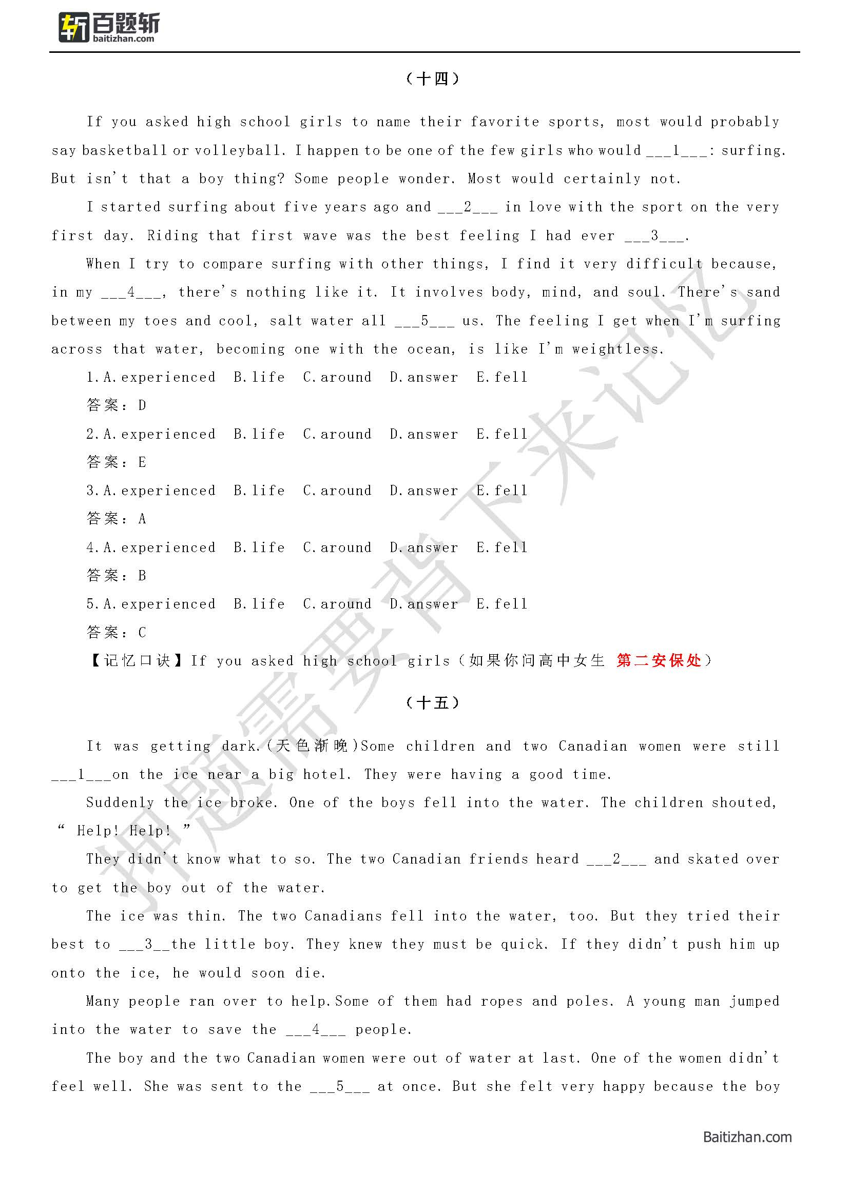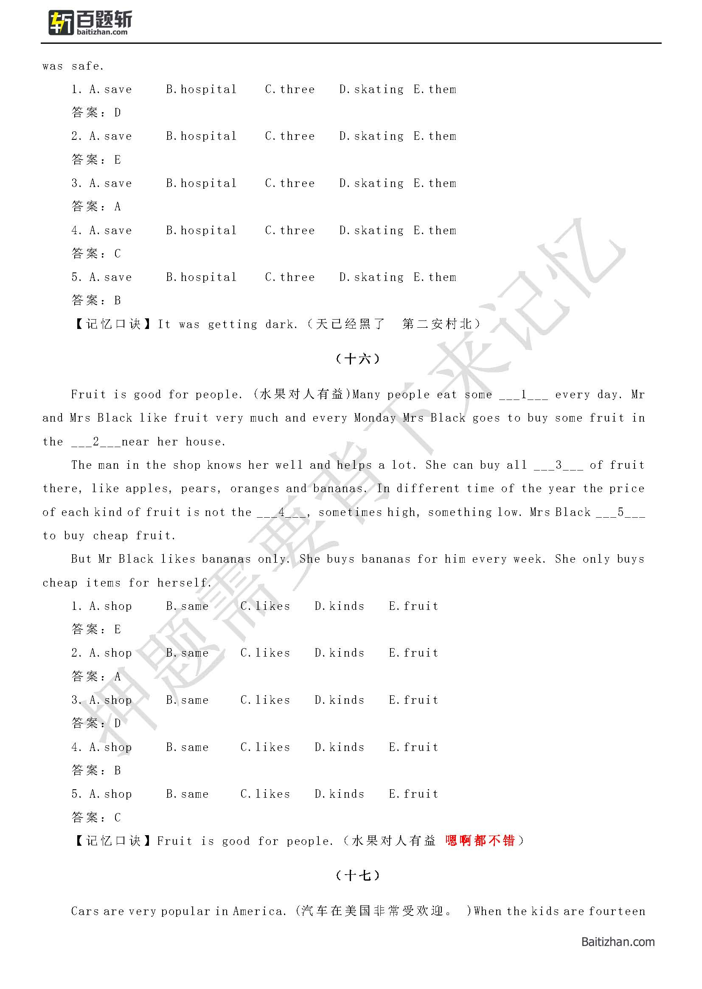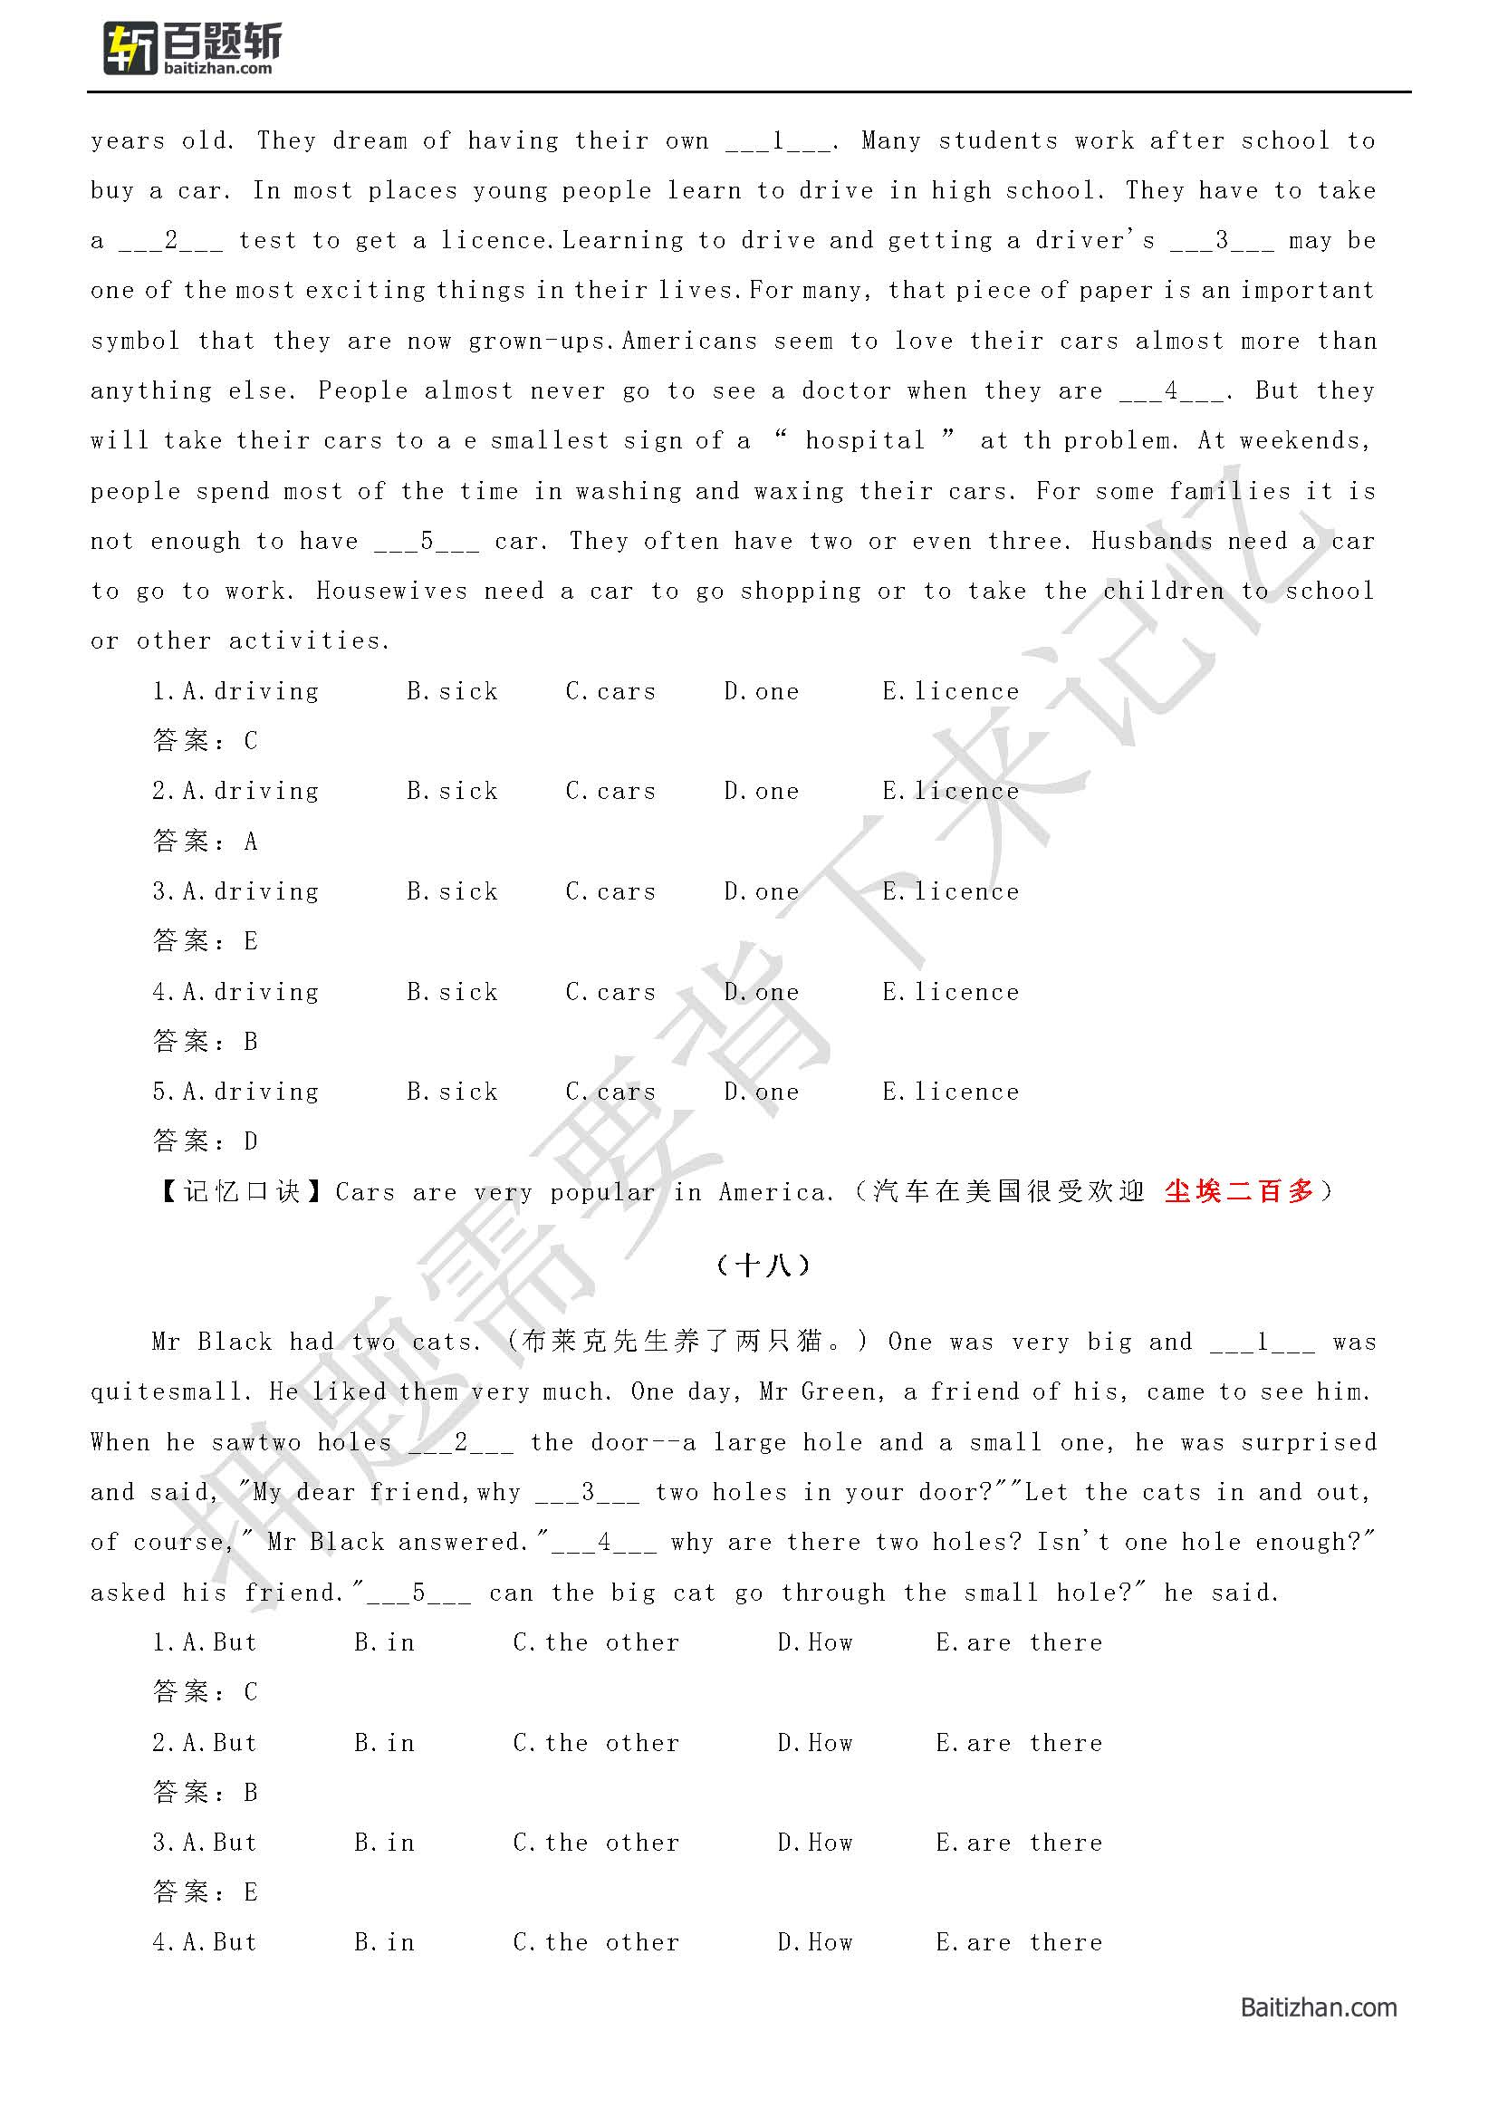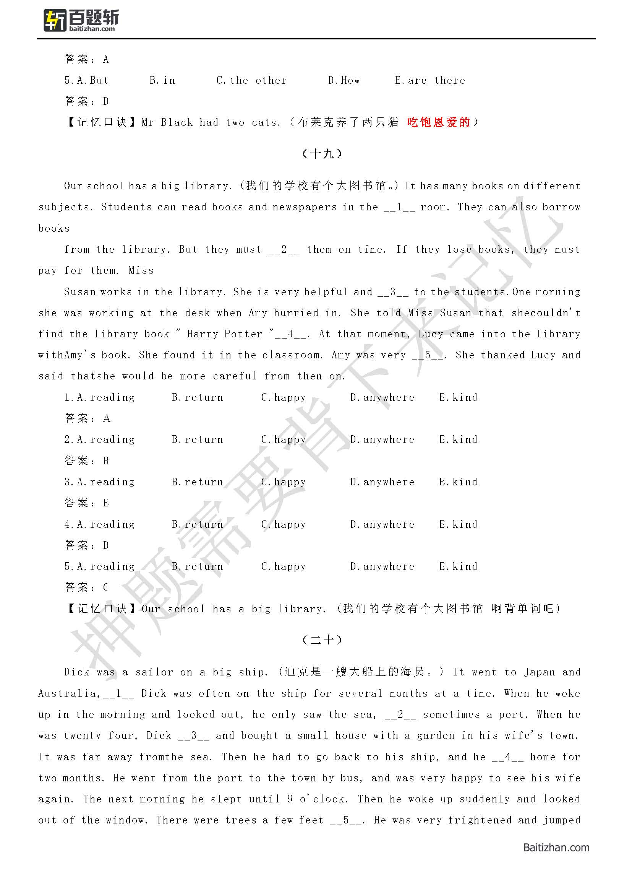

out ofbed, shouting, "We've hit land!"

1.A.or B.did not come C.so D.got married E.away

答案：C

2.A.or B.did not come C.so D.got married E.away

答案：A

3.A.or B.did not come C.so D.got married E.away

答案：D

4.A.or B.did not come C.so D.got married E.away

答案：B

5.A.or B.did not come C.so D.got married E.away

答案：E

【记忆口诀】Dick was a sailor on a big ship. (迪克是一艘大船上的海员。)

（陈爱都不错）

# 第五部分 英译汉

**重点！此部分建议花较多时间来进行记忆！30分！已掌握的可快速过！**

1.We are getting ready for our Englishexamination.

答案：我们正在为英语考试做准备。

2.In the past few days, news of victory haskept coming in.

答案：在过去的几天里胜利的消息不断传来。

3.She has only a small room to live in.

答案：她只有一个小房间住。

4.I read the local newspapers with greatinterest every evening.

答案：每晚我怀着极大的兴趣读当地报纸。

5.You and your team can discover the answersto problems together.

答案：你和你的团队能够一起找到问题的答案。

6.I rang your house last night but yourmother answered the phone.

答案：我昨夜给你家打电话，但接电话的是你母亲。

7.I'll try not to take up too much of your time.

答案：我尽量不占用你太多的时间。

8.I'm now a distance education student.

答案：我现在是一名远程教育学员。

9.The pen that I'm writing with is a birthday present from my sister.

答案：我正在用的这支笔是我姐姐送我的生日礼物。

10.Promise me never to be late again.

答案：答应我以后再也不要迟到了。

11.Have you seen Tom recently?

答案：最近你看见汤姆了吗?

12.My classmate is much cleverer than I.

答案：我的同学比我聪明多了。

13.What would you like to drink, mineral water or tea?

答案：你喜欢喝点什么，矿泉水还是茶水?

14.I've got used to the weather in Shanghai.

答案：我已经适应了上海的这种天气。

15.He had a traffic accident last week.

答案：他上星期出了一起交通事故。

16.Many schools will open for lessons at the beginning of September.

答案：很多学校九月初开学。

17.She likes to help any one who is in difficulty.

答案：她乐意帮助任何一个有困难的人。

18.The students are encouraged to do more listening, reading and writing by their teacher.

答案：老师鼓励学生多听、多读、多写。

19.He is always very active in student activities.

答案：他在学生活动中一直非常积极。

20.Do you think students should do a part-time job?

答案：你认为学生应该业余打工吗?

21.No matter what happens, I'll be your best friend.

答案：无论发生什么，我都是你最好的朋友。

22.Is this the magazine which you want to borrow?

答案：这就是你要借的那本杂志吗?

23.I could hardly agree to what you said just now.

答案：我不能同意你刚才说的话。

24.I can't go with you today because I'm too busy.

答案：我今天不能和你一块儿去，因为我太忙了。

25.He has a foreign friend who lives in the United States.

答案：他有一个住在美国的外国朋友。

26.But it looks like something I would never buy.

答案：但它看起来就像是我绝不会买的东西。

27.He tried many times to pass the examination, and in the end he succeeded.

答案：好多次他试图通过考试，最后他成功了。

28.I've never heard such a good music in a game.

答案：我在游戏里从未听过这样好的音乐。

29.Apples here like water and sunshine.

答案：这里的苹果喜欢水和阳光。

30.There is a large amount of energy wasted due to friction(摩擦).

答案：由于摩擦而损耗了大量的能量。

31.Ted and William have lived under the same roof for five years.

答案：泰德和威廉已经在同一个屋檐下生活了五年了。

32.A friend of mine from high school is working in England now.

答案：我高中的一个朋友正在英格兰国工作。

33. A lot of natural resources in the mountain area are to be exploited and used.

答案：那个山区有许多自然资源有待于开发利用

34. About half of the fruit is ripe.

答案：大约一半的果实已经成熟。

35. As is known to all, China is the largest developing country in the world today.

答案：众所周知，中国是世界上最大的发展中国家。

36. Bill hit his car into a wall last night

答案：昨晚比尔开车时车撞到了墙上

37. Both Ann and Mary are suitable for the job.

答案：安妮和玛丽都适合这份工作。

38. Could you tell me where the post office is?

答案：请问邮局在哪里

39. Did you get that E-mail from me

答案：你收到我发的那封电子邮件了吗

40. Do you have access to the Internet?

答案：你连接了互联网吗?

41. Do you think you can do it by yourself?

答案：你认为你自己可以单独干完这件事吗

42. Does the computer have instructions on it?

答案：电脑上面有使用说明吗

43. Don’t you think smoking is harmful to your health?

答案：难道你不认为抽烟有害于你的健康吗？

44. Don't believe whatever he tells you.

答案：无论他告诉你什么你都不要相信。

45. Fred was such a hardworking student that he soon came out first in the class.

答案：弗雷德是一个学习十分用功的学生,以至于不久他就成了班里学习最好的学生。

46. He has taught English in this university ever since he moved to this city．

答案：自从移居到这座城市以来，他就一直在这所大学教英语。

47. He prefers coffee to tea. / I prefer coffee to tea.

答案：与茶相比，他更喜欢咖啡。/ 与茶相比，我更喜欢咖啡。

48. He was very happy to hear from his old friend.

答案：他很高兴收到他的老朋友的信。

49. How are you doing these days?

答案：这些日子你怎么样

50. I don't know who broke the window

答案：我不知道是谁打破了窗户

51. I enjoyed this meal thoroughly.

答案：我很喜欢这顿饭

52. I knocked on his door but nobody came to answer it.

答案：我敲了他的门但没人来开门。

53. I slept soundly all night

答案：我整夜睡得很熟。

54. I was having a nap when suddenly the telephone rang

答案：我在睡觉时，电话铃突然响了

55. I would appreciate it if you would just let me deal with this case.

答案：如果您愿意让我处理这个事件，我将不胜感激。

56. I’ll have to try using the search engines.

答案：我得试着用搜索引擎。

57. I’m now a distance education student.

答案：我现在是远程教育的学生。

58. I’ve lost interest in my work.

答案：我已经对我的工作失去了兴趣。

59. If you decided to learn a new language, you would have to dedicate yourself wholeheartedly to the cause.

答案：如果你决定学一门新的语言，你必须全身心地投入。

60. In an age of plenty, we feel spiritual hunger.

答案：这个物质财富充裕的时代，我们感到精神上的饥渴。

61. It has not been decided yet whether they will take part in our experiment.

答案：他们还没有决定是否会参加我们的实验。

62. It is known to all that exercises are good for health

答案：众所周知，锻炼有益于健康

63. It is well known that coal is an important source of energy.

答案：众所周知，煤炭是一种重要的能源来源。

64. It was a hard job, but he did not mind

答案：这项工作很艰苦，但他并不在乎

65. Jane moved to new york at the end of last month.

答案：上个月底，Jane搬到了纽约

66. Let`s try something different

答案：让我们尝尝其他不同的口味

67. Let's find a place to shelter from the rain or we'll get wet

答案：我们找个地方躲雨吧，不然就淋湿了。

68. Li Ming is a friend of mine whom I have known since childhood.

答案：李明是我从小就认识的一位朋友。

69. Lincoln was the US president who set the slaves free。

答案：林肯是解放奴隶的美国总统

70. Look out the window it's still raining today!

答案：看窗外，今天还在下雨。

71. Most students feel satisfied with the progress they’ve made.

答案：大多数学生对自己所取得的进步感到满意。

72. My idea is that this experiment should be stopped.

答案：我的意见是这个实验应该停止了。

73. Not all Americans are interested in sports, of course.

答案：当然并非所有的美国人都对运动感兴趣。

74. One can never succeed without enough confidence in himself.

答案：一个人如果没有足够的自信永远不会成功。

75. Only those who work hard will be in a better position in the competition.

答案：只有勤奋者才会在这场竞争中处于更为有利的地位。

76. Our teacher always encourage us to speak English bravely.

答案：我们的老师总是鼓励我们大胆说英语。

77. Our text books are very different from theirs.

答案：我们的教科书与他们的很不一样。

78. Scientists think that there is no life on the Mars.

答案：科学家们认为火星上没有生命。

79. That team withdrew from the match as a protest against the unfair referee.

答案：那个球队退出了比赛，抗议那个不公平的裁判。

80. The doctor had no choice but reach out to their colleagues across the nation.

答案：医生除了向全国的同行寻求帮助外别无他法

81. The doctor told me to have more water.

答案：医生让我多喝些水。

82. The friend saw everything but did not say a single word.

答案：这位朋友看到了一切，却一言不发。/朋友目睹一切,却只字不提。

83. The jury (陪审团) was composed of eight white people and four black people.

答案：陪审团由八位白人和四位黑人组成。

84. The little boy wanted to exchange his toy car for my cake.

答案：这个小男孩想他用的玩具车换我的蛋糕。

85. The more I study, the less I seem to learn.

答案：我读的书越多，好像学到得东西越少

86. The more passions we have, the more happiness we are likely to experience.

答案：我们的激情越多，我们可能经历的幸福就越多。

87. The price of gasoline will come down in Chinese market.

答案：中国市场上的汽油价将会下降。

88. The reason why he failed is that he relies on others too much.

答案：他失败的原因是他太依赖别人。

89. The traffic jams during morning and afternoon rush hours are headache in big cities now.

答案：早晚高峰阶段的交通拥挤令很多大城市头疼

90. There's a party at my house this Friday.

答案：这个周五在我家有个派对

91. These goods are not up to standard.

答案：这些货物达不到标准/这些货物不符合标准。

92. They have been working together for three months and have come to know each other better.

答案：他们一起工作了三个月，相互之间也更了解了。

93. They thought that there must be something wrong with their TV set.

答案：他们认为他们的电视机准是哪里有问题了。

94. This box can hold more book than that one.

答案：这个箱子比那个箱子能装更多的书。

95. This pair of shoes cost me 260 yuan.

答案：买这双鞋我花了260元。

96. This place has plentiful material resources

答案：这个地方的物质资源是丰富的

97. Trees need water to grow.

答案：树木有水才能生长

98. We are more convinced than ever that the reform and open-door policy is correct.

答案：我们比过去任何时候都坚信，改革开放的政策是正确的。

99. We have made little progress.

答案：我们几乎没有进步。

100. We must take some measures to control the pollution.

答案：我们必须采取措施来控制污染

101. We should encourage him to have confidence in himself.

答案：我们应当鼓励他对自己要有信心。

102. We should keep it in mind that our country is a developing one.

答案：我们应该牢记这一点,我们的国家是一个发展中国家。

103. What kind of life do most people enjoy?

答案：大多数的人喜欢怎样的生活呢？

104. What time do you go swimming every day?

答案：你每天何时去游泳

105. Would you mind closing the window for me?

答案：你可以帮我关下窗户吗？

106. You can buy water inside.

答案：你可以在里面买水。

107. Your composition is well written, but there's still some room for improvement.

答案：你的作文很不错，但是还有改进的余地。

108. Their parents don't know them as well as their friends do.

答案：他们的父母不像朋友那样了解他们。

109. Only on weekends, cars can not go into the Central Park.

答案：只有在周末，中央公园不许汽车入内。

110. He didn't need to attend the meeting.

答案：他没必要参加那个会议。

111. It is no good hoping to read all these books.

答案：希望能够读完所有这些书是毫无意义的。

112. I saved the baby and became a hero.

答案：我因救了这个婴儿而成了英雄。

113. I'm thinking about a visit to Paris.

答案：我在考虑去巴黎旅游。

114. But I've got room for only two of you in the house.

答案：但是我家里只能住下你们其中的两个人。

115. "Why does the parrot ( 鹦鹉 ) cost so much?" the man asked.

答案：这个人问道： “这只鹦鹉为什么这么贵? ”。

116. He often went from town to town giving lectures.

答案：他经常辗转在城镇间作演讲。

117. Jim was clever, but he does not work hard.

答案：吉姆很聪明，但他讨厌吃苦。

118. He was happy with his new car, and drove to work in it the next day.

答案：他对自己的新车感到很满意，第二天就开着去上班了。

119. Playing the sport you like is an important part of a person's life.

答案：进行一项自己喜欢的运动是一个人生活中重要的一部分。

120. he People's Republic of China (PRC), founded on October 1, 1949, covers an area of 9.6 million square kilometers.

答案：中华人民共和国成立于 1949年10月1日，国土面积约 960万平方公里。

121. I hurried to my office.

答案：我匆忙赶到了办公室。

122. If you travel by ship across the Pacific, you cross the international date line( 国际日期变更线 ).

答案：如果你乘船航行穿越太平洋，你会穿过国际日期变更线。

123. On their way they came to a bread shop.

答案：在途中，他们来到一家面包店。

124. Are you fond of music?

答案：你喜欢音乐吗?

125.I am writing this letter to complain about the service in your hotel.

答案：我写这封信的目的是要投诉你们旅馆的服务。

126. We enjoyed ourselves very much at the party.

答案：在那次晚会上我们玩得很愉快。

127. This new country hopes to establish friendly relations with all its neighbours.

答案：这个新成立的国家希望和所有邻国建立友好关系。

128. She was the only daughter and the youngest child of the five.

答案：她是家里唯一的女儿，是五个孩子中年龄最小的。

129. She could not understand me when I spoke to her.

答案：当我跟她讲话的时候，她根本听不懂我的话。

130. Since the earth looks like a ball, the sun can shine on only half of it at a time.

答案：由于地球看上去像一个球，太阳一次只能照到它的一半。

# 第六部分 作文

作文部分：作文挑选出了几篇较为容易考到的题，作文一定要写，不会的用万能模板，不能空！

Failure is the mother of success（失败是成功之母）

All of us experience failure every now and then. Although some people will avoid failure at all costs, some people welcome it. Failure can be a good teacher. It always teaches us to be better the second time around. As they say, The more you try, the more you'll succeed. There is some wisdom to be learned from failure. If we can learn to turn a failure to our advantage, we will have learned another secret to success. Failure is the mother of success and success that comes after failure is so sweet.

Plant more trees（种更多的树）

April is the best time for green. Everything turns back to life in the warm weather and is enjoying the energy of a new life. Trees are more and more important to the earth. Planting trees is the basic thing to provide a green and healthy environment. Trees, as they are green in color, can make a city or place look more beautiful. It is also valuable in avoiding noises, sandstorms and deserts. It can bring us back a beautiful earth.So, everyone, if you want to make the air clean, please try your best to protect the environment and plant more trees.

My dream house（我理想中的家）/ My dream( 我的梦想)

I dream to have a house in Shanghai. My dream house should be very big. There should be three bedrooms in the house, because I would like to live with my parents. I would like my parents to live in a bedroom, my wife and I live in another bedroom and my son live in the third room. There should be a big kitchen. I like eating very much. With a big kitchen, I can cook a lot of good food to eat and enjoy my life in Shanghai.

Honesty is the Best Policy. (诚实乃上策。)

There is an English proverb saying Honesty is the best policy. It tells us the importance of honesty. What are the benefits of honesty? If you are honest to others, they will be honest to you in return. When you are sad, they will comfort you. When you are in trouble, they will help you.

It is usually better to be honest than dishonest. Sometimes honesty may get you in trouble or hurt someone, but on the whole telling the truth is less harmful than lying.

In a word, honesty not only brings us honor and friendship, but also material gains. Honesty is the best policy we can take.

My Hobbies（我的爱好，喜欢的运动之类的）

I have many hobbies, such as sports, singing, playing the violin and keeping a diary. I like sports very much. I go running at five o'clock in the morning. After classes in the afternoon, I play table-tennis with my friends. These sports have kept me healthy. At home, I like to sing and play the violin. I practice singing and playing the violin every day. Busy as I am, I am quite happy. Of all my hobbies I like reading books best. In my bedroom there are nearly six hundred books. There are story books, textbooks, magazines, and others. All these books have enriched my knowledge.

My Family （我的家庭，我的父母，我的老师之类可用）

As the old saying goes, East, west, home is the best. Whenever I’m tired, I can have a good rest at home. Whenever I feel sad, my parents will come to comfort me. Whenever I’m happy, I can share my joy with my family members. I live in Shanghai. There are two bedrooms and a living room in my home. Although the flat is not big, I feel comfortable to live there. It is near my company, so I can ride a bike to work everyday. During the weekends, I will do some housework and study English at home. I love my home. It is the best place ever.

Parents are the best teachers（父母是最好的老师）

Parents are the best teachers. Firstly, parents stay with children every day. Children will regard them as examples and learn from them. If the parents are polite, the children will be polite. Secondly, parents influence children with their words and behaviors. If parents always are nice to others and say good words about others, their children will also be kind to other children. If parents are good to old people, when the parents are getting older, the children will be good to them too. To sum up, from what has been discussed above we can draw the conclusion that parents are our best parents.

Dear Sam, （给朋友一封信，邀请的）

I have just received your letter and know that you are going to come to China to see me. I am really excited by it. You know I miss you so much. In your letter, you mentioned your travel plan. I advise you to go to Beijing and Xi’an. There are many royal buildings in Beijing like Palace Museum, Summer Palace. Xi’an is typical of old China. There are lots of historical buildings there, especially those of Qin Dynasty. I hope you enjoy your stay in China. I am looking forward to your coming. Yours ever, John?