# A02014087 张文滔 复杂网络作业五

对Email数据集，用Katz, CN, AA, RA, LP, ACT，SimRank算法进行链路预测。设置训练集比例为90%，并比较AUC值和Precision (L=100,200)。

## 代码：

借鉴了<https://github.com/CodeZWT/Link-Prediction>的代码

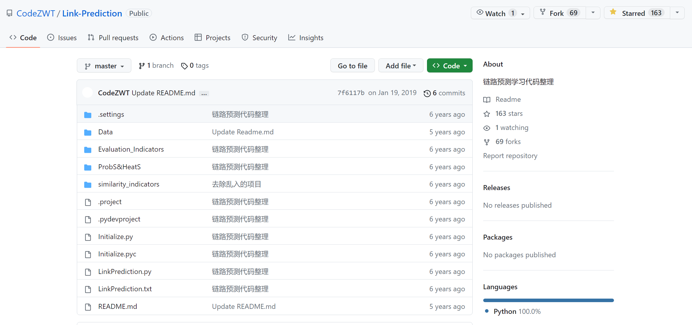

主函数：LinkPrediction.py

import time

import os

import Initialize

import Evaluation_Indicators.AUC

import similarity_indicators.CommonNeighbor

import similarity_indicators.AA

import similarity_indicators.RA

import similarity_indicators.LP

import similarity_indicators.Katz

import similarity_indicators.ACT

startTime = time.time()

NetFile = 'Data/Email.txt'

NetName = 'Email'

print("\nLink Prediction start:\n")

TrainFile_Path = 'Data\\'+NetName+'\\Train.txt'

if os.path.exists(TrainFile_Path):

    Train_File = 'Data\\'+NetName+'\\Train.txt'

    Test_File = 'Data\\'+NetName+'\\Test.txt'

    MatrixAdjacency_Train, MatrixAdjacency_Test, MaxNodeNum = Initialize.Init2(Test_File, Train_File)

else:

    MatrixAdjacency_Net, MaxNodeNum = Initialize.Init(NetFile)

    MatrixAdjacency_Train, MatrixAdjacency_Test = Initialize.Divide(NetFile, MatrixAdjacency_Net, MaxNodeNum, NetName)

similarity_StartTime = time.time()

for Method in range(6):

    if Method == 0:

        print('----------SIM----------计算相似性矩阵1 7----------SIM----------')

        print('----------Cn----------')

        Matrix_similarity = similarity_indicators.CommonNeighbor.Cn(MatrixAdjacency_Train)

        Evaluation_Indicators.AUC.Calculation_AUC(MatrixAdjacency_Train, MatrixAdjacency_Test, Matrix_similarity, MaxNodeNum)

    elif Method == 1:

        print('----------RA----------')

        Matrix_similarity = similarity_indicators.RA.RA(MatrixAdjacency_Train)

        Evaluation_Indicators.AUC.Calculation_AUC(MatrixAdjacency_Train, MatrixAdjacency_Test, Matrix_similarity, MaxNodeNum)

    elif Method == 2:

        print('----------Katz----------')

        Matrix_similarity = similarity_indicators.Katz.Katz(MatrixAdjacency_Train)

        Evaluation_Indicators.AUC.Calculation_AUC(MatrixAdjacency_Train, MatrixAdjacency_Test, Matrix_similarity, MaxNodeNum)

    elif Method == 3:

        print('----------SIM----------基于随机游走----------SIM----------')

        print('----------ACT----------')

        Matrix_similarity = similarity_indicators.ACT.ACT(MatrixAdjacency_Train)

        Evaluation_Indicators.AUC.Calculation_AUC(MatrixAdjacency_Train, MatrixAdjacency_Test, Matrix_similarity, MaxNodeNum)

    elif Method == 4:

        print('----------AA----------')

        Matrix_similarity = similarity_indicators.AA.AA(MatrixAdjacency_Train)

        Evaluation_Indicators.AUC.Calculation_AUC(MatrixAdjacency_Train, MatrixAdjacency_Test, Matrix_similarity, MaxNodeNum)

    elif Method == 5:

        print('----------SIM----------基于路径----------SIM----------')

        print('----------LP----------')

        Matrix_similarity = similarity_indicators.LP.LP(MatrixAdjacency_Train)

        Evaluation_Indicators.AUC.Calculation_AUC(MatrixAdjacency_Train, MatrixAdjacency_Test, Matrix_similarity, MaxNodeNum)

    else:

        print("Method Error!")

similarity_EndTime = time.time()

print('----------汇总----------')

print("All SimilarityTime: {} s".format(similarity_EndTime - similarity_StartTime))

# Calculate AUC

Evaluation_Indicators.AUC.Calculation_AUC(MatrixAdjacency_Train, MatrixAdjacency_Test, Matrix_similarity, MaxNodeNum)

endTime = time.time()

print(f"\nRunTime: {endTime - startTime} s")

## 运行结果：

Link Prediction start:

DataShape......

数据集长度：4906

第一列节点长度：(750)

第二列节点长度：(1123)

节点数量为：1133

数据集长度：545

第一列节点长度：(314)

第二列节点长度：(373)

节点数量为：1105

----------ACT----------

----------Cn----------

SimilarityTime: 0.056853600006434135 s

Calculation AUC......

AUC指标为：0.8854290600832838

AUCTime：1.2904255390167236 s

precision(L=100):0.32

precision(L=200):0.28

----------RA----------

SimilarityTime: 0.109375 s

Calculation AUC......

AUC指标为：0.8874189470553242

AUCTime：1.1307573318481445 s

precision(L=100):0.33

precision(L=200):0.22

----------Katz----------

SimilarityTime: 0.093750 s

Calculation AUC......

AUC指标为：0.9531751933372993

AUCTime：1.126634120941162 s

precision(L=100):0.31

precision(L=200):0.275

----------ACT----------

Calculation AUC......

AUC指标为：0.8350089232599643

AUCTime：1.173448085784912 s

precision(L=100):0.06

precision(L=200):0.055

----------AA----------

SimilarityTime: 0.250000 s

Calculation AUC......

AUC指标为：0.8881246281975015

AUCTime：1.1335554122924805 s

precision(L=100):0.39

precision(L=200):0.275

----------LP----------

SimilarityTime: 0.265625 s

Calculation AUC......

AUC指标为：0.8981640392623439

AUCTime：1.1891725063323975 s

precision(L=100):0.11

precision(L=200):0.11

----------汇总----------

All SimilarityTime: 9.964800119400024 s

RunTime: 9.99631929397583 s

## 整理后的结果：

AUC保留小数点后三位

|  |  |  |  |  |  |  |  |
| --- | --- | --- | --- | --- | --- | --- | --- |
| 方法  指标 | | Katz(=0.01) | CN | AA | RA | LP(=0.01) | ACT |
| AUC | | 0.953 | 0.885 | 0.888 | 0.887 | 0.898 | 0.835 |
| Precision | L=100 | 0.31 | 0.32 | 0.39 | 0.33 | 0.11 | 0.06 |
| L=200 | 0.275 | 0.28 | 0.275 | 0.22 | 0.11 | 0.055 |