Build File prospector

- Open FileProspector.sln and build
- Set working directory if you want to trace code
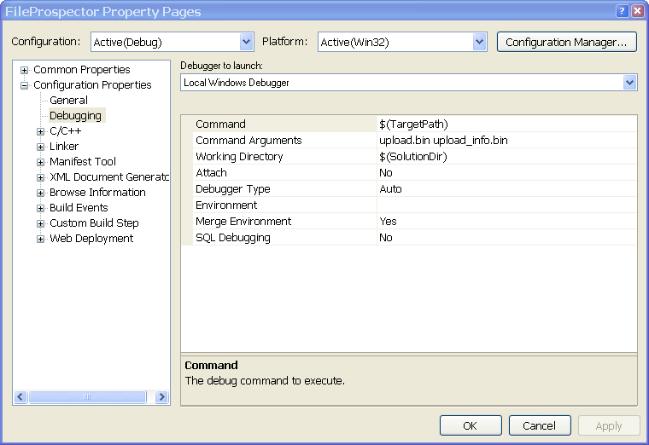
- Run FileProspector, then you can see
